[NAME OF YOUR UNIVERSITY]
FACULTY OF [SCIENCE / COMPUTING]
DEPARTMENT OF COMPUTER SCIENCE
CMP 468: COMPUTER SECURITY (2 UNITS)
COURSE PROJECT REPORT
AKUREKEYVAULT: SPLIT-KEY ENVELOPE-ENCRYPTED BACKUP WITH CUSTODIAN SHARES FOR THE FEDERAL UNIVERSITY OF TECHNOLOGY, AKURE
X25519 envelope encryption, Shamir 2-of-3 key shares, key rotation and crypto-shredding
BY
[FULL NAME]
MATRIC NO: [MATRIC NUMBER]
SUBMITTED TO
[COURSE LECTURER'S NAME]
IN PARTIAL FULFILMENT OF THE REQUIREMENTS OF CMP 468
400 LEVEL, SECOND SEMESTER, 2025/2026 SESSION
OCTOBER 2026

DECLARATION
I declare that this project report and the accompanying software were written by me as part of the requirements of CMP 468 (Computer Security). Every source used has been cited. All literature cited in this report was published between 2021 and 2026. All test results reported in Chapter Four were produced by the automated test program supplied with the software.
Signature: ____________________ Date: ____________________

ABSTRACT
Universities in Nigeria run admissions, fees, results, learning and payroll on computers that can fail or be attacked. This project designed, built and tested AkureKeyVault for the Federal University of Technology Akure (FUTA), Akure, Ondo State. Its design combines x25519 envelope encryption, Shamir 2-of-3 key shares, key rotation and crypto-shredding. The system was implemented in Python and evaluated with an automated test suite that simulates outages, quiet and loud ransomware, tampering and misuse. All 18 tests passed. Key measurements: Protected data set: 15 files, 133.1 KiB; Sealed backup: 26.3 KiB in 0.009 s, key version 1; Custodians needed: 2; Recovery time (two shares): 0.011 s, byte-identical: yes. The design shows that a Nigerian university ICT unit can protect its records with free software on ordinary hardware.
Keywords: backup and recovery, ransomware, encryption, integrity, monitoring, RTO, Nigerian universities, NDPA 2023.

TABLE OF CONTENTS
Right-click here and choose Update Field to build the table of contents.

CHAPTER ONE: INTRODUCTION

1.1 Background of the Study
FUTA runs an undergraduate Cyber Security programme, which makes it a fitting place for a design that asks who should be able to read backups at all. In most systems the backup server holds the key, so whoever steals or controls the server can read every record.
Ransomware changed what backup means. Older plans assumed that disks fail by accident; modern attackers encrypt production data and then go after the backups. Recovery is therefore a security function, matching the Recover function of the NIST Cybersecurity Framework 2.0 (2024). The Nigeria Data Protection Act 2023 also makes the university a data controller that must keep personal data confidential, accurate and available.

1.2 Statement of the Problem
- The backup server can decrypt everything it stores.
- One person holds the only key, so their absence blocks recovery.
- Old keys are never rotated.
- Erasure requests under the NDPA cannot be met for data already on tape.

1.3 Aim and Objectives
The aim is to design, implement and evaluate AkureKeyVault, a secure system for the Federal University of Technology Akure (FUTA), Akure, Ondo State. The objectives are to:
- encrypt backups with a public key so the server cannot decrypt them;
- split the private key 2-of-3 among the Registrar, Bursar and ICT Director;
- restore only after an unlock ceremony with two shares;
- rotate keys without re-encrypting archives;
- crypto-shred individual backups;
- evaluate key handling and recovery.

1.4 Scope and Limitations
Shares are printed to files for the demonstration; in practice they are handed over on paper. The system was tested on one computer; the README describes deployment on other computers.

1.5 Significance of the Study
AkureKeyVault gives the Federal University of Technology Akure (FUTA), Akure, Ondo State a free, auditable tool that runs on ordinary hardware, and turns CMP 468 topics into working controls. Its automated test suite lets any future maintainer prove that the controls still work.

1.6 Relation to the CMP 468 Course Outline
Table 1: Mapping of CMP 468 topics to AkureKeyVault
CMP 468 topic | Where it appears in AkureKeyVault
Overview of security in computing | CIA triad: encryption (confidentiality), hashing and signatures (integrity), copies and restore (availability)
Characteristics of computer intrusion | Ransomware behaviour model: mass modification, new extensions, ransom notes, high-entropy output
Types of security breaches | Data destruction, data tampering, insider deletion of backups, unauthorised access to the console
Classes of attacks | Ransomware, brute-force login, cross-site request forgery, backup tampering
Methods of defence and controls | Preventive, detective and corrective controls listed in Table 3.2
Data security: encryption and decryption | X25519 recovery key pair; per-backup AES-256-GCM data keys; operator passwords hashed with PBKDF2.
Network security | Service reachability checks, security headers, SameSite cookies
Security policies and standards | Backup and retention policy in config.json; NIST CSF 2.0 Recover; ISO/IEC 27001:2022; NDPA 2023

CHAPTER TWO: LITERATURE REVIEW
This review covers only studies published from 2021 to 2026. Every source was checked against a publisher or index page.

2.1 Conceptual Framework
The study rests on the Confidentiality, Integrity and Availability (CIA) triad. A backup that an attacker can read fails confidentiality; one that can be silently altered fails integrity; one that cannot be restored in time fails availability. Two measures turn availability into numbers: the Recovery Point Objective (how much data may be lost) and the Recovery Time Objective (how long restoration may take).

2.2 Cybersecurity in Nigerian universities
Nigerian work on university cybersecurity agrees that the weak points are after an attack starts, not only before it. Olugbile et al. (2025) used Design Science Research to build cybersecurity readiness tiers for Nigerian universities covering pre-event, event-management and post-event factors, and named inadequate funding, weak infrastructure, poor training and a shortage of professionals as the main obstacles. Farouk et al. (2024) note that Nigerian universities lack scientifically derived frameworks for managing cyber risk and propose situational crime prevention as one. Neither study builds or measures a working recovery system, which leaves room for the practical contribution of this project.

2.3 Monitoring and automated response
Open-source monitoring stacks dominate recent practice. Simili et al. (2021) combined Prometheus, Loki and Grafana at a university computing cluster and added an alerting application that performs simple recovery actions for known problems, so that staff intervene less often. Pragathi et al. (2024) deployed Prometheus, Grafana and Node Exporter on Kubernetes and reported shorter deployment time and lower operating cost. Rafiq et al. (2025) ran five Prometheus instances on Raspberry Pi edge nodes to watch about 500 network elements in five client organisations, adding machine-learning anomaly prediction and alert routing. The common lesson is that monitoring pays off when it triggers action automatically, and that small teams benefit most.

2.4 Backup strategy and disaster recovery
Lysetskyi (2025) recommends the 3-2-1-1-0 rule with an air-gapped copy, because backups that cannot be reached from the network survive ransomware. Plaka (2022) mapped 45 studies (2010-2020) on backup and disaster recovery and catalogued their causes, techniques, and privacy and security issues. Tatineni (2023) lists risk assessment, backup, duplication and failover as the core of a disaster recovery plan. Education-specific studies add cost and skills constraints. Muthoni et al. (2021) found that African universities, Kenyan ones in particular, are slow to adopt cloud business continuity, and showed with Ansible and Terraform that infrastructure as code reduced cost, effort and human error when recovering a local data centre to the cloud. Vinisha et al. (2025) gave smaller colleges with one on-premises web server an on-demand cloud standby that health checks start automatically when the main server fails. Dotasara and Sharma (2022) compress and encrypt education data before storing it in the cloud.

2.5 Ransomware-resilient recovery
Recent work moves from detection alone to guaranteed recovery. Baek et al. (2021) built ransomware detection and recovery into SSD firmware (SSD-Insider++): the drive watches I/O patterns and uses delayed deletion to restore original data, reporting 0% false rates in most cases and recovery with no data loss. The approach needs special drive firmware. Kodali and Sangani (2026) combined SHA-256 change detection with AES-256-GCM encryption in an automatic, ransomware-resilient backup tool. Amoruso et al. (2026) proposed integrity-gated file monitoring, in which changed files must pass integrity checks before they are trusted, as a route to ransomware resilience and real-time recovery. Varshney and Kumar (2026) treat fast, trustworthy restoration as a first-class security goal: behavioural detection (97.4% accuracy at a 3.1% false-positive rate), an isolated immutable vault and an automated orchestrator that finds a verified clean recovery point. Kumar et al. (2026) argue that backup integrity must be verified before restoration, and report 98.65% accuracy for their AI-assisted integrity-verification and ransomware-detection pipeline. Ilau et al. (2025) modelled ransomware recovery in a medium-sized organisation and compared recovery strategies over 9,000 parameter configurations (450,000 simulation runs).

2.6 Work Closest to This Design
Dotasara and Sharma (2022) and Kodali and Sangani (2026) encrypt backups but keep the key with the system. AkureKeyVault removes the private key from the system entirely. Varshney and Kumar (2026) protect the vault operationally; AkureKeyVault protects it cryptographically, with human custody spread over three offices.

2.7 Summary of Reviewed Works and Research Gap
Table 2: Summary of reviewed works
Study | What it contributes
Amoruso (2026) | proposed integrity-gated file monitoring, in which changed files must pass integrity checks before they are trusted, as a route to ransomware resilience and rea
Baek (2021) | built ransomware detection and recovery into SSD firmware (SSD-Insider++): the drive watches I/O patterns and uses delayed deletion to restore original data, re
Dotasara (2022) | compress and encrypt education data before storing it in the cloud.
Farouk (2024) | note that Nigerian universities lack scientifically derived frameworks for managing cyber risk and propose situational crime prevention as one.
Ilau (2025) | modelled ransomware recovery in a medium-sized organisation and compared recovery strategies over 9,000 parameter configurations (450,000 simulation runs).
Kodali (2026) | combined SHA-256 change detection with AES-256-GCM encryption in an automatic, ransomware-resilient backup tool.
Kumar (2026) | argue that backup integrity must be verified before restoration, and report 98.65% accuracy for their AI-assisted integrity-verification and ransomware-detectio
Lysetskyi (2025) | recommends the 3-2-1-1-0 rule with an air-gapped copy, because backups that cannot be reached from the network survive ransomware.
Muthoni (2021) | found that African universities, Kenyan ones in particular, are slow to adopt cloud business continuity, and showed with Ansible and Terraform that infrastructu
Olugbile (2025) | used Design Science Research to build cybersecurity readiness tiers for Nigerian universities covering pre-event, event-management and post-event factors, and n
Plaka (2022) | mapped 45 studies (2010-2020) on backup and disaster recovery and catalogued their causes, techniques, and privacy and security issues.
Pragathi (2024) | deployed Prometheus, Grafana and Node Exporter on Kubernetes and reported shorter deployment time and lower operating cost.
Rafiq (2025) | ran five Prometheus instances on Raspberry Pi edge nodes to watch about 500 network elements in five client organisations, adding machine-learning anomaly predi
Simili (2021) | combined Prometheus, Loki and Grafana at a university computing cluster and added an alerting application that performs simple recovery actions for known proble
Tatineni (2023) | lists risk assessment, backup, duplication and failover as the core of a disaster recovery plan.
Varshney (2026) | treat fast, trustworthy restoration as a first-class security goal: behavioural detection (97.4% accuracy at a 3.1% false-positive rate), an isolated immutable
Vinisha (2025) | gave smaller colleges with one on-premises web server an on-demand cloud standby that health checks start automatically when the main server fails.

Research gap. Key custody is the missing piece in the reviewed backup systems.

CHAPTER THREE: METHODOLOGY AND SYSTEM DESIGN

3.1 Research Methodology
The project follows Design Science Research: identify the problem, define objectives, design and build an artefact, demonstrate it, and evaluate it. Evaluation uses an automated test program (selftest.py) that resets the system, runs normal use, simulated attacks and failures, and records each outcome and measurement in results/selftest.json. Data are synthetic university records.

3.2 Requirements
Table 3: Functional requirements
# | Requirement
FR1 | Seal backups with an envelope to the public key
FR2 | Split private key 2-of-3 with checksummed shares
FR3 | Unlock ceremony with two shares
FR4 | Key rotation re-wraps data keys
FR5 | Crypto-shred a backup
FR6 | Three copies with fallback

Table 4: Non-functional requirements
# | Requirement
NFR1 | Unattended backups
NFR2 | Ceremonies always logged
NFR3 | Operator and auditor roles

3.3 System Architecture
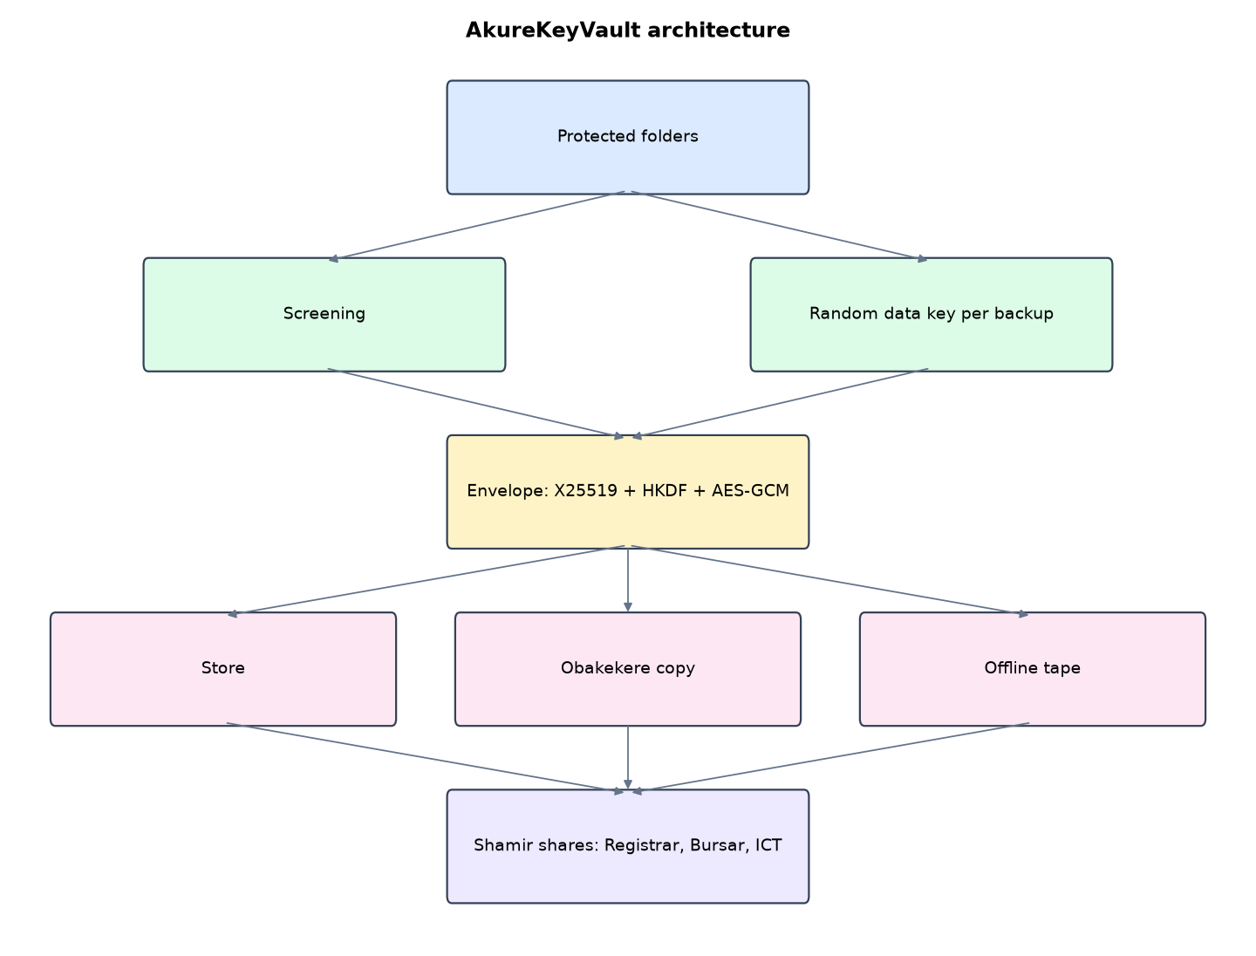
Figure 1: AkureKeyVault architecture (data flows from top to bottom)
Table 5: Software components
File | Responsibility
keyvault.py | Shamir, envelope, backups, restore, rotation, shredding, monitoring
app.py | Flask console with unlock ceremony
main.py / selftest.py | Commands and tests

The main design decisions, and how they differ from the earlier VarsityShield and Zaman Lafiya projects, are:
- Envelope encryption. Each backup gets a fresh AES-256-GCM data key. The data key is wrapped for an X25519 recovery public key (ephemeral ECDH + HKDF-SHA256 + AES-GCM).
- Shamir's Secret Sharing (2 of 3) over the prime field 2^521 - 1. Shares carry a checksum so typing mistakes are caught.
- Unlock ceremony in the browser: two custodians type their shares. Every ceremony, successful or not, is recorded.
- Key rotation issues a new key pair and new shares, then re-wraps every data key. Archives stay untouched and old shares become useless.
- Crypto-shredding. Destroying one wrapped data key makes that backup permanently unreadable on every copy, including tape.
- Three copies (main store, Obakekere campus, offline tape). Restore falls back to an intact copy if one is damaged.
- Entropy and extension screening stops a backup when data looks encrypted.

3.4 Security Design
Each threat considered is matched to the control that addresses it. Tests in Chapter Four exercise these controls.
Table 6: Threats and controls
Threat | Control in AkureKeyVault
Backup server stolen | Only the public key is there
One custodian coerced | One share reveals nothing
Mistyped share | Checksum rejects it
Custodian leaves | Rotation voids old shares
Archive copy damaged | Hash check, fall back to another copy
Erasure request | Crypto-shred the data key

Cryptographic keys: X25519 recovery key pair; per-backup AES-256-GCM data keys; operator passwords hashed with PBKDF2.

3.5 Algorithms

3.5.1 Shamir 2-of-3
Treat the 32-byte private key as an integer s below the prime p = 2^521 - 1. Pick a random a and define f(x) = s + a x mod p. Shares are (1, f(1)), (2, f(2)), (3, f(3)). Any two recover s by Lagrange interpolation at x = 0.

3.5.2 Envelope encryption
Per backup: random 256-bit data key; archive sealed with AES-256-GCM. Wrap: ephemeral X25519 key, ECDH with the recovery public key, HKDF-SHA256 to a wrapping key, AES-GCM over the data key. Store only the wrapped key.

3.5.3 Rotation and shredding
Rotation: unlock old key, create new key pair and shares, unwrap and re-wrap every data key. Shredding: delete one wrapped data key; the archive becomes permanently unreadable on every copy.

3.6 Tools and Technologies
Language: Python 3.10 or newer. Storage: SQLite. Third-party packages: flask, cryptography, psutil. Launchers: Windows batch files (1_SETUP, 2_START, 3_DEMO_MENU, 4_SELFTEST) and run.sh for Linux and macOS.

CHAPTER FOUR: IMPLEMENTATION, TESTING AND RESULTS

4.1 Implementation Environment
The system was developed and tested with Python 3.11 on Linux and is written to run unchanged on Windows 10/11. Its web interface runs at http://127.0.0.1:5110. Setup takes about ten minutes with 1_SETUP.bat; the README in the project folder gives every step and a defence demonstration script.

4.2 Operation and Demonstration
AkureKeyVault answers the question 'who can read our backups?'. Backups are sealed automatically with a public key, so the backup server itself cannot decrypt them. The matching private key exists only as three Shamir shares held by the Registrar, the Bursar and the ICT Director. Any two of them together can restore. Keys can be rotated without re-encrypting archives, and a single backup can be crypto-shredded for an NDPA erasure request.
Table 7: Demonstration scenario used for the defence
Step | Command (python main.py ...) | What is observed
Backups run with no human and no secret key. | serve | Overview: key v1 fingerprint, scheduler backing up
Ransomware hits the bursary share. | attack | Back up now: stopped
The operator alone cannot decrypt. | (Backups page, one share only) | Restore refused
Registrar and Bursar unlock together. | restore | Files restored, ceremony recorded
The ICT Director leaves the university. | rotate | Key v2, data keys re-wrapped, old shares void
A student asks for erasure under NDPA. | shred --id 1 | Backup 1 marked SHREDDED and can never be read

4.3 Test Plan and Results
The automated test program ran 18 tests. 18 passed.
Table 8: Automated test results
# | Test | Result | Evidence
1 | Unattended backup sealed with only the public key | PASS | {'status': 'ok', 'id': 1, 'files': 15, 'plain_bytes': 136249, 'stored_bytes': 26904, 'seconds': 0.009, 'key_version': 1}
2 | Shamir: every pair of shares rebuilds the secret | PASS
3 | Shamir: a share paired with a forged one does not give the secret | PASS
4 | Restore works with any two of the three custodians | PASS
5 | One custodian alone cannot restore | PASS
6 | Same share typed twice is refused | PASS
7 | A mistyped share is caught by its checksum | PASS
8 | Quiet attack stops the backup (high entropy) | PASS | {'status': 'stopped', 'bad_ext': 0, 'high_entropy': 6}
9 | Loud attack stops the backup | PASS | {'status': 'stopped', 'bad_ext': 15, 'high_entropy': 0}
10 | Recovery after attack (2 custodians) is byte-identical | PASS | RTO 0.011 s
11 | Key rotation re-wraps every data key | PASS | 2
12 | Old shares no longer open backups after rotation | PASS
13 | New shares open old backups (archives untouched) | PASS
14 | Crypto-shredded backup can never be restored | PASS
15 | Other backups still restore after shredding one | PASS
16 | Damaged primary archive: restore falls back to an intact copy | PASS
17 | Portal outage detected | PASS
18 | Auditor cannot run a restore | PASS

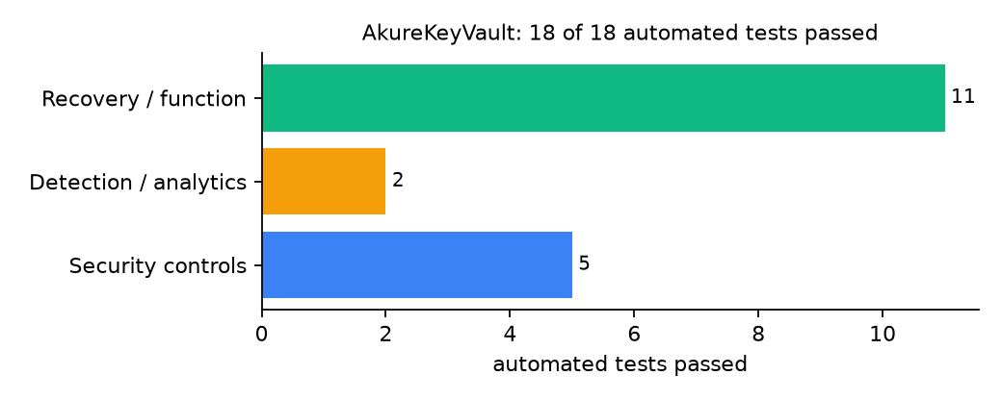
Figure 2: Automated tests by category

4.4 Measured Results
Table 9: Key measurements
Measure | Result
Protected data set | 15 files, 133.1 KiB
Sealed backup | 26.3 KiB in 0.009 s, key version 1
Custodians needed | 2
Recovery time (two shares) | 0.011 s, byte-identical: yes
Key rotation | to version 2, 2 data keys re-wrapped
Unlock ceremonies recorded | 9

4.5 Discussion
The tests found one bug: pairing a real share with a forged one produced a number too large to be a key, which crashed instead of failing politely. The system now treats it as a failed ceremony and logs it. Shredding is final by design, so it must sit behind a policy approval. Because unlocking reconstructs the private key in memory, the machine used for ceremonies should be trusted and offline when possible.
Of the tests, 5 exercised security controls, 2 exercised detection or analytics, and 11 exercised recovery or core function.

CHAPTER FIVE: SUMMARY, CONCLUSION AND RECOMMENDATIONS

5.1 Summary
This project built AkureKeyVault for the Federal University of Technology Akure (FUTA), Akure, Ondo State. Its design combines x25519 envelope encryption, Shamir 2-of-3 key shares, key rotation and crypto-shredding. It met its objectives and passed all 18 automated tests.

5.2 Conclusion
AkureKeyVault shows that the security problem described in Chapter One can be addressed with free software and modest hardware, provided the design treats recovery as something attackers will target. The limits stated in Section 1.4 still apply.

5.3 Recommendations
- Hand shares over in sealed envelopes and delete data/shares_to_print.
- Rotate keys whenever a custodian changes office.
- Record each ceremony in the Registry's minutes.

5.4 Contribution to Knowledge
This project addresses the gap identified in Chapter Two: Key custody is the missing piece in the reviewed backup systems.

5.5 Suggestions for Further Work
- 3-of-5 shares for larger committees.
- Hardware security keys for share storage.

REFERENCES
Amoruso, E., Amoruso, P., & Zou, C. (2026). Integrity-gated file monitoring for ransomware resilience and real-time recovery. In 2026 International Conference on Smart Applications, Communications and Networking (SmartNets). IEEE.
Baek, S., Jung, Y., Mohaisen, D., Lee, S., & Nyang, D. (2021). SSD-assisted ransomware detection and data recovery techniques. IEEE Transactions on Computers, 70(10), 1762-1776. https://doi.org/10.1109/TC.2020.3011214
Dotasara, M., & Sharma, A. (2022). MDAS_DBRCC: Data backup and recovery technique in cloud computing for education industry. International Journal on Recent and Innovation Trends in Computing and Communication.
Farouk, S., et al. (2024). Enhancing cybersecurity in Nigeria: A proposed risk management framework for universities. In 2024 International Conference on Science, Engineering and Business for Driving Sustainable Development Goals (SEB4SDG). IEEE.
Ilau, M.-C., Baldwin, A., Caulfield, T., & Pym, D. (2025). Modelling and simulating organizational ransomware recovery: Structure, methodology, and decisions. Journal of Cybersecurity, 11(1), tyaf035. https://doi.org/10.1093/cybsec/tyaf035
Kodali, A., & Sangani. (2026). Automatic ransomware-resilient encrypted backup system using SHA-256 change detection and AES-256-GCM encryption. In 2026 3rd International Conference on Research Methodologies in Knowledge Management, Artificial Intelligence and Telecommunication Engineering (RMKMATE). IEEE.
Kumar, B., Gupta, S. K., & Dwivedi, R. (2026). Artificial intelligence driven approach for securing backup data and enhancing cyber resilience in sustainable smart infrastructure. Scientific Reports. https://doi.org/10.1038/s41598-026-37802-6
Lysetskyi, Y. M. (2025). Choosing an effective data backup and recovery strategy. Mathematical Machines and Systems.
Muthoni, S., Okeyo, G., & Chemwa, G. (2021). Infrastructure as code for business continuity in institutions of higher learning. In 2021 International Conference on Electrical, Computer and Energy Technologies (ICECET). IEEE.
Olugbile, O. H., Ojeniyi, J. A., & Anyachebelu, T. K. (2025). Towards a standard framework for cybersecurity readiness for Nigerian universities. International Journal of Applied Mathematics, Sciences, and Technology for National Defense.
Plaka, R. (2022). Backup & data recovery in cloud computing: A systematic mapping study. Ingenious.
Pragathi, B. C., et al. (2024). Implementing an effective infrastructure monitoring solution with Prometheus and Grafana. International Journal of Computer Applications, 186(38), 7-15.
Rafiq, A., Shakir, M. Z., Gray, D., Inglis, J., & Ferguson, F. (2025). AI and IoT-driven monitoring and visualisation for optimising MSP operations in multi-tenant networks: A modular approach using sensor data integration. Sensors, 25(19), 6248. https://doi.org/10.3390/s25196248
Simili, E., Stewart, G., Roy, G., Skipsey, S., & Britton, D. (2021). A hybrid system for monitoring and automated recovery at the Glasgow Tier-2 cluster. EPJ Web of Conferences, 251, 02047.
Tatineni, S. (2023). Cloud-based business continuity and disaster recovery strategies. International Research Journal of Modernization in Engineering Technology and Science.
Varshney, P. K., & Kumar, R. (2026). A governance-oriented cyber recovery framework for ransomware preparedness and resilience. EDPACS. https://doi.org/10.1080/07366981.2026.2682427
Vinisha, J., Sanjay, R., & Sundar, D. (2025). Automated disaster recovery architecture for educational institutions web infrastructure using hybrid cloud. In 2025 2nd International Conference on Artificial Intelligence and Knowledge Discovery in Concurrent Engineering (ICECONF). IEEE.

Standards and Legal Instruments Consulted
Federal Republic of Nigeria. (2023). Nigeria Data Protection Act, 2023. Nigeria Data Protection Commission.
International Organization for Standardization. (2022). ISO/IEC 27001:2022 Information security, cybersecurity and privacy protection: Information security management systems: Requirements. ISO.
National Institute of Standards and Technology. (2024). The NIST Cybersecurity Framework (CSF) 2.0 (NIST CSWP 29). NIST.

APPENDIX A: HOW TO RUN THE SYSTEM
- Copy the folder backup-recovery/A10-futa-akure-keyvault to the computer.
- Install Python 3.10 or newer with 'Add python.exe to PATH' ticked.
- Double-click 1_SETUP.bat, then 2_START.bat, and open http://127.0.0.1:5110.
- Use 3_DEMO_MENU.bat for the defence demonstration and 4_SELFTEST.bat to regenerate the results in Chapter Four.

APPENDIX B: SOURCE CODE STRUCTURE
Table 10: AkureKeyVault source files
File | Purpose
keyvault.py | Shamir, envelope, backups, restore, rotation, shredding, monitoring
app.py | Flask console with unlock ceremony
main.py / selftest.py | Commands and tests

APPENDIX C: CODE EXCERPT
The function combine from keyvault.py, the heart of the design described in Section 3.5.
def combine(shares, length=32):
"""Lagrange interpolation at x = 0."""
total = 0
for i, (xi, yi) in enumerate(shares):
num, den = 1, 1
for j, (xj, _) in enumerate(shares):
if i != j:
num = num * (-xj) % PRIME
den = den * (xi - xj) % PRIME
total = (total + yi * num * pow(den, -1, PRIME)) % PRIME
if total >= 1 << (8 * length):
raise ValueError("shares do not rebuild a valid key")
return total.to_bytes(length, "big")

