[NAME OF YOUR UNIVERSITY]
FACULTY OF [SCIENCE / COMPUTING]
DEPARTMENT OF COMPUTER SCIENCE
CMP 468: COMPUTER SECURITY (2 UNITS)
COURSE PROJECT REPORT
BENUEPEACEGRID: AN AHP-WEIGHTED HEXAGON RISK GRID FOR FARMER-HERDER CONFLICT EARLY WARNING IN BENUE STATE
Multi-criteria risk on 9 km cells, signed GPS collars and protected community reporting
BY
[FULL NAME]
MATRIC NO: [MATRIC NUMBER]
SUBMITTED TO
[COURSE LECTURER'S NAME]
IN PARTIAL FULFILMENT OF THE REQUIREMENTS OF CMP 468
400 LEVEL, SECOND SEMESTER, 2025/2026 SESSION
OCTOBER 2026

DECLARATION
I declare that this project report and the accompanying software were written by me as part of the requirements of CMP 468 (Computer Security). Every source used has been cited. All literature cited in this report was published between 2021 and 2026. All test results reported in Chapter Four were produced by the automated test program supplied with the software.
Signature: ____________________ Date: ____________________

ABSTRACT
Farmer-herder conflict in Nigeria destroys lives, livelihoods and food supply. Early warning helps only when it is timely, trusted and secure. This project designed, built and tested BenuePeaceGrid for Benue State (12 LGAs including Makurdi, Guma, Agatu, Logo and Kwande). Its design combines multi-criteria risk on 9 km cells, signed GPS collars and protected community reporting. The system was implemented in Python and evaluated with an automated test suite on synthetic data that follows documented conflict patterns, including attacks on the system itself. All 15 tests passed. Key measurements: Hexagon cells: 435; Synthetic incidents in history: 288; Consistency ratio: 0.0152 (limit 0.10); Back-test: incidents in top 20% cells: 12 of 15 (hit rate 0.8, lift 4.0). The results show the design works as specified; field validation with real data is the next step.
Keywords: early warning, farmer-herder conflict, GIS, information security, privacy, Nigeria, NDPA 2023.

TABLE OF CONTENTS
Right-click here and choose Update Field to build the table of contents.

CHAPTER ONE: INTRODUCTION

1.1 Background of the Study
Benue State, the 'Food Basket of the Nation', sits on the main southward routes of transhumant herds. Guma, Agatu and Logo have suffered repeated deadly clashes. Risk reported at LGA level is too coarse to send a patrol: an LGA can be larger than 2,000 km2, and the trouble is usually in a few farming settlements near a route or a river crossing.
Nigerian farmer-herder conflict is driven by competition for land and water, changing herd mobility, weak institutions and perceived injustice. Early warning systems try to detect rising risk early enough for mediation, patrols or community action. They handle sensitive data (who reported what) and are themselves targets of manipulation, so they are a computer security problem as much as a data problem.

1.2 Statement of the Problem
- Risk is reported per LGA, which is too coarse for patrols.
- How risk factors are weighted is hidden, so stakeholders distrust it.
- Herd positions are unknown or can be faked.
- Community reporters fear exposure.

1.3 Aim and Objectives
The aim is to design, implement and evaluate BenuePeaceGrid, a secure system for Benue State (12 LGAs including Makurdi, Guma, Agatu, Logo and Kwande). The objectives are to:
- divide the state into hexagonal cells and score each from five factors;
- derive factor weights with AHP and reject inconsistent judgements;
- accept only signed, fresh GPS collar positions;
- receive community reports with rate limits and encrypted phone numbers;
- alert police, peace committees and LGA chairmen; back-test the grid against later incidents.

1.4 Scope and Limitations
LGA positions are approximate and incident history is synthetic, generated to follow documented seasonal patterns. The system was tested on one computer; the README describes deployment on other computers.

1.5 Significance of the Study
BenuePeaceGrid gives Benue State (12 LGAs including Makurdi, Guma, Agatu, Logo and Kwande) a free, auditable tool that runs on ordinary hardware, and turns CMP 468 topics into working controls. Its automated test suite lets any future maintainer prove that the controls still work.

1.6 Relation to the CMP 468 Course Outline
Table 1: Mapping of CMP 468 topics to BenuePeaceGrid
CMP 468 topic | Where it appears in BenuePeaceGrid
Overview of security in computing | Confidentiality of informants, integrity of reports and data, availability of alerts
Characteristics of computer intrusion | Forged reports, fake devices, replayed messages, tampered records
Types of security breaches | Disclosure of informant identity, falsified incident data, unauthorised access to case files
Classes of attacks | Impersonation, replay, injection, brute force, cross-site request forgery, disinformation
Methods of defence and controls | Table 3.2 maps each threat to its control
Data security: encryption and decryption | See Section 3.5
Database security | Parameterised SQL, role checks before every query, encrypted personal fields
Security policies and standards | NDPA 2023 (personal data of reporters), ISO/IEC 27001:2022 access control

CHAPTER TWO: LITERATURE REVIEW
This review covers only studies published from 2021 to 2026. Every source was checked against a publisher or index page.

2.1 Conceptual Framework
The study uses the early warning chain: collect signals, analyse risk, warn the right people, and respond. Each link has security needs: signals must be authentic, analysis must be on untampered data, warnings must reach people quickly, and the identities of informants must stay confidential.

2.2 Farmer-herder conflict in Nigeria and the region
Nnaji et al. (2022) surveyed 401 rural Nigerian households and found that both the incidence and the severity of farmer-herder conflict raise food insecurity, severity more so. Nwankwo (2025) showed from interviews in the Benue-Nasarawa borderland that perceived injustice drives escalation of farmer-herder violence. Babatunde and Ibnouf (2024) showed that officials, traditional rulers and security agents in Plateau State deepened conflict through unequal resource allocation and peacebuilding that favoured some groups. Eke et al. (2025) found Enugu farmers coping with herd incursions by farming in groups, reducing what they plant and preparing for crop loss, with falling income and productivity. Tarif (2022) reviewed the West African evidence and grouped climate-conflict links into four pathways, including changing pastoral mobility, while warning that the research base is thin. Together these studies explain why prevention must be local, fast and trusted by both farming and herding communities.

2.3 Conflict early warning systems and forecasting
Rød et al. (2024) compared conflict early warning systems on transparency, key parameters and forecasts, found weak access to data and code and large differences between systems, and called for shared standards. Goodman et al. (2024) predicted sub-national conflict-fatality risk in Nigeria from Landsat 8 imagery and ACLED data, with an average AUC above 0.75, but performance fell when the geography of conflict shifted. Sola et al. (2025) predicted pastoral conflict in Cameroon, Chad, the Central African Republic and the DRC from weather and terrain data (AUC 0.99 for Cameroon) and found that vegetation affects risk differently in each country. Browning et al. (2026) fitted a Bayesian spatiotemporal Hawkes process to ACLED events in South Asia, treating political violence as self-exciting (contagious) in space and time. Forecast accuracy matters, but so do transparency and whether the people at risk can act on the warning.

2.4 Environment, mobility and herd tracking
Schwarz et al. (2022) modelled environmental suitability for transhumance in Chad and the Central African Republic from Earth observation data, found most conflicts where suitability was high, and suggested combining herd tracking with satellite data for early warning along corridors. Estefania-Salazar and Iglesias (2025) analysed 250 m NDVI for 2003-2023 across 13 West African countries and found growing seasons shortening through a later start, with consequences for transhumance routes. Navarro et al. (2025) found in the Karamoja Cluster that vegetation data predicted pastoral conflict one month ahead better than rainfall, and that conflict clustered 'on the greener grass'. Parlato et al. (2024) tracked grazing cattle with low-power GPS collars and used heatmaps and kernel density estimation to find the areas animals use most. Kanagamalliga et al. (2024) used IoT collars with geofencing and temperature sensing for remote monitoring of livestock movement and health.

2.5 Community reporting and mobile alerting
Rochana et al. (2024) surveyed 267 villagers, found low public participation in conflict prevention, and proposed village-level early warning through WhatsApp groups. Cicek and Kantarci (2023) reviewed mobile crowdsensing for disasters and found most studies conceptual, with little testing in real incidents. Shimizu et al. (2025) describe the EWARS Mobile pilot in Darfur, whose offline reporting worked where network coverage was poor: 158 health facilities sent 752 weekly reports and the system was expanded to all Darfur states. Ronoh et al. (2022) built a low-cost early warning unit (motion sensor, GPS, camera, YOLO detection) that sends SMS alerts to response teams when animals approach a park border. Low-cost phones, SMS and offline-capable tools reach people that web dashboards miss.

2.6 Work Closest to This Design
Schwarz et al. (2022) map environmental suitability for transhumance; BenuePeaceGrid uses route and water proximity in the same spirit but adds live herds and incidents. Goodman et al. (2024) predict fatalities in Nigeria from imagery with a black-box model; BenuePeaceGrid uses an explicit weighted model that local actors can inspect, answering the transparency concern of Rød et al. (2024).

2.7 Summary of Reviewed Works and Research Gap
Table 2: Summary of reviewed works
Study | What it contributes
Babatunde (2024) | showed that officials, traditional rulers and security agents in Plateau State deepened conflict through unequal resource allocation and peacebuilding that favo
Browning (2026) | fitted a Bayesian spatiotemporal Hawkes process to ACLED events in South Asia, treating political violence as self-exciting (contagious) in space and time.
Cicek (2023) | reviewed mobile crowdsensing for disasters and found most studies conceptual, with little testing in real incidents.
Eke (2025) | found Enugu farmers coping with herd incursions by farming in groups, reducing what they plant and preparing for crop loss, with falling income and productivity
Estefania-Salazar (2025) | analysed 250 m NDVI for 2003-2023 across 13 West African countries and found growing seasons shortening through a later start, with consequences for transhumanc
Goodman (2024) | predicted sub-national conflict-fatality risk in Nigeria from Landsat 8 imagery and ACLED data, with an average AUC above 0.75, but performance fell when the ge
Kanagamalliga (2024) | used IoT collars with geofencing and temperature sensing for remote monitoring of livestock movement and health.
Navarro (2025) | found in the Karamoja Cluster that vegetation data predicted pastoral conflict one month ahead better than rainfall, and that conflict clustered 'on the greener
Nnaji (2022) | surveyed 401 rural Nigerian households and found that both the incidence and the severity of farmer-herder conflict raise food insecurity, severity more so.
Nwankwo (2025) | showed from interviews in the Benue-Nasarawa borderland that perceived injustice drives escalation of farmer-herder violence.
Parlato (2024) | tracked grazing cattle with low-power GPS collars and used heatmaps and kernel density estimation to find the areas animals use most.
Rochana (2024) | surveyed 267 villagers, found low public participation in conflict prevention, and proposed village-level early warning through WhatsApp groups.
Ronoh (2022) | built a low-cost early warning unit (motion sensor, GPS, camera, YOLO detection) that sends SMS alerts to response teams when animals approach a park border.
Rød (2024) | compared conflict early warning systems on transparency, key parameters and forecasts, found weak access to data and code and large differences between systems,
Schwarz (2022) | modelled environmental suitability for transhumance in Chad and the Central African Republic from Earth observation data, found most conflicts where suitability
Shimizu (2025) | describe the EWARS Mobile pilot in Darfur, whose offline reporting worked where network coverage was poor: 158 health facilities sent 752 weekly reports and the
Sola (2025) | predicted pastoral conflict in Cameroon, Chad, the Central African Republic and the DRC from weather and terrain data (AUC 0.99 for Cameroon) and found that veg
Tarif (2022) | reviewed the West African evidence and grouped climate-conflict links into four pathways, including changing pastoral mobility, while warning that the research

Research gap. Reviewed systems either forecast at coarse units or use models stakeholders cannot inspect. A fine grid with negotiated, checkable weights is missing.

CHAPTER THREE: METHODOLOGY AND SYSTEM DESIGN

3.1 Research Methodology
The project follows Design Science Research: identify the problem, define objectives, design and build an artefact, demonstrate it, and evaluate it. Evaluation uses an automated test program (selftest.py) that resets the system, runs normal use, simulated attacks and failures, and records each outcome and measurement in results/selftest.json. Data are synthetic, generated to follow documented seasonal and retaliation patterns, so results show how the system behaves, not how accurate it would be in the field.

3.2 Requirements
Table 3: Functional requirements
# | Requirement
FR1 | Build hexagon grid
FR2 | Compute five factors per cell
FR3 | AHP weights and consistency ratio
FR4 | Score, rank and alert with cooldown
FR5 | Signed collar ping API
FR6 | Community report form
FR7 | Back-test

Table 4: Non-functional requirements
# | Requirement
NFR1 | Leaflet map with OpenStreetMap tiles
NFR2 | Roles: admin, analyst, responder
NFR3 | Runs on a laptop

3.3 System Architecture
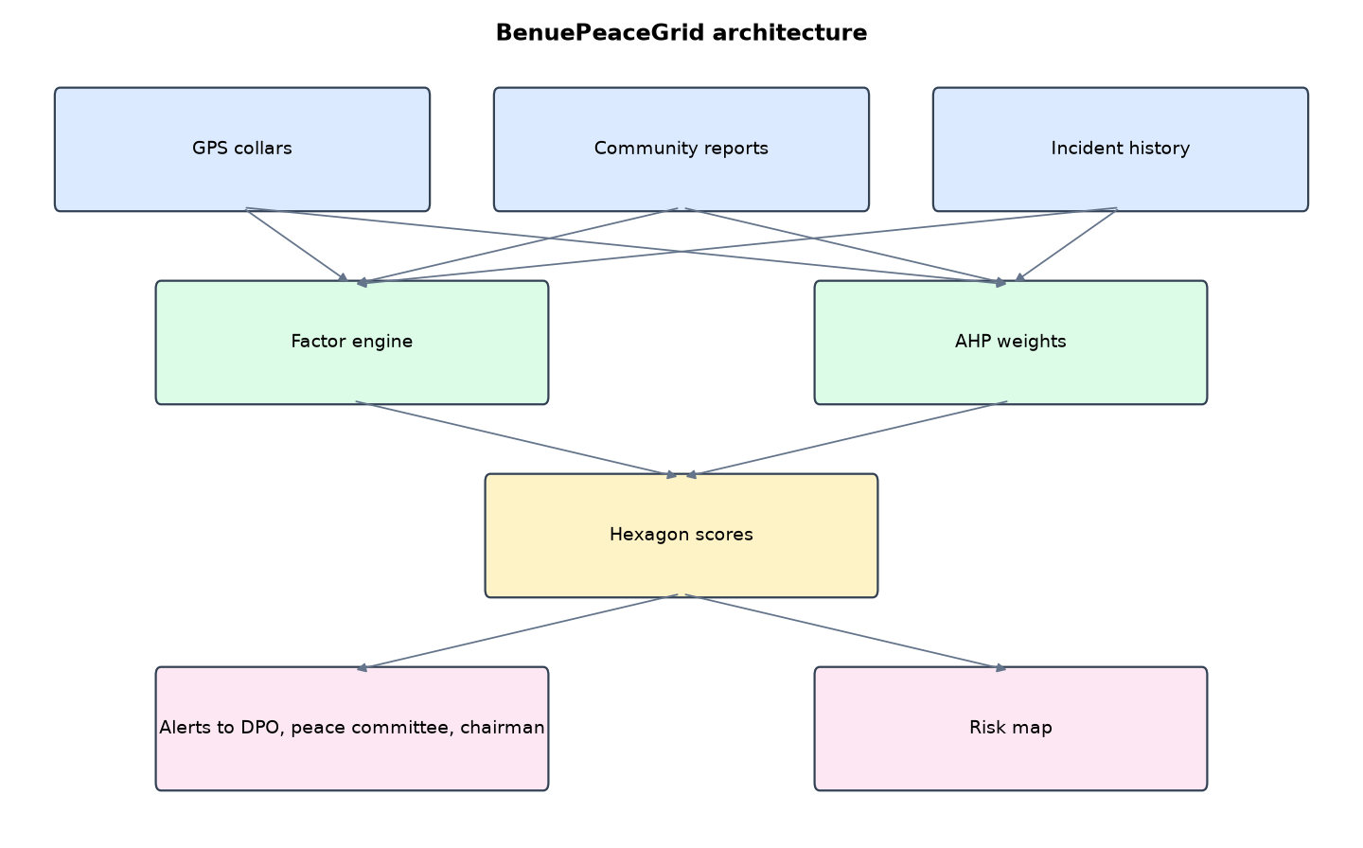
Figure 1: BenuePeaceGrid architecture (data flows from top to bottom)
Table 5: Software components
File | Responsibility
grid.py | Hexagons, AHP, factors, scoring, alerts, device signatures, back-test
geo.py | Geography helpers, synthetic history
app.py | Flask app, map, report form, ping API
main.py / selftest.py | Commands, live feed, tests

The main design decisions, and how they differ from the earlier VarsityShield and Zaman Lafiya projects, are:
- Hexagonal grid instead of LGA boundaries, so risk can be located to within a few kilometres.
- Analytic Hierarchy Process (AHP). A Saaty pairwise matrix in config.json becomes weights by power iteration. The consistency ratio is computed and an inconsistent matrix (CR 0.10 or more) is refused.
- Five factors: severity-weighted incidents with a 21-day half-life, herd heads within 10 km, stock-route distance, farmland count, water-point distance. A seasonal multiplier lifts the dry season.
- HMAC-signed GPS collar pings with a 5-minute freshness window, so a fake device cannot move herds on the map.
- Community report form with an arithmetic check, a 5-per-hour limit per address, Fernet-encrypted phone numbers and HMAC pseudonyms for reporters.
- Back-test that scores the grid as it was 60 days ago and measures how many later incidents fell in the top 20% of cells.
- Leaflet map with OpenStreetMap tiles, farms, corridors, incidents and live herds.

3.4 Security Design
Each threat considered is matched to the control that addresses it. Tests in Chapter Four exercise these controls.
Table 6: Threats and controls
Threat | Control in BenuePeaceGrid
Fake collar moves herds on the map | HMAC per device, 5-minute freshness
Report flooding | Arithmetic check, 5 per hour per address
Reporter identity exposed | Fernet-encrypted phone, HMAC pseudonym
Responder alters data | Role checks
Coordinates outside the state | Bounding-box validation
Clickjacking or script injection | CSP, X-Frame-Options, escaped output

3.5 Algorithms

3.5.1 Hexagon grid
Pointy-top hexagons 9 km across are laid row by row over the state's bounding box with alternate rows offset by half a cell; cells further than 32 km from any LGA headquarters are dropped. Result: 435 cells.

3.5.2 AHP weights
A 5x5 Saaty pairwise matrix is reduced to its principal eigenvector by power iteration. lambda_max gives CI = (lambda_max - n)/(n - 1) and CR = CI / RI(5 = 1.12). CR must be below 0.10.

3.5.3 Cell score
Factors: severity x 0.5^(age/21 days) x exp(-distance/6 km) summed over incidents; herd heads within 10 km; exp(-route distance/10); farmland count within 8 km; exp(-water distance/15). Incidents, herds and farms are scaled 0-1 by the state maximum. Score = 100 x sum(weight x factor) x (0.6 + 0.4 x season factor), capped at 100.

3.6 Tools and Technologies
Language: Python 3.10 or newer. Storage: SQLite. Third-party packages: flask, cryptography. Launchers: Windows batch files (1_SETUP, 2_START, 3_DEMO_MENU, 4_SELFTEST) and run.sh for Linux and macOS.

CHAPTER FOUR: IMPLEMENTATION, TESTING AND RESULTS

4.1 Implementation Environment
The system was developed and tested with Python 3.11 on Linux and is written to run unchanged on Windows 10/11. Its web interface runs at http://127.0.0.1:5201. Setup takes about ten minutes with 1_SETUP.bat; the README in the project folder gives every step and a defence demonstration script.

4.2 Operation and Demonstration
BenuePeaceGrid covers Benue State with about 435 hexagonal cells, each about 9 km across. Every cell gets a risk score from five factors: recent incidents, collared herds nearby, closeness to a stock route, farmland exposure, and closeness to water points. The factor weights come from the Analytic Hierarchy Process, so stakeholders can see and argue about them. When a cell crosses the alert line, the LGA's police DPO, peace committee and chairman are alerted.
Table 7: Demonstration scenario used for the defence
Step | Command (python main.py ...) | What is observed
This is Benue's risk grid today. | serve | Coloured hexagons, highest-risk cells listed on the right
Why does Guma score high? | (click a Guma hexagon) | Popup shows each factor value
The weights are not a black box. | ahp | AHP page: matrix, weights, CR = 0.015 (acceptable)
Herds start moving. Two leave the corridor. | simulate --steps 30 --interval 2 | Purple herd markers move toward Guma farms
The grid reacts. | score | Guma cells turn High or Severe; Alerts page shows the SMS text and recipients
Does it actually predict? | backtest | Top 20% of cells caught most next-month incidents (lift above 1)

4.3 Test Plan and Results
The automated test program ran 15 tests. 15 passed.
Table 8: Automated test results
# | Test | Result | Evidence
1 | AHP weights sum to 1 and matrix is consistent (CR < 0.10) | PASS | weights [0.4185, 0.2625, 0.1599, 0.0973, 0.0618], CR 0.0152
2 | Hexagon grid covers every LGA | PASS | 435 cells
3 | Back-test: top 20% cells capture more future incidents than chance | PASS | hit rate 0.8 vs chance 0.2 (lift 4.0)
4 | A burst of attacks and herds raises Kwande's top cell | PASS | 8.2 -> 71.8
5 | Alert dispatched to Kwande contacts | PASS | BenuePeaceGrid SEVERE risk in Kwande: 1 grid cell(s) at or above 70. Main driver: recent incidents. Deploy patrol and ca
6 | Cooldown prevents duplicate alerts | PASS
7 | Signed herd ping accepted | PASS
8 | Ping with altered body rejected | PASS
9 | Old (replayed) ping rejected | PASS
10 | Community report stored with phone encrypted, not in plain text | PASS
11 | Report flooding from one address is rate-limited | PASS | [200, 200, 200, 200, 429, 429]
12 | Unknown LGA in a report is rejected | PASS
13 | Responder cannot verify reports | PASS
14 | Map data needs sign-in | PASS
15 | Staff map loads | PASS

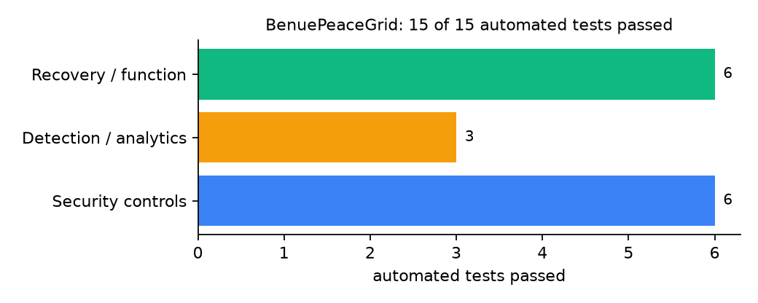
Figure 2: Automated tests by category

4.4 Measured Results
Table 9: Key measurements
Measure | Result
Hexagon cells | 435
Synthetic incidents in history | 288
AHP weights | recent incidents 0.4185, herd presence 0.2625, stock route proximity 0.1599, farmland exposure 0.0973, water point proximity 0.0618
Consistency ratio | 0.0152 (limit 0.10)
Back-test: incidents in top 20% cells | 12 of 15 (hit rate 0.8, lift 4.0)
Time to score all cells | 0.048 s
Kwande top cell before / after attack burst | 8.2 / 71.8

4.5 Discussion
The back-test lift of 4.0 is encouraging but rests on 15 future incidents in synthetic data, so it shows that the pipeline behaves sensibly, not that it predicts real violence. Weights are only as good as the stakeholder session that produced the pairwise matrix; the consistency ratio catches contradictions, not bias. Signed pings stop a fake device, but not a real collar moved by vehicle; MambillaWatch's speed check would add that.
Of the tests, 6 exercised security controls, 3 exercised detection or analytics, and 6 exercised recovery or core function.

CHAPTER FIVE: SUMMARY, CONCLUSION AND RECOMMENDATIONS

5.1 Summary
This project built BenuePeaceGrid for Benue State (12 LGAs including Makurdi, Guma, Agatu, Logo and Kwande). Its design combines multi-criteria risk on 9 km cells, signed GPS collars and protected community reporting. It met its objectives and passed all 15 automated tests.

5.2 Conclusion
BenuePeaceGrid shows that the security problem described in Chapter One can be addressed with free software and modest hardware, provided the design treats the warning data as something attackers will target. The limits stated in Section 1.4 still apply.

5.3 Recommendations
- Hold an AHP workshop with farmers' and herders' representatives and police to agree the matrix.
- Load official LGA and settlement boundaries.
- Pilot in Guma and Agatu with collars on willing herds.

5.4 Contribution to Knowledge
This project addresses the gap identified in Chapter Two: Reviewed systems either forecast at coarse units or use models stakeholders cannot inspect. A fine grid with negotiated, checkable weights is missing.

5.5 Suggestions for Further Work
- Learn weights from verified incidents and compare with AHP.
- Add satellite NDVI as a sixth factor.

REFERENCES
Babatunde, A. O., & Ibnouf, F. O. (2024). The dynamics of herder-farmer conflicts in Plateau State, Nigeria, and Central Darfur State, Sudan. African Studies Review, 67(2), 321-350. https://doi.org/10.1017/asr.2024.45
Browning, R., Patten, H., Rousseau, J., & Mengersen, K. (2026). Bayesian spatiotemporal modelling of political violence and conflict events using discrete-time Hawkes processes. Journal of the Royal Statistical Society Series A. https://doi.org/10.1093/jrsssa/qnag039
Cicek, D., & Kantarci, B. (2023). Use of mobile crowdsensing in disaster management: A systematic review, challenges, and open issues. Sensors, 23(3), 1699. https://doi.org/10.3390/s23031699
Eke, O. G., et al. (2025). Climate-driven conflicts in Nigeria: Farmers' strategies for coping with herders' incursion on crop lands. Sustainability, 17(24), 11316. https://doi.org/10.3390/su172411316
Estefania-Salazar, E., & Iglesias, E. (2025). Assessing vegetation phenology dynamics in West African rangelands: Implications for livestock sustainability and transhumance. Ecological Informatics, 88.
Goodman, S., BenYishay, A., & Runfola, D. (2024). Spatiotemporal prediction of conflict fatality risk using convolutional neural networks and satellite imagery. Remote Sensing, 16(18), 3411. https://doi.org/10.3390/rs16183411
Kanagamalliga, S., et al. (2024). Integration of IoT for precision livestock monitoring through geofencing. In 2024 5th International Conference on Electronics and Sustainable Communication Systems (ICESC). IEEE.
Navarro, R., Saleh, L., & Owino, E. (2025). Pastoral conflict on the greener grass? Exploring the climate-conflict nexus in the Karamoja Cluster. International Journal of Disaster Risk Reduction.
Nnaji, A., Ma, W., Ratna, N., & Renwick, A. (2022). Farmer-herder conflicts and food insecurity: Evidence from rural Nigeria. Agricultural and Resource Economics Review.
Nwankwo, C. F. (2025). Perceptions of injustices in the struggle for scarce critical lands: Farmer-herder conflict and violence escalation in the Benue-Nasarawa borderland. World Development, 186, 106824.
Parlato, M. C. M., Valenti, F., & Porto, S. M. C. (2024). GIS-based methodology for tracking the grazing cattle site use. Heliyon, 10(13), e33166. https://doi.org/10.1016/j.heliyon.2024.e33166
Rochana, E., et al. (2024). The urgency of an early warning system for social conflict by using WhatsApp. International Journal of Innovative Research and Scientific Studies, 7(1), 107-114.
Ronoh, E. K., Mirau, S., & Dida, M. A. (2022). Human-wildlife conflict early warning system using the Internet of Things and short message service. Engineering, Technology & Applied Science Research.
Rød, E. G., Gåsste, T., & Hegre, H. (2024). A review and comparison of conflict early warning systems. International Journal of Forecasting, 40(1), 96-112.
Schwarz, M., Landmann, T., Jusselme, D., Zambrano, E., Danzeglocke, J., Siegert, F., & Franke, J. (2022). Assessing the environmental suitability for transhumance in support of conflict prevention in the Sahel. Remote Sensing, 14(5), 1109. https://doi.org/10.3390/rs14051109
Shimizu, K., et al. (2025). Piloting a mobile early warning alert and response system for East and Central Darfur, Sudan. International Health, 18(2), ihaf122.
Sola, L., Chen, Y., Murphy, S. K., & Subrahmanian, V. S. (2025). Quantifying the risk of pastoral conflict in 4 central African countries. EPJ Data Science, 14. https://doi.org/10.1140/epjds/s13688-025-00591-5
Tarif, K. (2022). Climate change and violent conflict in West Africa: Assessing the evidence (SIPRI Insights on Peace and Security). Stockholm International Peace Research Institute.

Standards and Legal Instruments Consulted
Federal Republic of Nigeria. (2023). Nigeria Data Protection Act, 2023. Nigeria Data Protection Commission.
International Organization for Standardization. (2022). ISO/IEC 27001:2022 Information security, cybersecurity and privacy protection: Information security management systems: Requirements. ISO.
National Institute of Standards and Technology. (2024). The NIST Cybersecurity Framework (CSF) 2.0 (NIST CSWP 29). NIST.

APPENDIX A: HOW TO RUN THE SYSTEM
- Copy the folder conflict-early-warning/B01-benue-peacegrid to the computer.
- Install Python 3.10 or newer with 'Add python.exe to PATH' ticked.
- Double-click 1_SETUP.bat, then 2_START.bat, and open http://127.0.0.1:5201.
- Use 3_DEMO_MENU.bat for the defence demonstration and 4_SELFTEST.bat to regenerate the results in Chapter Four.

APPENDIX B: SOURCE CODE STRUCTURE
Table 10: BenuePeaceGrid source files
File | Purpose
grid.py | Hexagons, AHP, factors, scoring, alerts, device signatures, back-test
geo.py | Geography helpers, synthetic history
app.py | Flask app, map, report form, ping API
main.py / selftest.py | Commands, live feed, tests

APPENDIX C: CODE EXCERPT
The function ahp from grid.py, the heart of the design described in Section 3.5.
def ahp():
m = geo.cfg()["ahp"]["pairwise"]
n = len(m)
w = [1.0 / n] * n
for _ in range(100): # power iteration for the principal eigenvector
nw = [sum(m[i][j] * w[j] for j in range(n)) for i in range(n)]
s = sum(nw)
nw = [x / s for x in nw]
if max(abs(a - b) for a, b in zip(w, nw)) < 1e-12:
break
w = nw
lam = sum(sum(m[i][j] * w[j] for j in range(n)) / w[i] for i in range(n)) / n
ci = (lam - n) / (n - 1)
cr = ci / RANDOM_INDEX[n] if RANDOM_INDEX[n] else 0.0
return {"factors": geo.cfg()["ahp"]["factors"], "weights": [round(x, 4) for x in w], "lambda_max": round(lam, 4),
"ci": round(ci, 4), "cr": round(cr, 4), "consistent": cr < 0.10}

