[NAME OF YOUR UNIVERSITY]
FACULTY OF [SCIENCE / COMPUTING]
DEPARTMENT OF COMPUTER SCIENCE
CMP 468: COMPUTER SECURITY (2 UNITS)
COURSE PROJECT REPORT
PLATEAUWATCH: OFFLINE KERNEL-DENSITY HOTSPOT EARLY WARNING FOR FARMER-HERDER CONFLICT IN PLATEAU STATE
Server-drawn SVG maps, Silverman bandwidth and emerging-hotspot analysis with no internet dependency
BY
[FULL NAME]
MATRIC NO: [MATRIC NUMBER]
SUBMITTED TO
[COURSE LECTURER'S NAME]
IN PARTIAL FULFILMENT OF THE REQUIREMENTS OF CMP 468
400 LEVEL, SECOND SEMESTER, 2025/2026 SESSION
OCTOBER 2026

DECLARATION
I declare that this project report and the accompanying software were written by me as part of the requirements of CMP 468 (Computer Security). Every source used has been cited. All literature cited in this report was published between 2021 and 2026. All test results reported in Chapter Four were produced by the automated test program supplied with the software.
Signature: ____________________ Date: ____________________

ABSTRACT
Farmer-herder conflict in Nigeria destroys lives, livelihoods and food supply. Early warning helps only when it is timely, trusted and secure. This project designed, built and tested PlateauWatch for Plateau State (12 LGAs including Bokkos, Barkin Ladi, Mangu, Riyom and Bassa). Its design combines server-drawn SVG maps, Silverman bandwidth and emerging-hotspot analysis with no internet dependency. The system was implemented in Python and evaluated with an automated test suite on synthetic data that follows documented conflict patterns, including attacks on the system itself. All 12 tests passed. Key measurements: Synthetic incidents: 191; Bandwidth used: 10 km; Predictive Accuracy Index: 4.19 (hit rate 0.273 in 6.5% of the area); Analysis time: 0.018 s. The results show the design works as specified; field validation with real data is the next step.
Keywords: early warning, farmer-herder conflict, GIS, information security, privacy, Nigeria, NDPA 2023.

TABLE OF CONTENTS
Right-click here and choose Update Field to build the table of contents.

CHAPTER ONE: INTRODUCTION

1.1 Background of the Study
Plateau State has seen repeated waves of rural attacks, especially in Bokkos, Barkin Ladi, Mangu and Riyom. Babatunde and Ibnouf (2024) show how resource management and peacebuilding choices there shaped the conflict. Field offices often have no reliable internet, so a map that needs online tiles is blank exactly when it is needed.
Nigerian farmer-herder conflict is driven by competition for land and water, changing herd mobility, weak institutions and perceived injustice. Early warning systems try to detect rising risk early enough for mediation, patrols or community action. They handle sensitive data (who reported what) and are themselves targets of manipulation, so they are a computer security problem as much as a data problem.

1.2 Statement of the Problem
- Online map tools fail without internet.
- Points on a map do not show where violence is concentrating.
- Analysts cannot tell new hotspots from old ones.
- Data from police and NGOs arrive as messy spreadsheets.

1.3 Aim and Objectives
The aim is to design, implement and evaluate PlateauWatch, a secure system for Plateau State (12 LGAs including Bokkos, Barkin Ladi, Mangu, Riyom and Bassa). The objectives are to:
- estimate a severity-weighted density surface with kernel density estimation;
- choose the bandwidth from the data;
- classify hotspots as emerging, persistent or fading;
- draw maps on the server so they work offline;
- validate imported data; evaluate with the Predictive Accuracy Index.

1.4 Scope and Limitations
Synthetic incidents; 3 km raster; one web server for a state office. The system was tested on one computer; the README describes deployment on other computers.

1.5 Significance of the Study
PlateauWatch gives Plateau State (12 LGAs including Bokkos, Barkin Ladi, Mangu, Riyom and Bassa) a free, auditable tool that runs on ordinary hardware, and turns CMP 468 topics into working controls. Its automated test suite lets any future maintainer prove that the controls still work.

1.6 Relation to the CMP 468 Course Outline
Table 1: Mapping of CMP 468 topics to PlateauWatch
CMP 468 topic | Where it appears in PlateauWatch
Overview of security in computing | Confidentiality of informants, integrity of reports and data, availability of alerts
Characteristics of computer intrusion | Forged reports, fake devices, replayed messages, tampered records
Types of security breaches | Disclosure of informant identity, falsified incident data, unauthorised access to case files
Classes of attacks | Impersonation, replay, injection, brute force, cross-site request forgery, disinformation
Methods of defence and controls | Table 3.2 maps each threat to its control
Data security: encryption and decryption | See Section 3.5
Database security | Parameterised SQL, role checks before every query, encrypted personal fields
Security policies and standards | NDPA 2023 (personal data of reporters), ISO/IEC 27001:2022 access control

CHAPTER TWO: LITERATURE REVIEW
This review covers only studies published from 2021 to 2026. Every source was checked against a publisher or index page.

2.1 Conceptual Framework
The study uses the early warning chain: collect signals, analyse risk, warn the right people, and respond. Each link has security needs: signals must be authentic, analysis must be on untampered data, warnings must reach people quickly, and the identities of informants must stay confidential.

2.2 Farmer-herder conflict in Nigeria and the region
Nnaji et al. (2022) surveyed 401 rural Nigerian households and found that both the incidence and the severity of farmer-herder conflict raise food insecurity, severity more so. Nwankwo (2025) showed from interviews in the Benue-Nasarawa borderland that perceived injustice drives escalation of farmer-herder violence. Babatunde and Ibnouf (2024) showed that officials, traditional rulers and security agents in Plateau State deepened conflict through unequal resource allocation and peacebuilding that favoured some groups. Eke et al. (2025) found Enugu farmers coping with herd incursions by farming in groups, reducing what they plant and preparing for crop loss, with falling income and productivity. Tarif (2022) reviewed the West African evidence and grouped climate-conflict links into four pathways, including changing pastoral mobility, while warning that the research base is thin. Together these studies explain why prevention must be local, fast and trusted by both farming and herding communities.

2.3 Conflict early warning systems and forecasting
Rød et al. (2024) compared conflict early warning systems on transparency, key parameters and forecasts, found weak access to data and code and large differences between systems, and called for shared standards. Goodman et al. (2024) predicted sub-national conflict-fatality risk in Nigeria from Landsat 8 imagery and ACLED data, with an average AUC above 0.75, but performance fell when the geography of conflict shifted. Sola et al. (2025) predicted pastoral conflict in Cameroon, Chad, the Central African Republic and the DRC from weather and terrain data (AUC 0.99 for Cameroon) and found that vegetation affects risk differently in each country. Browning et al. (2026) fitted a Bayesian spatiotemporal Hawkes process to ACLED events in South Asia, treating political violence as self-exciting (contagious) in space and time. Forecast accuracy matters, but so do transparency and whether the people at risk can act on the warning.

2.4 Environment, mobility and herd tracking
Schwarz et al. (2022) modelled environmental suitability for transhumance in Chad and the Central African Republic from Earth observation data, found most conflicts where suitability was high, and suggested combining herd tracking with satellite data for early warning along corridors. Estefania-Salazar and Iglesias (2025) analysed 250 m NDVI for 2003-2023 across 13 West African countries and found growing seasons shortening through a later start, with consequences for transhumance routes. Navarro et al. (2025) found in the Karamoja Cluster that vegetation data predicted pastoral conflict one month ahead better than rainfall, and that conflict clustered 'on the greener grass'. Parlato et al. (2024) tracked grazing cattle with low-power GPS collars and used heatmaps and kernel density estimation to find the areas animals use most. Kanagamalliga et al. (2024) used IoT collars with geofencing and temperature sensing for remote monitoring of livestock movement and health.

2.5 Community reporting and mobile alerting
Rochana et al. (2024) surveyed 267 villagers, found low public participation in conflict prevention, and proposed village-level early warning through WhatsApp groups. Cicek and Kantarci (2023) reviewed mobile crowdsensing for disasters and found most studies conceptual, with little testing in real incidents. Shimizu et al. (2025) describe the EWARS Mobile pilot in Darfur, whose offline reporting worked where network coverage was poor: 158 health facilities sent 752 weekly reports and the system was expanded to all Darfur states. Ronoh et al. (2022) built a low-cost early warning unit (motion sensor, GPS, camera, YOLO detection) that sends SMS alerts to response teams when animals approach a park border. Low-cost phones, SMS and offline-capable tools reach people that web dashboards miss.

2.6 Work Closest to This Design
Parlato et al. (2024) used kernel density estimation to find where cattle spend time; PlateauWatch uses it to find where violence concentrates. Browning et al. (2026) treat conflict as contagious in space and time; the window-on-window comparison here is a light-weight way to spot that spread.

2.7 Summary of Reviewed Works and Research Gap
Table 2: Summary of reviewed works
Study | What it contributes
Babatunde (2024) | showed that officials, traditional rulers and security agents in Plateau State deepened conflict through unequal resource allocation and peacebuilding that favo
Browning (2026) | fitted a Bayesian spatiotemporal Hawkes process to ACLED events in South Asia, treating political violence as self-exciting (contagious) in space and time.
Cicek (2023) | reviewed mobile crowdsensing for disasters and found most studies conceptual, with little testing in real incidents.
Eke (2025) | found Enugu farmers coping with herd incursions by farming in groups, reducing what they plant and preparing for crop loss, with falling income and productivity
Estefania-Salazar (2025) | analysed 250 m NDVI for 2003-2023 across 13 West African countries and found growing seasons shortening through a later start, with consequences for transhumanc
Goodman (2024) | predicted sub-national conflict-fatality risk in Nigeria from Landsat 8 imagery and ACLED data, with an average AUC above 0.75, but performance fell when the ge
Kanagamalliga (2024) | used IoT collars with geofencing and temperature sensing for remote monitoring of livestock movement and health.
Navarro (2025) | found in the Karamoja Cluster that vegetation data predicted pastoral conflict one month ahead better than rainfall, and that conflict clustered 'on the greener
Nnaji (2022) | surveyed 401 rural Nigerian households and found that both the incidence and the severity of farmer-herder conflict raise food insecurity, severity more so.
Nwankwo (2025) | showed from interviews in the Benue-Nasarawa borderland that perceived injustice drives escalation of farmer-herder violence.
Parlato (2024) | tracked grazing cattle with low-power GPS collars and used heatmaps and kernel density estimation to find the areas animals use most.
Rochana (2024) | surveyed 267 villagers, found low public participation in conflict prevention, and proposed village-level early warning through WhatsApp groups.
Ronoh (2022) | built a low-cost early warning unit (motion sensor, GPS, camera, YOLO detection) that sends SMS alerts to response teams when animals approach a park border.
Rød (2024) | compared conflict early warning systems on transparency, key parameters and forecasts, found weak access to data and code and large differences between systems,
Schwarz (2022) | modelled environmental suitability for transhumance in Chad and the Central African Republic from Earth observation data, found most conflicts where suitability
Shimizu (2025) | describe the EWARS Mobile pilot in Darfur, whose offline reporting worked where network coverage was poor: 158 health facilities sent 752 weekly reports and the
Sola (2025) | predicted pastoral conflict in Cameroon, Chad, the Central African Republic and the DRC from weather and terrain data (AUC 0.99 for Cameroon) and found that veg
Tarif (2022) | reviewed the West African evidence and grouped climate-conflict links into four pathways, including changing pastoral mobility, while warning that the research

Research gap. Hotspot analysis tools assume online GIS software; none of the reviewed early warning tools works fully offline.

CHAPTER THREE: METHODOLOGY AND SYSTEM DESIGN

3.1 Research Methodology
The project follows Design Science Research: identify the problem, define objectives, design and build an artefact, demonstrate it, and evaluate it. Evaluation uses an automated test program (selftest.py) that resets the system, runs normal use, simulated attacks and failures, and records each outcome and measurement in results/selftest.json. Data are synthetic, generated to follow documented seasonal and retaliation patterns, so results show how the system behaves, not how accurate it would be in the field.

3.2 Requirements
Table 3: Functional requirements
# | Requirement
FR1 | KDE surface on a raster
FR2 | Silverman bandwidth with cap
FR3 | Hotspot peaks and status
FR4 | Emerging-hotspot alerts
FR5 | SVG map for 7/30/90 days
FR6 | Validated CSV import
FR7 | PAI back-test

Table 4: Non-functional requirements
# | Requirement
NFR1 | No JavaScript, no external resources
NFR2 | Standard library server
NFR3 | Coordinator and observer roles

3.3 System Architecture
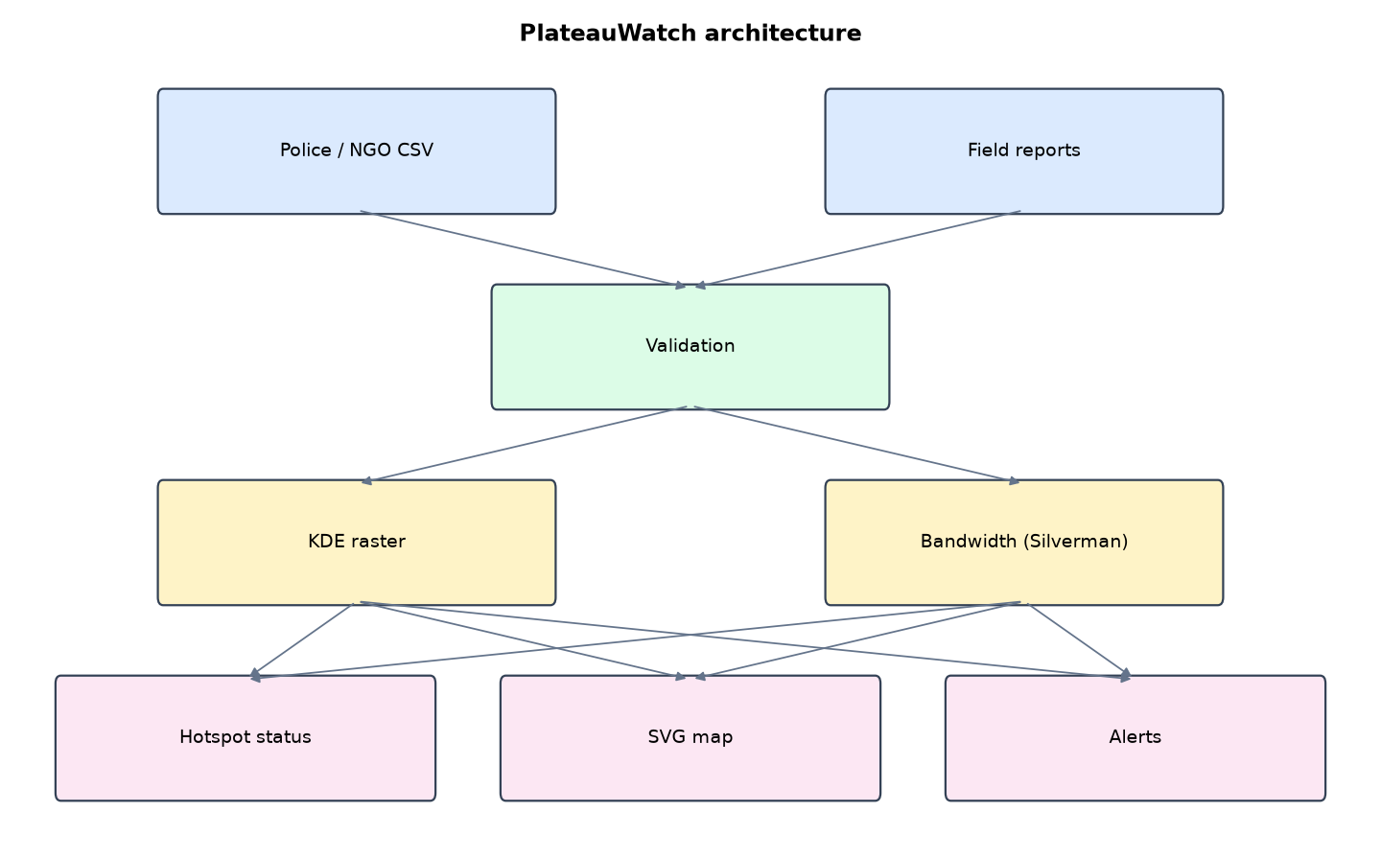
Figure 1: PlateauWatch architecture (data flows from top to bottom)
Table 5: Software components
File | Responsibility
kde.py | Density, bandwidth, peaks, emerging analysis, PAI, CSV import
server.py | Standard-library server and SVG renderer
geo.py | Geography and synthetic history
main.py / selftest.py | Commands and tests

The main design decisions, and how they differ from the earlier VarsityShield and Zaman Lafiya projects, are:
- Offline-first. No map tiles, no JavaScript. The server draws the density surface, LGAs, corridors, incidents and hotspot rings as SVG. The Content-Security-Policy blocks every external resource.
- Gaussian kernel density estimation on a 3 km raster, weighted by incident severity, with the kernel normalised so each incident's weight integrates to 1.
- Silverman's rule of thumb for bandwidth, capped at 10 km because the rule assumes one cluster and over-smooths multi-cluster conflict data.
- Emerging hotspot analysis: local maxima above the 90th percentile, compared with the previous 30-day window.
- Predictive Accuracy Index (PAI) evaluation: share of next-month incidents inside the top 10% density area, divided by that area's share.
- Validated CSV import for police and NGO data: unknown LGAs, bad severities, locations outside the state and unknown types are rejected with a reason.
- Standard-library web server with PBKDF2 passwords, session tokens, CSRF tokens and login lockout.

3.4 Security Design
Each threat considered is matched to the control that addresses it. Tests in Chapter Four exercise these controls.
Table 6: Threats and controls
Threat | Control in PlateauWatch
Malicious CSV (injection) | Parameterised SQL, strict field validation
False locations | State bounding-box check
Session theft | HttpOnly, SameSite=Strict cookies, 30-minute expiry
CSRF on import | Per-session token
Brute force | Lock after 5 failures
Map loads attacker content | CSP default-src 'none'

3.5 Algorithms

3.5.1 Kernel density estimation
density(cell) = sum over incidents of severity x (1 / 2 pi h^2) x exp(-d^2 / 2 h^2), where d is the great-circle distance in km from the incident to the cell centre, evaluated within 3h.

3.5.2 Bandwidth
Silverman's rule h = 1.06 x sigma x n^(-1/5), with sigma the average spread of incident positions in km, capped at 10 km because the rule assumes a single cluster.

3.5.3 Emerging hotspots
Peaks are cells above the 90th percentile and at least as dense as their 5x5 neighbourhood. A peak is emerging if the previous 30-day window was below half the previous threshold there, or if density at least tripled.

3.6 Tools and Technologies
Language: Python 3.10 or newer. Storage: SQLite. Third-party packages: cryptography. Launchers: Windows batch files (1_SETUP, 2_START, 3_DEMO_MENU, 4_SELFTEST) and run.sh for Linux and macOS.

CHAPTER FOUR: IMPLEMENTATION, TESTING AND RESULTS

4.1 Implementation Environment
The system was developed and tested with Python 3.11 on Linux and is written to run unchanged on Windows 10/11. Its web interface runs at http://127.0.0.1:5202. Setup takes about ten minutes with 1_SETUP.bat; the README in the project folder gives every step and a defence demonstration script.

4.2 Operation and Demonstration
PlateauWatch turns incident points into a heat surface with kernel density estimation, finds the hotspots, and compares the last 30 days with the 30 days before to say which hotspots are emerging, persistent or fading. An emerging hotspot raises an alert for an assessment team. The whole system runs on Python's standard library plus one package, and the map is drawn on the server as SVG, so it works with no internet at all.
Table 7: Demonstration scenario used for the defence
Step | Command (python main.py ...) | What is observed
This map needs no internet. | serve | Heat surface, LGAs, corridors. Switch last 7, 30, 90 days
Where are the hotspots and are they growing? | (Hotspots page) | Mangu persistent (intensifying), others
Attacks start in Kanam, a quiet LGA. | flare --lga Kanam | Kanam appears as EMERGING with a red ring, alert written
Is KDE better than guessing? | pai | PAI above 1: the top 10% area holds far more than 10% of next-month incidents
Police send data as a spreadsheet. | (Data page, paste CSV) | Good rows imported, bad rows rejected with reasons

4.3 Test Plan and Results
The automated test program ran 12 tests. 12 passed.
Table 8: Automated test results
# | Test | Result | Evidence
1 | Gaussian kernel integrates to about 1 (correct normalisation) | PASS | 0.984
2 | Silverman bandwidth computed from data | PASS | 10
3 | Predictive Accuracy Index above 1 (better than random) | PASS | {'bandwidth_km': 10, 'cells': 2968, 'hot_cells': 193, 'area_share': 0.065, 'test_incidents': 11, 'captured': 3, 'hit_rat
4 | New wave in quiet Kanam appears as an EMERGING hotspot | PASS | [('Kanam', 'emerging'), ('Mangu', 'persistent (intensifying)'), ('Riyom', 'persistent (cooling)')]
5 | Emerging hotspot raises one alert | PASS | EMERGING HOTSPOT near Kanam (9.369, 9.7408): new or at least 3x denser than the previous 30 days. Send an assessment tea
6 | No duplicate alert within 24 h | PASS
7 | CSV import accepts good rows and rejects bad ones with reasons | PASS | {'imported': 1, 'rejected': ["line 3: 'atlantis'", 'line 4: severity must be 1-5', 'line 5: location outside Plateau Sta
8 | SQL injection attempt stored nothing harmful (table intact) | PASS
9 | Offline SVG map renders without any external resource | PASS
10 | Observer sees no import form | PASS
11 | Import without valid CSRF token is refused | PASS
12 | Login locks after 5 failures | PASS | [401, 401, 401, 401, 401, 401]

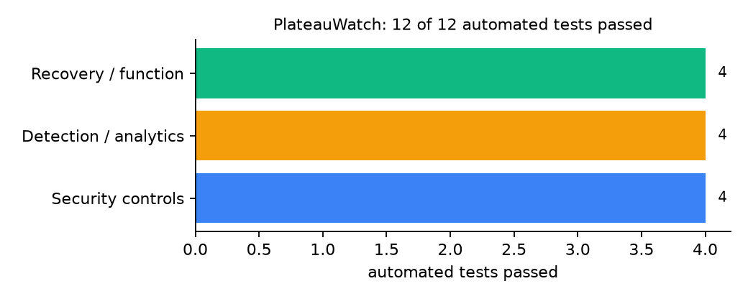
Figure 2: Automated tests by category

4.4 Measured Results
Table 9: Key measurements
Measure | Result
Synthetic incidents | 191
Bandwidth used | 10 km
Predictive Accuracy Index | 4.19 (hit rate 0.273 in 6.5% of the area)
Analysis time | 0.018 s
Hotspots after Kanam flare | Kanam: emerging; Mangu: persistent (intensifying); Riyom: persistent (cooling)

4.5 Discussion
Silverman's rule gave about 19-24 km on this data, which blurred separate LGAs into one blob; the 10 km cap is a documented judgement, not a derived value. The first emerging rule missed Kanam because there had been some earlier activity there; adding 'at least three times denser' fixed it. PAI rests on 11 test incidents, so it is a sanity check, not proof of skill.
Of the tests, 4 exercised security controls, 4 exercised detection or analytics, and 4 exercised recovery or core function.

CHAPTER FIVE: SUMMARY, CONCLUSION AND RECOMMENDATIONS

5.1 Summary
This project built PlateauWatch for Plateau State (12 LGAs including Bokkos, Barkin Ladi, Mangu, Riyom and Bassa). Its design combines server-drawn SVG maps, Silverman bandwidth and emerging-hotspot analysis with no internet dependency. It met its objectives and passed all 12 automated tests.

5.2 Conclusion
PlateauWatch shows that the security problem described in Chapter One can be addressed with free software and modest hardware, provided the design treats the warning data as something attackers will target. The limits stated in Section 1.4 still apply.

5.3 Recommendations
- Feed police and Operation Safe Haven situation reports through the CSV import.
- Review the 10 km cap with field staff.
- Print the map weekly for LGA security meetings.

5.4 Contribution to Knowledge
This project addresses the gap identified in Chapter Two: Hotspot analysis tools assume online GIS software; none of the reviewed early warning tools works fully offline.

5.5 Suggestions for Further Work
- Space-time KDE with a time kernel.
- Export SVG maps to PDF bulletins.

REFERENCES
Babatunde, A. O., & Ibnouf, F. O. (2024). The dynamics of herder-farmer conflicts in Plateau State, Nigeria, and Central Darfur State, Sudan. African Studies Review, 67(2), 321-350. https://doi.org/10.1017/asr.2024.45
Browning, R., Patten, H., Rousseau, J., & Mengersen, K. (2026). Bayesian spatiotemporal modelling of political violence and conflict events using discrete-time Hawkes processes. Journal of the Royal Statistical Society Series A. https://doi.org/10.1093/jrsssa/qnag039
Cicek, D., & Kantarci, B. (2023). Use of mobile crowdsensing in disaster management: A systematic review, challenges, and open issues. Sensors, 23(3), 1699. https://doi.org/10.3390/s23031699
Eke, O. G., et al. (2025). Climate-driven conflicts in Nigeria: Farmers' strategies for coping with herders' incursion on crop lands. Sustainability, 17(24), 11316. https://doi.org/10.3390/su172411316
Estefania-Salazar, E., & Iglesias, E. (2025). Assessing vegetation phenology dynamics in West African rangelands: Implications for livestock sustainability and transhumance. Ecological Informatics, 88.
Goodman, S., BenYishay, A., & Runfola, D. (2024). Spatiotemporal prediction of conflict fatality risk using convolutional neural networks and satellite imagery. Remote Sensing, 16(18), 3411. https://doi.org/10.3390/rs16183411
Kanagamalliga, S., et al. (2024). Integration of IoT for precision livestock monitoring through geofencing. In 2024 5th International Conference on Electronics and Sustainable Communication Systems (ICESC). IEEE.
Navarro, R., Saleh, L., & Owino, E. (2025). Pastoral conflict on the greener grass? Exploring the climate-conflict nexus in the Karamoja Cluster. International Journal of Disaster Risk Reduction.
Nnaji, A., Ma, W., Ratna, N., & Renwick, A. (2022). Farmer-herder conflicts and food insecurity: Evidence from rural Nigeria. Agricultural and Resource Economics Review.
Nwankwo, C. F. (2025). Perceptions of injustices in the struggle for scarce critical lands: Farmer-herder conflict and violence escalation in the Benue-Nasarawa borderland. World Development, 186, 106824.
Parlato, M. C. M., Valenti, F., & Porto, S. M. C. (2024). GIS-based methodology for tracking the grazing cattle site use. Heliyon, 10(13), e33166. https://doi.org/10.1016/j.heliyon.2024.e33166
Rochana, E., et al. (2024). The urgency of an early warning system for social conflict by using WhatsApp. International Journal of Innovative Research and Scientific Studies, 7(1), 107-114.
Ronoh, E. K., Mirau, S., & Dida, M. A. (2022). Human-wildlife conflict early warning system using the Internet of Things and short message service. Engineering, Technology & Applied Science Research.
Rød, E. G., Gåsste, T., & Hegre, H. (2024). A review and comparison of conflict early warning systems. International Journal of Forecasting, 40(1), 96-112.
Schwarz, M., Landmann, T., Jusselme, D., Zambrano, E., Danzeglocke, J., Siegert, F., & Franke, J. (2022). Assessing the environmental suitability for transhumance in support of conflict prevention in the Sahel. Remote Sensing, 14(5), 1109. https://doi.org/10.3390/rs14051109
Shimizu, K., et al. (2025). Piloting a mobile early warning alert and response system for East and Central Darfur, Sudan. International Health, 18(2), ihaf122.
Sola, L., Chen, Y., Murphy, S. K., & Subrahmanian, V. S. (2025). Quantifying the risk of pastoral conflict in 4 central African countries. EPJ Data Science, 14. https://doi.org/10.1140/epjds/s13688-025-00591-5
Tarif, K. (2022). Climate change and violent conflict in West Africa: Assessing the evidence (SIPRI Insights on Peace and Security). Stockholm International Peace Research Institute.

Standards and Legal Instruments Consulted
Federal Republic of Nigeria. (2023). Nigeria Data Protection Act, 2023. Nigeria Data Protection Commission.
International Organization for Standardization. (2022). ISO/IEC 27001:2022 Information security, cybersecurity and privacy protection: Information security management systems: Requirements. ISO.
National Institute of Standards and Technology. (2024). The NIST Cybersecurity Framework (CSF) 2.0 (NIST CSWP 29). NIST.

APPENDIX A: HOW TO RUN THE SYSTEM
- Copy the folder conflict-early-warning/B02-plateau-plateauwatch to the computer.
- Install Python 3.10 or newer with 'Add python.exe to PATH' ticked.
- Double-click 1_SETUP.bat, then 2_START.bat, and open http://127.0.0.1:5202.
- Use 3_DEMO_MENU.bat for the defence demonstration and 4_SELFTEST.bat to regenerate the results in Chapter Four.

APPENDIX B: SOURCE CODE STRUCTURE
Table 10: PlateauWatch source files
File | Purpose
kde.py | Density, bandwidth, peaks, emerging analysis, PAI, CSV import
server.py | Standard-library server and SVG renderer
geo.py | Geography and synthetic history
main.py / selftest.py | Commands and tests

APPENDIX C: CODE EXCERPT
The function density from kde.py, the heart of the design described in Section 3.5.
def density(points, h=None):
"""Return (grid, h) where grid[r][c] is the KDE value (events per km^2, severity-weighted)."""
h = h or (silverman(points) if geo.cfg()["bandwidth_km"] == "silverman" else float(geo.cfg()["bandwidth_km"]))
s, w, dlat, dlon, rows, cols = raster()
grid = [[0.0] * cols for _ in range(rows)]
norm = 1.0 / (2 * math.pi * h * h)
reach = 3 * h
for p in points:
r0, c0 = int((p["lat"] - s) / dlat), int((p["lon"] - w) / dlon)
span_r, span_c = int(reach / (dlat * 110.57)) + 1, int(reach / (dlon * 111.32 * math.cos(math.radians(p["lat"])))) + 1
for r in range(max(0, r0 - span_r), min(rows, r0 + span_r + 1)):
for c in range(max(0, c0 - span_c), min(cols, c0 + span_c + 1)):
d = geo.km(p["lat"], p["lon"], s + (r + .5) * dlat, w + (c + .5) * dlon)
if d <= reach:
grid[r][c] += p["severity"] * norm * math.exp(-0.5 * (d / h) ** 2)
return grid, h

