[NAME OF YOUR UNIVERSITY]
FACULTY OF [SCIENCE / COMPUTING]
DEPARTMENT OF COMPUTER SCIENCE
CMP 468: COMPUTER SECURITY (2 UNITS)
COURSE PROJECT REPORT
LAFIAALERT: SMS-BASED MULTILINGUAL EARLY WARNING WITH NAIVE BAYES CLASSIFICATION FOR NASARAWA STATE
Signed SMS gateway webhook, English-Hausa-Pidgin classifier, village gazetteer, corroboration and Poisson spike test
BY
[FULL NAME]
MATRIC NO: [MATRIC NUMBER]
SUBMITTED TO
[COURSE LECTURER'S NAME]
IN PARTIAL FULFILMENT OF THE REQUIREMENTS OF CMP 468
400 LEVEL, SECOND SEMESTER, 2025/2026 SESSION
OCTOBER 2026

DECLARATION
I declare that this project report and the accompanying software were written by me as part of the requirements of CMP 468 (Computer Security). Every source used has been cited. All literature cited in this report was published between 2021 and 2026. All test results reported in Chapter Four were produced by the automated test program supplied with the software.
Signature: ____________________ Date: ____________________

ABSTRACT
Farmer-herder conflict in Nigeria destroys lives, livelihoods and food supply. Early warning helps only when it is timely, trusted and secure. This project designed, built and tested LafiaAlert for Nasarawa State (11 LGAs including Lafia, Keana, Doma, Awe and Obi). Its design combines signed SMS gateway webhook, English-Hausa-Pidgin classifier, village gazetteer, corroboration and Poisson spike test. The system was implemented in Python and evaluated with an automated test suite on synthetic data that follows documented conflict patterns, including attacks on the system itself. All 16 tests passed. Key measurements: Classifier accuracy on held-out template messages: 1.0; Test messages: 180; Hand-written probes (Hausa, Pidgin, English): 5 probes, all correct: yes; Processing time per SMS: 6.36 ms. The results show the design works as specified; field validation with real data is the next step.
Keywords: early warning, farmer-herder conflict, GIS, information security, privacy, Nigeria, NDPA 2023.

TABLE OF CONTENTS
Right-click here and choose Update Field to build the table of contents.

CHAPTER ONE: INTRODUCTION

1.1 Background of the Study
Nasarawa borders Benue, and Nwankwo (2025) documents how perceived injustice escalates violence in the Benue-Nasarawa borderland. Most rural people there have basic phones and write in Hausa, English or Pidgin. A situation room that receives hundreds of texts cannot read and map them all by hand.
Nigerian farmer-herder conflict is driven by competition for land and water, changing herd mobility, weak institutions and perceived injustice. Early warning systems try to detect rising risk early enough for mediation, patrols or community action. They handle sensitive data (who reported what) and are themselves targets of manipulation, so they are a computer security problem as much as a data problem.

1.2 Statement of the Problem
- Texts arrive in three languages and mixed spelling.
- Duplicate texts about one event look like many events.
- Fake SMS-gateway calls could inject false reports.
- Nobody knows whether today's count in an LGA is unusual.

1.3 Aim and Objectives
The aim is to design, implement and evaluate LafiaAlert, a secure system for Nasarawa State (11 LGAs including Lafia, Keana, Doma, Awe and Obi). The objectives are to:
- classify texts into incident types plus noise with a Naive Bayes model built from scratch;
- detect urgency in three languages;
- locate reports from village names;
- merge reports per village and count independent senders;
- accept only signed, fresh gateway calls; flag LGAs whose daily count is statistically unusual.

1.4 Scope and Limitations
Training messages are synthetic templates; real use needs labelled hotline messages. The system was tested on one computer; the README describes deployment on other computers.

1.5 Significance of the Study
LafiaAlert gives Nasarawa State (11 LGAs including Lafia, Keana, Doma, Awe and Obi) a free, auditable tool that runs on ordinary hardware, and turns CMP 468 topics into working controls. Its automated test suite lets any future maintainer prove that the controls still work.

1.6 Relation to the CMP 468 Course Outline
Table 1: Mapping of CMP 468 topics to LafiaAlert
CMP 468 topic | Where it appears in LafiaAlert
Overview of security in computing | Confidentiality of informants, integrity of reports and data, availability of alerts
Characteristics of computer intrusion | Forged reports, fake devices, replayed messages, tampered records
Types of security breaches | Disclosure of informant identity, falsified incident data, unauthorised access to case files
Classes of attacks | Impersonation, replay, injection, brute force, cross-site request forgery, disinformation
Methods of defence and controls | Table 3.2 maps each threat to its control
Data security: encryption and decryption | See Section 3.5
Database security | Parameterised SQL, role checks before every query, encrypted personal fields
Security policies and standards | NDPA 2023 (personal data of reporters), ISO/IEC 27001:2022 access control

CHAPTER TWO: LITERATURE REVIEW
This review covers only studies published from 2021 to 2026. Every source was checked against a publisher or index page.

2.1 Conceptual Framework
The study uses the early warning chain: collect signals, analyse risk, warn the right people, and respond. Each link has security needs: signals must be authentic, analysis must be on untampered data, warnings must reach people quickly, and the identities of informants must stay confidential.

2.2 Farmer-herder conflict in Nigeria and the region
Nnaji et al. (2022) surveyed 401 rural Nigerian households and found that both the incidence and the severity of farmer-herder conflict raise food insecurity, severity more so. Nwankwo (2025) showed from interviews in the Benue-Nasarawa borderland that perceived injustice drives escalation of farmer-herder violence. Babatunde and Ibnouf (2024) showed that officials, traditional rulers and security agents in Plateau State deepened conflict through unequal resource allocation and peacebuilding that favoured some groups. Eke et al. (2025) found Enugu farmers coping with herd incursions by farming in groups, reducing what they plant and preparing for crop loss, with falling income and productivity. Tarif (2022) reviewed the West African evidence and grouped climate-conflict links into four pathways, including changing pastoral mobility, while warning that the research base is thin. Together these studies explain why prevention must be local, fast and trusted by both farming and herding communities.

2.3 Conflict early warning systems and forecasting
Rød et al. (2024) compared conflict early warning systems on transparency, key parameters and forecasts, found weak access to data and code and large differences between systems, and called for shared standards. Goodman et al. (2024) predicted sub-national conflict-fatality risk in Nigeria from Landsat 8 imagery and ACLED data, with an average AUC above 0.75, but performance fell when the geography of conflict shifted. Sola et al. (2025) predicted pastoral conflict in Cameroon, Chad, the Central African Republic and the DRC from weather and terrain data (AUC 0.99 for Cameroon) and found that vegetation affects risk differently in each country. Browning et al. (2026) fitted a Bayesian spatiotemporal Hawkes process to ACLED events in South Asia, treating political violence as self-exciting (contagious) in space and time. Forecast accuracy matters, but so do transparency and whether the people at risk can act on the warning.

2.4 Environment, mobility and herd tracking
Schwarz et al. (2022) modelled environmental suitability for transhumance in Chad and the Central African Republic from Earth observation data, found most conflicts where suitability was high, and suggested combining herd tracking with satellite data for early warning along corridors. Estefania-Salazar and Iglesias (2025) analysed 250 m NDVI for 2003-2023 across 13 West African countries and found growing seasons shortening through a later start, with consequences for transhumance routes. Navarro et al. (2025) found in the Karamoja Cluster that vegetation data predicted pastoral conflict one month ahead better than rainfall, and that conflict clustered 'on the greener grass'. Parlato et al. (2024) tracked grazing cattle with low-power GPS collars and used heatmaps and kernel density estimation to find the areas animals use most. Kanagamalliga et al. (2024) used IoT collars with geofencing and temperature sensing for remote monitoring of livestock movement and health.

2.5 Community reporting and mobile alerting
Rochana et al. (2024) surveyed 267 villagers, found low public participation in conflict prevention, and proposed village-level early warning through WhatsApp groups. Cicek and Kantarci (2023) reviewed mobile crowdsensing for disasters and found most studies conceptual, with little testing in real incidents. Shimizu et al. (2025) describe the EWARS Mobile pilot in Darfur, whose offline reporting worked where network coverage was poor: 158 health facilities sent 752 weekly reports and the system was expanded to all Darfur states. Ronoh et al. (2022) built a low-cost early warning unit (motion sensor, GPS, camera, YOLO detection) that sends SMS alerts to response teams when animals approach a park border. Low-cost phones, SMS and offline-capable tools reach people that web dashboards miss.

2.6 Work Closest to This Design
Rochana et al. (2024) propose WhatsApp-based village warning; LafiaAlert uses plain SMS, which works on any phone. Cicek and Kantarci (2023) found most crowdsensing studies untested; LafiaAlert reports a full pipeline test. Ronoh et al. (2022) send SMS alerts out; LafiaAlert also reads them in.

2.7 Summary of Reviewed Works and Research Gap
Table 2: Summary of reviewed works
Study | What it contributes
Babatunde (2024) | showed that officials, traditional rulers and security agents in Plateau State deepened conflict through unequal resource allocation and peacebuilding that favo
Browning (2026) | fitted a Bayesian spatiotemporal Hawkes process to ACLED events in South Asia, treating political violence as self-exciting (contagious) in space and time.
Cicek (2023) | reviewed mobile crowdsensing for disasters and found most studies conceptual, with little testing in real incidents.
Eke (2025) | found Enugu farmers coping with herd incursions by farming in groups, reducing what they plant and preparing for crop loss, with falling income and productivity
Estefania-Salazar (2025) | analysed 250 m NDVI for 2003-2023 across 13 West African countries and found growing seasons shortening through a later start, with consequences for transhumanc
Goodman (2024) | predicted sub-national conflict-fatality risk in Nigeria from Landsat 8 imagery and ACLED data, with an average AUC above 0.75, but performance fell when the ge
Kanagamalliga (2024) | used IoT collars with geofencing and temperature sensing for remote monitoring of livestock movement and health.
Navarro (2025) | found in the Karamoja Cluster that vegetation data predicted pastoral conflict one month ahead better than rainfall, and that conflict clustered 'on the greener
Nnaji (2022) | surveyed 401 rural Nigerian households and found that both the incidence and the severity of farmer-herder conflict raise food insecurity, severity more so.
Nwankwo (2025) | showed from interviews in the Benue-Nasarawa borderland that perceived injustice drives escalation of farmer-herder violence.
Parlato (2024) | tracked grazing cattle with low-power GPS collars and used heatmaps and kernel density estimation to find the areas animals use most.
Rochana (2024) | surveyed 267 villagers, found low public participation in conflict prevention, and proposed village-level early warning through WhatsApp groups.
Ronoh (2022) | built a low-cost early warning unit (motion sensor, GPS, camera, YOLO detection) that sends SMS alerts to response teams when animals approach a park border.
Rød (2024) | compared conflict early warning systems on transparency, key parameters and forecasts, found weak access to data and code and large differences between systems,
Schwarz (2022) | modelled environmental suitability for transhumance in Chad and the Central African Republic from Earth observation data, found most conflicts where suitability
Shimizu (2025) | describe the EWARS Mobile pilot in Darfur, whose offline reporting worked where network coverage was poor: 158 health facilities sent 752 weekly reports and the
Sola (2025) | predicted pastoral conflict in Cameroon, Chad, the Central African Republic and the DRC from weather and terrain data (AUC 0.99 for Cameroon) and found that veg
Tarif (2022) | reviewed the West African evidence and grouped climate-conflict links into four pathways, including changing pastoral mobility, while warning that the research

Research gap. Reviewed community warning systems do not classify multilingual free text automatically or quantify how unusual a day is.

CHAPTER THREE: METHODOLOGY AND SYSTEM DESIGN

3.1 Research Methodology
The project follows Design Science Research: identify the problem, define objectives, design and build an artefact, demonstrate it, and evaluate it. Evaluation uses an automated test program (selftest.py) that resets the system, runs normal use, simulated attacks and failures, and records each outcome and measurement in results/selftest.json. Data are synthetic, generated to follow documented seasonal and retaliation patterns, so results show how the system behaves, not how accurate it would be in the field.

3.2 Requirements
Table 3: Functional requirements
# | Requirement
FR1 | Verify gateway signature
FR2 | Classify, score urgency, geocode
FR3 | Merge by village; count senders
FR4 | UNCONFIRMED then CORROBORATED alerts
FR5 | Poisson spike test
FR6 | Encrypt phone numbers

Table 4: Non-functional requirements
# | Requirement
NFR1 | Classifier needs no external libraries
NFR2 | Roles: supervisor, operator, viewer
NFR3 | Auto-refreshing dashboard

3.3 System Architecture
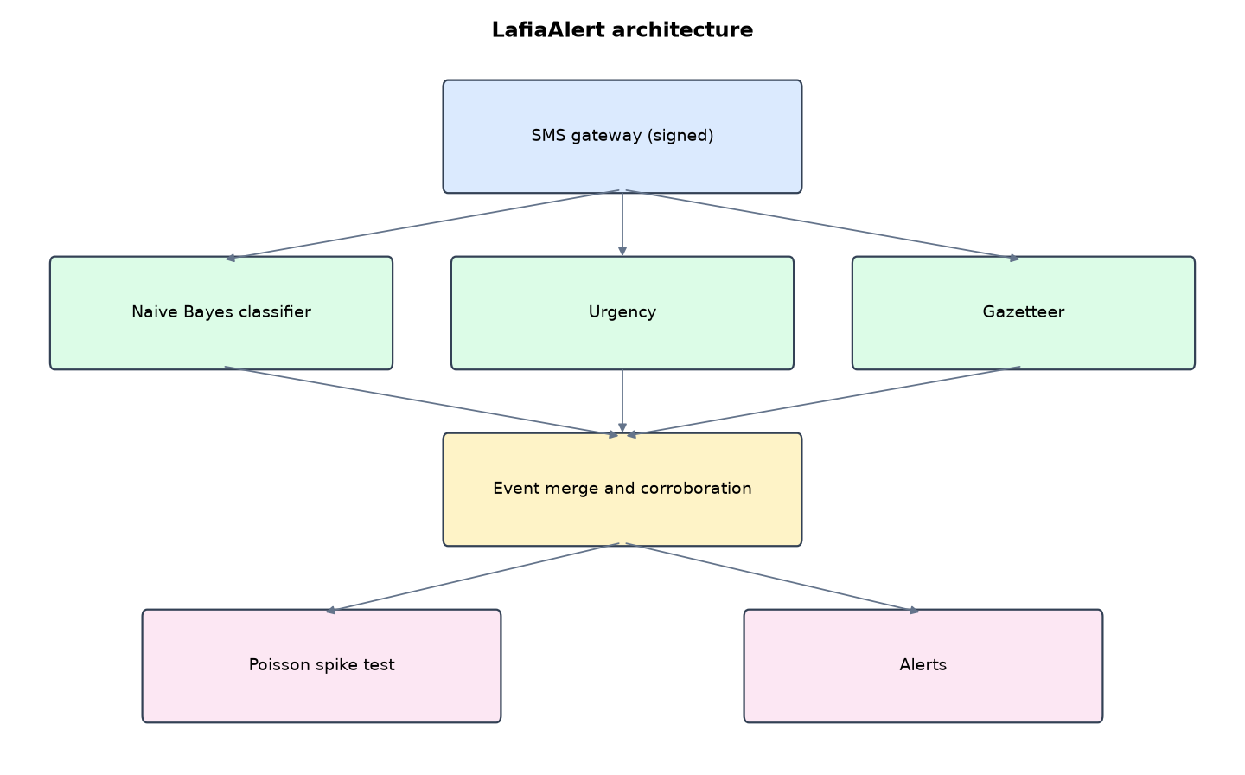
Figure 1: LafiaAlert architecture (data flows from top to bottom)
Table 5: Software components
File | Responsibility
nlp.py | Naive Bayes, training corpus, urgency, gazetteer
pipeline.py | Webhook check, ingest, merge, Poisson test, alerts
app.py | Dashboard and webhook
main.py / selftest.py | Commands and tests

The main design decisions, and how they differ from the earlier VarsityShield and Zaman Lafiya projects, are:
- SMS gateway webhook with HMAC-SHA256 signature and a 5-minute timestamp window, the same pattern Termii and Africa's Talking use. Forged or replayed calls are refused.
- Multinomial Naive Bayes from scratch (unigrams + bigrams, Laplace smoothing) over 6 classes including 'noise' for irrelevant texts. Precision, recall, F1 and the confusion matrix are shown on the Model page.
- Three languages: English, Hausa ('an kai hari ... yanzu da bindigogi') and Pidgin ('cow don chop my yam').
- Urgency detection in all three languages (now/yanzu, gun/bindiga, killed/an kashe).
- Village gazetteer geocoding for messages without GPS.
- Event merging and corroboration: same village + same type within 6 hours = one event. A second, different sender upgrades an UNCONFIRMED alert to CORROBORATED. The same sender repeating does not count.
- Poisson spike test per LGA against a 60-day baseline (alert when p < 0.01).
- Privacy: phone numbers are Fernet-encrypted. Staff see only an HMAC pseudonym.

3.4 Security Design
Each threat considered is matched to the control that addresses it. Tests in Chapter Four exercise these controls.
Table 6: Threats and controls
Threat | Control in LafiaAlert
Forged gateway call | HMAC-SHA256 signature
Replayed gateway call | 5-minute timestamp window
Informant exposure | Fernet phone encryption; HMAC pseudonym
One person faking corroboration | Same sender counts once
Viewer injects test SMS | Role check

3.5 Algorithms

3.5.1 Multinomial Naive Bayes
Tokens are words and word pairs. For class c: log P(c) + sum log((count(t, c) + 1) / (total(c) + V)). Probabilities are normalised with the log-sum-exp trick. Below 0.6 confidence a message goes to review.

3.5.2 Event merge
Same village, same type, within 6 hours = one event. A different sender increments the sender count; the first urgent report alerts as UNCONFIRMED, the second sender upgrades it to CORROBORATED.

3.5.3 Poisson spike test
lambda = events in the LGA over the last 60 days / 60. p = P(X >= today's count). If p < 0.01 the LGA is flagged.

3.6 Tools and Technologies
Language: Python 3.10 or newer. Storage: SQLite. Third-party packages: flask, cryptography. Launchers: Windows batch files (1_SETUP, 2_START, 3_DEMO_MENU, 4_SELFTEST) and run.sh for Linux and macOS.

CHAPTER FOUR: IMPLEMENTATION, TESTING AND RESULTS

4.1 Implementation Environment
The system was developed and tested with Python 3.11 on Linux and is written to run unchanged on Windows 10/11. Its web interface runs at http://127.0.0.1:5203. Setup takes about ten minutes with 1_SETUP.bat; the README in the project folder gives every step and a defence demonstration script.

4.2 Operation and Demonstration
LafiaAlert is built around the phone most rural people already have. Community members text what they see in English, Hausa or Pidgin. A Naive Bayes classifier written from scratch decides what kind of incident it is, a gazetteer finds the village and LGA, and reports about the same village are merged into one event so the situation room sees corroboration, not noise. A Poisson test flags an LGA when today's events are far above its normal daily rate.
Table 7: Demonstration scenario used for the defence
Step | Command (python main.py ...) | What is observed
People text us in their own language. | demo-feed | Inbox fills: Hausa, Pidgin and English messages classified, noise greyed out
Two people report the same attack in Giza. | (Events page) | One event, 2 senders, alert upgraded to CORROBORATED
Is Keana unusual today? | spikes | Keana p-value below 0.01: SPIKE alert to the State Security Council
How good is the classifier? | (Model page) | Accuracy, precision, recall per class
Can someone fake the SMS gateway? | (selftest) | Forged and replayed webhooks are refused

4.3 Test Plan and Results
The automated test program ran 16 tests. 16 passed.
Table 8: Automated test results
# | Test | Result | Evidence
1 | Naive Bayes accuracy on held-out messages is at least 0.90 | PASS | 1.0
2 | Correct class for Hausa, Pidgin and English probes | PASS | {'an kai hari a giza yanzu da bindigogi': 'armed_attack', 'cow don chop my maize for shabu': 'crop_destruction', 'barayi
3 | Gazetteer finds the LGA from a village name | PASS
4 | Urgency detector (Hausa 'yanzu' and 'bindigogi') | PASS
5 | Poisson tail P(X>=3 | 0.1) is tiny and P(X>=0) = 1 | PASS | 0.00015465307026474306
6 | Signed gateway webhook accepted | PASS
7 | Forged webhook (wrong signature) refused | PASS
8 | Replayed webhook (old timestamp) refused | PASS
9 | Irrelevant SMS marked noise and not turned into an event | PASS
10 | Two senders about Giza merge into one corroborated event | PASS
11 | Same sender repeating does not count as corroboration | PASS | senders 2, reports 3
12 | Urgent alert sent first as UNCONFIRMED, then CORROBORATED | PASS
13 | Spike test flags Keana (several attack events in one day) | PASS | ['SPIKE in Keana: 2 incident events today against a normal 0.08 per day (Poisson p = 0.0033). Escalate to State Security
14 | Phone numbers never stored in plain text | PASS
15 | Viewer cannot inject test SMS | PASS
16 | Webhook without signature refused over HTTP | PASS

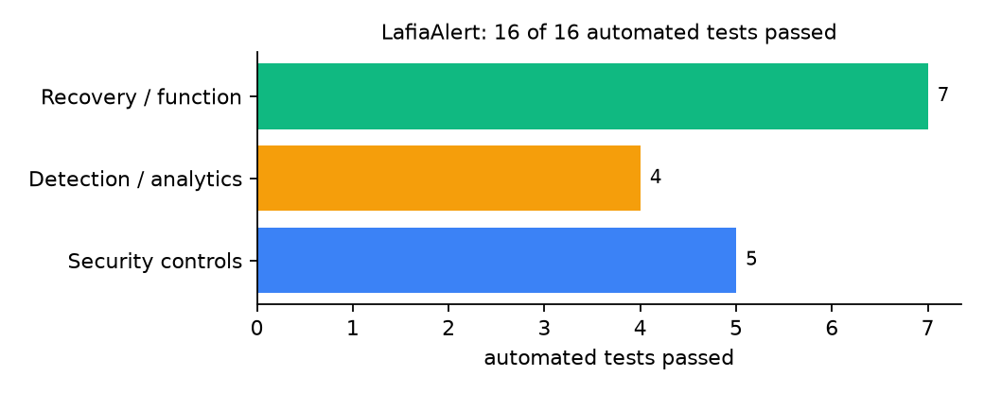
Figure 2: Automated tests by category

4.4 Measured Results
Table 9: Key measurements
Measure | Result
Classifier accuracy on held-out template messages | 1.0
Test messages | 180
Hand-written probes (Hausa, Pidgin, English) | 5 probes, all correct: yes
Processing time per SMS | 6.36 ms
Alerts in demo feed | 6

4.5 Discussion
Accuracy of 1.0 on template messages is not a real-world figure: templates are easy. The five hand-written probes, which are not templates, were all correct, which is more meaningful but still small. An early version merged every report in an LGA into one event, which hid separate attacks and stopped the spike test from firing; merging by village fixed that.
Of the tests, 5 exercised security controls, 4 exercised detection or analytics, and 7 exercised recovery or core function.

CHAPTER FIVE: SUMMARY, CONCLUSION AND RECOMMENDATIONS

5.1 Summary
This project built LafiaAlert for Nasarawa State (11 LGAs including Lafia, Keana, Doma, Awe and Obi). Its design combines signed SMS gateway webhook, English-Hausa-Pidgin classifier, village gazetteer, corroboration and Poisson spike test. It met its objectives and passed all 16 automated tests.

5.2 Conclusion
LafiaAlert shows that the security problem described in Chapter One can be addressed with free software and modest hardware, provided the design treats the warning data as something attackers will target. The limits stated in Section 1.4 still apply.

5.3 Recommendations
- Collect and label 1,000 real hotline messages and retrain.
- Grow the gazetteer with ward and village lists from the LGAs.
- Contract a gateway that signs webhooks.

5.4 Contribution to Knowledge
This project addresses the gap identified in Chapter Two: Reviewed community warning systems do not classify multilingual free text automatically or quantify how unusual a day is.

5.5 Suggestions for Further Work
- Add Tiv, Eggon and Alago vocabulary.
- Voice-call reports transcribed to text.

REFERENCES
Babatunde, A. O., & Ibnouf, F. O. (2024). The dynamics of herder-farmer conflicts in Plateau State, Nigeria, and Central Darfur State, Sudan. African Studies Review, 67(2), 321-350. https://doi.org/10.1017/asr.2024.45
Browning, R., Patten, H., Rousseau, J., & Mengersen, K. (2026). Bayesian spatiotemporal modelling of political violence and conflict events using discrete-time Hawkes processes. Journal of the Royal Statistical Society Series A. https://doi.org/10.1093/jrsssa/qnag039
Cicek, D., & Kantarci, B. (2023). Use of mobile crowdsensing in disaster management: A systematic review, challenges, and open issues. Sensors, 23(3), 1699. https://doi.org/10.3390/s23031699
Eke, O. G., et al. (2025). Climate-driven conflicts in Nigeria: Farmers' strategies for coping with herders' incursion on crop lands. Sustainability, 17(24), 11316. https://doi.org/10.3390/su172411316
Estefania-Salazar, E., & Iglesias, E. (2025). Assessing vegetation phenology dynamics in West African rangelands: Implications for livestock sustainability and transhumance. Ecological Informatics, 88.
Goodman, S., BenYishay, A., & Runfola, D. (2024). Spatiotemporal prediction of conflict fatality risk using convolutional neural networks and satellite imagery. Remote Sensing, 16(18), 3411. https://doi.org/10.3390/rs16183411
Kanagamalliga, S., et al. (2024). Integration of IoT for precision livestock monitoring through geofencing. In 2024 5th International Conference on Electronics and Sustainable Communication Systems (ICESC). IEEE.
Navarro, R., Saleh, L., & Owino, E. (2025). Pastoral conflict on the greener grass? Exploring the climate-conflict nexus in the Karamoja Cluster. International Journal of Disaster Risk Reduction.
Nnaji, A., Ma, W., Ratna, N., & Renwick, A. (2022). Farmer-herder conflicts and food insecurity: Evidence from rural Nigeria. Agricultural and Resource Economics Review.
Nwankwo, C. F. (2025). Perceptions of injustices in the struggle for scarce critical lands: Farmer-herder conflict and violence escalation in the Benue-Nasarawa borderland. World Development, 186, 106824.
Parlato, M. C. M., Valenti, F., & Porto, S. M. C. (2024). GIS-based methodology for tracking the grazing cattle site use. Heliyon, 10(13), e33166. https://doi.org/10.1016/j.heliyon.2024.e33166
Rochana, E., et al. (2024). The urgency of an early warning system for social conflict by using WhatsApp. International Journal of Innovative Research and Scientific Studies, 7(1), 107-114.
Ronoh, E. K., Mirau, S., & Dida, M. A. (2022). Human-wildlife conflict early warning system using the Internet of Things and short message service. Engineering, Technology & Applied Science Research.
Rød, E. G., Gåsste, T., & Hegre, H. (2024). A review and comparison of conflict early warning systems. International Journal of Forecasting, 40(1), 96-112.
Schwarz, M., Landmann, T., Jusselme, D., Zambrano, E., Danzeglocke, J., Siegert, F., & Franke, J. (2022). Assessing the environmental suitability for transhumance in support of conflict prevention in the Sahel. Remote Sensing, 14(5), 1109. https://doi.org/10.3390/rs14051109
Shimizu, K., et al. (2025). Piloting a mobile early warning alert and response system for East and Central Darfur, Sudan. International Health, 18(2), ihaf122.
Sola, L., Chen, Y., Murphy, S. K., & Subrahmanian, V. S. (2025). Quantifying the risk of pastoral conflict in 4 central African countries. EPJ Data Science, 14. https://doi.org/10.1140/epjds/s13688-025-00591-5
Tarif, K. (2022). Climate change and violent conflict in West Africa: Assessing the evidence (SIPRI Insights on Peace and Security). Stockholm International Peace Research Institute.

Standards and Legal Instruments Consulted
Federal Republic of Nigeria. (2023). Nigeria Data Protection Act, 2023. Nigeria Data Protection Commission.
International Organization for Standardization. (2022). ISO/IEC 27001:2022 Information security, cybersecurity and privacy protection: Information security management systems: Requirements. ISO.
National Institute of Standards and Technology. (2024). The NIST Cybersecurity Framework (CSF) 2.0 (NIST CSWP 29). NIST.

APPENDIX A: HOW TO RUN THE SYSTEM
- Copy the folder conflict-early-warning/B03-nasarawa-lafiaalert to the computer.
- Install Python 3.10 or newer with 'Add python.exe to PATH' ticked.
- Double-click 1_SETUP.bat, then 2_START.bat, and open http://127.0.0.1:5203.
- Use 3_DEMO_MENU.bat for the defence demonstration and 4_SELFTEST.bat to regenerate the results in Chapter Four.

APPENDIX B: SOURCE CODE STRUCTURE
Table 10: LafiaAlert source files
File | Purpose
nlp.py | Naive Bayes, training corpus, urgency, gazetteer
pipeline.py | Webhook check, ingest, merge, Poisson test, alerts
app.py | Dashboard and webhook
main.py / selftest.py | Commands and tests

APPENDIX C: CODE EXCERPT
The function merge from pipeline.py, the heart of the design described in Section 3.5.
def merge(mid, ts, sender, lga_name, place, label, is_urgent):
"""Reports of the same type from the same village within 6 hours are one event. Several
different senders corroborate it; the same sender repeating does not."""
with db() as con:
ev = con.execute("SELECT * FROM events WHERE lga=? AND place=? AND label=? AND last_ts > ? ORDER BY id DESC LIMIT 1",
(lga_name, place, label, ts - 6 * 3600)).fetchone()
if ev:
senders = {r["sender"] for r in con.execute("SELECT sender FROM messages WHERE merged_into=?", (ev["id"],))}
new_sender = sender not in senders
con.execute("UPDATE events SET last_ts=?, reports=reports+1, senders=senders+?, urgent=max(urgent,?) WHERE id=?",
(ts, int(new_sender), int(is_urgent), ev["id"]))
con.execute("UPDATE messages SET merged_into=?, status=? WHERE id=?",
(ev["id"], "corroborates" if new_sender else "repeat", mid))
eid = ev["id"]
n_senders = ev["senders"] + int(new_sender)
else:
cur = con.execute("INSERT INTO events(first_ts,last_ts,lga,place,label,severity,urgent,reports,senders) "
"VALUES(?,?,?,?,?,?,?,1,1)", (ts, ts, lga_name, place, label, SEVERITY[label], int(is_urgent)))
eid = cur.lastrowid
con.execute("UPDATE messages SET merged_into=? WHERE id=?", (eid, mid))
n_senders = 1
if is_urgent and SEVERITY[label] >= 4 and n_senders in (1, 2):
word = "UNCONFIRMED" if n_senders == 1 else "CORROBORATED by a second person"
alert(lga_name, "urgent", f"{word}: {label.replace('_', ' ')} reported at {place}, {lga_name} (event {eid}). "
f"Police DPO and peace committee notified.")
return eid

