[NAME OF YOUR UNIVERSITY]
FACULTY OF [SCIENCE / COMPUTING]
DEPARTMENT OF COMPUTER SCIENCE
CMP 468: COMPUTER SECURITY (2 UNITS)
COURSE PROJECT REPORT
MAMBILLAWATCH: SIGNED-COLLAR GEOFENCING AND CROP-CALENDAR EARLY WARNING FOR HERDS IN TARABA STATE
Point-in-polygon breach detection, approach ETA, counter-based replay protection and spoofing checks
BY
[FULL NAME]
MATRIC NO: [MATRIC NUMBER]
SUBMITTED TO
[COURSE LECTURER'S NAME]
IN PARTIAL FULFILMENT OF THE REQUIREMENTS OF CMP 468
400 LEVEL, SECOND SEMESTER, 2025/2026 SESSION
OCTOBER 2026

DECLARATION
I declare that this project report and the accompanying software were written by me as part of the requirements of CMP 468 (Computer Security). Every source used has been cited. All literature cited in this report was published between 2021 and 2026. All test results reported in Chapter Four were produced by the automated test program supplied with the software.
Signature: ____________________ Date: ____________________

ABSTRACT
Farmer-herder conflict in Nigeria destroys lives, livelihoods and food supply. Early warning helps only when it is timely, trusted and secure. This project designed, built and tested MambillaWatch for Taraba State (12 LGAs including Wukari, Takum, Bali, Gassol and Sardauna on the Mambilla Plateau). Its design combines point-in-polygon breach detection, approach ETA, counter-based replay protection and spoofing checks. The system was implemented in Python and evaluated with an automated test suite on synthetic data that follows documented conflict patterns, including attacks on the system itself. All 15 tests passed. Key measurements: Processing time per ping: 4.21 ms; Warning lead time before breach: 30 minutes. The results show the design works as specified; field validation with real data is the next step.
Keywords: early warning, farmer-herder conflict, GIS, information security, privacy, Nigeria, NDPA 2023.

TABLE OF CONTENTS
Right-click here and choose Update Field to build the table of contents.

CHAPTER ONE: INTRODUCTION

1.1 Background of the Study
On the Mambilla Plateau and along the Benue valley, the trigger for many clashes is simple: cattle in a farm while the crop is still standing. Eke et al. (2025) describe farmers reducing what they plant because of such incursions. Both farmers and herders lose when the first they hear of a problem is the damage itself.
Nigerian farmer-herder conflict is driven by competition for land and water, changing herd mobility, weak institutions and perceived injustice. Early warning systems try to detect rising risk early enough for mediation, patrols or community action. They handle sensitive data (who reported what) and are themselves targets of manipulation, so they are a computer security problem as much as a data problem.

1.2 Statement of the Problem
- Herd positions are unknown until damage is done.
- Warnings reach one community, not both.
- GPS data could be forged or replayed.
- Off-season grazing on harvested fields raises needless alarms.

1.3 Aim and Objectives
The aim is to design, implement and evaluate MambillaWatch, a secure system for Taraba State (12 LGAs including Wukari, Takum, Bali, Gassol and Sardauna on the Mambilla Plateau). The objectives are to:
- accept signed collar pings with counters;
- detect breaches of in-season farms and approaching herds with an ETA;
- detect corridor deviations and protected-area entry;
- flag collars that jump at impossible speeds;
- alert farmers' and herders' leaders together; evaluate lead time.

1.4 Scope and Limitations
Farm polygons, corridors and the park boundary are illustrative. The system was tested on one computer; the README describes deployment on other computers.

1.5 Significance of the Study
MambillaWatch gives Taraba State (12 LGAs including Wukari, Takum, Bali, Gassol and Sardauna on the Mambilla Plateau) a free, auditable tool that runs on ordinary hardware, and turns CMP 468 topics into working controls. Its automated test suite lets any future maintainer prove that the controls still work.

1.6 Relation to the CMP 468 Course Outline
Table 1: Mapping of CMP 468 topics to MambillaWatch
CMP 468 topic | Where it appears in MambillaWatch
Overview of security in computing | Confidentiality of informants, integrity of reports and data, availability of alerts
Characteristics of computer intrusion | Forged reports, fake devices, replayed messages, tampered records
Types of security breaches | Disclosure of informant identity, falsified incident data, unauthorised access to case files
Classes of attacks | Impersonation, replay, injection, brute force, cross-site request forgery, disinformation
Methods of defence and controls | Table 3.2 maps each threat to its control
Data security: encryption and decryption | See Section 3.5
Database security | Parameterised SQL, role checks before every query, encrypted personal fields
Security policies and standards | NDPA 2023 (personal data of reporters), ISO/IEC 27001:2022 access control

CHAPTER TWO: LITERATURE REVIEW
This review covers only studies published from 2021 to 2026. Every source was checked against a publisher or index page.

2.1 Conceptual Framework
The study uses the early warning chain: collect signals, analyse risk, warn the right people, and respond. Each link has security needs: signals must be authentic, analysis must be on untampered data, warnings must reach people quickly, and the identities of informants must stay confidential.

2.2 Farmer-herder conflict in Nigeria and the region
Nnaji et al. (2022) surveyed 401 rural Nigerian households and found that both the incidence and the severity of farmer-herder conflict raise food insecurity, severity more so. Nwankwo (2025) showed from interviews in the Benue-Nasarawa borderland that perceived injustice drives escalation of farmer-herder violence. Babatunde and Ibnouf (2024) showed that officials, traditional rulers and security agents in Plateau State deepened conflict through unequal resource allocation and peacebuilding that favoured some groups. Eke et al. (2025) found Enugu farmers coping with herd incursions by farming in groups, reducing what they plant and preparing for crop loss, with falling income and productivity. Tarif (2022) reviewed the West African evidence and grouped climate-conflict links into four pathways, including changing pastoral mobility, while warning that the research base is thin. Together these studies explain why prevention must be local, fast and trusted by both farming and herding communities.

2.3 Conflict early warning systems and forecasting
Rød et al. (2024) compared conflict early warning systems on transparency, key parameters and forecasts, found weak access to data and code and large differences between systems, and called for shared standards. Goodman et al. (2024) predicted sub-national conflict-fatality risk in Nigeria from Landsat 8 imagery and ACLED data, with an average AUC above 0.75, but performance fell when the geography of conflict shifted. Sola et al. (2025) predicted pastoral conflict in Cameroon, Chad, the Central African Republic and the DRC from weather and terrain data (AUC 0.99 for Cameroon) and found that vegetation affects risk differently in each country. Browning et al. (2026) fitted a Bayesian spatiotemporal Hawkes process to ACLED events in South Asia, treating political violence as self-exciting (contagious) in space and time. Forecast accuracy matters, but so do transparency and whether the people at risk can act on the warning.

2.4 Environment, mobility and herd tracking
Schwarz et al. (2022) modelled environmental suitability for transhumance in Chad and the Central African Republic from Earth observation data, found most conflicts where suitability was high, and suggested combining herd tracking with satellite data for early warning along corridors. Estefania-Salazar and Iglesias (2025) analysed 250 m NDVI for 2003-2023 across 13 West African countries and found growing seasons shortening through a later start, with consequences for transhumance routes. Navarro et al. (2025) found in the Karamoja Cluster that vegetation data predicted pastoral conflict one month ahead better than rainfall, and that conflict clustered 'on the greener grass'. Parlato et al. (2024) tracked grazing cattle with low-power GPS collars and used heatmaps and kernel density estimation to find the areas animals use most. Kanagamalliga et al. (2024) used IoT collars with geofencing and temperature sensing for remote monitoring of livestock movement and health.

2.5 Community reporting and mobile alerting
Rochana et al. (2024) surveyed 267 villagers, found low public participation in conflict prevention, and proposed village-level early warning through WhatsApp groups. Cicek and Kantarci (2023) reviewed mobile crowdsensing for disasters and found most studies conceptual, with little testing in real incidents. Shimizu et al. (2025) describe the EWARS Mobile pilot in Darfur, whose offline reporting worked where network coverage was poor: 158 health facilities sent 752 weekly reports and the system was expanded to all Darfur states. Ronoh et al. (2022) built a low-cost early warning unit (motion sensor, GPS, camera, YOLO detection) that sends SMS alerts to response teams when animals approach a park border. Low-cost phones, SMS and offline-capable tools reach people that web dashboards miss.

2.6 Work Closest to This Design
Kanagamalliga et al. (2024) apply geofencing to animal management, and Parlato et al. (2024) track cattle with low-power GPS. MambillaWatch turns those tools toward conflict prevention by adding the crop calendar and joint alerts. Ronoh et al. (2022) alert response teams before animals reach people; MambillaWatch does the same with an estimated arrival time.

2.7 Summary of Reviewed Works and Research Gap
Table 2: Summary of reviewed works
Study | What it contributes
Babatunde (2024) | showed that officials, traditional rulers and security agents in Plateau State deepened conflict through unequal resource allocation and peacebuilding that favo
Browning (2026) | fitted a Bayesian spatiotemporal Hawkes process to ACLED events in South Asia, treating political violence as self-exciting (contagious) in space and time.
Cicek (2023) | reviewed mobile crowdsensing for disasters and found most studies conceptual, with little testing in real incidents.
Eke (2025) | found Enugu farmers coping with herd incursions by farming in groups, reducing what they plant and preparing for crop loss, with falling income and productivity
Estefania-Salazar (2025) | analysed 250 m NDVI for 2003-2023 across 13 West African countries and found growing seasons shortening through a later start, with consequences for transhumanc
Goodman (2024) | predicted sub-national conflict-fatality risk in Nigeria from Landsat 8 imagery and ACLED data, with an average AUC above 0.75, but performance fell when the ge
Kanagamalliga (2024) | used IoT collars with geofencing and temperature sensing for remote monitoring of livestock movement and health.
Navarro (2025) | found in the Karamoja Cluster that vegetation data predicted pastoral conflict one month ahead better than rainfall, and that conflict clustered 'on the greener
Nnaji (2022) | surveyed 401 rural Nigerian households and found that both the incidence and the severity of farmer-herder conflict raise food insecurity, severity more so.
Nwankwo (2025) | showed from interviews in the Benue-Nasarawa borderland that perceived injustice drives escalation of farmer-herder violence.
Parlato (2024) | tracked grazing cattle with low-power GPS collars and used heatmaps and kernel density estimation to find the areas animals use most.
Rochana (2024) | surveyed 267 villagers, found low public participation in conflict prevention, and proposed village-level early warning through WhatsApp groups.
Ronoh (2022) | built a low-cost early warning unit (motion sensor, GPS, camera, YOLO detection) that sends SMS alerts to response teams when animals approach a park border.
Rød (2024) | compared conflict early warning systems on transparency, key parameters and forecasts, found weak access to data and code and large differences between systems,
Schwarz (2022) | modelled environmental suitability for transhumance in Chad and the Central African Republic from Earth observation data, found most conflicts where suitability
Shimizu (2025) | describe the EWARS Mobile pilot in Darfur, whose offline reporting worked where network coverage was poor: 158 health facilities sent 752 weekly reports and the
Sola (2025) | predicted pastoral conflict in Cameroon, Chad, the Central African Republic and the DRC from weather and terrain data (AUC 0.99 for Cameroon) and found that veg
Tarif (2022) | reviewed the West African evidence and grouped climate-conflict links into four pathways, including changing pastoral mobility, while warning that the research

Research gap. Livestock geofencing is studied for productivity, not for preventing farmer-herder violence; the security of the collar data is rarely addressed.

CHAPTER THREE: METHODOLOGY AND SYSTEM DESIGN

3.1 Research Methodology
The project follows Design Science Research: identify the problem, define objectives, design and build an artefact, demonstrate it, and evaluate it. Evaluation uses an automated test program (selftest.py) that resets the system, runs normal use, simulated attacks and failures, and records each outcome and measurement in results/selftest.json. Data are synthetic, generated to follow documented seasonal and retaliation patterns, so results show how the system behaves, not how accurate it would be in the field.

3.2 Requirements
Table 3: Functional requirements
# | Requirement
FR1 | Collar registry with keys
FR2 | Signature, counter, bounds and speed checks
FR3 | BREACH, APPROACH (with ETA), DEVIATION, RESTRICTED alerts
FR4 | Battery alerts
FR5 | Joint notification
FR6 | Live map

Table 4: Non-functional requirements
# | Requirement
NFR1 | Map refresh every 4 s
NFR2 | Coordinator and ranger roles

3.3 System Architecture
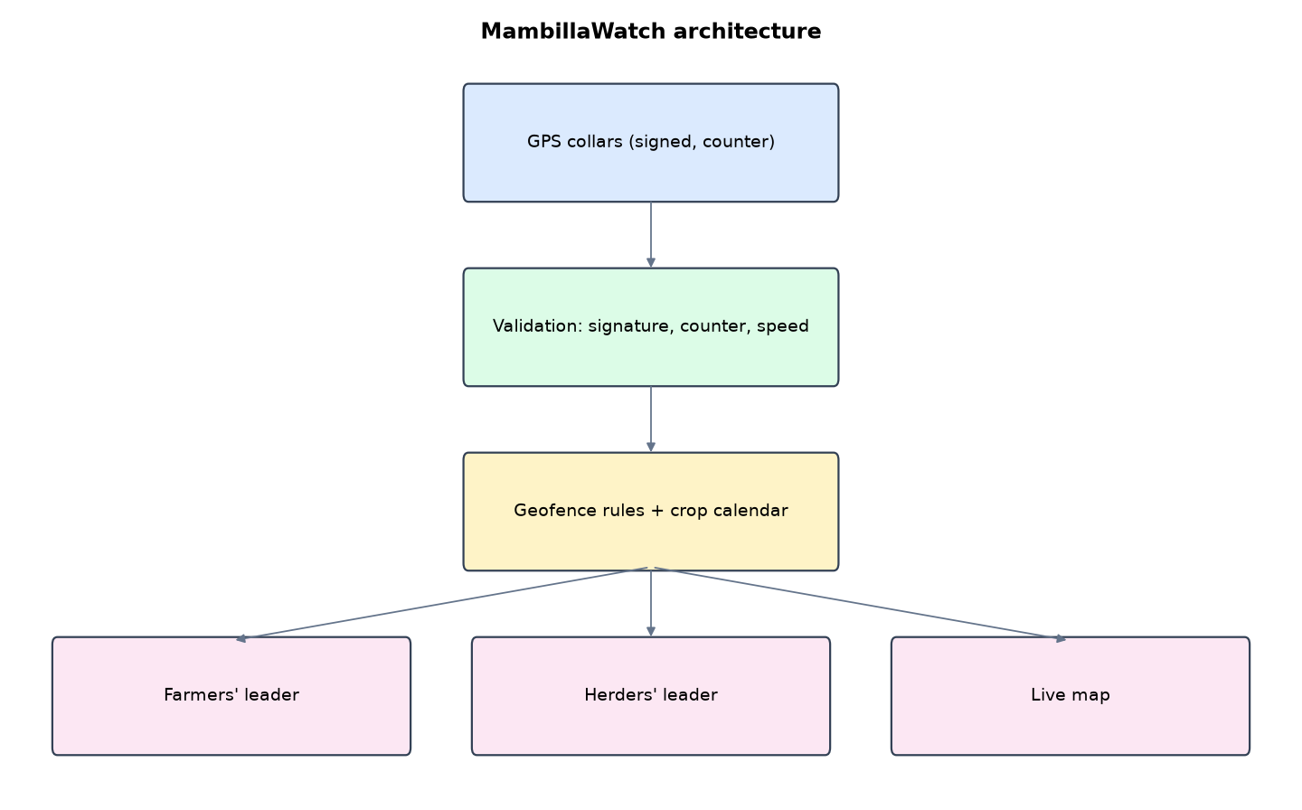
Figure 1: MambillaWatch architecture (data flows from top to bottom)
Table 5: Software components
File | Responsibility
fence.py | Collar keys, validation, geofencing, alerts
app.py | Flask app, live map, ping API
geo.py | Geography helpers
main.py / selftest.py | Commands, scenario, tests

The main design decisions, and how they differ from the earlier VarsityShield and Zaman Lafiya projects, are:
- Geofencing with ray-casting point-in-polygon for farms and great-circle distance for corridors (3 km buffer), grazing reserves and the protected park.
- Crop calendar. Yam March to October, rice June to November, and so on (config.json). A herd in a harvested field is not an alert.
- APPROACH alerts with ETA from the herd's closing speed toward the farm. In the test, the warning came 30 minutes before the breach.
- Dual notification. Every farm alert goes to both the farmers' union chair and the herders' Ardo of the LGA, so neither side hears it second-hand.
- Counter-based replay protection. Each collar signs collar|counter|lat|lon|battery with its own HMAC key. A ping with an old counter is refused, so no clock is needed on the collar.
- Spoofing detection. A jump faster than 12 km/h (cattle walk 2 to 5 km/h) marks the collar suspect and the position is ignored.
- Live Leaflet map with in-season farms highlighted, corridors, reserves, herd tracks and an alert feed refreshed every 4 seconds.

3.4 Security Design
Each threat considered is matched to the control that addresses it. Tests in Chapter Four exercise these controls.
Table 6: Threats and controls
Threat | Control in MambillaWatch
Forged ping | Per-collar HMAC
Replayed ping | Counter must increase
Spoofed GPS jump | Speed above 12 km/h ignored and flagged
Unknown collar | Refused
Malformed request | 400 response
Ranger registers rogue collar | Role check

3.5 Algorithms

3.5.1 Ray casting
A horizontal ray from the point crosses the polygon's edges; an odd number of crossings means inside.

3.5.2 Approach and ETA
If a herd is within 2 km of an in-season farm edge and its distance to the farm centre fell at more than 0.3 km/h since the last ping, ETA = distance / closing speed.

3.5.3 Spoofing check
speed = great-circle distance between consecutive accepted pings / elapsed hours; above 12 km/h the ping is ignored and the collar marked suspect.

3.6 Tools and Technologies
Language: Python 3.10 or newer. Storage: SQLite. Third-party packages: flask, cryptography. Launchers: Windows batch files (1_SETUP, 2_START, 3_DEMO_MENU, 4_SELFTEST) and run.sh for Linux and macOS.

CHAPTER FOUR: IMPLEMENTATION, TESTING AND RESULTS

4.1 Implementation Environment
The system was developed and tested with Python 3.11 on Linux and is written to run unchanged on Windows 10/11. Its web interface runs at http://127.0.0.1:5204. Setup takes about ten minutes with 1_SETUP.bat; the README in the project folder gives every step and a defence demonstration script.

4.2 Operation and Demonstration
MambillaWatch prevents the most common trigger of farmer-herder violence: cattle entering a farm while the crop is still in the field. GPS collars on herds send signed positions. The system knows each farm's crop and its season, so it warns when a herd is heading toward an in-season farm, estimates how many minutes until it arrives, and sends the same warning to the farmers' leader and the herders' Ardo. It also spots herds leaving the agreed corridor, entering a protected park, and collars that look spoofed.
Table 7: Demonstration scenario used for the defence
Step | Command (python main.py ...) | What is observed
These are Taraba's collared herds and in-season farms. | serve | Map: brown in-season farms, green corridors, purple herds
Ardo Musa's herd drifts toward a Bali farm. | simulate --interval 3 | APPROACH alert with ETA, then BREACH, sent to both leaders
Another herd leaves the corridor. | (same run) | DEVIATION alert for TRB-003, low-battery warning
Someone fakes a collar position. | (same run) | TRB-004 jumps 120 km: SPOOF alert, position ignored, collar marked suspect
Can a recorded ping be replayed? | (Collars page) | Rejected pings: replayed counter, bad signature

4.3 Test Plan and Results
The automated test program ran 15 tests. 15 passed.
Table 8: Automated test results
# | Test | Result | Evidence
1 | Point-in-polygon (ray casting) inside and outside | PASS
2 | Herd walking into an in-season farm: APPROACH with ETA, then BREACH | PASS | ETA 22 min
3 | Warning came before the breach (lead time) | PASS | 30 minutes
4 | Breach alert reaches both the farmers' and the herders' leader | PASS | farmers: Bali farmers' union chair, herders: Bali herders' Ardo
5 | Herd on the agreed corridor raises no farm alerts | PASS | set()
6 | Herd leaving the corridor raises DEVIATION | PASS
7 | Low collar battery reported | PASS
8 | Teleporting (spoofed) collar is flagged and its position ignored | PASS | ['impossible speed']
9 | Replayed old ping (lower counter) refused | PASS | replayed or out-of-order counter
10 | Ping with a forged signature refused | PASS | bad signature
11 | Unknown collar refused | PASS
12 | Position outside Taraba refused | PASS
13 | Malformed ping returns 400 | PASS
14 | Ranger cannot register collars | PASS
15 | Live state API works for staff | PASS

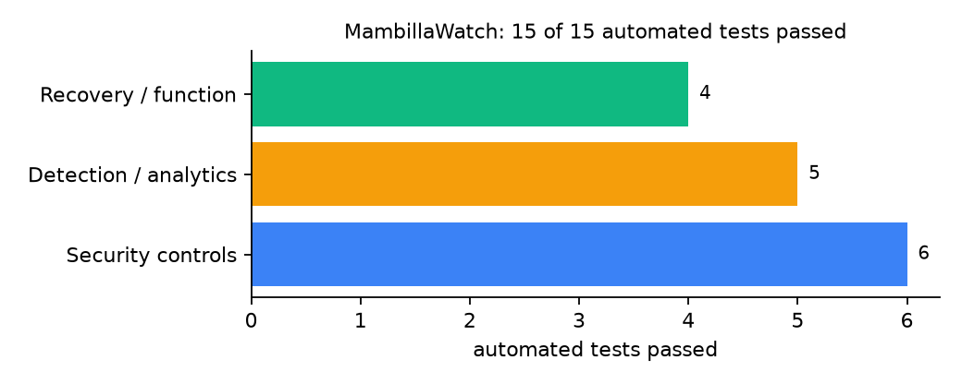
Figure 2: Automated tests by category

4.4 Measured Results
Table 9: Key measurements
Measure | Result
Processing time per ping | 4.21 ms
Warning lead time before breach | 30 minutes
Alerts by collar | TRB-001: APPROACH, BREACH; TRB-002: none; TRB-003: DEVIATION; TRB-004: none

4.5 Discussion
The 30-minute lead time comes from a scripted path and 10-minute pings; real lead time depends on ping interval and herd speed. Counter-based replay protection needs no clock on the collar, but a collar that loses its counter after a battery failure must be re-registered.
Of the tests, 6 exercised security controls, 5 exercised detection or analytics, and 4 exercised recovery or core function.

CHAPTER FIVE: SUMMARY, CONCLUSION AND RECOMMENDATIONS

5.1 Summary
This project built MambillaWatch for Taraba State (12 LGAs including Wukari, Takum, Bali, Gassol and Sardauna on the Mambilla Plateau). Its design combines point-in-polygon breach detection, approach ETA, counter-based replay protection and spoofing checks. It met its objectives and passed all 15 automated tests.

5.2 Conclusion
MambillaWatch shows that the security problem described in Chapter One can be addressed with free software and modest hardware, provided the design treats the warning data as something attackers will target. The limits stated in Section 1.4 still apply.

5.3 Recommendations
- Survey real farm boundaries with farmer groups each season.
- Agree the crop calendar with the State Ministry of Agriculture.
- Pilot with herders' associations as willing partners, not targets.

5.4 Contribution to Knowledge
This project addresses the gap identified in Chapter Two: Livestock geofencing is studied for productivity, not for preventing farmer-herder violence; the security of the collar data is rarely addressed.

5.5 Suggestions for Further Work
- LoRaWAN collars for areas without GSM.
- Predict paths from past tracks.

REFERENCES
Babatunde, A. O., & Ibnouf, F. O. (2024). The dynamics of herder-farmer conflicts in Plateau State, Nigeria, and Central Darfur State, Sudan. African Studies Review, 67(2), 321-350. https://doi.org/10.1017/asr.2024.45
Browning, R., Patten, H., Rousseau, J., & Mengersen, K. (2026). Bayesian spatiotemporal modelling of political violence and conflict events using discrete-time Hawkes processes. Journal of the Royal Statistical Society Series A. https://doi.org/10.1093/jrsssa/qnag039
Cicek, D., & Kantarci, B. (2023). Use of mobile crowdsensing in disaster management: A systematic review, challenges, and open issues. Sensors, 23(3), 1699. https://doi.org/10.3390/s23031699
Eke, O. G., et al. (2025). Climate-driven conflicts in Nigeria: Farmers' strategies for coping with herders' incursion on crop lands. Sustainability, 17(24), 11316. https://doi.org/10.3390/su172411316
Estefania-Salazar, E., & Iglesias, E. (2025). Assessing vegetation phenology dynamics in West African rangelands: Implications for livestock sustainability and transhumance. Ecological Informatics, 88.
Goodman, S., BenYishay, A., & Runfola, D. (2024). Spatiotemporal prediction of conflict fatality risk using convolutional neural networks and satellite imagery. Remote Sensing, 16(18), 3411. https://doi.org/10.3390/rs16183411
Kanagamalliga, S., et al. (2024). Integration of IoT for precision livestock monitoring through geofencing. In 2024 5th International Conference on Electronics and Sustainable Communication Systems (ICESC). IEEE.
Navarro, R., Saleh, L., & Owino, E. (2025). Pastoral conflict on the greener grass? Exploring the climate-conflict nexus in the Karamoja Cluster. International Journal of Disaster Risk Reduction.
Nnaji, A., Ma, W., Ratna, N., & Renwick, A. (2022). Farmer-herder conflicts and food insecurity: Evidence from rural Nigeria. Agricultural and Resource Economics Review.
Nwankwo, C. F. (2025). Perceptions of injustices in the struggle for scarce critical lands: Farmer-herder conflict and violence escalation in the Benue-Nasarawa borderland. World Development, 186, 106824.
Parlato, M. C. M., Valenti, F., & Porto, S. M. C. (2024). GIS-based methodology for tracking the grazing cattle site use. Heliyon, 10(13), e33166. https://doi.org/10.1016/j.heliyon.2024.e33166
Rochana, E., et al. (2024). The urgency of an early warning system for social conflict by using WhatsApp. International Journal of Innovative Research and Scientific Studies, 7(1), 107-114.
Ronoh, E. K., Mirau, S., & Dida, M. A. (2022). Human-wildlife conflict early warning system using the Internet of Things and short message service. Engineering, Technology & Applied Science Research.
Rød, E. G., Gåsste, T., & Hegre, H. (2024). A review and comparison of conflict early warning systems. International Journal of Forecasting, 40(1), 96-112.
Schwarz, M., Landmann, T., Jusselme, D., Zambrano, E., Danzeglocke, J., Siegert, F., & Franke, J. (2022). Assessing the environmental suitability for transhumance in support of conflict prevention in the Sahel. Remote Sensing, 14(5), 1109. https://doi.org/10.3390/rs14051109
Shimizu, K., et al. (2025). Piloting a mobile early warning alert and response system for East and Central Darfur, Sudan. International Health, 18(2), ihaf122.
Sola, L., Chen, Y., Murphy, S. K., & Subrahmanian, V. S. (2025). Quantifying the risk of pastoral conflict in 4 central African countries. EPJ Data Science, 14. https://doi.org/10.1140/epjds/s13688-025-00591-5
Tarif, K. (2022). Climate change and violent conflict in West Africa: Assessing the evidence (SIPRI Insights on Peace and Security). Stockholm International Peace Research Institute.

Standards and Legal Instruments Consulted
Federal Republic of Nigeria. (2023). Nigeria Data Protection Act, 2023. Nigeria Data Protection Commission.
International Organization for Standardization. (2022). ISO/IEC 27001:2022 Information security, cybersecurity and privacy protection: Information security management systems: Requirements. ISO.
National Institute of Standards and Technology. (2024). The NIST Cybersecurity Framework (CSF) 2.0 (NIST CSWP 29). NIST.

APPENDIX A: HOW TO RUN THE SYSTEM
- Copy the folder conflict-early-warning/B04-taraba-mambillawatch to the computer.
- Install Python 3.10 or newer with 'Add python.exe to PATH' ticked.
- Double-click 1_SETUP.bat, then 2_START.bat, and open http://127.0.0.1:5204.
- Use 3_DEMO_MENU.bat for the defence demonstration and 4_SELFTEST.bat to regenerate the results in Chapter Four.

APPENDIX B: SOURCE CODE STRUCTURE
Table 10: MambillaWatch source files
File | Purpose
fence.py | Collar keys, validation, geofencing, alerts
app.py | Flask app, live map, ping API
geo.py | Geography helpers
main.py / selftest.py | Commands, scenario, tests

APPENDIX C: CODE EXCERPT
The function accept from fence.py, the heart of the design described in Section 3.5.
def accept(collar_id, counter, lat, lon, battery, sig, now=None):
"""Validate one ping. Returns (accepted, reason, alerts)."""
now = now or time.time()
with db() as con:
c = con.execute("SELECT * FROM collars WHERE id=?", (collar_id,)).fetchone()
if not c:
return False, "unknown collar", []
if not hmac.compare_digest(sign(c["key"], collar_id, counter, lat, lon, battery), sig):
return _log(now, collar_id, counter, lat, lon, None, 0, "bad signature")
if counter <= c["last_counter"]:
return _log(now, collar_id, counter, lat, lon, None, 0, "replayed or out-of-order counter")
s, w, n, e = geo.bbox(0.5)
if not (s <= lat <= n and w <= lon <= e):
return _log(now, collar_id, counter, lat, lon, None, 0, "outside Taraba State")
speed = None
if c["last_ts"]:
hours = max((now - c["last_ts"]) / 3600, 1 / 3600)
speed = geo.km(c["last_lat"], c["last_lon"], lat, lon) / hours
if speed > geo.cfg()["max_speed_kmh"]:
with db() as con:
con.execute("UPDATE collars SET last_counter=?, state='suspect' WHERE id=?", (counter, collar_id))
_alert(now, collar_id, "SPOOF", geo.nearest_lga(lat, lon), "-", None,
f"Collar {collar_id} jumped at {speed:.0f} km/h: possible GPS spoofing or a collar moved by vehicle. "
f"Position ignored; send a ranger to check.", to_staff_only=True)
return _log(now, collar_id, counter, lat, lon, speed, 0, "impossible speed")
with db() as con:
con.execute("UPDATE collars SET last_counter=?, last_ts=?, last_lat=?, last_lon=?, battery=?, state='ok' WHERE id=?",
(counter, now, lat, lon, battery, collar_id))
if battery < 15:
_alert(now, collar_id, "BATTERY", geo.nearest_lga(lat, lon), "-", None,
f"Collar {collar_id} battery {battery}%. Replace within 48 hours.", to_staff_only=True)
prev = (c["last_lat"], c["last_lon"], c["last_ts"]) if c["last_ts"] else None
alerts = evaluate(collar_id, c, lat, lon, prev, now)
_log(now, collar_id, counter, lat, lon, speed, 1, "ok")
return True, "ok", alerts

