[NAME OF YOUR UNIVERSITY]
FACULTY OF [SCIENCE / COMPUTING]
DEPARTMENT OF COMPUTER SCIENCE
CMP 468: COMPUTER SECURITY (2 UNITS)
COURSE PROJECT REPORT
KADUNACORRIDOR: HAWKES SELF-EXCITING PROCESS FORECASTING OF RETALIATORY FARMER-HERDER VIOLENCE IN SOUTHERN KADUNA
Maximum-likelihood fitting, escalation status, 7-day forecasts and retaliation chains
BY
[FULL NAME]
MATRIC NO: [MATRIC NUMBER]
SUBMITTED TO
[COURSE LECTURER'S NAME]
IN PARTIAL FULFILMENT OF THE REQUIREMENTS OF CMP 468
400 LEVEL, SECOND SEMESTER, 2025/2026 SESSION
OCTOBER 2026

DECLARATION
I declare that this project report and the accompanying software were written by me as part of the requirements of CMP 468 (Computer Security). Every source used has been cited. All literature cited in this report was published between 2021 and 2026. All test results reported in Chapter Four were produced by the automated test program supplied with the software.
Signature: ____________________ Date: ____________________

ABSTRACT
Farmer-herder conflict in Nigeria destroys lives, livelihoods and food supply. Early warning helps only when it is timely, trusted and secure. This project designed, built and tested KadunaCorridor for Kaduna State (12 LGAs including Jema'a, Kauru, Kajuru, Zangon Kataf, Kaura and Sanga). Its design combines maximum-likelihood fitting, escalation status, 7-day forecasts and retaliation chains. The system was implemented in Python and evaluated with an automated test suite on synthetic data that follows documented conflict patterns, including attacks on the system itself. All 11 tests passed. Key measurements: Fitted branching ratio alpha: 0.25; Fitted memory: 5.0 days; Held-out log-likelihood, Hawkes vs Poisson: -101.15 vs -104.47; Parameter recovery (true alpha 0.5, memory 3 d): alpha 0.45, memory 3.0 d. The results show the design works as specified; field validation with real data is the next step.
Keywords: early warning, farmer-herder conflict, GIS, information security, privacy, Nigeria, NDPA 2023.

TABLE OF CONTENTS
Right-click here and choose Update Field to build the table of contents.

CHAPTER ONE: INTRODUCTION

1.1 Background of the Study
Southern Kaduna has suffered cycles in which one attack is followed by reprisals. A system that only counts incidents treats each event as independent and misses the most predictable thing about them: violence breeds violence for a few days.
Nigerian farmer-herder conflict is driven by competition for land and water, changing herd mobility, weak institutions and perceived injustice. Early warning systems try to detect rising risk early enough for mediation, patrols or community action. They handle sensitive data (who reported what) and are themselves targets of manipulation, so they are a computer security problem as much as a data problem.

1.2 Statement of the Problem
- Counting models ignore retaliation.
- Commanders cannot tell an escalating LGA from a normally busy one.
- Mediators do not see which events belong to one cycle.
- Forecasts are not compared with simpler alternatives.

1.3 Aim and Objectives
The aim is to design, implement and evaluate KadunaCorridor, a secure system for Kaduna State (12 LGAs including Jema'a, Kauru, Kajuru, Zangon Kataf, Kaura and Sanga). The objectives are to:
- fit a Hawkes process by maximum likelihood;
- verify the fitter on data with known parameters;
- compare with a Poisson model on held-out data;
- compute escalation status and 7-day probabilities;
- link events into retaliation chains.

1.4 Scope and Limitations
Synthetic incidents generated with a retaliation mechanism; parameters shared across LGAs. The system was tested on one computer; the README describes deployment on other computers.

1.5 Significance of the Study
KadunaCorridor gives Kaduna State (12 LGAs including Jema'a, Kauru, Kajuru, Zangon Kataf, Kaura and Sanga) a free, auditable tool that runs on ordinary hardware, and turns CMP 468 topics into working controls. Its automated test suite lets any future maintainer prove that the controls still work.

1.6 Relation to the CMP 468 Course Outline
Table 1: Mapping of CMP 468 topics to KadunaCorridor
CMP 468 topic | Where it appears in KadunaCorridor
Overview of security in computing | Confidentiality of informants, integrity of reports and data, availability of alerts
Characteristics of computer intrusion | Forged reports, fake devices, replayed messages, tampered records
Types of security breaches | Disclosure of informant identity, falsified incident data, unauthorised access to case files
Classes of attacks | Impersonation, replay, injection, brute force, cross-site request forgery, disinformation
Methods of defence and controls | Table 3.2 maps each threat to its control
Data security: encryption and decryption | See Section 3.5
Database security | Parameterised SQL, role checks before every query, encrypted personal fields
Security policies and standards | NDPA 2023 (personal data of reporters), ISO/IEC 27001:2022 access control

CHAPTER TWO: LITERATURE REVIEW
This review covers only studies published from 2021 to 2026. Every source was checked against a publisher or index page.

2.1 Conceptual Framework
The study uses the early warning chain: collect signals, analyse risk, warn the right people, and respond. Each link has security needs: signals must be authentic, analysis must be on untampered data, warnings must reach people quickly, and the identities of informants must stay confidential.

2.2 Farmer-herder conflict in Nigeria and the region
Nnaji et al. (2022) surveyed 401 rural Nigerian households and found that both the incidence and the severity of farmer-herder conflict raise food insecurity, severity more so. Nwankwo (2025) showed from interviews in the Benue-Nasarawa borderland that perceived injustice drives escalation of farmer-herder violence. Babatunde and Ibnouf (2024) showed that officials, traditional rulers and security agents in Plateau State deepened conflict through unequal resource allocation and peacebuilding that favoured some groups. Eke et al. (2025) found Enugu farmers coping with herd incursions by farming in groups, reducing what they plant and preparing for crop loss, with falling income and productivity. Tarif (2022) reviewed the West African evidence and grouped climate-conflict links into four pathways, including changing pastoral mobility, while warning that the research base is thin. Together these studies explain why prevention must be local, fast and trusted by both farming and herding communities.

2.3 Conflict early warning systems and forecasting
Rød et al. (2024) compared conflict early warning systems on transparency, key parameters and forecasts, found weak access to data and code and large differences between systems, and called for shared standards. Goodman et al. (2024) predicted sub-national conflict-fatality risk in Nigeria from Landsat 8 imagery and ACLED data, with an average AUC above 0.75, but performance fell when the geography of conflict shifted. Sola et al. (2025) predicted pastoral conflict in Cameroon, Chad, the Central African Republic and the DRC from weather and terrain data (AUC 0.99 for Cameroon) and found that vegetation affects risk differently in each country. Browning et al. (2026) fitted a Bayesian spatiotemporal Hawkes process to ACLED events in South Asia, treating political violence as self-exciting (contagious) in space and time. Forecast accuracy matters, but so do transparency and whether the people at risk can act on the warning.

2.4 Environment, mobility and herd tracking
Schwarz et al. (2022) modelled environmental suitability for transhumance in Chad and the Central African Republic from Earth observation data, found most conflicts where suitability was high, and suggested combining herd tracking with satellite data for early warning along corridors. Estefania-Salazar and Iglesias (2025) analysed 250 m NDVI for 2003-2023 across 13 West African countries and found growing seasons shortening through a later start, with consequences for transhumance routes. Navarro et al. (2025) found in the Karamoja Cluster that vegetation data predicted pastoral conflict one month ahead better than rainfall, and that conflict clustered 'on the greener grass'. Parlato et al. (2024) tracked grazing cattle with low-power GPS collars and used heatmaps and kernel density estimation to find the areas animals use most. Kanagamalliga et al. (2024) used IoT collars with geofencing and temperature sensing for remote monitoring of livestock movement and health.

2.5 Community reporting and mobile alerting
Rochana et al. (2024) surveyed 267 villagers, found low public participation in conflict prevention, and proposed village-level early warning through WhatsApp groups. Cicek and Kantarci (2023) reviewed mobile crowdsensing for disasters and found most studies conceptual, with little testing in real incidents. Shimizu et al. (2025) describe the EWARS Mobile pilot in Darfur, whose offline reporting worked where network coverage was poor: 158 health facilities sent 752 weekly reports and the system was expanded to all Darfur states. Ronoh et al. (2022) built a low-cost early warning unit (motion sensor, GPS, camera, YOLO detection) that sends SMS alerts to response teams when animals approach a park border. Low-cost phones, SMS and offline-capable tools reach people that web dashboards miss.

2.6 Work Closest to This Design
Browning et al. (2026) fit a Bayesian discrete-time Hawkes model to ACLED data; KadunaCorridor fits a simpler continuous-time version by grid-search maximum likelihood that a state analyst can run on a laptop. Rød et al. (2024) ask for transparent parameters; alpha and memory have plain meanings.

2.7 Summary of Reviewed Works and Research Gap
Table 2: Summary of reviewed works
Study | What it contributes
Babatunde (2024) | showed that officials, traditional rulers and security agents in Plateau State deepened conflict through unequal resource allocation and peacebuilding that favo
Browning (2026) | fitted a Bayesian spatiotemporal Hawkes process to ACLED events in South Asia, treating political violence as self-exciting (contagious) in space and time.
Cicek (2023) | reviewed mobile crowdsensing for disasters and found most studies conceptual, with little testing in real incidents.
Eke (2025) | found Enugu farmers coping with herd incursions by farming in groups, reducing what they plant and preparing for crop loss, with falling income and productivity
Estefania-Salazar (2025) | analysed 250 m NDVI for 2003-2023 across 13 West African countries and found growing seasons shortening through a later start, with consequences for transhumanc
Goodman (2024) | predicted sub-national conflict-fatality risk in Nigeria from Landsat 8 imagery and ACLED data, with an average AUC above 0.75, but performance fell when the ge
Kanagamalliga (2024) | used IoT collars with geofencing and temperature sensing for remote monitoring of livestock movement and health.
Navarro (2025) | found in the Karamoja Cluster that vegetation data predicted pastoral conflict one month ahead better than rainfall, and that conflict clustered 'on the greener
Nnaji (2022) | surveyed 401 rural Nigerian households and found that both the incidence and the severity of farmer-herder conflict raise food insecurity, severity more so.
Nwankwo (2025) | showed from interviews in the Benue-Nasarawa borderland that perceived injustice drives escalation of farmer-herder violence.
Parlato (2024) | tracked grazing cattle with low-power GPS collars and used heatmaps and kernel density estimation to find the areas animals use most.
Rochana (2024) | surveyed 267 villagers, found low public participation in conflict prevention, and proposed village-level early warning through WhatsApp groups.
Ronoh (2022) | built a low-cost early warning unit (motion sensor, GPS, camera, YOLO detection) that sends SMS alerts to response teams when animals approach a park border.
Rød (2024) | compared conflict early warning systems on transparency, key parameters and forecasts, found weak access to data and code and large differences between systems,
Schwarz (2022) | modelled environmental suitability for transhumance in Chad and the Central African Republic from Earth observation data, found most conflicts where suitability
Shimizu (2025) | describe the EWARS Mobile pilot in Darfur, whose offline reporting worked where network coverage was poor: 158 health facilities sent 752 weekly reports and the
Sola (2025) | predicted pastoral conflict in Cameroon, Chad, the Central African Republic and the DRC from weather and terrain data (AUC 0.99 for Cameroon) and found that veg
Tarif (2022) | reviewed the West African evidence and grouped climate-conflict links into four pathways, including changing pastoral mobility, while warning that the research

Research gap. Self-exciting models appear in research on national data but not in tools for LGA-level farmer-herder early warning.

CHAPTER THREE: METHODOLOGY AND SYSTEM DESIGN

3.1 Research Methodology
The project follows Design Science Research: identify the problem, define objectives, design and build an artefact, demonstrate it, and evaluate it. Evaluation uses an automated test program (selftest.py) that resets the system, runs normal use, simulated attacks and failures, and records each outcome and measurement in results/selftest.json. Data are synthetic, generated to follow documented seasonal and retaliation patterns, so results show how the system behaves, not how accurate it would be in the field.

3.2 Requirements
Table 3: Functional requirements
# | Requirement
FR1 | Fit alpha, memory and background rates
FR2 | Simulate a Hawkes process for testing
FR3 | Held-out log-likelihood comparison
FR4 | Status, intensity ratio and 7-day probability
FR5 | Warnings with cooldown
FR6 | Retaliation chains
FR7 | SVG intensity charts

Table 4: Non-functional requirements
# | Requirement
NFR1 | Pure Python
NFR2 | Analyst and commander roles

3.3 System Architecture
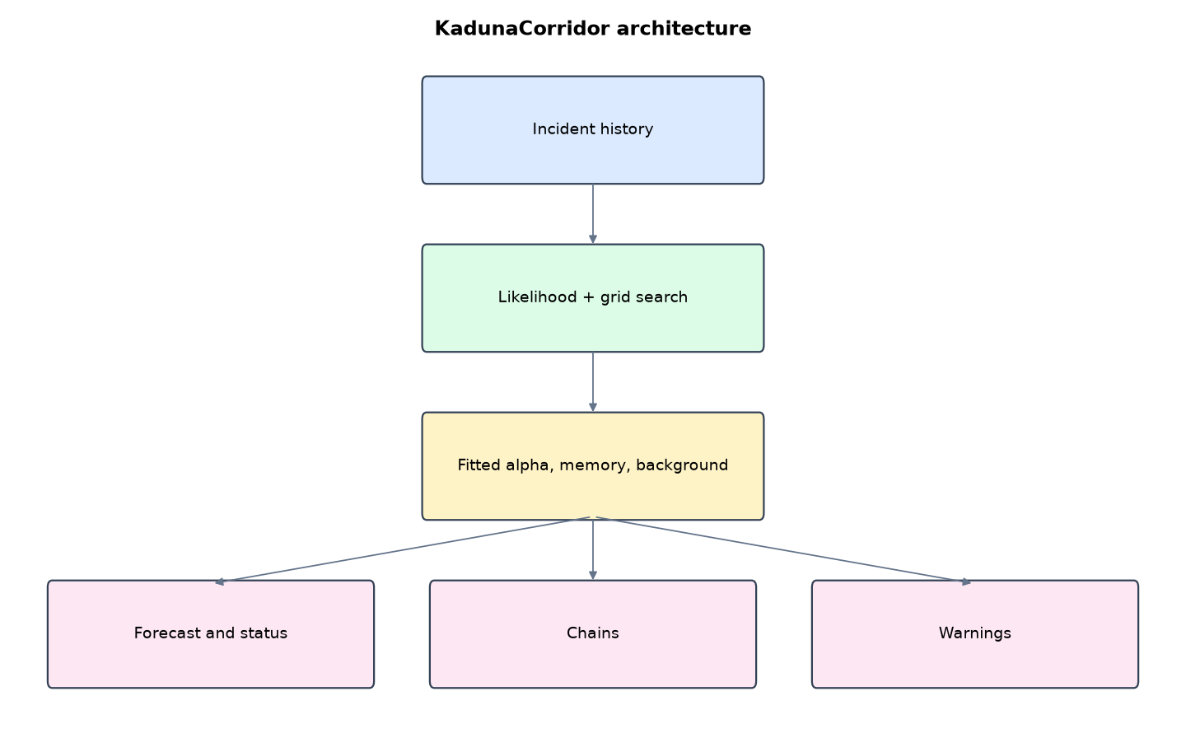
Figure 1: KadunaCorridor architecture (data flows from top to bottom)
Table 5: Software components
File | Responsibility
hawkes.py | Likelihood, fitting, simulation, forecast, chains
app.py | Flask app with SVG charts
geo.py | Geography and synthetic history
main.py / selftest.py | Commands and tests

The main design decisions, and how they differ from the earlier VarsityShield and Zaman Lafiya projects, are:
- Hawkes process with an exponential kernel: intensity = background + alpha x beta x sum of exp(-beta x time since each past event).
- Maximum likelihood fitting by grid search over the branching ratio alpha and memory 1/beta, with an O(n) recursive likelihood. Background rates per LGA use a closed-form estimate.
- Validated fitter: on data simulated with Ogata's thinning algorithm (alpha 0.5, memory 3 days) it recovered alpha 0.45 and memory 3.0 days.
- Held-out comparison with a plain Poisson model on the last 60 days.
- Escalation status: intensity at least 3x background = ESCALATING, with the probability of at least one more violent event in the next 7 days.
- Retaliation chains: violent events within 72 hours and 25 km of an earlier one are linked.
- Server-drawn SVG intensity charts for the four most elevated LGAs.

3.4 Security Design
Each threat considered is matched to the control that addresses it. Tests in Chapter Four exercise these controls.
Table 6: Threats and controls
Threat | Control in KadunaCorridor
Unauthorised refit with bad data | Only analysts can refit; CSRF token
Data exposure | Login required for every page
Brute force | Lockout
Clickjacking | X-Frame-Options DENY

3.5 Algorithms

3.5.1 Hawkes intensity
lambda(t) = mu + alpha x beta x sum over past events of exp(-beta (t - t_i)). alpha is the branching ratio (expected follow-ups per event); 1/beta is memory in days.

3.5.2 Likelihood
log L = sum log lambda(t_i) - integral of lambda over [0, T]. The excitation sum is computed recursively: A_i = exp(-beta (t_i - t_{i-1})) x (1 + A_{i-1}), so the cost is linear in the number of events.

3.5.3 Forecast
Expected events in the next 7 days = mu x 7 + alpha x sum (exp(-beta (T - t_i)) - exp(-beta (T + 7 - t_i))). P(at least one) = 1 - exp(-expected). Status is ESCALATING when lambda / mu >= 3.

3.6 Tools and Technologies
Language: Python 3.10 or newer. Storage: SQLite. Third-party packages: flask. Launchers: Windows batch files (1_SETUP, 2_START, 3_DEMO_MENU, 4_SELFTEST) and run.sh for Linux and macOS.

CHAPTER FOUR: IMPLEMENTATION, TESTING AND RESULTS

4.1 Implementation Environment
The system was developed and tested with Python 3.11 on Linux and is written to run unchanged on Windows 10/11. Its web interface runs at http://127.0.0.1:5205. Setup takes about ten minutes with 1_SETUP.bat; the README in the project folder gives every step and a defence demonstration script.

4.2 Operation and Demonstration
In Southern Kaduna one attack often triggers a reprisal, which triggers another. KadunaCorridor models that directly with a Hawkes self-exciting process: every violent event temporarily raises the chance of more events in the same LGA, and the boost fades over days. The system fits the model by maximum likelihood, shows each LGA's current intensity against its normal background, forecasts the next 7 days, and lists retaliation chains so mediators know which cycle to break.
Table 7: Demonstration scenario used for the defence
Step | Command (python main.py ...) | What is observed
Every LGA has a normal level of violence. | serve | Forecast table: mostly background, ratio near 1
How much does one attack provoke? | (Model page) | alpha about 0.25: each violent event triggers about a quarter of another; memory 5 days
An attack in Sanga, then two reprisals. | flare --lga Sanga | Sanga ESCALATING, about 6x background, 7-day risk jumps
Which cycle should mediators break? | (Retaliation chains page) | Chain of events linked within 72 h and 25 km
Is this better than counting? | fit | Held-out log-likelihood: Hawkes beats Poisson

4.3 Test Plan and Results
The automated test program ran 11 tests. 11 passed.
Table 8: Automated test results
# | Test | Result | Evidence
1 | Fitter recovers known parameters from simulated data (alpha 0.5, memory 3 days) | PASS | {'true_alpha': 0.5, 'fitted_alpha': 0.45, 'true_memory_days': 3, 'fitted_memory_days': 3.0, 'events': 769}
2 | Evenly spaced (non-clustered) events give a low branching ratio | PASS | 0.0
3 | Fitted on the history: retaliation present (alpha > 0) | PASS | {'alpha': 0.25, 'memory_days': 5.0, 'loglik': -674.71, 'n_train': 170, 'n_test': 23, 'test_loglik_hawkes': -101.15, 'tes
4 | Hawkes beats Poisson on held-out data (log-likelihood) | PASS | -101.15 vs -104.47
5 | Three linked attacks in Sanga raise its status to ESCALATING | PASS | ratio 1.01 -> 6.31
6 | 7-day risk rises after the flare | PASS | 0.146 -> 0.455
7 | One escalation warning issued for Sanga | PASS | ESCALATION WARNING Sanga: violence intensity is 6.31x its background level. Chance of at least one more violent event in
8 | No repeated warning within 24 h | PASS
9 | Retaliation chain detected around the Sanga flare | PASS | 3 chains, longest 4
10 | Forecast page renders with intensity charts | PASS
11 | Commander cannot refit the model | PASS

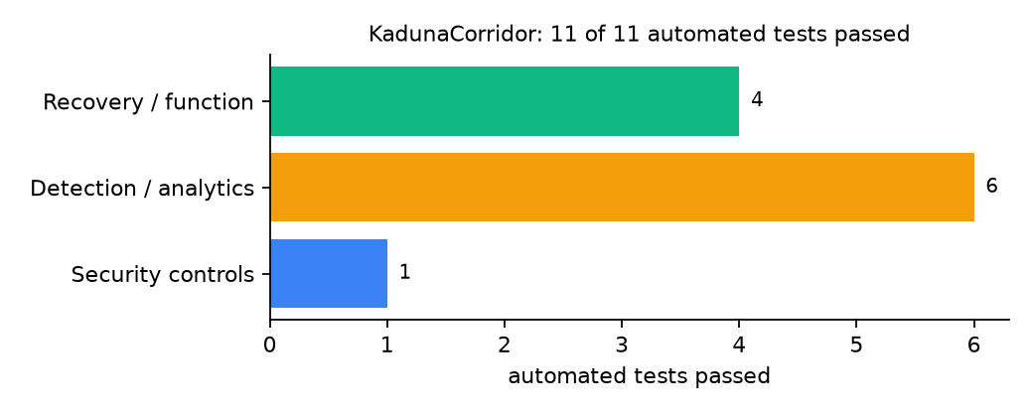
Figure 2: Automated tests by category

4.4 Measured Results
Table 9: Key measurements
Measure | Result
Fitted branching ratio alpha | 0.25
Fitted memory | 5.0 days
Held-out log-likelihood, Hawkes vs Poisson | -101.15 vs -104.47
Parameter recovery (true alpha 0.5, memory 3 d) | alpha 0.45, memory 3.0 d
Sanga 7-day probability before / after flare | 0.146 / 0.455
Longest retaliation chain | 4
Setup and fit time | 0.37 s

4.5 Discussion
The parameter-recovery test matters more than the forecast numbers: it shows the fitter finds alpha 0.45 and memory 3.0 days when the truth is 0.5 and 3. The held-out gain over Poisson is modest (3.3 log-likelihood units) on 23 events. Sharing alpha across LGAs keeps the model stable on little data but hides LGA differences.
Of the tests, 1 exercised security controls, 6 exercised detection or analytics, and 4 exercised recovery or core function.

CHAPTER FIVE: SUMMARY, CONCLUSION AND RECOMMENDATIONS

5.1 Summary
This project built KadunaCorridor for Kaduna State (12 LGAs including Jema'a, Kauru, Kajuru, Zangon Kataf, Kaura and Sanga). Its design combines maximum-likelihood fitting, escalation status, 7-day forecasts and retaliation chains. It met its objectives and passed all 11 automated tests.

5.2 Conclusion
KadunaCorridor shows that the security problem described in Chapter One can be addressed with free software and modest hardware, provided the design treats the warning data as something attackers will target. The limits stated in Section 1.4 still apply.

5.3 Recommendations
- Feed verified incidents from the state security council and NEMA.
- Review alpha and memory monthly.
- Use chains to brief traditional rulers and youth leaders.

5.4 Contribution to Knowledge
This project addresses the gap identified in Chapter Two: Self-exciting models appear in research on national data but not in tools for LGA-level farmer-herder early warning.

5.5 Suggestions for Further Work
- Spatial kernel linking neighbouring LGAs.
- Separate alpha per LGA with Bayesian shrinkage.

REFERENCES
Babatunde, A. O., & Ibnouf, F. O. (2024). The dynamics of herder-farmer conflicts in Plateau State, Nigeria, and Central Darfur State, Sudan. African Studies Review, 67(2), 321-350. https://doi.org/10.1017/asr.2024.45
Browning, R., Patten, H., Rousseau, J., & Mengersen, K. (2026). Bayesian spatiotemporal modelling of political violence and conflict events using discrete-time Hawkes processes. Journal of the Royal Statistical Society Series A. https://doi.org/10.1093/jrsssa/qnag039
Cicek, D., & Kantarci, B. (2023). Use of mobile crowdsensing in disaster management: A systematic review, challenges, and open issues. Sensors, 23(3), 1699. https://doi.org/10.3390/s23031699
Eke, O. G., et al. (2025). Climate-driven conflicts in Nigeria: Farmers' strategies for coping with herders' incursion on crop lands. Sustainability, 17(24), 11316. https://doi.org/10.3390/su172411316
Estefania-Salazar, E., & Iglesias, E. (2025). Assessing vegetation phenology dynamics in West African rangelands: Implications for livestock sustainability and transhumance. Ecological Informatics, 88.
Goodman, S., BenYishay, A., & Runfola, D. (2024). Spatiotemporal prediction of conflict fatality risk using convolutional neural networks and satellite imagery. Remote Sensing, 16(18), 3411. https://doi.org/10.3390/rs16183411
Kanagamalliga, S., et al. (2024). Integration of IoT for precision livestock monitoring through geofencing. In 2024 5th International Conference on Electronics and Sustainable Communication Systems (ICESC). IEEE.
Navarro, R., Saleh, L., & Owino, E. (2025). Pastoral conflict on the greener grass? Exploring the climate-conflict nexus in the Karamoja Cluster. International Journal of Disaster Risk Reduction.
Nnaji, A., Ma, W., Ratna, N., & Renwick, A. (2022). Farmer-herder conflicts and food insecurity: Evidence from rural Nigeria. Agricultural and Resource Economics Review.
Nwankwo, C. F. (2025). Perceptions of injustices in the struggle for scarce critical lands: Farmer-herder conflict and violence escalation in the Benue-Nasarawa borderland. World Development, 186, 106824.
Parlato, M. C. M., Valenti, F., & Porto, S. M. C. (2024). GIS-based methodology for tracking the grazing cattle site use. Heliyon, 10(13), e33166. https://doi.org/10.1016/j.heliyon.2024.e33166
Rochana, E., et al. (2024). The urgency of an early warning system for social conflict by using WhatsApp. International Journal of Innovative Research and Scientific Studies, 7(1), 107-114.
Ronoh, E. K., Mirau, S., & Dida, M. A. (2022). Human-wildlife conflict early warning system using the Internet of Things and short message service. Engineering, Technology & Applied Science Research.
Rød, E. G., Gåsste, T., & Hegre, H. (2024). A review and comparison of conflict early warning systems. International Journal of Forecasting, 40(1), 96-112.
Schwarz, M., Landmann, T., Jusselme, D., Zambrano, E., Danzeglocke, J., Siegert, F., & Franke, J. (2022). Assessing the environmental suitability for transhumance in support of conflict prevention in the Sahel. Remote Sensing, 14(5), 1109. https://doi.org/10.3390/rs14051109
Shimizu, K., et al. (2025). Piloting a mobile early warning alert and response system for East and Central Darfur, Sudan. International Health, 18(2), ihaf122.
Sola, L., Chen, Y., Murphy, S. K., & Subrahmanian, V. S. (2025). Quantifying the risk of pastoral conflict in 4 central African countries. EPJ Data Science, 14. https://doi.org/10.1140/epjds/s13688-025-00591-5
Tarif, K. (2022). Climate change and violent conflict in West Africa: Assessing the evidence (SIPRI Insights on Peace and Security). Stockholm International Peace Research Institute.

Standards and Legal Instruments Consulted
Federal Republic of Nigeria. (2023). Nigeria Data Protection Act, 2023. Nigeria Data Protection Commission.
International Organization for Standardization. (2022). ISO/IEC 27001:2022 Information security, cybersecurity and privacy protection: Information security management systems: Requirements. ISO.
National Institute of Standards and Technology. (2024). The NIST Cybersecurity Framework (CSF) 2.0 (NIST CSWP 29). NIST.

APPENDIX A: HOW TO RUN THE SYSTEM
- Copy the folder conflict-early-warning/B05-kaduna-corridor to the computer.
- Install Python 3.10 or newer with 'Add python.exe to PATH' ticked.
- Double-click 1_SETUP.bat, then 2_START.bat, and open http://127.0.0.1:5205.
- Use 3_DEMO_MENU.bat for the defence demonstration and 4_SELFTEST.bat to regenerate the results in Chapter Four.

APPENDIX B: SOURCE CODE STRUCTURE
Table 10: KadunaCorridor source files
File | Purpose
hawkes.py | Likelihood, fitting, simulation, forecast, chains
app.py | Flask app with SVG charts
geo.py | Geography and synthetic history
main.py / selftest.py | Commands and tests

APPENDIX C: CODE EXCERPT
The function loglik from hawkes.py, the heart of the design described in Section 3.5.
def loglik(ev, T, alpha, beta, mu=None):
"""Log-likelihood over [0, T] days. If mu is None, use the closed-form background estimate."""
total, mus = 0.0, {}
for g, times in ev.items():
comp = sum(1 - math.exp(-beta * (T - t)) for t in times)
m = mu[g] if mu else max((len(times) - alpha * comp) / T, 1e-4)
mus[g] = m
A = _excitation_sums(times, beta)
total += sum(math.log(m + alpha * beta * a) for a in A) - m * T - alpha * comp
return total, mus

