[NAME OF YOUR UNIVERSITY]
FACULTY OF [SCIENCE / COMPUTING]
DEPARTMENT OF COMPUTER SCIENCE
CMP 468: COMPUTER SECURITY (2 UNITS)
COURSE PROJECT REPORT
YOLASHIELD: USSD INCIDENT REPORTING WITH A SIGNED, TAMPER-EVIDENT LEDGER FOR ADAMAWA STATE
Three-language USSD menus, Merkle-rooted Ed25519 blocks, an outside witness and lawful erasure
BY
[FULL NAME]
MATRIC NO: [MATRIC NUMBER]
SUBMITTED TO
[COURSE LECTURER'S NAME]
IN PARTIAL FULFILMENT OF THE REQUIREMENTS OF CMP 468
400 LEVEL, SECOND SEMESTER, 2025/2026 SESSION
OCTOBER 2026

DECLARATION
I declare that this project report and the accompanying software were written by me as part of the requirements of CMP 468 (Computer Security). Every source used has been cited. All literature cited in this report was published between 2021 and 2026. All test results reported in Chapter Four were produced by the automated test program supplied with the software.
Signature: ____________________ Date: ____________________

ABSTRACT
Farmer-herder conflict in Nigeria destroys lives, livelihoods and food supply. Early warning helps only when it is timely, trusted and secure. This project designed, built and tested YolaShield for Adamawa State (12 LGAs including Numan, Demsa, Lamurde, Guyuk and Song). Its design combines three-language USSD menus, Merkle-rooted Ed25519 blocks, an outside witness and lawful erasure. The system was implemented in Python and evaluated with an automated test suite on synthetic data that follows documented conflict patterns, including attacks on the system itself. All 20 tests passed. Key measurements: Key presses for a Hausa report: 6; Longest screen: 139 characters; Ledger in test: 2 blocks, 8 records, verified: yes; Lamurde level after urgent reports: Severe (score 37.3). The results show the design works as specified; field validation with real data is the next step.
Keywords: early warning, farmer-herder conflict, GIS, information security, privacy, Nigeria, NDPA 2023.

TABLE OF CONTENTS
Right-click here and choose Update Field to build the table of contents.

CHAPTER ONE: INTRODUCTION

1.1 Background of the Study
In the Numan-Demsa-Lamurde axis many people have only basic phones with no data. Reports that do reach the authorities can be lost, changed or quietly deleted, which destroys trust in any warning system.
Nigerian farmer-herder conflict is driven by competition for land and water, changing herd mobility, weak institutions and perceived injustice. Early warning systems try to detect rising risk early enough for mediation, patrols or community action. They handle sensitive data (who reported what) and are themselves targets of manipulation, so they are a computer security problem as much as a data problem.

1.2 Statement of the Problem
- Smartphone apps exclude most rural callers.
- Reports can be altered or deleted without trace.
- Personal data on a ledger cannot be erased.
- Callers rarely hear back about risk in their area.

1.3 Aim and Objectives
The aim is to design, implement and evaluate YolaShield, a secure system for Adamawa State (12 LGAs including Numan, Demsa, Lamurde, Guyuk and Song). The objectives are to:
- offer a USSD menu in English, Hausa and Pidgin;
- fit every screen on a basic phone;
- fingerprint reports into signed, chained blocks;
- keep personal data off-chain and erasable;
- let callers hear their LGA alert level; protect the gateway endpoint.

1.4 Scope and Limitations
Simulated gateway; a real USSD code is leased through an aggregator. The system was tested on one computer; the README describes deployment on other computers.

1.5 Significance of the Study
YolaShield gives Adamawa State (12 LGAs including Numan, Demsa, Lamurde, Guyuk and Song) a free, auditable tool that runs on ordinary hardware, and turns CMP 468 topics into working controls. Its automated test suite lets any future maintainer prove that the controls still work.

1.6 Relation to the CMP 468 Course Outline
Table 1: Mapping of CMP 468 topics to YolaShield
CMP 468 topic | Where it appears in YolaShield
Overview of security in computing | Confidentiality of informants, integrity of reports and data, availability of alerts
Characteristics of computer intrusion | Forged reports, fake devices, replayed messages, tampered records
Types of security breaches | Disclosure of informant identity, falsified incident data, unauthorised access to case files
Classes of attacks | Impersonation, replay, injection, brute force, cross-site request forgery, disinformation
Methods of defence and controls | Table 3.2 maps each threat to its control
Data security: encryption and decryption | See Section 3.5
Database security | Parameterised SQL, role checks before every query, encrypted personal fields
Security policies and standards | NDPA 2023 (personal data of reporters), ISO/IEC 27001:2022 access control

CHAPTER TWO: LITERATURE REVIEW
This review covers only studies published from 2021 to 2026. Every source was checked against a publisher or index page.

2.1 Conceptual Framework
The study uses the early warning chain: collect signals, analyse risk, warn the right people, and respond. Each link has security needs: signals must be authentic, analysis must be on untampered data, warnings must reach people quickly, and the identities of informants must stay confidential.

2.2 Farmer-herder conflict in Nigeria and the region
Nnaji et al. (2022) surveyed 401 rural Nigerian households and found that both the incidence and the severity of farmer-herder conflict raise food insecurity, severity more so. Nwankwo (2025) showed from interviews in the Benue-Nasarawa borderland that perceived injustice drives escalation of farmer-herder violence. Babatunde and Ibnouf (2024) showed that officials, traditional rulers and security agents in Plateau State deepened conflict through unequal resource allocation and peacebuilding that favoured some groups. Eke et al. (2025) found Enugu farmers coping with herd incursions by farming in groups, reducing what they plant and preparing for crop loss, with falling income and productivity. Tarif (2022) reviewed the West African evidence and grouped climate-conflict links into four pathways, including changing pastoral mobility, while warning that the research base is thin. Together these studies explain why prevention must be local, fast and trusted by both farming and herding communities.

2.3 Conflict early warning systems and forecasting
Rød et al. (2024) compared conflict early warning systems on transparency, key parameters and forecasts, found weak access to data and code and large differences between systems, and called for shared standards. Goodman et al. (2024) predicted sub-national conflict-fatality risk in Nigeria from Landsat 8 imagery and ACLED data, with an average AUC above 0.75, but performance fell when the geography of conflict shifted. Sola et al. (2025) predicted pastoral conflict in Cameroon, Chad, the Central African Republic and the DRC from weather and terrain data (AUC 0.99 for Cameroon) and found that vegetation affects risk differently in each country. Browning et al. (2026) fitted a Bayesian spatiotemporal Hawkes process to ACLED events in South Asia, treating political violence as self-exciting (contagious) in space and time. Forecast accuracy matters, but so do transparency and whether the people at risk can act on the warning.

2.4 Environment, mobility and herd tracking
Schwarz et al. (2022) modelled environmental suitability for transhumance in Chad and the Central African Republic from Earth observation data, found most conflicts where suitability was high, and suggested combining herd tracking with satellite data for early warning along corridors. Estefania-Salazar and Iglesias (2025) analysed 250 m NDVI for 2003-2023 across 13 West African countries and found growing seasons shortening through a later start, with consequences for transhumance routes. Navarro et al. (2025) found in the Karamoja Cluster that vegetation data predicted pastoral conflict one month ahead better than rainfall, and that conflict clustered 'on the greener grass'. Parlato et al. (2024) tracked grazing cattle with low-power GPS collars and used heatmaps and kernel density estimation to find the areas animals use most. Kanagamalliga et al. (2024) used IoT collars with geofencing and temperature sensing for remote monitoring of livestock movement and health.

2.5 Community reporting and mobile alerting
Rochana et al. (2024) surveyed 267 villagers, found low public participation in conflict prevention, and proposed village-level early warning through WhatsApp groups. Cicek and Kantarci (2023) reviewed mobile crowdsensing for disasters and found most studies conceptual, with little testing in real incidents. Shimizu et al. (2025) describe the EWARS Mobile pilot in Darfur, whose offline reporting worked where network coverage was poor: 158 health facilities sent 752 weekly reports and the system was expanded to all Darfur states. Ronoh et al. (2022) built a low-cost early warning unit (motion sensor, GPS, camera, YOLO detection) that sends SMS alerts to response teams when animals approach a park border. Low-cost phones, SMS and offline-capable tools reach people that web dashboards miss.

2.6 Work Closest to This Design
Shimizu et al. (2025) show simple, offline-capable reporting working in Darfur; YolaShield uses USSD for the same reach. Rochana et al. (2024) rely on WhatsApp, which needs data. Rød et al. (2024) call for transparency; a ledger anyone can verify is a concrete step.

2.7 Summary of Reviewed Works and Research Gap
Table 2: Summary of reviewed works
Study | What it contributes
Babatunde (2024) | showed that officials, traditional rulers and security agents in Plateau State deepened conflict through unequal resource allocation and peacebuilding that favo
Browning (2026) | fitted a Bayesian spatiotemporal Hawkes process to ACLED events in South Asia, treating political violence as self-exciting (contagious) in space and time.
Cicek (2023) | reviewed mobile crowdsensing for disasters and found most studies conceptual, with little testing in real incidents.
Eke (2025) | found Enugu farmers coping with herd incursions by farming in groups, reducing what they plant and preparing for crop loss, with falling income and productivity
Estefania-Salazar (2025) | analysed 250 m NDVI for 2003-2023 across 13 West African countries and found growing seasons shortening through a later start, with consequences for transhumanc
Goodman (2024) | predicted sub-national conflict-fatality risk in Nigeria from Landsat 8 imagery and ACLED data, with an average AUC above 0.75, but performance fell when the ge
Kanagamalliga (2024) | used IoT collars with geofencing and temperature sensing for remote monitoring of livestock movement and health.
Navarro (2025) | found in the Karamoja Cluster that vegetation data predicted pastoral conflict one month ahead better than rainfall, and that conflict clustered 'on the greener
Nnaji (2022) | surveyed 401 rural Nigerian households and found that both the incidence and the severity of farmer-herder conflict raise food insecurity, severity more so.
Nwankwo (2025) | showed from interviews in the Benue-Nasarawa borderland that perceived injustice drives escalation of farmer-herder violence.
Parlato (2024) | tracked grazing cattle with low-power GPS collars and used heatmaps and kernel density estimation to find the areas animals use most.
Rochana (2024) | surveyed 267 villagers, found low public participation in conflict prevention, and proposed village-level early warning through WhatsApp groups.
Ronoh (2022) | built a low-cost early warning unit (motion sensor, GPS, camera, YOLO detection) that sends SMS alerts to response teams when animals approach a park border.
Rød (2024) | compared conflict early warning systems on transparency, key parameters and forecasts, found weak access to data and code and large differences between systems,
Schwarz (2022) | modelled environmental suitability for transhumance in Chad and the Central African Republic from Earth observation data, found most conflicts where suitability
Shimizu (2025) | describe the EWARS Mobile pilot in Darfur, whose offline reporting worked where network coverage was poor: 158 health facilities sent 752 weekly reports and the
Sola (2025) | predicted pastoral conflict in Cameroon, Chad, the Central African Republic and the DRC from weather and terrain data (AUC 0.99 for Cameroon) and found that veg
Tarif (2022) | reviewed the West African evidence and grouped climate-conflict links into four pathways, including changing pastoral mobility, while warning that the research

Research gap. Reviewed systems do not make collected reports tamper-evident to outsiders.

CHAPTER THREE: METHODOLOGY AND SYSTEM DESIGN

3.1 Research Methodology
The project follows Design Science Research: identify the problem, define objectives, design and build an artefact, demonstrate it, and evaluate it. Evaluation uses an automated test program (selftest.py) that resets the system, runs normal use, simulated attacks and failures, and records each outcome and measurement in results/selftest.json. Data are synthetic, generated to follow documented seasonal and retaliation patterns, so results show how the system behaves, not how accurate it would be in the field.

3.2 Requirements
Table 3: Functional requirements
# | Requirement
FR1 | USSD menu (report, alert level, advice, mediator)
FR2 | Idempotent submission per session
FR3 | Seal blocks every 5 reports or 10 minutes
FR4 | Verify chain against witness
FR5 | Erase personal data lawfully
FR6 | Phone simulator for staff

Table 4: Non-functional requirements
# | Requirement
NFR1 | Screens of 182 characters or fewer
NFR2 | Standard library server
NFR3 | Language packs as JSON

3.3 System Architecture
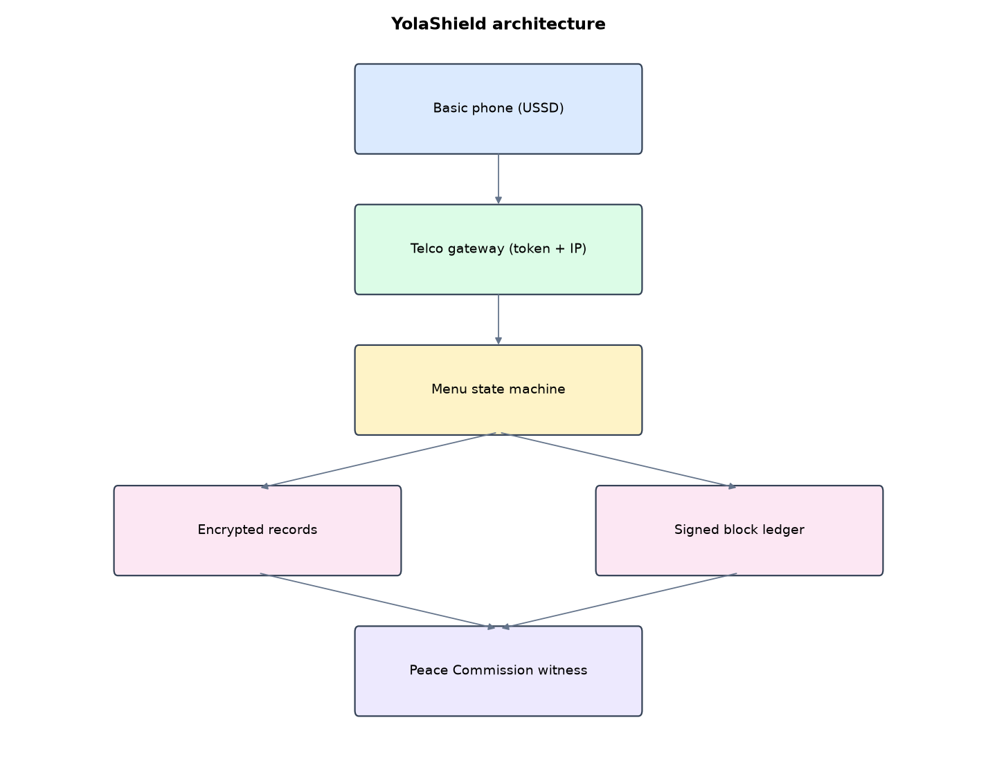
Figure 1: YolaShield architecture (data flows from top to bottom)
Table 5: Software components
File | Responsibility
ussd.py | Menu state machine
ledger.py | Records, blocks, Merkle, signatures, verification, erasure, risk
server.py | Gateway endpoint, simulator, staff pages
lang/ | Language packs
main.py / selftest.py | Commands and tests

The main design decisions, and how they differ from the earlier VarsityShield and Zaman Lafiya projects, are:
- USSD menu in Africa's Talking format (CON/END, cumulative text like 2*1*3*2*1*1). The menu is rebuilt from the path, so the server keeps no session state. A telco retry of the same session never duplicates a report.
- Three languages in editable JSON packs (lang/en.json, ha.json, pcm.json). A Fulfulde pack can be added by copying en.json.
- Every screen fits 182 characters for basic phones, with LGA lists paged 5 at a time.
- Tamper-evident ledger: blocks of report fingerprints with Merkle roots, previous-block hash links and Ed25519 signatures. Block hashes are copied to an outside witness file.
- Verification detects edited reports, deleted reports, deleted blocks and rewritten blocks.
- Privacy by design: phone numbers and details are Fernet-encrypted off-chain. Erasure on request keeps the chain valid.
- Gateway protection: shared token plus IP allow-list on the USSD endpoint. The phone simulator needs a staff session and CSRF token.

3.4 Security Design
Each threat considered is matched to the control that addresses it. Tests in Chapter Four exercise these controls.
Table 6: Threats and controls
Threat | Control in YolaShield
Report edited in database | Fingerprint mismatch
Report deleted | Sealed fingerprint has no record
Block rewritten | Signature and witness mismatch
Fake gateway | Token and IP allow-list
Telco retries | One report per session
Personal data kept forever | Off-chain, erasable records

3.5 Algorithms

3.5.1 Stateless USSD
The gateway sends all choices so far as '2*1*3*2*1*1'. Each request rebuilds the screen from that path, so the server keeps no session state and retries are harmless.

3.5.2 Block sealing
block = {height, time, previous hash, Merkle root, fingerprints}; hash = SHA-256(block); signature = Ed25519(block). The hash is appended to the witness file held by the Peace Commission.

3.5.3 Verification
Check heights, links, hashes against the witness, signatures and Merkle roots, then check every non-erased record's fingerprint and that every sealed fingerprint still has a record.

3.6 Tools and Technologies
Language: Python 3.10 or newer. Storage: SQLite. Third-party packages: cryptography. Launchers: Windows batch files (1_SETUP, 2_START, 3_DEMO_MENU, 4_SELFTEST) and run.sh for Linux and macOS.

CHAPTER FOUR: IMPLEMENTATION, TESTING AND RESULTS

4.1 Implementation Environment
The system was developed and tested with Python 3.11 on Linux and is written to run unchanged on Windows 10/11. Its web interface runs at http://127.0.0.1:5206. Setup takes about ten minutes with 1_SETUP.bat; the README in the project folder gives every step and a defence demonstration script.

4.2 Operation and Demonstration
YolaShield lets anyone with a basic phone, no data and no smartphone report an incident by dialling *347*22# in English, Hausa or Pidgin. Callers can also hear the alert level for their LGA, get safety advice, or ask for a mediator. Every report is fingerprinted into a hash-chained, Ed25519-signed ledger whose block hashes are also held by the State Peace Commission, so no official can quietly delete or change a report. Personal data stays outside the chain and can be lawfully erased.
Table 7: Demonstration scenario used for the defence
Step | Command (python main.py ...) | What is observed
A farmer in Lamurde has only a basic phone. | (Phone simulator page) | Dial, choose Hausa, report an attack in 6 key presses
Several callers report from Lamurde. | demo-calls | Calls run through the gateway; reports appear with refs
Reports are sealed. | seal | Ledger page: blocks with hashes, all checks green
An insider changes a report to hide it. | tamper | Ledger page turns red: content changed after sealing
Callers hear the alert level. | (simulator: 1, 2, Lamurde) | Alert level and advice in their language

4.3 Test Plan and Results
The automated test program ran 20 tests. 20 passed.
Table 8: Automated test results
# | Test | Result | Evidence
1 | Hausa caller reports an attack in Lamurde (6 key presses) | PASS | END An karbi rahoto YS00001. Na gode. Idan rai na cikin hatsari kira 112.
2 | Every screen fits a basic phone (182 characters or fewer) | PASS | 139
3 | Telco retry of the same session does not create a duplicate | PASS
4 | LGA list pages with 0 = more (English, Song on page 2) | PASS | CON Send report: Cattle in farm in Song?  1. Send  2. Cancel
5 | Second-page LGA stored correctly | PASS | Song
6 | Pidgin caller can cancel at the confirm step | PASS | END E don cancel. We no send anything.
7 | Invalid key press ends politely | PASS
8 | Caller can hear their LGA's alert level | PASS | END Lamurde: alert level Low. Normal activity.
9 | Mediation request accepted | PASS
10 | Reports sealed into signed blocks and the ledger verifies | PASS | {'blocks': 2, 'records': 8, 'ok': True, 'problems': []}
11 | Urgent attack reports raise Lamurde to High or Severe | PASS | {'score': 37.3, 'level': 'Severe'}
12 | Edited report detected (does not match its sealed fingerprint) | PASS | ['record YS00001: content changed after sealing']
13 | Deleted report detected | PASS | ['1 sealed report(s) deleted from the database']
14 | Ledger verifies again after the row is put back | PASS
15 | Rewritten block (without the signing key) fails signature and witness checks | PASS | ['block 1: hash differs from witness copy', 'block 1: bad signature', 'record YS00008: fingerprint not in ledger']
16 | Lawful erasure removes personal data but the ledger still verifies | PASS | {'erased': 'YS00003', 'reason': 'test'}
17 | Caller phone numbers not stored in plain text | PASS
18 | Gateway call with the wrong token refused | PASS
19 | Gateway call with the right token gets the language menu | PASS | CON YolaShield  1. English  2. Hausa  3. Pidgin
20 | Phone simulator needs a staff session | PASS

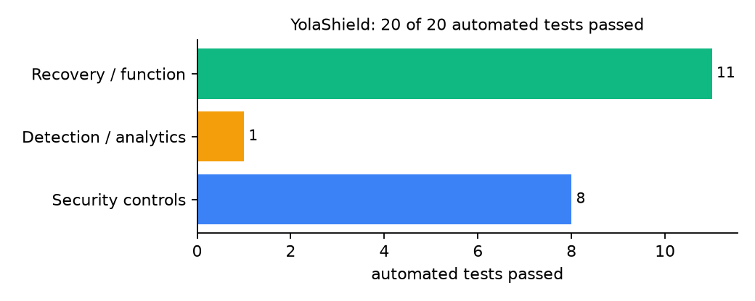
Figure 2: Automated tests by category

4.4 Measured Results
Table 9: Key measurements
Measure | Result
Key presses for a Hausa report | 6
Longest screen | 139 characters
Ledger in test | 2 blocks, 8 records, verified: yes
Lamurde level after urgent reports | Severe (score 37.3)

4.5 Discussion
The ledger proves integrity only if the witness copy is truly held elsewhere; a single administrator controlling both the database and the witness file could rewrite both. The Hausa and Pidgin texts were written for this project and need review by native speakers before use.
Of the tests, 8 exercised security controls, 1 exercised detection or analytics, and 11 exercised recovery or core function.

CHAPTER FIVE: SUMMARY, CONCLUSION AND RECOMMENDATIONS

5.1 Summary
This project built YolaShield for Adamawa State (12 LGAs including Numan, Demsa, Lamurde, Guyuk and Song). Its design combines three-language USSD menus, Merkle-rooted Ed25519 blocks, an outside witness and lawful erasure. It met its objectives and passed all 20 automated tests.

5.2 Conclusion
YolaShield shows that the security problem described in Chapter One can be addressed with free software and modest hardware, provided the design treats the warning data as something attackers will target. The limits stated in Section 1.4 still apply.

5.3 Recommendations
- Send each block hash to the Peace Commission by SMS or email automatically.
- Have native speakers review the language packs and add Fulfulde.
- Lease a short USSD code through a licensed aggregator.

5.4 Contribution to Knowledge
This project addresses the gap identified in Chapter Two: Reviewed systems do not make collected reports tamper-evident to outsiders.

5.5 Suggestions for Further Work
- Voice IVR for people who cannot read.
- Publish block hashes on a public web page.

REFERENCES
Babatunde, A. O., & Ibnouf, F. O. (2024). The dynamics of herder-farmer conflicts in Plateau State, Nigeria, and Central Darfur State, Sudan. African Studies Review, 67(2), 321-350. https://doi.org/10.1017/asr.2024.45
Browning, R., Patten, H., Rousseau, J., & Mengersen, K. (2026). Bayesian spatiotemporal modelling of political violence and conflict events using discrete-time Hawkes processes. Journal of the Royal Statistical Society Series A. https://doi.org/10.1093/jrsssa/qnag039
Cicek, D., & Kantarci, B. (2023). Use of mobile crowdsensing in disaster management: A systematic review, challenges, and open issues. Sensors, 23(3), 1699. https://doi.org/10.3390/s23031699
Eke, O. G., et al. (2025). Climate-driven conflicts in Nigeria: Farmers' strategies for coping with herders' incursion on crop lands. Sustainability, 17(24), 11316. https://doi.org/10.3390/su172411316
Estefania-Salazar, E., & Iglesias, E. (2025). Assessing vegetation phenology dynamics in West African rangelands: Implications for livestock sustainability and transhumance. Ecological Informatics, 88.
Goodman, S., BenYishay, A., & Runfola, D. (2024). Spatiotemporal prediction of conflict fatality risk using convolutional neural networks and satellite imagery. Remote Sensing, 16(18), 3411. https://doi.org/10.3390/rs16183411
Kanagamalliga, S., et al. (2024). Integration of IoT for precision livestock monitoring through geofencing. In 2024 5th International Conference on Electronics and Sustainable Communication Systems (ICESC). IEEE.
Navarro, R., Saleh, L., & Owino, E. (2025). Pastoral conflict on the greener grass? Exploring the climate-conflict nexus in the Karamoja Cluster. International Journal of Disaster Risk Reduction.
Nnaji, A., Ma, W., Ratna, N., & Renwick, A. (2022). Farmer-herder conflicts and food insecurity: Evidence from rural Nigeria. Agricultural and Resource Economics Review.
Nwankwo, C. F. (2025). Perceptions of injustices in the struggle for scarce critical lands: Farmer-herder conflict and violence escalation in the Benue-Nasarawa borderland. World Development, 186, 106824.
Parlato, M. C. M., Valenti, F., & Porto, S. M. C. (2024). GIS-based methodology for tracking the grazing cattle site use. Heliyon, 10(13), e33166. https://doi.org/10.1016/j.heliyon.2024.e33166
Rochana, E., et al. (2024). The urgency of an early warning system for social conflict by using WhatsApp. International Journal of Innovative Research and Scientific Studies, 7(1), 107-114.
Ronoh, E. K., Mirau, S., & Dida, M. A. (2022). Human-wildlife conflict early warning system using the Internet of Things and short message service. Engineering, Technology & Applied Science Research.
Rød, E. G., Gåsste, T., & Hegre, H. (2024). A review and comparison of conflict early warning systems. International Journal of Forecasting, 40(1), 96-112.
Schwarz, M., Landmann, T., Jusselme, D., Zambrano, E., Danzeglocke, J., Siegert, F., & Franke, J. (2022). Assessing the environmental suitability for transhumance in support of conflict prevention in the Sahel. Remote Sensing, 14(5), 1109. https://doi.org/10.3390/rs14051109
Shimizu, K., et al. (2025). Piloting a mobile early warning alert and response system for East and Central Darfur, Sudan. International Health, 18(2), ihaf122.
Sola, L., Chen, Y., Murphy, S. K., & Subrahmanian, V. S. (2025). Quantifying the risk of pastoral conflict in 4 central African countries. EPJ Data Science, 14. https://doi.org/10.1140/epjds/s13688-025-00591-5
Tarif, K. (2022). Climate change and violent conflict in West Africa: Assessing the evidence (SIPRI Insights on Peace and Security). Stockholm International Peace Research Institute.

Standards and Legal Instruments Consulted
Federal Republic of Nigeria. (2023). Nigeria Data Protection Act, 2023. Nigeria Data Protection Commission.
International Organization for Standardization. (2022). ISO/IEC 27001:2022 Information security, cybersecurity and privacy protection: Information security management systems: Requirements. ISO.
National Institute of Standards and Technology. (2024). The NIST Cybersecurity Framework (CSF) 2.0 (NIST CSWP 29). NIST.

APPENDIX A: HOW TO RUN THE SYSTEM
- Copy the folder conflict-early-warning/B06-adamawa-yolashield to the computer.
- Install Python 3.10 or newer with 'Add python.exe to PATH' ticked.
- Double-click 1_SETUP.bat, then 2_START.bat, and open http://127.0.0.1:5206.
- Use 3_DEMO_MENU.bat for the defence demonstration and 4_SELFTEST.bat to regenerate the results in Chapter Four.

APPENDIX B: SOURCE CODE STRUCTURE
Table 10: YolaShield source files
File | Purpose
ussd.py | Menu state machine
ledger.py | Records, blocks, Merkle, signatures, verification, erasure, risk
server.py | Gateway endpoint, simulator, staff pages
lang/ | Language packs
main.py / selftest.py | Commands and tests

APPENDIX C: CODE EXCERPT
The function seal_if_due from ledger.py, the heart of the design described in Section 3.5.
def seal_if_due(force=False):
c = geo.cfg()
with db() as con:
pending = con.execute("SELECT ref, ts, fingerprint FROM records WHERE block IS NULL ORDER BY ts").fetchall()
if not pending:
return None
if not force and len(pending) < c["block_size"] and time.time() - pending[0]["ts"] < c["block_seconds"]:
return None
with db() as con:
last = con.execute("SELECT * FROM blocks ORDER BY height DESC LIMIT 1").fetchone()
height = (last["height"] + 1) if last else 0
prev = last["hash"] if last else "0" * 64
items = [r["fingerprint"] for r in pending]
body = {"height": height, "ts": round(time.time(), 3), "prev": prev, "merkle": merkle(items), "items": items}
raw = json.dumps(body, sort_keys=True).encode()
h = hashlib.sha256(raw).hexdigest()
sk = serialization.load_pem_private_key(open(kpath("ledger_signing.pem"), "rb").read(), None)
sig = sk.sign(raw).hex()
with db() as con:
con.execute("INSERT INTO blocks VALUES(?,?,?,?,?,?,?)", (height, body["ts"], prev, body["merkle"], json.dumps(items), h, sig))
con.executemany("UPDATE records SET block=? WHERE ref=?", [(height, r["ref"]) for r in pending])
with open(os.path.join(DATA, "witness_peace_commission", "block_hashes.txt"), "a") as fh:
fh.write(f"{height} {h}\n")
return {"height": height, "hash": h, "items": len(items)}

