[NAME OF YOUR UNIVERSITY]
FACULTY OF [SCIENCE / COMPUTING]
DEPARTMENT OF COMPUTER SCIENCE
CMP 468: COMPUTER SECURITY (2 UNITS)
COURSE PROJECT REPORT
NIGERBASINWATCH: SEASONAL TRANSHUMANCE PRESSURE FORECASTING FROM VEGETATION AND RAINFALL DATA FOR NIGER STATE
An 8-week risk calendar with validated, fingerprinted environmental datasets
BY
[FULL NAME]
MATRIC NO: [MATRIC NUMBER]
SUBMITTED TO
[COURSE LECTURER'S NAME]
IN PARTIAL FULFILMENT OF THE REQUIREMENTS OF CMP 468
400 LEVEL, SECOND SEMESTER, 2025/2026 SESSION
OCTOBER 2026

DECLARATION
I declare that this project report and the accompanying software were written by me as part of the requirements of CMP 468 (Computer Security). Every source used has been cited. All literature cited in this report was published between 2021 and 2026. All test results reported in Chapter Four were produced by the automated test program supplied with the software.
Signature: ____________________ Date: ____________________

ABSTRACT
Farmer-herder conflict in Nigeria destroys lives, livelihoods and food supply. Early warning helps only when it is timely, trusted and secure. This project designed, built and tested NigerBasinWatch for Niger State (12 LGAs including Mokwa, Mariga, Rafi, Shiroro, Borgu and Agwara). Its design combines an 8-week risk calendar with validated, fingerprinted environmental datasets. The system was implemented in Python and evaluated with an automated test suite on synthetic data that follows documented conflict patterns, including attacks on the system itself. All 13 tests passed. Key measurements: Dataset rows imported: 2028; Calendar cells: 96; Spearman rho (simulation study): 0.321 over 432 LGA-months; Mean TPI: February / June / September: 0.026 / 0.381 / 0.507. The results show the design works as specified; field validation with real data is the next step.
Keywords: early warning, farmer-herder conflict, GIS, information security, privacy, Nigeria, NDPA 2023.

TABLE OF CONTENTS
Right-click here and choose Update Field to build the table of contents.

CHAPTER ONE: INTRODUCTION

1.1 Background of the Study
Niger State is Nigeria's largest by area and receives herds moving south from Sokoto, Kebbi and Zamfara and toward the Kainji and Jebba lakes. Estefania-Salazar and Iglesias (2025) show West African growing seasons shortening, which changes when herds move and when crops stand in their way.
Nigerian farmer-herder conflict is driven by competition for land and water, changing herd mobility, weak institutions and perceived injustice. Early warning systems try to detect rising risk early enough for mediation, patrols or community action. They handle sensitive data (who reported what) and are themselves targets of manipulation, so they are a computer security problem as much as a data problem.

1.2 Statement of the Problem
- Warnings come hours before violence, too late for planning.
- Satellite data are not used by state planners.
- Datasets can be altered without anyone noticing.
- No calendar tells planners when and where pressure will peak.

1.3 Aim and Objectives
The aim is to design, implement and evaluate NigerBasinWatch, a secure system for Niger State (12 LGAs including Mokwa, Mariga, Rafi, Shiroro, Borgu and Agwara). The objectives are to:
- build a Transhumance Pressure Index from northern dryness, local pull and crop exposure;
- forecast it 8 weeks ahead;
- validate and fingerprint every dataset;
- show a risk calendar and NDVI charts;
- test the pipeline with a simulation study.

1.4 Scope and Limitations
Synthetic NDVI, rainfall and incidents; the validation is a simulation study. The system was tested on one computer; the README describes deployment on other computers.

1.5 Significance of the Study
NigerBasinWatch gives Niger State (12 LGAs including Mokwa, Mariga, Rafi, Shiroro, Borgu and Agwara) a free, auditable tool that runs on ordinary hardware, and turns CMP 468 topics into working controls. Its automated test suite lets any future maintainer prove that the controls still work.

1.6 Relation to the CMP 468 Course Outline
Table 1: Mapping of CMP 468 topics to NigerBasinWatch
CMP 468 topic | Where it appears in NigerBasinWatch
Overview of security in computing | Confidentiality of informants, integrity of reports and data, availability of alerts
Characteristics of computer intrusion | Forged reports, fake devices, replayed messages, tampered records
Types of security breaches | Disclosure of informant identity, falsified incident data, unauthorised access to case files
Classes of attacks | Impersonation, replay, injection, brute force, cross-site request forgery, disinformation
Methods of defence and controls | Table 3.2 maps each threat to its control
Data security: encryption and decryption | See Section 3.5
Database security | Parameterised SQL, role checks before every query, encrypted personal fields
Security policies and standards | NDPA 2023 (personal data of reporters), ISO/IEC 27001:2022 access control

CHAPTER TWO: LITERATURE REVIEW
This review covers only studies published from 2021 to 2026. Every source was checked against a publisher or index page.

2.1 Conceptual Framework
The study uses the early warning chain: collect signals, analyse risk, warn the right people, and respond. Each link has security needs: signals must be authentic, analysis must be on untampered data, warnings must reach people quickly, and the identities of informants must stay confidential.

2.2 Farmer-herder conflict in Nigeria and the region
Nnaji et al. (2022) surveyed 401 rural Nigerian households and found that both the incidence and the severity of farmer-herder conflict raise food insecurity, severity more so. Nwankwo (2025) showed from interviews in the Benue-Nasarawa borderland that perceived injustice drives escalation of farmer-herder violence. Babatunde and Ibnouf (2024) showed that officials, traditional rulers and security agents in Plateau State deepened conflict through unequal resource allocation and peacebuilding that favoured some groups. Eke et al. (2025) found Enugu farmers coping with herd incursions by farming in groups, reducing what they plant and preparing for crop loss, with falling income and productivity. Tarif (2022) reviewed the West African evidence and grouped climate-conflict links into four pathways, including changing pastoral mobility, while warning that the research base is thin. Together these studies explain why prevention must be local, fast and trusted by both farming and herding communities.

2.3 Conflict early warning systems and forecasting
Rød et al. (2024) compared conflict early warning systems on transparency, key parameters and forecasts, found weak access to data and code and large differences between systems, and called for shared standards. Goodman et al. (2024) predicted sub-national conflict-fatality risk in Nigeria from Landsat 8 imagery and ACLED data, with an average AUC above 0.75, but performance fell when the geography of conflict shifted. Sola et al. (2025) predicted pastoral conflict in Cameroon, Chad, the Central African Republic and the DRC from weather and terrain data (AUC 0.99 for Cameroon) and found that vegetation affects risk differently in each country. Browning et al. (2026) fitted a Bayesian spatiotemporal Hawkes process to ACLED events in South Asia, treating political violence as self-exciting (contagious) in space and time. Forecast accuracy matters, but so do transparency and whether the people at risk can act on the warning.

2.4 Environment, mobility and herd tracking
Schwarz et al. (2022) modelled environmental suitability for transhumance in Chad and the Central African Republic from Earth observation data, found most conflicts where suitability was high, and suggested combining herd tracking with satellite data for early warning along corridors. Estefania-Salazar and Iglesias (2025) analysed 250 m NDVI for 2003-2023 across 13 West African countries and found growing seasons shortening through a later start, with consequences for transhumance routes. Navarro et al. (2025) found in the Karamoja Cluster that vegetation data predicted pastoral conflict one month ahead better than rainfall, and that conflict clustered 'on the greener grass'. Parlato et al. (2024) tracked grazing cattle with low-power GPS collars and used heatmaps and kernel density estimation to find the areas animals use most. Kanagamalliga et al. (2024) used IoT collars with geofencing and temperature sensing for remote monitoring of livestock movement and health.

2.5 Community reporting and mobile alerting
Rochana et al. (2024) surveyed 267 villagers, found low public participation in conflict prevention, and proposed village-level early warning through WhatsApp groups. Cicek and Kantarci (2023) reviewed mobile crowdsensing for disasters and found most studies conceptual, with little testing in real incidents. Shimizu et al. (2025) describe the EWARS Mobile pilot in Darfur, whose offline reporting worked where network coverage was poor: 158 health facilities sent 752 weekly reports and the system was expanded to all Darfur states. Ronoh et al. (2022) built a low-cost early warning unit (motion sensor, GPS, camera, YOLO detection) that sends SMS alerts to response teams when animals approach a park border. Low-cost phones, SMS and offline-capable tools reach people that web dashboards miss.

2.6 Work Closest to This Design
Schwarz et al. (2022) model environmental suitability for transhumance and link it to conflict; Navarro et al. (2025) find vegetation predicts pastoral conflict a month ahead; Sola et al. (2025) find vegetation effects differ by country. NigerBasinWatch combines northern push and local pull with the crop calendar and adds data provenance, which none of these address. Tarif (2022) warns the evidence base is thin, so the index must stay open to revision.

2.7 Summary of Reviewed Works and Research Gap
Table 2: Summary of reviewed works
Study | What it contributes
Babatunde (2024) | showed that officials, traditional rulers and security agents in Plateau State deepened conflict through unequal resource allocation and peacebuilding that favo
Browning (2026) | fitted a Bayesian spatiotemporal Hawkes process to ACLED events in South Asia, treating political violence as self-exciting (contagious) in space and time.
Cicek (2023) | reviewed mobile crowdsensing for disasters and found most studies conceptual, with little testing in real incidents.
Eke (2025) | found Enugu farmers coping with herd incursions by farming in groups, reducing what they plant and preparing for crop loss, with falling income and productivity
Estefania-Salazar (2025) | analysed 250 m NDVI for 2003-2023 across 13 West African countries and found growing seasons shortening through a later start, with consequences for transhumanc
Goodman (2024) | predicted sub-national conflict-fatality risk in Nigeria from Landsat 8 imagery and ACLED data, with an average AUC above 0.75, but performance fell when the ge
Kanagamalliga (2024) | used IoT collars with geofencing and temperature sensing for remote monitoring of livestock movement and health.
Navarro (2025) | found in the Karamoja Cluster that vegetation data predicted pastoral conflict one month ahead better than rainfall, and that conflict clustered 'on the greener
Nnaji (2022) | surveyed 401 rural Nigerian households and found that both the incidence and the severity of farmer-herder conflict raise food insecurity, severity more so.
Nwankwo (2025) | showed from interviews in the Benue-Nasarawa borderland that perceived injustice drives escalation of farmer-herder violence.
Parlato (2024) | tracked grazing cattle with low-power GPS collars and used heatmaps and kernel density estimation to find the areas animals use most.
Rochana (2024) | surveyed 267 villagers, found low public participation in conflict prevention, and proposed village-level early warning through WhatsApp groups.
Ronoh (2022) | built a low-cost early warning unit (motion sensor, GPS, camera, YOLO detection) that sends SMS alerts to response teams when animals approach a park border.
Rød (2024) | compared conflict early warning systems on transparency, key parameters and forecasts, found weak access to data and code and large differences between systems,
Schwarz (2022) | modelled environmental suitability for transhumance in Chad and the Central African Republic from Earth observation data, found most conflicts where suitability
Shimizu (2025) | describe the EWARS Mobile pilot in Darfur, whose offline reporting worked where network coverage was poor: 158 health facilities sent 752 weekly reports and the
Sola (2025) | predicted pastoral conflict in Cameroon, Chad, the Central African Republic and the DRC from weather and terrain data (AUC 0.99 for Cameroon) and found that veg
Tarif (2022) | reviewed the West African evidence and grouped climate-conflict links into four pathways, including changing pastoral mobility, while warning that the research

Research gap. Environmental conflict models in the reviewed work are research outputs; none is packaged as a planning calendar with data integrity controls.

CHAPTER THREE: METHODOLOGY AND SYSTEM DESIGN

3.1 Research Methodology
The project follows Design Science Research: identify the problem, define objectives, design and build an artefact, demonstrate it, and evaluate it. Evaluation uses an automated test program (selftest.py) that resets the system, runs normal use, simulated attacks and failures, and records each outcome and measurement in results/selftest.json. Data are synthetic, generated to follow documented seasonal and retaliation patterns, so results show how the system behaves, not how accurate it would be in the field.

3.2 Requirements
Table 3: Functional requirements
# | Requirement
FR1 | Import and validate NDVI/rainfall CSV
FR2 | Fingerprint and HMAC-seal each version
FR3 | Compute TPI history
FR4 | 8-week forecast and warnings
FR5 | Spearman validation
FR6 | Integrity warning on the calendar

Table 4: Non-functional requirements
# | Requirement
NFR1 | Analyst and planner roles
NFR2 | Files up to 2 MB

3.3 System Architecture
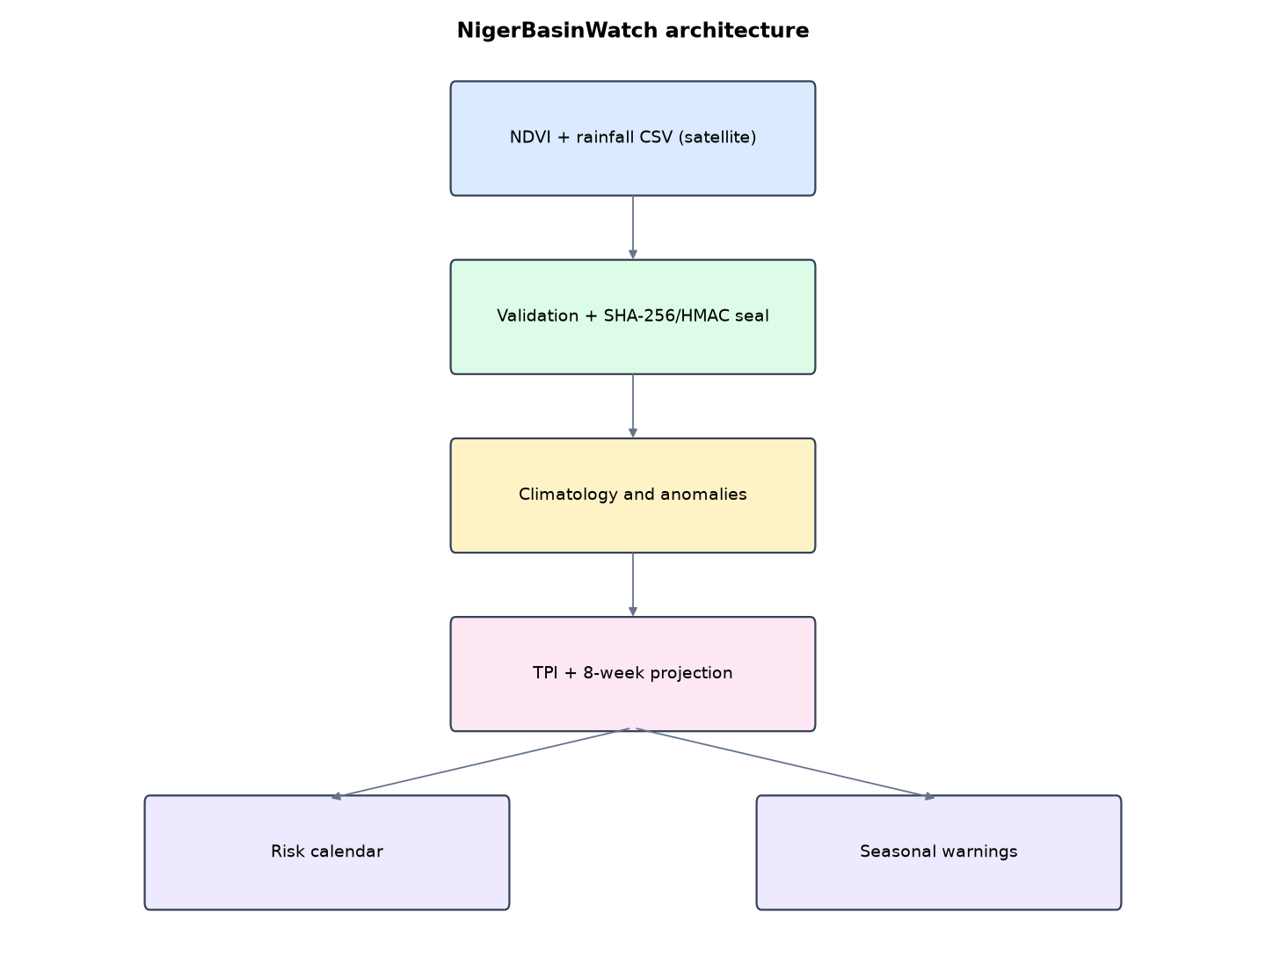
Figure 1: NigerBasinWatch architecture (data flows from top to bottom)
Table 5: Software components
File | Responsibility
tpi.py | Index, climatology, forecast, import and sealing, validation
app.py | Calendar heatmap, charts, dataset page
main.py / selftest.py | Commands, simulation, tests

The main design decisions, and how they differ from the earlier VarsityShield and Zaman Lafiya projects, are:
- Transhumance Pressure Index = sqrt(northern dryness) x local pull (pasture, water, route) x share of crops in the field.
- 8-week projection: current NDVI anomalies decay toward the weekly climatology (persistence 0.85 per week) while the crop calendar moves forward.
- Risk calendar heatmap (LGA x week) and per-LGA NDVI charts drawn as SVG.
- Validated dataset import: area names, ISO dates, NDVI range and rainfall range are checked. A file with more than 5% bad rows is refused.
- Data provenance: each dataset version's SHA-256 is sealed with HMAC. The calendar page shows a red integrity warning if any stored file or fingerprint record changes.
- Simulation-study validation with Spearman rank correlation between monthly TPI and incident counts.

3.4 Security Design
Each threat considered is matched to the control that addresses it. Tests in Chapter Four exercise these controls.
Table 6: Threats and controls
Threat | Control in NigerBasinWatch
Edited dataset file | SHA-256 mismatch shown on calendar
Forged fingerprint record | HMAC seal fails
Bad data (out of range, wrong area) | Row validation; file refused above 5% errors
Planner uploads data | Role check

3.5 Algorithms

3.5.1 Transhumance Pressure Index
push = clip(1 - NDVI_north / greenest-week NDVI_north); pull = 0.5 NDVI_local/max + 0.3 exp(-water km/40) + 0.2 exp(-route km/25); exposure = share of crops in field that month; TPI = clip(sqrt(push) x pull x exposure x 1.8, 0, 1).

3.5.2 Projection
Weekly climatology per area; current anomaly x 0.85^k added to climatology for week k = 1..8.

3.5.3 Spearman validation
Rank monthly mean TPI and monthly incident counts per LGA and compute the rank correlation.

3.6 Tools and Technologies
Language: Python 3.10 or newer. Storage: SQLite. Third-party packages: flask. Launchers: Windows batch files (1_SETUP, 2_START, 3_DEMO_MENU, 4_SELFTEST) and run.sh for Linux and macOS.

CHAPTER FOUR: IMPLEMENTATION, TESTING AND RESULTS

4.1 Implementation Environment
The system was developed and tested with Python 3.11 on Linux and is written to run unchanged on Windows 10/11. Its web interface runs at http://127.0.0.1:5207. Setup takes about ten minutes with 1_SETUP.bat; the README in the project folder gives every step and a defence demonstration script.

4.2 Operation and Demonstration
NigerBasinWatch works weeks ahead instead of hours ahead. It reads weekly vegetation (NDVI) and rainfall for each LGA and for the Sahel zone that herds come from, combines northern dryness, local pasture and water, stock routes and the crop calendar into a Transhumance Pressure Index, and projects it 8 weeks forward as a colour-coded calendar. Planners can then open routes, agree water-point timetables and place mediators before herds arrive. Every dataset version carries a sealed SHA-256 fingerprint, so a quietly edited file is caught before it misleads the forecast.
Table 7: Demonstration scenario used for the defence
Step | Command (python main.py ...) | What is observed
This is the next 8 weeks for Niger State. | serve | Calendar heatmap with TPI per LGA and week
Why is Mokwa red in week 4? | (click Mokwa) | Chart: Mokwa green but the northern source zone is drying
A new satellite week shows drought in the Sahel. | drought | Projected pressure rises in every LGA; seasonal warnings issued
Someone edits the NDVI file to hide the drought. | verify-data | File changed after import: the calendar shows a red integrity warning
Does TPI follow conflict? | validate | Spearman rho between monthly TPI and incidents

4.3 Test Plan and Results
The automated test program ran 13 tests. 13 passed.
Table 8: Automated test results
# | Test | Result | Evidence
1 | Three years of weekly NDVI and rainfall imported and fingerprinted | PASS | {'dataset_rows': 2028, 'sha256': '43b3a1fd00223e0c', 'incidents': 231, 'calendar_cells': 96}
2 | Spearman of identical rankings is 1 | PASS
3 | Simulation study: monthly TPI tracks incident counts (Spearman rho > 0.3) | PASS | {'lga_months': 432, 'spearman_rho': 0.321}
4 | Pressure is low in the heart of the dry season (Jan-Feb, few crops in field) | PASS | {1: 0.027, 2: 0.026, 3: 0.053, 4: 0.141, 5: 0.313, 6: 0.381, 7: 0.278, 8: 0.172, 9: 0.507, 10: 0.459, 11: 0.274, 12: 0.0
5 | 8-week calendar produced for every LGA | PASS | 96
6 | A northern drought week raises projected pressure in most LGAs | PASS | 12/12 LGAs higher
7 | Invalid dataset rejected with reasons (NDVI range, unknown area, bad date) | PASS | ['row 2: NDVI must be between -0.2 and 1', "row 3: unknown area 'Atlantis'", "row 4: time data '05/01/2026' does not mat
8 | All stored dataset files match their sealed fingerprints | PASS
9 | Edited dataset file detected before it can mislead the forecast | PASS | ['version 1: file changed after import']
10 | Forged fingerprint record detected (HMAC seal) | PASS
11 | Calendar page shows the integrity warning when data is tampered | PASS
12 | Planner cannot upload datasets | PASS
13 | LGA chart page renders | PASS

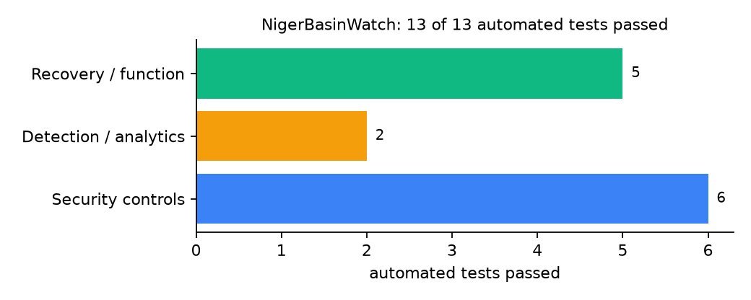
Figure 2: Automated tests by category

4.4 Measured Results
Table 9: Key measurements
Measure | Result
Dataset rows imported | 2028
Calendar cells | 96
Spearman rho (simulation study) | 0.321 over 432 LGA-months
Mean TPI: February / June / September | 0.026 / 0.381 / 0.507
LGAs with higher projected peak after drought week | 12 of 12

4.5 Discussion
Because incidents were simulated with pressure built in, rho = 0.32 says the pipeline recovers a signal, not that the index works in the field. The fingerprint test caught a real bug: Windows-style line endings were silently changed when files were written and read in text mode, which broke the hash. Writing with newline='' fixed it. The index peaks at the start and end of the rains, when herds and standing crops overlap.
Of the tests, 6 exercised security controls, 2 exercised detection or analytics, and 5 exercised recovery or core function.

CHAPTER FIVE: SUMMARY, CONCLUSION AND RECOMMENDATIONS

5.1 Summary
This project built NigerBasinWatch for Niger State (12 LGAs including Mokwa, Mariga, Rafi, Shiroro, Borgu and Agwara). Its design combines an 8-week risk calendar with validated, fingerprinted environmental datasets. It met its objectives and passed all 13 automated tests.

5.2 Conclusion
NigerBasinWatch shows that the security problem described in Chapter One can be addressed with free software and modest hardware, provided the design treats the warning data as something attackers will target. The limits stated in Section 1.4 still apply.

5.3 Recommendations
- Use real MODIS or Sentinel NDVI and CHIRPS rainfall.
- Validate against verified incidents before trusting the calendar.
- Share the calendar with the Niger State Ministry of Livestock each month.

5.4 Contribution to Knowledge
This project addresses the gap identified in Chapter Two: Environmental conflict models in the reviewed work are research outputs; none is packaged as a planning calendar with data integrity controls.

5.5 Suggestions for Further Work
- Learn index weights from data.
- Add herd-count estimates from veterinary records.

REFERENCES
Babatunde, A. O., & Ibnouf, F. O. (2024). The dynamics of herder-farmer conflicts in Plateau State, Nigeria, and Central Darfur State, Sudan. African Studies Review, 67(2), 321-350. https://doi.org/10.1017/asr.2024.45
Browning, R., Patten, H., Rousseau, J., & Mengersen, K. (2026). Bayesian spatiotemporal modelling of political violence and conflict events using discrete-time Hawkes processes. Journal of the Royal Statistical Society Series A. https://doi.org/10.1093/jrsssa/qnag039
Cicek, D., & Kantarci, B. (2023). Use of mobile crowdsensing in disaster management: A systematic review, challenges, and open issues. Sensors, 23(3), 1699. https://doi.org/10.3390/s23031699
Eke, O. G., et al. (2025). Climate-driven conflicts in Nigeria: Farmers' strategies for coping with herders' incursion on crop lands. Sustainability, 17(24), 11316. https://doi.org/10.3390/su172411316
Estefania-Salazar, E., & Iglesias, E. (2025). Assessing vegetation phenology dynamics in West African rangelands: Implications for livestock sustainability and transhumance. Ecological Informatics, 88.
Goodman, S., BenYishay, A., & Runfola, D. (2024). Spatiotemporal prediction of conflict fatality risk using convolutional neural networks and satellite imagery. Remote Sensing, 16(18), 3411. https://doi.org/10.3390/rs16183411
Kanagamalliga, S., et al. (2024). Integration of IoT for precision livestock monitoring through geofencing. In 2024 5th International Conference on Electronics and Sustainable Communication Systems (ICESC). IEEE.
Navarro, R., Saleh, L., & Owino, E. (2025). Pastoral conflict on the greener grass? Exploring the climate-conflict nexus in the Karamoja Cluster. International Journal of Disaster Risk Reduction.
Nnaji, A., Ma, W., Ratna, N., & Renwick, A. (2022). Farmer-herder conflicts and food insecurity: Evidence from rural Nigeria. Agricultural and Resource Economics Review.
Nwankwo, C. F. (2025). Perceptions of injustices in the struggle for scarce critical lands: Farmer-herder conflict and violence escalation in the Benue-Nasarawa borderland. World Development, 186, 106824.
Parlato, M. C. M., Valenti, F., & Porto, S. M. C. (2024). GIS-based methodology for tracking the grazing cattle site use. Heliyon, 10(13), e33166. https://doi.org/10.1016/j.heliyon.2024.e33166
Rochana, E., et al. (2024). The urgency of an early warning system for social conflict by using WhatsApp. International Journal of Innovative Research and Scientific Studies, 7(1), 107-114.
Ronoh, E. K., Mirau, S., & Dida, M. A. (2022). Human-wildlife conflict early warning system using the Internet of Things and short message service. Engineering, Technology & Applied Science Research.
Rød, E. G., Gåsste, T., & Hegre, H. (2024). A review and comparison of conflict early warning systems. International Journal of Forecasting, 40(1), 96-112.
Schwarz, M., Landmann, T., Jusselme, D., Zambrano, E., Danzeglocke, J., Siegert, F., & Franke, J. (2022). Assessing the environmental suitability for transhumance in support of conflict prevention in the Sahel. Remote Sensing, 14(5), 1109. https://doi.org/10.3390/rs14051109
Shimizu, K., et al. (2025). Piloting a mobile early warning alert and response system for East and Central Darfur, Sudan. International Health, 18(2), ihaf122.
Sola, L., Chen, Y., Murphy, S. K., & Subrahmanian, V. S. (2025). Quantifying the risk of pastoral conflict in 4 central African countries. EPJ Data Science, 14. https://doi.org/10.1140/epjds/s13688-025-00591-5
Tarif, K. (2022). Climate change and violent conflict in West Africa: Assessing the evidence (SIPRI Insights on Peace and Security). Stockholm International Peace Research Institute.

Standards and Legal Instruments Consulted
Federal Republic of Nigeria. (2023). Nigeria Data Protection Act, 2023. Nigeria Data Protection Commission.
International Organization for Standardization. (2022). ISO/IEC 27001:2022 Information security, cybersecurity and privacy protection: Information security management systems: Requirements. ISO.
National Institute of Standards and Technology. (2024). The NIST Cybersecurity Framework (CSF) 2.0 (NIST CSWP 29). NIST.

APPENDIX A: HOW TO RUN THE SYSTEM
- Copy the folder conflict-early-warning/B07-niger-basinwatch to the computer.
- Install Python 3.10 or newer with 'Add python.exe to PATH' ticked.
- Double-click 1_SETUP.bat, then 2_START.bat, and open http://127.0.0.1:5207.
- Use 3_DEMO_MENU.bat for the defence demonstration and 4_SELFTEST.bat to regenerate the results in Chapter Four.

APPENDIX B: SOURCE CODE STRUCTURE
Table 10: NigerBasinWatch source files
File | Purpose
tpi.py | Index, climatology, forecast, import and sealing, validation
app.py | Calendar heatmap, charts, dataset page
main.py / selftest.py | Commands, simulation, tests

APPENDIX C: CODE EXCERPT
The function tpi_value from tpi.py, the heart of the design described in Section 3.5.
def tpi_value(north_nd, north_peak, local_nd, local_max, month, static):
push = min(1.0, max(0.0, 1 - north_nd / north_peak)) if north_peak else 0
pull = 0.5 * local_nd / local_max + 0.3 * static[0] + 0.2 * static[1]
expo = geo.cfg()["crop_share_in_field"][str(month)]
return min(1.0, max(0.0, (push ** 0.5) * pull * expo * 1.8))

