[NAME OF YOUR UNIVERSITY]
FACULTY OF [SCIENCE / COMPUTING]
DEPARTMENT OF COMPUTER SCIENCE
CMP 468: COMPUTER SECURITY (2 UNITS)
COURSE PROJECT REPORT
KWARAHARMONY: EARLY RESPONSE AND MEDIATION CASE MANAGEMENT WITH ATTRIBUTE-BASED ACCESS CONTROL FOR KWARA STATE
A strict case workflow, SLA monitoring, relapse detection, encrypted field notes and a k-anonymous public export
BY
[FULL NAME]
MATRIC NO: [MATRIC NUMBER]
SUBMITTED TO
[COURSE LECTURER'S NAME]
IN PARTIAL FULFILMENT OF THE REQUIREMENTS OF CMP 468
400 LEVEL, SECOND SEMESTER, 2025/2026 SESSION
OCTOBER 2026

DECLARATION
I declare that this project report and the accompanying software were written by me as part of the requirements of CMP 468 (Computer Security). Every source used has been cited. All literature cited in this report was published between 2021 and 2026. All test results reported in Chapter Four were produced by the automated test program supplied with the software.
Signature: ____________________ Date: ____________________

ABSTRACT
Farmer-herder conflict in Nigeria destroys lives, livelihoods and food supply. Early warning helps only when it is timely, trusted and secure. This project designed, built and tested KwaraHarmony for Kwara State (12 LGAs including Baruten, Kaiama, Moro, Edu and Patigi). Its design combines a strict case workflow, SLA monitoring, relapse detection, encrypted field notes and a k-anonymous public export. The system was implemented in Python and evaluated with an automated test suite on synthetic data that follows documented conflict patterns, including attacks on the system itself. All 23 tests passed. Key measurements: Synthetic cases: 60; Median days to close: 54.0; SLA breaches in 3 days' time: 22; Export: 10 km grid, k = 3, 31 cases suppressed. The results show the design works as specified; field validation with real data is the next step.
Keywords: early warning, farmer-herder conflict, GIS, information security, privacy, Nigeria, NDPA 2023.

TABLE OF CONTENTS
Right-click here and choose Update Field to build the table of contents.

CHAPTER ONE: INTRODUCTION

1.1 Background of the Study
Kwara's northern LGAs border Benin Republic and Niger State and see seasonal herd movement. Peace committees and traditional rulers resolve many disputes, but follow-up is informal: agreements are not tracked, and when trouble returns nobody links it to the earlier case.
Nigerian farmer-herder conflict is driven by competition for land and water, changing herd mobility, weak institutions and perceived injustice. Early warning systems try to detect rising risk early enough for mediation, patrols or community action. They handle sensitive data (who reported what) and are themselves targets of manipulation, so they are a computer security problem as much as a data problem.

1.2 Statement of the Problem
- Warnings are not followed through to agreement and monitoring.
- Response deadlines are not measured.
- Sensitive mediation notes are visible to too many people.
- Sharing data with NGOs risks exposing families.

1.3 Aim and Objectives
The aim is to design, implement and evaluate KwaraHarmony, a secure system for Kwara State (12 LGAs including Baruten, Kaiama, Moro, Edu and Patigi). The objectives are to:
- enforce a case workflow with role-specific moves;
- measure service-level deadlines;
- detect relapses and reopen mediation;
- control access by role, LGA and assignment; encrypt notes per case;
- publish a privacy-preserving export.

1.4 Scope and Limitations
Synthetic cases and fictional mediators. The system was tested on one computer; the README describes deployment on other computers.

1.5 Significance of the Study
KwaraHarmony gives Kwara State (12 LGAs including Baruten, Kaiama, Moro, Edu and Patigi) a free, auditable tool that runs on ordinary hardware, and turns CMP 468 topics into working controls. Its automated test suite lets any future maintainer prove that the controls still work.

1.6 Relation to the CMP 468 Course Outline
Table 1: Mapping of CMP 468 topics to KwaraHarmony
CMP 468 topic | Where it appears in KwaraHarmony
Overview of security in computing | Confidentiality of informants, integrity of reports and data, availability of alerts
Characteristics of computer intrusion | Forged reports, fake devices, replayed messages, tampered records
Types of security breaches | Disclosure of informant identity, falsified incident data, unauthorised access to case files
Classes of attacks | Impersonation, replay, injection, brute force, cross-site request forgery, disinformation
Methods of defence and controls | Table 3.2 maps each threat to its control
Data security: encryption and decryption | See Section 3.5
Database security | Parameterised SQL, role checks before every query, encrypted personal fields
Security policies and standards | NDPA 2023 (personal data of reporters), ISO/IEC 27001:2022 access control

CHAPTER TWO: LITERATURE REVIEW
This review covers only studies published from 2021 to 2026. Every source was checked against a publisher or index page.

2.1 Conceptual Framework
The study uses the early warning chain: collect signals, analyse risk, warn the right people, and respond. Each link has security needs: signals must be authentic, analysis must be on untampered data, warnings must reach people quickly, and the identities of informants must stay confidential.

2.2 Farmer-herder conflict in Nigeria and the region
Nnaji et al. (2022) surveyed 401 rural Nigerian households and found that both the incidence and the severity of farmer-herder conflict raise food insecurity, severity more so. Nwankwo (2025) showed from interviews in the Benue-Nasarawa borderland that perceived injustice drives escalation of farmer-herder violence. Babatunde and Ibnouf (2024) showed that officials, traditional rulers and security agents in Plateau State deepened conflict through unequal resource allocation and peacebuilding that favoured some groups. Eke et al. (2025) found Enugu farmers coping with herd incursions by farming in groups, reducing what they plant and preparing for crop loss, with falling income and productivity. Tarif (2022) reviewed the West African evidence and grouped climate-conflict links into four pathways, including changing pastoral mobility, while warning that the research base is thin. Together these studies explain why prevention must be local, fast and trusted by both farming and herding communities.

2.3 Conflict early warning systems and forecasting
Rød et al. (2024) compared conflict early warning systems on transparency, key parameters and forecasts, found weak access to data and code and large differences between systems, and called for shared standards. Goodman et al. (2024) predicted sub-national conflict-fatality risk in Nigeria from Landsat 8 imagery and ACLED data, with an average AUC above 0.75, but performance fell when the geography of conflict shifted. Sola et al. (2025) predicted pastoral conflict in Cameroon, Chad, the Central African Republic and the DRC from weather and terrain data (AUC 0.99 for Cameroon) and found that vegetation affects risk differently in each country. Browning et al. (2026) fitted a Bayesian spatiotemporal Hawkes process to ACLED events in South Asia, treating political violence as self-exciting (contagious) in space and time. Forecast accuracy matters, but so do transparency and whether the people at risk can act on the warning.

2.4 Environment, mobility and herd tracking
Schwarz et al. (2022) modelled environmental suitability for transhumance in Chad and the Central African Republic from Earth observation data, found most conflicts where suitability was high, and suggested combining herd tracking with satellite data for early warning along corridors. Estefania-Salazar and Iglesias (2025) analysed 250 m NDVI for 2003-2023 across 13 West African countries and found growing seasons shortening through a later start, with consequences for transhumance routes. Navarro et al. (2025) found in the Karamoja Cluster that vegetation data predicted pastoral conflict one month ahead better than rainfall, and that conflict clustered 'on the greener grass'. Parlato et al. (2024) tracked grazing cattle with low-power GPS collars and used heatmaps and kernel density estimation to find the areas animals use most. Kanagamalliga et al. (2024) used IoT collars with geofencing and temperature sensing for remote monitoring of livestock movement and health.

2.5 Community reporting and mobile alerting
Rochana et al. (2024) surveyed 267 villagers, found low public participation in conflict prevention, and proposed village-level early warning through WhatsApp groups. Cicek and Kantarci (2023) reviewed mobile crowdsensing for disasters and found most studies conceptual, with little testing in real incidents. Shimizu et al. (2025) describe the EWARS Mobile pilot in Darfur, whose offline reporting worked where network coverage was poor: 158 health facilities sent 752 weekly reports and the system was expanded to all Darfur states. Ronoh et al. (2022) built a low-cost early warning unit (motion sensor, GPS, camera, YOLO detection) that sends SMS alerts to response teams when animals approach a park border. Low-cost phones, SMS and offline-capable tools reach people that web dashboards miss.

2.6 Work Closest to This Design
Babatunde and Ibnouf (2024) and Nwankwo (2025) show that how institutions handle disputes, and whether people see it as fair, shapes escalation. KwaraHarmony makes that handling visible and accountable. Rød et al. (2024) discuss warnings; this system covers the response that must follow.

2.7 Summary of Reviewed Works and Research Gap
Table 2: Summary of reviewed works
Study | What it contributes
Babatunde (2024) | showed that officials, traditional rulers and security agents in Plateau State deepened conflict through unequal resource allocation and peacebuilding that favo
Browning (2026) | fitted a Bayesian spatiotemporal Hawkes process to ACLED events in South Asia, treating political violence as self-exciting (contagious) in space and time.
Cicek (2023) | reviewed mobile crowdsensing for disasters and found most studies conceptual, with little testing in real incidents.
Eke (2025) | found Enugu farmers coping with herd incursions by farming in groups, reducing what they plant and preparing for crop loss, with falling income and productivity
Estefania-Salazar (2025) | analysed 250 m NDVI for 2003-2023 across 13 West African countries and found growing seasons shortening through a later start, with consequences for transhumanc
Goodman (2024) | predicted sub-national conflict-fatality risk in Nigeria from Landsat 8 imagery and ACLED data, with an average AUC above 0.75, but performance fell when the ge
Kanagamalliga (2024) | used IoT collars with geofencing and temperature sensing for remote monitoring of livestock movement and health.
Navarro (2025) | found in the Karamoja Cluster that vegetation data predicted pastoral conflict one month ahead better than rainfall, and that conflict clustered 'on the greener
Nnaji (2022) | surveyed 401 rural Nigerian households and found that both the incidence and the severity of farmer-herder conflict raise food insecurity, severity more so.
Nwankwo (2025) | showed from interviews in the Benue-Nasarawa borderland that perceived injustice drives escalation of farmer-herder violence.
Parlato (2024) | tracked grazing cattle with low-power GPS collars and used heatmaps and kernel density estimation to find the areas animals use most.
Rochana (2024) | surveyed 267 villagers, found low public participation in conflict prevention, and proposed village-level early warning through WhatsApp groups.
Ronoh (2022) | built a low-cost early warning unit (motion sensor, GPS, camera, YOLO detection) that sends SMS alerts to response teams when animals approach a park border.
Rød (2024) | compared conflict early warning systems on transparency, key parameters and forecasts, found weak access to data and code and large differences between systems,
Schwarz (2022) | modelled environmental suitability for transhumance in Chad and the Central African Republic from Earth observation data, found most conflicts where suitability
Shimizu (2025) | describe the EWARS Mobile pilot in Darfur, whose offline reporting worked where network coverage was poor: 158 health facilities sent 752 weekly reports and the
Sola (2025) | predicted pastoral conflict in Cameroon, Chad, the Central African Republic and the DRC from weather and terrain data (AUC 0.99 for Cameroon) and found that veg
Tarif (2022) | reviewed the West African evidence and grouped climate-conflict links into four pathways, including changing pastoral mobility, while warning that the research

Research gap. The reviewed early warning work stops at the warning; response tracking with privacy controls is missing.

CHAPTER THREE: METHODOLOGY AND SYSTEM DESIGN

3.1 Research Methodology
The project follows Design Science Research: identify the problem, define objectives, design and build an artefact, demonstrate it, and evaluate it. Evaluation uses an automated test program (selftest.py) that resets the system, runs normal use, simulated attacks and failures, and records each outcome and measurement in results/selftest.json. Data are synthetic, generated to follow documented seasonal and retaliation patterns, so results show how the system behaves, not how accurate it would be in the field.

3.2 Requirements
Table 3: Functional requirements
# | Requirement
FR1 | Workflow with allowed moves table
FR2 | Business rules for agreement and closure
FR3 | ABAC on every action, refusals logged
FR4 | Encrypted field notes
FR5 | Relapse detection
FR6 | SLA breaches
FR7 | LGA risk
FR8 | k-anonymous GeoJSON

Table 4: Non-functional requirements
# | Requirement
NFR1 | Six roles including auditor
NFR2 | No sign-in for the internal system account

3.3 System Architecture
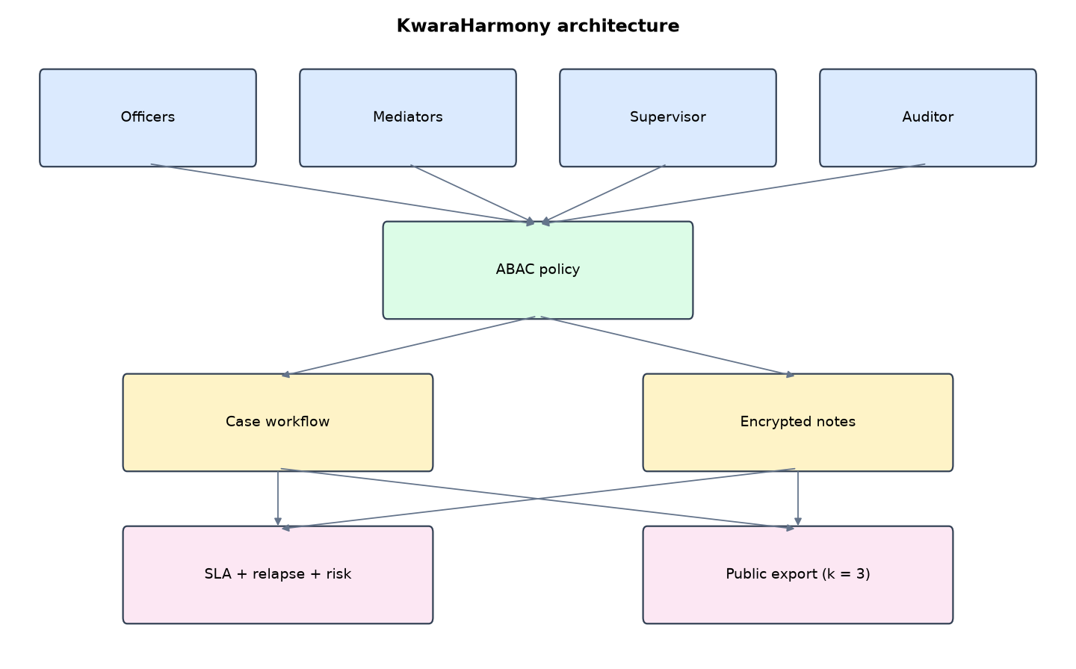
Figure 1: KwaraHarmony architecture (data flows from top to bottom)
Table 5: Software components
File | Responsibility
cases.py | Workflow, ABAC, notes encryption, relapse, SLA, risk, export
app.py | Flask app
main.py / selftest.py | Commands, synthetic history, tests

The main design decisions, and how they differ from the earlier VarsityShield and Zaman Lafiya projects, are:
- Workflow state machine with an explicit table of allowed moves and the roles allowed to make each one. Skipping a step is impossible.
- Business rules: an agreement needs written terms and a compensation figure. A case cannot close before 30 days of monitoring.
- Attribute-based access control (ABAC): decisions use the user's role, their LGAs, the case's LGA and whether they are the assigned mediator. Every refusal is logged.
- Per-case encryption of field notes with AES-256-GCM, keys derived by HKDF from a master key and the case number.
- Relapse detection: a new case in an LGA with an agreement under monitoring reopens mediation and alerts the supervisor.
- Service-level monitoring: verify within 24 h, assign within 48 h, first meeting within 7 days.
- Privacy-preserving GeoJSON export: locations snapped to a 10 km grid and cells with fewer than 3 cases suppressed (k-anonymity).

3.4 Security Design
Each threat considered is matched to the control that addresses it. Tests in Chapter Four exercise these controls.
Table 6: Threats and controls
Threat | Control in KwaraHarmony
Officer reads another LGA's cases | ABAC by LGA
Mediator acts on another's case | ABAC by assignment
Note disclosure | AES-256-GCM per case (HKDF key)
Re-identification from export | 10 km grid, k = 3 suppression
Skipping workflow steps | Allowed-move table
Probing for access | Every denial logged

3.5 Algorithms

3.5.1 ABAC decision
can(user, action, case) uses role, the user's LGAs, the case LGA and the assigned mediator. Moves also need the (from, to) pair to list the user's role.

3.5.2 Relapse rule
When a case opens in an LGA where another case is in monitoring, that case moves back to mediation and an alert asks the mediator to call both parties within 24 hours.

3.5.3 k-anonymous export
Each case is snapped to a 10 km grid cell (one longitude step per grid row). Cells with fewer than 3 cases are suppressed; published cells show counts and types only.

3.6 Tools and Technologies
Language: Python 3.10 or newer. Storage: SQLite. Third-party packages: flask, cryptography. Launchers: Windows batch files (1_SETUP, 2_START, 3_DEMO_MENU, 4_SELFTEST) and run.sh for Linux and macOS.

CHAPTER FOUR: IMPLEMENTATION, TESTING AND RESULTS

4.1 Implementation Environment
The system was developed and tested with Python 3.11 on Linux and is written to run unchanged on Windows 10/11. Its web interface runs at http://127.0.0.1:5208. Setup takes about ten minutes with 1_SETUP.bat; the README in the project folder gives every step and a defence demonstration script.

4.2 Operation and Demonstration
An early warning that nobody acts on prevents nothing. KwaraHarmony follows each incident from report to closure: verification, mediator assignment, mediation, written agreement, 30 days of monitoring, and closure. It flags missed response deadlines, treats a new incident during monitoring as a relapse that reopens mediation, and ranks LGAs by open cases and relapses. Officers only see their own LGAs, mediators only their own cases, field notes are encrypted per case, and the public map export cannot reveal any single family's location.
Table 7: Demonstration scenario used for the defence
Step | Command (python main.py ...) | What is observed
Sign in as officer_north. | serve | Only northern LGA cases are listed
Open a case and push it through the workflow. | (case page) | Each role sees only the moves it may make
The mediator writes a confidential note. | (case page, as mediator_aisha) | Note readable by her; mediator_tunde and the auditor are refused
Trouble returns in a community under monitoring. | relapse | Dashboard: RELAPSE alert, case back in mediation, LGA risk rises
Share data with NGOs safely. | export | Grid-snapped counts only; small cells suppressed

4.3 Test Plan and Results
The automated test program ran 23 tests. 23 passed.
Table 8: Automated test results
# | Test | Result | Evidence
1 | Synthetic case history loaded across the workflow | PASS | {'assigned': 5, 'closed': 5, 'mediation': 9, 'monitoring': 25, 'reported': 12, 'verified': 4}
2 | Officer cannot open a case outside their LGAs | PASS
3 | Workflow refuses skipping steps (reported -> mediation) | PASS
4 | Only a supervisor can assign a mediator | PASS
5 | Another mediator cannot act on the case | PASS
6 | Agreement needs terms and compensation | PASS
7 | Case cannot close before 30 days of monitoring | PASS
8 | Assigned mediator reads the encrypted notes | PASS
9 | Unassigned mediator cannot read notes | PASS
10 | Auditor cannot read notes | PASS
11 | Notes are not stored in plain text | PASS
12 | Officer sees only their own LGAs | PASS | {'Ekiti', 'Oyun', 'Isin', 'Asa', 'Ilorin East', 'Ilorin South'}
13 | Mediator sees only assigned cases | PASS
14 | New incident during monitoring reopens mediation and alerts (relapse) | PASS | RELAPSE in Baruten: new incident (case 62) while agreement of case 61 was being monitored. Mediation reopened; call both
15 | Relapse raises Baruten's risk score | PASS | {'open': 8, 'recent_30d': 3, 'relapses_90d': 4, 'score': 85, 'level': 'Severe'}
16 | SLA monitor flags the new unverified case after 24 h | PASS
17 | Public export publishes data, and every published cell has at least k=3 cases | PASS | 7 cells
18 | Public export accounts for every case (published + suppressed) | PASS | 62
19 | Exported points are grid centres, not real locations | PASS
20 | Every refused action is logged | PASS | 6
21 | Officer cannot open a case page in another LGA | PASS
22 | Officer cannot download the public export | PASS
23 | The internal 'system' account cannot sign in | PASS

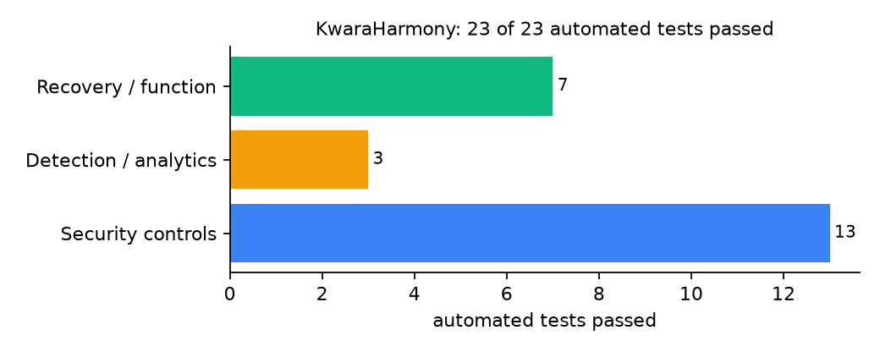
Figure 2: Automated tests by category

4.4 Measured Results
Table 9: Key measurements
Measure | Result
Synthetic cases | 60
Cases by state | assigned 5, closed 5, mediation 9, monitoring 25, reported 12, verified 4
Median days to close | 54.0
SLA breaches in 3 days' time | 22
Export | 10 km grid, k = 3, 31 cases suppressed
Refused actions logged | 6

4.5 Discussion
The export first used a 5 km grid and, because of a keying bug, published nothing at all. Fixing the bug and moving to 10 km published 7 cells while still suppressing small ones. This is the usual privacy-utility trade-off: a finer grid helps NGOs, a coarser one protects families.
Of the tests, 13 exercised security controls, 3 exercised detection or analytics, and 7 exercised recovery or core function.

CHAPTER FIVE: SUMMARY, CONCLUSION AND RECOMMENDATIONS

5.1 Summary
This project built KwaraHarmony for Kwara State (12 LGAs including Baruten, Kaiama, Moro, Edu and Patigi). Its design combines a strict case workflow, SLA monitoring, relapse detection, encrypted field notes and a k-anonymous public export. It met its objectives and passed all 23 automated tests.

5.2 Conclusion
KwaraHarmony shows that the security problem described in Chapter One can be addressed with free software and modest hardware, provided the design treats the warning data as something attackers will target. The limits stated in Section 1.4 still apply.

5.3 Recommendations
- Agree SLA targets with the State Peace Committee.
- Train mediators to write notes in the system, not on paper.
- Review the export grid with community leaders.

5.4 Contribution to Knowledge
This project addresses the gap identified in Chapter Two: The reviewed early warning work stops at the warning; response tracking with privacy controls is missing.

5.5 Suggestions for Further Work
- SMS reminders before SLA deadlines.
- Differential privacy for counts.

REFERENCES
Babatunde, A. O., & Ibnouf, F. O. (2024). The dynamics of herder-farmer conflicts in Plateau State, Nigeria, and Central Darfur State, Sudan. African Studies Review, 67(2), 321-350. https://doi.org/10.1017/asr.2024.45
Browning, R., Patten, H., Rousseau, J., & Mengersen, K. (2026). Bayesian spatiotemporal modelling of political violence and conflict events using discrete-time Hawkes processes. Journal of the Royal Statistical Society Series A. https://doi.org/10.1093/jrsssa/qnag039
Cicek, D., & Kantarci, B. (2023). Use of mobile crowdsensing in disaster management: A systematic review, challenges, and open issues. Sensors, 23(3), 1699. https://doi.org/10.3390/s23031699
Eke, O. G., et al. (2025). Climate-driven conflicts in Nigeria: Farmers' strategies for coping with herders' incursion on crop lands. Sustainability, 17(24), 11316. https://doi.org/10.3390/su172411316
Estefania-Salazar, E., & Iglesias, E. (2025). Assessing vegetation phenology dynamics in West African rangelands: Implications for livestock sustainability and transhumance. Ecological Informatics, 88.
Goodman, S., BenYishay, A., & Runfola, D. (2024). Spatiotemporal prediction of conflict fatality risk using convolutional neural networks and satellite imagery. Remote Sensing, 16(18), 3411. https://doi.org/10.3390/rs16183411
Kanagamalliga, S., et al. (2024). Integration of IoT for precision livestock monitoring through geofencing. In 2024 5th International Conference on Electronics and Sustainable Communication Systems (ICESC). IEEE.
Navarro, R., Saleh, L., & Owino, E. (2025). Pastoral conflict on the greener grass? Exploring the climate-conflict nexus in the Karamoja Cluster. International Journal of Disaster Risk Reduction.
Nnaji, A., Ma, W., Ratna, N., & Renwick, A. (2022). Farmer-herder conflicts and food insecurity: Evidence from rural Nigeria. Agricultural and Resource Economics Review.
Nwankwo, C. F. (2025). Perceptions of injustices in the struggle for scarce critical lands: Farmer-herder conflict and violence escalation in the Benue-Nasarawa borderland. World Development, 186, 106824.
Parlato, M. C. M., Valenti, F., & Porto, S. M. C. (2024). GIS-based methodology for tracking the grazing cattle site use. Heliyon, 10(13), e33166. https://doi.org/10.1016/j.heliyon.2024.e33166
Rochana, E., et al. (2024). The urgency of an early warning system for social conflict by using WhatsApp. International Journal of Innovative Research and Scientific Studies, 7(1), 107-114.
Ronoh, E. K., Mirau, S., & Dida, M. A. (2022). Human-wildlife conflict early warning system using the Internet of Things and short message service. Engineering, Technology & Applied Science Research.
Rød, E. G., Gåsste, T., & Hegre, H. (2024). A review and comparison of conflict early warning systems. International Journal of Forecasting, 40(1), 96-112.
Schwarz, M., Landmann, T., Jusselme, D., Zambrano, E., Danzeglocke, J., Siegert, F., & Franke, J. (2022). Assessing the environmental suitability for transhumance in support of conflict prevention in the Sahel. Remote Sensing, 14(5), 1109. https://doi.org/10.3390/rs14051109
Shimizu, K., et al. (2025). Piloting a mobile early warning alert and response system for East and Central Darfur, Sudan. International Health, 18(2), ihaf122.
Sola, L., Chen, Y., Murphy, S. K., & Subrahmanian, V. S. (2025). Quantifying the risk of pastoral conflict in 4 central African countries. EPJ Data Science, 14. https://doi.org/10.1140/epjds/s13688-025-00591-5
Tarif, K. (2022). Climate change and violent conflict in West Africa: Assessing the evidence (SIPRI Insights on Peace and Security). Stockholm International Peace Research Institute.

Standards and Legal Instruments Consulted
Federal Republic of Nigeria. (2023). Nigeria Data Protection Act, 2023. Nigeria Data Protection Commission.
International Organization for Standardization. (2022). ISO/IEC 27001:2022 Information security, cybersecurity and privacy protection: Information security management systems: Requirements. ISO.
National Institute of Standards and Technology. (2024). The NIST Cybersecurity Framework (CSF) 2.0 (NIST CSWP 29). NIST.

APPENDIX A: HOW TO RUN THE SYSTEM
- Copy the folder conflict-early-warning/B08-kwara-harmony to the computer.
- Install Python 3.10 or newer with 'Add python.exe to PATH' ticked.
- Double-click 1_SETUP.bat, then 2_START.bat, and open http://127.0.0.1:5208.
- Use 3_DEMO_MENU.bat for the defence demonstration and 4_SELFTEST.bat to regenerate the results in Chapter Four.

APPENDIX B: SOURCE CODE STRUCTURE
Table 10: KwaraHarmony source files
File | Purpose
cases.py | Workflow, ABAC, notes encryption, relapse, SLA, risk, export
app.py | Flask app
main.py / selftest.py | Commands, synthetic history, tests

APPENDIX C: CODE EXCERPT
The function can from cases.py, the heart of the design described in Section 3.5.
def can(u, action, case=None):
"""Attribute-based access decision. Returns True or False and records every denial."""
if u is None:
return False
r, mine = u["role"], (case is None or "*" in u["lgas"] or case["lga"] in u["lgas"])
if action == "view":
ok = r in ("supervisor", "auditor") or (r == "officer" and mine) or (r == "mediator" and case and case["mediator"] == u["name"])
elif action == "read_notes":
ok = r == "supervisor" or (r == "mediator" and case and case["mediator"] == u["name"]) or (r == "officer" and mine)
elif action == "add_note":
ok = r in ("officer", "mediator") and can(u, "read_notes", case)
elif action == "create":
ok = r in ("officer", "supervisor") and mine
elif action == "export_public":
ok = r in ("supervisor", "auditor")
elif action.startswith("move:"):
to = action[5:]
roles = MOVES.get((case["state"], to), set())
ok = r in roles and (r in ("supervisor", "system") or (r == "officer" and mine) or
(r == "mediator" and case["mediator"] == u["name"]))
else:
ok = False
if not ok:
with db() as con:
con.execute("INSERT INTO denied VALUES(?,?,?,?)", (time.time(), u["name"], action, case.get("id") if case else None))
return ok

