[NAME OF YOUR UNIVERSITY]
FACULTY OF [SCIENCE / COMPUTING]
DEPARTMENT OF COMPUTER SCIENCE
CMP 468: COMPUTER SECURITY (2 UNITS)
COURSE PROJECT REPORT
ZAMFARAGUARD: TRUST-WEIGHTED VERIFICATION OF CROWDSOURCED CONFLICT REPORTS AGAINST DISINFORMATION IN ZAMFARA STATE
Beta reputation, DBSCAN space-time clustering, noisy-OR credibility, Sybil caps and copy-paste flood detection
BY
[FULL NAME]
MATRIC NO: [MATRIC NUMBER]
SUBMITTED TO
[COURSE LECTURER'S NAME]
IN PARTIAL FULFILMENT OF THE REQUIREMENTS OF CMP 468
400 LEVEL, SECOND SEMESTER, 2025/2026 SESSION
OCTOBER 2026

DECLARATION
I declare that this project report and the accompanying software were written by me as part of the requirements of CMP 468 (Computer Security). Every source used has been cited. All literature cited in this report was published between 2021 and 2026. All test results reported in Chapter Four were produced by the automated test program supplied with the software.
Signature: ____________________ Date: ____________________

ABSTRACT
Farmer-herder conflict in Nigeria destroys lives, livelihoods and food supply. Early warning helps only when it is timely, trusted and secure. This project designed, built and tested ZamfaraGuard for Zamfara State (12 LGAs including Gusau, Maru, Anka, Tsafe and Zurmi). Its design combines beta reputation, DBSCAN space-time clustering, noisy-OR credibility, Sybil caps and copy-paste flood detection. The system was implemented in Python and evaluated with an automated test suite on synthetic data that follows documented conflict patterns, including attacks on the system itself. All 15 tests passed. Key measurements: Mean trust: reliable / unreliable informants: 0.871 / 0.112; Maru (3 trusted informants): credibility 0.998, probable; Gusau (6 new numbers, copy-paste): credibility 0.3, watch; Anka (one unknown reporter): credibility 0.5, watch. The results show the design works as specified; field validation with real data is the next step.
Keywords: early warning, farmer-herder conflict, GIS, information security, privacy, Nigeria, NDPA 2023.

TABLE OF CONTENTS
Right-click here and choose Update Field to build the table of contents.

CHAPTER ONE: INTRODUCTION

1.1 Background of the Study
Zamfara has suffered cattle rustling and rural attacks. In such settings rumours spread fast, and a false message can provoke real reprisals. An open reporting line is both necessary and a target.
Nigerian farmer-herder conflict is driven by competition for land and water, changing herd mobility, weak institutions and perceived injustice. Early warning systems try to detect rising risk early enough for mediation, patrols or community action. They handle sensitive data (who reported what) and are themselves targets of manipulation, so they are a computer security problem as much as a data problem.

1.2 Statement of the Problem
- False reports trigger needless deployments or reprisals.
- Coordinated rumours use many fresh SIM cards.
- Repeated reports from one person look like confirmation.
- Reporters fear being identified.

1.3 Aim and Objectives
The aim is to design, implement and evaluate ZamfaraGuard, a secure system for Zamfara State (12 LGAs including Gusau, Maru, Anka, Tsafe and Zurmi). The objectives are to:
- learn reporter reliability from verified outcomes;
- cluster reports of one event in space and time;
- combine independent sources, capping new reporters;
- flag copy-paste floods;
- apply a two-source rule before dispatch;
- keep reporters pseudonymous.

1.4 Scope and Limitations
Synthetic reports and verdicts; thresholds need tuning on real data. The system was tested on one computer; the README describes deployment on other computers.

1.5 Significance of the Study
ZamfaraGuard gives Zamfara State (12 LGAs including Gusau, Maru, Anka, Tsafe and Zurmi) a free, auditable tool that runs on ordinary hardware, and turns CMP 468 topics into working controls. Its automated test suite lets any future maintainer prove that the controls still work.

1.6 Relation to the CMP 468 Course Outline
Table 1: Mapping of CMP 468 topics to ZamfaraGuard
CMP 468 topic | Where it appears in ZamfaraGuard
Overview of security in computing | Confidentiality of informants, integrity of reports and data, availability of alerts
Characteristics of computer intrusion | Forged reports, fake devices, replayed messages, tampered records
Types of security breaches | Disclosure of informant identity, falsified incident data, unauthorised access to case files
Classes of attacks | Impersonation, replay, injection, brute force, cross-site request forgery, disinformation
Methods of defence and controls | Table 3.2 maps each threat to its control
Data security: encryption and decryption | See Section 3.5
Database security | Parameterised SQL, role checks before every query, encrypted personal fields
Security policies and standards | NDPA 2023 (personal data of reporters), ISO/IEC 27001:2022 access control

CHAPTER TWO: LITERATURE REVIEW
This review covers only studies published from 2021 to 2026. Every source was checked against a publisher or index page.

2.1 Conceptual Framework
The study uses the early warning chain: collect signals, analyse risk, warn the right people, and respond. Each link has security needs: signals must be authentic, analysis must be on untampered data, warnings must reach people quickly, and the identities of informants must stay confidential.

2.2 Farmer-herder conflict in Nigeria and the region
Nnaji et al. (2022) surveyed 401 rural Nigerian households and found that both the incidence and the severity of farmer-herder conflict raise food insecurity, severity more so. Nwankwo (2025) showed from interviews in the Benue-Nasarawa borderland that perceived injustice drives escalation of farmer-herder violence. Babatunde and Ibnouf (2024) showed that officials, traditional rulers and security agents in Plateau State deepened conflict through unequal resource allocation and peacebuilding that favoured some groups. Eke et al. (2025) found Enugu farmers coping with herd incursions by farming in groups, reducing what they plant and preparing for crop loss, with falling income and productivity. Tarif (2022) reviewed the West African evidence and grouped climate-conflict links into four pathways, including changing pastoral mobility, while warning that the research base is thin. Together these studies explain why prevention must be local, fast and trusted by both farming and herding communities.

2.3 Conflict early warning systems and forecasting
Rød et al. (2024) compared conflict early warning systems on transparency, key parameters and forecasts, found weak access to data and code and large differences between systems, and called for shared standards. Goodman et al. (2024) predicted sub-national conflict-fatality risk in Nigeria from Landsat 8 imagery and ACLED data, with an average AUC above 0.75, but performance fell when the geography of conflict shifted. Sola et al. (2025) predicted pastoral conflict in Cameroon, Chad, the Central African Republic and the DRC from weather and terrain data (AUC 0.99 for Cameroon) and found that vegetation affects risk differently in each country. Browning et al. (2026) fitted a Bayesian spatiotemporal Hawkes process to ACLED events in South Asia, treating political violence as self-exciting (contagious) in space and time. Forecast accuracy matters, but so do transparency and whether the people at risk can act on the warning.

2.4 Environment, mobility and herd tracking
Schwarz et al. (2022) modelled environmental suitability for transhumance in Chad and the Central African Republic from Earth observation data, found most conflicts where suitability was high, and suggested combining herd tracking with satellite data for early warning along corridors. Estefania-Salazar and Iglesias (2025) analysed 250 m NDVI for 2003-2023 across 13 West African countries and found growing seasons shortening through a later start, with consequences for transhumance routes. Navarro et al. (2025) found in the Karamoja Cluster that vegetation data predicted pastoral conflict one month ahead better than rainfall, and that conflict clustered 'on the greener grass'. Parlato et al. (2024) tracked grazing cattle with low-power GPS collars and used heatmaps and kernel density estimation to find the areas animals use most. Kanagamalliga et al. (2024) used IoT collars with geofencing and temperature sensing for remote monitoring of livestock movement and health.

2.5 Community reporting and mobile alerting
Rochana et al. (2024) surveyed 267 villagers, found low public participation in conflict prevention, and proposed village-level early warning through WhatsApp groups. Cicek and Kantarci (2023) reviewed mobile crowdsensing for disasters and found most studies conceptual, with little testing in real incidents. Shimizu et al. (2025) describe the EWARS Mobile pilot in Darfur, whose offline reporting worked where network coverage was poor: 158 health facilities sent 752 weekly reports and the system was expanded to all Darfur states. Ronoh et al. (2022) built a low-cost early warning unit (motion sensor, GPS, camera, YOLO detection) that sends SMS alerts to response teams when animals approach a park border. Low-cost phones, SMS and offline-capable tools reach people that web dashboards miss.

2.6 Work Closest to This Design
Cicek and Kantarci (2023) note that crowdsensing studies rarely test real incidents; ZamfaraGuard tests the specific failure of false and coordinated reports. Rochana et al. (2024) encourage participation; ZamfaraGuard adds the credibility layer such participation needs.

2.7 Summary of Reviewed Works and Research Gap
Table 2: Summary of reviewed works
Study | What it contributes
Babatunde (2024) | showed that officials, traditional rulers and security agents in Plateau State deepened conflict through unequal resource allocation and peacebuilding that favo
Browning (2026) | fitted a Bayesian spatiotemporal Hawkes process to ACLED events in South Asia, treating political violence as self-exciting (contagious) in space and time.
Cicek (2023) | reviewed mobile crowdsensing for disasters and found most studies conceptual, with little testing in real incidents.
Eke (2025) | found Enugu farmers coping with herd incursions by farming in groups, reducing what they plant and preparing for crop loss, with falling income and productivity
Estefania-Salazar (2025) | analysed 250 m NDVI for 2003-2023 across 13 West African countries and found growing seasons shortening through a later start, with consequences for transhumanc
Goodman (2024) | predicted sub-national conflict-fatality risk in Nigeria from Landsat 8 imagery and ACLED data, with an average AUC above 0.75, but performance fell when the ge
Kanagamalliga (2024) | used IoT collars with geofencing and temperature sensing for remote monitoring of livestock movement and health.
Navarro (2025) | found in the Karamoja Cluster that vegetation data predicted pastoral conflict one month ahead better than rainfall, and that conflict clustered 'on the greener
Nnaji (2022) | surveyed 401 rural Nigerian households and found that both the incidence and the severity of farmer-herder conflict raise food insecurity, severity more so.
Nwankwo (2025) | showed from interviews in the Benue-Nasarawa borderland that perceived injustice drives escalation of farmer-herder violence.
Parlato (2024) | tracked grazing cattle with low-power GPS collars and used heatmaps and kernel density estimation to find the areas animals use most.
Rochana (2024) | surveyed 267 villagers, found low public participation in conflict prevention, and proposed village-level early warning through WhatsApp groups.
Ronoh (2022) | built a low-cost early warning unit (motion sensor, GPS, camera, YOLO detection) that sends SMS alerts to response teams when animals approach a park border.
Rød (2024) | compared conflict early warning systems on transparency, key parameters and forecasts, found weak access to data and code and large differences between systems,
Schwarz (2022) | modelled environmental suitability for transhumance in Chad and the Central African Republic from Earth observation data, found most conflicts where suitability
Shimizu (2025) | describe the EWARS Mobile pilot in Darfur, whose offline reporting worked where network coverage was poor: 158 health facilities sent 752 weekly reports and the
Sola (2025) | predicted pastoral conflict in Cameroon, Chad, the Central African Republic and the DRC from weather and terrain data (AUC 0.99 for Cameroon) and found that veg
Tarif (2022) | reviewed the West African evidence and grouped climate-conflict links into four pathways, including changing pastoral mobility, while warning that the research

Research gap. Reviewed community reporting systems trust reports equally; none models reporter reliability or coordinated disinformation.

CHAPTER THREE: METHODOLOGY AND SYSTEM DESIGN

3.1 Research Methodology
The project follows Design Science Research: identify the problem, define objectives, design and build an artefact, demonstrate it, and evaluate it. Evaluation uses an automated test program (selftest.py) that resets the system, runs normal use, simulated attacks and failures, and records each outcome and measurement in results/selftest.json. Data are synthetic, generated to follow documented seasonal and retaliation patterns, so results show how the system behaves, not how accurate it would be in the field.

3.2 Requirements
Table 3: Functional requirements
# | Requirement
FR1 | Pseudonymous reporters
FR2 | Beta reputation from verdicts
FR3 | DBSCAN clustering
FR4 | Noisy-OR with new-reporter cap
FR5 | Flood flag
FR6 | Two-source dispatch rule
FR7 | Verifier verdicts
FR8 | Map

Table 4: Non-functional requirements
# | Requirement
NFR1 | Verifier and analyst roles
NFR2 | 4 reports per number per hour

3.3 System Architecture
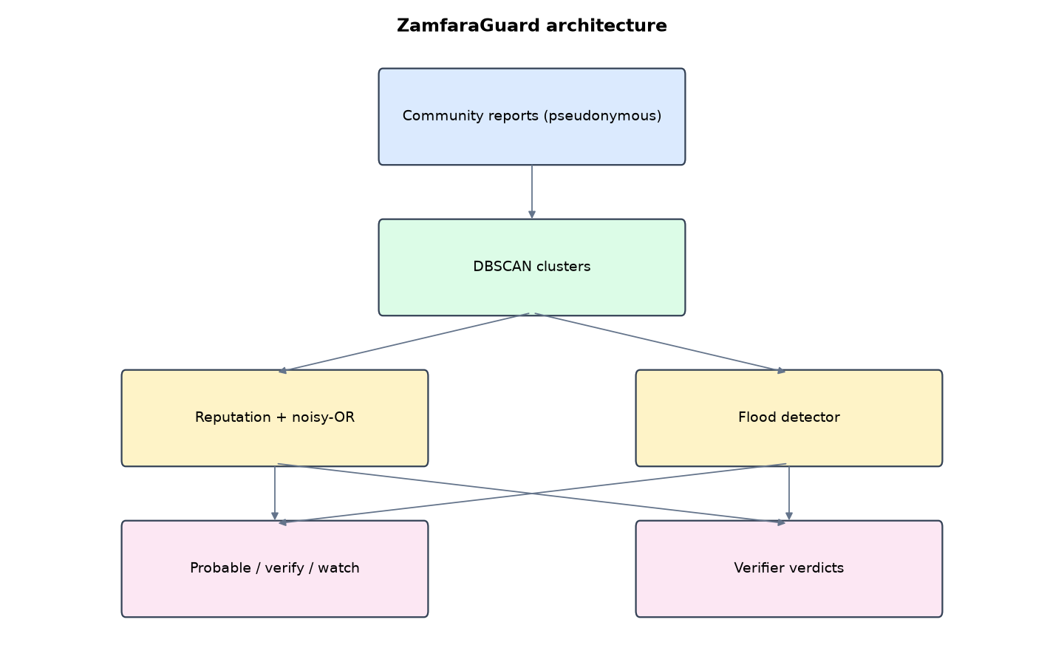
Figure 1: ZamfaraGuard architecture (data flows from top to bottom)
Table 5: Software components
File | Responsibility
trust.py | Reputation, clustering, credibility, flood detection, verdicts
app.py | Flask app and map
main.py / selftest.py | Commands, scenario, tests

The main design decisions, and how they differ from the earlier VarsityShield and Zaman Lafiya projects, are:
- Beta reputation per pseudonymous reporter: trust = (1 + confirmed) / (2 + confirmed + false). In the demo, reliable informants reach 0.87 and rumour spreaders fall to 0.11.
- DBSCAN space-time clustering (5 km and 6 hours) groups reports of one event.
- Noisy-OR credibility over distinct reporters. The same person repeating counts once.
- Sybil cap: brand-new numbers together can add at most 0.60 credibility.
- Copy-paste flood detection with word-set Jaccard similarity. Flagged clusters lose half their credibility.
- Two-source rule: a dispatch alert needs credibility of at least 0.80 and two independent reporters.
- Privacy: phones become HMAC pseudonyms and are never stored. Locations are rounded to about 100 m. 4 reports per number per hour.

3.4 Security Design
Each threat considered is matched to the control that addresses it. Tests in Chapter Four exercise these controls.
Table 6: Threats and controls
Threat | Control in ZamfaraGuard
Coordinated rumour from new SIMs | Sybil cap 0.60, copy-paste flag halves credibility
One person repeating | Counted once
One trusted person alone | Two-source rule
Report flooding | 4 per hour per number
Reporter identification | HMAC pseudonym; phone never stored
Analyst records verdicts | Role check

3.5 Algorithms

3.5.1 Beta reputation
trust = (1 + confirmed) / (2 + confirmed + false), the mean of Beta(1 + confirmed, 1 + false).

3.5.2 DBSCAN in space-time
Neighbours are reports within 5 km and 6 hours; min points 2; clusters grow through dense neighbours; others are noise (single reports).

3.5.3 Credibility
Over distinct reporters: known reporters combine by noisy-OR, 1 - product(1 - trust); new reporters combine separately and are capped at 0.60. If at least half of report pairs have Jaccard similarity >= 0.8 and 60% come from new numbers, credibility is halved. Dispatch needs >= 0.80 and two reporters.

3.6 Tools and Technologies
Language: Python 3.10 or newer. Storage: SQLite. Third-party packages: flask. Launchers: Windows batch files (1_SETUP, 2_START, 3_DEMO_MENU, 4_SELFTEST) and run.sh for Linux and macOS.

CHAPTER FOUR: IMPLEMENTATION, TESTING AND RESULTS

4.1 Implementation Environment
The system was developed and tested with Python 3.11 on Linux and is written to run unchanged on Windows 10/11. Its web interface runs at http://127.0.0.1:5209. Setup takes about ten minutes with 1_SETUP.bat; the README in the project folder gives every step and a defence demonstration script.

4.2 Operation and Demonstration
Open reporting lines are attacked with rumours: one false 'they have killed many people, share this' message can start a reprisal. ZamfaraGuard treats every report as evidence of uncertain quality. Each anonymous reporter earns a reputation from past verified reports, reports about the same event are grouped in space and time, independent sources are combined, and copy-paste floods from new SIM cards are flagged. Only well-supported events trigger a dispatch. The rest go to a verifier or stay on watch.
Table 7: Demonstration scenario used for the defence
Step | Command (python main.py ...) | What is observed
Our informants have track records. | serve | Reporters page: trust per pseudonym
Two things happen at once. | scenario | Maru: 3 trusted informants, PROBABLE, alert. Gusau: 6 new numbers, same text, flagged, WATCH
Why not believe the Gusau messages? | (Clusters page) | Flag: near-identical texts from new numbers; credibility 0.30
The verifier checks Gusau: it was false. | (Verify False) | Those 6 numbers lose trust for next time
Can one person trigger a dispatch? | (selftest) | No: two-source rule gives VERIFY

4.3 Test Plan and Results
The automated test program ran 15 tests. 15 passed.
Table 8: Automated test results
# | Test | Result | Evidence
1 | Reputation learned from past verdicts separates reliable and unreliable informants | PASS | {'reliable_mean': 0.871, 'unreliable_mean': 0.112}
2 | DBSCAN groups close-in-space-and-time points and leaves others as noise | PASS | [0, 0, 0, -1, -1]
3 | Jaccard similarity spots copy-paste text | PASS
4 | Real attack, 3 trusted informants: PROBABLE and alert sent | PASS | {'reports': 3, 'reporters': 3, 'credibility': 0.998, 'status': 'probable', 'flag': None}
5 | Six new numbers with copy-paste rumour: flagged, NOT probable | PASS | {'reports': 6, 'reporters': 6, 'credibility': 0.3, 'status': 'watch', 'flag': 'possible coordinated false reports (near-
6 | Single unknown reporter stays on WATCH | PASS | {'reports': 1, 'reporters': 1, 'credibility': 0.5, 'status': 'watch'}
7 | Only Maru triggered a dispatch alert | PASS | ['Maru']
8 | The same informant sending repeats counts once | PASS | 3
9 | Per-number rate limit (5th report in one hour refused) | PASS | {'accepted': False, 'reason': 'too many reports from this number in one hour'}
10 | Two-source rule: one trusted informant alone gets VERIFY, not dispatch | PASS
11 | Location outside Zamfara rejected | PASS
12 | Verdict 'false' lowers trust of the rumour numbers | PASS | 0.5 -> 0.3333333333333333
13 | Phone numbers never stored | PASS
14 | Analyst cannot record verdicts | PASS
15 | Cluster map data needs sign-in | PASS

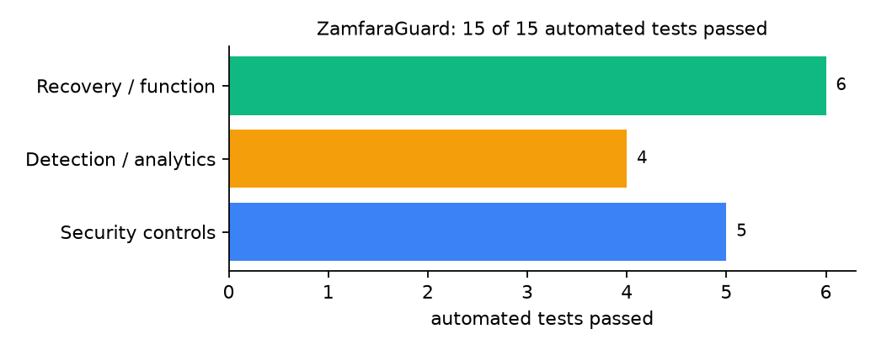
Figure 2: Automated tests by category

4.4 Measured Results
Table 9: Key measurements
Measure | Result
Mean trust: reliable / unreliable informants | 0.871 / 0.112
Maru (3 trusted informants) | credibility 0.998, probable
Gusau (6 new numbers, copy-paste) | credibility 0.3, watch
Anka (one unknown reporter) | credibility 0.5, watch
Scenario processing time | 66.1 ms

4.5 Discussion
The design trades speed for caution: a single highly trusted informant gets a verifier, not a dispatch. In an attack in progress that may cost minutes; it also prevents one compromised informant from directing forces. Reputation can be gamed slowly by building a record with true minor reports; the cap on new reporters limits but does not remove that risk.
Of the tests, 5 exercised security controls, 4 exercised detection or analytics, and 6 exercised recovery or core function.

CHAPTER FIVE: SUMMARY, CONCLUSION AND RECOMMENDATIONS

5.1 Summary
This project built ZamfaraGuard for Zamfara State (12 LGAs including Gusau, Maru, Anka, Tsafe and Zurmi). Its design combines beta reputation, DBSCAN space-time clustering, noisy-OR credibility, Sybil caps and copy-paste flood detection. It met its objectives and passed all 15 automated tests.

5.2 Conclusion
ZamfaraGuard shows that the security problem described in Chapter One can be addressed with free software and modest hardware, provided the design treats the warning data as something attackers will target. The limits stated in Section 1.4 still apply.

5.3 Recommendations
- Record verifier verdicts consistently; reputation depends on them.
- Tune thresholds with real data.
- Combine with LafiaAlert-style SMS intake.

5.4 Contribution to Knowledge
This project addresses the gap identified in Chapter Two: Reviewed community reporting systems trust reports equally; none models reporter reliability or coordinated disinformation.

5.5 Suggestions for Further Work
- Text similarity that handles Hausa spelling variants.
- Time-decay of reputation.

REFERENCES
Babatunde, A. O., & Ibnouf, F. O. (2024). The dynamics of herder-farmer conflicts in Plateau State, Nigeria, and Central Darfur State, Sudan. African Studies Review, 67(2), 321-350. https://doi.org/10.1017/asr.2024.45
Browning, R., Patten, H., Rousseau, J., & Mengersen, K. (2026). Bayesian spatiotemporal modelling of political violence and conflict events using discrete-time Hawkes processes. Journal of the Royal Statistical Society Series A. https://doi.org/10.1093/jrsssa/qnag039
Cicek, D., & Kantarci, B. (2023). Use of mobile crowdsensing in disaster management: A systematic review, challenges, and open issues. Sensors, 23(3), 1699. https://doi.org/10.3390/s23031699
Eke, O. G., et al. (2025). Climate-driven conflicts in Nigeria: Farmers' strategies for coping with herders' incursion on crop lands. Sustainability, 17(24), 11316. https://doi.org/10.3390/su172411316
Estefania-Salazar, E., & Iglesias, E. (2025). Assessing vegetation phenology dynamics in West African rangelands: Implications for livestock sustainability and transhumance. Ecological Informatics, 88.
Goodman, S., BenYishay, A., & Runfola, D. (2024). Spatiotemporal prediction of conflict fatality risk using convolutional neural networks and satellite imagery. Remote Sensing, 16(18), 3411. https://doi.org/10.3390/rs16183411
Kanagamalliga, S., et al. (2024). Integration of IoT for precision livestock monitoring through geofencing. In 2024 5th International Conference on Electronics and Sustainable Communication Systems (ICESC). IEEE.
Navarro, R., Saleh, L., & Owino, E. (2025). Pastoral conflict on the greener grass? Exploring the climate-conflict nexus in the Karamoja Cluster. International Journal of Disaster Risk Reduction.
Nnaji, A., Ma, W., Ratna, N., & Renwick, A. (2022). Farmer-herder conflicts and food insecurity: Evidence from rural Nigeria. Agricultural and Resource Economics Review.
Nwankwo, C. F. (2025). Perceptions of injustices in the struggle for scarce critical lands: Farmer-herder conflict and violence escalation in the Benue-Nasarawa borderland. World Development, 186, 106824.
Parlato, M. C. M., Valenti, F., & Porto, S. M. C. (2024). GIS-based methodology for tracking the grazing cattle site use. Heliyon, 10(13), e33166. https://doi.org/10.1016/j.heliyon.2024.e33166
Rochana, E., et al. (2024). The urgency of an early warning system for social conflict by using WhatsApp. International Journal of Innovative Research and Scientific Studies, 7(1), 107-114.
Ronoh, E. K., Mirau, S., & Dida, M. A. (2022). Human-wildlife conflict early warning system using the Internet of Things and short message service. Engineering, Technology & Applied Science Research.
Rød, E. G., Gåsste, T., & Hegre, H. (2024). A review and comparison of conflict early warning systems. International Journal of Forecasting, 40(1), 96-112.
Schwarz, M., Landmann, T., Jusselme, D., Zambrano, E., Danzeglocke, J., Siegert, F., & Franke, J. (2022). Assessing the environmental suitability for transhumance in support of conflict prevention in the Sahel. Remote Sensing, 14(5), 1109. https://doi.org/10.3390/rs14051109
Shimizu, K., et al. (2025). Piloting a mobile early warning alert and response system for East and Central Darfur, Sudan. International Health, 18(2), ihaf122.
Sola, L., Chen, Y., Murphy, S. K., & Subrahmanian, V. S. (2025). Quantifying the risk of pastoral conflict in 4 central African countries. EPJ Data Science, 14. https://doi.org/10.1140/epjds/s13688-025-00591-5
Tarif, K. (2022). Climate change and violent conflict in West Africa: Assessing the evidence (SIPRI Insights on Peace and Security). Stockholm International Peace Research Institute.

Standards and Legal Instruments Consulted
Federal Republic of Nigeria. (2023). Nigeria Data Protection Act, 2023. Nigeria Data Protection Commission.
International Organization for Standardization. (2022). ISO/IEC 27001:2022 Information security, cybersecurity and privacy protection: Information security management systems: Requirements. ISO.
National Institute of Standards and Technology. (2024). The NIST Cybersecurity Framework (CSF) 2.0 (NIST CSWP 29). NIST.

APPENDIX A: HOW TO RUN THE SYSTEM
- Copy the folder conflict-early-warning/B09-zamfara-guard to the computer.
- Install Python 3.10 or newer with 'Add python.exe to PATH' ticked.
- Double-click 1_SETUP.bat, then 2_START.bat, and open http://127.0.0.1:5209.
- Use 3_DEMO_MENU.bat for the defence demonstration and 4_SELFTEST.bat to regenerate the results in Chapter Four.

APPENDIX B: SOURCE CODE STRUCTURE
Table 10: ZamfaraGuard source files
File | Purpose
trust.py | Reputation, clustering, credibility, flood detection, verdicts
app.py | Flask app and map
main.py / selftest.py | Commands, scenario, tests

APPENDIX C: CODE EXCERPT
The function credibility from trust.py, the heart of the design described in Section 3.5.
def credibility(reps):
"""Noisy-OR over distinct reporters with a cap on the combined weight of new reporters."""
c = geo.cfg()
seen, miss_known, new_weight = set(), 1.0, 0.0
for r in reps:
if r["reporter"] in seen:
continue
seen.add(r["reporter"])
t, is_new = trust(r["reporter"])
if is_new:
new_weight = 1 - (1 - new_weight) * (1 - t)
else:
miss_known *= 1 - t
new_weight = min(new_weight, c["new_reporter_cap"])
cred = 1 - miss_known * (1 - new_weight)
flag = None
if len(reps) >= 3:
pairs = [(a, b) for i, a in enumerate(reps) for b in reps[i + 1:]]
copies = sum(1 for a, b in pairs if jaccard(a["text"], b["text"]) >= c["copy_similarity"])
fresh = sum(1 for r in reps if trust(r["reporter"])[1])
if copies / len(pairs) >= 0.5 and fresh / len(reps) >= 0.6:
flag = "possible coordinated false reports (near-identical texts from new numbers)"
cred *= 0.5
return round(cred, 3), len(seen), flag

