[NAME OF YOUR UNIVERSITY]
FACULTY OF [SCIENCE / COMPUTING]
DEPARTMENT OF COMPUTER SCIENCE
CMP 468: COMPUTER SECURITY (2 UNITS)
COURSE PROJECT REPORT
CONFLUENCEEWS: OFFLINE-FIRST FIELD REPORTING WITH SECURE SYNCHRONISATION AND A LOGISTIC RISK MODEL FOR KOGI STATE
Signed, replay-proof, idempotent sync with conflict resolution and a from-scratch logistic regression
BY
[FULL NAME]
MATRIC NO: [MATRIC NUMBER]
SUBMITTED TO
[COURSE LECTURER'S NAME]
IN PARTIAL FULFILMENT OF THE REQUIREMENTS OF CMP 468
400 LEVEL, SECOND SEMESTER, 2025/2026 SESSION
OCTOBER 2026

DECLARATION
I declare that this project report and the accompanying software were written by me as part of the requirements of CMP 468 (Computer Security). Every source used has been cited. All literature cited in this report was published between 2021 and 2026. All test results reported in Chapter Four were produced by the automated test program supplied with the software.
Signature: ____________________ Date: ____________________

ABSTRACT
Farmer-herder conflict in Nigeria destroys lives, livelihoods and food supply. Early warning helps only when it is timely, trusted and secure. This project designed, built and tested ConfluenceEWS for Kogi State (12 LGAs including Omala, Bassa, Dekina, Ibaji and Kotonkarfe). Its design combines signed, replay-proof, idempotent sync with conflict resolution and a from-scratch logistic regression. The system was implemented in Python and evaluated with an automated test suite on synthetic data that follows documented conflict patterns, including attacks on the system itself. All 17 tests passed. Key measurements: Training / test rows: 396 / 132; AUC: model / naive last-30-days rule: 0.63 / 0.511; Brier: model / always-average: 0.2136 / 0.2247; Retry after lost reply: 0 new, 2 duplicates recognised. The results show the design works as specified; field validation with real data is the next step.
Keywords: early warning, farmer-herder conflict, GIS, information security, privacy, Nigeria, NDPA 2023.

TABLE OF CONTENTS
Right-click here and choose Update Field to build the table of contents.

CHAPTER ONE: INTRODUCTION

1.1 Background of the Study
Kogi sits at the confluence of the Niger and Benue rivers. Omala, Bassa and Ibaji have riverine and remote communities with weak network coverage, so field officers often record events hours before they can send them.
Nigerian farmer-herder conflict is driven by competition for land and water, changing herd mobility, weak institutions and perceived injustice. Early warning systems try to detect rising risk early enough for mediation, patrols or community action. They handle sensitive data (who reported what) and are themselves targets of manipulation, so they are a computer security problem as much as a data problem.

1.2 Statement of the Problem
- Field reporting fails without network.
- Retries after a dropped connection create duplicates.
- Captured uploads can be replayed.
- Officers in the field have no current risk picture.

1.3 Aim and Objectives
The aim is to design, implement and evaluate ConfluenceEWS, a secure system for Kogi State (12 LGAs including Omala, Bassa, Dekina, Ibaji and Kotonkarfe). The objectives are to:
- queue reports on tablets offline;
- sync with signed, counter-protected requests;
- make retries idempotent and resolve offline edits;
- return the latest LGA risk table to tablets;
- predict 14-day risk with logistic regression and evaluate it against baselines.

1.4 Scope and Limitations
Standard library only; tablets simulated on one machine; synthetic incidents. The system was tested on one computer; the README describes deployment on other computers.

1.5 Significance of the Study
ConfluenceEWS gives Kogi State (12 LGAs including Omala, Bassa, Dekina, Ibaji and Kotonkarfe) a free, auditable tool that runs on ordinary hardware, and turns CMP 468 topics into working controls. Its automated test suite lets any future maintainer prove that the controls still work.

1.6 Relation to the CMP 468 Course Outline
Table 1: Mapping of CMP 468 topics to ConfluenceEWS
CMP 468 topic | Where it appears in ConfluenceEWS
Overview of security in computing | Confidentiality of informants, integrity of reports and data, availability of alerts
Characteristics of computer intrusion | Forged reports, fake devices, replayed messages, tampered records
Types of security breaches | Disclosure of informant identity, falsified incident data, unauthorised access to case files
Classes of attacks | Impersonation, replay, injection, brute force, cross-site request forgery, disinformation
Methods of defence and controls | Table 3.2 maps each threat to its control
Data security: encryption and decryption | See Section 3.5
Database security | Parameterised SQL, role checks before every query, encrypted personal fields
Security policies and standards | NDPA 2023 (personal data of reporters), ISO/IEC 27001:2022 access control

CHAPTER TWO: LITERATURE REVIEW
This review covers only studies published from 2021 to 2026. Every source was checked against a publisher or index page.

2.1 Conceptual Framework
The study uses the early warning chain: collect signals, analyse risk, warn the right people, and respond. Each link has security needs: signals must be authentic, analysis must be on untampered data, warnings must reach people quickly, and the identities of informants must stay confidential.

2.2 Farmer-herder conflict in Nigeria and the region
Nnaji et al. (2022) surveyed 401 rural Nigerian households and found that both the incidence and the severity of farmer-herder conflict raise food insecurity, severity more so. Nwankwo (2025) showed from interviews in the Benue-Nasarawa borderland that perceived injustice drives escalation of farmer-herder violence. Babatunde and Ibnouf (2024) showed that officials, traditional rulers and security agents in Plateau State deepened conflict through unequal resource allocation and peacebuilding that favoured some groups. Eke et al. (2025) found Enugu farmers coping with herd incursions by farming in groups, reducing what they plant and preparing for crop loss, with falling income and productivity. Tarif (2022) reviewed the West African evidence and grouped climate-conflict links into four pathways, including changing pastoral mobility, while warning that the research base is thin. Together these studies explain why prevention must be local, fast and trusted by both farming and herding communities.

2.3 Conflict early warning systems and forecasting
Rød et al. (2024) compared conflict early warning systems on transparency, key parameters and forecasts, found weak access to data and code and large differences between systems, and called for shared standards. Goodman et al. (2024) predicted sub-national conflict-fatality risk in Nigeria from Landsat 8 imagery and ACLED data, with an average AUC above 0.75, but performance fell when the geography of conflict shifted. Sola et al. (2025) predicted pastoral conflict in Cameroon, Chad, the Central African Republic and the DRC from weather and terrain data (AUC 0.99 for Cameroon) and found that vegetation affects risk differently in each country. Browning et al. (2026) fitted a Bayesian spatiotemporal Hawkes process to ACLED events in South Asia, treating political violence as self-exciting (contagious) in space and time. Forecast accuracy matters, but so do transparency and whether the people at risk can act on the warning.

2.4 Environment, mobility and herd tracking
Schwarz et al. (2022) modelled environmental suitability for transhumance in Chad and the Central African Republic from Earth observation data, found most conflicts where suitability was high, and suggested combining herd tracking with satellite data for early warning along corridors. Estefania-Salazar and Iglesias (2025) analysed 250 m NDVI for 2003-2023 across 13 West African countries and found growing seasons shortening through a later start, with consequences for transhumance routes. Navarro et al. (2025) found in the Karamoja Cluster that vegetation data predicted pastoral conflict one month ahead better than rainfall, and that conflict clustered 'on the greener grass'. Parlato et al. (2024) tracked grazing cattle with low-power GPS collars and used heatmaps and kernel density estimation to find the areas animals use most. Kanagamalliga et al. (2024) used IoT collars with geofencing and temperature sensing for remote monitoring of livestock movement and health.

2.5 Community reporting and mobile alerting
Rochana et al. (2024) surveyed 267 villagers, found low public participation in conflict prevention, and proposed village-level early warning through WhatsApp groups. Cicek and Kantarci (2023) reviewed mobile crowdsensing for disasters and found most studies conceptual, with little testing in real incidents. Shimizu et al. (2025) describe the EWARS Mobile pilot in Darfur, whose offline reporting worked where network coverage was poor: 158 health facilities sent 752 weekly reports and the system was expanded to all Darfur states. Ronoh et al. (2022) built a low-cost early warning unit (motion sensor, GPS, camera, YOLO detection) that sends SMS alerts to response teams when animals approach a park border. Low-cost phones, SMS and offline-capable tools reach people that web dashboards miss.

2.6 Work Closest to This Design
Shimizu et al. (2025) show offline reporting succeeding in Darfur; ConfluenceEWS adds the security of the sync itself. Goodman et al. (2024) and Sola et al. (2025) report strong AUCs with richer data; ConfluenceEWS uses a simple, explainable model and reports a modest AUC honestly against a naive baseline.

2.7 Summary of Reviewed Works and Research Gap
Table 2: Summary of reviewed works
Study | What it contributes
Babatunde (2024) | showed that officials, traditional rulers and security agents in Plateau State deepened conflict through unequal resource allocation and peacebuilding that favo
Browning (2026) | fitted a Bayesian spatiotemporal Hawkes process to ACLED events in South Asia, treating political violence as self-exciting (contagious) in space and time.
Cicek (2023) | reviewed mobile crowdsensing for disasters and found most studies conceptual, with little testing in real incidents.
Eke (2025) | found Enugu farmers coping with herd incursions by farming in groups, reducing what they plant and preparing for crop loss, with falling income and productivity
Estefania-Salazar (2025) | analysed 250 m NDVI for 2003-2023 across 13 West African countries and found growing seasons shortening through a later start, with consequences for transhumanc
Goodman (2024) | predicted sub-national conflict-fatality risk in Nigeria from Landsat 8 imagery and ACLED data, with an average AUC above 0.75, but performance fell when the ge
Kanagamalliga (2024) | used IoT collars with geofencing and temperature sensing for remote monitoring of livestock movement and health.
Navarro (2025) | found in the Karamoja Cluster that vegetation data predicted pastoral conflict one month ahead better than rainfall, and that conflict clustered 'on the greener
Nnaji (2022) | surveyed 401 rural Nigerian households and found that both the incidence and the severity of farmer-herder conflict raise food insecurity, severity more so.
Nwankwo (2025) | showed from interviews in the Benue-Nasarawa borderland that perceived injustice drives escalation of farmer-herder violence.
Parlato (2024) | tracked grazing cattle with low-power GPS collars and used heatmaps and kernel density estimation to find the areas animals use most.
Rochana (2024) | surveyed 267 villagers, found low public participation in conflict prevention, and proposed village-level early warning through WhatsApp groups.
Ronoh (2022) | built a low-cost early warning unit (motion sensor, GPS, camera, YOLO detection) that sends SMS alerts to response teams when animals approach a park border.
Rød (2024) | compared conflict early warning systems on transparency, key parameters and forecasts, found weak access to data and code and large differences between systems,
Schwarz (2022) | modelled environmental suitability for transhumance in Chad and the Central African Republic from Earth observation data, found most conflicts where suitability
Shimizu (2025) | describe the EWARS Mobile pilot in Darfur, whose offline reporting worked where network coverage was poor: 158 health facilities sent 752 weekly reports and the
Sola (2025) | predicted pastoral conflict in Cameroon, Chad, the Central African Republic and the DRC from weather and terrain data (AUC 0.99 for Cameroon) and found that veg
Tarif (2022) | reviewed the West African evidence and grouped climate-conflict links into four pathways, including changing pastoral mobility, while warning that the research

Research gap. Offline reporting tools in the review do not describe replay protection, idempotency or conflict resolution.

CHAPTER THREE: METHODOLOGY AND SYSTEM DESIGN

3.1 Research Methodology
The project follows Design Science Research: identify the problem, define objectives, design and build an artefact, demonstrate it, and evaluate it. Evaluation uses an automated test program (selftest.py) that resets the system, runs normal use, simulated attacks and failures, and records each outcome and measurement in results/selftest.json. Data are synthetic, generated to follow documented seasonal and retaliation patterns, so results show how the system behaves, not how accurate it would be in the field.

3.2 Requirements
Table 3: Functional requirements
# | Requirement
FR1 | Offline queue on tablets
FR2 | HMAC-signed sync with counter
FR3 | UUID idempotency
FR4 | Version-based conflict resolution
FR5 | Risk table in reply
FR6 | Logistic regression with AUC and Brier
FR7 | Staff pages

Table 4: Non-functional requirements
# | Requirement
NFR1 | No third-party packages
NFR2 | Payload limit 1 MB, 500 reports per sync

3.3 System Architecture
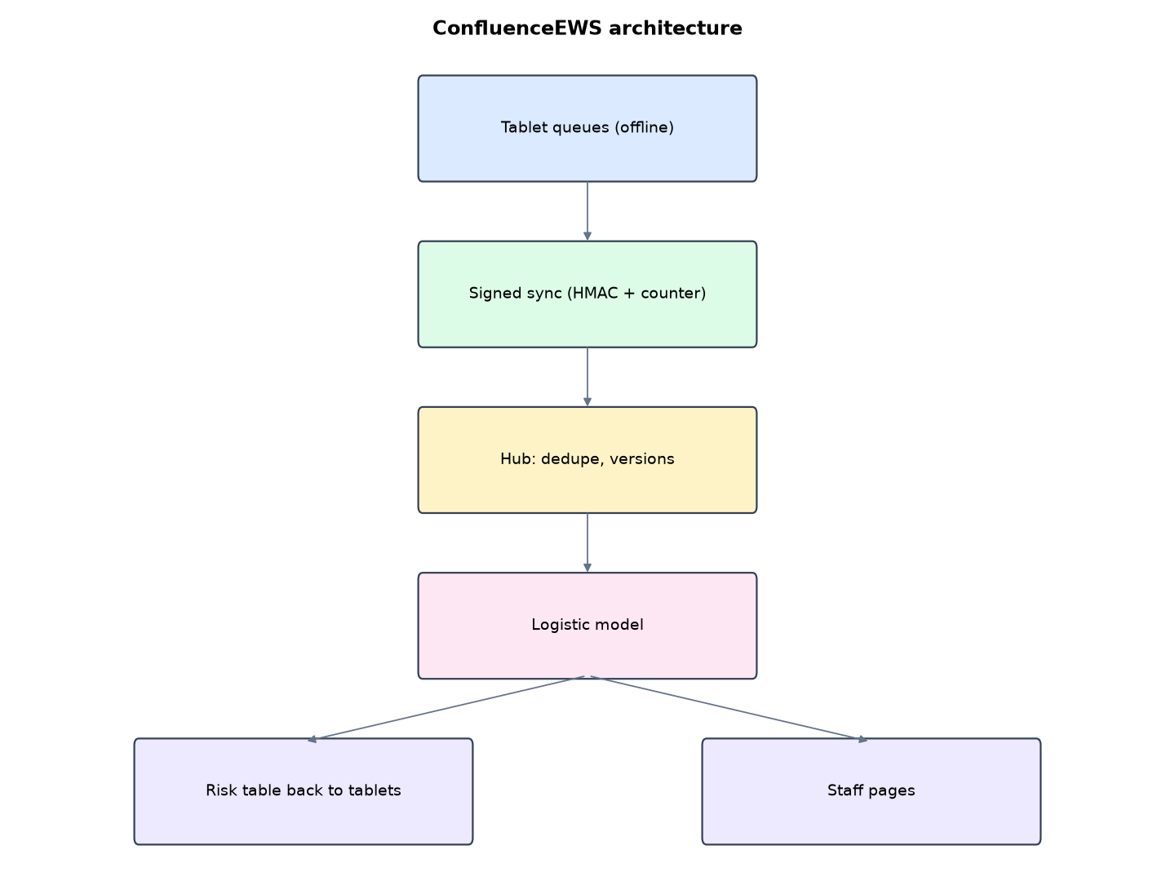
Figure 1: ConfluenceEWS architecture (data flows from top to bottom)
Table 5: Software components
File | Responsibility
field.py | Tablet queue, edits, sync, lost-reply simulation
hub.py | Sync protocol, conflict rules, scoring
model.py | Features, logistic regression, AUC
server.py | Standard-library hub server
main.py / selftest.py | Commands and tests

The main design decisions, and how they differ from the earlier VarsityShield and Zaman Lafiya projects, are:
- Offline-first tablets with their own SQLite queue. A failed sync keeps everything queued.
- Signed sync protocol: HMAC-SHA256 per tablet key. A strictly increasing counter blocks replay of captured uploads.
- Idempotent uploads: each report has a UUID created on the tablet, so a retry after a lost reply creates no duplicates.
- Conflict resolution: offline edits carry a version number. The highest version wins and a late older copy cannot overwrite newer data.
- Two-way sync: the reply returns the latest LGA risk table, so the field has risk levels without network.
- Logistic regression from scratch (gradient descent, L2) on 7 features. It is tested on the most recent 90 days and reported with AUC and Brier score against simple baselines.
- Standard library only on the hub and tablets: no pip install needed, which suits low-bandwidth sites.

3.4 Security Design
Each threat considered is matched to the control that addresses it. Tests in Chapter Four exercise these controls.
Table 6: Threats and controls
Threat | Control in ConfluenceEWS
Captured upload replayed | Counter must increase
Upload signed with another tablet's key | Signature fails
Retry after lost reply | UUID makes it a no-op
Stale edit overwrites new data | Highest version wins
Malformed body | 400 response
Staff pages without login | Session required

3.5 Algorithms

3.5.1 Sync protocol
body = {device, counter, reports}; X-Sig = HMAC-SHA256(device key, body). Accept only counter > last counter. For each report: insert if UUID new; replace if (version, edited) is greater; else count as duplicate. Reply with acked UUIDs and the risk table.

3.5.2 Logistic regression
Seven standardised features per LGA-week. Batch gradient descent on log-loss with L2 = 0.01, learning rate 0.5, 600 epochs. Temporal split: train on older weeks, test on the last 90 days.

3.5.3 AUC
Mann-Whitney: the probability that a random positive LGA-week is ranked above a random negative, with ties averaged.

3.6 Tools and Technologies
Language: Python 3.10 or newer. Storage: SQLite. Third-party packages: none (standard library only). Launchers: Windows batch files (1_SETUP, 2_START, 3_DEMO_MENU, 4_SELFTEST) and run.sh for Linux and macOS.

CHAPTER FOUR: IMPLEMENTATION, TESTING AND RESULTS

4.1 Implementation Environment
The system was developed and tested with Python 3.11 on Linux and is written to run unchanged on Windows 10/11. Its web interface runs at http://127.0.0.1:5210. Setup takes about ten minutes with 1_SETUP.bat; the README in the project folder gives every step and a defence demonstration script.

4.2 Operation and Demonstration
Many Kogi communities along the Niger and Benue have no reliable network. ConfluenceEWS lets police, peace officers and extension workers record incidents on a tablet with no signal at all. When they reach a town, the tablet syncs: every upload is signed, cannot be replayed, never duplicates on retry, and resolves offline edits. The hub then rescores a logistic regression that gives each LGA's chance of a violent incident in the next 14 days, and the tablet carries that risk table back to the field for offline use. The hub needs only Python, with no extra packages.
Table 7: Demonstration scenario used for the defence
Step | Command (python main.py ...) | What is observed
This is the 14-day risk for every Kogi LGA. | serve | Risk table with probabilities
Officers in Omala and Bassa have no network. | field-day | Tablets queue reports, then sync: new reports, an offline edit, risk table returned
What if the network drops mid-upload? | (selftest) | Retry gives 0 new and 2 duplicates recognised: no double counting
Can someone replay a captured upload? | (Tablets page, Sync log) | replay refused, bad signature rows
How good is the model? | (Model page) | AUC and Brier against the naive rule and the average forecast

4.3 Test Plan and Results
The automated test program ran 17 tests. 17 passed.
Table 8: Automated test results
# | Test | Result | Evidence
1 | AUC of a perfect ranking is 1 and of a reversed ranking is 0 | PASS
2 | Model beats chance on the most recent 90 days (AUC > 0.6) | PASS | 0.63
3 | Model at least matches the naive last-30-days rule | PASS | 0.63 vs 0.511
4 | Probabilities are better calibrated than an always-average forecast (Brier) | PASS | 0.2136 vs 0.2247
5 | Tablet works with no network (reports queued locally) | PASS
6 | Sync with no connection fails safely and keeps the queue | PASS | {'offline': True, 'error': '<urlopen error [Errno 111] Connection refused>', 'pending': 2}
7 | Network drops after the hub stored the data (reply lost) | PASS
8 | Retry is idempotent: 0 new, 2 recognised duplicates, queue cleared | PASS | {'code': 200, 'acked': ['3e2126aa-a89e-4661-88c0-719957af3cd7', 'f41fd3e9-6b89-4107-bb0f-115dbd78a618'], 'new': 0, 'upda
9 | Hub holds exactly 2 reports (no duplicates) | PASS | 2
10 | Offline edit with a higher version replaces the old copy | PASS | {'severity': 5, 'version': 2}
11 | Older version arriving late does not overwrite newer data | PASS
12 | Captured request replayed later is refused (counter) | PASS | {'error': 'counter already used (replay)'}
13 | Request signed with another tablet's key is refused | PASS | {'error': 'bad signature'}
14 | Malformed body refused | PASS
15 | New violent reports raise Bassa's 14-day probability | PASS | 0.538 -> 0.762
16 | Tablet received the risk table for offline use | PASS
17 | Staff pages need sign-in | PASS

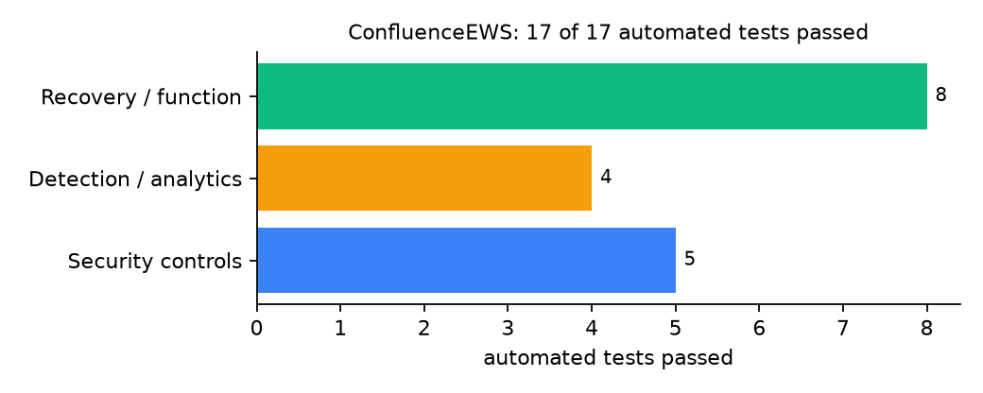
Figure 2: Automated tests by category

4.4 Measured Results
Table 9: Key measurements
Measure | Result
Training / test rows | 396 / 132
AUC: model / naive last-30-days rule | 0.63 / 0.511
Brier: model / always-average | 0.2136 / 0.2247
Retry after lost reply | 0 new, 2 duplicates recognised
Bassa 14-day probability before / after reports | 0.538 / 0.762

4.5 Discussion
An AUC of 0.63 is modest; it beats the naive rule (0.51) and the Brier score beats an always-average forecast, but only slightly. That is an honest result for seven simple features. The sync tests found that the tablet received the old risk table because the hub replied before rescoring; the hub now rescoring first means officers take home levels that include their own reports.
Of the tests, 5 exercised security controls, 4 exercised detection or analytics, and 8 exercised recovery or core function.

CHAPTER FIVE: SUMMARY, CONCLUSION AND RECOMMENDATIONS

5.1 Summary
This project built ConfluenceEWS for Kogi State (12 LGAs including Omala, Bassa, Dekina, Ibaji and Kotonkarfe). Its design combines signed, replay-proof, idempotent sync with conflict resolution and a from-scratch logistic regression. It met its objectives and passed all 17 automated tests.

5.2 Conclusion
ConfluenceEWS shows that the security problem described in Chapter One can be addressed with free software and modest hardware, provided the design treats the warning data as something attackers will target. The limits stated in Section 1.4 still apply.

5.3 Recommendations
- Put the hub behind HTTPS.
- Issue tablets with full-disk encryption.
- Retrain monthly on verified incidents.

5.4 Contribution to Knowledge
This project addresses the gap identified in Chapter Two: Offline reporting tools in the review do not describe replay protection, idempotency or conflict resolution.

5.5 Suggestions for Further Work
- Peer-to-peer sync between tablets.
- More features: market days, rainfall, NDVI.

REFERENCES
Babatunde, A. O., & Ibnouf, F. O. (2024). The dynamics of herder-farmer conflicts in Plateau State, Nigeria, and Central Darfur State, Sudan. African Studies Review, 67(2), 321-350. https://doi.org/10.1017/asr.2024.45
Browning, R., Patten, H., Rousseau, J., & Mengersen, K. (2026). Bayesian spatiotemporal modelling of political violence and conflict events using discrete-time Hawkes processes. Journal of the Royal Statistical Society Series A. https://doi.org/10.1093/jrsssa/qnag039
Cicek, D., & Kantarci, B. (2023). Use of mobile crowdsensing in disaster management: A systematic review, challenges, and open issues. Sensors, 23(3), 1699. https://doi.org/10.3390/s23031699
Eke, O. G., et al. (2025). Climate-driven conflicts in Nigeria: Farmers' strategies for coping with herders' incursion on crop lands. Sustainability, 17(24), 11316. https://doi.org/10.3390/su172411316
Estefania-Salazar, E., & Iglesias, E. (2025). Assessing vegetation phenology dynamics in West African rangelands: Implications for livestock sustainability and transhumance. Ecological Informatics, 88.
Goodman, S., BenYishay, A., & Runfola, D. (2024). Spatiotemporal prediction of conflict fatality risk using convolutional neural networks and satellite imagery. Remote Sensing, 16(18), 3411. https://doi.org/10.3390/rs16183411
Kanagamalliga, S., et al. (2024). Integration of IoT for precision livestock monitoring through geofencing. In 2024 5th International Conference on Electronics and Sustainable Communication Systems (ICESC). IEEE.
Navarro, R., Saleh, L., & Owino, E. (2025). Pastoral conflict on the greener grass? Exploring the climate-conflict nexus in the Karamoja Cluster. International Journal of Disaster Risk Reduction.
Nnaji, A., Ma, W., Ratna, N., & Renwick, A. (2022). Farmer-herder conflicts and food insecurity: Evidence from rural Nigeria. Agricultural and Resource Economics Review.
Nwankwo, C. F. (2025). Perceptions of injustices in the struggle for scarce critical lands: Farmer-herder conflict and violence escalation in the Benue-Nasarawa borderland. World Development, 186, 106824.
Parlato, M. C. M., Valenti, F., & Porto, S. M. C. (2024). GIS-based methodology for tracking the grazing cattle site use. Heliyon, 10(13), e33166. https://doi.org/10.1016/j.heliyon.2024.e33166
Rochana, E., et al. (2024). The urgency of an early warning system for social conflict by using WhatsApp. International Journal of Innovative Research and Scientific Studies, 7(1), 107-114.
Ronoh, E. K., Mirau, S., & Dida, M. A. (2022). Human-wildlife conflict early warning system using the Internet of Things and short message service. Engineering, Technology & Applied Science Research.
Rød, E. G., Gåsste, T., & Hegre, H. (2024). A review and comparison of conflict early warning systems. International Journal of Forecasting, 40(1), 96-112.
Schwarz, M., Landmann, T., Jusselme, D., Zambrano, E., Danzeglocke, J., Siegert, F., & Franke, J. (2022). Assessing the environmental suitability for transhumance in support of conflict prevention in the Sahel. Remote Sensing, 14(5), 1109. https://doi.org/10.3390/rs14051109
Shimizu, K., et al. (2025). Piloting a mobile early warning alert and response system for East and Central Darfur, Sudan. International Health, 18(2), ihaf122.
Sola, L., Chen, Y., Murphy, S. K., & Subrahmanian, V. S. (2025). Quantifying the risk of pastoral conflict in 4 central African countries. EPJ Data Science, 14. https://doi.org/10.1140/epjds/s13688-025-00591-5
Tarif, K. (2022). Climate change and violent conflict in West Africa: Assessing the evidence (SIPRI Insights on Peace and Security). Stockholm International Peace Research Institute.

Standards and Legal Instruments Consulted
Federal Republic of Nigeria. (2023). Nigeria Data Protection Act, 2023. Nigeria Data Protection Commission.
International Organization for Standardization. (2022). ISO/IEC 27001:2022 Information security, cybersecurity and privacy protection: Information security management systems: Requirements. ISO.
National Institute of Standards and Technology. (2024). The NIST Cybersecurity Framework (CSF) 2.0 (NIST CSWP 29). NIST.

APPENDIX A: HOW TO RUN THE SYSTEM
- Copy the folder conflict-early-warning/B10-kogi-confluence to the computer.
- Install Python 3.10 or newer with 'Add python.exe to PATH' ticked.
- Double-click 1_SETUP.bat, then 2_START.bat, and open http://127.0.0.1:5210.
- Use 3_DEMO_MENU.bat for the defence demonstration and 4_SELFTEST.bat to regenerate the results in Chapter Four.

APPENDIX B: SOURCE CODE STRUCTURE
Table 10: ConfluenceEWS source files
File | Purpose
field.py | Tablet queue, edits, sync, lost-reply simulation
hub.py | Sync protocol, conflict rules, scoring
model.py | Features, logistic regression, AUC
server.py | Standard-library hub server
main.py / selftest.py | Commands and tests

APPENDIX C: CODE EXCERPT
The function sync from hub.py, the heart of the design described in Section 3.5.
def sync(body, sig):
try:
d = json.loads(body)
dev = str(d["device"])
counter = int(d["counter"])
except (ValueError, KeyError, TypeError):
return 400, {"error": "malformed"}
with db() as con:
row = con.execute("SELECT * FROM devices WHERE id=?", (dev,)).fetchone()
if not row:
return 401, {"error": "unknown device"}
def log(result, n=0, u=0, dup=0):
with db() as con:
con.execute("INSERT INTO sync_log(ts,device,counter,result,new,updated,duplicates) VALUES(?,?,?,?,?,?,?)",
(time.time(), dev, counter, result, n, u, dup))
if not hmac.compare_digest(sign(row["key"], body), sig or ""):
log("bad signature")
return 401, {"error": "bad signature"}
if counter <= row["last_counter"]:
log("replay refused")
return 409, {"error": "counter already used (replay)"}
names = {g["name"] for g in geo.lgas()}
new = upd = dup = 0
acked = []
with db() as con:
for r in d.get("reports", [])[:500]:
if r.get("lga") not in names or r.get("type") not in geo.TYPES or not 1 <= int(r.get("severity", 0)) <= 5:
continue
old = con.execute("SELECT version, edited FROM reports WHERE uuid=?", (r["uuid"],)).fetchone()
if old is None:
con.execute("INSERT INTO reports VALUES(?,?,?,?,?,?,?,?,?,?)", (r["uuid"], dev, float(r["created"]), float(r["edited"]),
int(r["version"]), r["lga"], r["type"], int(r["severity"]),
str(r.get("note", ""))[:300], time.time()))
new += 1
elif (int(r["version"]), float(r["edited"])) > (old["version"], old["edited"]):
con.execute("UPDATE reports SET version=?, edited=?, lga=?, type=?, severity=?, note=? WHERE uuid=?",
(int(r["version"]), float(r["edited"]), r["lga"], r["type"], int(r["severity"]), str(r.get("note", ""))[:300],
r["uuid"]))
upd += 1
else:
dup += 1
acked.append(r["uuid"])
con.execute("UPDATE devices SET last_counter=?, last_sync=? WHERE id=?", (counter, time.time(), dev))
log("ok", new, upd, dup)
if new or upd:
score() # rescore first, so the tablet takes home risk levels that include its own reports
with db() as con:
risk = {r["lga"]: {"prob": r["prob"], "level": r["level"]} for r in con.execute("SELECT * FROM risk")}
return 200, {"acked": acked, "new": new, "updated": upd, "duplicates": dup, "risk": risk}

