**Bugs found:**

1. **Following operations supports only double input:**

**Multiply, Divide**

1. **Pow function returns Wrong input exception for all types of input**
2. **Add – string input throws Invalid Cast error**
3. **Abs – value after the comma is not returned for Double**
4. **Sqrt – result is slightly different vs .Math result**

**Visual Studio execution results**

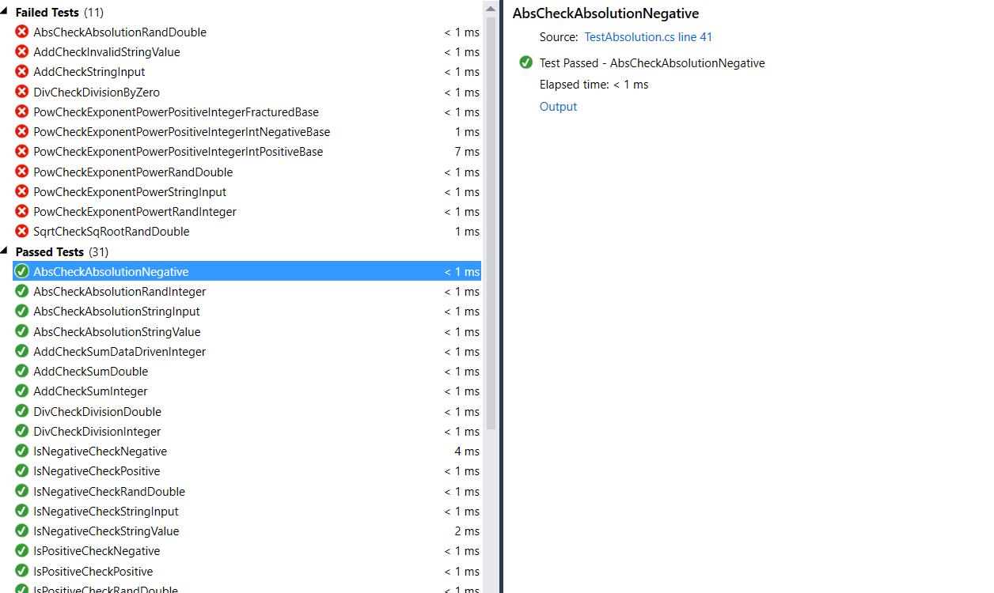

**MS Tests via command line**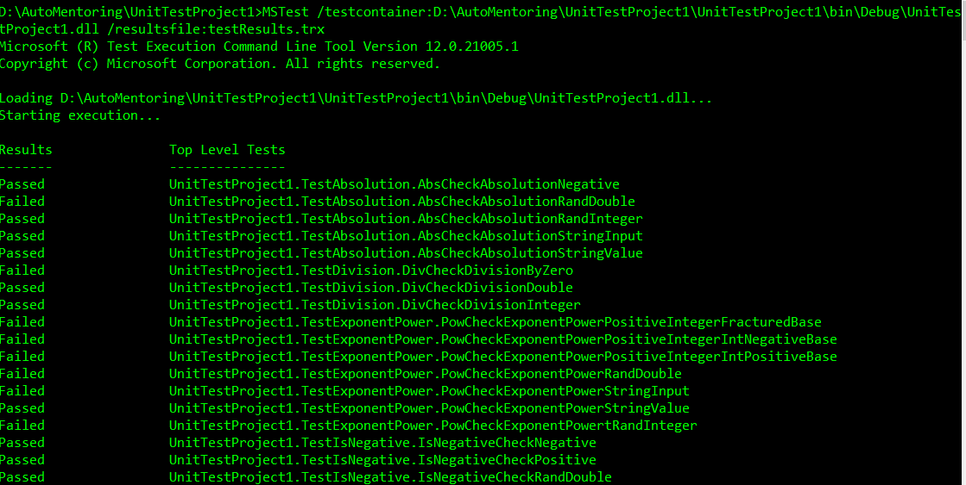

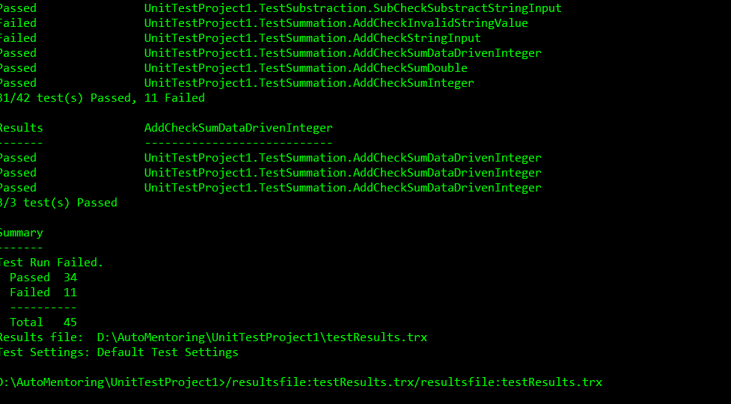

**MS Tests via command line**

