insert into Employee values ('Emma','Carter' )

insert into Employee values ('Lucas' ,'Bennett' )

insert into Employee values ('Mia' ,'Thompson' )

insert into Employee values ('Noah' ,'Reed' )

insert into Employee values ('Ava' ,'Patterson' )

insert into Employee values ('Liam' ,'Foster' )

insert into Employee values ('Sophia' ,'Hayes' )

insert into Employee values ('Ethan' ,'Mitchell' )

insert into Employee values ('Isabella' ,'Gray' )

insert into Employee values ('Oliver' ,'West' )

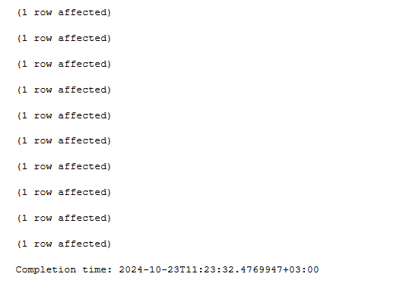

insert into Specialist values('Ala')

insert into Specialist values('Ele')

insert into Specialist values('Melle')

insert into Specialist values('Telle')

insert into Specialist values('Nelle')

insert into Specialist values('Delle')

insert into Specialist values('Relle')

insert into Specialist values('Olla')

insert into Specialist values('Iso')

insert into Specialist values('Raze')

insert into Project values('Yoru','Emma')

insert into Project values('Reyna','Lucas')

insert into Project values('Gekko','Mia')

insert into Project values('Astra','Noah')

insert into Project values('Omen','Ava')

insert into Project values('Skye','Liam')

insert into Project values('KAYO','Sophia')

insert into Project values('Phoenix','Ethan')

insert into Project values('Jett','Isabella')

insert into Project values('Viper','Oliver')

insert into Department values('Icebox','Yoru')

insert into Department values('Lotus','Reyna')

insert into Department values('Fracture','Gekko')

insert into Department values('Ascent','Astra')

insert into Department values('Split','Omen')

insert into Department values('Haven','Skye')

insert into Department values('Breeze','KAYO')

insert into Department values('Pearl','Phoenix')

insert into Department values('Bind','Jett')

insert into Department values('Sunset','Viper')

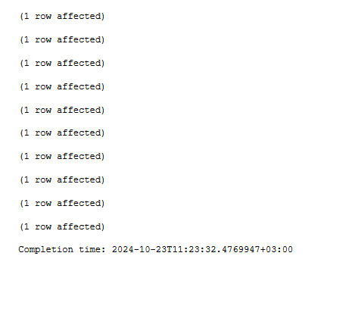

select FirstName, LastName, Name

From Employee

join Project on FirstName = Name

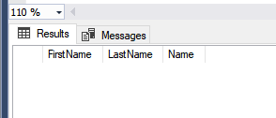

Select Project.Name, Department.Name

from Project

join Department on Project.Name = Department.Name

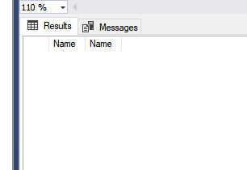

select Specialist.Name

from Specialist

Join Department on SpecialistIdId = DepartmentId

