AP Mini project:

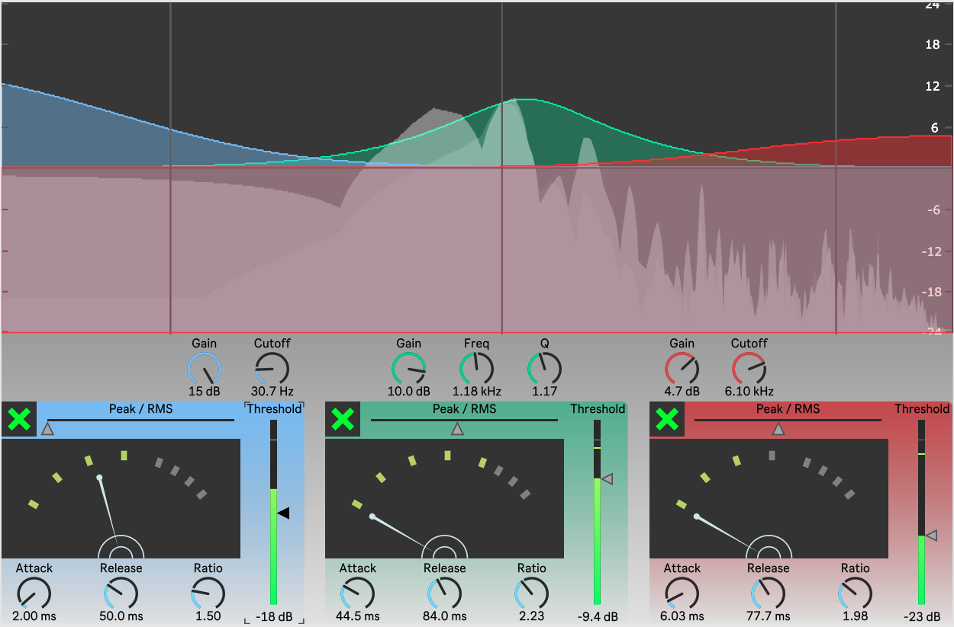Graphic Multiband Compressor

*Get from github:* [*https://github.com/MikkelKPersson/Multiband_Compressor*](https://github.com/MikkelKPersson/Multiband_Compressor)

My main patcher can be seen in Figure 1 below. It consists of a three eq. filters: lowpass, bandpass, highpass. The gain of each filter is controlled by a compressor.

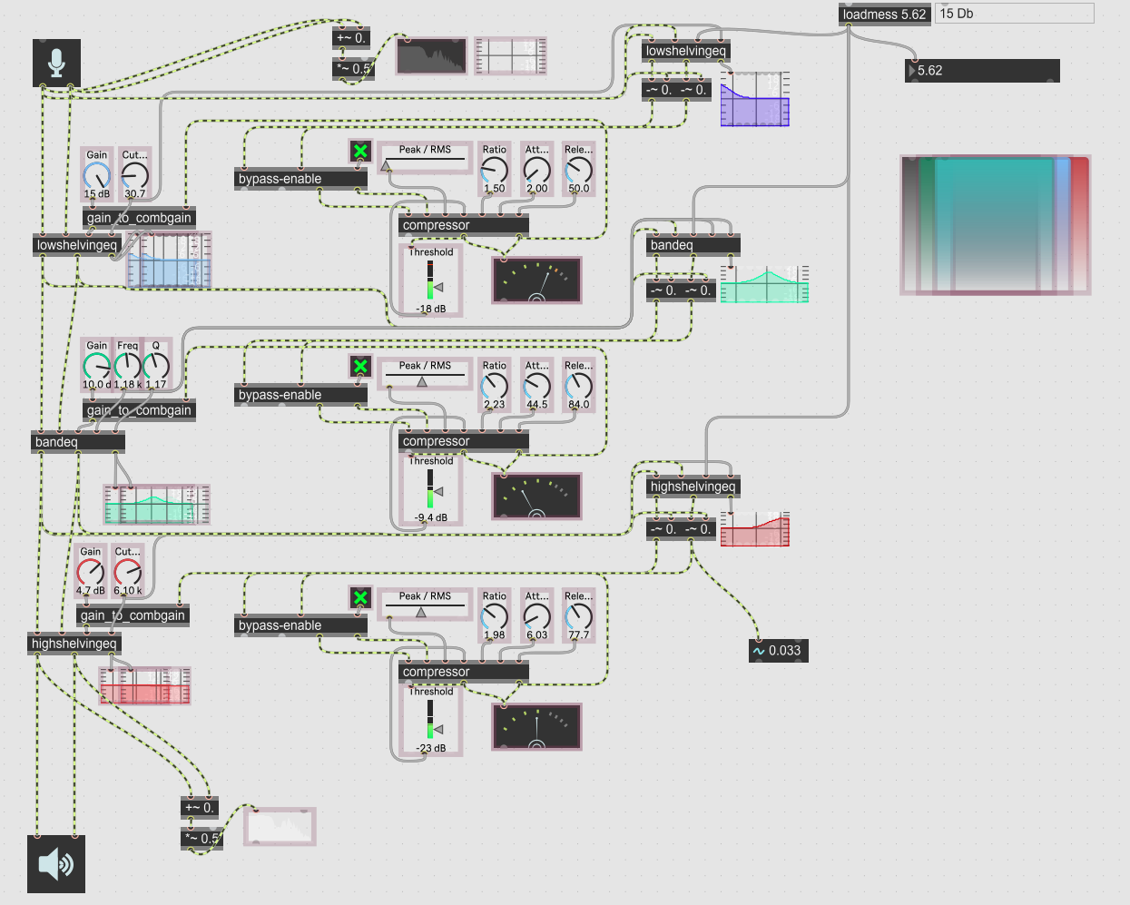

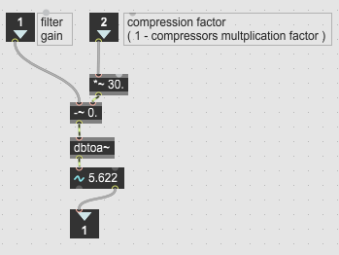Figure 1: main patcher

The input to each compressor is an equivalent filter minus the input signal of the filter. This controlling filter have a fixed gain but else it mirrors the original filter.

The output of the compressor I usually a multiplication factor. This is recalculated into the gain of the filter to keep it consistent. This is done in the abstraction gain_to_combgain in Figure 2.

Figure : gain_to_combgain

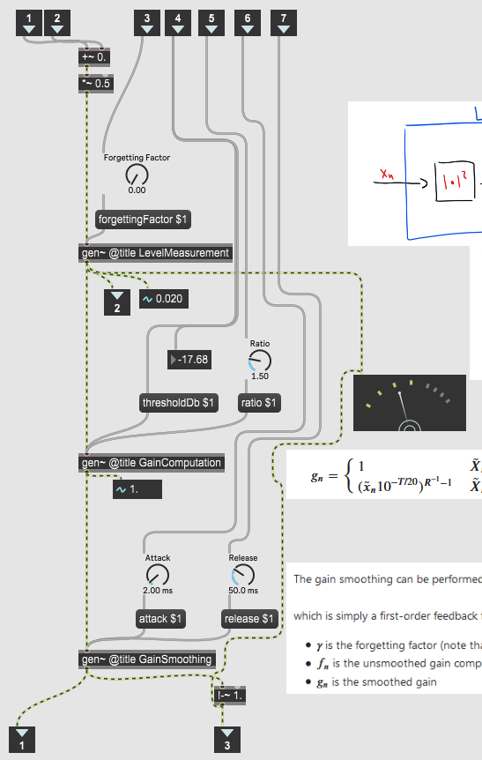

Figure : compressor

The compressor is seen in Figure 3.

In consists of three gen patches:

* LevelMeasurement
* GainComputation
* GainSmoothing

These are shown in the next pages

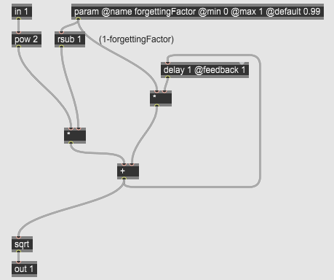The LevelMeasurement seen in Figure 4, is a simple IIR filter where the input is in the power of 2 and the output squared

Figure : LevelMeasurement

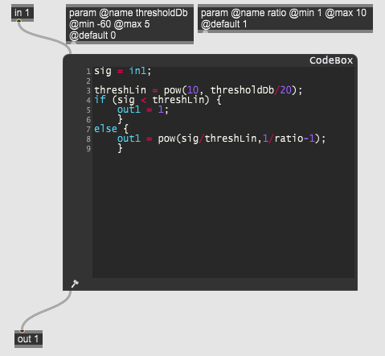The GainComputation can be seen in Figure 5

Figure : GainComputation

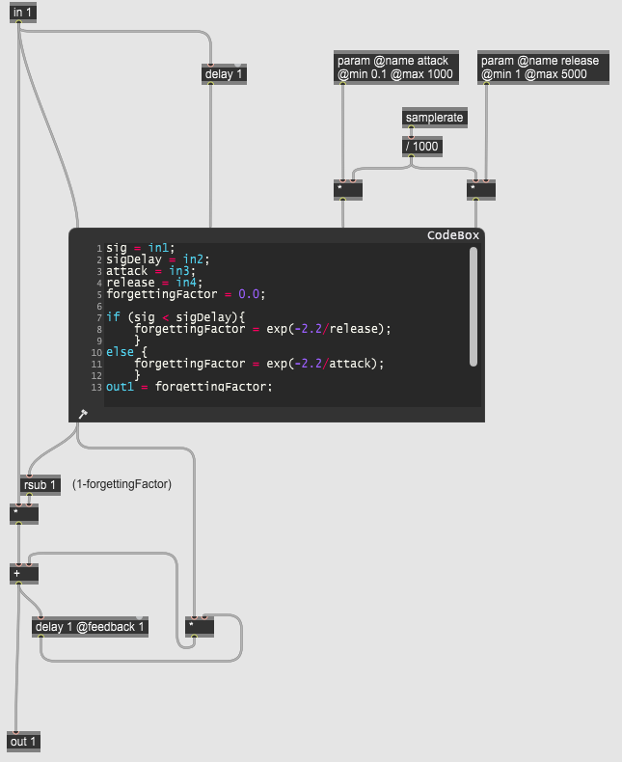The GainSmoothing can be seen in Figure 6

Figure : GainSmoothing

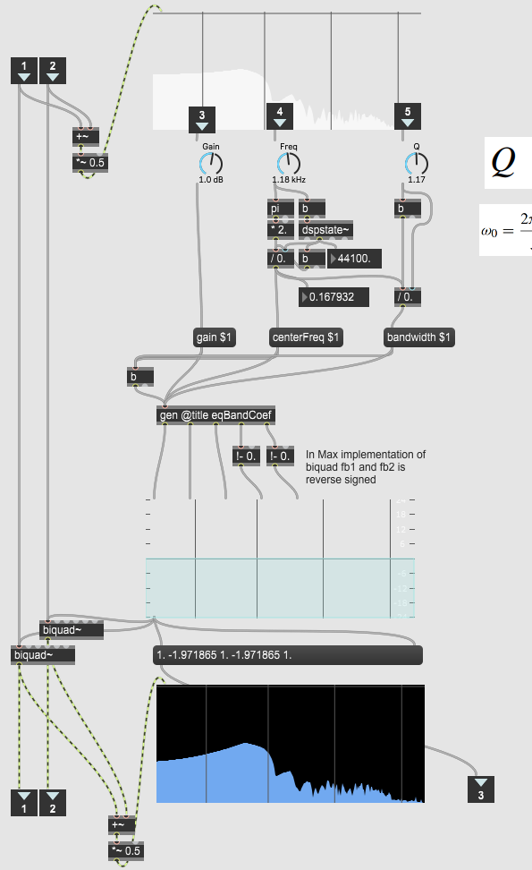The eq filter are all built the same way. But all have a different gen patches to calculate the filter coefficients fort the biquad filter. On Figure 7 an eq patcher is shown with a gen patch calculating the coefficients for the band filter. The filter calculations are shown on the next pages.

Figure : Eq patcher (bandeq)

The calculations for the band pass filter are shown in Figure 8.

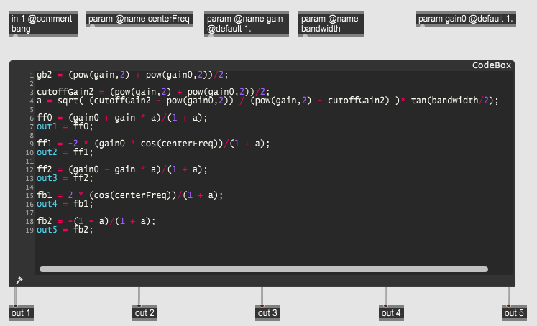

Figure : eqBandCoef

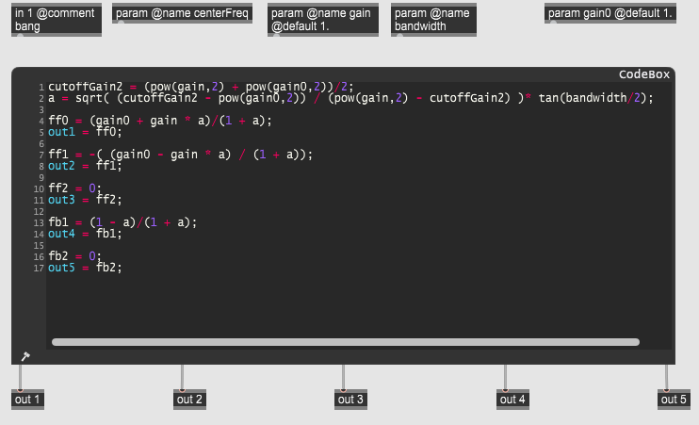The calculations for the low shelf filter are shown in Figure 9

Figure : eqLowShelfCoef

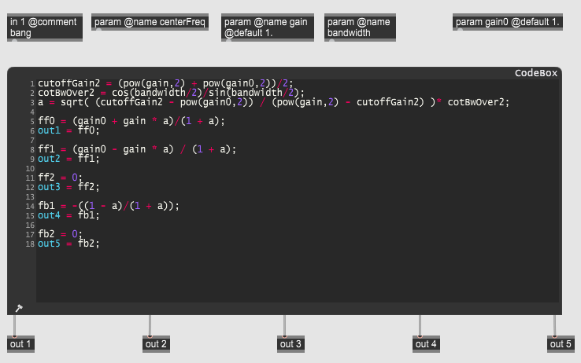The calculations for the high shelf filter are shown in Figure 10

Figure : eqHighShelfCoef