Group-Based Community Interventions to Support the Social Reintegration of Marginalized Adults with Mental Illness: A Systematic Review and Meta-Analysis

This paper presents a preregistered systematic review and meta-analysis of the effects of group-based community interventions for socially marginalized adults with mental illness in OECD countries. Extensive literature searches identified 28,980 records from which 49 studies (349 effect sizes) contributed to the meta-analysis. Outcomes were categorized as social reintegration, including social functioning, loneliness, employment, and quality of life, or mental health, including anxiety, depression, and psychotic symptoms. Sophisticated multivariate meta-analysis showed that group-based interventions improved both social reintegration (g = 0.195, 95% CI[0.122-0.268]) and mental health (g = 0.215, 95% CI[0.090-0.340]) relative to control conditions. Effects were generally invariant across sensitivity and moderator analyses, and showed little indication of publication bias. Nearly half of the included studies were preregistered, strengthening confidence in the evidence. Overall, these findings suggest that group-based interventions can support multidimensional recovery among adults experiencing both mental and social problems, while offering cost-effective alternatives to individual care.

Authors
Nina Thorup Dalgaard¹, Jakob Kaarup Jensen², Jasmin Sami Adada³, Maya Christiane Flensborg Jensen¹, Elizabeth Bengtsen³, Mikkel Helding Vembye¹
Affiliations
¹ VIVE – The Danish Center for Social Science Research, Denmark
² ROCKWOOL Foundation, Denmark
³ Independent researcher
Corresponding author
Mikkel Helding Vembye, mihv@vive.dk

Mental illness is often accompanied by social and personal adversities that extend beyond psychiatric symptoms. Adults with mental illness are at elevated risk of substance use, homelessness, unemployment, poverty, self-harm, criminal justice involvement, and social isolation. These co-occurring problems can intensify stigma, deepen exclusion, and increase public costs.^{1–4} Mental illness and marginalization may also become mutually reinforcing: people may withdraw from social participation because of anticipated or experienced stigma, while isolation and exclusion can further worsen mental health.^{5–7} For many adults, the challenge is therefore not only to manage symptoms, but also to sustain relationships, participate in social life, and avoid persistent exclusion.
This broader reality poses a challenge for intervention research. Many mental health interventions are designed primarily to reduce symptoms of a specific disorder. Yet, symptom reduction alone does not capture whether people become more socially integrated or are able to live meaningful and connected lives. For adults facing both psychiatric difficulties and social marginalization, recovery may also depend on housing stability, employment, reduced substance use, stronger social ties, improved quality of life, and a greater sense of agency.
A range of interventions has been developed to address these needs, including occupational therapy, case management, psychoeducation, supportive psychotherapy, and mentoring. However, such interventions are often resource-intensive, and evidence of their effectiveness remains mixed.^{8–10} At the same time, mental healthcare systems in many high-income countries have shifted from hospital-centered care toward community-based and outpatient services. This transition has increased pressure on local systems to deliver effective support under constrained budgets.¹¹ Within this context, group-based interventions have become increasingly attractive because they can serve multiple participants simultaneously and may offer a more scalable alternative to individually delivered care with low costs.^{12,13}
Group-based interventions may also offer benefits beyond efficiency. Their distinctive feature is that interpersonal contact and social support are built into the intervention itself. Group-based interventions will often be provided in a small, selected group of individuals who meet regularly with a therapist or case worker.¹⁴ This may be especially important for populations whose difficulties are closely linked to loneliness, stigma, and impaired social functioning¹². Across mental health conditions, interpersonal functioning and social support are important predictors of relapse, recurrence, and longer-term adjustment.^{15–18} These are also modifiable factors relevant to sustained recovery¹⁹. Group settings may therefore address mechanisms that individual treatment cannot fully target, including social learning, mutual recognition, shared norms, and supportive relationships.^{12,17–20}
These potential benefits can be understood through recovery²¹ and social identity²² perspectives. A recovery perspective emphasizes that improvement is not limited to symptom remission, but includes building a satisfying and meaningful life despite ongoing difficulties. Group-based interventions may support recovery by fostering coping skills, confidence, hope, and participation in social and occupational roles. A social identity perspective suggests that becoming part of a group may reshape how marginalized individuals see themselves and others. Group membership can foster a sense of belonging, validate experiences, and promote health-related behaviors through shared norms and mutual support.
Yet the promise of group-based interventions should not be assumed. Group processes can also be harmful^{14,23,24}. Poor cohesion, breaches of confidentiality, invalidation or rejection by other members may reinforce feelings of isolation and low self-worth. More generally, not all participants are equally likely to benefit from the same treatment format. Depending on diagnosis, comorbidity, interpersonal style, or broader circumstances, some individuals may benefit less from group-based care than from individual intervention. The key question is therefore not simply whether group-based interventions work, but for whom, under what conditions, and whether they improve outcomes relevant to both mental health and social reintegration among marginalized adults with mental illness.
Existing evidence does not provide a clear answer regarding the effects of group-based interventions on social reintegration outcomes. Reviews of psychiatric group interventions^{25,26} have largely focused on specific diagnoses and typically prioritize symptom reduction as the main endpoint. Other reviews have examined broader outcomes in areas such as psychosis recovery, substance use, homelessness, and trauma, but these studies tend to focus on narrower populations, single comorbidities, or specific intervention models^{27–32}. As a result, the evidence base remains fragmented. We still know relatively little about whether group-based community interventions improve the wider outcomes that matter for adults living with both mental illness and social marginalization.
This gap is important for science and policy. The social and economic burden of comorbidity is substantial. Yet, many evaluations rely on narrow clinical outcomes that may underestimate the value of interventions affecting housing, work, social functioning, or quality of life. Policymakers are increasingly asked to fund group-based community interventions because of their potential scalability and lower cost relative to individual treatment. These decisions require stronger evidence.
The present review addresses this gap by systematically evaluating group-based community interventions for adults with mental illness who also experience social or personal problems associated with marginalization. We examine effects not only on mental health, but also on social reintegration outcomes, including substance use, homelessness, employment, loneliness, well-being, and quality of life. By synthesizing evidence across intervention types and populations, the review assesses whether group-based community interventions more generally support multidimensional recovery in a population for whom both clinical and social outcomes are central.
We address four research questions. First, what is the overall effect of group-based community interventions on social reintegration outcomes, such as problem behavior, subjective well-being, homelessness, poverty, and employment? Second, do effects on social reintegration vary across substantive (i.e., theoretically and empirically relevant) or methodological moderators? Third, what is the overall effect of these interventions on mental health outcomes? Fourth, do effects on mental health vary across substantive or methodological moderators?
These questions follow the analysis plan specified in our preregistered and peer-reviewed protocol³³, although we refined the wording to state the review aims more precisely. Our primary focus is on social reintegration outcomes, which reflect the main aim of the review. Because the protocol primarily focused, albeit indirectly, on social reintegration rather than mental health, analyses of mental health outcomes should be considered exploratory. All materials supporting this manuscript are available on OSF at https://osf.io/s2j9a. We used generative AI for text editing and coding support; we take full responsibility for the final content of the manuscript.

Results

Preregistration has increased over the last decade
As shown in Figure 1, the search identified 62 eligible studies, comprising 51 randomized controlled trials (RCTs) and 11 non-randomized studies with at least one intervention and one control group. Together, these studies included 62 independent samples of participants. Of the 62 eligible studies, 49 studies containing 349 effect sizes were included in the meta-analysis. The remaining 13 studies were excluded from quantitative synthesis because one study was judged to be at critical risk of bias, and 12 studies did not report sufficient information to calculate effect sizes. In the Supplementary Material, we assess whether the conclusions of these 12 studies differed from the overall meta-analytic findings, and found no indication that they reached different conclusions.

FIG. 1 | Flow chart of the screening process, following the Preferred Reporting Items for Systematic Reviews and Meta-Analyses (PRISMA) guideline.
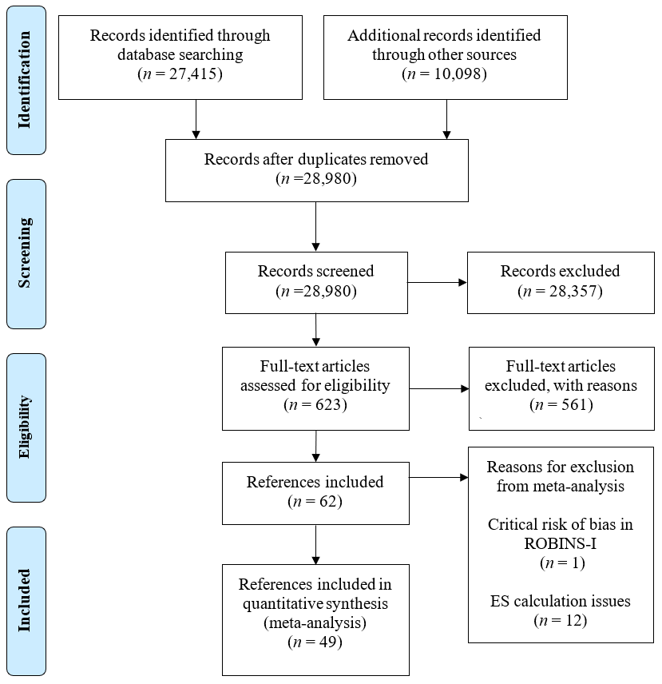

Figure 2 shows the publication year and preregistration status of the studies included in the meta-analysis. The evidence base has grown substantially since 2009, with 40 (82%) studies published from 2009 onwards. Preregistration also became increasingly common after 2012: among studies published between 2012 and 2022, 23 of 34 studies were preregistered. This pattern suggests a marked improvement in the transparency and methodological quality of the literature over time.

Fig. 2 | Number of studies included in meta-analysis by year and type of registration
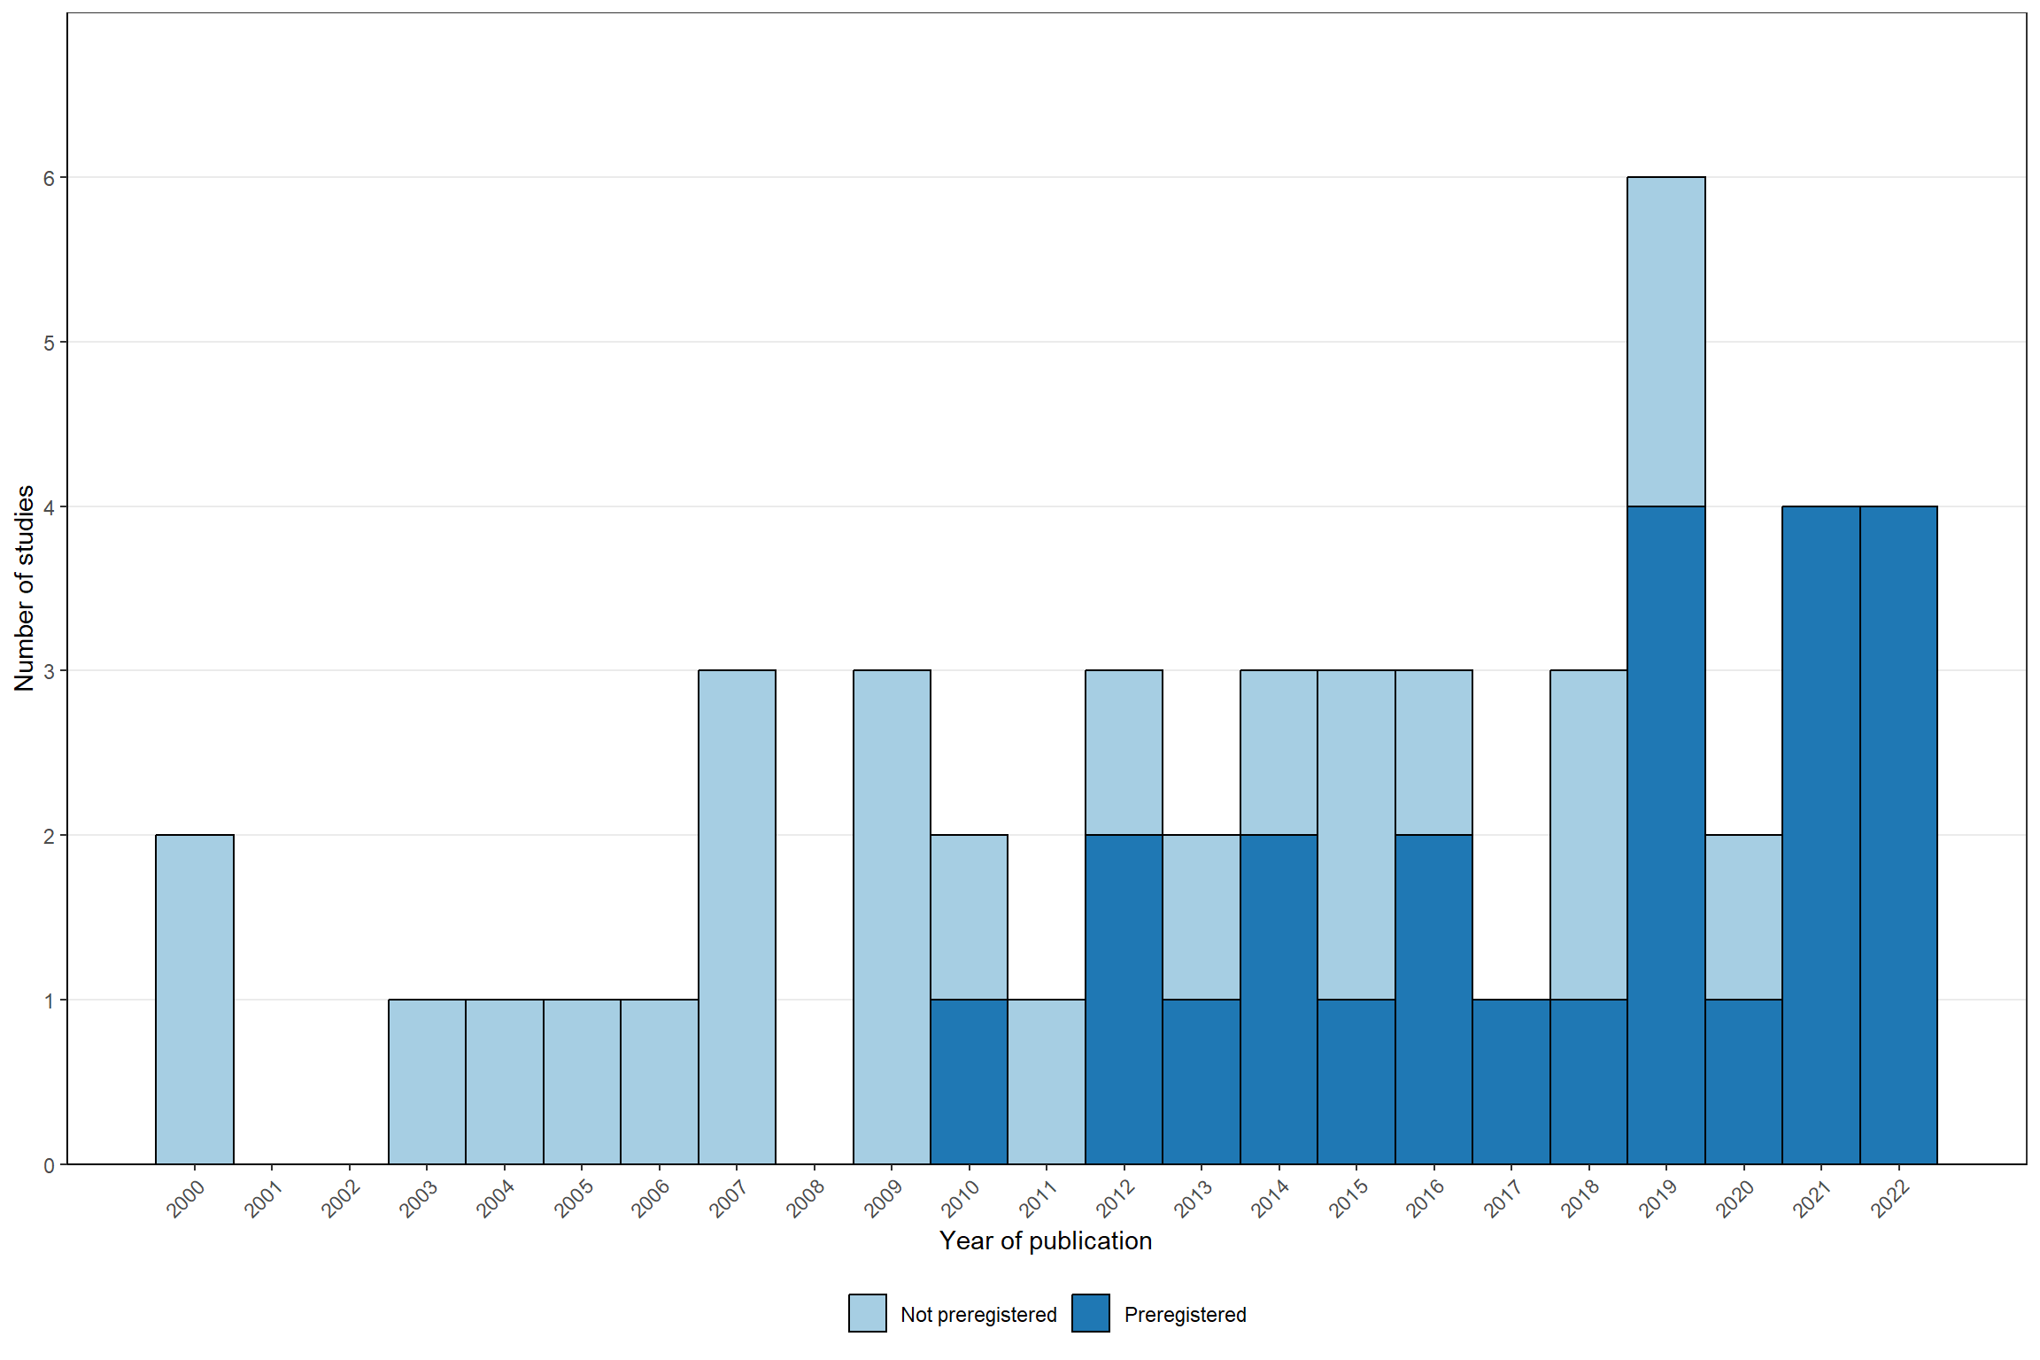

Diverse types of group-based interventions
The included studies evaluated a broad range of group-based interventions, as highlighted in Table 1.
Table 1 | Included group-based interventions
Intervention category | Studies | In meta-analysis
Group-based cognitive behavioral therapy^{34–45} | 12 | 10
Group psychoeducation and social skills training^{46–54} | 9 | 6
Illness management^{55–62} | 8 | 8
Social cognition and interaction training^{63–68} | 6 | 6
Cognitive-behavioral social skills training^{41,69–73} | 6 | 3
Group psychoeducation^{74–78} | 5 | 3
Illness and addiction management^{79–82} | 4 | 2
Vocational training^{83–85} | 3 | 2
Addiction management^{86,87} | 2 | 2
Residential treatment^{88,89} | 2 | 2
Seeking Safety^{87,90} | 2 | 2
Social network training^{91,92} | 2 | 2
Positive psychology group intervention^{93,94} | 2 | 2
Art therapy⁶³ | 1 | 1
Reading group intervention⁹⁵ | 1 | 1
Note. The numbers might sum to more than 62 (i.e., 65) and 49 (i.e., 52) studies included meta-analysis, as three studies contributed with two treatments each.
Interventions were categorized by their primary content and therapeutic focus. Most combined symptom management, psychoeducation, social-skills training, or CBT-based techniques reflect the dual clinical and social aims of the review. Smaller groups of studies addressed addiction, employment, residential support, social network development, positive thinking, trauma-related coping, art therapy, or reading-based reflection. Some interventions included elements from multiple categories, but each study was assigned to the category that best captured its main component.

Types of participants
The included studies covered a clinically diverse population, but with a clear concentration around schizophrenia or other primary psychotic disorders, followed by depressive, bipolar, and anxiety disorders. Indicators of social marginalization were more unevenly reported. Substance abuse was the most frequently specified social or personal problem, whereas homelessness, loneliness, and criminal justice involvement were rarely represented. Notably, nearly half of the studies did not clearly specify the form of social marginalization. Here, ‘not clearly specified’ means that the study authors did not explicitly state the relevant characteristic, but that it could be identified from their description of the participant sample. Find a full description of the included participants by primary type of mental disorder and primary indicator of social marginalization in the Supplementary Material Table S1.

Descriptive statistics
Table 3 presents descriptive percentages for the studies and outcomes included in the meta-analysis of social reintegration outcomes. Descriptive averages for the social reintegration outcomes and the descriptive statistics for mental health can be found in the Supplementary Material Tables S2-S4. The meta-analysis of social reintegration outcomes included 46 studies, 205 effect sizes, and 5,406 participants. All studies were journal articles and reported short-term effects, defined per-protocol as outcomes measured within one year after the intervention. Measurement timing within this period did not explain variation in effect sizes.
Studies were conducted mainly in the United States (13 studies), Europe (15), and Commonwealth countries (16), with only two studies from Asia. The most frequently assessed social reintegration outcomes were well-being and quality of life (25 studies), social functioning (17), hope, empowerment, and self-efficacy (12), and alcohol or drug use (8). Less common outcomes included self-esteem, loneliness, physical health, employment, and psychiatric hospitalization; the latter three were combined into an “Other” category for subgroup analyses.
Most outcomes were self-reported: 39 studies contributed 168 self-reported effect sizes, while 12 studies contributed 36 clinician-rated effect sizes. Twenty-four studies reported treatment-on-the-treated effects, and 22 reported intention-to-treat effects.
Participants were, on average, 41 years old (median = 41; range = 25-67), and the samples were 47% male (median = 46; range = 0-81). The average raw sample size was 118 participants, although the median was 60 (range = 16-631), indicating that a few large studies increased the mean. Treatment and control group sizes were generally balanced, and the average treatment group size of the group-based interventions was 7.9 participants (median 8, range 4-22).
Most studies were randomized controlled trials (38 of 46), of which 22 were preregistered. The remaining eight were quasi-experimental. Only three studies accounted for clustering introduced by group-based delivery. The most common comparison condition was treatment as usual, with or without a waiting list (39 studies). Interventions lasted, on average, 18 weeks (median = 12; range = 4-78), with most delivered at a frequency of 0.5 to 2 sessions per week. See Online Appendix B Figure 72 for a visualization of the joint distribution of duration and intensity.
Table 3 | Descriptive percentages for the included studies with reintegration outcomes
Characteristics | Studies (j) | Effects (m) | % Studies | % Effects
Context
Australia | 9 | 15 | 19.6 | 7.3
Austria | 1 | 1 | 2.2 | 0.5
Canada | 4 | 12 | 8.7 | 5.9
Korea | 1 | 1 | 2.2 | 0.5
Finland | 1 | 5 | 2.2 | 2.4
Germany | 4 | 46 | 8.7 | 22.4
Ireland | 1 | 6 | 2.2 | 2.9
Italy | 1 | 2 | 2.2 | 1.0
Japan | 1 | 2 | 2.2 | 1.0
Netherlands | 2 | 14 | 4.3 | 6.8
Norway | 2 | 3 | 4.3 | 1.5
Spain | 2 | 35 | 4.3 | 17.1
Turkey | 1 | 2 | 2.2 | 1.0
UK | 3 | 19 | 6.5 | 9.3
US | 13 | 42 | 28.3 | 20.5
Outcome measure
Alcohol and drug abuse/misuse | 8 | 32 | 17.4 | 15.6
Employment | 1 | 2 | 2.2 | 1.0
Hope, empowerment & self-efficacy | 12 | 32 | 26.1 | 15.6
Loneliness | 4 | 5 | 8.7 | 2.4
Physical health | 2 | 3 | 4.3 | 1.5
Psychiatric hospitalization | 1 | 1 | 2.2 | 0.5
Self-esteem | 5 | 14 | 10.9 | 6.8
Social functioning (degree of impairment) | 17 | 48 | 37.0 | 23.4
Well-being and quality of life | 25 | 68 | 54.3 | 33.2
Diagnosis in the sample
Schizophrenia | 9 | 33 | 19.6 | 16.1
Other | 37 | 172 | 80.4 | 83.9
Intervention type
CBT | 12 | 55 | 26.1 | 26.8
Other | 35 | 150 | 76.1 | 73.2
Preregistration status
Not preregistered | 24 | 65 | 52.2 | 31.7
Preregistered | 22 | 140 | 47.8 | 68.3
Outlet
Journal article | 46 | 205 | 100.0 | 100.0
Research design
QES | 8 | 18 | 17.4 | 8.8
RCT | 38 | 187 | 82.6 | 91.2
Test type
Clinician-rated measure | 12 | 36 | 26.1 | 17.6
Raw events | 1 | 1 | 2.2 | 0.5
Self-reported | 39 | 168 | 84.8 | 82.0
Analysis strategy
ITT | 22 | 108 | 47.8 | 52.7
TOT | 24 | 97 | 52.2 | 47.3
Control group
Individual treatment | 3 | 4 | 6.5 | 2.0
TAU | 30 | 154 | 65.2 | 75.1
TAU with Waiting-list | 9 | 34 | 19.6 | 16.6
Waiting-list only | 4 | 13 | 8.7 | 6.3
Overall risk of bias
Low | 10 | 69 | 21.7 | 33.7
Some concerns/Moderate | 21 | 94 | 45.7 | 45.9
Serious/High | 16 | 42 | 34.8 | 20.5
Timing of measurement
Short-term measure (< 52 weeks) | 46 | 205 | 100.0 | 100.0
Effect size metric
Posttest only ES | 1 | 2 | 2.2 | 1.0
Pre-posttest/covariate adj. ES | 45 | 203 | 97.8 | 99.0
Handles multilevel structure
No | 43 | 186 | 93.5 | 90.7
Yes | 3 | 19 | 6.5 | 9.3
Note: ES = Effect size, ITT = Intention-To-Treat; TOT; Treatment-On-the-Treated; QES = Quasi-Experimental Design (non- randomized); RCT = Randomized Controlled Trial; TAU = Treatment as usual; CBT = cognitive behavioral therapy

The overall descriptive statistical patterns were proportionally similar between social reintegration and mental health outcomes. The mental health dataset included 144 effect sizes derived from 42 studies, encompassing a total of 4679 individual participants. Specifically, nine studies contributed 14 effect sizes for anxiety, 20 studies contributed 37 effect sizes for depression, 29 studies contributed 72 effect sizes for general mental health, and seven studies contributed 21 effect sizes for psychotic symptoms. Of note, three studies^{53,57,62} were included in this data only, as they did not report on any usable social reintegration outcomes.

The quality of the evidence is generally sound
We conducted comprehensive risk-of-bias assessments to exclude critically flawed evidence, examine whether study quality influenced the meta-analytic findings, and describe the overall quality of the literature. Risk of bias for randomized studies was assessed using Cochrane’s RoB 2⁹⁶ and is shown across preregistration status in Figure 3 Panel (A) for social reintegration and mental health outcomes. This distinction was only relevant for randomized trials, as no non-randomized studies were preregistered. Additional risk-of-bias plots are provided in the Online Appendix B, Figures 1-24.
Overall, most effect sizes from randomized trials were judged to have an overall low risk of bias or some concerns: approximately 90% for both social reintegration and mental health outcomes. Preregistered studies were generally less biased than non-preregistered studies, particularly because prespecified protocols reduced concerns about selective reporting.

Fig. 3 | Risk of bias assessments of randomized controlled trials and non-randomized studies
(A)  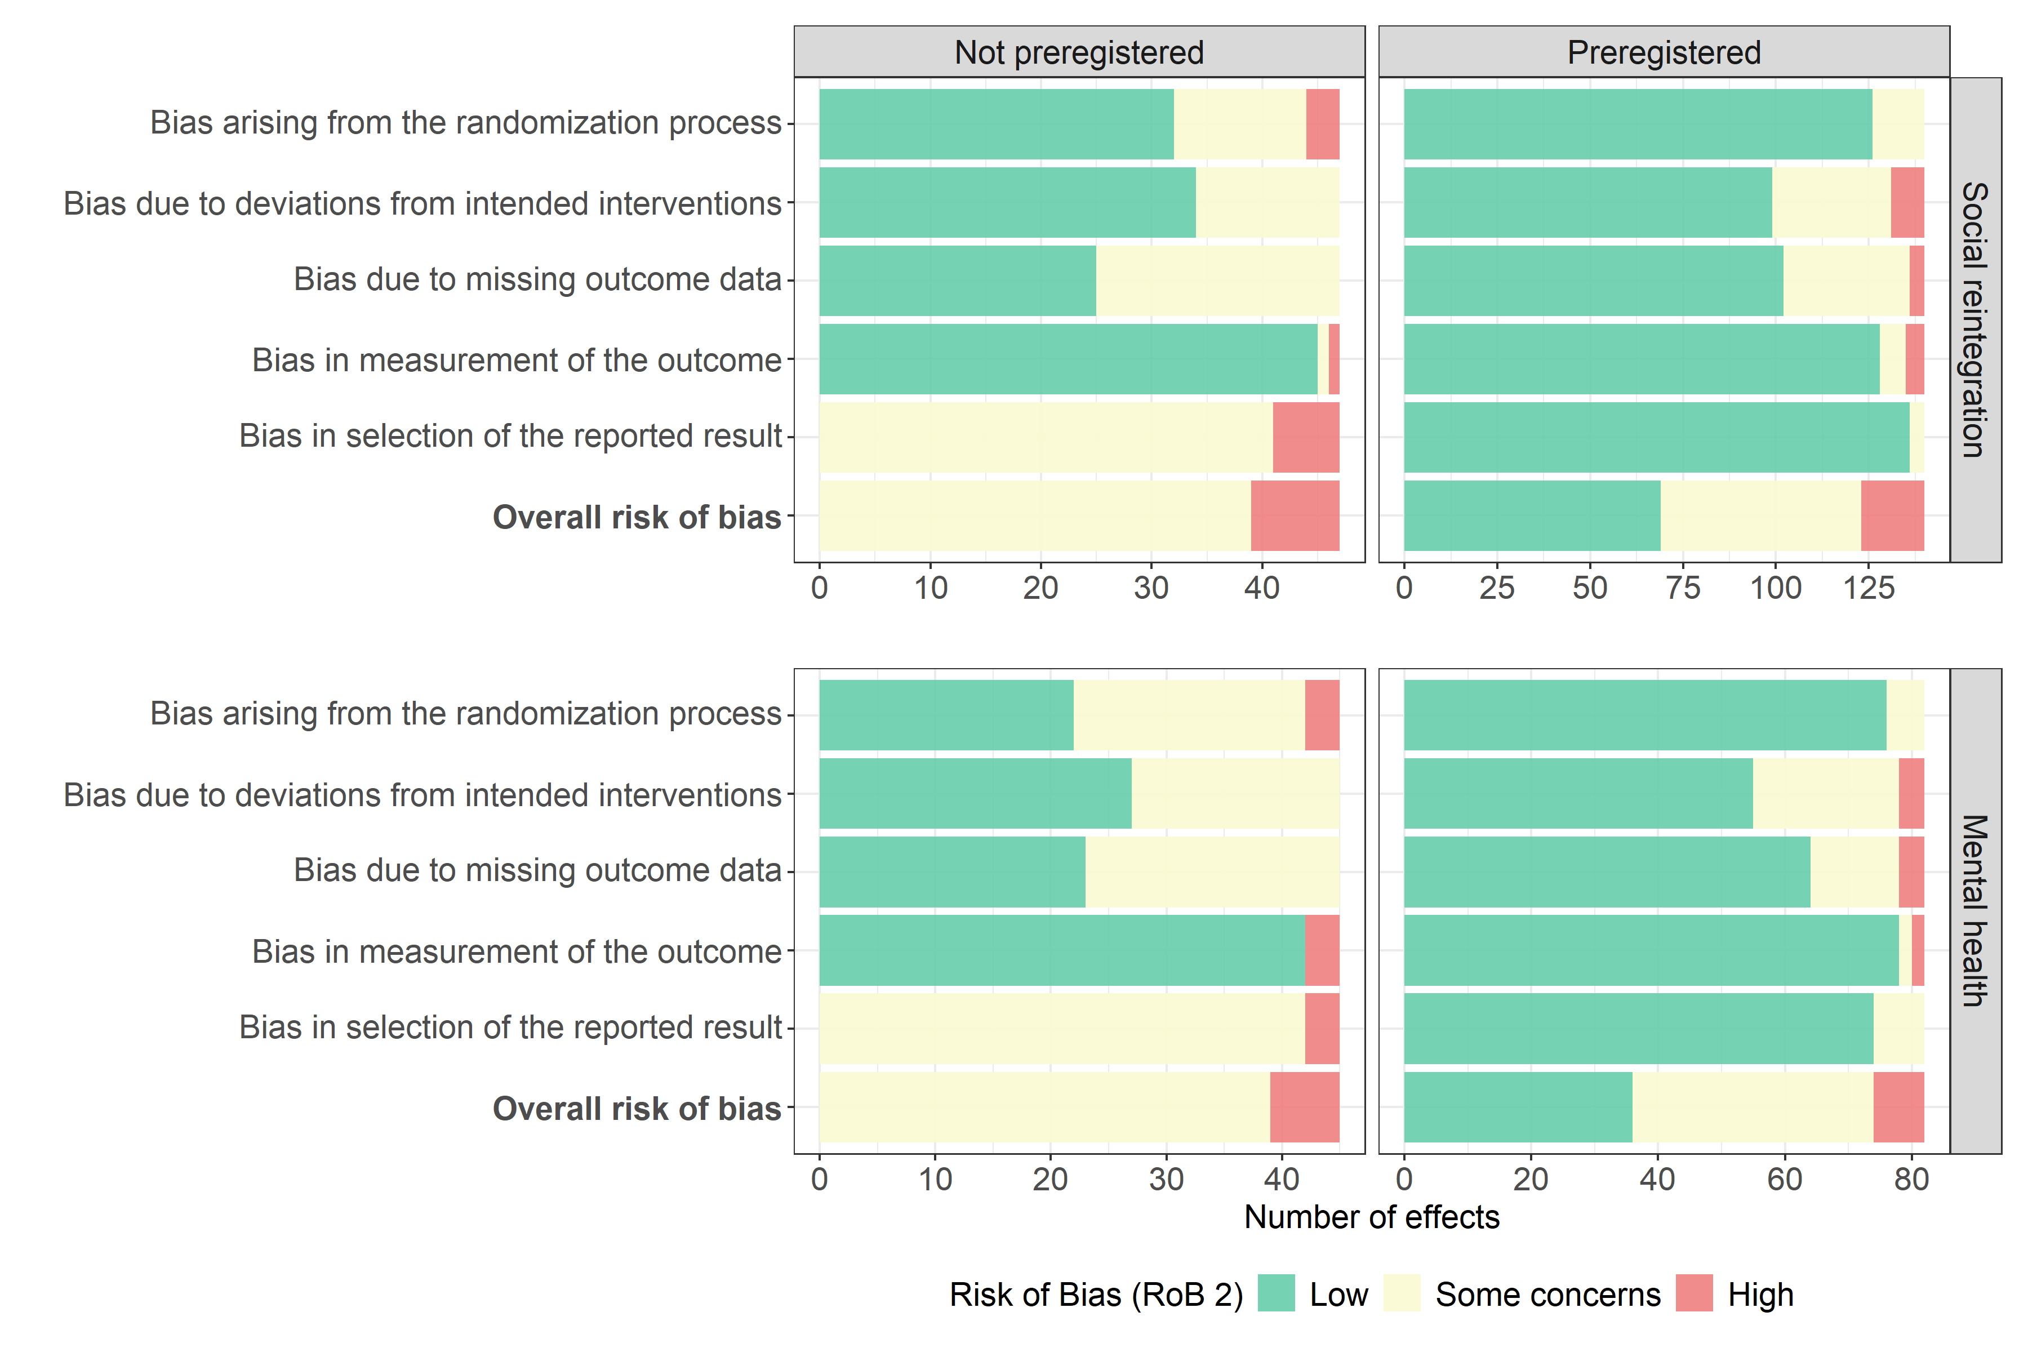 | (B)  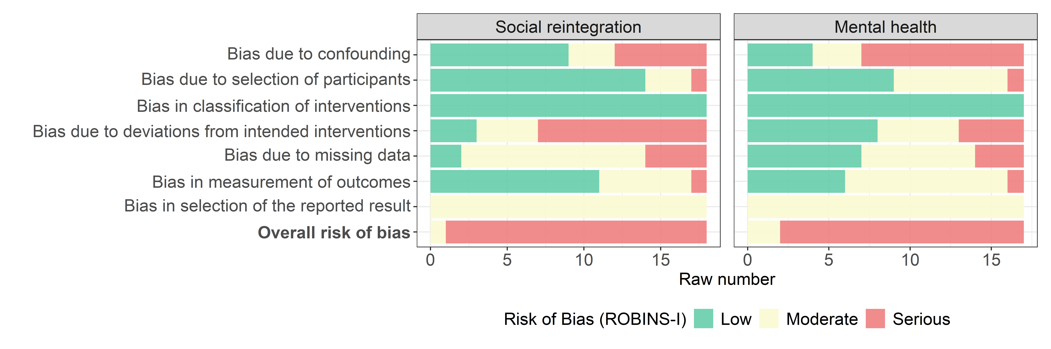
Note. Panel (A) is based on 187 social reintegration effect sizes from 38 studies and 127 mental health effect sizes from 34 studies. Panel (B) is based on 18 social reintegration effect sizes from 8 studies and 17 mental health effect sizes from 8 studies. studies.
As shown in Figure 3 Panel (B), the risk of bias was generally higher among non-randomized studies assessed with Cochrane’s ROBINS-I.⁹⁷ Most effect sizes were judged to be at serious risk of bias, primarily because of confounding and deviation from the intended intervention. Other concerns included missing data. Because none of the non-randomized studies had a prespecified protocol, none could receive an overall low risk of bias judgment. We excluded one non-randomized study⁷⁴ from the meta-analysis because it was judged to be at critical risk of bias.
Given these concerns, risk of bias was included as a control variable in the covariate-adjusted moderator analyses. However, we found no systematic or substantial differences in effect sizes between studies judged to be at high or serious risk of bias and those judged to be at low or moderate/some concern risk.

Significant impact on both social integration and mental health
Figure 4 depicts the distribution of all effect sizes across studies and the type of outcome. For more detailed forest plots, including study weights, see Supplementary Material Figures S2-S3.
Across the main analyses, group-based community interventions produced statistically significant benefits for both social reintegration and mental health. The meta-analysis of social reintegration yielded a positive overall average effect of 0.195 SD (95% CI [0.122, 0.268], t(24.9) = 5.51, p < 0.001). This indicates that participants receiving group-based interventions had better reintegration outcomes than those receiving individual treatment, treatment as usual, or wait-list controls. The effect was approximately 2.3 times larger than the typical improvement observed under treatment as usual.
For mental health outcomes, the meta-analysis yielded a positive overall average effect of 0.215 SD (95% CI [0.090, 0.340], t(37.5) = 3.48, p = .001). This effect was approximately 1.4 times larger than the typical improvement observed under treatment as usual.

Fig. 4 | Effect size forest plot across dependent effect sizes by type of outcome
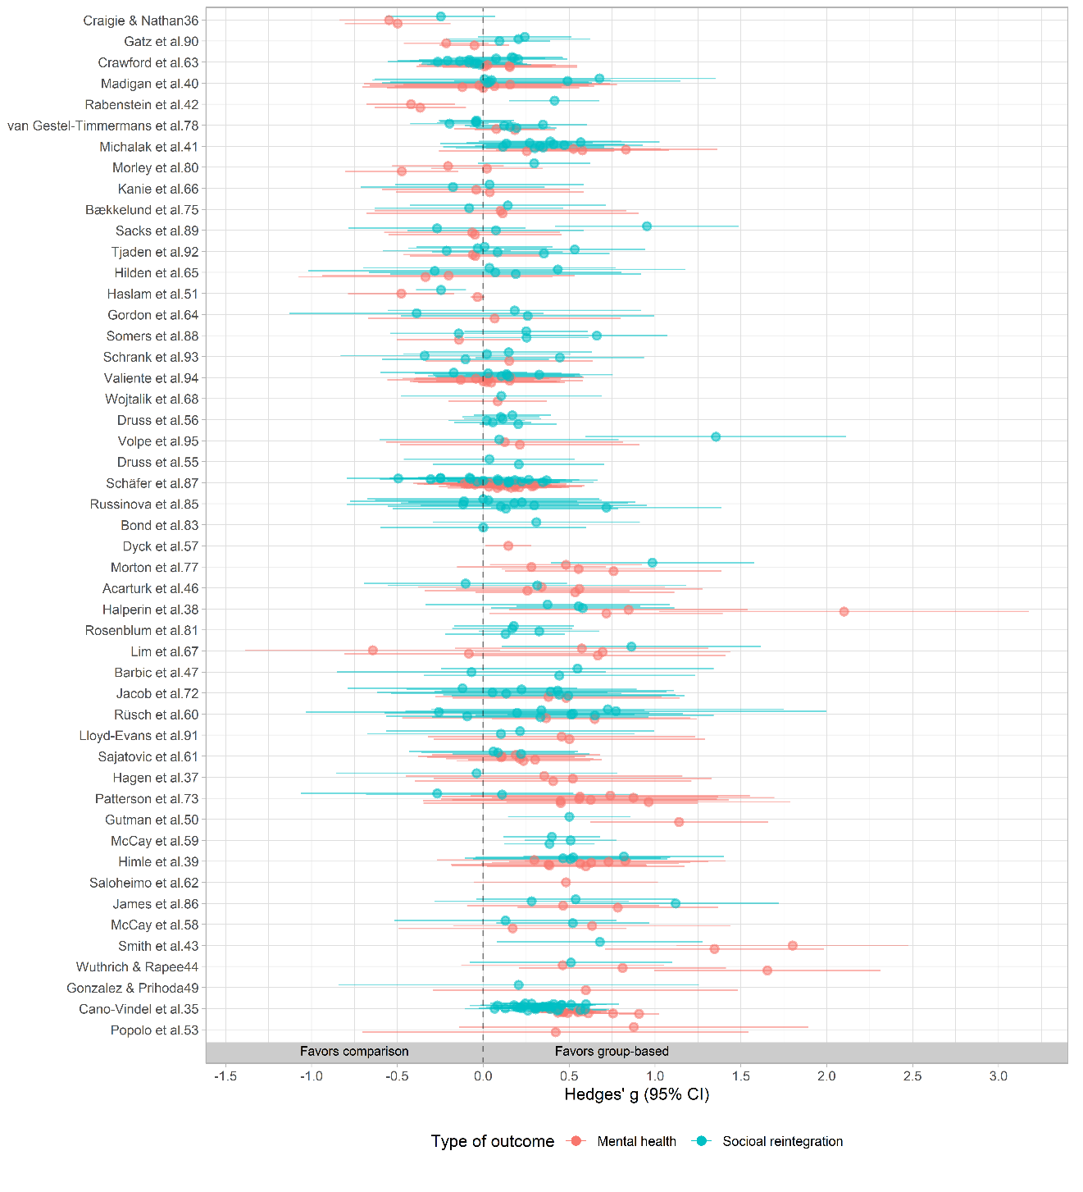

In addition, and as depicted in Figure 5, we find that effects on social reintegration and mental health also covaried: studies showing larger reintegration gains tended to show larger mental health gains. This suggests that group-based community interventions may support multidimensional recovery, improving both social participation and clinical well-being.

Fig. 5 | Scatter plot illustrating the aggregated effects of social reintegration and mental health outcomes
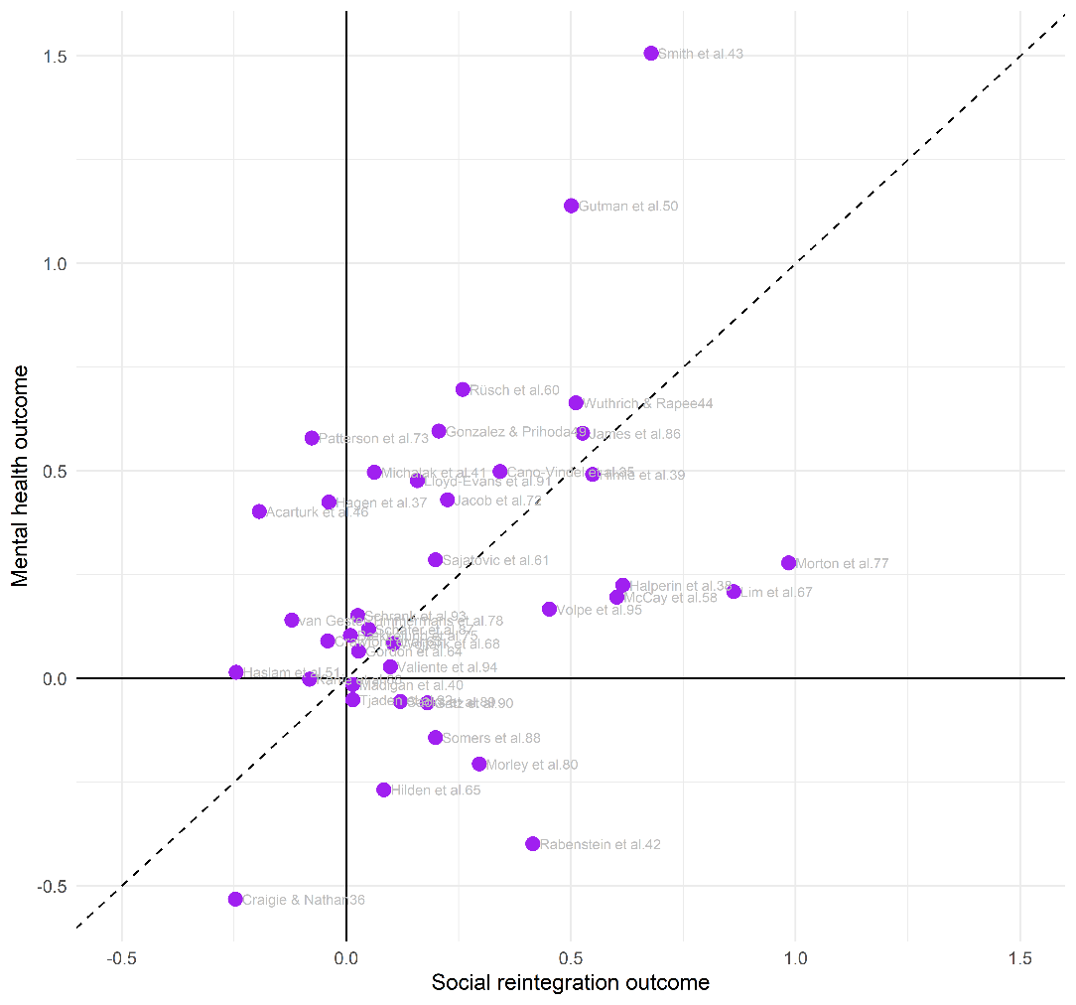
Note. This plot is based on the 39 studies that both report social integration and mental health outcomes. The dashed line indicates equal effects on social reintegration and mental health.

Substantial heterogeneity across both types of outcomes
There was substantial heterogeneity in both outcome domains, indicating that the effects of group-based community interventions varied considerably across studies and effect sizes. For social reintegration outcomes, heterogeneity was high, with Q(204) = 1220.8, p < 0.001, $I²$ = 88.9% and total heterogeneity of 0.204 SD. Most of this variation occurred within studies rather than between studies, suggesting that effects differed meaningfully across outcome measures within the same study. The 67% prediction interval ranged from −0.012 to 0.401, and approximately 82% of future studies would be expected to yield effects above zero.
Heterogeneity was even larger for mental health outcomes, with Q(143) = 174072.2, p < .001, $I²$ = 99.94% and total heterogeneity of 0.333 SD. In contrast to the reintegration analysis, most variation occurred between studies, suggesting that study-level differences, such as population, intervention type, or implementation context, may be especially important for mental health effects. The 67% prediction interval ranged from −0.120 to 0.549, with approximately 74% of future studies expected to show positive effects.
Overall, the predictive distributions indicate that group-based interventions are likely to produce positive effects in most future studies, particularly for social reintegration. However, the wider prediction interval for mental health suggests that effects on clinical outcomes are less stable and may depend more strongly on study context, population, or intervention characteristics. However, it is important to remember that effects equivalent to individual treatment may have practical value if more people can be treated with the same resources.

Robust results across sensitivity analyses
Sensitivity analyses showed that the main findings were robust. The overall effect for social reintegration was largely unchanged across alternative assumptions about within-study effect-size correlations, while the mental health effect decreased only slightly as the assumed correlation among within-study effect sizes increased. Leave-one-study-out analyses indicated that no single study drove the overall effects in either outcome domain.
Results were also stable across alternative effect-size calculations and inclusion criteria. When analyses were restricted to low-risk-of-bias effect sizes, estimates were no longer statistically significant, but their magnitude remained close to the main effects, suggesting reduced statistical power rather than a substantive change in conclusions. Overall, the sensitivity analyses support the robustness of the main findings. Find detailed sensitivity results in the Online Appendix D and visualizations of the main sensitivity analyses in the Supplementary Figures S4-S5.

No indication of publication bias and related issues
We conducted a range of complementary publication bias analyses, as recommended in meta-analysis^{98–101}, finding little evidence that the main findings were driven by selective publication, selective reporting, or p-hacking. As seen in the funnel plots in Figure 6, we found no consistent association between effect sizes and standard errors, and publication bias-adjusted estimates generally remained positive. Overall, publication bias does not appear to be a major concern, likely aided by the high proportion of preregistered studies. See the Supplementary Table S5 for publication-bias adjusted overall average effects. Moreover, all publication bias tests and visualizations can be found in the Online Appendix E.

Fig. 6 | Funnel plot across registration status and type of outcome
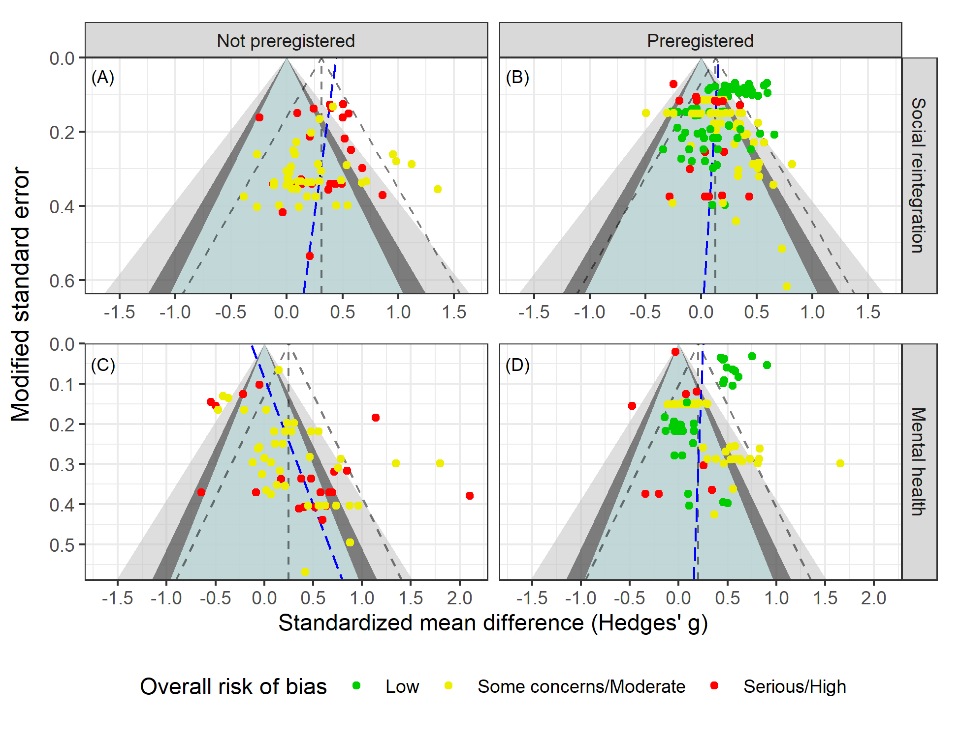
Note. Following van Aert¹⁰², slopes at the effect size level were obtained from PECHE-ISCW-RVE⁹⁹ tests. Effects in the green region have p-values above 0.1, effects in the dark gray area have p-values between 0.05-0.1, effects in the light gray area contain p-values ranging from 0.01 to 0.05, and finally effects in the white area have p-values less than 0.01.

Moderators explained little heterogeneity
Given the substantial heterogeneity in both outcome domains, we conducted protocol-informed meta-regression analyses to examine whether effects varied by substantive or methodological moderators. Analyses were conducted separately for social reintegration and mental health outcomes, using both unadjusted and covariate-adjusted models. Results were generally similar across model specifications, although covariate-adjusted estimates were often slightly larger. All conducted moderator analyses can be found in the Supplementary Material Tables S6-S11.
Overall, moderators explained little of the heterogeneity among social reintegration outcomes. Most subgroup estimates clustered around the main effect, and differences between subgroups were generally small and statistically insignificant. We found no clear evidence that effects differed by reintegration outcome type, schizophrenia status, cognitive behavioral therapy versus other intervention types, risk of bias, intervention duration, session frequency, follow-up timing, or sample gender composition. Some extreme subgroup estimates were based on very few studies and should therefore be interpreted cautiously.
The main exception was preregistration: preregistered studies produced smaller effects than non-preregistered studies. This difference was statistically significant only at the conventional 0.05 level, but not after adjustment for multiplicity^{103–105}. Nevertheless, the effect among preregistered studies remained statistically significant and substantively meaningful in size (g = 0.130, 95% CI[0.030, 0.220]), corresponding to an effect 1.6 times larger than the typical improvement in social reintegration under treatment as usual. Moreover, preregistration explained only a small share of the heterogeneity in effects.
As with social reintegration outcomes, most moderators did not explain meaningful variation in mental health effect sizes. Unlike the reintegration analyses, preregistered and non-preregistered studies produced similar effects. Mental health effects showed a statistically significant association with participant age. Yet this association explained only a limited share of the heterogeneity across effects.
Overall, moderator analyses provided limited evidence that the effectiveness of group-based interventions depends strongly on measured study, sample, or intervention characteristics. The positive average effects were broadly consistent across subgroups, but remaining heterogeneity indicates that important sources of variation are unmeasured, potentially operating both within and between studies. Future research should focus on explaining the unmeasured heterogeneity.

Discussion
This review provides robust evidence that group-based community interventions benefit adults experiencing both mental illness and social marginalization, adding to existing evidence base showing the efficacy of group-based interventions^{13,25,106–109}. Across heterogeneous studies varying in intervention type, setting, implementation, design, outcomes, and participant characteristics, group-based interventions produced statistically significant improvements in both social reintegration and mental health. Effects on social reintegration were approximately 2.4 times larger than the typical gains observed under usual individual treatment, while effects on mental health were approximately 1.4 times larger. Importantly, effects across the two domains covaried: studies showing larger gains in social reintegration also tended to show larger gains in mental health. This suggests that group-based interventions may support multidimensional recovery rather than producing isolated improvements in a single outcome domain.
The findings were stable across extensive sensitivity analyses. Effect sizes remained similar in magnitude when varying analytic assumptions, inclusion criteria, and model specifications, and the main conclusions were not driven by studies judged to be at higher risk of bias. We also found little evidence of publication bias. A notable strength of this evidence base is that nearly half of the included trials were preregistered, which strengthens confidence in the robustness and transparency of the findings.
We conducted comprehensive moderator analyses to examine whether effects varied by outcome type, participant characteristics, intervention type, test type, preregistration status, research design, control condition, risk of bias, age, sex composition, intensity, duration, and measurement timing. Overall, moderators explained little of the observed heterogeneity. Effects were broadly consistent across subgroups and generally clustered around the overall mean. Close to all heterogeneity remained unexplained, indicating that important sources of variation may be unmeasured.
Although not all subgroup meta-analyses were statistically significant, all average subgroup effects consistently favored group-based interventions. This pattern suggests that group-based interventions are unlikely to produce adverse effects at the aggregate level. Consistent with this interpretation, only 9 of 349 effect sizes were negative and statistically different from zero. However, aggregate effects can mask individual-level variation: the absence of average deterioration does not imply that all participants benefited. Some individuals may still experience group-based interventions negatively, and future research should examine this participant-level heterogeneity more directly.
Several limitations should be noted. Though we used comprehensive database searches, grey-literature searches, and hand searches, some potentially relevant references could not be obtained in full text. In addition, though we were able to use highly sophisticated meta-analysis methods, 12 eligible studies could not be included in the meta-analysis because effect sizes could not be calculated. However, supplementary analyses found no indication that these studies reached different conclusions from the quantitative synthesis. Finally, although publication-bias tests were consistently reassuring, such tests are imperfect and cannot fully exclude selective reporting. Yet, the high number of preregistered studies might mitigate this issue.
The evidence appears broadly applicable to adults with psychiatric diagnoses who also experience personal or social difficulties. The included studies covered a wide range of countries, diagnoses, interventions, and outcomes, and we found no clear evidence that effects differed systematically by sample type, intervention type, or national context. However, the review focused specifically on adults experiencing both mental illness and indicators of social marginalization, not on all people receiving mental health care. Evidence that group-based interventions are superior to individually delivered interventions in other populations remains mixed^{25,106–109}. The present findings should therefore not be generalized beyond the target population of the review without caution.
The quality of the evidence was generally strong. Most studies included in the meta-analysis were randomized trials, and many were preregistered. Most effect sizes were rated as having low or moderate risk of bias, and only one study was excluded from the synthesis because of critical risk of bias. Nonetheless, studies were typically small, reflecting the difficulty of recruiting this population. We mitigated some small-study concerns (e.g., the impact of chance bias¹¹⁰) by using baseline- or covariate-adjusted effect sizes for nearly all included effects. A more important limitation is that all included studies measured outcomes within one year of the intervention. The evidence, therefore, speaks to short-term effects only and cannot determine whether gains persist, fade, or grow over time.
Still, the findings have direct implications for practice and policy. Mental health systems in many high-income countries face rising demand while hospital-based care is increasingly replaced by community services. Group-based interventions are attractive in this context because they can increase treatment intensity and structure at a lower cost than individually delivered care. Our findings suggest that such interventions are not merely cheaper substitutes: on average, they improve both social reintegration and mental health. However, most control conditions were treatment as usual rather than the same intervention delivered individually. Thus, some benefits may reflect greater intensity, organization, or face-to-face contact rather than the group format alone. Policymakers should therefore view group-based interventions as a promising strategy for strengthening community care, while recognizing that the precise active ingredients remain uncertain.
On this background, future research in this field must address five priorities. First, studies should compare the same intervention delivered individually and in groups to isolate the added value of the group format. Second, a longer follow-up is needed to determine whether effects persist and which intervention features support durable recovery. Third, future work should examine the heterogeneity of participant experience, including whether some individuals benefit less or experience harm from group-based formats. Fourth, future research should identify the factors that explain variation in intervention effects in this field. Fifth and finally, formal economic evaluations are also needed to quantify cost-effectiveness for adults facing both mental illness and social marginalization.

Methods

Protocol and preregistration
The protocol of this systematic review was peer-reviewed and pre-registered in Campbell Systematic Reviews³³. We followed the protocol to the greatest extent possible. However, we made a small number of protocol deviations, primarily to incorporate newer methods with better statistical performance than those available when the protocol was submitted. These updates reflected recent methodological developments and were implemented to keep the analyses aligned with current best practice. All data and code are openly available, enabling replication and reanalysis using the originally proposed methods.
Two further clarifications were made. We did not add a ‘critical’ risk-of-bias category to RoB 2, as the tool guidance does not permit modification, and we now distinguish more clearly between primary social reintegration outcomes and secondary mental health outcomes than in the original protocol.

Eligibility criteria

Types of studies and settings
The review included RCTs, cluster RCTs, quasi-randomized trials, and non-randomized studies¹¹¹ with a well-defined control group. Non-randomized studies had to demonstrate baseline equivalence or adequately control for key confounders. Baseline equivalence was assessed using Cochrane RoB2 for randomized studies and ROBINS-I for non-randomized studies. Single-group pre–post studies and studies comparing two group-based interventions without a non-group control condition were excluded.
Eligible interventions had to be delivered in community or outpatient settings and aim to support participants’ social reintegration. We excluded interventions delivered during inpatient hospital care, but included outpatient group-based services following hospitalization or delivered within psychiatric or hospital settings.

Type of participants (P)
The population of this review consists of adults in OECD countries with at least one psychiatric diagnosis who are experiencing personal and social problems in addition to their mental health condition. We included participants with any type of psychiatric diagnosis, drawing on both studies in which patients self-reported their diagnosis and studies in which diagnoses were established by a mental health professional. Social and personal problems are defined broadly.
We excluded studies of interventions targeting youth under the age of 18. Psychiatric patients, without any co-morbid personal and social problems, who received outpatient treatment for their specific mental disorder with symptom reduction as the primary aim, were also not eligible for this review.

Type of interventions (I)
We applied a broad definition of group-based interventions. This included all interventions targeting adults who suffer from mental illness and related social and personal problems that received an intervention delivered in a group format. Specifically, this means that more than one participant should have received the intervention simultaneously, in the same physical setting, and from the same therapist, caseworker, mentor, etc. In addition, interventions were required to take place in a community or outpatient setting.

Type of control group (C)
We included three control types: individually delivered versions of the intervention, treatment as usual, and wait-list comparisons. Studies comparing two group-based interventions without a non-group control condition were excluded.

Type outcome measures (O)
We analyzed outcomes separately as primary social reintegration outcomes and secondary mental health outcomes. For social reintegration, the outcome included measures of social functioning, loneliness, hope, empowerment, self-efficacy, subjective well-being, quality of life, self-esteem, homelessness, employment, hospital admissions, and alcohol or substance use. Mental health outcomes included measures of general mental health, anxiety, depression, and psychosis symptoms. Find a full list of all included measures and scales in the Supplementary Material.

We included all follow-up time points, but the available literature reported only post-test effects, defined per-protocol as outcomes measured within one year after the intervention ended.

Search methods for the identification of studies
The following databases were searched electronically: MEDLINE, EMBASE (OVID) 1974 – 2022, APA PsycINFO (EBSCO), CINAHL (EBSCO), Sociological Abstracts (ProQuest), Social Services Abstracts (ProQuest), SocINDEX (EBSCO), Academic Search Premier (EBSCO), International Bibliography of the Social Sciences (IBSS) (ProQuest), Science Citation Index (Web of Science Core Collection), Social Sciences Citation Index (Web of Science Core Collection), Cochrane Central Register of Controlled Trials (CENTRAL). The electronic database searches were completed in September 2022, and other resources were completed in July 2024. We searched to identify both published and unpublished literature. The searches were international in scope. In addition to electronic searches, we implemented a wide range of search methods and strategies to maximize coverage of relevant references. Find further details in the Supplementary Material. The full search string can be found in the protocol³³.

Screening and data extraction
All title and abstract screening as well as full-text screening were conducted independently by at least two review authors, and all disagreements were resolved by either N.T.D and/or M.H.V. Exact screening performances can be found in Vembye et al.¹¹² Figure 2. Studies considered eligible by at least one team member or studies where there was insufficient information in the title and abstract to judge eligibility were retrieved in full text.
Data extraction was done in collaboration between N.T.D, J.S.A, J.K.J, and M.H.V, with minor support from two research assistants. All coding and data extraction were done independently by at least two reviewers. Before initiating the final extraction, our extraction scheme was piloted to ensure a standardized use thereof. Throughout the entire process, any extraction disagreements were resolved by N.T.D and/or M.H.V.
Effect sizes were primarily extracted and calculated by J.K.J and M.H.V, and quality checked by J.S.A in accordance with the prescribed procedures for ensuring reproducible research in statistics developed by Hofner et al.¹¹³. All effect size issues were resolved by M.H.V.

Risk of bias assessment
Risk of bias was assessed independently by at least two reviewers, with disagreements resolved by N.T.D or M.H.V. Assessments were conducted at the effect-size level to account for studies contributing multiple outcomes. We primarily assessed risk of bias for the treatment-on-the-treated effect, reflecting our focus on the effect of starting and adhering to the intended intervention.
Randomized and cluster-randomized trials were assessed using Cochrane’s RoB 2⁹⁶, covering randomization, deviations from intended interventions, missing data, outcome measurement, and selective reporting. Non-randomized studies were assessed using Cochrane’s ROBINS-I⁹⁷, with particular attention to confounding, participant selection, intervention classification, deviations from intended interventions, missing data, outcome measurement, and selective reporting.
For non-randomized studies, we assessed whether authors established baseline equivalence or adequately controlled for key confounders, including pretest scores, age, gender, psychiatric diagnosis, and comorbid social or personal problems. Across tools, studies with four non-low domain judgments were moved to the next overall risk category. Following the tool guideline, studies judged to be at critical risk of bias were excluded from the meta-analysis.

Effect size calculation
Treatment effects were estimated by comparing group-based interventions with eligible control conditions. We used standardized mean differences, calculated as Hedges’ g,^{114–118} and coded all effects so that positive values favored group-based interventions. Odds ratios were calculated for one study only and were not analyzed further.
For all but one study⁸³, effect sizes were baseline- or covariate-adjusted to improve precision and internal validity.¹¹⁹ Where studies reported results for non-prespecified subgroups of the review, these were aggregated to reduce artificial within-study variation.¹²⁰ When more than five studies reported effects using the same scale, we computed the population-based standard deviation obtained from the control group¹²¹ to increase the generalizability.
Because group-based interventions create dependence among participants treated in the same group, we adjusted effect sizes and variances for partial clustering in the intervention arm.¹²² When intraclass correlations were not reported, we imputed an ICC of 0.10 in the main analyses and tested alternative values in sensitivity analyses. All formulas behind this calculation can be found at https://mikkelvembye.github.io/VIVECampbell/reference/vgt_smd_1armcluster.html. Although cluster-bias correction is recommended for group-delivered treatments¹²³, both adjusted and unadjusted standard errors may be biased. We therefore tested robustness using a non-cluster-adjusted version of the g estimator.
All effect size calculations for each study can be found in the Online Appendix A, and further details about the statistical procedure can be found in the Supplementary Material.

Statistical synthesis of effect sizes

Overall average effects
Because studies often contributed multiple dependent effect sizes, we estimated overall effects using the partially empirical correlated-hierarchical effects model with robust variance estimation (PECHE-RVE).¹²⁴ This model accounts for effect sizes nested within studies, estimates heterogeneity at both study and effect-size levels, and adjusts for correlated sampling errors. Within-study correlations were estimated where possible (hence the term “partially empirical”) and otherwise imputed as $ρ$ = 0.8, as specified in the protocol. Robust variance estimation was used to reduce sensitivity to model misspecification.^{125,126}
We assessed heterogeneity using between-study (τ), within-study (ω), and total true-effect variation, supplemented by Q statistics, $I²$ and 67% prediction intervals for the main effects. See the Supplementary Material for further model heterogeneity details as well as how we defined the unit of analysis.

Sensitivity analysis
We tested robustness by varying the assumed within-study effect-size correlation, effect-size metric, clustering adjustment, and intraclass correlation, switching TOT with ITT measures for the three studies reporting both, and by excluding high-risk-of-bias effects and non-randomized studies. We did not conduct outlier sensitivity analyses because no effect sizes met the prespecified outlier definition.^{127,128}

Publication bias analysis
We assessed publication bias and small-study effects using multiple complementary methods, as no single test is optimal across all levels of selection. Analyses were conducted separately for social reintegration and mental health outcomes and included the hybrid extended meta-analysis (HYEMA)¹⁰², worst-case sensitivity analyses¹²⁹, puniform*¹³⁰, PECHE-ISCW⁹⁹, PET/PEESE-ISCW⁹⁹, and bootstrapped selection models¹³¹. Contour-enhanced funnel plots¹³² were used for visualization. All models accounted for dependent effect sizes and preregistration status.
We examined whether publication-bias adjustments altered subgroup effects by preregistration status or outcome type. Modified standard errors were used where appropriate to avoid artificial associations between standardized mean differences and their sampling variances¹³³. Find further model details in the Supplementary Material.

Moderator analysis
We examined heterogeneity using subgroup and moderator analyses for theoretical, methodological, and bias-related factors. Categorical moderators were analyzed with the partially empirical subgroup correlated-effects plus (PESCE+[-RVE]) models with robust variance estimation and cluster wild bootstrapping¹³⁴, while continuous moderators were analyzed with PECHE-RVE models. Models were estimated with and without covariate adjustment, controlling for key outcome, sample, intervention, and design characteristics where multicollinearity permitted. We also used the partial empirical correlated multivariate effects (PECMVE) model to test whether effects on social reintegration and mental health covaried within studies. See Supplementary Material for the full list of all included moderators and further model details.

Used software
The review used EPPI-Reviewer for screening and study management. Microsoft Excel was used for extracting covariates and background data, and R (4.5.1 & 4.5.2) and RStudio for effect-size calculation, meta-analysis, and visualization. Key R packages included tidyverse¹³⁵ for data management, estmeansd¹³⁶ for effect-size inputs from medians and quantiles, metafor¹³⁷ and clubSandwich¹³⁸ for meta-analysis and robust inference, ggplot2¹³⁹ for visualization, and our own VIVECampbell¹⁴⁰ package for cluster-bias adjustments. Publication-bias analyses used wildmeta¹⁴¹, boot¹⁴², metaselection¹⁴³, and puniform¹⁴⁴.

Data availability
All data and materials behind this study can be found at https://osf.io/s2j9a. This includes search string examples, all data extractions, risk of bias assessments, effect size calculations, and meta-analysis code and data, etc. A full variable description is available in the second sheet of the gb_dat.xlsx data.

Code availability
All codes can be found in the following online material stored at https://osf.io/s2j9a:
- Appendix A: Effect size calculation
- Appendix B: Data manipulation, RoB visualization, and PRIMED workflow
- Appendix C: Main results code
- Appendix D: Sensitivity analysis code
- Appendix E: Publication bias code
- Appendix F: Descriptive tables code

References
1. Draine, J., Salzer, M. S., Culhane, D. P. & Hadley, T. R. Role of social disadvantage in crime, joblessness, and homelessness among persons with serious mental illness. Psychiatr. Serv. 53, 565–573 (2002).
2. Lai, H. M. X., Cleary, M., Sitharthan, T. & Hunt, G. E. Prevalence of comorbid substance use, anxiety and mood disorders in epidemiological surveys, 1990–2014: A systematic review and meta-analysis. Drug Alcohol Depend. 154, 1–13 (2015).
3. Nielsen, S. F., Hjorthøj, C. R., Erlangsen, A. & Nordentoft, M. Psychiatric disorders and mortality among people in homeless shelters in Denmark: a nationwide register-based cohort study. The Lancet 377, 2205–2214 (2011).
4. Schreiter, S. et al. The prevalence of mental illness in homeless people in Germany: A systematic review and meta-analysis. Dtsch. Aerzteblatt Int. 114, 665 (2017).
5. Brouwers, E. P. Social stigma is an underestimated contributing factor to unemployment in people with mental illness or mental health issues: position paper and future directions. BMC Psychol. 8, 36 (2020).
6. Feldman, D. B. & Crandall, C. S. Dimensions of mental illness stigma: What about mental illness causes social rejection? J. Soc. Clin. Psychol. 26, 137–154 (2007).
7. Dinos, S. et al. Stigma: the feelings and experiences of 46 people with mental illness: qualitative study. Br. J. Psychiatry 184, 176–181 (2004).
8. Dutra, L. et al. A meta-analytic review of psychosocial interventions for substance use disorders. Am. J. Psychiatry 165, 179–187 (2008).
9. Sledge, W. H. et al. Effectiveness of peer support in reducing readmissions of persons with multiple psychiatric hospitalizations. Psychiatr. Serv. 62, 541–544 (2011).
10. Ziguras, S. J. & Stuart, G. W. A meta-analysis of the effectiveness of mental health case management over 20 years. Psychiatr. Serv. 51, 1410–1421 (2000).
11. Wahlbeck, K., Westman, J., Nordentoft, M., Gissler, M. & Laursen, T. M. Outcomes of Nordic mental health systems: life expectancy of patients with mental disorders. Br. J. Psychiatry 199, 453–458 (2011).
12. Ruesch, M., Helmes, A. W., Bengel, & J. Immediate help through group therapy for patients with somatic diseases and depressive or adjustment disorders in outpatient care: study protocol for a randomized controlled trial. Trials 16, 1–11 (2015).
13. NICE. Gambling related-harms: identification, assessment and management. Natl. Inst. Health Care Excell. NG248, (2025).
14. Fehr, S. S. Introduction to Group Therapy ( 3rd Ed.). (2019).
15. Brown, R. A. & Lewinsohn, P. M. A psychoeducational approach to the treatment of depression: Comparison of group, individual, and minimal contact procedures. J. Consult. Clin. Psychol. 52, 774 (1984).
16. Hammen, C. Depression Runs in Families: The social context of risk and resilience in children of depressed mothers. N. Y. Springer‐Verlag (1991).
17. Keitner, G. I. & Miller, I. W. Family functioning and major depression: An overview. Am. J. Psychiatry 147, 1128–1137 (1990).
18. Ford, J. D., Fallot, R. D., Harris, & M. Group therapy. Treat. Complex Trauma. Stress Disord. Evid.-Based Guide 415-440 (2009).
19. Keitner, G. I. et al. Recovery and major depression: Factors associated with twelve-month outcome. Am. J. Psychiatry 149, 93–99 (1992).
20. McDermut, W., Miller, I. W. & Brown, R. A. The efficacy of group psychotherapy for depression: A meta-analysis and review of the empirical research. Clin. Psychol. Sci. Pract. 8, 98–116 (2001).
21. Gibson, R. W., D’Amico, M., Jaffe, L. & Arbesman, M. Occupational therapy interventions for recovery in the areas of community integration and normative life roles for adults with serious mental illness: A systematic review. Am. J. Occup. Ther. 65, 247–256 (2011).
22. Tarrant, M., Hagger, M. S. & Farrow, C. V. Promoting positive orientation towards health through social identity. in In J. Jolanda, H. Catherine, & S. Haslam Alexander (Eds.), The social cure: Identity, health and well-being (pp. 39–54). Psychology Press (2012).
23. Roback, H. B. Adverse outcomes in group psychotherapy: Risk factors, prevention, and research directions. J. Psychother. Pract. Res. 9, 113 (2000).
24. Strupp, H. H., Hadley, S. W. & Gomes-Schwartz, B. Psychotherapy for Better or Worse: The Problem of Negative Effects. (Jason Aronson, 1977).
25. Barkowski, S., Schwartze, D., Strauss, B., Burlingame, G. M. & Rosendahl, J. Efficacy of group psychotherapy for anxiety disorders: A systematic review and meta-analysis. Psychother. Res. 30, 965–982 (2020).
26. McLaughlin, S. P. B., Barkowski, S., Burlingame, G. M., Strauss, B. & Rosendahl, J. Group psychotherapy for borderline personality disorder: A meta-analysis of randomized-controlled trials. Psychotherapy 56, 260 (2019).
27. Segredou, E., Livaditis, M., Liolios, K. & Skartsila, G. Group programmes for recovery from psychosis: a systematic review. Ann. Gen. Psychiatry 7, 1 (2008).
28. Bøg, M., Filges, T., Brännström, L., Jørgensen, A.-M. K. & Fredrikksson, M. K. 12-step programs for reducing illicit drug use. Campbell Syst. Rev. 13, 1–149 (2017).
29. Munthe-Kaas, H. M., Berg, R. C. & Blaasvær, N. Effectiveness of interventions to reduce homelessness: a systematic review and meta-analysis. Campbell Syst. Rev. 14, 1–281 (2018).
30. Mahoney, A., Karatzias, T., Hutton, & P. A systematic review and meta-analysis of group treatments for adults with symptoms associated with complex post-traumatic stress disorder. J. Affect. Disord. 243 305–321Reproducibility Individ. Eff. Sizes Meta-Anal. Psychol. PloS One 15, e0233107 (2019).
31. Coco, G. L. et al. Group treatment for substance use disorder in adults: A systematic review and meta-analysis of randomized-controlled trials. J. Subst. Abuse Treat. 99, 104–116 (2019).
32. Kelly, J. F., Humphreys, K., Ferri, & M. Alcoholics anonymous and other 12-step programs for alcohol use disorder. Cochrane Database Syst. Rev. 3, 012880 (2020).
33. Dalgaard, N. T., Flensborg Jensen, M. C., Bengtsen, E., Krassel, K. F. & Vembye, M. H. PROTOCOL: Group‐based community interventions to support the social reintegration of marginalised adults with mental illness. Campbell Syst. Rev. 18, e1254 (2022).
34. Beames L et al. A Feasibility Study of the Translation of Cognitive Behaviour Therapy for Psychosis into an Australian Adult Mental Health Clinical Setting. Behav. CHANGE 37, 22–32 (2020).
35. Cano-Vindel, A. et al. Transdiagnostic group cognitive behavioural therapy for emotional disorders in primary care: the results of the PsicAP randomized controlled trial. Psychol. Med. 52, 3336–3348 (2022).
36. Craigie, M. A. & Nathan, P. A Nonrandomized Effectiveness Comparison of Broad-Spectrum Group CBT to Individual CBT for Depressed Outpatients in a Community Mental Health Setting. Behav. Ther. 40, 302–314 (2009).
37. Hagen, R., Nordahl, H. M., Kristiansen, L. & Morken, G. A Randomized Trial of Cognitive Group Therapy vs. Waiting List for Patients with Co-Morbid Psychiatric Disorders: Effect of Cognitive Group Therapy after Treatment and Six and Twelve Months Follow-Up. Behav. Cogn. Psychother. 33, 33–44 (2005).
38. Halperin Stephen, Nathan Paula, Drummond Peter, & Castle David. A cognitive-behavioural, group-based intervention for social anxiety in schizophrenia. Aust. N. Z. J. Psychiatry 34, 809–813 (2000).
39. Himle, J. et al. Work-related CBT versus vocational services as usual for unemployed persons with social anxiety disorder: A randomized controlled pilot trial. Behav. Res. Ther. 63, 169–176 (2014).
40. Madigan, K. et al. A multi-center, randomized controlled trial of a group psychological intervention for psychosis with comorbid cannabis dependence over the early course of illness. Schizophr. Res. 143, 138–142 (2013).
41. Michalak, J., Schultze, M., Heidenreich, T., Schramm, & E. A randomized controlled trial on the efficacy of mindfulness-based cognitive therapy and a group version of cognitive behavioral analysis system of psychotherapy for chronically depressed patients. J. Consult. Clin. Psychol. 83, 951 (2015).
42. Rabenstein, R. et al. Effectiveness of a cognitive-behavioral rehabilitation day clinic program - A waiting list controlled trial. Verhaltenstherapie 25, 192‐200 (2015).
43. Smith, R., Wuthrich, V., Johnco, C. & Belcher, J. Effect of group cognitive behavioural therapy on loneliness in a community sample of older adults: A secondary analysis of a randomized controlled trial. Clin. Gerontol. 44, 439–449 (2021).
44. Wuthrich, V. M. & Rapee, R. M. Randomised controlled trial of group cognitive behavioural therapy for comorbid anxiety and depression in older adults. Behav. Res. Ther. 51, 779–786 (2013).
45. Yanos Philip T, Roe David, West Michelle L, Smith Stephen M, & Lysaker Paul H. Group-based treatment for internalized stigma among persons with severe mental illness: Findings from a randomized controlled trial. Psychol. Serv. 9, 248–258 (2012).
46. Acarturk, C. et al. Group problem management plus (PM+) to decrease psychological distress among Syrian refugees in Turkey: a pilot randomised controlled trial. BMC Psychiatry 22, 1–11 (2022).
47. Barbic, S., Krupa, T. & Armstrong, I. A randomized controlled trial of the effectiveness of a modified recovery workbook program: preliminary findings. Psychiatr. Serv. 60, 491–497 (2009).
48. Burnam M Audrey et al. An Experimental Evaluation of Residential and Nonresidential Treatment for Dually Diagnosed Homeless Adults. J. Addict. Dis. 14, 111–134 (1995).
49. Gonzalez, J. M. & Prihoda, T. J. A Case Study of Psychodynamic Group Psychotherapy for Bipolar Disorder. Am. J. Psychother. 61, 405–422 (2007).
50. Gutman, S. A. et al. Pilot Effectiveness of a Stress Management Program for Sheltered Homeless Adults With Mental Illness: A Two-Group Controlled Study. Occup. Ther. Ment. Health 35, 59–71 (2019).
51. Haslam, C. et al. GROUPS 4 HEALTH reduces loneliness and social anxiety in adults with psychological distress: Findings from a randomized controlled trial. J. Consult. Clin. Psychol. 87, 787–801 (2019).
52. Munroe-Blum, H. & Marziali, E. A controlled trial of short-term group treatment for borderline personality disorder. J. Personal. Disord. 9, 190‐198 (1995).
53. Popolo, R. et al. Metacognitive Interpersonal Therapy in group (MIT-G) for young adults with personality disorders: a pilot randomized controlled trial. Psychol. Psychother. 92, 342‐358 (2019).
54. Vallina-Fernandez, O. et al. Controlled study of an integrated psychological intervention in schizophrenia. Eur. J. PSYCHIATRY 15, 167–179 (2001).
55. Druss, B. G. et al. The Health and Recovery Peer (HARP) Program: A peer-led intervention to improve medical self-management for persons with serious mental illness. Schizophr. Res. 118, 264–270 (2010).
56. Druss, B. G. et al. Peer-Led Self-Management of General Medical Conditions for Patients With Serious Mental Illnesses: A Randomized Trial. Psychiatr. Serv. 69, 529–535 (2018).
57. Dyck, D. G. et al. Management of Negative Symptoms Among Patients With Schizophrenia Attending Multiple-Family Groups. Psychiatr. Serv. 51, 513–519 (2000).
58. McCay, E. et al. A Group Intervention to Promote Healthy Self-Concepts and Guide Recovery in First Episode Schizophrenia: A Pilot Study. Psychiatr. Rehabil. J. 30, 105–111 (2006).
59. McCay, E. et al. A randomised controlled trial of a group intervention to reduce engulfment and self-stigmatisation in first episode schizophrenia. Aust. E-J. Adv. Ment. Health 6, (2007).
60. Rüsch, N. et al. Efficacy of a peer-led group program for unemployed people with mental health problems: Pilot randomized controlled trial. Int. J. Soc. Psychiatry 65, 333–337 (2019).
61. Sajatovic M et al. A comparison of the life goals program and treatment as usual for individuals with bipolar disorder. Psychiatr. Serv. Wash. DC 60, 1182–1189 (2009).
62. Saloheimo, H. P. et al. Psychotherapy effectiveness for major depression: a randomized trial in a Finnish community. BMC Psychiatry 16, 1–9 (2016).
63. Crawford, M. J. et al. Group art therapy as an adjunctive treatment for people with schizophrenia: multicentre pragmatic randomised trial. Bmj 344, (2012).
64. Gordon, A. et al. A randomized waitlist control community study of Social Cognition and Interaction Training for people with schizophrenia. Br. J. Clin. Psychol. 57, 116–130 (2018).
65. Hilden, H. M. et al. Effectiveness of brief schema group therapy for borderline personality disorder symptoms: a randomized pilot study. Nord. J. Psychiatry 75, 176–185 (2021).
66. Kanie, A. et al. The Feasibility and Efficacy of Social Cognition and Interaction Training for Outpatients With Schizophrenia in Japan: A Multicenter Randomized Clinical Trial. Front. PSYCHIATRY 10, (2019).
67. Lim, J. E. et al. Benefits of social cognitive skills training within routine community mental health services: Evidence from a non-randomized parallel controlled study. Asian J. Psychiatry 54, 102314 (2020).
68. Wojtalik, J., Eack, S. & Keshavan, M. Confirmatory efficacy of cognitive enhancement therapy for early schizophrenia: Results from a multi-site randomized trial. 2019 Congr. Schizophr. Int. Res. Soc. SIRS 2019 Orlando FL U. S. 45, S184 (2019).
69. Rajji Tarek K, Mamo David C, Holden Jason, Granholm Eric, & Mulsant Benoit H. Cognitive-Behavioral Social Skills Training for patients with late-life schizophrenia and the moderating effect of executive dysfunction. Schizophr. Res. 239, 160–167 (2022).
70. Daniels, L. & Roll, D. Group treatment of social impairment in people with mental illness. Psychiatr. Rehabil. J. 21, 273–278.
71. Izquierdo, G. et al. Training coping skills and coping with stress self-efficacy for successful daily functioning and improved clinical status in patients with psychosis: A randomized controlled pilot study. Sci. Prog. 1–22 (2021) doi:10.1177/00368504211056818.
72. Jacob, G. et al. Group therapy module to enhance self-esteem in patients with borderline personality disorder: A pilot study. Int. J. Group Psychother. 60, 373–387 (2010).
73. Patterson, T. L. et al. Functional Adaptation Skills Training (FAST): A Pilot Psychosocial Intervention Study in Middle-Aged and Older Patients With Chronic Psychotic Disorders. Am. J. Geriatr. Psychiatry 11, 17–23 (2003).
74. Bond, G. R., McDonel, E. C., Miller, L. D. & Pensec, M. Assertive community treatment and reference groups: An evaluation of their effectiveness for young adults with serious mental illness and substance abuse problems. Psychosoc. Rehabil. J. 15, 31 (1991).
75. Bækkelund, H., Ulvenes, P., Boon-Langelaan, S. & Arnevik, E. A. Group treatment for complex dissociative disorders: a randomized clinical trial. BMC Psychiatry 22, 338 (2022).
76. Kallestad Håvard, Wullum Elin, Scott Jan, Stiles Tore C, & Morken Gunnar. The long-term outcomes of an effectiveness trial of group versus individual psychoeducation for bipolar disorders. J. Affect. Disord. 202, 32–38 (2016).
77. Morton, J., Snowdon, S., Gopold, M. & Guymer, E. Acceptance and commitment therapy group treatment for symptoms of borderline personality disorder: a public sector pilot study. Cogn. Behav. Pract. 19, 527‐544 (2012).
78. van Gestel-Timmermans, H., Brouwers, E. P. M., van Assen, M. A. L. M. & van Nieuwenhuizen, C. Effects of a peer-run course on recovery from serious mental illness: a randomized controlled trial. Psychiatr. Serv. 63, 54–60 (2012).
79. Ball SA, Cobb-Richardson P, Connolly AJ, Bujosa CT, & O’Neall TW. Substance abuse and personality disorders in homeless drop-in center clients: Symptom severity and psychotherapy retention in a randomized clinical trial. Compr. PSYCHIATRY 46, 371–379 (2005).
80. Morley, K. C., Sitharthan, G., Haber, P. S., Tucker, P. & Sitharthan, T. The efficacy of an opportunistic cognitive behavioral intervention package (OCB) on substance use and comorbid suicide risk: A multisite randomized controlled trial. J. Consult. Clin. Psychol. 82, 130 (2014).
81. Rosenblum, A. et al. Efficacy of dual focus mutual aid for persons with mental illness and substance misuse. Drug Alcohol Depend. 135, 78–87 (2014).
82. Weiss Roger D et al. Group therapy for patients with bipolar disorder and substance dependence: Results of a pilot study. J. Clin. Psychiatry 61, 361–367 (2000).
83. Bond, G. R. et al. A controlled trial of supported employment for people with severe mental illness and justice involvement. Psychiatr. Serv. 66, 1027–1034 (2015).
84. Bozzer, M., Samsom, D. & Anson, J. An evaluation of a community-based vocational rehabilitation program for adults with psychiatric disabilities. Can. J. Community Ment. Health Rev. Can. Sante Ment. Communaut. 18, 165–179 (1999).
85. Russinova, Z., Gidugu, V., Bloch, P., Restrepo-Toro, M. & Rogers, E. S. Empowering individuals with psychiatric disabilities to work: Results of a randomized trial. Psychiatr. Rehabil. J. 41, 196–207 (2018).
86. James W et al. A group intervention which assists patients with dual diagnosis reduce their drug use: A randomized controlled trial. Psychol. Med. 34, 983–990 (2004).
87. Schäfer, I. et al. A multisite randomized controlled trial of Seeking Safety vs. Relapse Prevention Training for women with co-occurring posttraumatic stress disorder and substance use disorders. Eur. J. Psychotraumatology 10, (2019).
88. Somers, J. M. et al. A randomized trial examining housing first in congregate and scattered site formats. PloS One 12, e0168745 (2017).
89. Sacks, S., McKendrick, K., Vazan, P., Sacks, J. Y. & Cleland, C. M. Modified therapeutic community aftercare for clients triply diagnosed with HIV/AIDS and co-occurring mental and substance use disorders. AIDS Care 23, 1676–1686 (2011).
90. Gatz, M. et al. Effectiveness of an integrated, trauma‐informed approach to treating women with co‐occurring disorders and histories of trauma: The Los Angeles site experience. J. Community Psychol. 35, 863–878 (2007).
91. Lloyd-Evans, B. et al. The Community Navigator Study: Results from a feasibility randomised controlled trial of a programme to reduce loneliness for people with complex anxiety or depression. Plos One 15, e0233535 (2020).
92. Tjaden, C. et al. Effectiveness of Resource Groups for Improving Empowerment, Quality of Life, and Functioning of People With Severe Mental Illness A Randomized Clinical Trial. JAMA PSYCHIATRY 78, 1309–1318 (2021).
93. Schrank, B. et al. Evaluation of a positive psychotherapy group intervention for people with psychosis: pilot randomised controlled trial. Epidemiol. Psychiatr. Sci. 25, 235‐246 (2016).
94. Valiente, C. et al. A multicomponent positive psychology group intervention for people with severe psychiatric conditions; a randomized clinical trial. Psychiatr. Rehabil. J. 45, 103‐113 (2022).
95. Volpe, U., Torre, F., De Santis, V., Perris, F. & Catapano, F. Reading group rehabilitation for patients with psychosis: A randomized controlled study. Clin. Psychol. Psychother. 22, 15–21 (2015).
96. Sterne, J. A. C. et al. RoB 2: A revised tool for assessing risk of bias in randomised trials. BMJ 366, l4898 (2019).
97. Sterne, J. A. C. et al. ROBINS-I: A tool for assessing risk of bias in non-randomised studies of interventions. BMJ 355, i4919 (2016).
98. Carter, E. C., Schönbrodt, F. D., Gervais, W. M. & Hilgard, J. Correcting for bias in psychology: A comparison of meta-analytic methods. Adv. Methods Pract. Psychol. Sci. 2, 115–144 (2019).
99. Chen, M. & Pustejovsky, J. E. Adapting methods for correcting selective reporting bias in meta-analysis of dependent effect sizes. Psychol. Methods https://doi.org/10.1037/met0000773 (2025) doi:10.1037/met0000773.
100. Hedges, L. V., Vevea, & J. Selection method approaches. in In H. R. Rothstein, A. J. Sutton, & M. Borenstein (Eds.), Publication bias in meta-analysis: Prevention, assessment and adjustments (pp. 145–174). Wiley Online Library (2005). doi:10.1002/0470870168.ch9.
101. McShane, B. B., Böckenholt, U. & Hansen, K. T. Adjusting for publication bias in meta-analysis: An evaluation of selection methods and some cautionary notes. Perspect. Psychol. Sci. 11, 730–749 (2016).
102. van Aert, R. C. M. Meta-analyzing nonpreregistered and preregistered studies. Psychol. Methods https://doi.org/10.1037/met0000719 (2025) doi:10.1037/met0000719.
103. Polanin, J. R. Addressing the issue of meta-analysis multiplicity in education and psychology. https://ecommons.luc.edu/luc_diss/539/ (2013).
104. Laird, A. R. et al. ALE meta‐analysis: Controlling the false discovery rate and performing statistical contrasts. Hum. Brain Mapp. 25, 155–164 (2005).
105. Benjamini, Y. & Hochberg, Y. Controlling the false discovery rate: A practical and powerful approach to multiple testing. J. R. Stat. Soc. Ser. B Methodol. 57, 289–300 (1995).
106. Burlingame, G. M. et al. Outcome differences between individual and group formats when identical and nonidentical treatments, patients, and doses are compared: A 25-year meta-analytic perspective. Psychotherapy 53, 446–461 (2016).
107. Cuijpers, P., Noma, H., Karyotaki, E., Cipriani, A. & Furukawa, T. A. Effectiveness and acceptability of cognitive behavior therapy delivery formats in adults with depression: A network meta-analysis. JAMA Psychiatry 76, 700–707 (2019).
108. Guo, T. et al. Individual vs. group cognitive behavior therapy for anxiety disorder in children and adolescents: A meta-analysis of randomized controlled trials. Front. Psychiatry 12, 674267 (2021).
109. Schwartze, D., Barkowski, S., Strauss, B., Knaevelsrud, C. & Rosendahl, J. Efficacy of group psychotherapy for posttraumatic stress disorder: Systematic review and meta-analysis of randomized controlled trials. Psychother. Res. 29, 415–431 (2019).
110. Goldberg, M. H. How often does random assignment fail? Estimates and recommendations. J. Environ. Psychol. 66, 101351 (2019).
111. Shadish, W. R., Cook, T. D. & Campbell, D. T. Experimental and Quasi-Experimental Designs for Generalized Causal Inference. (Cengage Learning, Inc., 2002).
112. Vembye, M. H., Christensen, J., Mølgaard, A. B. & Schytt, F. L. W. Generative pretrained transformer models can function as highly reliable second screeners of titles and abstracts in systematic reviews: A proof of concept and common guidelines. Psychol. Methods https://doi.org/10.1037/met0000769 (2025) doi:10.1037/met0000769.
113. Hofner, B., Schmid, M. & Edler, L. Reproducible research in statistics: A review and guidelines for the Biometrical Journal. Biom. J. 58, 416–427 (2016).
114. Pustejovsky, J. E. Alternative formulas for the standardized mean difference. https://www.jepusto.com/alternative-formulas-for-the-smd/ (2016).
115. WWC. Supplement document for Appendix E and the What Works Clearinghouse procedures handbook, version 4.1. (2021).
116. Hedges, L. V. Distribution theory for Glass’s estimator of effect size and related estimators. J. Educ. Stat. 6, 107–128 (1981).
117. Wilson, D. B. Formulas used by the ‘Practical Meta-Analysis Effect Size Calculator’. (2016).
118. Borenstein, M. & Hedges, L. V. Effect sizes for meta-analysis. in The handbook of research synthesis and meta-analysis (eds Cooper, H., Hedges, L. V. & Valentine, J. C.) 207–242 (Russell Sage Foundation West Sussex, 2019).
119. Hedges, L. V., Tipton, E., Zejnullahi, R. & Diaz, K. G. Effect sizes in ANCOVA and difference-in-differences designs. Br. J. Math. Stat. Psychol. 76, 259–282 (2023).
120. Vembye, M. H., Pustejovsky, J. E. & Pigott, T. D. Conducting power analysis for meta-analysis with dependent effect sizes: Common guidelines and an introduction to the POMADE R package. Res. Synth. Methods 15, 1214–1230 (2024).
121. Fitzgerald, K. G. & Tipton, E. Using Extant Data to Improve Estimation of the Standardized Mean Difference. J. Educ. Behav. Stat. 50, 128–148 (2025).
122. Hedges, L. V. & Citkowicz, M. Estimating effect size when there is clustering in one treatment group. Behav. Res. Methods 47, 1295–1308 (2015).
123. Higgins, J. P. T., Eldridge, S. & Li, T. Including variants on randomized trials. in Cochrane handbook for systematic reviews of interventions (eds Higgins, J. P. T. et al.) 569–593 (Wiley Online Library, 2019). doi:10.1002/9781119536604.
124. Pustejovsky, J. E. & Tipton, E. Meta-analysis with robust variance estimation: Expanding the range of working models. Prev. Sci. 23, 425–438 (2022).
125. Tipton, E. Small sample adjustments for robust variance estimation with meta-regression. Psychol. Methods 20, 375–393 (2015).
126. Tipton, E. & Pustejovsky, J. E. Small-sample adjustments for tests of moderators and model fit using robust variance estimation in meta-regression. J. Educ. Behav. Stat. 40, 604–634 (2015).
127. Pustejovsky, J. E., Zhang, J., Tipton, & E. A preliminary data analysis workflow for meta-analysis of dependent effect sizes. OSF https://doi.org/10.31222/osf.io/vfsqx_v1 (2025) doi:10.31222/osf.io/vfsqx_v1.
128. Tukey, J. W. Exploratory Data Analysis. (Pearson Modern Classic, 1977).
129. Mathur, M. B. & VanderWeele, T. J. Sensitivity analysis for publication bias in meta‐analyses. J. R. Stat. Soc. Ser. C Appl. Stat. 69, 1091–1119 (2020).
130. van Aert, R. C. M. & van Assen, M. A. L. M. Correcting for publication bias in a meta-analysis with the p-uniform* method. Psychon. Bull. Rev. 33, 102 (2026).
131. Pustejovsky, J. E., Citkowicz, M. & Joshi, M. Estimation and inference for step-function selection models in meta-analysis with dependent effects. (2025) doi:10.31222/osf.io/qg5x6_v1.
132. Peters, J. L., Sutton, A. J., Jones, D. R., Abrams, K. R. & Rushton, L. Contour-enhanced meta-analysis funnel plots help distinguish publication bias from other causes of asymmetry. J. Clin. Epidemiol. 61, 991–996 (2008).
133. Pustejovsky, J. E. & Rodgers, M. A. Testing for funnel plot asymmetry of standardized mean differences. Res. Synth. Methods 10, 57–71 (2019).
134. Joshi, M., Pustejovsky, J. E. & Beretvas, S. N. Cluster wild bootstrapping to handle dependent effect sizes in meta-analysis with a small number of studies. Res. Synth. Methods 13, 457–477 (2022).
135. Wickham, H. et al. Welcome to the Tidyverse. J. Open Source Softw. 4, 1686 (2019).
136. McGrath, S., Zhao, X., Steele, R. & Benedetti, A. estmeansd: Estimating the sample mean and standard deviation from commonly reported quantiles in meta-analysis. CRAN Contrib. Packag. (2019).
137. Viechtbauer, W. Conducting meta-analyses in R with the metafor package. J. Stat. Softw. 36, 1–48 (2010).
138. Pustejovsky, J. E. clubSandwich: Cluster-robust (sandwich) variance estimators with small-sample corrections. cran.r-project.org (2020).
139. Wickham, H. ggplot2: Elegant graphics for data analysis. https://cran.r-project.org/web/packages/ggplot2/index.html (2016).
140. Vembye, M. H. VIVECampbell: Functions for Campbell reviews in VIVE. GitHub (2024).
141. Joshi, M. & Pustejovsky, J. E. wildmeta: Cluster wild bootstrapping for meta-analysis. https://github.com/meghapsimatrix/wildmeta (2022).
142. Canty, A. & Ripley, B. Package ‘boot’. Bootstrap Funct. CRAN R Proj (2017).
143. Pustejovsky, J. E., Joshi, M. & Citkowicz, M. metaselection: Meta-analytic selection models with cluster-robust and cluster-bootstrap standard errors for dependent effect size estimates. (2025).
144. van Aert, R. C. M. puniform: Meta-analysis methods correcting for publication bias (No. 027 CRAN (2023).

Acknowledgements
The authors would like to thank Jens Dietrichson and research assistants Rune Klitgård and Julie Mulla Reich.

Author contributions
Authors are listed in descending order of contribution within each role
Conceptualization: N.T.D, M.C.F.J, and M.H.V
Methodology: M.H.V and N.T.D
The search strategy and literature search: E.B and N.T.D
Data extraction conceptualization: N.T.D, M.H.V, and M.C.F.J,
Abstract screening: J.K.J, J.S.A, N.T.D, and M.H.V.
Full-text screening: J.K.J, J.S.A, N.T.D, and M.H.V.
Data coding and extraction: J.K.J, J.S.A, N.T.D., and M.H.V.
Statistical analysis: M.H.V and J.K.J
Formal analysis and investigation: M.H.V, N.T.D, and J.K.J
Writing (original draft preparation): M.H.V, N.T.D, and M.C.F.J

Funding
Internally funded by VIVE – The Danish Center for Social Science Research

Competing interests
The authors declare no competing interests.

