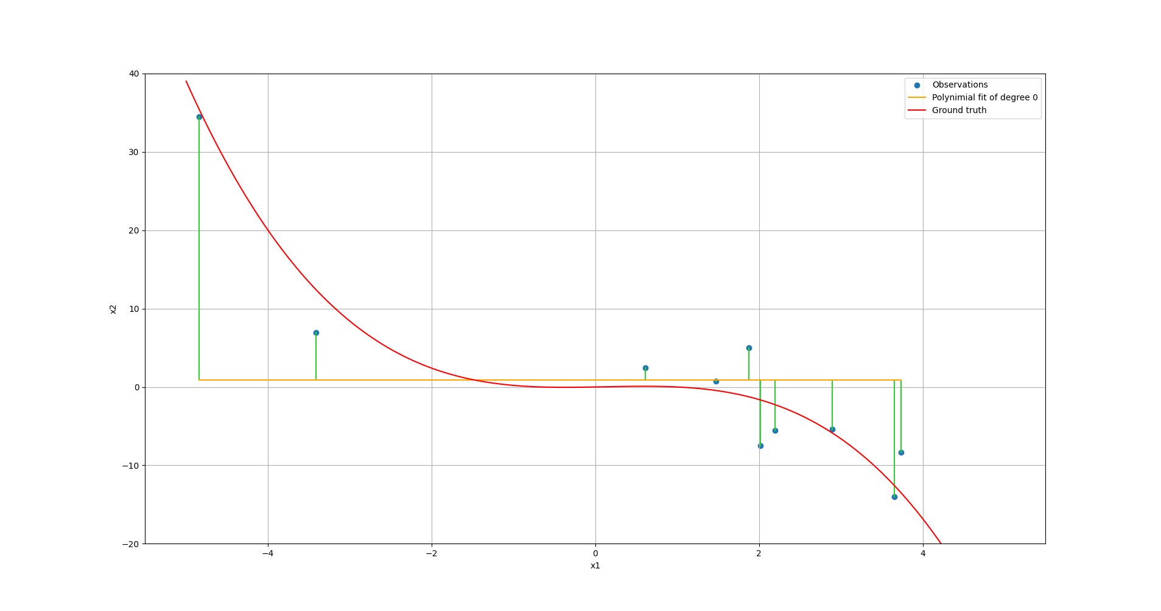
Exercise 1
Figure 1: 0 Degree Polynomial
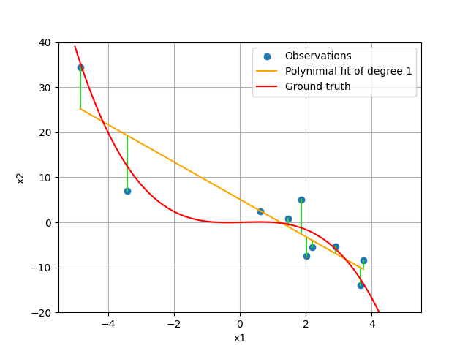
Figure 2: 1 Degree Polynomial

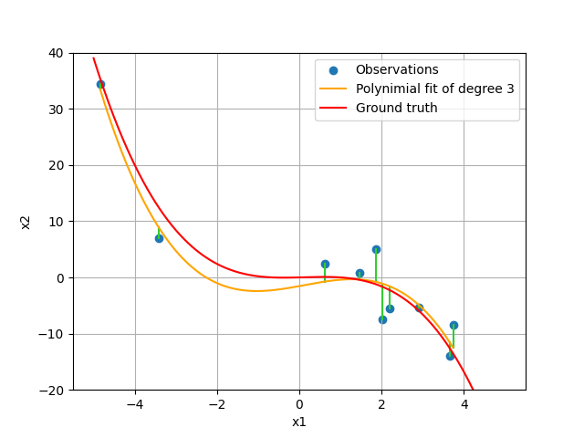

Figure 3: 2 Degree Polynomial
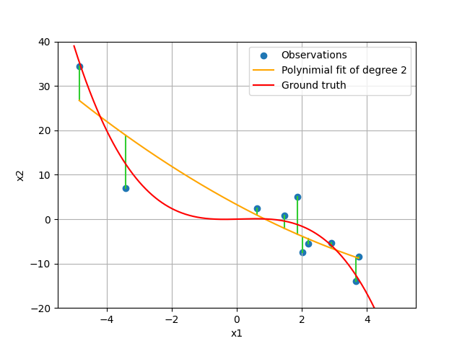

Figure 4: 3 Degree Polynomial

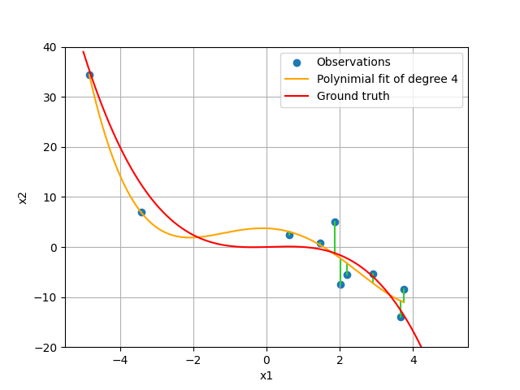

Figure 5: 4 Degree Polynomial

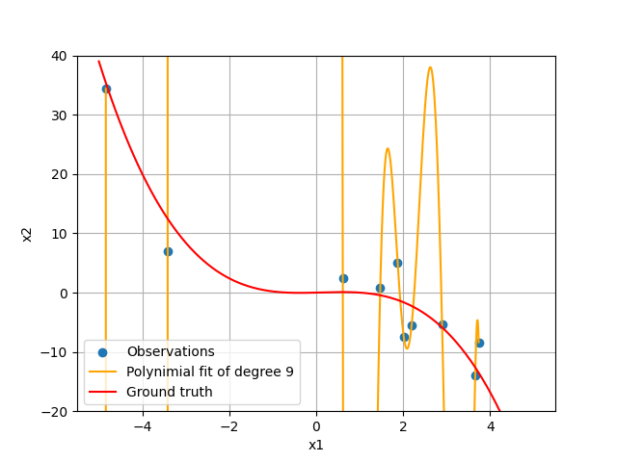

Figure 6: 9 Degree Polynomial

Exercise 2:
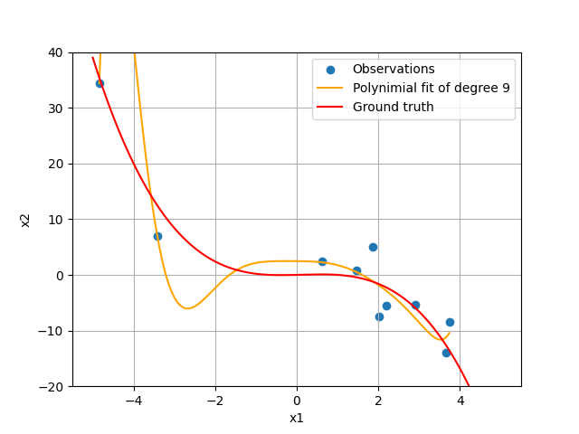

Figure 7: 10, L2 Regularization (Ridged)
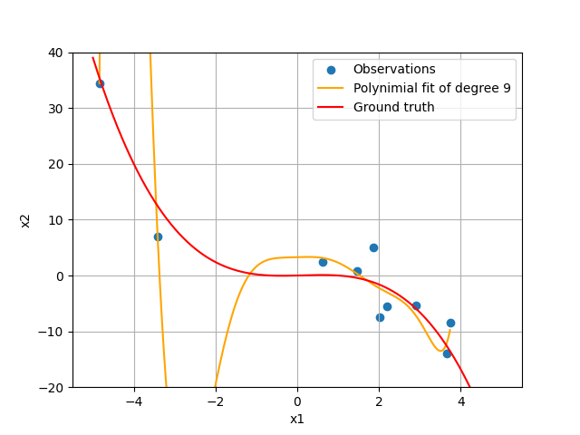

Figure 8: 1, L2 Regularization (Ridge)

Figure 9: 0.1, L2 Regularization (Ridge)

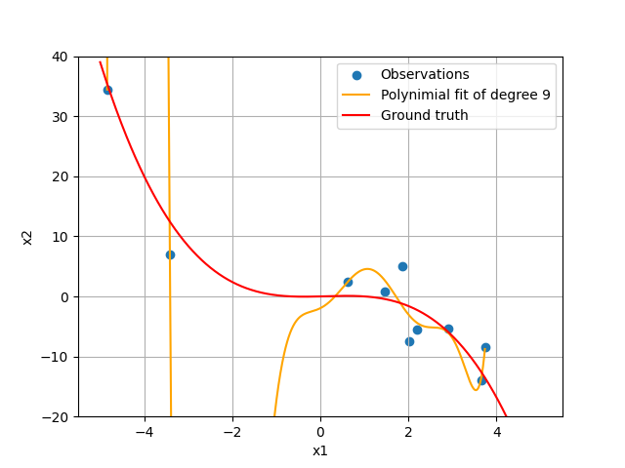

Figure 10: 0.01, L2 Regularization (Ridge)

Exercise 3:

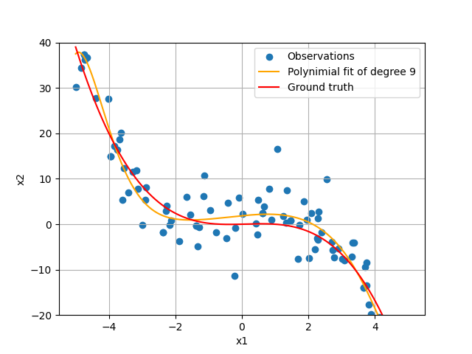

Figure 11: 100 Samples

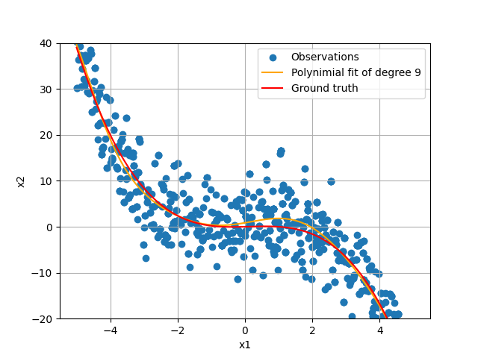

Figure 12: 1000 Samples

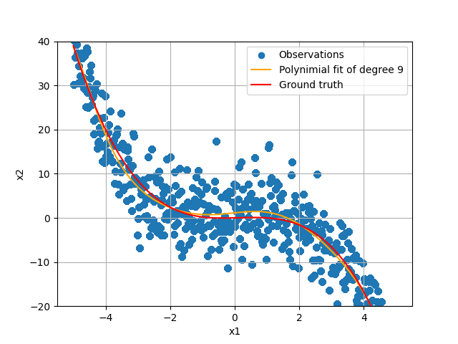

Figure 13: 10e5 Samples

