# 1 – Models and Entailment in Propositional Logic

1: Word symbol codes: ∨#8744 ∧#8743 → # 8594 ≡ #8801

1. A ∧ ¬B |= A ∨ B  **True**

|  |  |  |  |  |  |
| --- | --- | --- | --- | --- | --- |
| A | B | ¬B | A∧¬B | A∨B | A ∧ ¬B |= A ∨ B |
| 0 | 0 | 1 | 0 | 0 | 1 |
| 0 | 1 | 0 | 0 | 1 | 1 |
| 1 | 0 | 1 | 1 | 1 | 1 |
| 1 | 1 | 0 | 0 | 1 | 1 |

1. A ∨ B |= A ∧ ¬B **False**

|  |  |  |  |  |  |
| --- | --- | --- | --- | --- | --- |
| A | B | ¬B | A∨B | A∧¬B | A ∨ B |= A ∧ ¬B |
| 0 | 0 | 1 | 0 | 0 | 1 |
| 0 | 1 | 0 | 1 | 0 | 0 |
| 1 | 0 | 1 | 1 | 1 | 1 |
| 1 | 1 | 0 | 1 | 0 | 0 |

1. A ⇔ B |= A ⇒ B **False**

|  |  |  |  |  |
| --- | --- | --- | --- | --- |
| A | B | A ⇔ B | A ⇒ B | A ⇔ B |= A ⇒ B |
| 0 | 0 | 0 | 1 | 1 |
| 0 | 1 | 1 | 1 | 1 |
| 1 | 0 | 0 | 0 | 1 |
| 1 | 1 | 1 | 1 | 1 |

1. (A ⇔ B) ⇔ C |= A ∨ ¬B ∨ ¬C **TRUE**

|  |  |  |  |  |  |  |
| --- | --- | --- | --- | --- | --- | --- |
| A | B | C | (A ⇔ B) | (A ⇔ B) ⇔ C | A ∨ ¬B ∨ ¬C | …|=… |
| 0 | 0 | 0 | 1 | 0 | 1 | 1 |
| 0 | 0 | 1 | 1 | 1 | 1 | 1 |
| 0 | 1 | 0 | 0 | 1 | 1 | 1 |
| 0 | 1 | 1 | 0 | 0 | 0 | 1 |
| 1 | 0 | 0 | 0 | 1 | 1 | 1 |
| 1 | 0 | 1 | 0 | 0 | 1 | 1 |
| 1 | 1 | 0 | 1 | 0 | 1 | 1 |
| 1 | 1 | 1 | 1 | 1 | 1 | 1 |

1. (¬A ∧ B) ∧ (A ⇒ B) is satisfiable **Satisfiable**

|  |  |  |  |  |
| --- | --- | --- | --- | --- |
| A | B | (¬A ∧ B) | (A ⇒ B) | (¬A ∧ B) ∧ (A ⇒ B) |
| 0 | 0 | 0 | 1 | 0 |
| 0 | 1 | 1 | 1 | 1 |
| 1 | 0 | 0 | 0 | 0 |
| 1 | 1 | 0 | 1 | 0 |

1. (¬A ∧ B) ∧ (A ⇔ B) is satisfiable **Noot Satisfiable**

|  |  |  |  |  |
| --- | --- | --- | --- | --- |
| A | B | (¬A ∧ B) | (A ⇔ B) | (¬A ∧ B) ∧ (A ⇒ B) |
| 0 | 0 | 0 | 1 | 0 |
| 0 | 1 | 1 | 0 | 0 |
| 1 | 0 | 0 | 0 | 0 |
| 1 | 1 | 0 | 1 | 0 |

2:

(a) A31 ∧ ¬A76 = Q/4 = 2^98

(b) A44 ∧ A49 ∧ A78 = Q/8

(c) A44 ∨ A49 ∨ A78 = Q-(!A44∧!A49∧!A) =Q-Q/8 0 = Q*7/8

(d) A70 ⇒ ¬A92 = !A70 + A70∧!A92 =Q/2 + Q/4 = Q*3/4

(e) (A7 ⇔ A72) ∧ (A83 ⇔ A84)

= ((A7 ∧ A72) ∨ (!A7 ∧ !A73)) ∧ ((A83 ∧ A84) ∨ (!A83 ∧ !A84))

= (Q/4 + Q/4)*(Q/4 + Q/4) = Q/4

(f) ¬A9 ∧ ¬A19 ∧ A37 ∧ A50 ∧ A68 ∧ A73 ∧ A79 ∧ A81

= Q/2 * Q/2 * ….. *Q/2 = (Q/2)^8 = Q/256

3:

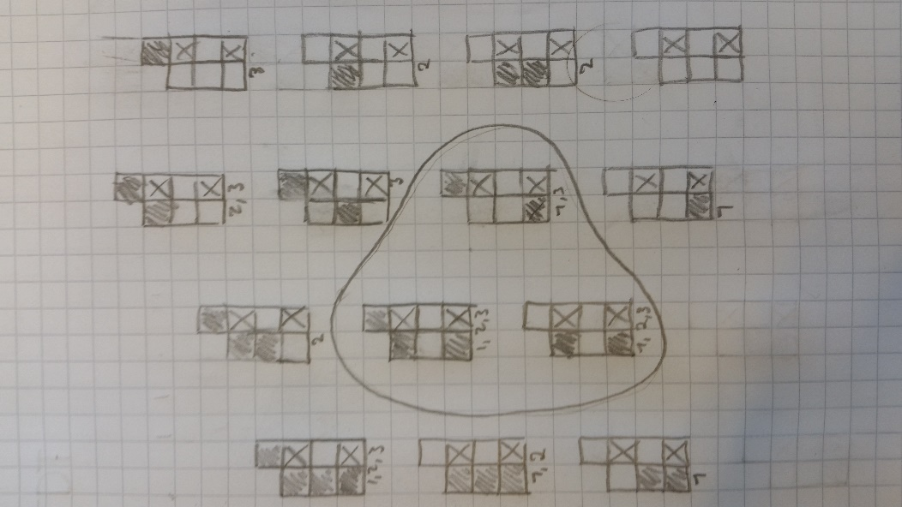

|  |  |  |  |  |  |  |  |
| --- | --- | --- | --- | --- | --- | --- | --- |
| P[3,1] | P[3,2] | P[3,3] | P[4,4] |  | KG |= α­1 | KG |= α­2 | KG |= α­3 |
| 0 | 0 | 0 | 0 |  | 0 | 0 | 0 |
| 0 | 0 | 0 | 1 |  | 0 | 0 | 1 |
| 0 | 0 | 1 | 0 |  | 0 | 1 | 1 |
| 0 | 0 | 1 | 1 |  | 0 | 1 | 1 |
| 0 | 1 | 0 | 0 |  | 0 | 0 | 0 |
| 0 | 1 | 0 | 1 |  | 0 | 0 | 1 |
| 0 | 1 | 1 | 0 |  | 0 | 1 | 1 |
| 0 | 1 | 1 | 1 |  | 0 | 1 | 1 |
| 1 | 0 | 0 | 0 |  | 1 | 0 | 0 |
| 1 | 0 | 0 | 1 |  | 1 | 0 | 1 |
| 1 | 0 | 1 | 0 |  | 1 | 1 | 1 |
| 1 | 0 | 1 | 1 |  | 1 | 1 | 1 |
| 1 | 1 | 0 | 0 |  | 1 | 0 | 0 |
| 1 | 1 | 0 | 1 |  | 1 | 0 | 1 |
| 1 | 1 | 1 | 0 |  | 1 | 1 | 1 |
| 1 | 1 | 1 | 1 |  | 1 | 1 | 1 |

Grey feils is the breeze, nad the black ones indicate potential holes.

The numbering under the worlds marks where the following statements are true:

α1 = “There is a pit in [3, 1]”.

α2 = “There is a pit in [3, 3]”.

α3 = “There is a pit in [3, 3] or [4, 4]”

From the figure we can conclude that statement 1 and 3 is true.

# 2. Resolution in Propositional Logic

1:

1. ¬A ∨ (B ∧ C) **= (¬A∧B) ∨ (¬A∧C)**
2. ¬(A ⇒ B) ∧ ¬(C ⇒ D) = ¬(¬A∨B)∧ ¬(¬C∨D)

=(A∧¬B)∧(C∧¬D)

= **A ∧ ¬B ∧ C ∧¬D**

1. (A ⇒ B) ⇔ C = ((A ⇒ B) ⇒C) ∧ (C⇒(A ⇒ B))

= (**¬** (A ⇒ B) ∨C)∧( **¬** C∨(A ⇒ B))

=(**¬(¬A ∨**B)∨C)∧( **¬C∨**(**¬**A∨B))

=((A∧¬B)∨C)∧( ¬C∨(¬A∨B))

=(¬B∨C)∧(A∨C)∧( ¬C∧¬A)∨( ¬C∧B)

=**(A∨C)∧( ¬C∧¬A)∨ (¬B∨C)∧( ( ¬C∧B)**

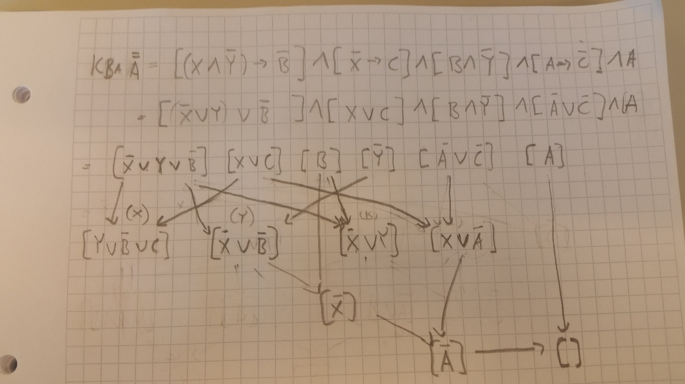2:

3: Could not find the exercise 7.17, nor 6.18 matching the task given.

# 3: Representations in First Order Logic

1)

1. ∀p ∈p[Christian Bale, Geroge Clooney, Val Kilmer) PlayedCharacter(p,Batman)]
2. ∀c[PlayedCharacter(Christian Balec) 🡪 ¬PlayedCharacter(Heath Ledger,c)]
3. ∀m [CharacterInMovie(Batman,m)∧Directed(Christpoher Nola, m)🡪 PlayedInMovie(Christian Bale, m)]
4. ∃m [CharacterInMovie(“Batman”,m)∧CharacterInMovie(“Joker”,m)]
5. ∃m (Directed(Kevin Costner,m) ∧ PlayedInMovie(Keniv Costner, m)]
6. ∀m [(PlayedInMovie(Tarantino,m) ∨ Directed(Tarantino,m)) 🡪 ( ¬PlayedInMovie(George Clooney, m)]
7. ∃m (Directed(Tarantino,m) ∧PlayedInMovie(Uma Thurman, m)]

2)

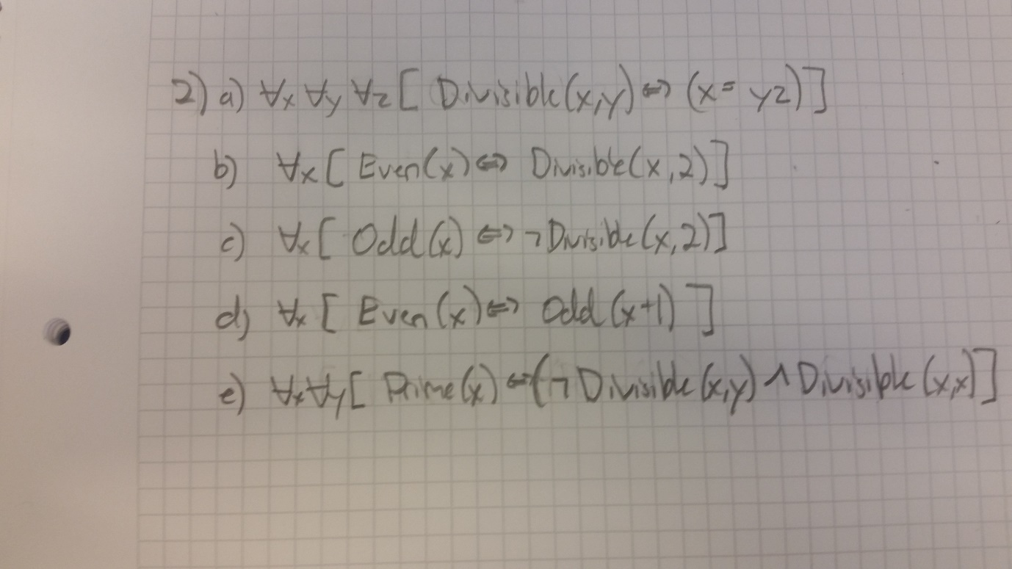

3) “Everyone’s DNA is unique and is derived rom their parents DNA

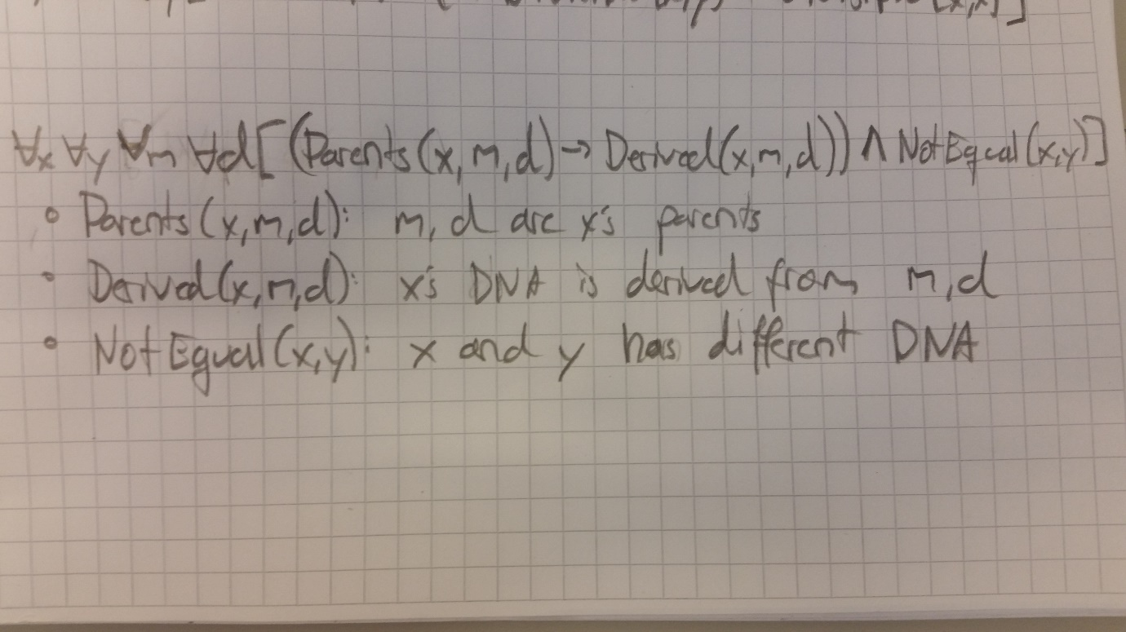

# 4. Resolution in First-Order Logic

1.

1. Θ = {x/Plato}
2. Θ = {y/TheRepublic}
3. Θ = {x/Peter,y/Metaphysics}
4. *Θ = {x/Kirkegaard,x/Fear And Trembeling}* Cant be done.
5. Θ = {y/CritiqueOfPureReason,Kant/Author(y)}

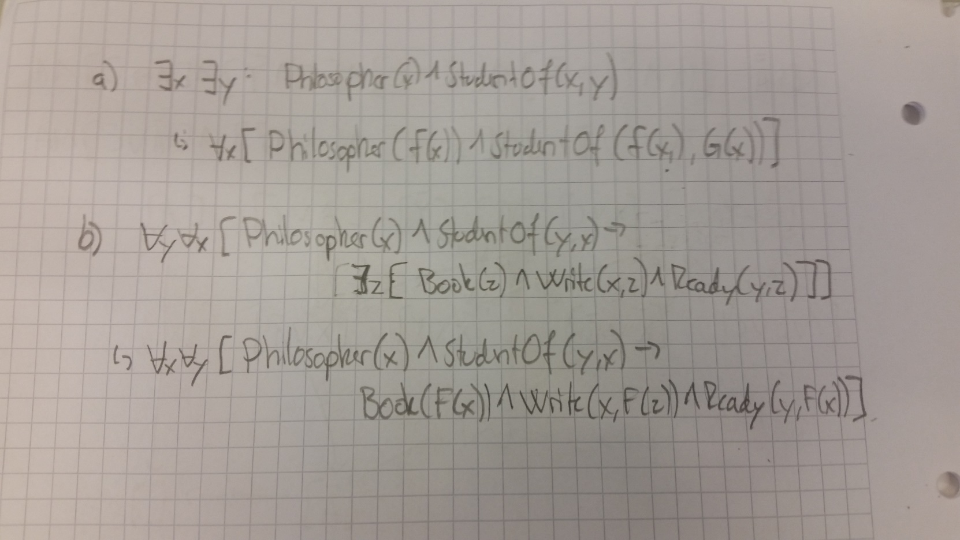2. “Skolemization is the process of removing existential quantifiers by elimination”

3.

So what I did in this task was to first write the expressions on CNF. I took some shortcuts here by computing in ny head, as they weren’t much work.

Next, I wrote all the AND-expressions down into blocks and gave them numbers for future references. From here the resolution shown is done as regular. Im argumenting for being able to compute PlayedInMovie(UmaThurman,m) with PlayedInMovie(x,f(x)) since x, m can take all values. Hope this is actually allowed.

From here the result shows that we get an empty statement, which proves that SuperActor(Tarantino) has to be true.

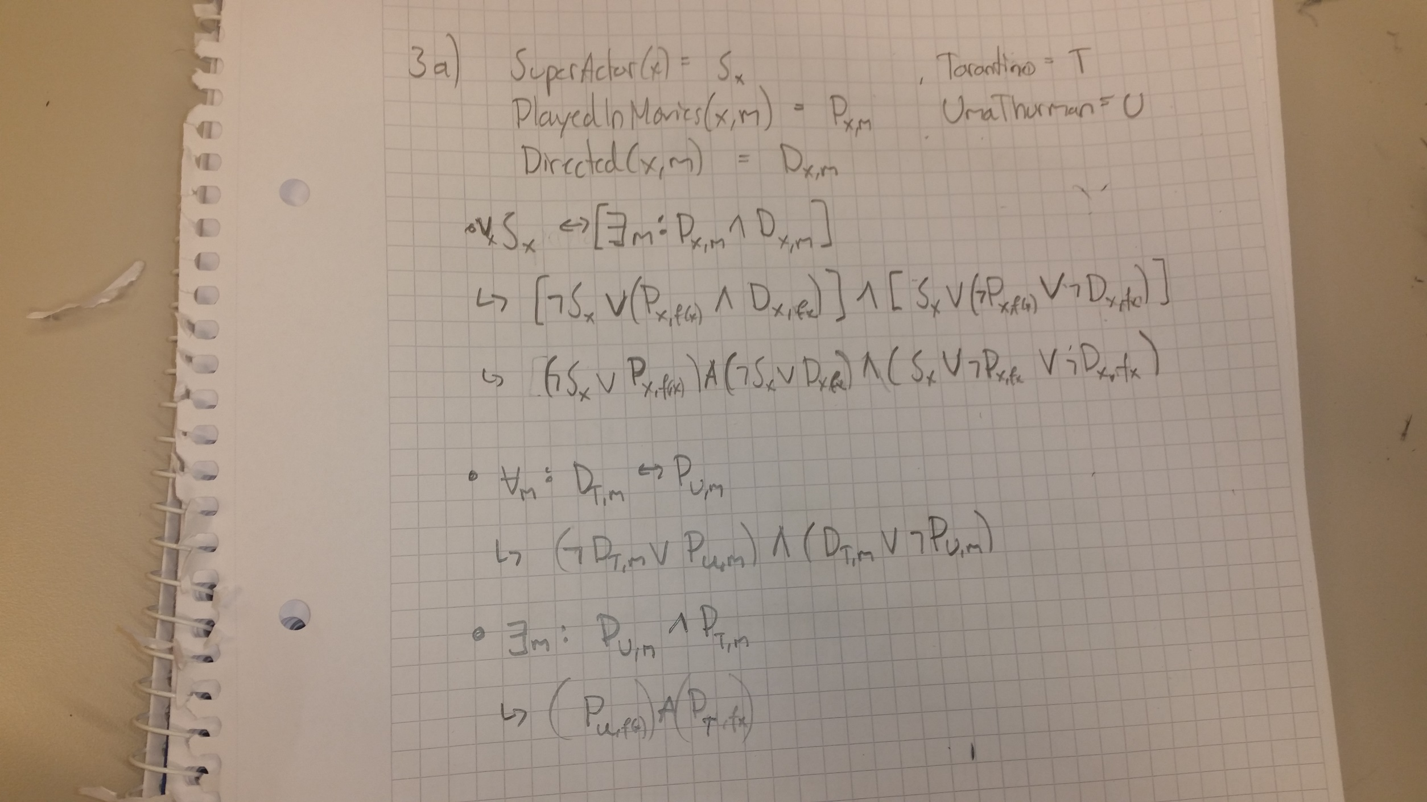

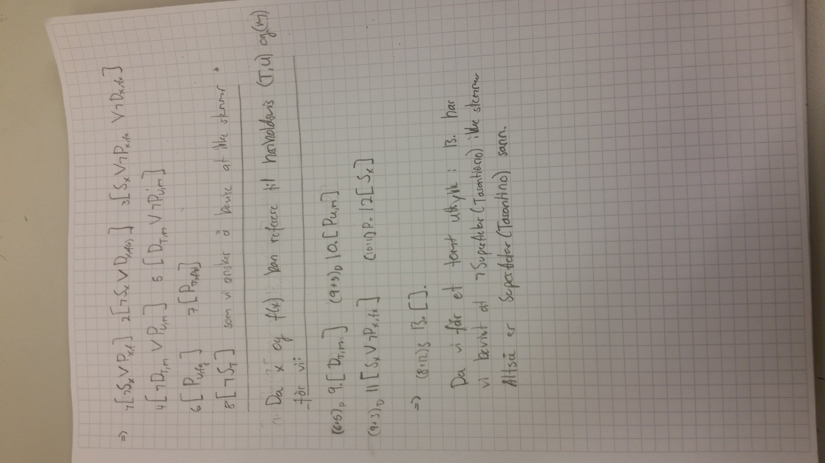‘

b)

A superactor is defined as an actor that has directed a movie he has acted in.

We know that in all the movies Tarantino has directed, Uma Thurman has starred in said movie, and that Uma Thurman has only acted in Tarantino movies.

Further do we know that Uma Thurman and Tarantio has acted in a movie together.

This gives that Tarantino has acted in his own movie, as he acted along with Uma Thurman.

As such, Tarantino is known as a superactor.