# A* Algorithm

I followed the pseudocode from the attachment, and produced the following agenda loop.

My function is able to run all the three algorithms, A*, BFS, and Dijkstra’s, depending on the setup.

The algorithms run in the two classes Node and A_star, while the rest of the functions are helping functions such as representing the GUI and getting the input from the files.

I’ve noticed that since I sort my open-list (agenda here) a different place than many others the results from the BFS search differs in some of the cases. 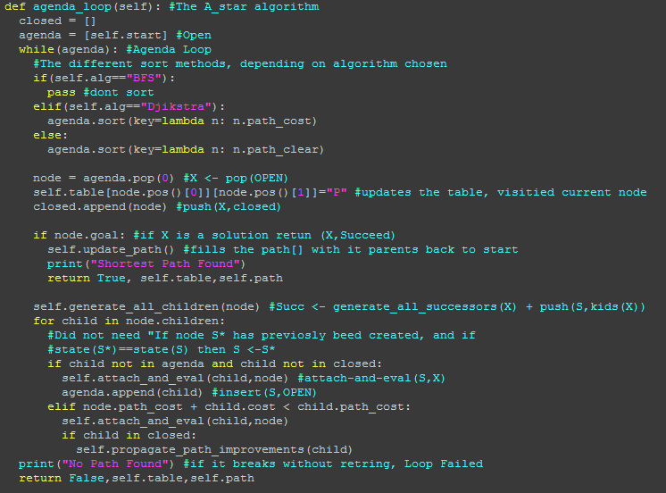

My program doesn’t take in any files, but rather reads them from the folders. Due to this it wont run if the the boards aren’t structured in the directory in the following way: boards/boards/”filename”.txt.

To run a file outside this structure described above, simply edit the “name” to the file path and set shortcut to false.

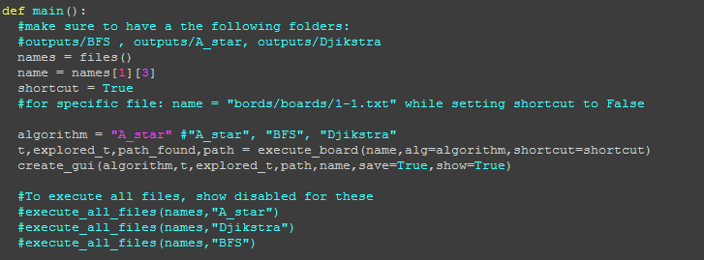

The execute_all_files execute all files in the boards/boards/ folder with the set algorithm, and saves them to a predefined folder. Hence the folder outputs/A_star/, “outputs/Djikstra” and “outputs/BFS” must exist. See the folder structure of my zipped file for clarification.

# Deliverables

Paths from deliverable 1, 2 and 3. For full output look in the “outputs/A_star/” folder of the zip file.

For the boards with walls the three algorithms are almost identical, but sometimes chooses to differ in the open fields.

In the weighted boards on the other hand, Djikstra and A* always finds the similar routes. BFS only cares about the shortest path, hence takes shortcuts through costly fields and won’t find the most optimal paths.

A* paths

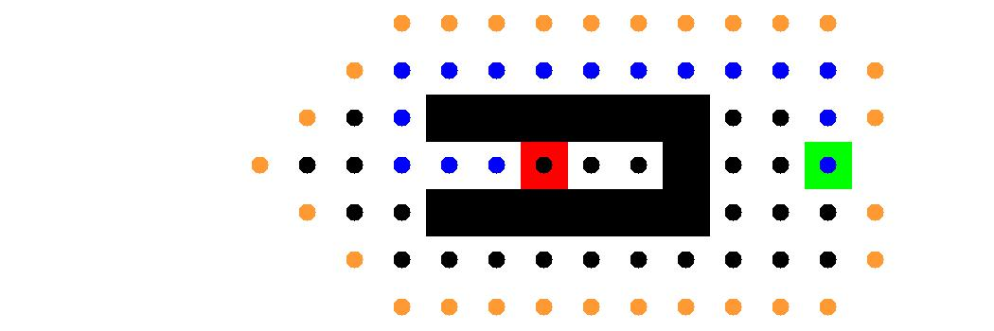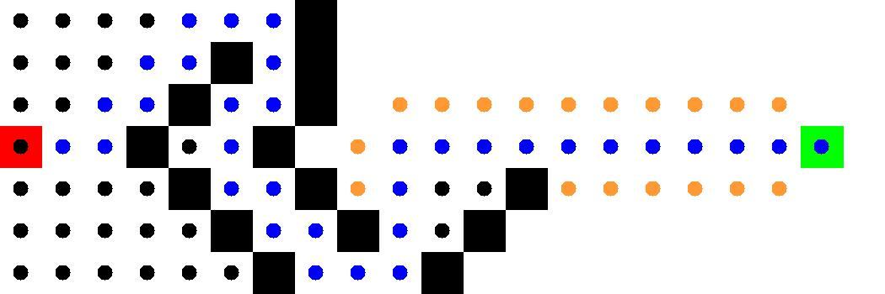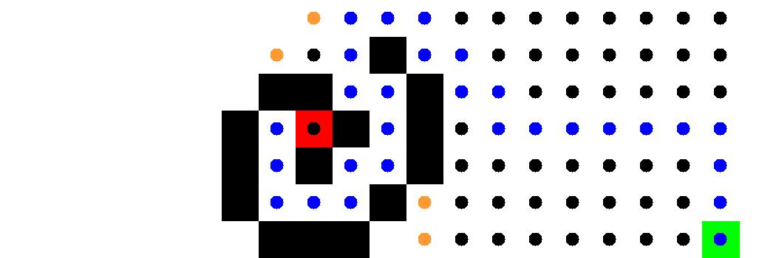

A* Paths



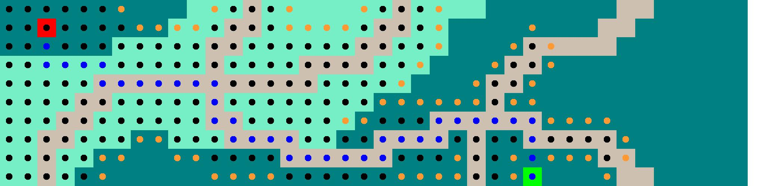

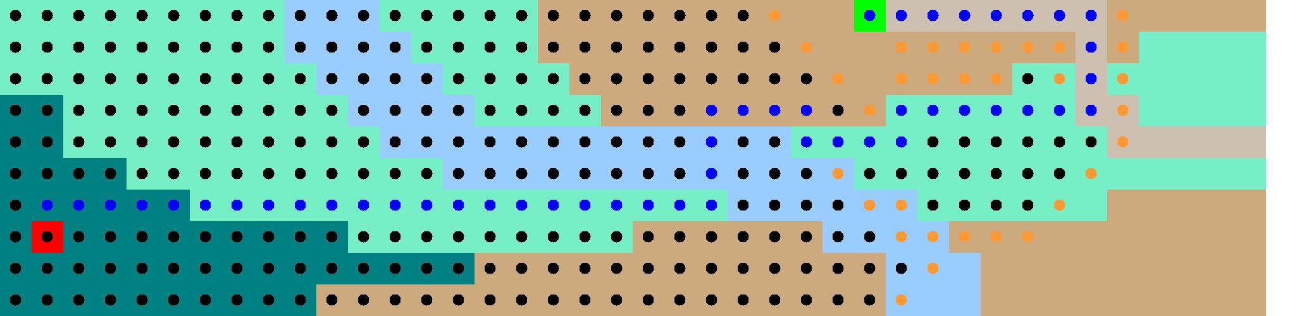

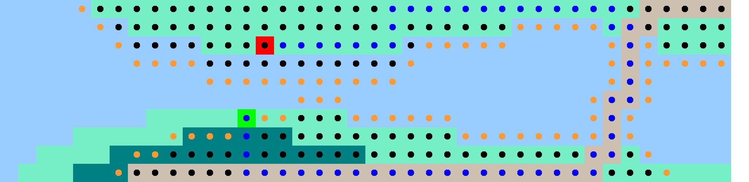

BFS’s Paths

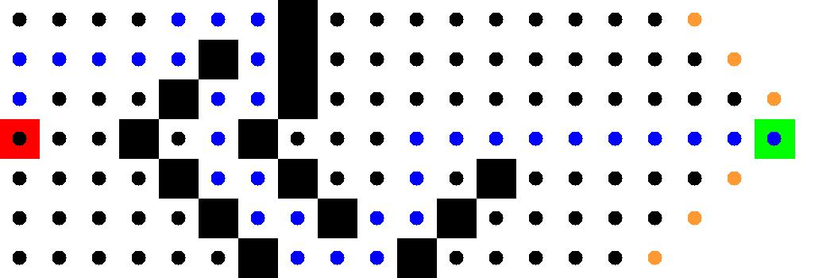

BFS’s Paths

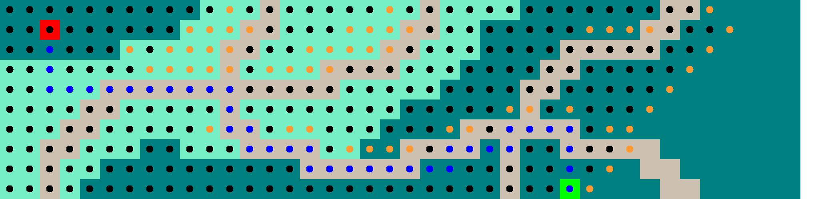

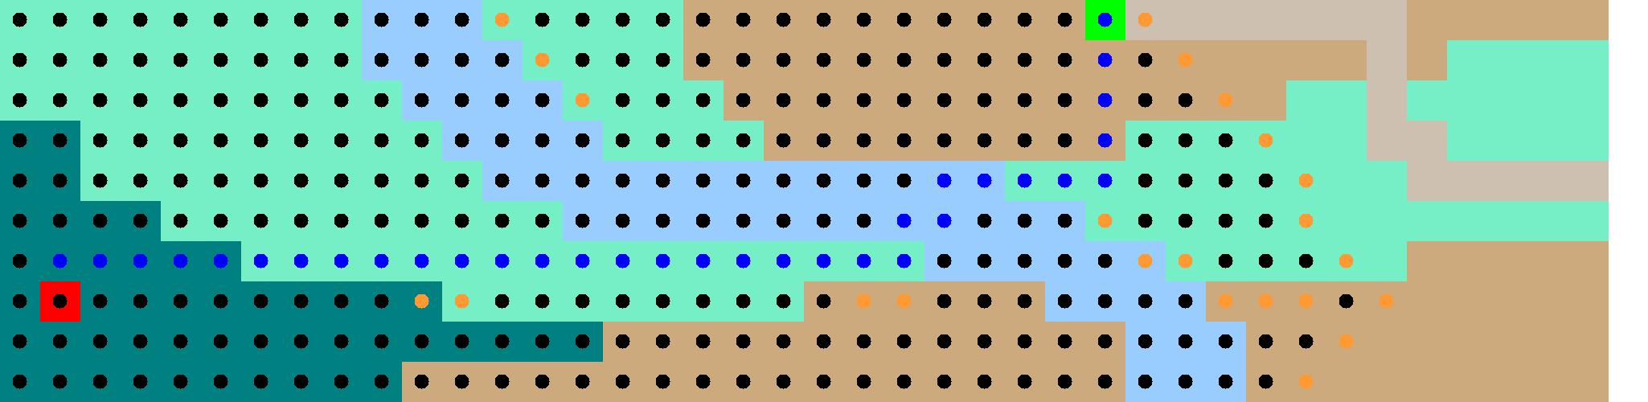





Djikstra’s Paths:

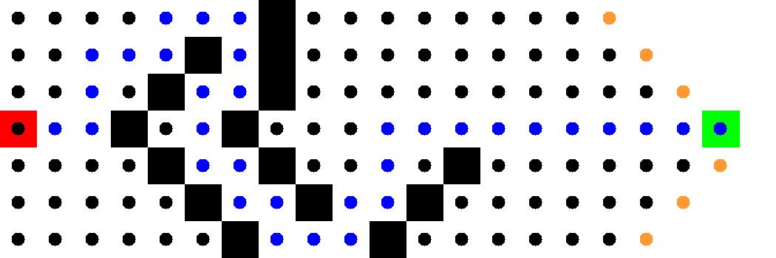

Djiksta’s Paths



