M-CASH Loan Recovery Analysis
Business Intelligence Project Documentation
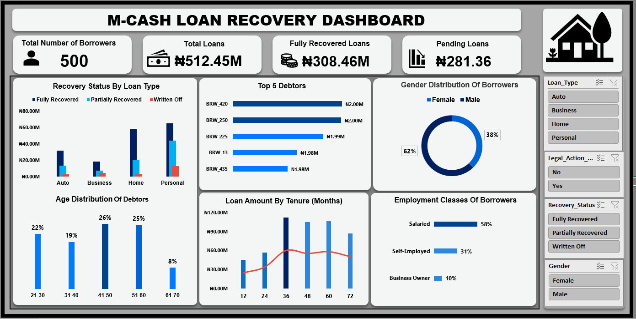

Executive Summary
The M-CASH Loan Recovery Analysis project was developed to evaluate portfolio performance, identify high-risk borrowers, and optimize recovery strategies. The dashboard provides management with a consolidated view of loan recovery performance, borrower demographics, employment classes, loan tenure exposure, and top debtors.

Business Problem
Lending institutions face increasing challenges in recovering delinquent loans while maintaining portfolio quality. Management required visibility into recovery performance, borrower behavior, and outstanding risk exposure.

Project Objectives
• Evaluate loan recovery performance
• Identify high-risk borrower segments
• Analyze recovery outcomes by loan type
• Monitor debtor exposure and tenure risk
• Support data-driven recovery decisions

Dashboard Overview
The dashboard tracks key portfolio KPIs including Total Borrowers, Total Loans, Fully Recovered Loans, Pending Loans, Recovery Status by Loan Type, Top Debtors, Gender Distribution, Age Distribution, Loan Amount by Tenure, and Employment Class.

Key Insights
• Personal Loans generated the highest recovery volume.
• Male borrowers account for 62% of the portfolio.
• Borrowers aged 41–60 represent the largest customer segment.
• Salaried employees account for 58% of borrowers.
• Longer-tenure loans carry higher portfolio exposure.
• Top debtors hold balances approaching ₦2M each.

Recommendations
1. Prioritize recovery efforts on high-value debtors.
2. Implement risk-based borrower segmentation.
3. Establish early-warning monitoring for delinquency.
4. Strengthen collection activities for long-tenure loans.
5. Track recovery KPIs monthly.

Conclusion
The analysis demonstrates that loan recovery performance is influenced by loan type, borrower demographics, employment status, and loan tenure. Targeted recovery strategies can improve collection efficiency, reduce write-offs, and enhance portfolio quality.

