# Concept:

**Platforms:** PC (Windows 10)

**Technologies:** Unreal Engine 4.25.1

**Languages:**   English/Russian

**Audience:**  people who like hardcore platformers

**Genre**: platformer

**Mood:** trash

**Emotions:** crazy

**Rating:**  0+

**User Number:**  1

**Gameplay time:**  1 hour - infinity

**Maine mechanic:**  procedure generation

**Setting:** lifeless world

**Goal:**reach max level

# Game Character

Wooden man

## Game mechanics and operating

## *Actor moving: A, D, space*

## Specific actions

change level: pgUp, pgDown

change seed: r

Restart: Enter

# Interface & Visual

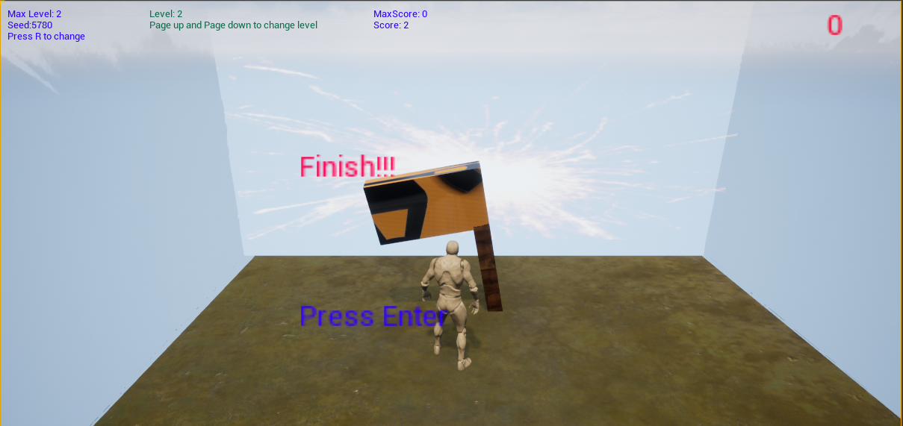

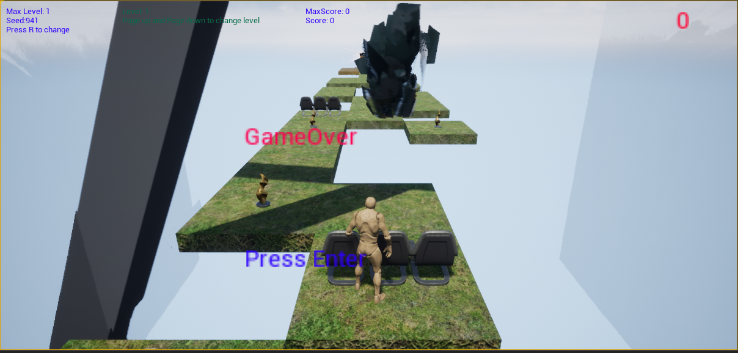

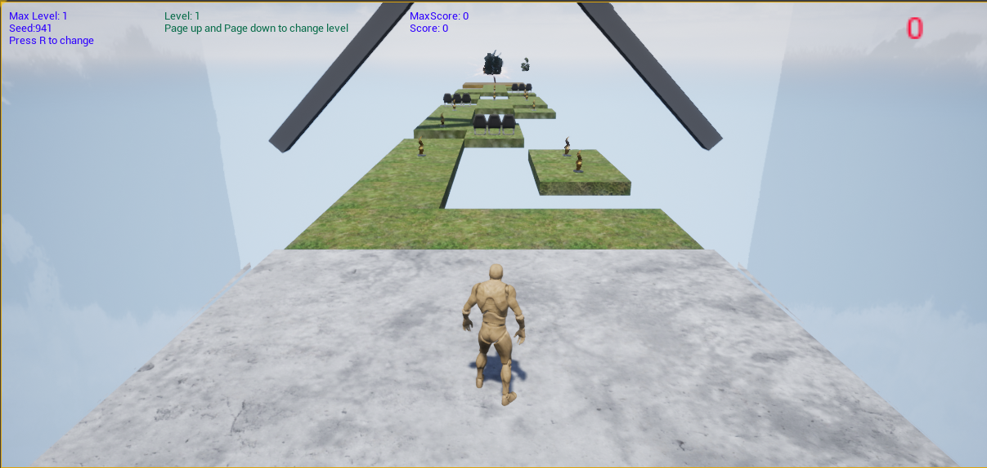

# Level Design

- Random platforms  
- Random collectable bonuses on platform

- Spinning fans

- WallHack bonus

- Fan slowdown bonus

- Finish

# Balance

Chunk – 3 horizontal cells

|  |  |  |
| --- | --- | --- |
| Name | Value | Comment |
| WallHack | Level + 1 sec | Spawn at ¼ way |
| SlowDown | Level + 1 sec | Spawn randomly |
| Platform | 1-2 per chunk (except first) | Spawn randomly |
| Obstacle | 0-2 in 1 chunk | Spawn randomly with 5 chunks distance |
| Statue | 0-1 on platform | Spawns randomly on platforms without obstacle |
| Fan | (speed * sowdown) *0.1 deg/sec | Spawn randomly with 10 chunks distance |
| Level Length | 1,3(Level – 1)*20 | Each level 30% longer |
| Speed | ((x - 1) * 0.1) + 10 | X = min(Level, 9) |
| Gravity | X*0,1 + 1 | X = min(Level, 9) |
| Jump Z Velocity | ((x - 1) * 100) + 600 | X = min(Level, 9) |

# Gameplay map

https://miro.com/welcomeonboard/9jk2RyBTIOfh8cLErOLArf5INBRXoesmGnhA2S347sazB60zWgrDUTEhsKf0sV2w