

|  |
| --- |
| Test Automation Mentoring |
| FINAL HOMEWORK |

Contents

Test Automation Mentoring 1

1 Summary 3

2 The Exercise 3

3 Briefly ABOUT the requirements 4

3.1 TECHNICAL ASPECTS 4

3.2 SELENIUM / CONFIGURATION 4

4 Evaluation 5

# Summary

In this exercise you will perform the test automation activities for the following site:

<http://automationpractice.com/index.php>

The exercise helps you to better understand the importance of Quality Assurance including the tools for creating automated functional tests.

# The Exercise

The following user scenarios need to be implemented as part of this exercise:

**Scenario 1: Sign in validation - Case 1**

* Open url: http://automationpractice.com/index.php
* Click on Sign in link
* Leave email & password fields empty
* Click on Sign in button
* Verify that validation message is displayed

**Scenario 2: Sign in validation - Case 2**

* Open url: http://automationpractice.com/index.php
* Click on Sign in link
* Fill email field with an invalid email address
* Click on Sign in button
* Verify that validation message is displayed

**Scenario 3: Sign in validation - Case 3**

* Open url: http://automationpractice.com/index.php
* Click on Sign in link
* Fill email field with a valid email address
* Fill password field with an incorrect password
* Click on Sign in button
* Verify that validation message is displayed

**Scenario 4: Contact Us form**

* Open url: http://automationpractice.com/index.php
* Click on Contact us link
* Fill in the form with valid data (file upload can be skipped)
* Click on Send button
* Verify message is shown on successful form submission

**Scenario 5: Search and verify content**

* Open url: http://automationpractice.com/index.php
* Search for "shirt"
* Verify search results match the search term
* Choose first product and save name & price
* Click the button to see More
* Verify name & price are correct on Product details page

**Scenario 6: Browse and add product to cart**

* Open url: http://automationpractice.com/index.php
* From the menu, select Dresses > Casual Dresses
* Click on Add to cart button for first result
* Verify that product is added to cart (popup)
* Click Proceed to checkout
* Verify selected product is in the cart

# Briefly ABOUT the requirements

The following technology stack is required for the final exercise (based on your goal):

|  |  |
| --- | --- |
| PRIMARY SKILL | SECONDARY SKILL |
| PageObject pattern | PageObject pattern |
| Logging | Logging |
| Maven | Maven |
| BDD |  |
| Jenkins |  |

## TECHNICAL ASPECTS

*Environment:* please note that you need to build up your environment / project from the resources that you have received during the program.

*Git:* Create your own final exercise folder on a new branch in your repository which will be merged back to master when you completed the exercise.

*Jenkins:* in case of primary skill change, you need to manage your tests using jenkins which can be accessed on the following link: [Jenkins](http://ecsc00a0ce8d.epam.com:8080/login?from=%2F) *(you need to be connected to EPAM VPN)*

Mentee Login credentials:

* *Name:* your domain name (e.g. firstname_lastname)
* *Password:* alma1234 (change it after logging in!)

When you logged into the application, you need to see the folders with the name of mentee

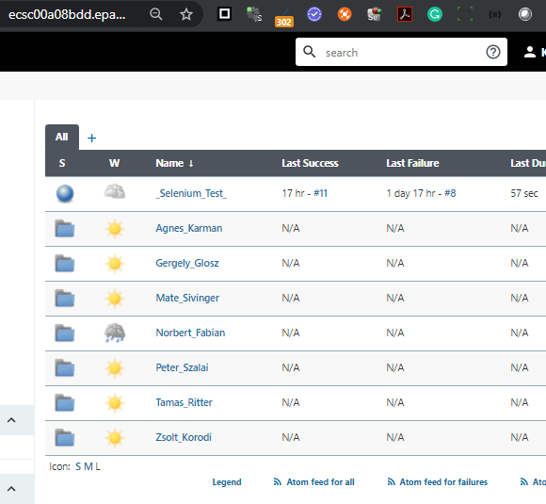

Under your folder, is your playground as part of this exercise. *Please note that the mentors have access to every mentee folder.*

## SELENIUM / CONFIGURATION

1. You need to [set your PATH](https://www.architectryan.com/2018/03/17/add-to-the-path-on-windows-10/) according to the location of your ChromeDriver (binary), you don’t need to use System.setProperty in your implementation.

E.g. “D:\tam2020\webdriver\chromedriver.exe then you need to add “D:\tam2020.com

\webdriver” to the PATH.

# Evaluation

This section describes the evaluation for the final exercise (based on your goal).

***PRIMARY SKILL (Discipline change to E1):***

* Mentor should notify curator, that mentee finished the final exercise, ready for demonstration and good candidate for E1
* Curator should organize informal ASMT session for mentee with 2 mentors from the program (mentee’s mentor is optional observer)
* Mentee should give permission for 2 ASMT Mentor and Curator on the repository
* Mentee should demonstrate final project
* Mentors should be sure, that mentee has E1 knowledge (Ask some question about final project and base knowledge)
  + *Edge case: Mentee has some experience about test automation, programing before TAM. Candidate for E2*
* Informal session should take ~30 min
* In end of call, Mentors will evaluate the mentee (Recommended or not Recommended)
  + *Recommended: change discipline*
  + *not Recommended: Secondary skill*

***SECONDARY SKILL:***

* Mentee should demonstrate solution for own Mentor
* Mentor will evaluate Mentee for Secondary skill
* Mentor should notify the Curator that mentee has finished the program and share the results

| REVISION HISTORY | | | | | |
| --- | --- | --- | --- | --- | --- |
| Ver. | Description of Change | Author | Date | Approved | |
| Name | Effective Date |
| 1.0 | First Version | Zoltan Petranyi | 11-Sep-2019 |  |  |
| 1.1 | Update: references | Kornel Kala | 14 Sep. 20 |  |  |
| 1.2 | Update: | Kornel Kala | 16 Sep. 20 |  |  |
| 1.3 | Update: URLs, Evaluation | Norbert Fabian | 10. Dec. 2021 |  |  |