

Translation Management System

XTM Support Portal User Guide

# XTM support portal overview

The purpose of the XTM Support portal is to enable the users to contact the XTM Support team. It helps to keep track of the issue resolution progress and organise the issues that have been raised. You can access the portal by visiting the following page: <https://support.xtm-intl.com>

# Creating an account

1. Visit <https://support.xtm-intl.com>
2. At the top click “Sign up”: 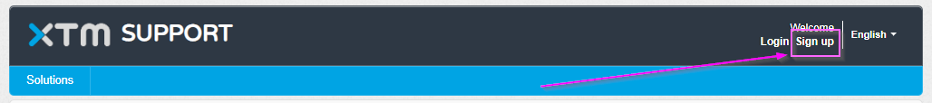
3. Fill in the form (please use your company e-mail address).
4. You should receive a confirmation e-mail with the activation link. Click that link and set the password.

**Creating a ticket**

The users can create a ticket by:

1. Sending an e-mail to [support@xtm-intl.com](mailto:support@xtm-intl.com). The ticket will be automatically created and the sender will be set as a requester.
2. Logging into the Support portal
   1. Visit the page <https://support.xtm-intl.com> and click “Login”
   2. Once you are logged in click “New support ticket”:  
      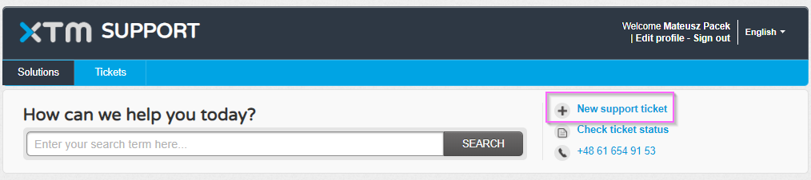
   3. Fill in the form:

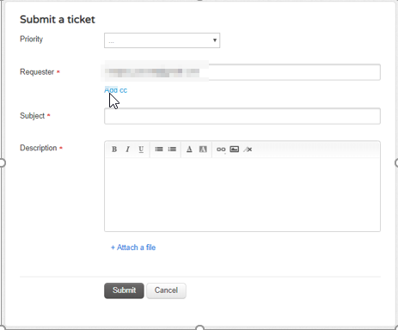

* 1. Once the “Submit” button is clicked the ticket is created and you should receive a confirmation e-mail.

**Ticket management**

You can view all your tickets (or all tickets within your company, however, this needs to be explicitly communicated to the Support team as it requires additional configuration) by logging into portal and clicking the “Tickets” button:

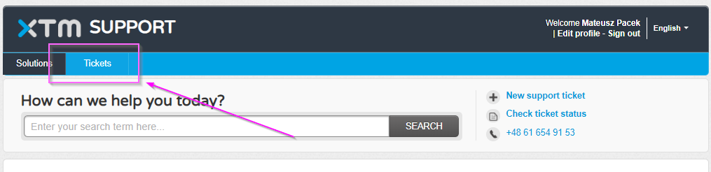

The list of all tickets can be filtered by using a few filtering options:

* All Tickets
* Open and Pending
* Resolved or Closed

Once the tickets are filtered by the master filter above, you can use the second filter to set the order of the tickets:

* Date Created
* Last Modified
* Status

They can be accessed by clicking the dropdown menu:

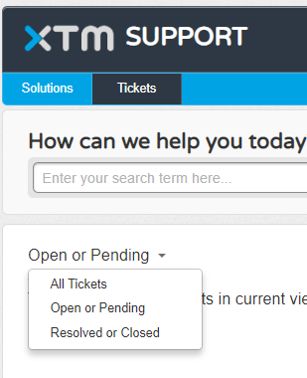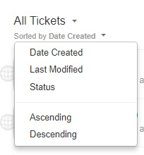

**Ticket view**

The ticket view looks like shown below:

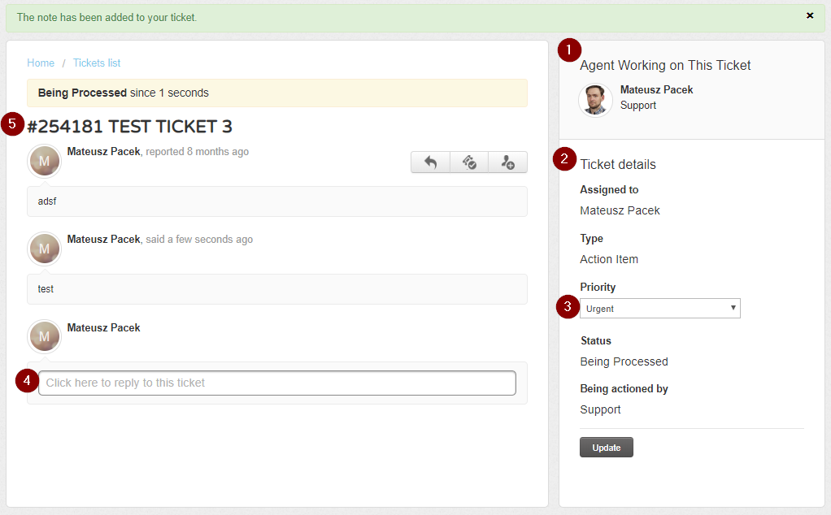

The most important elements are:

* Agent who is dealing with the ticket
* Ticket details which contain metadata
* Priority which can be set by the Customer
* Reply field which is used to reply to the ticket
* Ticket ID and the title