# Comment faire le Pudding

(Pour 2 personnes)

Amusez-vous bien avec votre dessert !

## Ingredientsxxx

|  |  |
| --- | --- |
| Sucre | 10 tablespoons xxx |
| Ouef | 2 |
| Milch | 400 cc |

## etaps

1. Add a tablespoonful of sugar and a teaspoonful of water in each of 2 mugs, then heat each mug in a microwave oven (600 W, 1.5 – 2.5 min. xxx.
2. Ajoutez the rest of sugar and 2 eggs in a bowl, and mix it *with whisk* xxx. Donc, add the milk into the bowl and mix **even more** xxx. Pour it into the 2 mugs (1) ccc.
3. Again, place each of the mugs into the microwave oven and heat it (600 W, 2.5 min.) xxx. Leave it in the oven until it gets cool xxx.
4. Chill them for 3 hours in the refrigerator xxx.

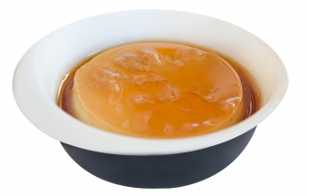

Please see more puddings [on the web](https://www.google.co.jp/search?q=pudding&hl=ja&source=lnms&tbm=isch&sa=X&ei=ValDVavqGsHNmwXs_oGoCA&ved=0CAgQ_AUoAQ&biw=1366&bih=645) xxx !

Amusez-vous bien avec votre dessert !