# How to cook Pudding

（2人分）

Enjoy your dessert!

## Ingredients

|  |  |
| --- | --- |
| sugar | 大さじ 10杯 |
| egg | 2 |
| 牛乳 | 400 cc |

## Steps

1. Add a tablespoonful of sugar and a teaspoonful of water in each of 2 mugs, then heat each mug in a microwave oven (600 W, 1.5 – 2.5 min.).
2. Add the rest of sugar and 2 eggs in a bowl, and mix it *with whisk*. Then, add the milk into the bowl and mix **even more**. Pour it into the 2 mugs (1).
3. Again, place each of the mugs into the microwave oven and heat it (600 W, 2.5 min.). Leave it in the oven until it gets cool.
4. Chill them for 3 hours in the refrigerator.

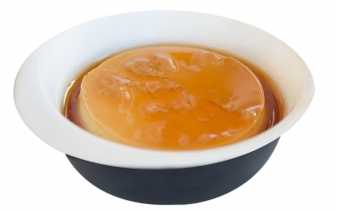

Please see more puddings [on the web](https://www.google.co.jp/search?q=pudding&hl=ja&source=lnms&tbm=isch&sa=X&ei=ValDVavqGsHNmwXs_oGoCA&ved=0CAgQ_AUoAQ&biw=1366&bih=645)!

Enjoy your dessert!