# How to cook Blueberry Mousse

(For 6 People)

## Ingredients

|  |  |
| --- | --- |
| Blueberries[1] | 150 g |
| アボカド[2] | 0.5 |
| milk or water | some |

## Steps

1. **Puree** blueberries and the half-size avocado *with blender*.
2. Pour some milk or water into the blender as properly.
3. Pour the puree into your favorite serving dishes.
4. Chill them for 4 hours in the refrigerator.

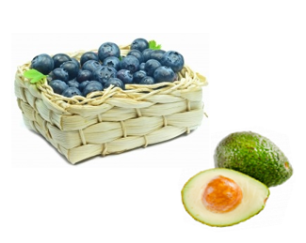

Please see more mousses [on the web](https://www.google.co.jp/search?q=%E3%83%A0%E3%83%BC%E3%82%B9&hl=ja&source=lnms&tbm=isch&sa=X&ei=YfBEVaS6OMHCmQWYxIHYAw&ved=0CAgQ_AUoAQ&biw=1366&bih=645)!

Enjoy your dessert!

1. The frozen berries may be used.
2. Mr. Smith’s pesticide-free avocado is highly recommended.