# How to cook Blueberry Mousse

(For 6 People)

## Ingredients

|  |  |
| --- | --- |
| Blueberries[1] | 150 g |
| avocado[2] | 0.5 |
| milk or water | some |

## Steps

1. **Puree** blueberries and the half-size avocado *with blender*.
2. Pour some milk or water into the blender as properly. And here is an additional sentence.
3. Pour the puree into your favorite serving dishes. And another additional sentence is inserted here.
4. Chill them for 4 hours in the refrigerator.

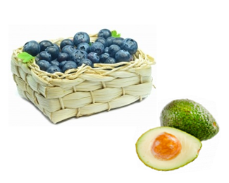

Please see more mousses [on the web](https://www.google.co.jp/search?q=%E3%83%A0%E3%83%BC%E3%82%B9&hl=ja&source=lnms&tbm=isch&sa=X&ei=YfBEVaS6OMHCmQWYxIHYAw&ved=0CAgQ_AUoAQ&biw=1366&bih=645)!

Enjoy your dessert!

1. The frozen berries may be used.
2. Mr. Smith’s pesticide-free avocado is highly recommended.