**N3_NJS1804**

1. **ERD/DB DIAGRAM**

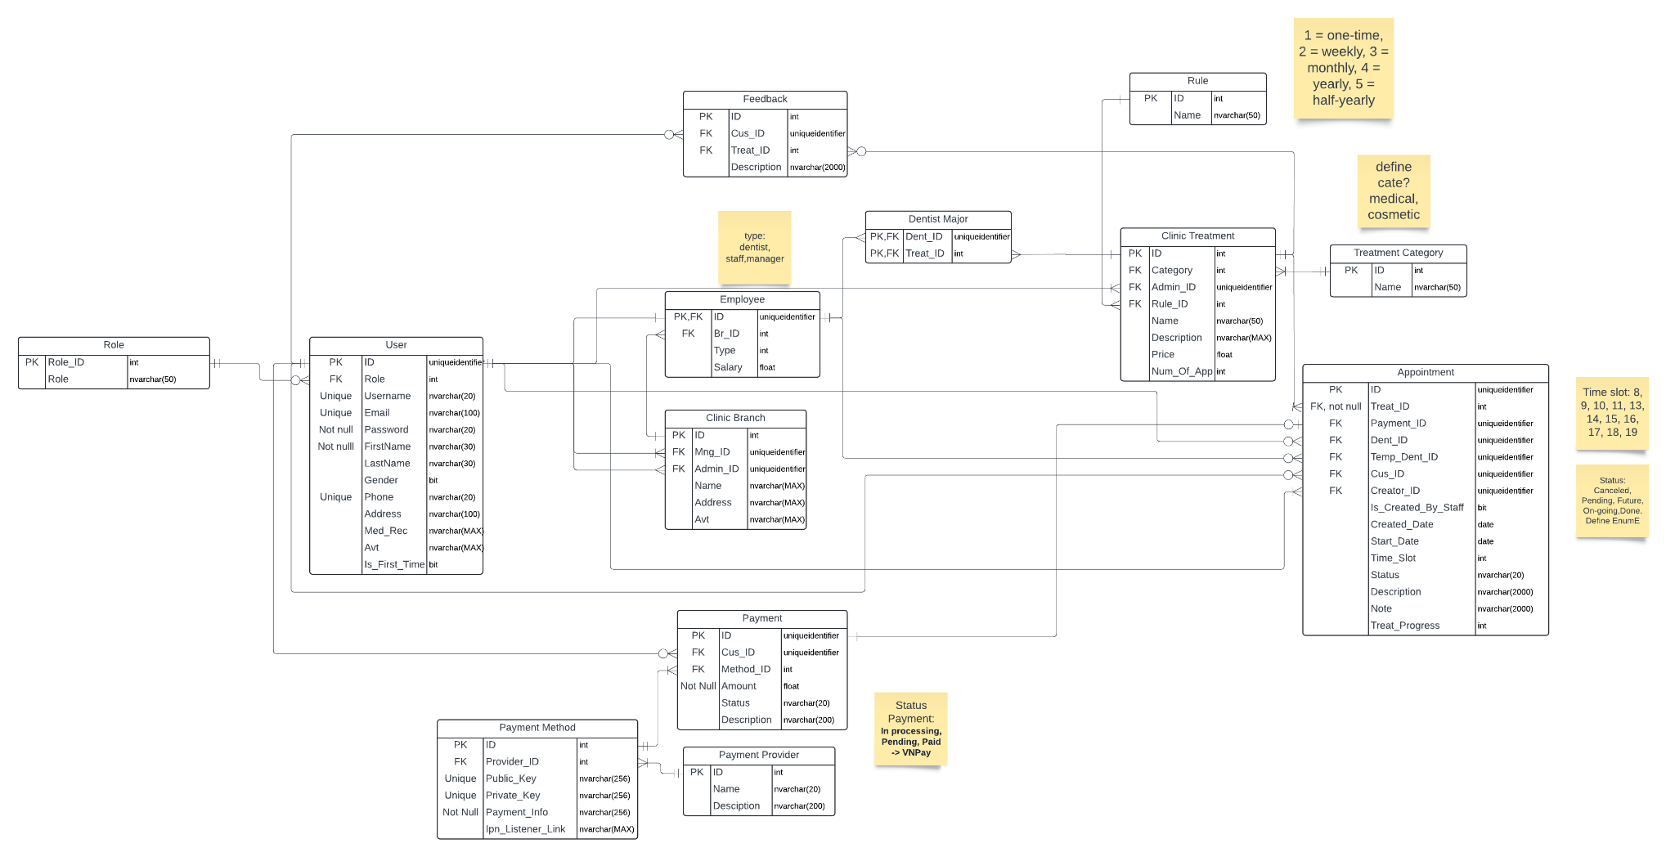

1. **FUNCTION REQUIREMENT**
2. **Authentication**
   1. **Login**
      1. **By credentials**
      2. **By Google**
   2. **Register (as Patient)**
3. **Appointment Management**
   1. **View Appointments**
      1. **Calendar**
      2. **List**
      3. **Appointment Detail**
   2. **Book Appointments (Patient, Staff)**
   3. **Reschedule Appointments**
   4. **Cancel Appointments**
   5. **Update result of Appointment (Dentist)**
   6. **Assign temporary dentist for rescheduled Appointments (Dentist)**
4. **User management**
   1. **Create account (Dentists, Staffs)**
   2. **View account(Dentists, Staffs, Customers)**
   3. **Update account(Dentists, Staffs, Customers)**
5. **Branch management**
   1. **View list Branch**
   2. **Update Branch**
   3. **Create Branch**
   4. **Delete Branch**
6. **Employee management (Branch manager)**
   1. **View List Branch Manager**
   2. **Create Branch Manager account**
   3. **Update Branch Manager account**
7. **Treatment management (Admin)**
   1. **View treatment list**
   2. **Create treatment**
   3. **Update treatment**
   4. **Delete treatment**
8. **Reporting and Analytics**
   1. **View report**
   2. **View dashboard**
9. **USE CASE LIST**
10. **Patient**
    1. Book Appointments
    2. Cancel Appointments
    3. Reschedule Appointments
    4. View Appointments
11. **Guest**
    1. Sign up as a Patient
    2. View the Clinic Information
12. **Dentist**
    1. View Appointments
    2. Submit the Appointment Result
    3. View Patients
    4. Assign a Temporary Dentist
    5. View Dashboard
13. **Admin**
    1. Manage Treatments
    2. Manage Employees
    3. Manage Patients
    4. Manage Branches
    5. View Reports
14. **Branch Manager**
    1. Manage Employees (Dentists, Staffs)
    2. Mange Branch Information
    3. View Reports
15. **Staff**
    1. View Appointments
    2. Book Appointments
16. **UI**

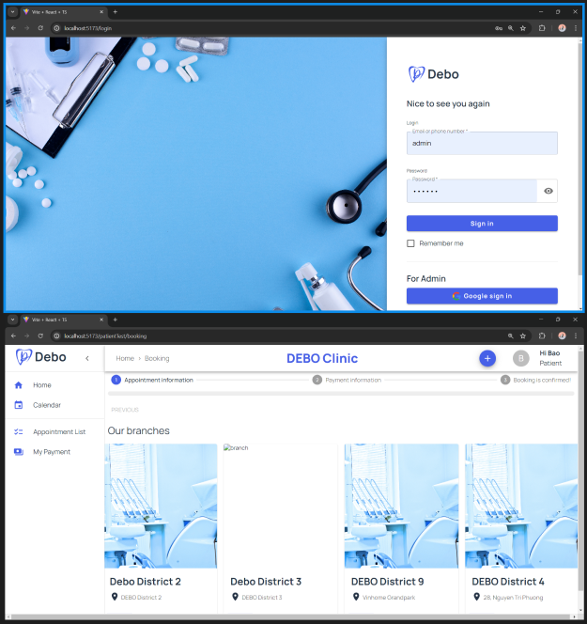

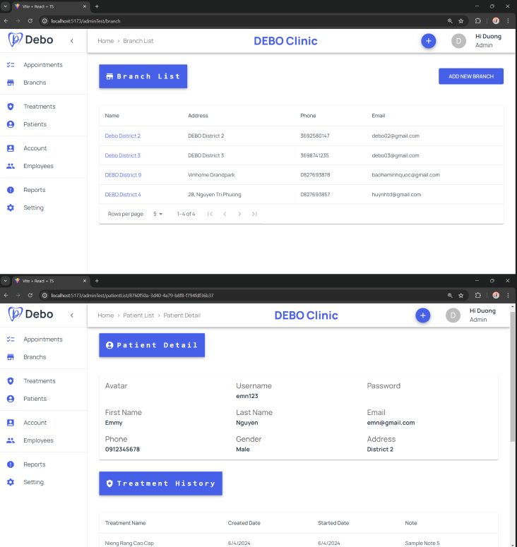

1. **TECHNICAL REQUIREMENTS**

**Login**

**Register**

**Booking**

**Manage Treatments**

**Manage Branches**

**Manage Employees**

**Manage Patients**

**Manage Appointments**

**Manage Dental Centre**

**Manage Account**

**Feedback**

**Manage Payment**

1. **SCREEN FLOW**

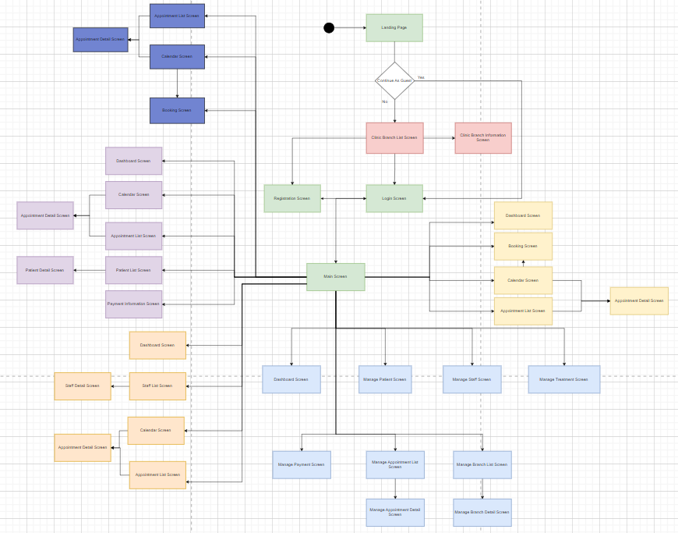

1. **BUSINESS RULE**

1. BR-01: Dentists work on office hours

2. BR-02: Pay 100% total price when create an appointment (EXCEPT dental check-up)

3. BR-03: Each account must has available phone number

4. BR-04: After completing treatment, the dentist must fill out a treatment summary immediately