PDB
https://www.youtube.com/watch?v=7Vmik1M_ry0

So what you do with pdb tool is you basically set a line in the code which will stop the execution and allow you to manually step forward on inspect the different values in your code. It’s a bit similar to breakpoints, so when the execution gets to that specific breakpoint or the line that you’ve set the breakpoint on, it will stop the execution and give you an interactive debugger access to that area of the code.

It stops at import pdb; pdb.set_trace() and shows next line which will be executed.

There’s lots you can do with pdb and it can be quite complicated, but there’s really only 3 main commands that you need to know in order to use it effectively.

next
step – it won’t just go to the next line, it will actually step into this function that we’re actually calling, this gives you a bit more depth into the code

At this point you can execute any python code that you want. This is the real value of the python debugger, you can go into the different variables and see during the execution what they are set to.

cont (i.e. continue) – it will continue to the either the end of the execution or the next set_trace() command

After you stop using debugger make sure that you remove any debug set_trace() lines and don’t commit it to your actual source code.

Rather than add debugger lines to your code, you can also run your code using "python -m pdb hello_debugger.py" - This loads pdb module as part of the script, and enters the debug tracer immediately. After that, you can set breakpoints to specific line numbers, and continue directly to the affected line without worrying about forgetting to remove debug lines from your code.

London App Developer
2 years ago
Great to hear from you Rich! Yes that is a good point, I should have mentioned that in the video.

Buddha
2 years ago
Aye man, glad to see you seem to be doing well too!

And no worries, pdb is useful either way - Nothing beats a a decent debugging interface in an IDE though - I've got a lot of love for PyCharm!

Now I just need more Python based projects to work on :)

hello_debugger.py:
import json
import pdb

def path_to_dict(path):
"""Open file at provided path and return as dictionary."""
with open(path) as json_file:
json_dict = json.load(json_file)
return json_dict

def print_values(input_dict):
"""Loop through dictionary and print values."""
pdb.set_trace()
for k, v in input_dict.items():
# pdb.set_trace()
print('{0}: {1}'.format(k, v))

def main():
"""Entrypoint to application."""
pdb.set_trace()
sample_dict = path_to_dict('sample.json')
print_values(sample_dict)

if __name__ == '__main__':
main()

sample.json:
{
"id": 1,
"name": "Test",
"date": "2017-09-02",
"person": "Mark",
"activity": "Video Recording"
}

wczytywanie helpów, funkcji modułów

https://www.youtube.com/watch?v=0twL6MXCLdQ

argparse is a command-line parsing library
Argparse is for making CLIs (or command line interfaces). Why might you actually want to make a command line interface? So to some degree it can make like interacting with your own program a little easier. You can just call it from the command line and you can change variables, just ‘--variable name =’ and boom it’s changed, you don’t have to open, edit the file and all that. So it can be quicker to tweak things and rerun it really quickly. Also, I think command line interfaces are exceptionally useful for anytime you set up sth like a cron job or sth like that. You want to maybe tweak some sort of variable, but also run the script via the system, so maybe a cron job or maybe even you’re running an os.system call in your script or sth you know and you want to change a variable or do sth, having your program be and have CLI options is useful.

With start with this, we have that kind of function:
def calc(x, y, operation):
if operation == 'add':
return x + y
elif operation == 'sub':
return x - y
elif operation == 'mul':
return x * y
elif operation == 'div':
return x / y

operation = calc(7,3,’div’)
print operation

So we’re going to convert this into a command line interface using argparse.
Main() is actually where we’re going to build the arguments themselves. Argparse means argument parser. We know that ArgumentParser is a class (as it adheres to PEP8 naming) and ‘parser’ is an object of that class.
[Studley case]
This (in yellow) is all necessary to do with argparse. And then the system out, the reason why we’re doing this is, so the output will actually come to the console. In many cases you could just use print, but there’s going to be times when actually you need to do a system out, because otherwise you’re just not going to see it.

Rather than passing x, y, operation we’re passing ‘args, that’s it.

We finish with this:
argparse_for_cli.py
import sys
import argparse

def main():
parser = argparse.ArgumentParser()
parser.add_argument('--x', type=float, default=1.0,
help='What is the first number?')
parser.add_argument('--y', type=float, default=1.0,
help='What is the second number?')
parser.add_argument('--operation', type=str, default='add',
help='What operation?')
args = parser.parse_args()
sys.stdout.write(str(calc(args)))

def calc(args):
if args.operation == 'add':
return args.x + args.y
elif args.operation == 'sub':
return args.x - args.y
elif args.operation == 'mul':
return args.x * args.y
elif args.operation == 'div':
return args.x / args.y

if __name__ == '__main__':
main()

PEP8 specifies 1 white space between functions, 2 between classes.

You can get arguments from the command line using actually just sys, but argparse is much more friendly way to parse arguments from the command line (the only reason that we use sys here is just to output from the function.

mikoaj@myszka:~/Projects/Tuts/Pdb$ python argparse_for_cli.py
2.0mikoaj@myszka:~/Projects/Tuts/Pdb$ python argparse_for_cli.py --x=5 --y=2 --operation=mul
10.0mikoaj@myszka:~/Projects/Tuts/Pdb$ python argparse_for_cli.py --x=5 --y=2 --operation=add
7.0mikoaj@myszka:~/Projects/Tuts/Pdb$ python argparse_for_cli.py --x=5 --y=2 --operation=div
2.5mikoaj@myszka:~/Projects/Tuts/Pdb$ python argparse_for_cli.py --x=5 --y=2 --operation=sub
3.0mikoaj@myszka:~/Projects/Tuts/Pdb$ python argparse_for_cli.py -h → help
usage: argparse_for_cli.py [-h] [--x X] [--y Y] [--operation OPERATION]

optional arguments:
-h, --help show this help message and exit
--x X What is the first number?
--y Y What is the second number?
--operation OPERATION
What operation?

re

https://www.youtube.com/watch?v=K8L6KVGG-7o

Raw strings purpose, we want our regular expressions to interpret the strings we’re passing in and not have python doing anything to them first, example:
print(r’\tTab’)

Let’s write some expressions and search for some patterns. So to write our patterns, I’m going to use the re.compile method, which will allow us to separate out our patterns into a variable and also will make it easier to reuse that variable to perform multiple searches, so to use this we can just say that our:
pattern = re.compile() and now in brackets we can specify our pattern. First let’s just create a pattern that matches some literal characters: pattern = re.compile(r’abc’). Now that we have that pattern specified, let’s actually search through our text with that pattern:
matches =pattern.finditer(text_to_search)
What we want to search is our very long string up here at the top i.e. text_to_search. To print out all of our matches I’m just going to do a for loop:
for match in matches:
print(match)

When we run it we can see that this ‘finditer’ method returns an iterator that contains all of the matches. Corey thinks that ‘finditer’ is one of the best for gathering all of the matches and an easy to read format.

So each of these match objects shows us the span and the match itself, so the span is the beginning and end index of the match, it only found one match of abc and it found it in our alphabet.

MetaCharacters need to be escaped
pattern = re.compile(r'\.') → escaping character
pattern = re.compile(r'coreyms\.com')
Ok, literal search isn’t too exciting, because that’s sth that we probably already know how to do within Python. Really we want to use regular expressions to search for patterns.

In the snippets.txt Corey has a list of values where we can see the types of characters that we can match:
. - Any Character Except New Line
\d - Digit (0-9)
\D - Not a Digit (0-9)
\w - Word Character (a-z, A-Z, 0-9, _)
\W - Not a Word Character
\s - Whitespace (space, tab, newline)
\S - Not Whitespace (space, tab, newline)

\b - Word Boundary
\B - Not a Word Boundary
^ - Beginning of a String
$ - End of a String

[] - Matches Characters in brackets
[^ ] - Matches Characters NOT in brackets
| - Either Or
( ) - Group

Quantifiers:
* - 0 or More
+ - 1 or More
? - 0 or One
{3} - Exact Number
{3,4} - Range of Numbers (Minimum, Maximum)

#### Sample Regexs ####

[a-zA-Z0-9_.+-]+@[a-zA-Z0-9-]+\.[a-zA-Z0-9-.]+

fnmatch

https://www.youtube.com/watch?v=HcjqcVcDrtw

fnmatch – Unix filename pattern matching in Python
This module is used for matching Unix shell-style wildcards. fnmatch() compares a single file name against a pattern and returns TRUE if they match else returns FALSE.
The comparison is case-sensitive when the operating system uses a case-sensitive file system.
The special characters and their functions used in shell-style wildcards are:

‘*’ – matches everything
‘?’ – matches any single character
‘[seq]’ – matches any character in seq
‘[!seq]’ – matches any character not in seq
The meta-characters should be wrapped in brackets for a literal match. For example, ‘[?]’ matches the character ‘?’.

fnmatch_test.py:
##### python3 fnmatch_tests.py

import fnmatch, os

current = os.listdir()

for file in current:
if fnmatch.fnmatch(file, '*.py'): # returns True/False
continue
else:
print(file) → prints all files, but .py

shutil

functools

https://www.youtube.com/watch?v=eqvY-XMihRU

Functional programming in python:
https://www.youtube.com/watch?v=2qI05zYRgbU&list=PLaYT64KWZAEMLZujkHkFkplXtv6c7S2co&index=19 (reduce)

The functools module is for higher-order functions: functions that act on or return other functions. In general, any callable object can be treated as a function for the purposes of this module (basically functions for other functions).

[which is what programming is, it takes sth and either remembers it or does sth else to it]

map, filter, reduce
https://www.youtube.com/watch?v=hUes6y2b--0
The map, filter, and reduce functions simplify the job of working with lists. In this lesson, we show you how to use each function. If you also use lambda expressions, you can accomplish a great deal in a single line of code!
streamline - usprawnić

map(area, radii)
area – functions
radii – list, tuple or other iterable object

Here map will apply the area function to each element in the list. But the output of the map function is not a list, it is a map object, which is actually an iterator over the results. This is highly favorable, especially when working with large collections of data. However we can turn it into a list by passing the map to the list constructor:
list(map(area, radii))

“If the brevity is the soul of wit, then python is in a class by itself”

import math

def area(r):
return math.pi * (r**2)

radii = [2, 5, 7, 1]

# 1. for loop
areas = []
for r in radii:
a = area(r)
areas.append(a)

print(areas)

# 2. map
m = list(map(area, radii))

print(m)

filter function is used to select certain pieces of data from a list,tuple or other collection of data. This name was chosen, because it filters out the data you do not need.

We will create an anonymous function that test the input to see if it is above average. The filter function will only return the data for which the function is true. Once again, the return value is not a list, but a filter object, which is an iterator over the results.

When you are working with data from outside sources, you will often encounter missing data or empty values.
Instead of passing in a function, we’ll simply pass None as first argument. This filters out all values that are treated as false in a boolean setting. In Python, the values that are treated as False are empty string, 0, empty list, tuple and dictionary, False, None.

import statistics

data = [1.3, 2.8, 4.2, 5.7, 3.3]

avg = statistics.mean(data)
print(avg)

f = list(filter(lambda x: x > avg, data))
print(f)

# Second example: Remove missing data
countries = ["", "Brasil", "", "Denmark"]

f = list(filter(None, countries))
print(f)

The map, filter and reduce functions greatly simplify the process of working with lists and other iterable collections of data. In fact, if you use lambda expressions, your work can often be done in a single line.

Lambda Expressions & Anonymous Functions
https://www.youtube.com/watch?v=25ovCm9jKfA

Lambda expressions - also known as “anonymous functions” - allow you to create and use a function in a single line. They are useful when you need a short function that you will only use once. For example, when using the map, filter and sort methods.

def f(x):
return 3*x + 1

print(f(2))

### the same with lambda ###
l = lambda x: 3*x + 1
print(l(2))

General way to create a lambda expression: keyword lambda followed by zero or more inputs. Just like functions, it is perfectly acceptable to have anonymous functions with no inputs. Then colon, then finally you enter a single expression, this expression is the return value. You cannot use lambda expressions for multi-line functions.

## Combine first name and last name into a single "Full Name"
full_name = lambda fn,ln: fn.strip().title() + " " + ln.strip().title()
print(full_name(" leonard", "EULER"))

# lambda with no function name
scifi_authors = ["Alberto Sousa", "K.C. Jones", "Bardo jones Zizi"]

# help(scifi_authors.sort) # if needed

scifi_authors.sort(key=lambda name: name.split(" ")[-1].lower())
print(scifi_authors)

fn.strip().title()
strip() - remove leading and trailing whitespaces
title() - uppercase for first letter in the sentence

L.sort(key=None, reverse=False)
key argument is a function that will be used for sorting. We will pass it a lambda expression. Thanks to lower() the sorting is not case-sensitive.

Then we go deeper, we will write a function that makes functions. With a single line we return an anonymous quadratic function with coefficients a, b, c.

def build_quadratic_function(a, b, c):
"""Returns the function f(x)=ax^2 + bx + c"""
return lambda x: a*x**2 + b*x + c

f = build_quadratic_function(2,3,-5)
print(f(0))
print(f(1))
print(f(2))

Let’s make and use a quadratic function without ever giving it a name. Let’s create a different (math) function and then pass in the value 2. This code creates the function 3x^2+1 and passes in the value 2 which should give us 13.

print(build_quadratic_function(3,0,1)(2)) # 3x^2+1 evaluated for x=2

This is a useful demonstration, but it is not the most readable code. Sometimes, an extra line is perfectly fine.

Lambda expressions are quite useful when you need a short, throwaway function. Sth simple that you will only use once. Common applications are sorting and filtering data.

[template engine]

Software Development Lifecycle – SDLC
https://www.youtube.com/watch?v=i-QyW8D3ei0

1. Planning requirements
Together the customer and the product owner will outline the requirements of the application. Example application requirements: user registration, login, logout, dashboard landing page.

2. Requirement Analysis (defining the requirements)
Once the requirements have been analyzed by the team and defined, the product owner will take all the defined requirements and create tickets in a project management system.

3. Design
The design phase takes all the requirements and starts to plan the product. The design phase may include business rules (e.g. clear session on logout), the user interface layouts (e.g. responsive web design, mobile support), color schemes (blue/grey), programming languages to use (ruby, java), frameworks, system server design, database relationships, architecture of the application, mobile aspects, supported browsers and much more.

4. Implementation / coding
Fun starts. The operation team will set up the physical hardware for the servers, the developers will start writing the code, the designers would continue planning the user interface and the testers will analyze the requirements and start building test cases for their test plans.

5. Testing
Now that we have the servers all set up and the database is set up, developers have finished coding, they’ve given us an application: an actual website that we can log into. Now testers can start testing and executing their test cases from the test plans, validate that all of the requirements have been met, make sure all the functionality is working as expected, find as many bugs as they possibly can.

6. Deployment
In the deployment phase the operations team will end up nearing the staging or development environment systems that we’ve been testing in and get them ready for production meaning that they’ll install new hardware or brand new servers have everything scalable for production. This includes setting up the links, the databases for real users, setting up with the development teams and release managers. Once they’ve completed all of these tasks, our application will go live to real users.

7. Maintenance
So imagine that we’ve released, our application became so successful, we’re just getting millions of users logging in and registering and using this application. So we need to maintain the servers in the environment, they need to monitor the load, the stress, everything coming on the servers by so many users logging in and using it, it doesn’t bring down the system, maybe they need to make larger servers, larger databases, maybe we need to get faster computers, there’s a lot that goes under this phase.
There will be bugs found in production, it’s called production support.

Agile
https://www.youtube.com/watch?v=Z9QbYZh1YXY

Agile is not a:
Methodology
Specific way of developing software
Framework or process

Agile is a set of Principles and Values

In fact, Agile is really a collection of beliefs that teams can use for making decisions about how to do the work of developing software. Well, this means the term Agile gets subjected to a great deal of abuse when ppl claim that this or that is the way to be agile, it also means that if you truly understand what agile is, it is surprisingly flexible. A doesn’t make decisions for you, instead it gives you a foundation that teams can use to make decisions that result in better software development.

Agile manifesto is only 68 words: we can develop software better by valuing the items on the left side of the list more than the items on the right side. Manifesto says: we are uncovering better ways of developing software by doing it and helping others do it. Through this work we have come to value:
- individuals and interactions (over)> processes and tools,
- working software > comprehensive documentation,
- customer collaboration > contract negotiation,
- responding to change > following a plan.
While this is value in the items on the right, we value the items on the left more.

In addition to the values of the manifesto, there are 12 principles that support the values. Once again, the principles are very general and are less about telling you what to do, than they are about giving you the ability to make a good decision in a particular situation. The principles are:
- Our highest priority is to satisfy the customer through early and continuous delivery of valuable software.
- Welcome changing requirements, even late in development. Agile processes harness (wykorzystują) change for the customer’s competitive advantage.
- Deliver working software frequently, from a couple of weeks to a couple of months, with a preference to the shorter timescale.
- Business ppl and developers must work together daily throughout the project.
- Build projects around motivated individuals. Give them environment and support they need, and trust them to get the job done.
- The most efficient and effective method of conveying (przekazywać) information to and within a development team is face to face conversations.
- Working software is the primary measure of progress.
- Agile processes promote sustainable (zrównoważony) development. The sponsors, developers, and users should be able to maintain a constant pace indefinitely.
- Continuous attention to technical excellence and good design enhances agility.
- Simplicity – the art of maximizing the amount of work not done – is essential.
- The best architectures, requirements and designs emerge from self-organizing teams.
- At regular intervals, the team reflects on how to become more effective, then tunes and adjust its behavior accordingly.

Since agile is a collection of values and principles, it’s real utility is in giving people a common foundation for making decisions about the best way to develop software.
When you have a team that is following Agile, they will be making hundreds of decisions each week in the way described above. That is what it means to be agile, making each decision based on the principles and values that the team has decided to follow.
The decision making process matters, you can’t try to short circuit things by taking decisions made by another team and just blindly doing what they decided to do. Another team may make decisions based on the agile principles and values that end up with a particular way of doing their work. Simply trying to mimic another team’s actions and practices won’t make your team agile.

[melanesian islanders and planes example]
It is easy to fall into a similar type of cargo cult mentality when it comes to agile. The things that are easy to notice in a highly functional agile team are the practices they are using. But the practices the team uses is the result of following Agile principles and values. It is less important what practices a team happens to be using than why they are using it. In fact, as time goes by, a good agile team is probably going to change and refine the practices they use.
A team might start with Scrum and later find that Kanban is a better fit for delivering value to their customers (a team might begin standing on daily meetings and later decide it works better for them to sit). That isn’t to say it us useless to look at practices being used by teams that are performing well, but you can’t go looking for practices to make you Agile. Your principles and values are what will make you agile. You have to look for practices that support your principles and values. The way you select your practices is what determines whether you are being agile or not. If a practice is being selected because it looks like a good way to follow agile principles, it’s probably a good place to start. The same practice can work poorly for a team if it is selected for the wrong reasons.

To sum up:
So what is Agile? It is a set of values and principles.
How does a team become agile? They make their decisions based on Agile values and principles.
The decision making process is how a team becomes agile.
[koncowka]

https://www.youtube.com/watch?v=HNd1_irOL5k
scrum vs kanban

Scrum

Scrum is a framework within which people can address complex adaptive problems, while productively and creatively delivering products of the highest possible value.

Scrum itself is a simple framework for effective team collaboration on complex products. Scrum co-creators Ken Schwaber and Jeff Sutherland have written The Scrum Guide to explain Scrum clearly and succinctly. This Guide contains the definition of Scrum. This definition consists of Scrum’s roles, events, artifacts, and the rules that bind them together.

Agile video : https://www.youtube.com/watch?v=NpCEj...

Scrum is:
Lightweight
Simple to understand
Difficult to master
-scrum.org

https://www.youtube.com/watch?v=XU0llRltyFM

Scrum is one of the best agile development practices in use today.

Let’s say we want to build a product. For this product we get all kinds of feature requests from customers, executives, or even other team members. In scrum, features are written from the perspective of the end user. Therefore, features are known as user stories. The collection of all these user stories is called the product backlog. Another way to think of the product backlog is to think of it as a wish list of all the things that would make this product great.
Once we have our wish list or the product backlog, we need to start planning which specific user-stories we’re going to put into a particular release of our product.
But we’re getting ahead of ourselves. Let’s back up a bit. To build this product we need to have 1 or more ppl in our team who are going to play a variety of roles. First we need her, she plays the role of Product Owner and helps make sure the right features make it into the product backlog representing the users and customers of the product. She helps set the direction of the product. Then we need the Scrum Master and his job is to make sure the project is progressing smoothly and that every member of the team has the tools they need to get their job done. He sets up meetings, monitors the work being done and facilitates release planning. He’s a lot like a project manager, but that’s such a boring title. And the rest of the team has similar roles to other development processes: Developers build the product, testers test it to make sure it works right, customers use it and hopefully pay for it. Executives generally get in the way, but it turns out you can’t build many products without them.
But let’s get back to this: Release Planning. To plan a release the team starts with the product backlog and they identify the user stories they want to put into this release. These user stories then become part of the release backlog. The team then prioritizes the user stories and estimates the amount of work involved for each item. Sometimes larger user stories are broken down into smaller more manageable chunks. The collection of all the estimates provides a rough idea of the total amount of work involved to complete the entire release.
A quick side note about estimates. There are a lot of techniques for creating good estimates. Author thinks that the best technique is to estimate work in hours, but to use some standards in how estimates are done. For example, things that take less than a day to complete eill be estimated as 1,2,4,8 hours (there will be no 3h estimate, for example, a 3h item would fall into the 4h bucket). Larger items will be estimated as 2, 3, 5, or 10 days (again, all estimates in between will fall into the next larger bucket). Extremely large itmes are similarly estimated in months: 1, 2, 4, or 6, but the reality is that such items will need to be broken down substantially before work actually begins.
Let’s get back to this: the release backlog. With the prioritized set of user stories and the estimated amount of work at hand, we are now ready to plan out several sprints to get the work done. Sprints are short duration milestones that allow teams to tackle a manageable chunk of the project and get it to a ship-ready state. Sprints generally range from a couple of days to as much as 30 days in length, depending on the product’s release cycles. The shorter the release cycles, the shorter each sprint should be. And you’ll want to have at least 2 to as many as a dozen sprints in a given release.

unittest
https://www.youtube.com/watch?v=1Lfv5tUGsn8
Unit tests are a way to make sure your code is correct. Python comes with a built-in unit test framework that makes it easy to write a lot of tests for your software. In fact, many engineers will write a series of tests before they begin coding. This approach is called “test driven development” and is very effective.

Let’s write a unit test to check that the function works properly. We typically put the unit tests in a separate file. There are 2 common conventions for naming the test module: filename_test.py or test_filename.py. Some ppl with put tests in a separate folder entirely.

Next we create a class that is a subclass of the TestCase class in the unittest module. We will call our class TestCircleArea. A more descriptive name is hard to imagine (tested function is called circle_area).
We write our test methods inside this class. Each test method must start with the word ‘test’.
The first will be ‘test_area’. Here we will check that the function correctly computes the areas of several circles. To do this we will call ‘assertAlmostEqual’ method. The first value will be the output of the circle area function and the second value will be the correct answer. The python unittest framework will compare these 2 values and if they are correct to 7 decimal places, it will assume they are equal.
If any of our comparisons fail, then python will register that the ‘test_area’ method failed.

To run this unit test run:
python -m unittest test_unittest1.py
-m instructs python to run the unittest module as a script
BTW we can also simply run python -m unittest. Python will then use a process called test discovery where it will search for tests and run them. A handy shortcut.

Let us now test the function to see if it handles improper inputs correctly. We will write a new test method called ‘test_values’ to see if the function raises a value error when the input is a negative number. To check that an exception is raised, we use ‘assertRaises’ method. The first argument is the exception class that should be raised. The second argument is a function and the remaining inputs are arguments to the function. In this case, if we try to compute the area of a circle with r = -2, the function should raise a value error.

As we see, a value error was not raised when the input was negative. Let’s refactor the unittest1.py module.

So far we have seen 2 assert methods: assertAlmostEqual and assertRaises. Python has many more methods for unit testing, dozens and dozens. One way to learn about particular assert method is by looking at the help text in interactive mode:
python3
import unittest
help(unittest.TestCase.assertSetEqual)
Python gives us a nice detailed description of this assert method.

Let’s get back to our example. We also want to make sure the function raises a type error whenever the input is not real number, so we will add a third test method.

To address this problem, we first check the type of the input. If the type is not an integer or a float, then we will raise a type error.

unittest1.py
from math import pi

def circle_area(r):
if type(r) not in [int, float]:
raise TypeError("The radius must be a non-negative real number.")
if r < 0:
raise ValueError("The radius cannot be negative.")
return pi*(r**2)

"""
# Test function
radii = [2, 0 , -3, 2+5j, True, "radio"]
message = "Area of circles with r = {radius} is {area}"

for r in radii:
A = circle_area(r)
print(message.format(radius=r, area=A))
"""

test_unittest1.py
import unittest
from unittest1 import circle_area
from math import pi

class TestCircleArea(unittest.TestCase):
def test_area(self):
# Test areas when radius >= 0
self.assertAlmostEqual(circle_area(1), pi)
self.assertAlmostEqual(circle_area(0), 0)
self.assertAlmostEqual(circle_area(2.1), pi * 2.1**2)

def test_values(self):
# Make sure value errors are raised when necessary
self.assertRaises(ValueError, circle_area, -2)

def test_types(self):
# Make sure type errors are raised when necessary
self.assertRaises(TypeError, circle_area, 3+5j)
self.assertRaises(TypeError, circle_area, True)
self.assertRaises(TypeError, circle_area, "lolo")

[Change is one constant in programming]

Logging
https://www.youtube.com/watch?v=g8nQ90Hk328
The Logging module in Python makes it easy to track events in your code. Log files are extremely valuable when you want to analyze usage or track down problems in your code. Today we cover the essentials of the Python logging system, and then give a demonstration of how to use logging in your code.

The logging module in Python gives you everything you need to report progress and problems in your code. It would be good if developers and machines were 100% reliable, but let’s be honest, life is messy. You’re expecting an integer, someone hands you a float. You call a cloud API – the service is down for maintenance.
A wide range of problems can happen that are out of your control. With logging, you can leave a trail of breadcrumbs, so when sth goes wrong, you can determine the cause. “Hope for the best, but plan for the worst” – with logging.

Logging allows you to write status messages to a file or other output streams. These messages contain information on which parts of your code have executed, and what problems may have arisen. Each log message has a level. The 5 built-in levels are: Debug, Info, Warning, Error, Critical. If you want you can create additional levels, but these should suffice for most cases.

Let’s now write a program and use logging module to help us track down bugs and leave a record of how our code was used.

print(dir(logging))
['BASIC_FORMAT', 'BufferingFormatter', 'CRITICAL', 'DEBUG', 'ERROR', 'FATAL', 'FileHandler', 'Filter', 'Filterer', 'Formatter', 'Handler', 'INFO', 'LogRecord', 'Logger', 'LoggerAdapter', 'Manager', 'NOTSET', 'NullHandler', 'PercentStyle', 'PlaceHolder', 'RootLogger', 'StrFormatStyle', 'StreamHandler', 'StringTemplateStyle', 'Template', 'WARN', 'WARNING', '_STYLES', '_StderrHandler', '__all__', '__author__', '__builtins__', '__cached__', '__date__', '__doc__', '__file__', '__loader__', '__name__', '__package__', '__path__', '__spec__', '__status__', '__version__', '_acquireLock', '_addHandlerRef', '_checkLevel', '_defaultFormatter', '_defaultLastResort', '_handlerList', '_handlers', '_levelToName', '_lock', '_logRecordFactory', '_loggerClass', '_nameToLevel', '_releaseLock', '_removeHandlerRef', '_showwarning', '_srcfile', '_startTime', '_warnings_showwarning', 'addLevelName', 'atexit', 'basicConfig', 'captureWarnings', 'collections', 'critical', 'currentframe', 'debug', 'disable', 'error', 'exception', 'fatal', 'getLevelName', 'getLogRecordFactory', 'getLogger', 'getLoggerClass', 'info', 'io', 'lastResort', 'log', 'logMultiprocessing', 'logProcesses', 'logThreads', 'makeLogRecord', 'os', 'raiseExceptions', 'root', 'setLogRecordFactory', 'setLoggerClass', 'shutdown', 'sys', 'threading', 'time', 'traceback', 'warn', 'warning', 'warnings', 'weakref']
This module is packed with features. The entries in all caps are constants, the capitalized items are classes and the items that start with a lowercase letter are methods.

Today we will keep things simple by setting up the logging systemusing the ‘basicConfig’ method. Next we’ll create a logger using the ‘getLogger’ method. We’ll then use the logger and adjust its features until it works the way we want. Let’s now switch to input output mode.

Let’s first configure the logging system and create a logger. Call the basicConfig method and pass in a filename – python will write all the log messages to this file, if the file does not exist, python will create it. Next call the getLogger method to create a logger object. You can give your logger a name if you wish, but there are some subtle issues with logging names, so today we will keep things simple and work with one logger without a name, known as the root logger.
Then we test it, to write an info message, call the info method and pass in a string → you can see that the ‘lumberjack.log’ file was created. But inside there is no our log message. Why? The reason lies in how we configured the logger. Let’s print the level of our logger and run again:
print(logger.level)
30
In the logging module, the six built-in level constants are: NOTSET, DEBUG, INFO, WARNING, ERROR and CRITICAL. These constants are integers with values of 0, 10, 20, 30, 40 and 50 respectively. Loggers will only write messages with a level greater than or equal to the set level. Our test log message was an info message which has a value of 20, but basicConfig sets the level of the root logger to warning (value = 30) by default. To fix this update the basicConfig call and set the level to DEBUG. This will guarantee that we will see all log messages.

If you open the log file once more, you will now see our test message:
INFO:root:Our first message.
Notice that the log message displays the level, the name of the logger (root in our case) and the message. This format is ok, but it’s missing an important piece of data: the time when the log message was created.
So let’s change the format of the log message, to do this we will create a format string. Python gives you a wide selection of information you can include in your log messages (→ python.org). Here we’re interested in the level, time and messsage.
To change the logging format create a string with the desired attributes:
LOG_FORMAT = “%(levelname)s %(asctime)s - %(message)s”
and pass the format string to the basicConfig call.

If you open the log file, you will see the message now appears in the new format:
INFO:root:Our first message.
INFO 2019-11-25 11:42:26,457 - Our first message.
Notice that the first message is still there. His is because by default, the log file is created in append mode. If you want the log file to be overwritten each time (only our most recent message appears), change the file mode to ‘w’.

You can log messages of any level by calling the method with the level name:
logger.debug("Debug mode.")
logger.info("Info mode.")
logger.warning("Warning mode.")
logger.error("Error mode.")
logger.critical("Critical mode.")
If you open the log file, you will see all 5 messages, but if you change the log level to error (level = logging.ERROR), you will now only see the error and critical messages.

Now that we know how to configure and use the logging module, let’s see it in action. We will write a function implementing the quadratic formula, which allows you to solve any quadratic equation.

We sometimes use the same message in message as in the comment. This may seem repetitive, but once we are confident the code is working properly, we may want to remove the debug logs, while keeping the comments.

logging1.py:
import logging
import math

# print(dir(logging))

# Create and configure logger
LOG_FORMAT = "%(levelname)s %(asctime)s - %(message)s"
logging.basicConfig(filename="lumberjack.log",
level=logging.DEBUG,
format=LOG_FORMAT,
filemode="w")
logger = logging.getLogger()

"""
# Test the logger
logger.debug("Debug mode.")
logger.info("Info mode.")
logger.warning("Warning mode.")
logger.error("Error mode.")
logger.critical("Critical mode.")

print(logger.level)
"""

def quadratic_formula(a, b, c):
"""Return the solution to the equation ax^2 + bx + c = 0."""
logger.info("quadratic_formula({0}, {1}, {2})".format(a, b, c))

# Compute the discriminant
logger.debug("# Compute the discriminant.")
disc = b^2 - 4*a*c

# Compute the 2 roots
logger.debug("# Compute the 2 roots")
root1 = (-b + math.sqrt(disc)) / (2*a)
root2 = (-b - math.sqrt(disc)) / (2*a)

# Return the roots (as a tuple)
logger.debug("# Return the roots")
return (root1, root2)

roots = quadratic_formula(1, 0, -4)
#roots = quadratic_formula(1, 0, 1)
print(roots)

Linux File System/Structure Explained!
https://www.youtube.com/watch?v=HbgzrKJvDRw

Docker Tutorial for Beginners - A Full DevOps Course on How to Run Applications in Containers
https://www.youtube.com/watch?v=fqMOX6JJhGo

To understand how docker works, let us revisit some base concepts of operating systems first. If you look at operating systems like Ubuntu, Fedora, Suse or CentOS, they all consist of 2 things: an OS kernel and a set of software. The os kernel is responsible for interacting with the underlying hardware. While the os kernel remains the same which is linux in this case, it’s the software above it that makes these operating systems different. This software may consist of a different user interface, drivers, compilers, file managers, developer tools, etc. So you have a common linux kernel shared across all OSes and some custom software that differentiate operating systems from each other.

We said earlier that d containers share the underlying kernel, so what that actually mean: sharing the kernel? Let’s say we have system with an Ubuntu os with d installed on it. D can run any flavor of OS on top of it as long as they are all based on the same kernel, in this case Linux. If the underlying OS is ubuntu, d can run a container based on another distribution like debian, fedora, suse, etc. Each d container only has the additional software that we just talked about in the previous slide that makes these operating systems different and d utilizes the underlying kernel of the d host, which works with all OSes above.
So what is an OS that do not share the same kernel as this? Windows, and so you won’t be able to run a windows based container on a d host with linux on it. For that you will require a docker on a windows server.
[linux container on linux virtual machine on windows]

Isn’t that a disadvantage then, not being able to run another kernel on the OS? The answer is no, because unlike hypervisors, d is not meant to virtualize and run different operating systems and kernels on the same hardware. The main purpose of d is to package and containerize applications and to ship them, and to run them anywhere, any times, as many times as you want.
So that brings us to the differences between virtual machines and containers, sth that we tend to do especially those from a virtualization background. As you can see on the right, in case of d, we have the underlying hardware infrastructure and then OS and then d installed on the OS. D then manages the containers that run with libraries and dependencies alone. In case of virtual machines we have the hypervisor like ESX on the hardware and then the virtual machines on them. As you can see, each virtual machine has its own OS inside it, then the dependencies and then the application. The overhead process causes higher utilization of underlying resources as there are multiple virtual operating systems
and kernels running. The Vms also consume higher disk space as each VM is heavy and is usually in gigabytes in size, whereas d containers are lightweight and are usually in megabytes in size. This allows d containers to boot up faster, usually in a matter of seconds, whereas Vms take minutes to boot up as it needs to boot up the entire operating system.
It is also important to note that d has less isolation as more resources are shared between the containers like kernel whereas Vms have complete isolation from each other. Since Vms don’t rely on the underlying OS or kernel, you can run different types of applications built on different OSes such as Linux based or Windows based apps on the same hypervisor.
Hypervisor[] <-
Those are some differences between the 2, now having said that, it’s not either container or vm situation – it’s containers and virtual machines. Now when you have large environments with thousands of application containers running on thousands of docker hosts, you will often see containers provisioned on virtual docker hosts. That way we can utilize the advantages of both technologies, we can use the benefits of virtualization to easily provision or decommission docker host as required. As the same time make use the benefits of docker to easily provision application and quickly scale them as required.
But remember, in this case we will not be provisioning that many virtual machines as we used to before, because earlier we provisioned a virtual machine for each application. Now you might provision a virtual machine for hundreds or thousands of containers [screen].

So how is it done?
There are lots of containerized versions of applications readily available as of today, so most organizations have their products containerized and available in a public docker repository called dockerhub/dockerstore. For example you can find images of most common operating systems, databases and other services and tools. Once you identify the images you need and you install docker on your host, bringing up an application is as easy as running:
docker run ansible
docker run mongdb
docker run redis
docker run nodejs
If you need to run multiple instances of the web service, simply add as many instances as you need and configure a [load balance or some kind in the front(?)]. In case one of the instances were to fail, simply destroy that instance and launch a new one. → there are other solutions available for handling such cases.

An image is a package or a template just like a vm template that you might have worked with in the virtualization world. It is used to create one or more containers. Containers are running instances of images that are isolated and have their own environment and set of processes.
You can also create your own image and push it to dhub repo making it available for public.

Traditionally, developers developed applications, then they hand it over to ops team to deploy and manage it in production environments. They do that by providing a set of instructions such as information about how the host must be set up, what prerequisites are to be installed on the host and how the dependencies are to be configured etc. Since the ops team did not really develop the application on their own, they struggled with setting it up.
With docker, developer and operations teams work hand in hand to transform the guide into a dockerfile with both of their requirements. This dockerfile is used to create an image for their applications. This image can now run on any host with docker installed on it and it’s guaranteed to run the same way everywhere. So the ops team can now simply use the image to deploy the application since the image was already working when the developer built it. That’s one example of how a tool like docker contributes to the DevOps culture.

Community Edition – set of free docker products
Enterprise Edition – certified and supported container platform that comes with enterprise add-ons.

CE is available on linux, mac, windows or cloud platforms like AWS or Azure.
Mac/Windows 2 options: install linux vm using virtualbox or other virtualization platform or install docker desktop for mac or windows.

$ cat /etc/*release* ← view the etsy release file

Docker Installation
$ sudo docker version

We will now run a simple container to ensure everything is working as expected.
$ sudo docker run docker/whalesay cowsay Hello-World
On running this command docker pulls the image of the ‘whalesay’ application from dockerhub and runs it. We’re all set.

Docker commands
docker run → run a container from an image

docker run nginx → will run an instance of an nginx application from the docker host if it already exists. If the image is not present on the host, it will go out to dockerhub and pull the image down. But this is done only once at the beginning, for the subsequent executions the same image will be reused.

ps → lists all running containers and some basic information about such as the container id, the name of the image we used to run the containers, the current status and the name of the container. Each container automatically gets a random id and name created for it by docker.

ps -a -> see all containers running or not

docker stop container_id/container_name → stopping container

docker rm container_name → removed stopped container permanently (if it prints the name back, we’re good)

docker images → list all images on our host

docker rmi nginx → remove an image, make sure there are no containers running off of that image

docker pull nginx → just pulls (and not run) the image and stores it on our host

Let’s look at another example, say you were to run a docker container from an ubuntu image. When you run the docker run ubuntu command, it runs an instance of ubuntu image and exits immediately. If you were to list the running containers you wouldn’t see the container running. If you did docker ps -a, you would see it is in exited state. Why? Unlike vms, containers are not meant to host an OS, containers are meant to run a specific task or process such as to host an instance of a web server or application server, or database, or simply to carry some kind of computation or analysis task. Once the task is complete, the container exits. A container only lives as long as the process inside it is alive. If the web service inside the container is stopped or crush, then the c exits.
This is why when you run a container from an ubuntu image, it stops immediately, because ubuntu is just an image of an OS that is used as the base image for other applications. There is no process or application running in it by default.
If the image isn’t running any service, as is the case with ubuntu, you could install docker to run a process:
docker run ubuntu sleep 5
When the container starts, it runs the sleep command and goes into sleep for 5 seconds, post which the sleep command exits and the container stops.

What we just saw was executing a command when we run the container. But what if we would like to execute a command on a running container, for example there is a running c with the ubuntu image and sleeps for 100 seconds. Let’s say we would like to see the contents of a file inside this particular container:
docker exec container_name cat etc/hosts
exec command to execute a command on my docker container, in this case to print the contents of the etsy hosts file

Let’s look at one more option. we’re going to run a d image we developed for a simple web app. The repo name is kodekloud/simplewebapp. It runs a simple web server that listens on port 8080. when you run a d command like this:
docker run kodekloud/simplewebapp
it runs in the foreground or in an attached mode, meaning you will be attached to the console or the standard out of the d c and you will see the output of the webservice on your screen. You won’t be able to do anything else on this console other than view the output until the d c stops. It won’t respond to your inputs. Ctrl + c to stop the container and the application hosted on the container exists and you get back to your prompt.
Another option is to run a c in the detached mode, by providing dash d option:
docker run -d kodekloud/simplewebapp
this will run the d c in the background mode and you will be back to your prompt immediately. The c will continue to run in the backend.
If you would like to attach back to the running c later:
docker attach name/container_id
* if you’re specifying the id of a container in any command, you can simply provide the first few characters alone.

Other docker run commands
docker run redis
run the container running a redis service, in the case the latest version of redis which happens to be 5.0.5
What if we want to run another version of redis, e.g. an older version like 4.0? Then you do:
docker run redis:4.0
This is called a tag. Notice that if you don’t specify any as in the first command, d will pull down the latest.

We have a simple app that when runs, it asks for my name and then prints a welcome message. If we were to dockerize this app and run it as a d c, like this:
docker kodekloud/simple-prompt-docker
it would not wait for the prompt. It just prints whatever the application is suppose to print on standard out. That is because by default d c does not listen to a standard input. Even though you’re attached to it’s console, it is not able to read any input from you. It doesn’t have terminal to read inputs from, it runs in a no interactive mode.
If you’d like to provide your input, you must map the standard input of your host to the d c using the dash i parameter:
docker -i kodekloud/simple-prompt-docker
-i parameter is for interactive mode and when I put my name it prints the expected output.
But there’s sth still missing from this, the prompt. When we run the app at first, it asked us for our name, but when dockerized, that prompt is missing even though it seems to have accepted my input. That is because the application prompt on the terminal and we have not attached to the containers terminal. Fot this we use -t option as well:
docker -it kodekloud/simple-prompt-docker
-t stands for sudo terminal, so with combination -it we are now attached to the terminal as well as in the interactive mode on the c.

Now let’s have a look at port mapping or port publishing on cs. Let’s go back to the example where we run a simple app in a d c on my docker host. Remember, the underlying host where d is installed is called docker host or docker engine. When we run a containerized web application, it runs and we’re able to see that the server is running, but how does a user access my application?
As you can see my application is listening on port 5000, so I could access my app by using port 5000, but what ip do I use to access it from the web browser?
There are 2 options available. 1 is use the ip of the d c. Every d c gets an ip assigned by default, in this case it is 172.17.0.2. But remember, this is an internal ip and it’s accessible only within the d host. So if you open a browser from within the d host, you can go to http://127.17.0.2:5000 to access the ip address. But since this is an internal ip, users outside of the d host cannot access it using this ip. For this we could use the ip of the d host which is 192.168.1.5, but for that to work you must have mapped the port inside the d c to a free port on the d host. For example if I want the users to access my application through port 80 on my d host, I could map port 80 of localhost to port 5000 on the d c using the -p parameter in my run command like this:
docker run -p 80:5000 kodkloud/simple-webapp
and so the user can access my application by going to the url http://192.168.1.5:80. And all traffic on my d host will get routed to port 5000 inside the d c.
This way you can run multiple instances of your application and map them to different ports on the docker host. Or run instances of different applications on different ports, for example in this case we’re running an instance of MySQL that runs a database on my host and listens on the default MySQL port, which happens to be 3306. Or another instance of MYSQL on another port 8306. So you can run as many applications like this and map them to as many ports as you want. And of course, you cannot map to the same port on the d host more than once.

How data is persisted in a d c?
Let’s say you were to run a MySQL c.
docker run mysql.
When databases and tables are created, the data files are stored in location varlib/mysql inside the d c. Remember d c has its own isolated filesystem and any changes to any files happen within the container.
Let’s assume you dump a lot of data into the database. What happens if you were to delete the MySQL container and remove it?
docker stop mysql
docker rm mysql
As soon as you do that, the container along with all the data inside it gets blown away, meaning all your data is gone. If you’d like to persist data, you would want to map a directory outside the container on the d host to a directory inside the c. In this case I create a directory called /opt/datadir and map that to /var/lib/mysql inside the d c using the -v option and specifying the directory on the d host followed by a : and the directory inside the d c:
docker run -v /opt/datadir:/var/lib/mysql mysql
This way, when d c runs, it will implicitly mount the external directory to a folder inside the d c. This way all your data will now be stored in the external volume /opt/datadir and thus it will remain even if you delete the d c.

The d ps command is good enough to get basic details about containers like their names and ids, but if you’d like to see additional details about a specific container, use the:
docker inspect container_name/id
It returns all details of a container in a JSON format, such as the state, mounts, configuration data, network settings etc. Remember to use it when you are required to find details on a container.

Finally how do we see the logs of a c we run in the background, for example I ran my simple web application using the -d parameter and it ran the container in a detached mode. How do we view the logs which happens to be the contents written to the standard out of that container?
docker logs container_name/id

Environment variables (to be done)

Docker Images
Now we’re going to see how to create your own image. Now, why would you need to create your own image? It could either be because you cannot find a component or a service that you want to use as part of your application on d hub already or you and your team decided that the application you’re developing will be dockerized for ease of shipping and deployment.
In this case I’m going to containerize an application, a simple web application that I have built using the flask framework. First we need to understand what we’re containerizing or what application we are creating an image for and how the application is built. So start by thinking what you might do if you want to deploy the application manually. We will write down steps required in the right order. I’m creating an image for a simple web application, if I were to set it up manually, I would start with an operating system like Ubuntu:
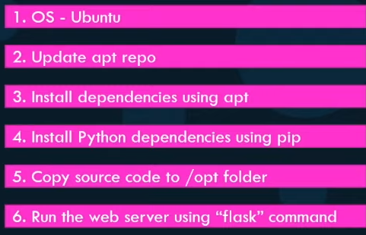

Now that I have the instructions, create a dockerfile using this this. Here’s a quick overview of the process of creating your own image. Create a dockerfile:

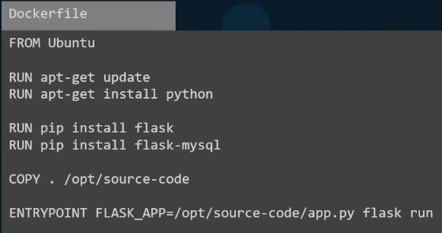
Once done, build your image using the d build command:
docker build Dockerfile -t mmumshad/my-custom-app (bez dockerfile?)
and specify the d file as input as well as a tag named for the image. This will create an image locally on your system. To make it available on the public d hub registry run:
docker push mmumshad/my-custom-app
and specify the name of the image you just created, in this case the name of the image is my account name (mmumshad) followed by the image name (my-custom-app).

Let’s take a closer look at the dockerfile. Df is a text file written in a specific format, it’s in an instruction and arguments format.

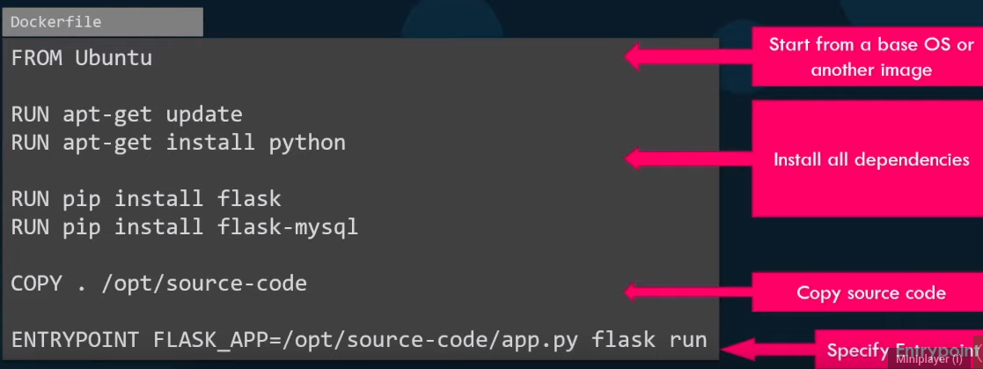
Everything on the left in caps is an instruction, everything on the right is an argument to those instructions. The first line defines what the base OS should be for this container. Every d image must be based off of another image, either an OS or another image that was created before based on an OS. It’s important to note that all dockerfiles must start with a FROM instruction. RUN instructs d to run a particular command on those base images. So at this point d runs ‘apt-get update’ commands to fetch the updated packages and installs required dependencies on the image. Then COPY instruction copies files from the local system onto the d image (in this case the source code of our application is in the current folder and I will be copying it over to the location /opt/source-code inside the d image). And finally ENTRYPOINT allows us to specify a command that will be run when the image is run as a container.

When d builds the images, it builds these in a layered architecture, each line of instruction creates a new layer in the d image with just the changes from the previous layer. For example the first layer is a base ubuntu OS followed by the second instruction that creates a second layer, which installs all the apt packages and then third layer…

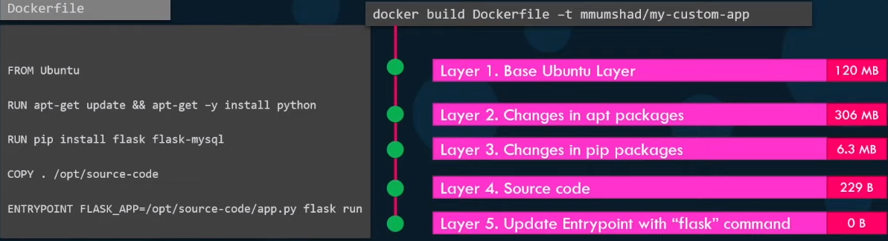
Since each layer only stores the changes from the previous layer, it is reflected in the size as well.

You could see this information if you run the d history command followed by the image name:
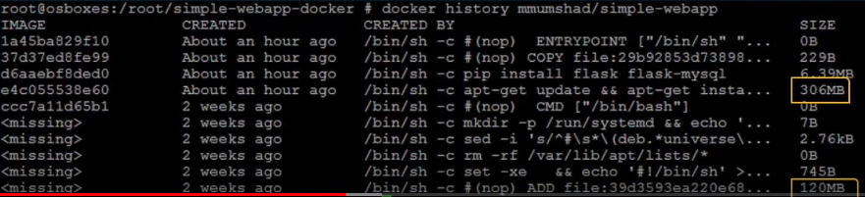

When you run the d build command, you can see the various steps involved and the result of each task. All the layers built are cached, so the layered architecture helps you restart docker build from that particular step in case it fails or if you were to add new steps in the build process, you wouldn’t have to start all over again. All the layers built are cached by d, so in case a particular step was to fail, for example in this case step 3 failed and you were to fix the issue and rerun docker build (docker build Dockerfile -t mmumshad/my-custom-app), it will reuse the previous layers from cache and continue to build the remaining layers. The same is true if you were to add additional steps in the dockerfile. This way rebuilding your image is faster and you don’t have to wait for d to rebuild the entire image each time. This is helpful especially when you update source code of your application as it may change more frequently. Only the layers above the updated layers need to be rebuilt.

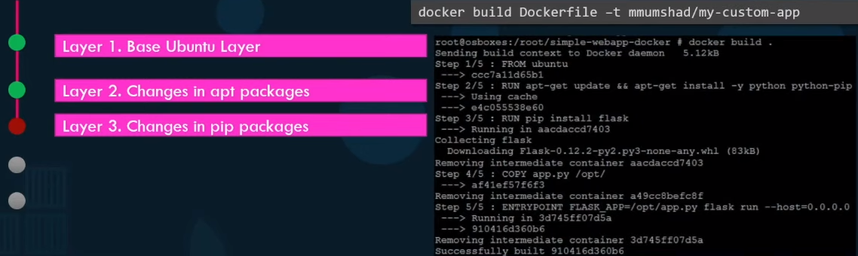
We just saw a number of products containerized such as databases, development tools, OSes etc. But that’s just not it, you can containerize almost all of the application, even simple ones like browsers or utilities like curl, apps like spotify, skype, etc. Basically you can containerize everything and going forward I see that how everyone is going to run applications. Nobody is going to install anything, anymore, going forward, instead they’re just going to run it using d and when they don’t need it anymore, get rid of it easily without having to clean up to much.

DOCKER COMPOSE
Going forward we will be working with configurations in yaml file. Let’s recap a few things real quick.
If we needed to set up a complex application, running multiple services:
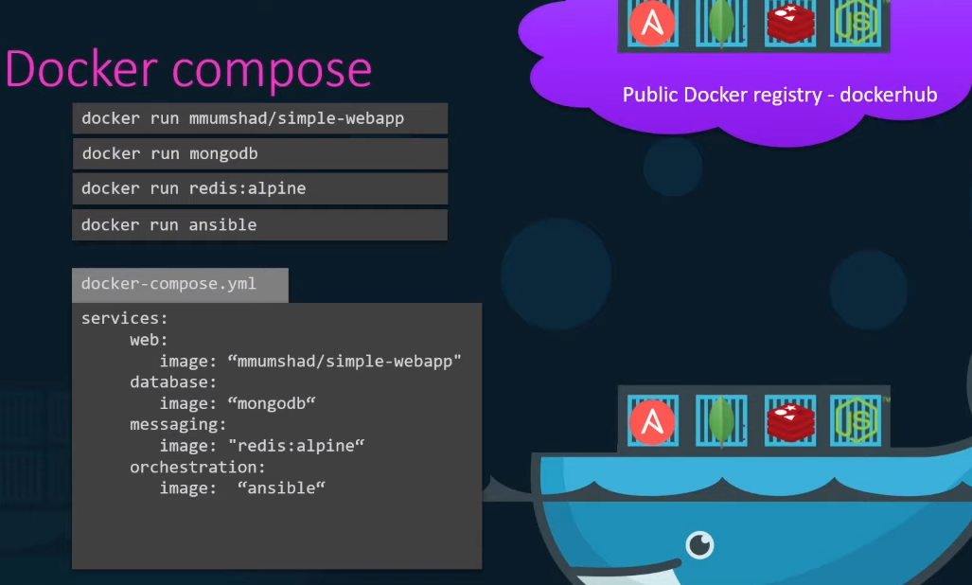
a better way to do it is to use docker compose (dc). With dc we could create a configuration file in yml format called docker-compose.yml and put together the different services and the options specific to running them in this file. Then we could simply run:
docker compose up
to bring up the entire application stack. This is easier to implement, run and maintain as all changes are always stored in the dc configuration file. However this is all only applicable to running containers on a single d host.

That was a really simple application that I put together. Let’s look at a better example. I’m going to use the sample application that everyone uses to demonstrate d. It’s a simple yet comprehensive application developed by d to demonstrate the various features available in running an application stack on d.

Let’s get familiarized with the application, because we will be working with the same application through the rest of this course. This is a sample voting application which provides an interface for a user to vote and another interface to show the results.
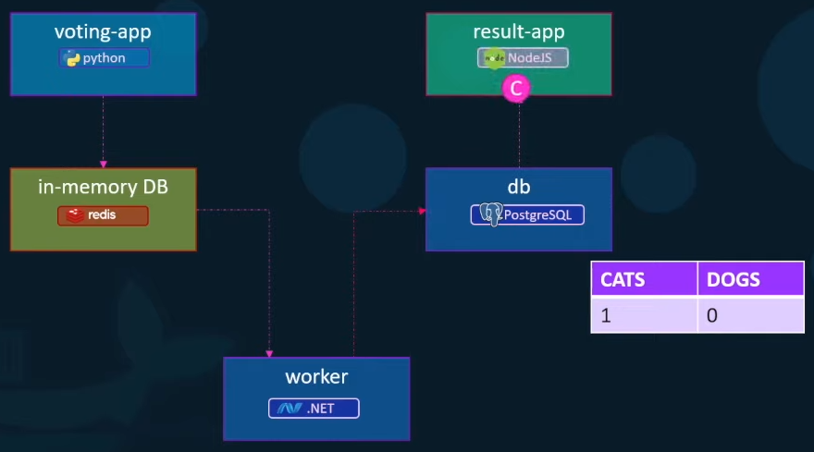

The app consists of various components such as the voting app which is a web application developed in python to provide the user with an interface to choose between 2 options: a cat and a dog. When you make a selection, the vote is stored in redis (to new guys: redis in this case serves as a database in memory). This vote is then processed by the worker which is an application written in .NET. The worker application takes the new vote and updates the persistent database which is a postgreSQL in our case. The postgres simply has a table with a number of votes for each category: cats and dogs. Finally the result of the vote is displayed in a web interface, which is another web application developed in node.js. This resulting application reads the count of votes from the postgres and displays it to the user. So that is the architecture and data flow of this simple voting application stack.
As you can see this sample application is built with a combination of different services, different development tools and multiple different development platforms, such as python, node.js,.net, etc. This sample application will be used to showcase, how easy it is to set up an entire application stack consisting of diverse components in d.

Let us keep aside d swarm services and stacks for a minute and see how we can put together this application stack on a single d engine, using first d run commands and then dc. Let us assume that all images of applications are already built and are available on d repo. Let us start with the data layer. First we start the d run command to start an instance of redis, by running the:
docker run -d --name=redis redis
with -d we run this container in the background and we will also name the container ‘redis’. Now, naming the containers is important. Next we will deploy the postgres db by running the:
docker run -d --name=db postgres:9.4
Next we will start with the application services, we will deploy a front end app for voting interface by running an instance of voting-app image:
docker run -d --name=vote -p 5000:80 voting-app
Since this is a web server it has a web ui instance running on port 80, we will publish that port to 5000 on the host system, so we can access it from a browser. Next we will deploy the result web application, that shows the results to the user. For this we deploy a container using:
docker run -d --name=result -p 5001:80 result-app
This way we can access the web ui of the resulting app on a browser. Finally we deployed the worker by running an instance of the worker image:
docker run -d --name=worker worker

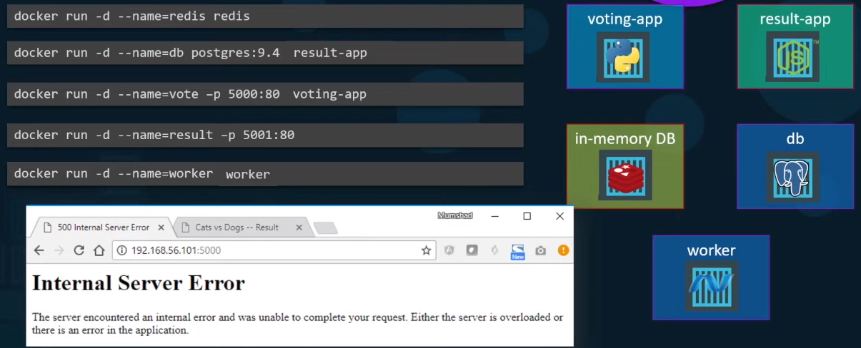
Ok, this is all good and we can see that all the instances are running on the host, but there is some problem, it just does not seem to work. The problem is that we have successfully run all the different containers, but we haven’t actually linked them together, as in we haven’t told the voting web application to use this particular redis instance. There could be multiple redis instances running, we haven’t told the worker and the resulting app to use this particular postgres db that we ran. How do we do that? That is where we use links. Link is a command line option, which can be used to link 2 containers together.
For example, the ‘voting-app’ web service is dependent on the redis service. When the web server starts, it looks for a redis service running on host redis, but the ‘voting-app’ container cannot resolve a host by the name redis. To make the ‘voting-app’ aware of the redis service, we add a link option while running the voting app container to link it to the redis container adding a --link option to the d run command and specifying the name of the redis c, which in this case is redis followed by the name of the host that the ‘voting-app’ is looking for, which is also redis in this case. Remember, this is why we named the container when we ran it the first time, so we could use its name while creating a link. What this is in fact doing is it creates an entry into the etsy host file on the ‘voting app’ container adding an entry with a host name redis with an internal IP of the redis container.
Similarly we add a link to the ‘result-app’ to communicate with the database by adding link option to refer the database by the name ‘db’. As you can see in the source code of the application, it makes an attempt to connect to a postgres database on host ‘db’. Finally, the worker application requires access to both the redis as well as the postgres database, so we add 2 links to the worker application: 1 link to link the redis and the other to link postgres database.
Note that using links this way is deprecated and the support may be removed in future in d, this is because as we will see in some time, advanced concepts in d swarm and networking supports better ways of achieving what we just did here with links. This example is to learn the concept.

Once we have the docker run commands tested and ready, it is easy to generate a docker compose file from it. We start by creating a dictionary of container names. We will use the same name we used in the docker run commands, so we take all the names and create a key with each of them. Then under each item we specify which image to use. The key is the ‘image’ and the value is the name of the image to use. Then we do ports and links whichever container requires one.
Note that you could also specify the name of the link this way (db:db = db) without the : and the target name and it will create a link with the same name as the target name.

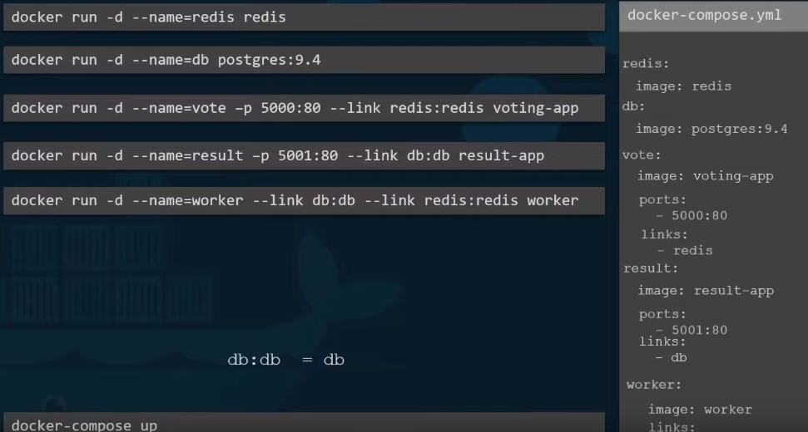

Now, that we’re all done with our dc file, bringing up the stack is really simple, run:
docker compose up
to bring up the entire application stack.

When we looked at an example of the sample application, we assumed that all images are already built. Out of the 5 different components, 2 of them: redis and postgres images, we know are already available on d hub, but the remaining 3 are our own applications. It is not necessary that they are already built and available in a d registry. If we would like to instruct dc to run a docker build instead of trying to pull an image, we can replace an image line with a build line and specify the location of a directory which contains the application code and a dockerfile with instructions to build the d image (this time when you run the dc up command, it will first build the images, give a temporary name for it and then use those images to run containers using the options you specified before).

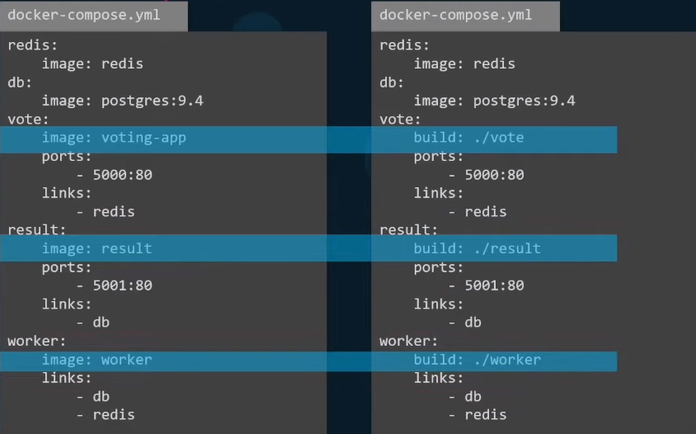

Docker compose - versions
We will now look at different versions of dc file. This is important, because you might see dc files in
different formats. Dc evolved over time and now supports a lot more options than it did in the beginning. Version 1 had number of limitations, for example if you wanted to deploy containers on a different network other than the default bridge network, there was no way of specifying that in v1. Also, say you have a dependency or startup order of some kind, for example your db container must come up first and only then should the voting application be started, there was no way you could specify that in the v1. Support for these came in v2, with v2 and up the format of the file also changed a little bit. We no longer specify our stack information directly as we did before, it is all encapsulated in a ‘service’ section.
How dc knows which version we are using. For version 2 and up we must specify the version of dc file we are intending to use by specifying the version at the top of the file, in this case ‘version: 2’. Another difference is with networking, in version 1 dc attaches all the containers it runs to the default bridged network and then use links to enable communication between the containers, as we did before. With version 2, dc automatically creates a dedicated bridged network for this application and then attaches all containers to that new network. All containers are then able to communicate to each other using each other’s service name. So you basically don’t need to use links in version 2 of d, you can simply get rid of all the links when you convert a file from v1 to v2.
Finally v2 also introduces ‘depends_on’ feature. If you wish to specify a start-up order, for instance the voting web app is dependent on the redis service, so you need to ensure that redis container is started first and only then the voting web application must be started, we could add a ‘depends_on’ property to the voting application and indicate that it is dependent on redis.
Then comes v3, which is the latest and is similar to v2 in the structure, meaning it has a version specification at the top and a ‘services’ section. V3 comes with support for docker swarm which we will see later on. There are some options that were removed and added, see docs. We will see v3 in much detail, when we discuss docker stacks.

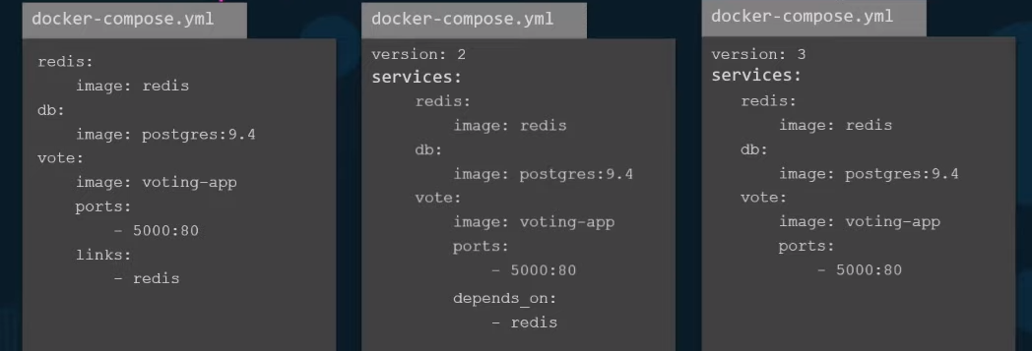

Docker compose Networks
Getting back to our application, so far we’ve been just deploying all containers on the default bridged network. Let us say we modify the architecture a little bit to contain the traffic from the different sources, for example we would like to separate the user generated traffic. So we create a front end network dedicated for traffic from users and a backend network dedicated for traffic within the application. We then connect the user facing application which are the voting-app and the result-app to the frontend network and all the components to an internal backend network.
So back in our dc file (port section is stripped out for simplicity sake, they are there but not shown). First thing that we need to use if we wanted to define networks is to define the networks we are going to use. In our case there are 2 networks: frontend and backend. So we create a new property ‘networks’ at the root level adjacent to the ‘services’ in the dc file and add a map of networks we are planning to use. Then under each service, create a ‘networks’ property and provide a list of networks that service must be attached to (there also should be a section for worker container in the yml file on the slide, but it was omitted due to space constraints).
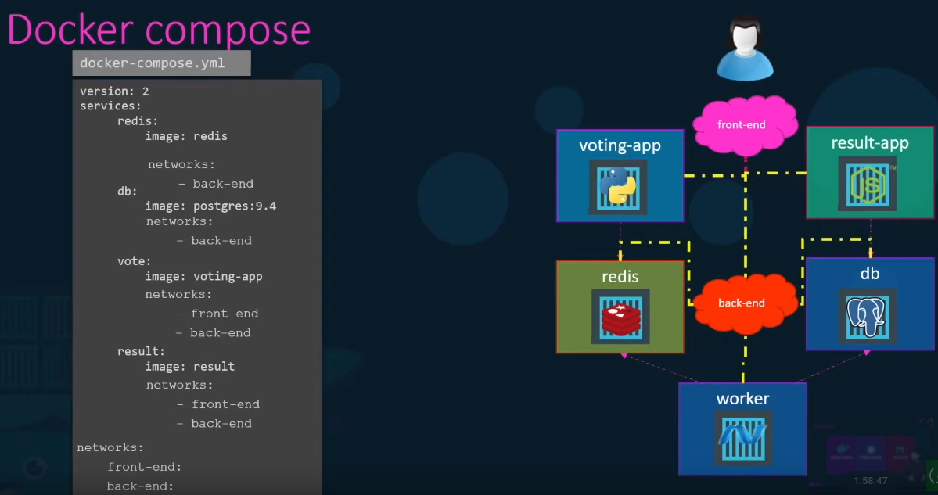
[HINT port host: container] → from docker quizes
What port is the web application run within the container? → EXPOSE 8080
[docker deamon]

Build a docker image using the Dockerfile and name it webapp-color. No tag to be specified:
docker build -t webapp-color . (-t this is basically what my image name is, . path to my dockerfile)
or docker build .

What is the base Operating System used by the python:3.6 image? If required, run an instance of the image to figure it out.
docker run python:3.6 cat /etc/*release*

DOCKER NETWORKING
When you install d, it creates 3 networks automatically: bridge, none and host. Bridge is the default network a container gets attached to. If you would like to associate the container with any other network, you specify the network information using the --network command line parameter.
Default Networks
The bridge network is a private internal network created by d on the host. All containers are attached to this network by default and they get an internal IP address, usually in the range 172.17.0.1 series. The containers can access each other using this internal ip if required. To access any of these containers from the outside world, map the ports of these containers to ports on the docker host as we have seen before.
Another way to access the containers externally is to associate the container to the host network. This takes out any network isolation between the d host and the d c. Meaning, if you were to run a webserver on port 5000 in a web app container, it is automatically accessible on the same port externally without requiring any port mapping as the web container uses the host’s network. This would also mean that unlike before, you will now not be able to run multiple web containers on the same host on the same port, as the ports are now common to all containers in the host network.
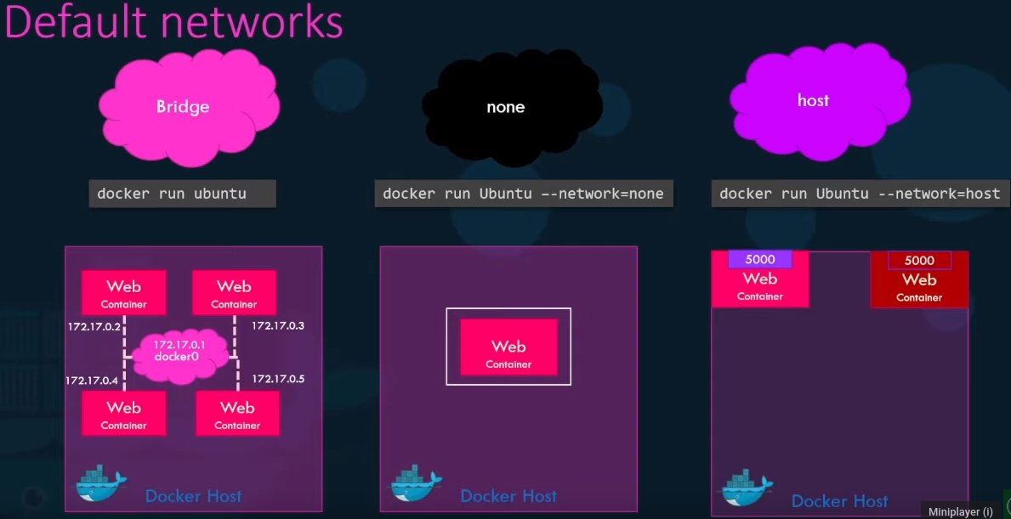
With the none network the containers are not attached to any network and doesn’t have any access to the external network or other containers. They run in an isolated network.
User-defined networks (tbc)

Inspect Network
docker inspect container_name/id
and then you will find a section on network settings.

Embedded DNS
Containers can reach each other using their names.
For example, in this case I have a webserver and a mysql database container running on the same node. How can I get my webserver to access the database on the database container? One thing we could do is to use the terminal ip address signed to the mysql container, which in this case is 172.17.0.3, but that is not very ideal, because it is not guaranteed that the container will get the same ip when the system reboots. The right way to do it is to use the container name. All containers in a d host can resolve each other with the name of the container. Docker has a built-in DNS server that helps the containers to resolve each other using the container name.
Note that the built in DNS server always runs at address 127.0.0.11. So how does docker implement networking? What’s the technology behind it, like how the containers isolated within the host? Docker uses network namespaces that create a separate namespace for each container. I then uses virtual ethernet pairs to connect containers together.

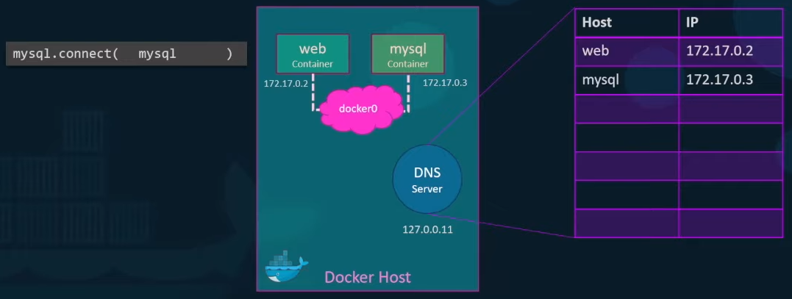

provision - zaopatrzyć
decommission – zamykać, likwidować
underlying – leżący u podstaw
cast – lity, obsadzony
adjacent – sąsiedni, przyległy

[sql vs nosql academind]

Complete Python Pandas Data Science Tutorial! (Reading CSV/Excel files, Sorting, Filtering, Groupby)
https://www.youtube.com/watch?v=vmEHCJofslg

Scrappy

What’s the meaning of underscores _ na __ in Python
https://www.youtube.com/watch?v=ALZmCy2u0jQ
Python OOP Tutorial 3: classmethods and staticmethods
https://www.youtube.com/watch?v=rq8cL2XMM5M

In this video we’ll be learning about the difference between regular methods, class methods and static methods. A lot of ppl get confused between class and static methods, so we’ll definitely go over that in detail.
As we already learned, regular methods in a class automatically take the instance as the first argument and by convention we were calling this ‘self’.
So if a regular method automatically takes in the instance as the first argument, then how can we change this so that it instead automatically takes the class as the first argument?
Now, to that we’re going to use class methods and to turn a regular method into a class method, it’s as easy as adding a decorator to the top called ‘@classmethod’. So let’s go ahead and create one of these, so I’m going to create a new method here with that ‘classmethod’ decorator and I’m going to call it ‘set_raise_amt()’. For this ‘set_raise_amt’ method we’re going to take in the ‘cls’ and ‘amount’. We receive the class as our first argument instead of the instance. There’s a common convention for class variables too and that is ‘cls’. Now, we can’t use the word ‘class’ (keyword).

# 1. classmethods
class Employee:

num_of_emps = 0
raise_amt = 1.04

def __init__(self, first, last, pay):
self.first = first
self.last = last
self.email = first + '.' + last + '@email.com'
self.pay = pay

Employee.num_of_emps += 1

def fullname(self):
return '{} {}'.format(self.first, self.last)

def apply_raise(self):
self.pay = (self.pay * self.raise_amt)

@classmethod
def set_raise_amt(cls, amount):
cls.raise_amt = amount

emp_1 = Employee('Corey', 'Schafer', 5000)
emp_2 = Employee('Test', 'Employee', 6000)

Employee.set_raise_amt(1.05)

print(Employee.raise_amt)
print(emp_1.raise_amt)
print(emp_2.raise_amt)
You may also ppl say that they use class methods as alternative constructors. Now, what do they mean by this? This mean that you can use these class methods in order to provide multiple ways of creating our objects.
[to investigate]

Now that we looked at class methods, now let’s talk about static methods. Now, lots of ppl gets class methods and static methods confused. Now, when working with classes, regular methods automatically pass the instance as the first argument (self) and class methods automatically pass the class as the first argument (cls) and static methods don’t pass anything automatically, they don’t pass the instance or the class, so really they behave just like regular functions, except we include them in our classes, because they have some logical connection with the class.

Let’s have a look at an example. So let’s say that we wanted a simple function that would take in a date and return whether or not that was a workday, so that has a logical connection to our Employee class, but it doesn’t actually depend on any specific instance or class variable, so instead I’m going to make this a static method. So to create a static method we use a decorator ‘@staticmethod’ and we’re going to call this method ‘is_workday’. Remember, static methods don’t take the instance or the class as the first argument, so we can just pass in the arguments that we want to work with and I’m going to take in a day here and return whether or not that is a workday. So to make this a simple example, I’m not going to do it too complicated.
Now sometimes ppl write regular methods or class methods that actually should be static methods and usually a giveaway that a method should be a static method is if you don’t access the instance or the class anywhere within the function.

# 2. staticmethods
class Employee:

num_of_emps = 0
raise_amt = 1.04

def __init__(self, first, last, pay):
self.first = first
self.last = last
self.email = first + '.' + last + '@email.com'
self.pay = pay

Employee.num_of_emps += 1

def fullname(self):
return '{} {}'.format(self.first, self.last)

def apply_raise(self):
self.pay = (self.pay * self.raise_amt)

@classmethod
def set_raise_amt(cls, amount):
cls.raise_amt = amount

@staticmethod
def is_workday(day):
if day.weekday() == 5 or day.weekday() == 6:
return False
return True

emp_1 = Employee('Corey', 'Schafer', 5000)
emp_2 = Employee('Test', 'Employee', 6000)

import datetime

my_date = datetime.date(2016, 7, 10)

print(Employee.is_workday(my_date))

In this video we learned the difference between regular instance methods, class methods which can also be used as alternative constructors and static methods, which don’t operate on the instance or the class.

Python Tutorial: Context Managers - Efficiently Managing Resources
https://www.youtube.com/watch?v=-aKFBoZpiqA

Context managers allow us to properly manage resources, so that we can specify exactly what we want to setup and tear down when working with certain objects.

2 different ways we can work with the files:
1)
f = open('sample.txt', 'w')
f.write('Lorem ipsum dolor sit amet')
f.close() → we have to remember to close it after we’re done
2)
with open('sample.txt', 'w') as f:
f.write('Lorem ipsum dolor sit amet2')

Recommended way to work with file objects is using a context manager. We can tell this is cm because of the ‘with’ statement. Worth noticing is the fact that we no longer have to remember to close down the file after we’re done working with it. And not only that, because if we throw an error when working with this file, then it’s still going to get closed properly. And the more that is handled for us automatically, the better.

This is great for files, but it’s useful for so many different resources. So for example we could use this to connect to and close databases automatically, we could acquire and release logs, there’s plenty of use cases.

In this video we’ll be learning how to write our own cm to handle custom resources. There are a couple of different ways that we can write out our own cm, we can either do this by using a class or by using a function with a decorator.

So to start off, let’s just replicate the functionality that we saw when using the cm when opening a file. So we’ll create a cm that opens the file for us and then automatically closes the file when we’re done with it. So first we’ll use a class, because it shows a little bit more clearly what’s going on:

So the ‘enter’ and ‘exit’ methods are going to be the setup and teardown of our context manager.
The init method is going to accept the arguments that we pass into our class and also allow us to access the attributes that we set from our other methods.
‘mode’ argument will be for opening this file for reading or writing or sth like that. And to turn these into instance attributes, so that we can access these from our other methods, we can say ‘self.filename = filename’ etc.
Within enter method, which would be the setup part of our cm, we’re going to open our file. ‘self.file’ we’re crating a new instance variable there.
When we ‘return self.file’ what we return here will be the object that we’re working with within our cm.
Exit method will be the teardown and this is what gets run when we exit the cm, so we want to be sure that our file gets closed at this point. The extra parameters here for the exit method are there for if we throw an exception and we could use those to access that information.

We print out the ‘closed’ attribute of that file, so we can see if it was closed properly.

Corey prefers to use a function and to do this we need a contextlib module to import the contextmanager decorator and we can use it to decorate a generator function.
This will be the open file context manager that is equivalent to what our class was:

from contextlib import contextmanager

@contextmanager
def open_file(file, mode):
try:
f = open(file, mode)
yield f
finally:
f.close()

with open_file('sample.txt', 'w') as f:
f.write('Lorem ipsum dolor etceefew22.')

print(f.closed)
So everything before the yield statement is going to be equivalent to what our ‘__enter__’ method of our class was, so this is going to be a setup of the cm. And then the yield is actually where the code within the with statement is going to run. And then after the yield statement is going to be equivalent to what was in the ‘__exit__’ method of our class, so this is going to be the teardown of the cm.

Technically we should be using some try and finally statements in here to handle errors, but we’ll take a look at that in just a second.

Basically we’re doing the same thing that we did with our class code, so we’re using the with statement here, calling our generator function and our function takes in a file name and a mode and then we are setting this to an f variable. Now, at this point, it’s going to run everything up until the yield statement. So, in our example here, it’s going to come in and actually create this f variable and open up that file with that filename and that mode and then it’s going to yield f. And yield f is just like when we returned that file within our ‘__enter__’ method of our class, it’s going to yield f and that is what this f (in ‘as f’) variable here is going to equal. And that’s what we’re going to be working with within our context manager.
So within our cm we can do whatever we like with this file. So in our example we’re just writing some more text. Now, after we exit the with statement block, then it’s going to run all of the code after the yield statement, so in our example that is closing our file. We do ‘print(f.closed)’ to know if the file that we opened is closed or not. Since that is run our teardown code then we should see a return value of True.
One more thing, when Corey said before that we should be using try and finally block s to handle errors, we can do that by putting our setup and yield code within a try block. And then we’re going to put the teardown code into a finally block. Doing that will ensure that even if we run into any errors, our teardown code is still going to get run.

Ok, so that’s going to do it for the open file example, but that’s not very practical, because open is already a cm within python and we can already do everything that we did here just using the open function. So now that we’ve seen how to replicate that built-in functionality of the open function using both classes and generators, now let’s look at the practical example that we’ll build from scratch.

So let’s say we’re using python to do some work in a lot of different directories and we’re constantly seeding into directories, doing some work and then seeding back to where we started.

import os

cwd = os.getcwd()
os.chdir('ContextManager_sample_dir_1')
print(os.listdir()) → listing everything out in that directory
os.chdir(cwd)

cwd = os.getcwd()
os.chdir('ContextManager_sample_dir_2')
print(os.listdir())
os.chdir(cwd)

We run it:
$ python context_managers.py
['1.txt']
['2.txt']
But this is a little inconvenient to save our current directory, switch directories and then switch back to the original after we’re done doing what we need to do.
So if we look at this, then saving the current directory and switching to the destination is basically setting up for the work that needs to be done and switching back to our original directory is basically the teardown. So these are things that we don’t want to have to remember to do each time, so this is a good candidate for a context manager.

So we’re going to do this with a generator function, but we can also convert it to a class:

Disclaimer: we are not working with any variables inside of our context manager, so we don’t actually have to yield anything, we can just say yield. If you remember in the open file example we did a ‘yield f’, where we yielded that file object and we worked with it inside of our cm, but now we’re not going to be working with any objects inside of our cm, so putting yield there is perfectly fine.

import os
from contextlib import contextmanager

@contextmanager
def change_dir(destination):
try:
cwd = os.getcwd()
os.chdir(destination)
yield
finally:
os.chdir(cwd)

with change_dir('ContextManager_sample_dir_1'):
print(os.listdir())

with change_dir('ContextManager_sample_dir_2'):
print(os.listdir())

We run it:
$ python context_managers.py
['1.txt']
['2.txt']

So we can see that works just like it did before, but now we don’t have to worry about the setup and teardown each time we use those cms. Now we can reuse this cm over and over and we always know these resources are going to be managed exactly how we want them to be managed and we don’t have to remember to do that on our own every single time.

PEP 8 -- Style Guide for Python Code
https://www.python.org/dev/peps/pep-0008/

A Foolish Consistency is the Hobgoblin of Little Minds
One of Guido's key insights is that code is read much more often than it is written. The guidelines provided here are intended to improve the readability of code and make it consistent across the wide spectrum of Python code. As PEP 20 says, "Readability counts".

A style guide is about consistency. Consistency with this style guide is important. Consistency within a project is more important. Consistency within one module or function is the most important.

Indentation
Use 4 spaces per indentation level.

# Aligned with opening delimiter.
foo = long_function_name(var_one, var_two,
var_three, var_four)

# Add 4 spaces (an extra level of indentation) to distinguish arguments from the rest.
def long_function_name(
var_one, var_two, var_three,
var_four):
print(var_one)

# Hanging indents should add a level.
foo = long_function_name(
var_one, var_two,
var_three, var_four)

The closing brace/bracket/parenthesis on multiline constructs may either line up under the first non-whitespace character of the last line of list, as in:
my_list = [
1, 2, 3,
4, 5, 6,
]
result = some_function_that_takes_arguments(
'a', 'b', 'c',
'd', 'e', 'f',
)

or it may be lined up under the first character of the line that starts the multiline construct, as in:
my_list = [
1, 2, 3,
4, 5, 6,
]
result = some_function_that_takes_arguments(
'a', 'b', 'c',
'd', 'e', 'f',
)

Tabs or Spaces?
Spaces are the preferred indentation method.
Tabs should be used solely to remain consistent with code that is already indented with tabs.
Python 3 disallows mixing the use of tabs and spaces for indentation.

Maximum Line Length
Limit all lines to a maximum of 79 characters.

For flowing long blocks of text with fewer structural restrictions (docstrings or comments), the line length should be limited to 72 characters.

Limiting the required editor window width makes it possible to have several files open side-by-side, and works well when using code review tools that present the two versions in adjacent columns.

The Python standard library is conservative and requires limiting lines to 79 characters (and docstrings/comments to 72).

The preferred way of wrapping long lines is by using Python's implied line continuation inside parentheses, brackets and braces. Long lines can be broken over multiple lines by wrapping expressions in parentheses. These should be used in preference to using a backslash for line continuation.
Backslashes may still be appropriate at times. For example, long, multiple with-statements cannot use implicit continuation, so backslashes are acceptable:

with open('/path/to/some/file/you/want/to/read') as file_1, \
open('/path/to/some/file/being/written', 'w') as file_2:
file_2.write(file_1.read())

Should a Line Break Before or After a Binary Operator?
Following the tradition from mathematics usually results in more readable code:
# Yes: easy to match operators with operands
income = (gross_wages
+ taxable_interest
+ (dividends - qualified_dividends)
- ira_deduction
- student_loan_interest)
In Python code, it is permissible to break before or after a binary operator, as long as the convention is consistent locally. For new code Knuth's style is suggested.

Blank Lines
Surround top-level function and class definitions with two blank lines.

Method definitions inside a class are surrounded by a single blank line.

Extra blank lines may be used (sparingly) to separate groups of related functions. Blank lines may be omitted between a bunch of related one-liners (e.g. a set of dummy implementations).

Use blank lines in functions, sparingly, to indicate logical sections.

Python accepts the control-L (i.e. ^L) form feed character as whitespace; Many tools treat these characters as page separators, so you may use them to separate pages of related sections of your file. Note, some editors and web-based code viewers may not recognize control-L as a form feed and will show another glyph in its place.

Source File Encoding
Code in the core Python distribution should always use UTF-8 (or ASCII in Python 2).
Files using ASCII (in Python 2) or UTF-8 (in Python 3) should not have an encoding declaration.

In the standard library, non-default encodings should be used only for test purposes or when a comment or docstring needs to mention an author name that contains non-ASCII characters; otherwise, using \x, \u, \U, or \N escapes is the preferred way to include non-ASCII data in string literals.

For Python 3.0 and beyond, the following policy is prescribed for the standard library (see PEP 3131): All identifiers in the Python standard library MUST use ASCII-only identifiers, and SHOULD use English words wherever feasible (in many cases, abbreviations and technical terms are used which aren't English). In addition, string literals and comments must also be in ASCII. The only exceptions are (a) test cases testing the non-ASCII features, and (b) names of authors. Authors whose names are not based on the Latin alphabet (latin-1, ISO/IEC 8859-1 character set) MUST provide a transliteration of their names in this character set.

Open source projects with a global audience are encouraged to adopt a similar policy.

Imports
- Imports should usually be on separate lines:
Yes: import os
import sys

No: import sys, os
It's okay to say this though:
from subprocess import Popen, PIPE

- Imports are always put at the top of the file, just after any module comments and docstrings, and before module globals and constants.
Imports should be grouped in the following order:

- Standard library imports.
- Related third party imports.
- Local application/library specific imports.
- You should put a blank line between each group of imports.

- Absolute imports are recommended, as they are usually more readable and tend to be better behaved (or at least give better error messages) if the import system is incorrectly configured (such as when a directory inside a package ends up on sys.path):
import mypkg.sibling
from mypkg import sibling
from mypkg.sibling import example

However, explicit relative imports are an acceptable alternative to absolute imports, especially when dealing with complex package layouts where using absolute imports would be unnecessarily verbose:
from . import sibling
from .sibling import example
Standard library code should avoid complex package layouts and always use absolute imports.

Implicit relative imports should never be used and have been removed in Python 3.

- When importing a class from a class-containing module, it's usually okay to spell this:

from myclass import MyClass
from foo.bar.yourclass import YourClass

If this spelling causes local name clashes, then spell them explicitly:
import myclass
import foo.bar.yourclass
and use "myclass.MyClass" and "foo.bar.yourclass.YourClass".

- Wildcard imports (from <module> import *) should be avoided, as they make it unclear which names are present in the namespace, confusing both readers and many automated tools. There is one defensible use case for a wildcard import, which is to republish an internal interface as part of a public API (for example, overwriting a pure Python implementation of an interface with the definitions from an optional accelerator module and exactly which definitions will be overwritten isn't known in advance).

When republishing names this way, the guidelines below regarding public and internal interfaces still apply.

Module Level Dunder Names
Module level "dunders" (i.e. names with two leading and two trailing underscores) such as __all__, __author__, __version__, etc. should be placed after the module docstring but before any import statements except from __future__ imports. Python mandates that future-imports must appear in the module before any other code except docstrings:
"""This is the example module.

This module does stuff.
"""

from __future__ import barry_as_FLUFL

__all__ = ['a', 'b', 'c']
__version__ = '0.1'
__author__ = 'Cardinal Biggles'

import os
import sys

String Quotes
In Python, single-quoted strings and double-quoted strings are the same. This PEP does not make a recommendation for this. Pick a rule and stick to it. When a string contains single or double quote characters, however, use the other one to avoid backslashes in the string. It improves readability.

For triple-quoted strings, always use double quote characters to be consistent with the docstring convention in PEP 257.

Whitespace in Expressions and Statements

Pet Peeves
Avoid extraneous whitespace in the following situations:

- Immediately inside parentheses, brackets or braces.
Yes: spam(ham[1], {eggs: 2})
No: spam( ham[ 1 ], { eggs: 2 } )

- Between a trailing comma and a following close parenthesis.
Yes: foo = (0,)
No: bar = (0, )

- Immediately before a comma, semicolon, or colon:
Yes: if x == 4: print x, y; x, y = y, x
No: if x == 4 : print x , y ; x , y = y , x

- However, in a slice the colon acts like a binary operator, and should have equal amounts on either side (treating it as the operator with the lowest priority). In an extended slice, both colons must have the same amount of spacing applied. Exception: when a slice parameter is omitted, the space is omitted.
Yes:
ham[1:9], ham[1:9:3], ham[:9:3], ham[1::3], ham[1:9:]
ham[lower:upper], ham[lower:upper:], ham[lower::step]
ham[lower+offset : upper+offset]
ham[: upper_fn(x) : step_fn(x)], ham[:: step_fn(x)]
ham[lower + offset : upper + offset]

No:
ham[lower + offset:upper + offset]
ham[1: 9], ham[1 :9], ham[1:9 :3]
ham[lower : : upper]
ham[ : upper]

- Immediately before the open parenthesis that starts the argument list of a function call:
Yes: spam(1)
No: spam (1)

- Immediately before the open parenthesis that starts an indexing or slicing:
Yes: dct['key'] = lst[index]
No: dct ['key'] = lst [index]

- More than one space around an assignment (or other) operator to align it with another.
Yes:
x = 1
y = 2
long_variable = 3

No:
x = 1
y = 2
long_variable = 3

Other Recommendations
- Avoid trailing whitespace anywhere. Because it's usually invisible, it can be confusing: e.g. a backslash followed by a space and a newline does not count as a line continuation marker. Some editors don't preserve it and many projects (like CPython itself) have pre-commit hooks that reject it.

- Always surround these binary operators with a single space on either side: assignment (=), augmented assignment (+=, -= etc.), comparisons (==, <, >, !=, <>, <=, >=, in, not in, is, is not), Booleans (and, or, not).

- If operators with different priorities are used, consider adding whitespace around the operators with the lowest priority(ies). Use your own judgment; however, never use more than one space, and always have the same amount of whitespace on both sides of a binary operator.
Yes:
i = i + 1
submitted += 1
x = x*2 - 1
hypot2 = x*x + y*y
c = (a+b) * (a-b)

No:
i=i+1
submitted +=1
x = x * 2 - 1
hypot2 = x * x + y * y
c = (a + b) * (a - b)

- Function annotations should use the normal rules for colons and always have spaces around the -> arrow if present. (See Function Annotations below for more about function annotations.)
Yes:
def munge(input: AnyStr): ...
def munge() -> PosInt: ...

No:
def munge(input:AnyStr): ...
def munge()->PosInt: ...

- Don't use spaces around the = sign when used to indicate a keyword argument, or when used to indicate a default value for an unannotated function parameter.
Yes:
def complex(real, imag=0.0):
return magic(r=real, i=imag)

No:
def complex(real, imag = 0.0):
return magic(r = real, i = imag)

- When combining an argument annotation(?) with a default value, however, do use spaces around the = sign:
Yes:
def munge(sep: AnyStr = None): ...
def munge(input: AnyStr, sep: AnyStr = None, limit=1000): ...

No:
def munge(input: AnyStr=None): ...
def munge(input: AnyStr, limit = 1000): ...

- Compound statements (multiple statements on the same line) are generally discouraged.
Yes:
if foo == 'blah':
do_blah_thing()
do_one()
do_two()
do_three()

Rather not:
if foo == 'blah': do_blah_thing()
do_one(); do_two(); do_three()

- While sometimes it's okay to put an if/for/while with a small body on the same line, never do this for multi-clause statements. Also avoid folding such long lines!
Rather not:
if foo == 'blah': do_blah_thing()
for x in lst: total += x
while t < 10: t = delay()

Definitely not:
if foo == 'blah': do_blah_thing()
else: do_non_blah_thing()

try: something()
finally: cleanup()

do_one(); do_two(); do_three(long, argument,
list, like, this)

if foo == 'blah': one(); two(); three()

When to Use Trailing Commas
Trailing commas are usually optional, except they are mandatory when making a tuple of one element (and in Python 2 they have semantics for the print statement). For clarity, it is recommended to surround the latter in (technically redundant) parentheses.

Yes:
FILES = ('setup.cfg',)

OK, but confusing:
FILES = 'setup.cfg',

When trailing commas are redundant, they are often helpful when a version control system is used, when a list of values, arguments or imported items is expected to be extended over time. The pattern is to put each value (etc.) on a line by itself, always adding a trailing comma, and add the close parenthesis/bracket/brace on the next line. However it does not make sense to have a trailing comma on the same line as the closing delimiter (except in the above case of singleton tuples).

Yes:
FILES = [
'setup.cfg',
'tox.ini',
]
initialize(FILES,
error=True,
)

No:
FILES = ['setup.cfg', 'tox.ini',]
initialize(FILES, error=True,)

Comments
Comments that contradict the code are worse than no comments. Always make a priority of keeping the comments up-to-date when the code changes!

Comments should be complete sentences. The first word should be capitalized, unless it is an identifier that begins with a lower case letter (never alter the case of identifiers!).

Block comments generally consist of one or more paragraphs built out of complete sentences, with each sentence ending in a period.

You should use two spaces after a sentence-ending period in multi- sentence comments, except after the final sentence.

When writing English, follow Strunk and White.

Python coders from non-English speaking countries: please write your comments in English, unless you are 120% sure that the code will never be read by people who don't speak your language.

Block Comments
Block comments generally apply to some (or all) code that follows them, and are indented to the same level as that code. Each line of a block comment starts with a # and a single space (unless it is indented text inside the comment).

Paragraphs inside a block comment are separated by a line containing a single #.

Inline Comments
Use inline comments sparingly (oszczędnie)

An inline comment is a comment on the same line as a statement. Inline comments should be separated by at least two spaces from the statement. They should start with a # and a single space.

Inline comments are unnecessary and in fact distracting if they state the obvious. Don't do this:
x = x + 1 # Increment x
But sometimes, this is useful:
x = x + 1 # Compensate for border

Documentation Strings
Conventions for writing good documentation strings (a.k.a. "docstrings") are immortalized in PEP 257.

- Write docstrings for all public modules, functions, classes, and methods. Docstrings are not necessary for non-public methods, but you should have a comment that describes what the method does. This comment should appear after the def line.

- PEP 257 describes good docstring conventions. Note that most importantly, the """ that ends a multiline docstring should be on a line by itself:
"""Return a foobang

Optional plotz says to frobnicate the bizbaz first.
"""

- For one liner docstrings, please keep the closing """ on the same line.

Naming Conventions
The naming conventions of Python's library are a bit of a mess, so we'll never get this completely consistent -- nevertheless, here are the currently recommended naming standards. New modules and packages (including third party frameworks) should be written to these standards, but where an existing library has a different style, internal consistency is preferred.

Overriding Principle
Names that are visible to the user as public parts of the API should follow conventions that reflect usage rather than implementation.

Descriptive: Naming Styles
There are a lot of different naming styles. It helps to be able to recognize what naming style is being used, independently from what they are used for.

The following naming styles are commonly distinguished:
b (single lowercase letter)
B (single uppercase letter)
lowercase
lower_case_with_underscores
UPPERCASE
UPPER_CASE_WITH_UNDERSCORES
CapitalizedWords (or CapWords, or CamelCase -- so named because of the bumpy look of its letters [4]). This is also sometimes known as StudlyCaps.

Note: When using acronyms in CapWords, capitalize all the letters of the acronym. Thus HTTPServerError is better than HttpServerError.

mixedCase (differs from CapitalizedWords by initial lowercase character!)
Capitalized_Words_With_Underscores (ugly!)

There's also the style of using a short unique prefix to group related names together. This is not used much in Python, but it is mentioned for completeness. For example, the os.stat() function returns a tuple whose items traditionally have names like st_mode, st_size, st_mtime and so on. (This is done to emphasize the correspondence with the fields of the POSIX system call struct, which helps programmers familiar with that.)

The X11 library uses a leading X for all its public functions. In Python, this style is generally deemed unnecessary because attribute and method names are prefixed with an object, and function names are prefixed with a module name.

In addition, the following special forms using leading or trailing underscores are recognized (these can generally be combined with any case convention):

_single_leading_underscore: weak "internal use" indicator. E.g. from M import * does not import objects whose names start with an underscore.

single_trailing_underscore_: used by convention to avoid conflicts with Python keyword, e.g.
Tkinter.Toplevel(master, class_='ClassName')

__double_leading_underscore: when naming a class attribute, invokes name mangling (inside class FooBar, __boo becomes _FooBar__boo; see below).

__double_leading_and_trailing_underscore__: "magic" objects or attributes that live in user-controlled namespaces. E.g. __init__, __import__ or __file__. Never invent such names; only use them as documented.

Prescriptive: Naming Conventions

Names to Avoid
Never use the characters 'l' (lowercase letter el), 'O' (uppercase letter oh), or 'I' (uppercase letter eye) as single character variable names.

In some fonts, these characters are indistinguishable from the numerals one and zero. When tempted to use 'l', use 'L' instead.

ASCII Compatibility
Identifiers used in the standard library must be ASCII compatible as described in the policy section of PEP 3131.

Package and Module Names
Modules should have short, all-lowercase names. Underscores can be used in the module name if it improves readability. Python packages should also have short, all-lowercase names, although the use of underscores is discouraged.

When an extension module written in C or C++ has an accompanying Python module that provides a higher level (e.g. more object oriented) interface, the C/C++ module has a leading underscore (e.g. _socket).

Class Names
Class names should normally use the CapWords convention.

The naming convention for functions may be used instead in cases where the interface is documented and used primarily as a callable.

Note that there is a separate convention for builtin names: most builtin names are single words (or two words run together), with the CapWords convention used only for exception names and builtin constants.

Type Variable Names
Names of type variables introduced in PEP 484 should normally use CapWords preferring short names: T, AnyStr, Num. It is recommended to add suffixes _co or _contra to the variables used to declare covariant or contravariant behavior correspondingly:

from typing import TypeVar

VT_co = TypeVar('VT_co', covariant=True)
KT_contra = TypeVar('KT_contra', contravariant=True)

Exception Names
Because exceptions should be classes, the class naming convention applies here. However, you should use the suffix "Error" on your exception names (if the exception actually is an error).

Global Variable Names
(Let's hope that these variables are meant for use inside one module only.) The conventions are about the same as those for functions.

Modules that are designed for use via from M import * should use the __all__ mechanism to prevent exporting globals, or use the older convention of prefixing such globals with an underscore (which you might want to do to indicate these globals are "module non-public").

Function and Variable Names
Function names should be lowercase, with words separated by underscores as necessary to improve readability.

Variable names follow the same convention as function names.

mixedCase is allowed only in contexts where that's already the prevailing style (e.g. threading.py), to retain backwards compatibility.

Function and Method Arguments
Always use self for the first argument to instance methods.

Always use cls for the first argument to class methods.

If a function argument's name clashes with a reserved keyword, it is generally better to append a single trailing underscore rather than use an abbreviation or spelling corruption. Thus class_ is better than clss. (Perhaps better is to avoid such clashes by using a synonym.)

Method Names and Instance Variables
Use the function naming rules: lowercase with words separated by underscores as necessary to improve readability.

Use one leading underscore only for non-public methods and instance variables.

To avoid name clashes with subclasses, use two leading underscores to invoke Python's name mangling rules.

Python mangles these names with the class name: if class Foo has an attribute named __a, it cannot be accessed by Foo.__a. (An insistent user could still gain access by calling Foo._Foo__a.) Generally, double leading underscores should be used only to avoid name conflicts with attributes in classes designed to be subclassed.

Note: there is some controversy about the use of __names (see below).

Constants
Constants are usually defined on a module level and written in all capital letters with underscores separating words. Examples include MAX_OVERFLOW and TOTAL.

mandated – mandatowy, nakazany
pet peeve – rzecz szczególnie obmierzła
sparingly – niewiele, oszczędnie
to mangle – magiel, maglownica, wyżymaczka
Scrapy
https://www.youtube.com/watch?v=yWRkc_E9CYg&list=PLE50-dh6JzC6dHxpAno-a6W7QpWdAFN20

1. WEB SCRAPING WITH SCRAPY - INTRODUCTION AND SETUP
Scrapy is “an open source and collaborative framework for extracting the data you need from websites. In a fast, simple, yet extensible way.”

cat > myspider.py <<EOF

$ scrapy startproject Example
‘spiders’ is the main folder where we’re gonna be working from.

robots.txt – some sites are more restrictive on the information that they allow you to scrape or for the occurrence or the frequency, they don’t let you scrape it so often, they have parameters for spiders, for web crawling. It’s recommended to have a look at robots.txt first to check if sites allow you to do so.

2. WEB SCRAPING WITH SCRAPY - FIRST SPIDER

spiders/first_spider.py
# First Spider

import scrapy

class FirstSpider(scrapy.Spider):
name = "FirstSpider"

def start_requests(self):
urls = [
'http://quotes.toscrape.com/page/1',
'http://quotes.toscrape.com/page/2'
]

for url in urls:
yield scrapy.Request(url=url, callback=self.parse)

def parse(self, response):
page = response.url.split("/")[-2]
filename = 'quotes-%s.html' % page
with open(filename, 'wb') as f:
f.write(response.body)
self.log('Saved file %s' % filename)
‘start_requests’ is actually built into scrapy, it’s going to return an iterable of requests, you can return a list of requests or run a generator function.
‘callback=self.parse’, the ‘parse’ method usually parses response, docs says it’s extracting the data as dicts and also finding new urls to follow and creating new request from them.

$ scrapy crawl FirstSpider [name of our spider]
What’s great when it’s done, then ‘scrapy.core.engine’ actually discloses that the spider is closed, that it has finished.

3. WEB SCRAPING WITH SCRAPY - HTML AND VISUALIZATION
We’re using scrapy to go out and extract information with what we call spiders and spiders are our web crawlers.

The default character encoding in HTML5 is UTF-8
The first things you have to do is actually declare a document type <!DOCTYPE html>.

4. WEB SCRAPING WITH SCRAPY - CSS AND SECOND SPIDER

$ scrapy shell
>>> fetch("https://www.superdatascience.com/artificial-intelligence")
We need to lok at the response, because what it did was store it in a response object, which we can now access through scrape.
>>> view(response) ← it shows our page locally
We are working with the response object that now it actually you can access the data in the file as raw text and you can go and select elelments from it and create further data structures or lists
>>> print(response.text) ← to access the raw data

5. WEB SCRAPING WITH SCRAPY - ITEMS AND SELECTORS

6. WEB SCRAPING WITH SCRAPY - ITEMS AND IMDB SCRAPER

7. WEB SCRAPING WITH SCRAPY - IMDB SPIDER PARSE

LDA clearly explained
https://www.youtube.com/watch?v=azXCzI57Yfc

Python Scrapy Tutorial- 1 - Web Scraping, Spiders and Crawling

Python Scrapy Tutorial- 2 - How does Web Scraping work?

Python Scrapy Tutorial - 3 - Robots.txt and Web Scraping Rules

This time we’ll be learning about obeying the laws of web scraping on the internet. Thses laws are usually written in the robots.txt file.

Examples:
facebook.com/robots.txt:
# Notice: Crawling Facebook is prohibited unless you have express written
# permission. See: http://www.facebook.com/apps/site_scraping_tos_terms.php

User-agent: Applebot
Disallow: /ajax/
Disallow: /album.php
Disallow: /checkpoint/
Disallow: /contact_importer/
Disallow: /dialog/
amazon.com/robots.txt:
User-agent: *
Disallow: /exec/obidos/account-access-login
Disallow: /exec/obidos/change-style
Disallow: /exec/obidos/flex-sign-in
Disallow: /exec/obidos/handle-buy-box
Disallow: /exec/obidos/tg/cm/member/
Disallow: /gp/aw/help/id=sss
It includes directories that these websites don’t want us to crawl. Obviously you don’t have to follow these rules written by these websites, but it’s always a good idea to follow them when you can.
Because we’re using scrapy, we don’t have to worry about the robots.txt, because scrapy automatically follows the rules of robots.txt and doesn’t crawl url links given in the file. But if you don’t want to follow the robot rules for some reason, you can always go to the settings file and change ROBOTSTXT_OBEY in settings.py

Python Scrapy Tutorial - 4 - Installation with Pycharm (recommended)

scrapy startproject quotetutorial

Python Scrapy Tutorial - 5 - Installation with Terminal / Sublime

Python Scrapy Tutorial- 6 - Project Structure in Scrapy

There are 2 init files or initialization files that we don’t need to worry about, scrappy just uses them for its purposes, mostly they are empty.
Example/spiders/__init__.py:
# This package will contain the spiders of your Scrapy project (inside the spiders folder)

settings.py
BOT_NAME = ‘Example’
Bot is basically anything that automates the writing of code or automate some kind of action on the internet or on our website and because we are automating the action of web scraping or crawling a website that is why our crawler can also be named as a bot.

Whenever you visit a website, like google.com, you need to identify yourself as to who you are, so who is the person basically sending the request. So what google does is it asks the browser that we’re using ‘hey, who the heck are you exactly?’. So browser sometimes sends a request to the Google saying ‘hey, I’m just a Mozilla Firefox browser’. And if you’re web scraping yourself, you can be a little bit more responsible and identify yourself by writing in your domain name, but you don’t have to:
#USER_AGENT = 'Example (+http://www.yourdomain.com)'
In the future videos you’ll also be seeing that a lot websites put a lot of restrictions on web scraping, so in the future we’ll be also bypassing those restrictions using the user agent.

# Obey robots.txt rules
ROBOTSTXT_OBEY = True

# Configure maximum concurrent requests performed by Scrapy (default: 16)
#CONCURRENT_REQUESTS = 32
Whenever you make a lot of requests at the same time, that is known as concurrent requests. Now, whenever we ask the website to open up once, we can get the data of that website once. But because we are going to be scrapping a lot data, that is why we can’t just use one request and that is why we are going to be sending a lot requests at the same time. And in our case we’re going to be sending the requests at the rate 16 (default).
Why don’t we just increase this number from 16 to sth like 1000?
Because it causes a lot of overload to the server and sometimes it can even go down. Now sth like 32 requests/second is actually pretty fine.

Now, if you come down, it has a lot of the same things and if you go come down a little bit more, you will be able to see it doesn’t have a lot of things that we’re interested in right now.
Autothrottle, it basically helps to make sure that a website that you’re scrapping does not get overloaded.

items.py
It has a class that scrapy automatically created for us and here we define the fields (like author or title) for our item.
http://quotes.toscrape.com was created by scrapy
So whenever we’re scrapping a project, it’s a good idea and actually it’s a good practice to define your items in items.py file.
pipelines.py
In a nutshell what happens is that after scrapping the data of this quotes website we want to store it somewhere, like json or sql file, or maybe an sql/mongo db. So this is done by using this pipelines.py file. So every quote that goes into this file, it makes sure that your web scraped data is handled properly and it goes to where you intend it to go.

middleware.py
What this does is when you are sending a request to a website, you can add some stuff to that request, so for example if we are going to be learning about user agents and we are going to be adding proxies to a request (proxy is basically using different ip addresses to bypass restrictions on web scraping on a website), so whenever we are going to be adding proxy to requests, we are going to be doing it through a middleware.
And whenever a website sends a response back, we can also handle that response, so for example if we extract this quote from this website and if we want to do sth with this quote, then we can use middleware to do sth with that quote and then we can obviously send it to the pipeline.py file where we can store it inside some kind of db.

[hidden api?]

Python Scrapy Tutorial- 7 - Creating our first spider ( web crawler )

quotes_spider.py
import scrapy

class QuotesSpider(scrapy.Spider):
name = 'quotes'
start_urls = [
'http://quotes.toscrape.com/'
]

def parse(self, response):
title = response.css('title').extract()
yield {'title_text': title}

‘name’ is the name of our spider
‘start_urls’ is a list of urls that you want scrapy to scrap
Don’t change the name of these 2 variables, because ‘scrapy.Spider’ class that we are inheriting from expects us to have these 2 with the same name.

We create a method called ‘parse’ that is inside scrappy.
‘self’ reference, when you want it to refer itself inside a class
‘response’ which basically contains the source code of our website that we want to scrap. So this website inside ‘start_url’ list is going to send the source code inside this response variable.
‘yield’ requires a dictionary (yield or return it to us in the form of dictionary)

Python Scrapy Tutorial- 8 - Running our first spider ( web crawler )

We can think of this ‘yield’ keyword as the ‘return’ keyword that we usually use inside a method or a function. Why use this instead of return? Because yield is usually used with a generator and this generator is being used by scrappy behind the scenes.

$ scrapy crawl quotes

Scraping with tag + text, e.g. <title>sth</title>:
title = response.css('title').extract()
Scraping with just text without tag:
title = response.css('title::text').extract()

Python Scrapy Tutorial - 9 - Extracting data w/ CSS Selectors

The idea of selecting a particular HTML tag or a particualr CSS or an ID inside the source code is known as a CSS selector.

A very good way to learn about CSS selectors is using sth known as a shell inside scrappy:
$ scrapy shell "http://quotes.toscrape.com/"
and scrappy is going to open up this website inside a shell. A shell inside scrappy is basically like command prompt for windows. So shell helps us control scrappy in command line mode.

We can look inside the source code to find out various things inside it or scrape the data inside that source code:
>>> response.css('title')
[<Selector xpath='descendant-or-self::title' data='<title>Quotes to Scrape</title>'>]
‘css’ is a css selector
it gives us a selector list

>>> response.css('title').extract()
['<title>Quotes to Scrape</title>']

>>> response.css('title::text').extract()
['Quotes to Scrape']

>>> response.css('title::text')[0].extract()
'Quotes to Scrape'
or another way:
>>> response.css('title::text').extract_first()
'Quotes to Scrape'
‘extract_first’ doesn’t return error if no items in a list

>>> response.css('span.text::text').extract()
['“The world as we have created it is a process of our thinking. It cannot be changed without changing our thinking.”', '“It is our choices, Harry, that show what we truly are, far more than our abilities.”', '“There are only two ways to live your life. One is as though nothing is a miracle. The other is as though everything is a miracle.”', '“The person, be it gentleman or lady, who has not pleasure in a good novel, must be intolerably stupid.”', "“Imperfection is beauty, madness is genius and it's better to be absolutely ridiculous than absolutely boring.”", '“Try not to become a man of success. Rather become a man of value.”', '“It is better to be hated for what you are than to be loved for what you are not.”', "“I have not failed. I've just found 10,000 ways that won't work.”", "“A woman is like a tea bag; you never know how strong it is until it's in hot water.”", '“A day without sunshine is like, you know, night.”']

>>> response.css('span.text::text')[1].extract()
'“It is our choices, Harry, that show what we truly are, far more than our abilities.”'

g: selector gadget chrome extension

>>> response.css('.author::text').extract()
['Albert Einstein', 'J.K. Rowling', 'Albert Einstein', 'Jane Austen', 'Marilyn Monroe', 'Albert Einstein', 'André Gide', 'Thomas A. Edison', 'Eleanor Roosevelt', 'Steve Martin']

Another page example:
scrapy shell "https://www.amazon.com/s?k=books+best+sellers&i=stripbooks&rh=n%3A283155%2Cp_n_publication_date%3A1250226011&dc&crid=24JNF0B11NLW&qid=1575642226&rnid=1250225011&sprefix=books%2Caps%2C244&ref=sr_nr_p_n_publication_date_1"

>>> response.css('.a-color-base.a-text-normal::text').extract()

Python Scrapy Tutorial - 10 - Extracting data w/ XPATH

Selector is basically a condition using which we can extract data from any website.
There are 2 types of selectors:
- css – pretty common
- xpath that are not that common

>>> response.xpath('//title').extract()
['<title>Quotes to Scrape</title>']

>>> response.xpath('//title/text()').extract()
['Quotes to Scrape']

>>> response.xpath('//span[@class="text"]/text()').extract()
['“The world as we have created it is a process of our thinking. It cannot be changed without changing our thinking.”', '“It is our choices, Harry, that show what we truly are, far more than our abilities.”', '“There are only two ways to live your life. One is as though nothing is a miracle. The other is as though everything is a miracle.”', '“The person, be it gentleman or lady, who has not pleasure in a good novel, must be intolerably stupid.”', "“Imperfection is beauty, madness is genius and it's better to be absolutely ridiculous than absolutely boring.”", '“Try not to become a man of success. Rather become a man of value.”', '“It is better to be hated for what you are than to be loved for what you are not.”', "“I have not failed. I've just found 10,000 ways that won't work.”", "“A woman is like a tea bag; you never know how strong it is until it's in hot water.”", '“A day without sunshine is like, you know, night.”']

>>> response.xpath('//span[@class="text"]/text()')[1].extract()
'“It is our choices, Harry, that show what we truly are, far more than our abilities.”'

We can easily combine css and xpath selectors, so you don’t have to use just one of them:
>>> response.css('li.next a').xpath('@href').extract()
['/page/2/']
we gave it a very unique condition, we tell our tool that li tag with a next class also contains an ‘a’ tag inside it. After it contains an a tag inside it we can use an xpath selector and tell it we want a value of ‘href’.

What if we want the values of all ‘a href’s?
>>> response.css('a').xpath('@href').extract()
['/', '/login', '/author/Albert-Einstein', '/tag/change/page/1/', '/tag/deep-thoughts/page/1/', '/tag/thinking/page/1/', '/tag/world/page/1/', '/author/J-K-Rowling', '/tag/abilities/page/1/', '/tag/choices/page/1/', '/author/Albert-Einstein', '/tag/inspirational/page/1/', '/tag/life/page/1/', '/tag/live/page/1/', '/tag/miracle/page/1/', '/tag/miracles/page/1/', '/author/Jane-Austen', '/tag/aliteracy/page/1/', '/tag/books/page/1/', '/tag/classic/page/1/', '/tag/humor/page/1/', '/author/Marilyn-Monroe', '/tag/be-yourself/page/1/', '/tag/inspirational/page/1/', '/author/Albert-Einstein', '/tag/adulthood/page/1/', '/tag/success/page/1/', '/tag/value/page/1/', '/author/Andre-Gide', '/tag/life/page/1/', '/tag/love/page/1/', '/author/Thomas-A-Edison', '/tag/edison/page/1/', '/tag/failure/page/1/', '/tag/inspirational/page/1/', '/tag/paraphrased/page/1/', '/author/Eleanor-Roosevelt', '/tag/misattributed-eleanor-roosevelt/page/1/', '/author/Steve-Martin', '/tag/humor/page/1/', '/tag/obvious/page/1/', '/tag/simile/page/1/', '/page/2/', '/tag/love/', '/tag/inspirational/', '/tag/life/', '/tag/humor/', '/tag/books/', '/tag/reading/', '/tag/friendship/', '/tag/friends/', '/tag/truth/', '/tag/simile/', 'https://www.goodreads.com/quotes', 'https://scrapinghub.com']

So this xpath has a very unique use case of extracting a value of a tag.

Python Scrapy Tutorial - 11 - Web Scraping Quotes and Authors

Example/spiders/quotes_spider.py
import scrapy

class QuotesSpider(scrapy.Spider):
name = 'quotes'
start_urls = [
'http://quotes.toscrape.com/'
]

def parse(self, response):
all_div_quotes = response.css('div.quote')
title = all_div_quotes.css('span.text::text').extract()
author = all_div_quotes.css('.author::text').extract()
tag = all_div_quotes.css('a.tag::text').extract()
yield {
'title': title,
'author': author,
'tag': tag
}
# Example 3 - getting data one by one
…
def parse(self, response):
all_div_quotes = response.css('div.quote')

for quotes in all_div_quotes:
title = quotes.css('span.text::text').extract()
author = quotes.css('.author::text').extract()
tag = quotes.css('a.tag::text').extract()
yield {
'title': title,
'author': author,
'tag': tag
}

Python Scrapy Tutorial - 12 - Item containers ( Storing scraped data )

Last time we extracted the data of quotes and authors. This time we’re going to learning how to put that extracted data in containers called as items. Why exactly do we need to put them in containers? Because we already extracted the data, can’t we just put them in some kind of a database directly?
The answer is yes, but there might be a few problems when you are storing the data directly inside the database when you are working on big/multiple projects. So scrappy spiders can return the extracted data as python dictionaries which we have already been doing right now with ‘quotes’ project, but the problem with p dictionaries is that it lacks structure. It is easy to make typo in a field name or return inconsistent data especially in a larger project with many spiders. So it’s always a good idea to move a scraped data to a temporary location called containers and then store them inside the database. And these temporary containers where we are storing the extracted data are called items.
We’ll be using the ‘items.py’ file to create our item containers (class is automatically created for us by scrappy).

Example/items.py
import scrapy

class ExampleItem(scrapy.Item):
# define the fields for your item here like:
# name = scrapy.Field()
title = scrapy.Field()
author = scrapy.Field()
tag = scrapy.Field()

Example/spiders/quotes_spider.py
import scrapy
from ..items import ExampleItem

class QuotesSpider(scrapy.Spider):
name = 'quotes'
start_urls = [
'http://quotes.toscrape.com/'
]

def parse(self, response):
quote_item = ExampleItem()

all_div_quotes = response.css('div.quote')

for quotes in all_div_quotes:
title = quotes.css('span.text::text').extract()
author = quotes.css('.author::text').extract()
tag = quotes.css('a.tag::text').extract()

quote_item['title'] = title
quote_item['author'] = author
quote_item['tag'] = tag

yield quote_item

Testing:
$ scrapy crawl quotes

Now that we’ve made sure that our data are in proper containers, now we can move on to the third part that is storing them inside our database.

Python Scrapy Tutorial - 13 - Storing in JSON, XML and CSV

$ scrapy crawl quotes -o items.json
$ scrapy crawl quotes -o items.xml
$ scrapy crawl quotes -o items.csv
-o is output

Python Scrapy Tutorial - 14 – Pipelines in Web Scraping

Before we go on to storing the scrapped data inside the database, we got to learn about ‘pipelines.py’. If we discuss the flow of our scrap data, it somewhat looks like this:
- scraped data → item containers → json/xml/csv files

What if we wanted to send this data to a database like SQLite or MySQL?
We have to add one more step to this flow:
- scraped data → item containers → pipeline → SQL/Mongo databases

After storing them inside the item containers, we are going to send them to this pipeline:
Example/pipeline.py
class ExamplePipeline(object):
def process_item(self, item, spider):
return item
where this ‘process_item’ method is automatically called and the ‘item’ variable will contain our scrap data.
Now, all of this code inside this pipeline has been automatically generated for us by scrappy, but we still need to activate this pipeline inside our ‘settings.py’ file:
# Configure item pipelines
# See https://docs.scrapy.org/en/latest/topics/item-pipeline.html
ITEM_PIPELINES = {
'Example.pipelines.ExamplePipeline': 300,
}
One thing about the number over here. The lower number is, the more priority a pipeline is given, so for example let’s say we’ve created multiple pipelines over here (in pipelines.py) and then in settings.py we have to add another pipeline, because this ‘ExamplePipeline’ has been automatically created for us by using scrapy, but if we add another pipeline over here we will have to add them inside ‘ITEM_PIPELINES’ and depending on the priority we have to give it a number.

Python Scrapy Tutorial - 15 - Basics of SQLite3 database

This time we’ll be using this ‘pipelines.py’ file to store the data inside a sqlite3 database. Feel free to use any other db.
The cool thing about SQLite3 is that it’s already inside Python (no need to install it).

We create a temporary ‘database.py’ file just for sqlite purposes:
Example/databse.py
import sqlite3

connection = sqlite3.connect('myquotes.db')
cursor = connection.cursor()

cursor.execute("""create table quotes_tb(
title text,
author text,
tag text
)""")

connection.commit()
connection.close()
After importing sqlite3 we can just create a connection and inside brackets we write down the database filename. So this line is going to connect to this ‘myquotes’ database. And if this db does not exist, then this is going to create this file.
Then we need to implement a cursor, this helps us take advantage of all the other functionalities that are inside this sqlite3 package.

Then we can go on to add stuff inside our ‘myquotes.db’, so we create a table and we do it using ‘execute’, which is used to execute sql statements. Triple quotes is used whenever we need to write a multiple sentence query (a statement that sql needs to execute).

Later in brackets we put the name of the variables that we want inside our db + data type. So sqlite3 if he remembers properly contains 5 kinds of data types, like text, integer, etc.
Now that our table has been written, it hasn’t been created yet inside our db, because for that we need to execute a ‘database.py’ file and we also need to commit this execute statement. ‘connection.commit()’ is going to make sure that all of these statements inside this ‘database.py’ file are executed when this ‘database.py’ file is run.
And it’s always a good practice to close a connection after you have done all of the work with the db (as we opened the connection to the db in the first line with ‘sqlite.connection()’).

How do we look inside the sqlite3 files?
We can download programs or use sth like https://sqliteonline.com/.

Now let’s actually add some kind of values to our ‘quotes_tb’ table:
Example/database.py
import sqlite3

connection = sqlite3.connect('myquotes.db')
cursor = connection.cursor()

# cursor.execute("""create table quotes_tb(
# title text,
# author text,
# tag text
# )""")

cursor.execute("""insert into quotes_tb values(
'Python is awesome', 'George', 'python')
""")

connection.commit()
connection.close()

We comment out creating a table as it is already created and insert example values into it.
Then we check the result in the https://sqliteonline.com/.

Python Scrapy Tutorial - 16 – Storing data in Sqlite3 Database

Now we can integrate our sqlite db into our project.

Example/pipelines.py
import sqlite3

class ExamplePipeline(object):

def __init__(self):
self.create_connection()
self.create_table()

def create_connection(self):
self.conn = sqlite3.connect('myquotes.db')
self.curr = self.conn.cursor()

def create_table(self):
self.curr.execute("""DROP TABLE IF EXISTS quotes_tb""")
self.curr.execute("""create table quotes_tb(
title text,
author text,
tag text
)""")

def process_item(self, item, spider):
self.store_db(item)
return item

def store_db(self, item):
self.curr.execute("""insert into quotes_tb values(?, ?, ?)""", (
item['title'][0],
item['author'][0],
item['tag'][0]
))
self.conn.commit()

Example/spiders/quotes_spider.py
Stays the same

Example/database.py
This can be deleted as it was only for sqlite purposes.

Every time this class instance is called or created (‘ExamplePipeline’), so every time we yield items from ‘QuotesSpider’ class, it automatically goes to the ‘pipelines.py’ file and it looks inside this ‘ExamplePipeline’ for method known as initialization method. So we want to create that method and inside it we’re going to create a connection, cursor and table.

Then we want to create 2 new methods for creating a connection and a table. Also, we need to create one more thing and that is drop (delete) the table if it’s already created, because we’re going to be executing the program a lot of times (besides, when we create a table when it is already created, we’re going to get an error it already exists).

Now, what happens is that whenever an instance of this class is created, this __init__ function is automatically called and both of these functions are called automatically.

Then we work inside this ‘process_item’ method. And now that we’ve finally created the table, we’re actually going to be storing the items in our db inside this method of ‘process_item’. And it contains all of the attributes that we want, for example a title, author and tag inside this ‘item’ dictionary.
Then we’re going to call another function inside this ‘process_item’ method, function ‘self.store_db()’ and we’re going to send this item dictionary to the new function.
Then let’s create this ‘store_db’ method. We write here ‘(?, ?, ?)’, because we’re taking these values externally, i.e. not writing these values ourselves. After that we give it the 3 values that it wants. One last thing we need to do is commit a connection. we’re not going to close the connection, because every time this for loop runs, it yields items and if we close the connection only one items is going to be stored in the db.

The mechanism is that every time the for loops runs (in QuotesSpider), this ‘yield item’ is going to send the item to our ExamplePipeline and then it’s going to automatically call this initialization method, which is going to create a table and connection. After that it’s going to go to the ‘process_item’ method, where it sends the item and then we call ‘store_db’, which is actually store our scraped data in the db.

Tip: one thing you might’ve noticed is that there are no multiple tags, but just one tag. That’s how sqllite works, you cannot store multiple items inside a single cell. For that we have to create a foreign key and attach that foreign key to a primary key. What you can do is create another table called ‘tags’
and then connect it to this table using foreign key.

Python Scrapy Tutorial – 17 - Storing data in MySQL Database

Installing MySQL database → choose ‘Developer Default’ option, because we want everything installed on a computer, including connectors, routers, servers and MYSQL bench software, which is basically a GUI software to connect and handle various databases and connections.
Tip: make sure you remember the root password, because we’re going to be using the same password everywhere (if you forget it, it’s going to be really difficult to re-set it).

When all is installed, we start MySQL workbench.

Inside our python project we need to install a new package/library (https://pypi.org/project/mysql-connector-python/):
pip install mysql-connector-python
We need this mysql-connector to connect our python code to the sql database.

After installing it, we need to create a db, so we go back to workbench and create a new connection (which is easy). Then there new GUI opens where we can manipulate db, create db and other cool stuff.
Schema is basically kind of pattern or place where we create our dbs and tables.
Create schema kind of stands for create db (with name ‘myquotes’).

Example/pipelines.py
import mysql.connector

class ExamplePipeline(object):

def __init__(self):
self.create_connection()
self.create_table()

def create_connection(self):
self.conn = mysql.connector.connect(
host = 'localhost',
user = 'root',
passwd = '1helloworld',
database = 'myquotes'
)
self.curr = self.conn.cursor()

def create_table(self):
self.curr.execute("""DROP TABLE IF EXISTS quotes_tb""")
self.curr.execute("""create table quotes_tb(
title text,
author text,
tag text
)""")

def process_item(self, item, spider):
self.store_db(item)
return item

def store_db(self, item):
self.curr.execute("""insert into quotes_tb values(%s, %s, %s)""", (
item['title'][0],
item['author'][0],
item['tag'][0]
))
self.conn.commit()

In MySQL instead of (?, ?, ?) we use (%s, %s, %s).

Example/spiders/quotes_spider.py
Stays the same

And then we test it:
scrapy crawl quotes

To check it in Workbench:
SCHEMAS → myquotes → Tables → quotes_tb → ‘Table Inspector‘ or ‘Select Rows – Limit 1000’
equivalent to:
SELECT * FROM myquotes.quotes_tb LIMIT 0, 1000

Python Scrapy Tutorial - 18 - Storing data in MongoDB

Now we do the same with MongoDB.
Install everything that’s inside the installation package. Also there’s one thing inside this installation package known as MongoDB Compass, which is kind of GUI version of MongoDB database, looking at the stuff we have inside, creating new connections etc. It’s a free tool (excluding advanced stuff).

Then create /data/db folders.
Then run ‘mongod.exe’, it starts our server and we get a cmd terminal and in the end it will say: ‘waiting for connections on port 27017’ (you will get here an error if you haven't created the folders from the previous step). Leave this server running in the background while we write our code.

Then we install Python driver for MongoDB (https://pypi.org/project/pymongo/):
pip install pymongo

Then make sure the pipeline is activated in settings.py.

Example/pipelines.py
import pymongo

class ExamplePipeline(object):

def __init__(self):
self.conn = pymongo.MongoClient(
'localhost',
27017
)
db = self.conn['myquotes']
self.collection = db['quotes_tb']

def process_item(self, item, spider):
self.collection.insert(dict(item))
return item

Inside our init function we will actually try to connect to our MongoDB, so for that we need to create a variable and we’ll just call this variable ‘conn’. Inside we give it 2 parameters: ‘localhost’, because we are doing it on our own computer and then the second parameter is the port number.
After that we need to create a database ‘db = self.conn[‘myquotes’]’.
Now, every db has a table, so now to create it we need sth known as a collection ‘self.collection = db[‘quotes_tb’]’ and we’re going to write the name of the table that we want, which is ‘quotes_db’.
So now we have a connection, db and inside that db we have created a table and we have stored the properties of that table inside this variable of ‘collection’.

Mechanism: so every time an item is scrapped, it is sent to this pipeline and inside this pipeline it goes automatically inside this init method where connection, db and table is created and then it goes to this ‘process_item’ function which it sees what it is supposed to do with that item.

So now we want to store this item inside this table, so we do ‘self.collection.insert(dict(item))’. And we use ‘dict’, because we’re going to be storing inside our mongodb and it is in kind of dictionary form.

Example/spiders/quotes_spider.py
Stays the same

And then we test it:
scrapy crawl quotes

In MongoDB Compass we check ‘quotes_tb’. There are like JS objects where we have properties like title, author and tag (with values as arrays).

This was the easiest of the dbs to implement.

Python Scrapy Tutorial - 19 - Web Crawling & Following links

How to create a more advanced spider that is able to crawl multiple pages. So currently we are just scrapping the first page of our example website.

Example/spiders/quotes_spider.py
import scrapy
from ..items import ExampleItem

class QuotesSpider(scrapy.Spider):
name = 'quotes'
start_urls = [
'http://quotes.toscrape.com/'
]

def parse(self, response):
quote_item = ExampleItem()

all_div_quotes = response.css('div.quote')

for quotes in all_div_quotes:
title = quotes.css('span.text::text').extract()
author = quotes.css('.author::text').extract()
tag = quotes.css('a.tag::text').extract()

quote_item['title'] = title
quote_item['author'] = author
quote_item['tag'] = tag

yield quote_item

next_page = response.css('li.next a::attr(href)').get()

if next_page is not None:
yield response.follow(next_page, callback=self.parse)

Scrapy should find this ‘next’ button and then ‘a href’ tag and take out this page number of 2 and then we want scrapy to redirect to second page. Then scrap items of the second page and go to the third, and so on till the end (so there’s no next button).
So in our scrapy python code we will have to add a condition which tells scrapy that if no more pages are found that is if condition is equal to None, then make sure to stop following this link.

Because we want the attribute of this href we have to write ‘attr(href)’ in parenthesis. And then ‘get()’ to get the value of the ‘next’.
Then we use an if condition to check whether this ‘next’ page value is empty or not

How do we exactly go to the next page even though we have the value of the next page?
Scrapy has a very cool method ‘response.follow’, it will automatically follow the next page. So what scrapy does is every time it goes inside the ‘parse’ method, it automatically looks for that ‘follow’ method. It takes 2 parameters, the page that we want it to follow (‘next_page’) and then it wants a callback, so what it should do (go back to ‘parse’) after going to the next page. This is kind of a recursive function.

Python Scrapy Tutorial - 20 - Scraping Websites with Pagination

Sometimes from the second page and on there is ‘page=x’ attribute visible in the url.

Example/spiders/quotes_spider.py
import scrapy
from ..items import ExampleItem

class QuotesSpider(scrapy.Spider):
name = 'quotes'
page_number = 2
start_urls = [
# 'http://quotes.toscrape.com/'
'http://quotes.toscrape.com/page/1/'
]

def parse(self, response):
quote_item = ExampleItem()

all_div_quotes = response.css('div.quote')

for quotes in all_div_quotes:
title = quotes.css('span.text::text').extract()
author = quotes.css('.author::text').extract()
tag = quotes.css('a.tag::text').extract()

quote_item['title'] = title
quote_item['author'] = author
quote_item['tag'] = tag

yield quote_item

next_page = 'http://quotes.toscrape.com/page/' + str(self.page_number) + '/'

if self.page_number < 11:
self.page_number += 1
yield response.follow(next_page, callback=self.parse)

Kolo robi ‘QuoteSpider.page_number’ and I do ‘self.page_number’. Both work.

Python Scrapy Tutorial - 21 - Logging in with Scrapy FormRequest

Why do we need to learn how to login using scrappy? A lot of websites will restrict the content that you might want to scrap behind a login page.

DevTools → Network (all)
Only ‘login’ and ‘quotes.toscrape.com’ are important
login – 302 status – redirect (to the main page)

Click ‘login’ and Headers tab
we are interested in Form Data with 3 values: csrf_token, username, password.
These are the 3 values that we’ll be using while coding in our scrapy project.

Csrf token is used in most of the websites for security purposes and mostly it’s always changing after we press on the login button. So it will be different after another login.
It is in the form input of type hidden.

Example/spiders/quotes_spider.py
import scrapy
from scrapy.http import FormRequest
from scrapy.utils.response import open_in_browser
from ..items import ExampleItem

class QuotesSpider(scrapy.Spider):
name = 'quotes'
# page_number = 2
start_urls = [
# 'http://quotes.toscrape.com/'
# 'http://quotes.toscrape.com/page/1/'
'http://quotes.toscrape.com/login'
]

def parse(self, response):
token = response.css('form input::attr(value)').extract_first()
# print('token: ', token)
return FormRequest.from_response(response, formdata={
'csrf_token': token,
'username': 'costam',
'password': 'trolololo'
}, callback=self.start_scraping)

def start_scraping(self, response):
open_in_browser(response)
quote_item = ExampleItem()

all_div_quotes = response.css('div.quote')

for quotes in all_div_quotes:
title = quotes.css('span.text::text').extract()
author = quotes.css('.author::text').extract()
tag = quotes.css('a.tag::text').extract()

quote_item['title'] = title
quote_item['author'] = author
quote_item['tag'] = tag

yield quote_item

We also need to import sth known as ‘FormRequest’. ‘FormRequest.from_response()’ requires a couple of parameters. The first one is the response, then ‘formdata’ which requires a dictionary and inside it we write values that it needs. So it needs currently 3 values as we saw in the network tab. The third parameter is what we want scrapy to do after it logged in into the website, so we introduce a parameter known as callback (which we already used).

‘start_scraping’ requires 2 parameters, the first is ‘self’ and the second is the ‘response’, otherwise we won’t be able to scrap the response.

Other way to find out whether our login functionality is working or not we can import sth like ‘open_in_browser’ and then in just when we start to scrap we can use it.

Python Scrapy Tutorial - 22 - Web Scraping Amazon

New folder: AmazonTutorial
$ scrapy startproject amazontutorial

$ cd amazontutorial
$ scrapy genspider amazon_tutorial amazon.com
Starting our spider, this will create a general spider for us in ‘/spiders’, so we won’t have to actually create it manually.

Before we go into the parse method and actually start scraping stuff, we need to create some items, which are temporary containers:
items.py
import scrapy

class AmazontutorialItem(scrapy.Item):
# define the fields for your item here like:
# name = scrapy.Field()
product_name = scrapy.Field()
product_author = scrapy.Field()
product_price = scrapy.Field()
product_imagelink = scrapy.Field()

spiders/amazon_tutorial.py
# -*- coding: utf-8 -*-
import scrapy
from ..items import AmazontutorialItem

class AmazonTutorialSpider(scrapy.Spider):
name = 'amazon_tutorial'
start_urls = [
'https://www.amazon.com/Books-Last-30-days/s?rh=n%3A283155%2Cp_n_publication_date%3A1250226011'
]

def parse(self, response):
item = AmazontutorialItem()

product_name = response.css('.a-color-base.a-text-normal:text').extract()
product_author = response.css('.a-color-secondary .a-siz.e-base.a-link-normal').css('::text').extract()
product_price = response.css('.a-spacing-top-small .a-price-whole').extract()
product_imagelink = response.css('.s-image::attr(src)').extract()

item['product_name'] = product_name
item['product_author'] = product_author
item['product_price'] = product_price
item['product_imagelink'] = product_imagelink

yield item

‘get’ and ‘extract_first’ are the same and ‘extract’ and ‘getall’ are also the same.
Because we are using multiple classes for the css selector, we need to add ‘::text’ in the last parenthesis.

Amazon puts on restrictions when you are trying to scrap a lot of its data. So we’re going to bypass those restrictions by sth known as ‘User-Agent’ and proxies.

Python Scrapy Tutorial - 23 - Bypass Restrictions using User-Agent

What is user agent and how is it able to bypass the restrictions placed by amazon? So whenever a browser like Chrome visits a website, that website asks for the identity of your browser and that identity of your browser is known as a user agent. And if we give the same identity to a website like amazon, it places restrictions and sometimes bans the computer from visiting amazon.
So there are 2 main ways to trick amazon using user agents:
- first is to use user agents that are allowed by amazon, for example amazon has to allow google to crawl its website if it wants its products to be shown on google search. So we can basically replace our user agent with google’s user agent which is known as google bot and trick amazon into thinking that actually google is crawling the website and not us (and this is exactly what we did in the last video. We found out Google’s user agent in google search engine and then we replaced our user agent with google’s.
- the other way is to keep rotating our user agents and if amazon identifies our computer using a user agent, then we can probably use fake user agents in rotation and trick amazon into thinking that a lot of browsers are visiting the website instead of just one.

And this is what we’ll be doing in this video. Doing this is really easy, we have cool libraries and packages for that (pypi.org):
pip install scrapy-user-agents

Written in the offical docs:
settings.py
DOWNLOADER_MIDDLEWARES = {
'scrapy.downloadermiddlewares.useragent.UserAgentMiddleware': None,
'scrapy_user_agents.middlewares.RandomUserAgentMiddleware': 400,
}

So how does it get the list of user agents to rotate through? So it basically has its own user agent file that we don’t even need to include, it already has about 2200 user agents, so basically 2200 browser means and in rotation.

$ scrapy crawl amazon
We will see a lot of warnings and other unsupported browser types are there and this is basically our user agent at work. It is basically trying out different user agents.
You can see here that we’ve used a user agent that is given over here and not our own user agent:
2019-12-13 14:47:45 [scrapy_user_agents.middlewares] DEBUG: Assigned User-Agent Mozilla/5.0 (Windows NT 6.1; WOW64) AppleWebKit/537.36 (KHTML, like Gecko) Chrome/56.0.2924.87 Safari/537.36

There are 2 ways to bypass restrictions, one is user agents, the other is proxies, which are basically rotating IP addresses. You can use both of these methods together and combine them to create a hybrid method for bypassing those restrictions (and using them together is very easy).

Python Scrapy Tutorial - 24 - Bypass Restrictions using Proxies

IP address is basically an address of your computer (like your house), address of its location.
g: what is my ip
And whenever you connect to a website, you are automatically telling them your ip address, so you cannot really hide it. A website like amazon can recognize your ip address and even ban you if you try to scrape a lot of their data.
But what if we used another ip address instead of our own?
It’s kind of like identity theft, but it’s not illegal. And even better, what if we used a lot of IP addresses that are not our own and put them in rotation, just like we did with user agents? So every time we send a request to amazon, it’s going to be with a different ip address and whenever you use an ip address that is not your own, then that other ip address is known as a proxy. If you look up the definition of proxy in google, it says ‘the authority to represent someone else’. So basically we are hiding our address and using someone else’s. But let’s make one thing clear, whenever you use another ip address, this is not the ip address of another computer, so every ip address has to be unique, so nobody is actually using those ip addresses, so you’re not actually doing identity theft, just wanted to make that clear.

Now, using this proxy is really easy, because of the libraries that a lot of python devs have created, like:
$ pip install scrapy_proxy_pool

Let’s have a look at the instructions https://github.com/hyan15/scrapy-proxy-pool:
settings.py
…
PROXY_POOL_ENABLED = True

# Configure maximum concurrent requests performed by Scrapy (default: 16)
…
DOWNLOADER_MIDDLEWARES = {
'scrapy_proxy_pool.middlewares.ProxyPoolMiddleware': 610,
'scrapy_proxy_pool.middlewares.BanDetectionMiddleware': 620,
}

# Enable or disable extensions
...

After this all requests will be proxied using proxies.

Now let’s test it:
$ scrapy crawl amazon
This crawling process is going to take a little bit of more time than normal crawling, but once it has access to the ip addresses that it wants, then you can just grab as much data as you want. It’s going to try out a lot of ips, because some of them might not work.
And if you want to use your own ip addresses you can always:
g: github proxy list
example:
https://raw.githubusercontent.com/clarketm/proxy-list/master/proxy-list.txt
…
81.190.208.52:47739 PL-H-S +
86.57.181.122:51078 BY-H-S +
52.30.92.45:8082 IE-A! +
...
There a re a lot of ip adresses, port numbers and countries they are from. And this is basically what proxies are, they are collection of ip addresses and port numbers (and more specifically ips of other people).

Python Scrapy Tutorial - 25 - Scraping multiple pages of Amazon

This time we’ll be scraping multiple pages from amazon. We’ll be scrapping multiple pagination of last 30 days book section.

In settings.py file he’s adding our google port, so we don’t have any problems scraping:
…
USER_AGENT = ‘Mozilla/5.0 (compatible; Googlebot/2.1; +http://www.google.com/bot.html)’
…

The rest of the code is already repeated in the previous section.

1.12. But Really...What's a Container?

Quick overview of the operating system on my computer

<screen 1:40>

Most operating systems have sth called a kernel. This is a running software process that governs access between all the programs that are running on my comp and all the physical hardware that is connected to my comp as well.
At the top of the diagram we have different programs that your comp is running, such as chrome etc.
If you ever made use of node.js before and you’ve written a file to the hard drive, it’s technically not node js that is speaking directly to the physical device. Instead, node js says to the kernel ‘hey, I want to write a file to the hard drive. The kernel then takes that information and eventually persists it to the hd. So the kernel is always kind of this intermediate layer tat governs access between these programs in your actual hd.
The other important thing to understand here is that these running programs interact with the kernel through things called system calls. These are essentially like function invocations. The kernel exposes different endpoints to say ‘hey, if you want to write a file to the hd, call this endpoint or this function right here. It takes some amount of information and then that information will be eventually written to the hd or memory or whatever else is required.

Namespacing – isolating resources per process (or group of processes)
Control Groups (cgroups) – limit amount of resources used per process

Namespacing is not only used for hardware, it can be also used for software elements as well, for example we can namespace a process to restrict the are of hard drive that is available, or the network devices that are available.

Container is really a process or a set of processes that have a grouping of resources specifically assigned to it.

<screen 6:45>

How is that single file image eventually create this container?
Any time we talk about an image, we’re really talking about a file system snapshot. So this is essentially kind of like a copy paste of a specific set of directories or files (we can have an image that contains just chrome and python). An image will also contain a specific startup command.

What happens behind the scenes when we take an image and turn it into a container?

<screen 8:10>

First off, the kernel is going to isolate a little section of the hd and make it available to just this container…
The startup command is then executed, this case is like startup chrome and so chrome is invoked, we create a new instance of that process and it is then isolated to this set of resources inside a container.

1.13. How's Docker Running on Your Computer?

Nice definition at the start.

2.14.
Docker client or docker cli

3.28. Creating Docker Images

Throughout this course we’ve been making use of images that have been created by other engineers, like Hello-World Image, Redis, Busybox. We download them onto our local machine and then created a container out of them.
At this point we’re going to start to figure out how we can build our own custom images, so that we can run our own applications inside of our own personalized containers.

Process is straightforward, like all things, we just have to learn a little bit of syntax.

<screen 1:00>

Dockerfile – this configuration is going to define how our container behaves or more specifically what different programs it’s going to contain and what it does when it starts up as a container.
Docker client will provide the file to the docker server which does the heavy lifting for us and build the image that can be used to start up a new container.

Just about every dockerfile is almost always going to look the same:
<1:44>

3.29. Building a Dockerfile

We create redis-server image even though we used redis image before.

$ mkdir redis-image
$ cd redis-image
$ code .

redis-image/Dockerfile:
FROM alpine

RUN apk add --update redis

CMD [“redis-server”]

In terminal:
$ sudo docker build .
$ sudo docker run f3c35623488b

3.30. Dockerfile Teardown

<2:18>

These are just 3 most important instructions to know

3.31. What's a Base Image?

<0:47>

By default when we create an image, we have an empty image. There’s really nothing inside there, no infrastructure, no programs so we can use to navigate around a file or folder system.
There’s nothing we can use to download or install or configure dependencies.
So the purpose of specifying a base image is to give us an initial starting point or initial set of programs that we can use to further customize our image. That’s the purpose of our first line.

<4:00>
So we just made use of Alpine as a base image, as kind of like an os of sorts, because it includes a default set of programs that are very useful for what we are trying to accomplish. And we are trying to install and run redis and the apline base image has a set of programs inside of it that are very useful for installing and running redis.
The profram that is most useful for us for installing and running redis was found on the second line ‘RUN apk add --update redis’. This is not a docker command, it has nothing to do with d whatsoever. ‘apk’ is a program called Apache package sth, it is a package manager that comes pre-installed on the ‘alpine’ image and we can use that package manager that is built into alpine to automatically download and install redis for us.

3.32. The Build Process in Detail

$ docker build .
The ‘build’ command is what we use to take a Dockerfile and generate an image out of it.
The . is specifying what is called the build context, it is essentially the set of files and folders that belong to our project, we want to encapsulate or wrap in this container.

D server reaches out to the d hub
Temporary containers created

Line 2 finishes and we have now a container that has a file system snapshot that contains the newly installed copy of redis. Then we stop it and we then take its current file system snapshot and we save it as a temporary image with some id.

CMD is setting the primary command or the primary process of the container. The container does not actually execute ‘redis-server’ command, it just tells the container ‘hey, if you were ever to run for real, you should be running redis-server as your primary command.

<10:20>

Now, the takeaway that Steven want us to understand here is that every step along the way with every additional instruction we essentially take the image that was generated during the previous step, we create a new container out of it, we execute a command in the container or make a change to its file system. We then look at that container, take a snapshot of its file system and save it as an output for the next instruction along the chain. And when there’s no more instructions to execute, the image that was generated during that last step is output from the entire process as the final image that we really care about.

3.33. A Brief Recap

Docker server ~= docker deamon

<2:00> I <3:00> long screen

3.34. Rebuilds with Cache

Anytime that we make a change to our Dockerfile, we’re going to have to only rerun the series of steps from the changed line on down.

If the order of the operations is different, the cache cannot be used.

Tip: if you expect to have to change your dockefile, you always want to put those changes like as far down as possible.

3.35. Tagging an Image

We can create container out of this image by copying the id and running:
$ docker run image_id
When we run this command, an instance of our image will get a new container and inside that we’re going to be running an instance of ‘redis-server’.

We’re going to add this argument that’s going to tag the image that is created:
<1;20>

The naming convention is:
<1:35>
Version traditionally is a number, for the latest version you simply say latest

Some other images have simplified names, because they are community images.

$ docker run stephengrider/redis
Tip: If you don’t put on the version on the end then the latest version of the image will be used by default.

Tip: Technically the version number on the very end is the tag. Everything else on here is actually like the repo or the project name. The entire process is called tagging.

To nitpick – szukać dziury w całym, czepiać się

3.36. Manual Image Generation with Docker Commit

can be skipped

4.37. Project Outline

<1:30>
<2:25>

4.38. Node Server Setup

4.39. Completed Server Code

4.40. A Few Planned Errors

<1:30>
<3:00>

4.41. Base Image Issues

<2:20>

simplewebapp/Dockerfile
FROM alpine
RUN npm install
CMD ["npm", "start"]

…
Step 2/3 : RUN npm install
---> Running in 029781164ca7
/bin/sh: npm: not found
…

We have 2 solutions for that: the first option is to find a different base image that already has node and npm pre-installed inside of it. Alternatively we can continue using the alpine image and run an additional command to attempt to install node js and npm inside of our image.

We use the 1st option and download node js image from docker hub.

Alpine is a term in the docker world for an image that is as small and compact as possible.

simplewebapp/Dockerfile → corrected
FROM node:alpine
RUN npm install
CMD ["npm", "start"]

…
Step 2/3 : RUN npm install
---> Running in fcda3b25fd42
npm WARN saveError ENOENT: no such file or directory, open '/package.json'
…
Now docker complains it doesn’t have ‘package.json’ file.

4.42. A Few Missing Files

So the takeaway here is that when you are building an image, none of the files inside of your project directory are available inside the container by default.
We have to allow it inside the dfile → make sure both index.js file and package.json file are available inside the container when we try to run the ‘npm install’ command.

4.43. Copying Build Files

Copy instruction is used to move files and folders from our local file system on our machine to the file system inside of that temporary container that is created during the build process.
<0:40>

simplewebapp/Dockerfile → corrected
FROM node:alpine
COPY ./ ./
RUN npm install
CMD ["npm", "start"]

$ sudo docker build .
…
Successfully built 0b13d5a2f800

Let’s re-build the image again, but with tagging the image:
$ sudo docker build -t stephengrider/simpleweb .
…
Successfully built 0b13d5a2f800
Successfully tagged stephengrider/simpleweb:latest

Last thing we do is try to start out that image and get the node server running:
$ sudo docker run stephengrider/simpleweb

terminal:
> @ start /
> node index.js
Listening on port 8080

localhost:8080 → this site can’t be reached
Well, we definitely got our image built and we are running a container out of it, but we still are not able to actually visit this port or see the web application running:
<4:30>

4.44. Container Port Mapping

So what went wrong? Here’s a diagram of what’s happening right now:
<0:20>

Our browser is making a request to localhost:8080, which is essentially a reference to our current machine on port 8080. By default no traffic that is coming into your computer or into your localhost network is routed into the container. So the container essentially has its own isolated set of ports that can receive traffic, but by default no incoming traffic to your computer is going to be directed into the container.
In order to make sure that any request from either your computer or some outside computer will be redirected into the container, we have to set up an explicit port mapping. A port mapping essentially says ‘any time that someone makes a request to a given port on your local network, take that request and automatically forward it to some port inside the container. So in other words if anyone makes a request to localhost:8080, take that request, automatically forward it into the container on port 8080 where the node application can then receive it and process the request and eventually respond to it.

One thing to make clear: this is only talking about the incoming requests. Our d container can by default make requests on its own behalf to the outside world. We’ve already seen that in action any time you’ve been installing a dependency (when we ran ‘npm install’ during the docker build process just a moment ago, npm reaches to the outside world, it reaches out across the internet. And there’s no limitation by default on your container’s ability to reach out). It’s strictly a limitation on the ability for incoming traffic to get in to the container.

So in order to set up this mapping, in order to kind of forward this traffic to a specific port inside the container, we’re going to make a slight adjustment to the way in which we docker run. The port forwarding stuff is strictly a run-time constraint. In other words, it’s sth that we only change when we run a container or start a container:
<2:50>
-p flag / <image_id or <image_name>
We’re specifying that any incoming traffic on our local network to this port 8080 should be automatically forwarded onto this port 8080 inside the container.

Ctrl+c stops the container

$ sudo docker run -p 8080:8080 stephengrider/simpleweb
Looks identical like it was before, but in the browser:
<4:10>
This is the response that we would expect to see from the running node application → we are now correctly forwarding incoming requests into the container. The node application is processing the request and then sending a response back out.

Note: the port from the source machine or the source network that we are mapping from, to the port that we are mapping to inside the container do not have to be identical:
$ sudo docker run -p 5000:8080 stephengrider/simpleweb
It is now taking traffic or incoming requests to localhost:5000 and redirecting them to 8080 inside the container.

Note: we can also change the port number inside the container. But we need to make sure that our actual web server application (inside index.js) we specify that our node application should listen on different port.

4.45. Specifying a Working Directory

Let’s start our container up using the image we’ve built, but this time we’re going to start up a shell inside the container, so we can do a little bit of debugging inside there. We can start a shell inside of most alpine based containers by running:
$ sudo docker run -it stephengrider/simpleweb sh
we override the default startup command with ‘sh’. This is a reference to the shell program we can type commands into inside the container.
We d not specify a port mapping here, because we are not going to actually start up the server, we just want to look at the files and folders inside the container.

/# command prompt inside of the root directory of the container.

<1:05>
Inside of here you’ll notice that when we did that COPY operation, we copied into the root directory of the container. So we can see there the dfile, package-lock.json which is automatically generated by npm, package.json, index.js. And all of our installed dependencies were placed into this ‘node_modules’ folder.
This is not the best practice (to have all in the root), because if we happen to have any files or folders that conflict with a default foder system, like we have a folder called ‘var’, ‘lib’ etc., we might accidentally overwrite some existing files or folders inside the container.

So we’re going to copy everything into kind of a nested directory instead. There is a special instruction for not overwriting:
<2:50>
WORKDIR /usr/app
If this folder does not exist inside the container, it will be automatically created for us.
Why use /usr/app? In the node js world it doesn't make a tremendous difference where you put your application into in a linux based os. At the end of the day the ‘usr’ folder is a safe place to put your application. It is specified as the location for all of your user home directories.

/# exit → exiting the running container

FROM node:alpine
WORKDIR /usr/app
COPY ./ ./
RUN npm install
CMD ["npm", "start"]

We first rebuild our container and then we’ll try to relaunch it:
$ sudo docker build -t stephengrider/simpleweb .
Because we made a change to an instruction above the COPY, everything after that instruction has to rerun from scratch. So we can not use any cache versions. In other words ‘npm install’ command has to run again etc.

To check our files in the container we can either rerun the $ sudo docker run -it stephengrider/simpleweb sh command or we can use:
$ sudo docker ps
to get the running container id
$ sudo docker exec -it c9a4c28c1824 sh
we can use it to start up a second process inside of a running container (in a second terminal window).
The program inside the container that we want to run in this case is shell. Don’t forget the ‘-it’ is to attach standard in and a nice looking terminal to the shell that starts up.

<screen 7:37> how files are now isolated

4.46. Unnecessary Rebuilds

Let’s start up our container.

index.js
…
app.get('/', (req, res) => {
res.send('How are you doing');
});
…
This is the route handler that is executed anytime sb visits the root route on our running server. We are sending back a string of ‘How are you doing’. If change it to ‘blalala’, it won’t refresh in the browser.
What’s going on?
Anytime we create our container, we’re taking a snapshot of the file system. So we took a snapshot of index.js after it got copied over and we are running our application based on that old version of index js. When we modify the index inside of our current working directory right here, that change is not going to be automatically reflected inside the container.

What do we have to do to reflect this change?
Completely rebuild the container. This is going to copy over the newly changed files, then run npm install and then start our server up.
During step 3 in the rebuilding process we are copying over all of our project files and folders. Every last one of them. Because we made a change to this step, this step and every step after it has to be executed again. In other words, we have to reinstall all of our dependencies even though we very clearly did not make a single change to any other dependencies inside of our project. That’s probably not ideal, all we did was change one of the source code files, it has nothing to do with our dependencies, so why rerun all the whole building process again?
If we’re working on a real application or real project, it might take several minutes to rerun the npm install, and we don’t want to reinstall all those dependencies every time we make a change to the source code of the project.

4.47. Minimizing Cache Busting and Rebuilds

So now we’re going to avoid having to completely reinstall all dependencies, just because we made a little change to one of the source code files inside of our project.

FROM node:alpine
WORKDIR /usr/app
COPY ./package.json ./
RUN npm install
COPY ./ ./
CMD ["npm", "start"]

We split the copy operation into 2 different steps. The only thing that npm install requires in order to run successfully is the package.json. So after installing all of the dependencies, we’ll copy over everything else.
Now we can make as many changes as we want to the index file and it will not invalidate the cache for either of the steps.

So the lesson to learn here is that yes, the order in which you put all these instructions into your d file it does make a difference. And wherever possible it is kind of nice to segment out the COPY operations to make sure that you’re only copying the bare minimum for each successive step.

to invalidate – obalić, unieważnić
get-go - początek

5.48. App Overview

Mockup of what we’re going to build.
This is a classic example of d in action, you’re oing to find a lot of other applications out there that are very similar in nature.

<1:00>

Purpose of this app is to make d container that contains a web application that simply displays inside the browser the number of times someone has visited this server.
In order to build this we’re going to need 2 separate components:
- some type of web server, to respond to http requests and generate some html to show inside the browser
- to store the number of visits, we’re going to use redis server. This is an in-memory data store, we can essentially think of it as a tiny little db that sits entirely inside of memory. Its only purpose is to contain the number of times the page has been visited.

Yes, we absolutely could store this number of visits inside the node application itself. However just to make the thing a little bit more complicated, we are using redis.

How are we going to architecture this app using d?
Our first guess might be we’re going to make a single container and inside it we can run both our node application and redis server. This is totally possible, we could take this approach. However of this app ever got popular, it would start to have some issues:
<2:04>
Let’s imagine you start getting more and more of traffic to this little somewhat useless website. Then you’re probably going to want to introduce more web application servers to respond to incoming http requests. And so in order to make additional servers, you might create additional instances of your d container that contains both the node application and an instance of redis.
The issue with this approach is that every one of these different redis servers will be completely disconnected from each other. And so one server or one redis instance might think the page has been visited 99 times and other redis instance in another container might think it’s been 3 times.
So in general, we would definitely not want to create multiple instances of a redis instance for a single app. Instead we would want to have one single instance and then if we need to scale up the web application itself, we could just scale the node server and make additional instances of the node server.
So essentially what we’re going to do is sth that looks a bit more like this:
<3:10>
We’re going to have a separate d containers for both the node application and the redis server. Each of the d containers that holds the node app will connect somehow over to the redis instance in a separate container and store the current visit variable inside of that redis server instead.

Now, for the first iteration of this project we’re not going to worry about scaling just yet. So we’re going to be setting up sth that looks like this:
<3:45>

mock-up – model, atrapa, makieta

5.49. App Server Code

$ mkdir docker-visits
$ cd docker-visits/
$ code .

package.json
{
"dependencies": {
"express": "*",
"redis": "2.8.0"
},
"scripts": {
"start": "node index.js"
}
}
* we don’t care what version of express we use
2nd dependency we didn’t use before is redis, a js client library for connecting to a redis server and pull information from it and update information inside it.
We have a single start script and anytime we run that it will actually execute ‘node index.js’.

index.js
const express = require('express');
const redis = require('redis');

const app = express();
const client = redis.createClient();
client.set('visits', 0);

app.get('/', (req, res) => {
client.get('visits', (err, visits) => {
res.send('Number of visits is ' + visits);
client.set('visits', parseInt(visits) + 1);
});
});

app.listen(8081, () => {
console.log('Listening on port 8081');
});

5.51. Assembling a Dockerfile

The dfile sole purpose is going to be to put together the node application and it has nothing to do with our redis server.

Dockerfile
FROM node:alpine
WORKDIR '/app'
COPY package.json .
RUN npm install
COPY . .
CMD ["npm", "start"]

$ sudo docker build .
Now, chances are we might not be making a tremendous number of changes to this image, so let’s name (tag) it:
$ sudo docker build -t stephengrider/visits:latest .
. is to indicate that we want to build out of the current directory

5.52. Introducing Docker Compose

We should now be able to start up our application:
$ sudo docker run stephengrider/visits
We get an error message: ‘Redis connection to 127.0.0.1:6379 failed..’
So our application is attempting to start up, but there’s no redis server running for it to connect to.

So in this section we’re going to focus on getting a separate container running a redis server.
Now, as far as getting up a separate redis server, it’s going to be pretty straightforward:
$ sudo docker run redis

Now let’s open a second terminal window and try again:
$ sudo docker run stephengrider/visits
And we still have the same error as before, even though we are now running a redis server inside of a separate container.

What’s the problem?
<1:50>
We’ve got a node application in one container and the redis application in the separate d container. These 2 container do not have any automatic communication, they are absolutely isolated processes. So in order to make sure that our node app has the ability to reach out to the redis server and stored information, we need to set up some networking infrastructure between the 2.

So we have 2 options:
<prawa strona 2:30>

- when we make a use of d CLI to set up some networking, it’s going to involve a handful of different commands that have to be rerun every single time we start up our different containers. We could make some type of little script to run all that stuff for us, but no one does that in the industry.
- much more frequently is used a separate CLI tool called docker compose:
<3:43>

What is the relationship between d compose and d CLI?
D compose really exists to keep you from having to write out a ton of different repetitive commands with the d CLI. So throughoit this course we’ve been running stuff like d run, d attach, exec and we’ve been specifying ports and tags and all this stuff all the time.

We need to use d CLI and learn it, but later on you say ‘ok I understand this d CLI’ and you get tired of writing out those commands.

One of the big purposes of d compose is to just avoid having to write out all these really annoying tiny little options every time you want to start up a container. Other is it’s going to make it very easy and straightforward to start up multiple d containers at the same time and automatically connect them together with some form of networking. It’s going to happen behind the scenes for us quite automatically.

The purpose of d compose is to essentially function as d CLI, but allows us to kind of issue multiple commands much more quickly.

5.53. Docker Compose Files

To make use of dc we’re essentially going to take the same commands that we are running before like d build and d run, but we’re going to encode these into a very special file docker-compose.yml.
<1:05>
It’s not copy pasting, but writing these commands in a special syntax inside the yml file. Once we create that file, we will then feed it to the dc CLI and it will be up to this CLI to parse that file and create all the different containers with the correct configuration that we specified.

The dc file can sometimes be a little bit complicated, so here’s a quick preview what’s going to be inside of it:
<2:00>

docker-compose.yml
version: '3'
services:
redis-server:
image: 'redis'
node-app:
build: .
ports:
- '4001:8081'
version is required, specifies the version of dc that we use with this formatted file.
Any time we see the term ‘service’, it’s essentially saying a type of container

‘node-app’, we want this container to be built using (based on) the dfile inside the current directory, so rather than just specifying an image, we build it with ‘build: .’ which means look in the current directory for a dfile and use that to build this image.

After that we’re going to specify all the different port that we want to have be opened up on this container.
We’re putting a dash, because a dash in a yml file is how we specify an array, so we can technically map many different ports inside of a single dc file for a single service or a single container.
In our case we only want to map one set of ports, so we’re going to connect 4001 on our local machine to 8081 inside the container.

5.54. Networking with Docker Compose

We want to use dc, because it makes networking or connecting these (two) containers together very straightforward. But we have put absolutely no configuration into this file right here to kind of specify any layer of networking. By just defining these 2 services inside this file, dc is going to automatically create both these containers on essentially the same network. And they’re going to have a free access to communicate to each other in any way that they please.
So by just using dc to create container 1 and 2, the two have free access to each other and can exchange as much information as they want without having to exchange or open up any ports between the two.

So when the two containers are created using dc, we don’t have to go through any port

https://www.youtube.com/watch?v=gACMl7R1Ns0

Learn Flask for Python – Full tutorial
https://www.youtube.com/watch?v=Z1RJmh_OqeA

substantial – istotny
to internalize - przyswoić

Web Programming with Flask – Intro to Computer Science – Harvard 2018
https://www.youtube.com/watch?v=zdgYw-3tzfI

https://www.youtube.com/watch?v=azcrPFhaY9k

