Full Name: _____Mikolaj Kubowicz____________________________
Date/Time Started: ___12_______
CSEC 378/418 - Lab 1
Deliverable and Instructions:
This lab assignment makes use of the Linux Server 1 and Linux Server 2 VMs through the Netlab environment. For instructions on how to get connected to the Netlab environment, please consult the Lab Connectivity Guide on D2L.
The file you submit for this assignment must be a word/pdf version of this document, with your answers and screenshots added in-line. Each correctly answered question prompt will count for 1 point. Each screenshot correctly provided will also count for 1 point and will be evaluated on whether it fully meets the requirements of the screenshot prompt. Your score will be determined by the percentage of total questions and screenshot prompts answered correctly.
Answer the questions below the prompts indicated in green. If a question is multi-part, you must answer all parts correctly to receive the point for that question. No partial credit will be given.
Add screenshots below the prompts indicated in green. When adding screenshots to the document, include the command itself (when applicable), as well as the command output or requested information. If a screenshot prompt asks for more than one screenshot, it will be treated the same as a multi-part question and will count for 1 point. No partial credit will be given.
This lab instructs you to create a file and a user with a name consisting of your first initial and last name - i.e. knaughton. Throughout this lab when you see the term yourname, I am referring to this. Substitute it in commands accordingly with the correct name. Please do not create a user named “yourname”. The presence of your unique username in screenshots is used to validate that the screenshots are your own. You will not receive credit if you do not have a unique username.

Ensure that each screenshot is readable in-line in the submission document.
If I am unable to read the contents of your screenshot in the document because it is too large of a screenshot, it will not count for credit. Do not include screenshots of your whole desktop or whole terminal window to when the prompt is asking about one single command.

Important note about network interfaces:
All pod VMs have two network interfaces. The interface configured with the 10.10.1.0/24 network is connected to the internal pod network. The interface configured with the 10.12.51.0/24 network is used for internet access and pod management. While some prompts may have you interact with both interfaces, you will never be asked to reconfigure the 10.12.51.0/24 interface. Doing so may break internet access for your VM.

Section 1: File & Directory Management
Step 1.1: Use the Netlab environment to access your “Linux Server 1” machine. Login with the username root and the password root. Once logged in you will see a prompt like the one below.
Question 1.1: What do the different components of the prompt mean? Explain each part of the prompt.
* root: The currently logged-in user.
* debian13-1: The computer’s hostname.
* ~: The current directory (root’s home directory).
- #: Indicates that the user has root (administrator) privileges.

Step 1.2: Type exit to logout of this session. Log back in with the username student and password student.
Question 1.2: What is different about the prompt when signed in as student? Explain the differences.
The username changes from root to student, and the # changes to $. The $ indicates a regular user without root privileges, while # indicates the root user.
Step 1.3: Enter the date command by typing date into the shell prompt.
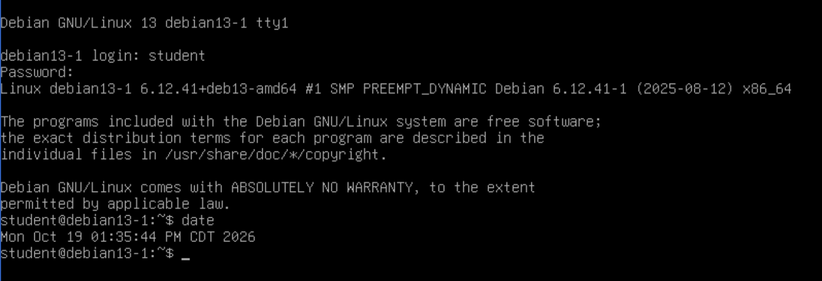
Screenshot 1.1: Take a screenshot of the command and output and include it below.

Step 1.4: Change the password of the student user. Enter the passwd command with no arguments while logged in as student to change the password.
Step 1.5: When asked to enter a new password enter the password CSEC378418!
Step 1.6: Use the touch command to create a new file with your first initial last name as the filename. touch is a command that can be used to update the timestamp on an existing file or create a blank new file if used on a filename that doesn’t already exist. For example, I would run the command touch knaughton to create my file.
Step 1.7: Use the command ls -lt to list the contents of your current directory and confirm you see the file you just created.
Question 1.3: What do the -l and -t options do? How do they change the output of the ls command?
The -l option displays detailed file information, including permissions, ownership, size, and modification date. The -t option sorts files by modification time, showing the most recently modified files first.
Step 1.8: Use the file command on your new file to get some details about the file type and contents of this file.
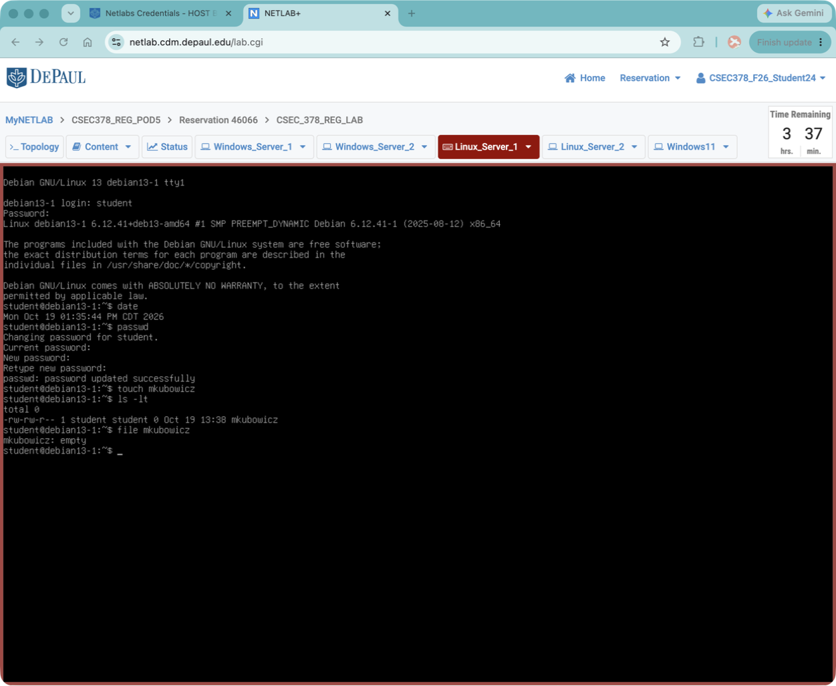
Screenshot 1.2: Include a screenshot of the command you ran and the output you received below.

Question 1.4: What does the file command you used in the last step tell you about your new file?
The file command tells me that mkubowicz is an empty file with no content stored in it.
Step 1.9: Add some content to the file you just created. A quick way to do this is to redirect some command output into the file. echo is a utility that will take input you give it and repeat it back to you as output. Try running the command echo DePaul University and observe the output.
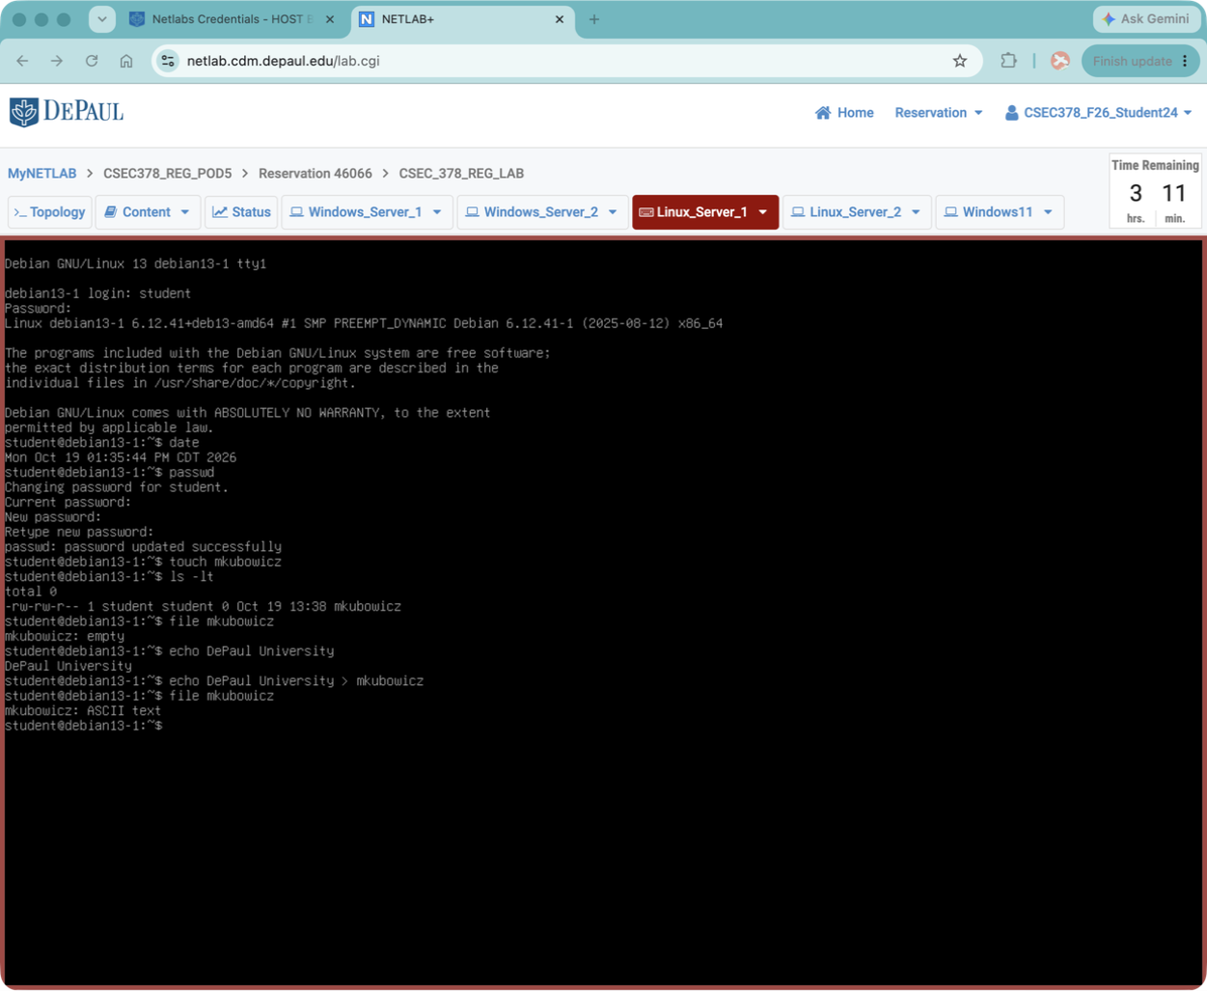
Step 1.10: echo takes text in via standard input (stdin) and gives it back out at you via standard output (stdout). We can redirect that output using the > character and save it to a file, rather than just displaying to your screen. Rerun the command from the last step but now redirect the output like so: echo DePaul University > yourname
Step 1.11: Now use the file command again on the file.
Screenshot 1.3: Include a screenshot of the file command and output here.

Question 1.5: What does the command output tell you about this file now?
The file is now recognized as an ASCII text file because it contains the text “DePaul University” instead of being empty.
Step 1.12: The file you created is small and only contains one line. You will most often be dealing with files with many lines of text. Use the following command to look at the first 10 lines of the /etc/passwd file on your Linux machine: head /etc/passwd.

Screenshot 1.4: Include a screenshot of the command and output here.

Question 1.6: Why are there no passwords contained in this file? What file stores passwords?
Passwords are not stored in /etc/passwd for security reasons because regular users can read this file. Password hashes are stored in /etc/shadow, which has restricted access.
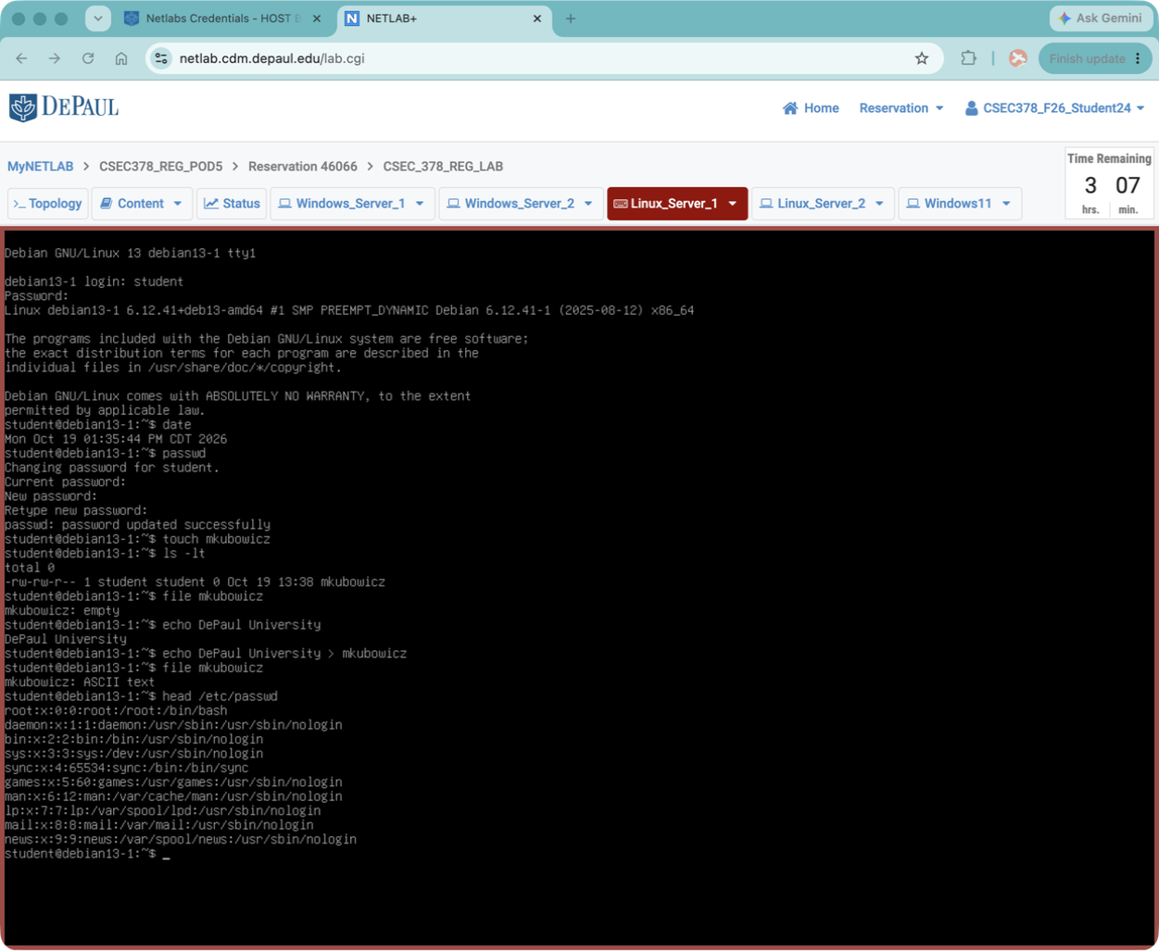
Question 1.7: When looking at the output, what does /bin/bash mean for the root account? Why do most other accounts indicate /usr/sbin/nologin?
/bin/bash means the root account can access the Bash shell and execute commands. Most other accounts use /usr/sbin/nologin because they are system accounts that don’t need interactive login access.
Step 1.13: Run the following: head -n 3 /etc/passwd and look at how the output differs from the last step.
Question 1.8: What do the command, option, and the argument used in the previous step do? Explain each.
The head command displays the beginning of a file. The -n option specifies how many lines to display, 3 tells it to show three lines, and /etc/passwd is the file being read.

Step 1.14: There is a command similar to the head command, but instead of displaying the top of a file, it displays the bottom of a file. Use this command to display the last 5 lines of the /etc/passwd file.
Screenshot 1.5: Include a screenshot of the command you ran and the output you received below.

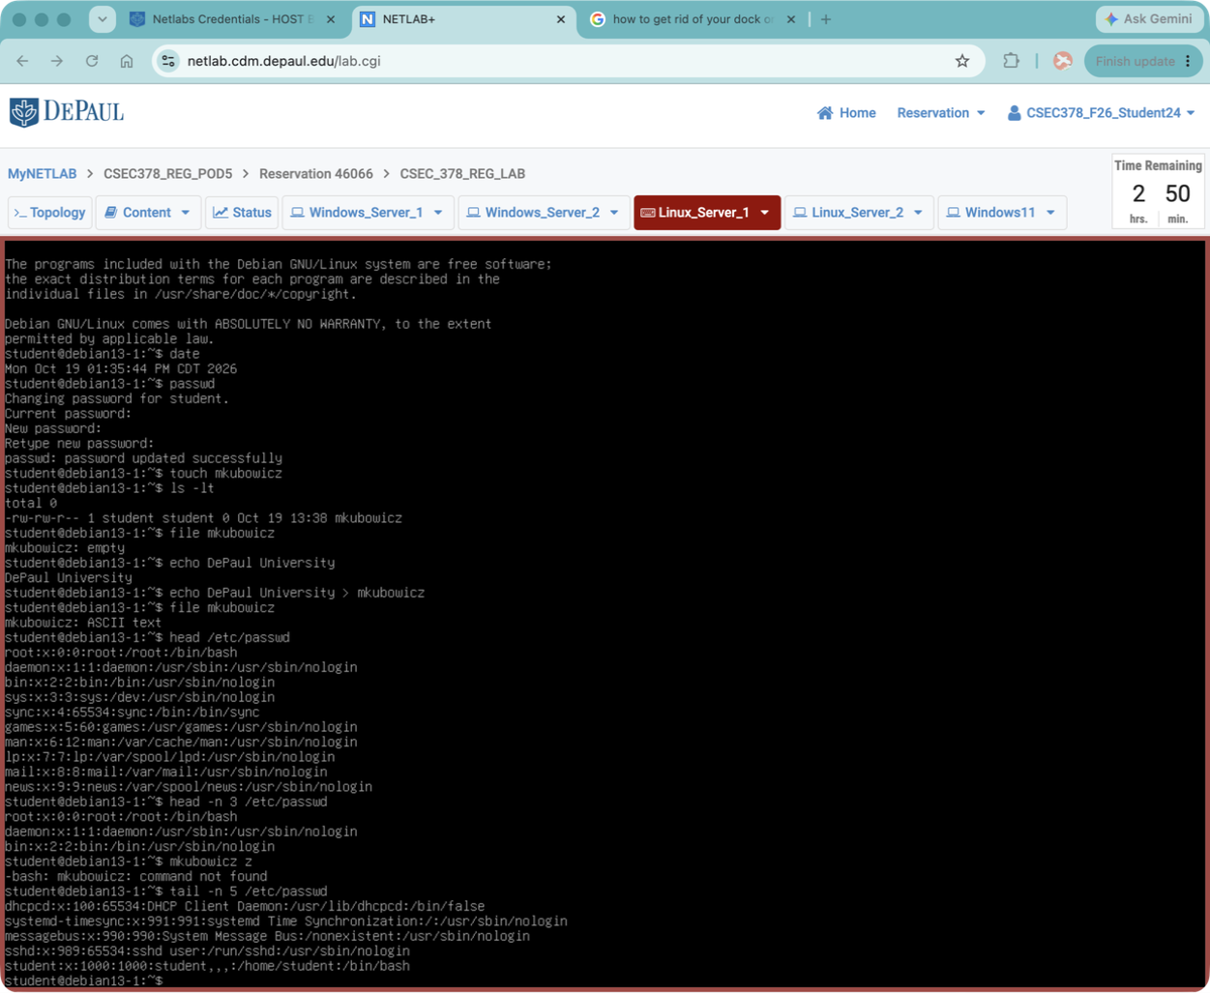

Question 1.9: Explain what the command you used in the previous step does and explain any options you used.
The tail command displays the last lines of a file. The -n 5 option tells it to display only the last five lines of the /etc/passwd file.
Step 1.15: Use the cd command move around the file system. Enter the command cd / to change your directory from the current location of student user’s home directory to the system’s root directory (which is represented by a “/”).
Step 1.16: Use the command ls to see which directories are contained here, then move into the etc directory using cd, and then use pwd to show where you are.
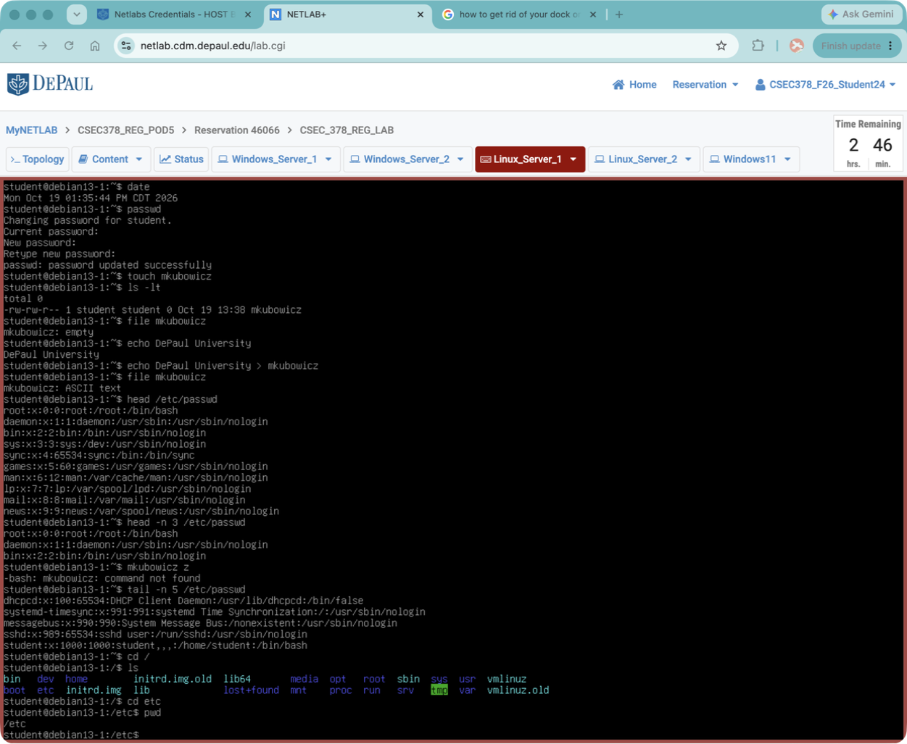
Screenshot 1.6: Include a screenshot showing all three commands and output below.

Note: cd will let you specify a full filepath so you can move through more than one directory at a time. Common file shortcuts like ./ or ../or ~ can be used with cd as well as shorthand for current directory, parent directory or home directory, respectively.
Step 1.17: From your current location, use the command cd /home/student
Question 1.10: Is the file path used in the last step an example of a relative path or an absolute path? How do you know?
This is an absolute path because it starts with /, meaning it specifies the full location of the directory starting from the root directory.
Step 1.18: There is a common command that is used to tell what directory you are currently in. Use that command to show that you are currently in your home directory: /home/student.
Screenshot 1.7: Include a screenshot of the command and output below.
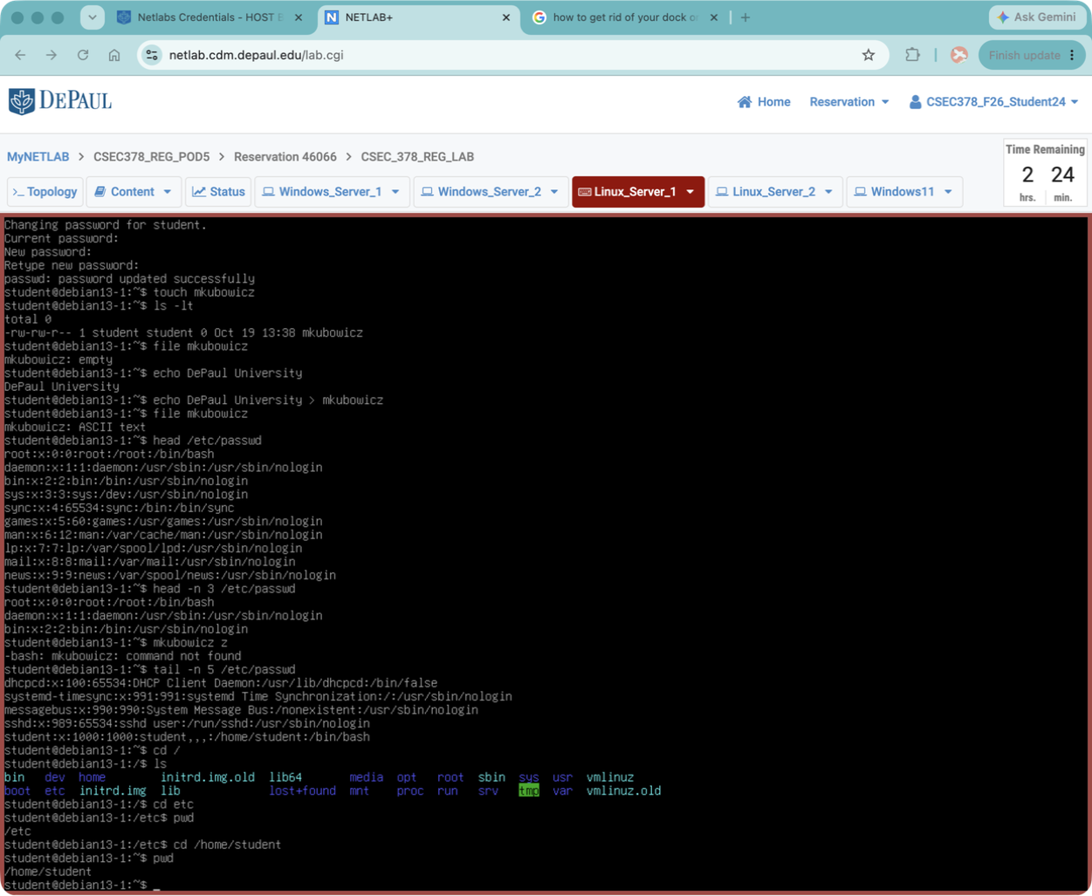

Step 1.19: Use the command mkdir to make a new directory called Lab1 using the following command mkdir Lab1.
Step 1.20: List out the contents of your current directory using ls -lt to view the newly created directory. Then use the file command on the new Lab1 directory.
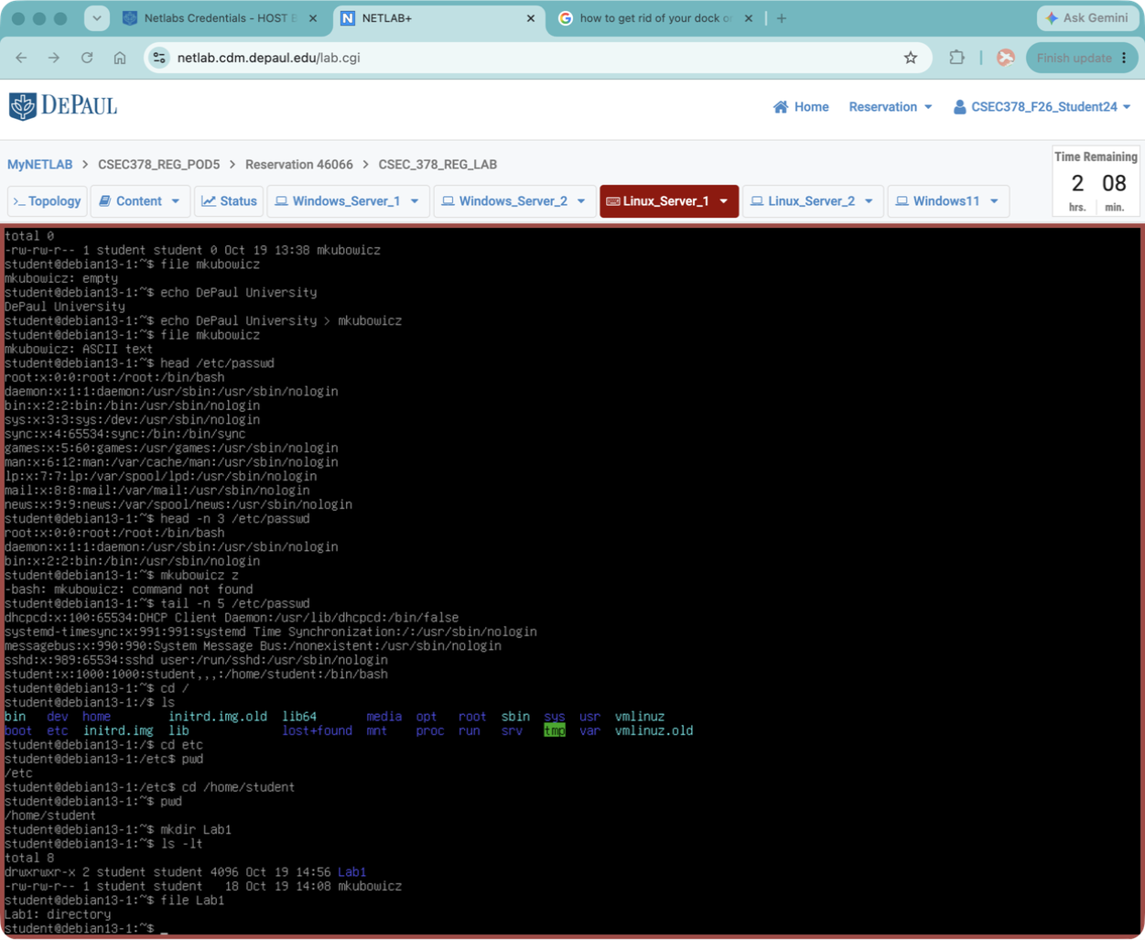
Screenshot 1.8: Include a screenshot of the output of both commands below.

Question 1.11: Without using the file command and without using the color-coded file names, how would you be able to tell that Lab1 is a directory based on the output of ls -lt?
Step 1.21: Use the cp command to copy your yourname file into your Lab1 directory. After running this command use the ls -lt command again to list out the contents of the Lab1 directory.
Screenshot 1.9: Include a screenshot showing the yourname file in your Lab1 directory.

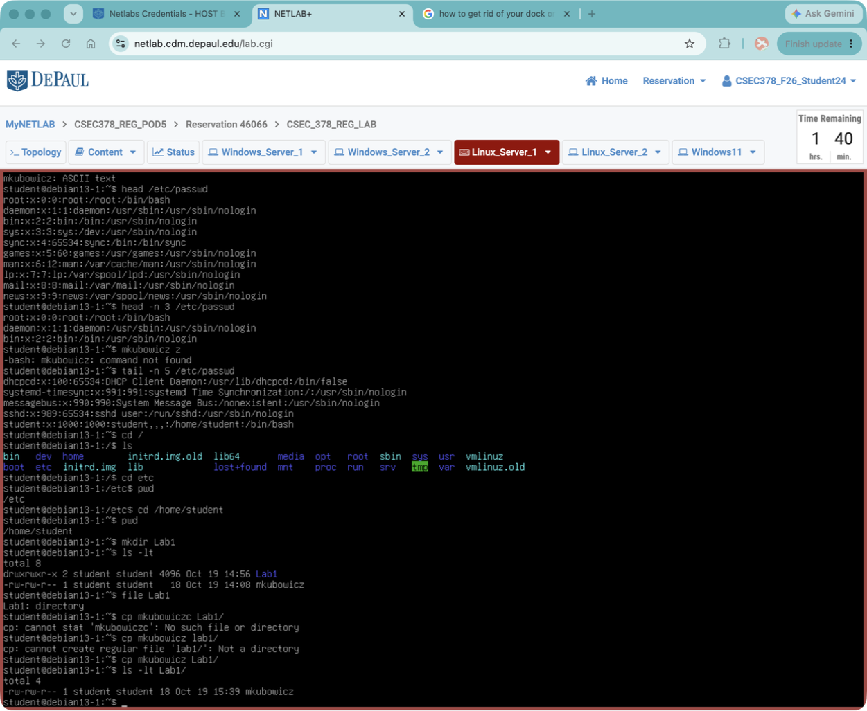

Question 1.12: When using the cp command, does the original copy of the file get retained or removed? Why?
The original file is retained because the cp command creates a copy of the file in another location without removing the original.
Step 1.22: Use the mv command to move the yourname file in your home directory to the Lab1 directory by entering the following command mv yourname Lab1/depaul
Step 1.23: Use the command ls -ltR to show the contents of your home directory and the contents Lab1 directory.
Screenshot 1.10: Include a screenshot of the output below.

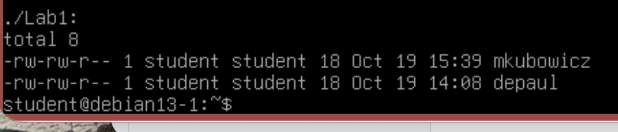

Question 1.13: How does the -R flag in ls change the output? What does that flag do?
The -R flag makes the ls command list directories recursively, meaning it displays the contents of the current directory and all subdirectories.
Step 1.24: Try to copy the Lab1 directory using cp Lab1 LabOne. This will not work because Lab1 has contents in it, but you will receive a helpful error message. Figure out how to use cp to copy the Lab1 directory and all its contents into a new directory named LabOne.
Screenshot 1.11: Include a screenshot of the cp command you used and the output of ls -ltR showing that it worked.
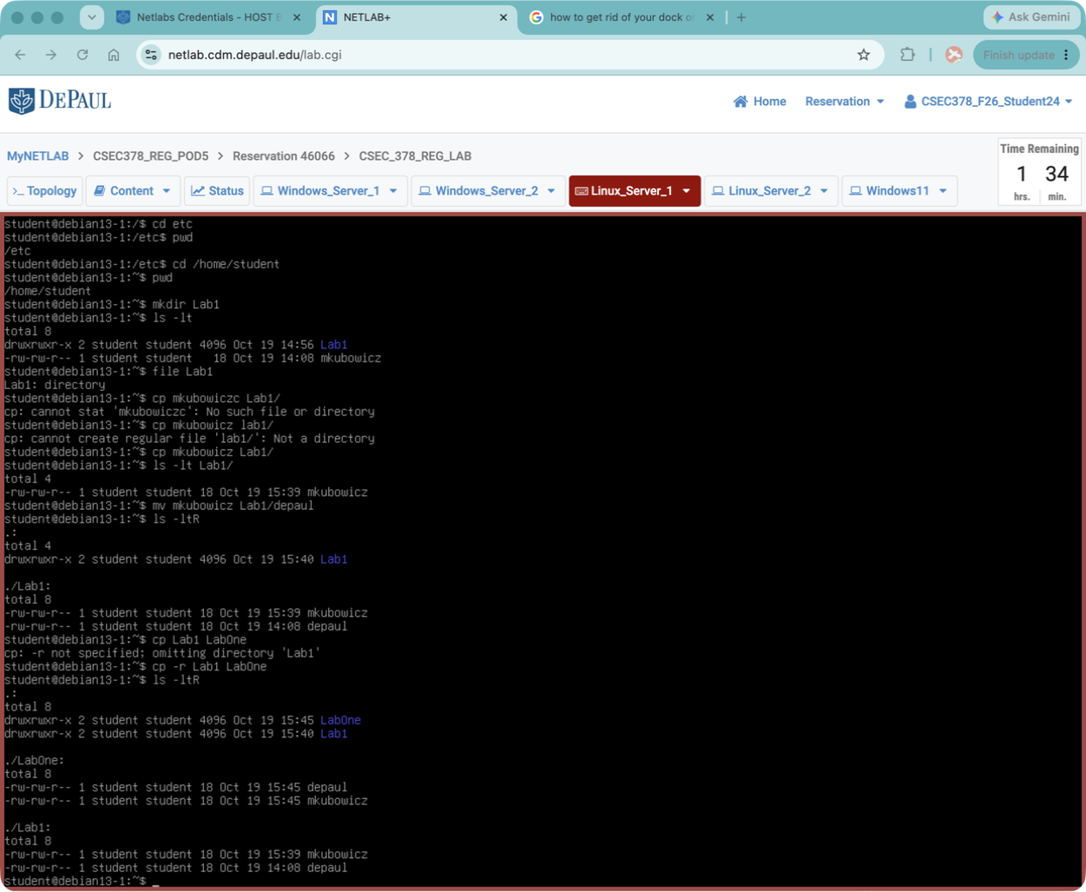

Note: Use Google, or you can use the man (short for manual) command to look at all the available options for the cp command by using man cp. You can use man on any bash command to see options.
Step 1.25: Try to use the rmdir command to remove the Lab1 directory with the command rmdir Lab1. It will not work.
Question 1.14: Why can’t you use the rmdir command to delete the Lab1 directory in the previous step?
The rmdir command can only remove empty directories. Since Lab1 contains files, the command cannot delete it.
Step 1.26: To delete a directory with contents, we will need to use the command rm -rf. Be aware that this command has the potential to do delete much more than intended or potentially do serious harm to your system if you do not specify the target directory correctly.
Question 1.15: What do the -r and -f flags do? Why can this cause so much damage if used improperly?
The -r flag removes directories and everything inside them recursively. The -f flag forces deletion without asking for confirmation. This command can be dangerous because it can permanently delete important files and directories if used incorrectly.
Step 1.27: Use the command rm -rf Lab1 to delete only the Lab1 directory. Use ls -lt from your home directory to verify that the Lab1 directory is gone.
Screenshot 1.12: Include a screenshot showing the rm and ls commands and any output.

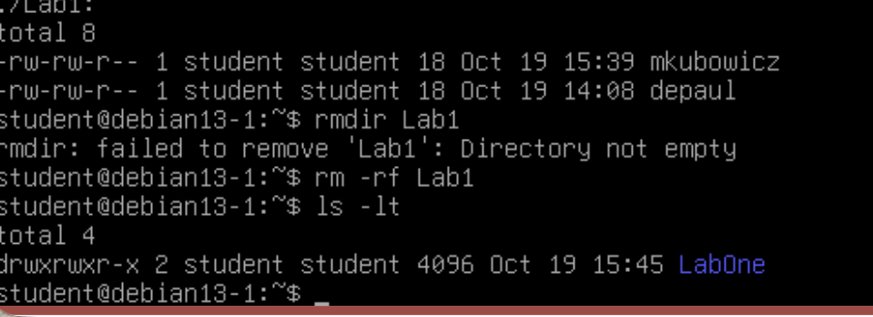

Note: If your screen is getting too cluttered with command output, you can always use ctrl+l (lowercase L) to clear your screen. You can also type clear to clear the screen as well.

Section 2: Users, Groups, and File Permissions
Step 2.1: Try to use the adduser command to add a user (using the first initial of your first name, full last name, all lowercase, no spaces – i.e. mine would be knaughton) with the command adduser yourname
This will not be successful.
Note: From here on out, when you see references to the yourname user, this is a reference to this user account. Substitute it in commands accordingly with the correct username.
Do not create a user named “yourname” or “knaughton”. If you do, your screenshots will not count.
Step 2.2: Creating a user requires additional permissions. You will need to use the sudo command in order to elevate your permissions for this command. Try again with the command sudo adduser yourname.
Step 2.3: You will be prompted for authentication to use the sudo command. Enter the student user’s CSEC378418! password when prompted.
Step 2.4: You will be prompted for the new user’s password and some other information. When prompted for a new password, enter the password Chicago1871! You can leave the other entries (Full name, room number, etc) blank.
Step 2.5: You can see details about a user account by using the id command. Use the id command on the newly created yourname user.
Question 2.1: Specify what uid, gid, and groups mean in the output.
* uid: The unique user ID number assigned to the account.
* gid: The ID number of the user’s primary group.
* groups: Lists all groups the user belongs to.
Step 2.6: Use the id command on the student account and compare their group membership to yourname’s.
Screenshot 2.1: Include a screenshot showing yourname and student’s id output

Question 2.2: Which account has more privileges? How do you know?
The student account has more privileges because it belongs to the sudo group, allowing it to execute commands with administrator permissions. The mkubowicz account does not currently have those privileges.
Step 2.7: All users have an entry added to the /etc/passwd file when they are created. Look at the file using tail to see the most recent entries near the bottom of the file.
Screenshot 2.2: Include a screenshot of the tail command you ran and the output showing the yourname user in /etc/passwd.
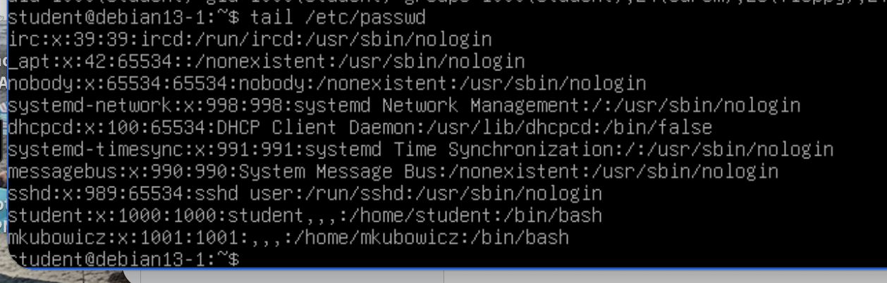

Step 2.8: Switch users and login as yourname. Use the following command to do so: su yourname. Enter yourname’s password Chicago1871! to switch to this account.
Step 2.9: As yourname try to add a new user called testuser. Use the command sudo adduser testuser
Question 2.3: In your own words (don’t just give me the error message), why doesn’t this work?

The command doesn’t work because the mkubowicz account doesn’t have sudo privileges. Only authorized users can perform administrative tasks like creating new accounts.
Step 2.10: You will need to grant the yourname account access to the sudo binary, but the yourname account does not have permission to make this change. Use the exit command to switch back to the student account, which already has permission to use sudo.
Note: The exit command works here because you were originally logged in as student and then used su to switch to yourname. exit lets you jump back to your previous user, but you could also use su student to switch to student as well.
Step 2.11: As student, use the gpasswd command to add yourname to the group called sudo. Use the following command to do this: sudo gpasswd -a yourname sudo.
Step 2.12: Use the id command on yourname again to verify that yourname is now a member of the sudo group.
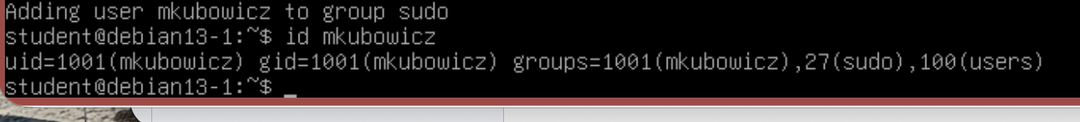
Screenshot 2.3: Include a screenshot of the output of both the gpasswd and id commands.
Question 2.4: If you wanted to remove a user from a group using gpasswd, what would the command be?
Adding a user to the sudo group allows them to execute administrative commands with elevated privileges, such as installing software, managing users, and changing system settings.
Note: There are multiple commands that can be used to modify a user’s group membership. gpasswd is just one of these commands. gpasswd can modify group passwords, as well as some other group features, thus its name (group password). Here, we simply use it to add a user to a group.
Step 2.13: Switch back to the yourname account. By default, you will still be in the student user’s home directory once you do. Use cd to move to yourname’s home directory. Verify you are in /home/yourname with pwd.
Step 2.14: You can view all groups that are configured on a system by looking at the /etc/group file. Run the command less /etc/group to view this file. less is a useful command that can be used to view and scroll through files without editing them. However, when files get large, it becomes unreasonable to scroll through the whole file looking for a single line manually. When using less you can search a file by typing / followed by your search term and then enter. Search for the sudo group in this file. When you are done, press q to exit from viewing the file.
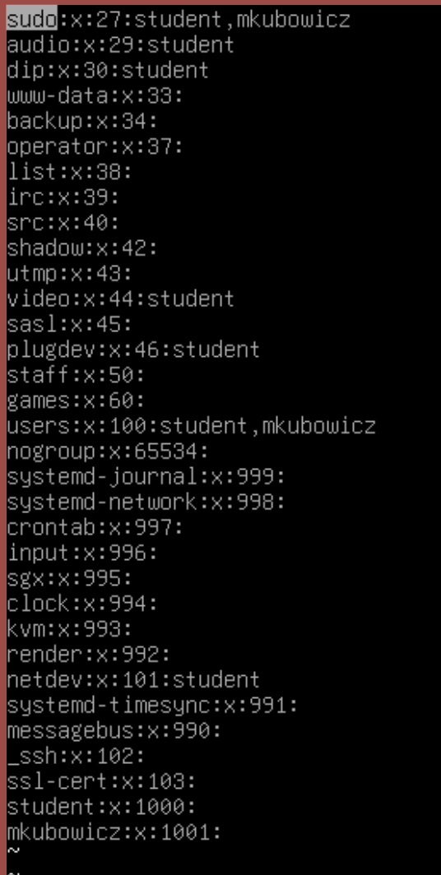
Screenshot 2.4: Include a screenshot of the sudo group and its listed members.

Note: When managing a Linux system, it is best practice to use the root account as infrequently as possible. Everyone should use a different user account with sudo permissions for day-to-day system administration. On a system with multiple users, this will help keep track of individual user’s actions. If everyone just logs in as root, you will not be able to tell individual user actions apart.
Step 2.15: Add a new group using the command groupadd followed by the name of the group we want to create. Create a group called depaulcdm and then add yourname to this group with gpasswd. Remember that you will need to elevate your permissions to do so.
Step 2.16: Verify that this group has been added to the /etc/group, you should also see yourname listed as the only member.
Screenshot 2.5: Include a screenshot of the new group and its membership in the /etc/group file.

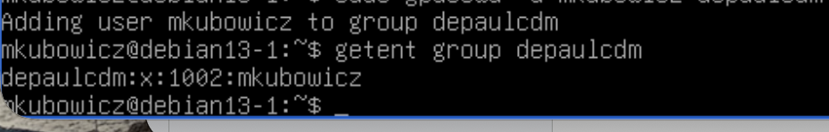

Step 2.17: You can change attributes of an existing group using the groupmod command. Use groupmod to rename the depaulcdm group to depaul. Use Google or man groupmod to find the right command options.
Screenshot 2.6: Include a screenshot of the command you used.
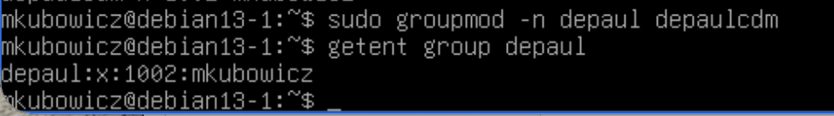

Question 2.5: Check the /etc/group file again. Is yourname now a member of the depaul group? Is the depaulcdm group still there?
Yes, mkubowicz is now a member of the depaul group. The depaulcdm group no longer exists because it was renamed to depaul.

Step 2.18: Be sure you are still in yourname’s home directory. Move there if you are not.
Step 2.19: Yourname’s home directory is currently empty (aside from configuration files). Use vim to start editing a new file. Use the command vim mynewfile to begin editing. You will be presented with a blank file. vim can be used to view files, as well as edit them. By default, when you open a file in vim you are in command-mode, which does not have the ability to edit. To enter insert-mode and be able to edit, press i. Enter the following three lines into this new file.
      - Hello World!
      - This is my new file.
      - Signed, yourname
When you are finished typing, you will still be in insert mode. To back out to command mode again, press escape. Try exiting vim by typing :q you will receive an error message. Vim is not going to allow you to quit the file until you indicate whether to save or discard the changes you made. To force vim to quit include an ! in your exit command like this :q!
Step 2.20: Now use ls to list all files in your directory. To your dismay, the mynewfile is not here! When you exited vim, you didn’t save your changes. Since vim was forced to quit without saving, your changes were discarded.
Step 2.21: Repeat that step again and recreate your file. However, at the end, instead of using :q! (quit, force) to exit, use :wq (write changes, quit) to save your changes and quit.
Note: vim may seem confusing at first, mainly because it uses a lot of keyboard shortcuts. If you’re new to vim, you may accidentally trigger these shortcuts, leading to unexpected behavior. Practice makes perfect with vim. When you get good with the shortcuts, you can very quickly move around and edit a file. When you are learning vim, if you ever end up stuck and can’t figure out how to exit, try pressing escape a few times before trying the :q! or :wq commands.
If you are struggling with maneuvering around in vim, check out this quick tutorial on YouTube that covers the basics: https://youtu.be/ggSyF1SVFr4?t=53
Step 2.22: Use ls again. Now you will see your mynewfile sitting in your home directory. Make a new directory called mynewdir using the following command: sudo mkdir mynewdir. Use ls -lt to see the mynewfile and mynewdir in your home directory.

Screenshot 2.7: Include a screenshot showing the output of ls from the last step.

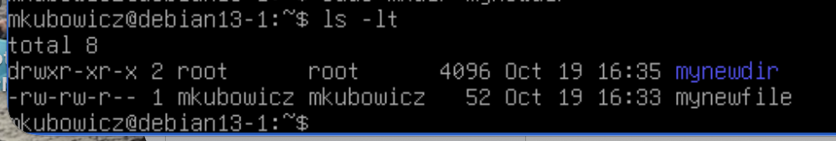

Question 2.6: Based on the command output, which user and group owns mynewfile? Which user and group owns mynewdir? Why are they not the same?
mynewfile is owned by user mkubowicz and group mkubowicz. mynewdir is owned by user root and group root. They have different owners because the directory was created using sudo, while the file was created by my regular user account.

Question 2.7: The output of ls -lt includes a string of letters and dashes in the left most column. What does the first character of this string indicate? What does it mean if it is a d?
The first character indicates the file type. A d means the item is a directory, while a - means it is a regular file.
Question 2.8: The other characters in the string of letters and dashes indicate file permissions. What is meant by rwx? Why are there three sets of rwx’s?
rwx stands for read, write, and execute. There are three sets because permissions are assigned separately to the owner, the group, and everyone else.

Step 2.23: Change the permissions on our mynewfile file. Issue the command chmod 700 mynewfile. Then issue ls -lt again to see the new permissions.
Question 2.9: What changed? Who has access to this file now?
The permissions changed so only the file owner has read, write, and execute access. The group and everyone else have no permissions.

Question 2.10: What does the “700” mean in the chmod 700 command?
700 means the owner has all three permissions (7 = 4+2+1), while the group and others have no permissions (0).

CSEC378418!
Step 2.24: Use the su command to change your user to the student user. As student, try to read the file using the command less mynewfile. It should fail, indicating that you do not have permissions as the student user.
Question 2.11: Without changing your user, or modifying the file permissions - What command can you use to view this file? Why are you able to read the file with that command, despite student not having permissions to view?
I can use sudo less /home/mkubowicz/mynewfile to read the file. This works because sudo runs the command with elevated privileges, allowing access even though the student account does not have normal read permission.

Step 2.25: Switch back to the yourname account.
Step 2.26: Use the cat command to print the contents of mynewfile to the screen using cat mynewfile. The cat command will print the contents of a file to the screen, rather than enter you into an interactive file viewer or text editor. This can be useful for quickly viewing small files, or filtering output.
Step 2.27: cat is simple, but useful. If we want to redirect or trim the output of cat, we can use some other operators and commands to do so. Let’s say we only want to see lines that contain yourname. Issue the command cat mynewfile | grep yourname. The pipe “|” will redirect the output of the cat command to grep. grep will search for any line containing yourname and print only those lines. By doing this, we are filtering our output from cat through grep, to display only what we want to see.
Screenshot 2.8: Include a screenshot showing the command and the resulting output below.

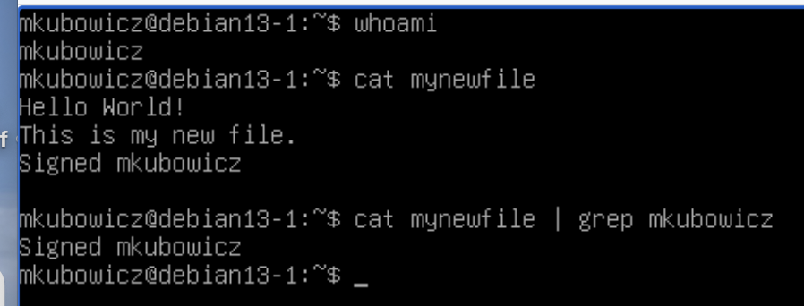

Step 2.28: You can redirect output with more than just |. Building on the command from the last step, you will now redirect the output of that command to a new file called secondfile. To do this, use > to redirect the output of the command somewhere else.
Issue the command cat mynewfile | grep Hello > secondfile then look at the contents and file permissions of secondfile.
Screenshot 2.9: Include a screenshot showing the file permissions and contents of secondfile
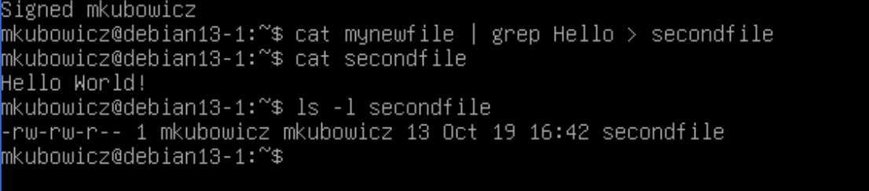

Question 2.12: Why does secondfile only contain one line?
secondfile contains only one line because grep Hello selects only the line containing the word "Hello" before redirecting it into the new file.

Question 2.13: Did this process copy over the file permissions from mynewfile to secondfile? How do you know?

No, the original permissions were not copied. secondfile was created as a new file with its own default permissions, which are different from the 700 permissions on mynewfile.

Step 2.29: Construct and execute a chmod command that will make it so that the owner and owning group have only read permissions over secondfile, but everyone else has no permissions.
Screenshot 2.10: Include a screenshot showing of the command you used, and the new permissions.
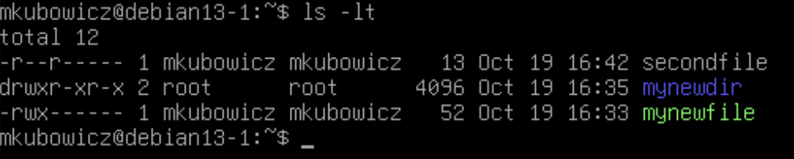

Note: Ensure that the file permissions on your two files are correct before moving to the next step. The permissions should be the same as the screenshot below.

Step 2.30: Change the ownership of the two text files you created. To do this use the chown command. chown allows you to specify more than one file as an argument when changing permissions. Use the following command: sudo chown student mynewfile secondfile
Step 2.31: Using ls -lt, note that the owner of both files has been changed to student, but yourname’s group still has ownership.
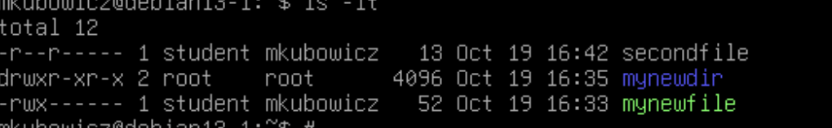
Screenshot 2.11: Include a screenshot showing the new permissions and owner information.

Question 2.14: Now use cat to try to read the contents of both mynewfile and secondfile. Which file can you still view? Why are you able to view this file, but unable to view the other file?
I can still read secondfile because my group has read permission. I cannot read mynewfile because it only allows the owner to access it, and the owner is now student.
Step 2.32: Now change the group ownership for these files with the chgrp command. chgrp also allows you to specify more than one file as an argument just like the chown command. Issue the following command: sudo chgrp student mynewfile secondfile
Again, using ls -lt, note that the group owner of both files has been changed to student.
Screenshot 2.12: Include a screenshot showing the output from ls from the previous step.

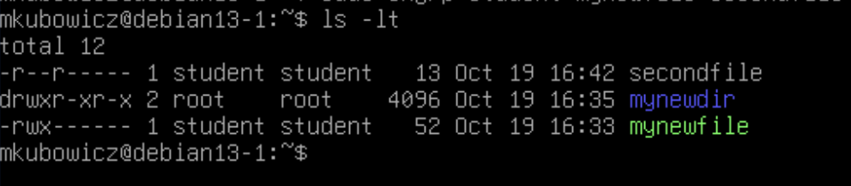

Question 2.15: Try to read the contents of both mynewfile and secondfile Why are you now unable to read the file that you were able to read in the previous question?
I can no longer read secondfile because its group ownership changed to student. My account is no longer the owner or a member of the owning group, and other users have no read permission.

Step 2.33: It is also possible to change the owning user and owning group configuration on a file or directory by using only one command, rather than a separate chown and chgrp command. Research how to do this, and change the owning user and group to yourname for the mynewdir directory.
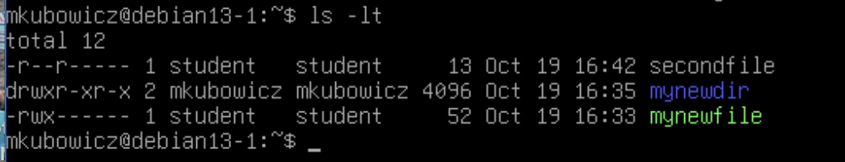
Screenshot 2.13: Include a screenshot showing the command you used, and the output of ls showing the new ownership information.

Section 3: Logging and Time Configuration
Step 3.1: While signed in as yourname on Linux Server 1 run the command journalctl. This will display system logs. At the top of the output, you will see a notice that indicates that you are not seeing all messages.
Question 3.1: What types of messages are currently visible to you here. Why can’t you see more?
I can see log messages that my user account has permission to access, mainly user-related logs. I cannot see all system logs because I do not have elevated privileges.

Step 3.2: Elevate your permissions with sudo and run journalctl again. Use the space key to page through the log output you see. When you are done being overwhelmed by the sheer volume of logs, press q to exit back out to a bash prompt.
Step 3.3: Using journalctl without any arguments is not very useful, there is way too much information to read through manually. The system journal on its own contains general logs, errors, informational messages and notices. When troubleshooting, journalctl becomes a lot more useful when the output is filtered. Determine how to filter for errors with journalctl and run the command on your machine.
Screenshot 3.1: Include a screenshot of the command you ran and some errors from the output.

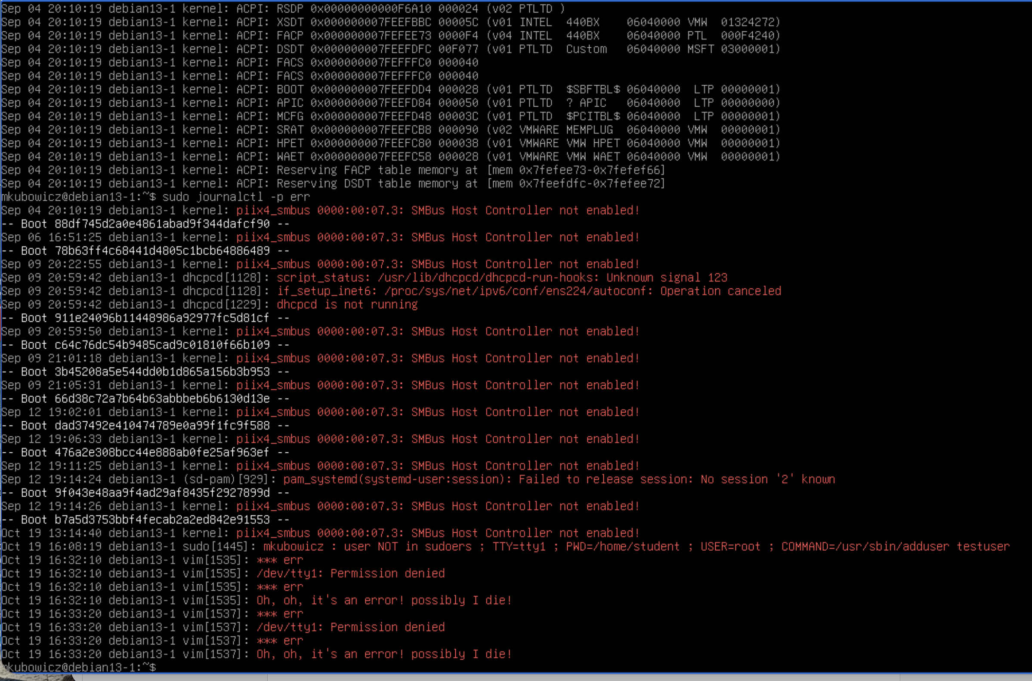

Step 3.4: Depending on how long your machine has been running and what errors have been generated, this view may still be a bit overwhelming. You may notice that the log messages near the top are quite old and probably not relevant to what you would be troubleshooting on a machine. Determine how to filter journalctl so that it only shows you messages that were generated today. Use that flag in combination with the one from the last step filtering for errors.
Screenshot 3.2: Include a screenshot of the command you ran and the output you got.

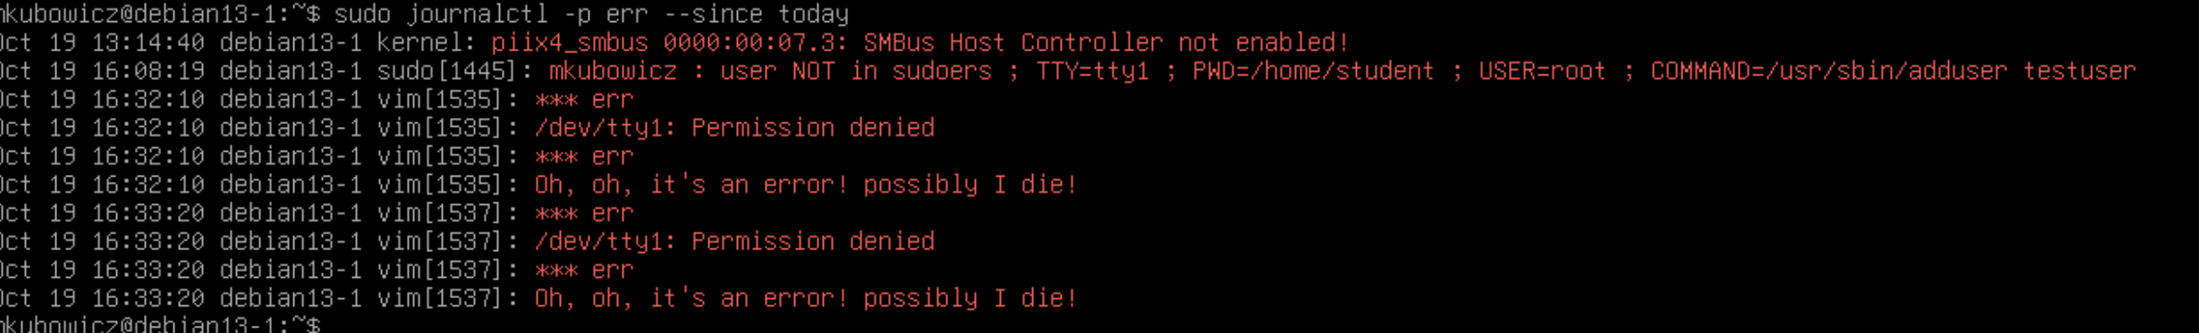

Question 3.2: Choose an error in your output. Explain what the error message says and describe the components of the error message you chose.
I chose the error piix4_smbus 0000:00:07.3: SMBus Host Controller not enabled!
This error means the Linux kernel detected that the SMBus host controller was not enabled. The message includes the date and time (Oct 19, 13:14:40), the hostname (debian13-1), the source (kernel), the driver (piix4_smbus), the device address (0000:00:07.3), and the error description.

Step 3.5: Run the su command with no username specified two or three times to try and switch to root. Purposely get the password wrong on these attempts. Do not actually switch your user, stay logged in as yourname.
Step 3.6: Now use the journalctl command to view the events associated with your failed attempts to use su. Filter down these specific messages by looking for log messages that were generated by the su utility. Issue the command sudo journalctl _COMM=su to view these logs.

Screenshot 3.3: Include a screenshot of the log messages from your failed attempts to su below.
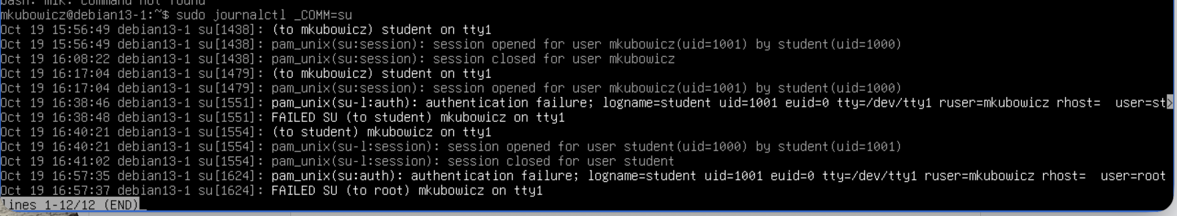

Step 3.7: These error messages are useful in their current form if you were trying to troubleshoot a login issue on the machine. However, the logs we have viewed so far have all been viewed after the event. There are times when it is useful to view log messages as they are being generated. Run the command sudo journalctl -f to follow new logs on your system.
Step 3.8: Use Netlab to access Linux Server 2. Sign in as student with the password student. From Linux Server 2, use SSH to connect to your Linux Server 1 machine as yourname. If you can view the Linux Server 1 Netlab screen in a different window while you do this, you will see the logs generate in real time.
Step 3.9: Once connected to Linux server restart the apache2 daemon for your webserver using systemctl. Keeping an eye on your logs as you do.
Question 3.3: What command did you use to restart the web server?
I used sudo systemctl restart apache2 to restart the Apache web server.
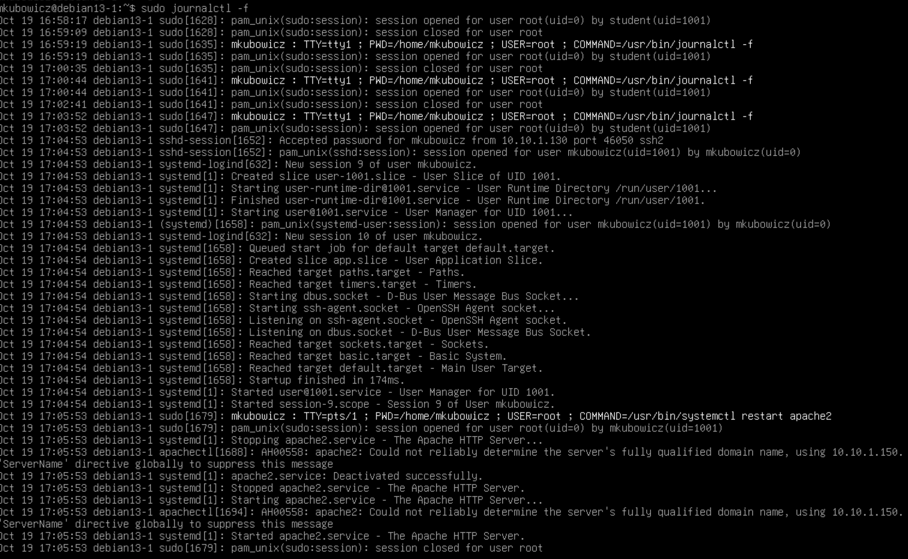
Screenshot 3.4: Include a screenshot of the log messages generated when you restarted the apache server.

Step 3.10: A busy linux system can generate a lot of logs very quickly. Managing these logs is important to keeping a server running in a healthy state while making sure that they can still be referenced if needed. Systemd will do a lot of this maintenance for you, but there are situations where you may need to manually clean up the system journal. Use the command sudo journalctl --disk-usage to see how much space is taken up by logs on your machine.
Screenshot 3.5: Take a screenshot of the output showing how much space is taken up by log files and include it here.

Step 3.11: The journal files in question here are stored in the /var/log/journal/ directory. Within that directory you will find a single directory with a long and seemingly random name, this is your machine ID. If you were gathering logs from multiple different systems, this machine ID would help organize which logs came from which machine. Use cd to move to that directory.
Step 3.12: Within that directory you will see several files. Find the file that corresponds to yourname’s UID, it will be named something like user-####.journal.
Step 3.13: Try to use cat to read the contents of that file. It won’t be particularly readable.
Question 3.4: Why is this file not readable with cat? What type of file is it and how do you know?
The file is not readable with cat because it is a binary journal file, not a regular text file. It stores structured log data that must be interpreted using journalctl. I can confirm its format using the file command.

Step 3.14: Journalctl has a specific command that can be used to view these files. Run the following command to view this log file, replacing the name of the log file with the one you determined in the previous step: sudo journalctl --file=user-####.journal
Question 3.5: What type of log messages are contained in this file?
The journal file contains logs related to my user account, including user sessions, authentication events, sudo commands, and activity from programs running under my account.

Step 3.15: There are a few options to “vacuum” log files in journalctl. Look at the man page for journalctl and determine the command you would use to clean up your systems logs so that only 10mb of logs remained. Run this command on your Linux 1 machine.
Screenshot 3.6: Include a screenshot of the command you ran and the output.

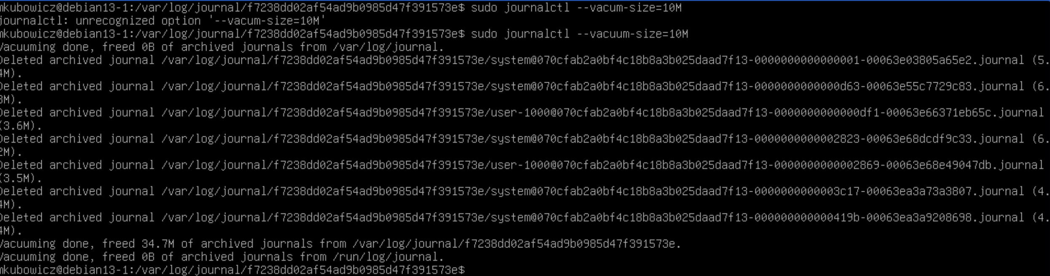

Step 3.16: Check the contents of your user-####.journal file again. You will notice that these logs are still intact, and nothing appears to have changed.
Step 3.17: Check the disk usage of your log files again. You will also notice that the amount of log files remaining is still larger than the 10mb you specified.
Question 3.6: Why didn’t the command you ran clean up your log files the way you may have expected?
The journal file contains logs related to my user account, including user sessions, authentication events, sudo commands, and activity from programs running under my account.

Step 3.18: Journalctl will not modify or clean up active journal files, only archived ones. Rotate your current log files and archive the active ones with the following command: sudo journalctl --rotate
Step 3.19: Run the command to vacuum your logs again like you did in the previous step. After you do, check the contents of your user-####.journal file again.
Question 3.7: Do you notice a difference now in the content of this file? Why or why not?
Yes, the journal content changed after rotating and vacuuming. Rotating archived the active journal, allowing the vacuum command to delete older logs. The remaining active journal file now contains newer log entries.

Step 3.20: Check the disk usage of your log files again.
Screenshot 3.7: Take another screenshot of the output showing how much space is taken up by log files now and include it here.

Question 3.8: Do you notice a difference now in the size of the remaining log files? Is it below the 10mb threshold you set? Why or why not?
Yes, the journal content changed after rotating and vacuuming. Rotating archived the active journal, allowing the vacuum command to delete older logs. The remaining active journal file now contains newer log entries.

Note: In this lab environment we can delete logs on a whim. In a professional setting your company may be required to retain log data for a certain period. Before cleaning up log information on any machine be sure you know what the legal requirements are and whether there are any company policies requiring logs to be retained for a certain period.

Date/Time Completed:______oct 19 5;35_________________________________
Estimated time it took you to complete this lab:_____4 hours_________

