NET 379 - Lab 1: CML Setup | Mikolaj Kubowicz
Screenshot #1 - Minimal Lab Running
Minimal Lab loaded in CML with all nodes running successfully.
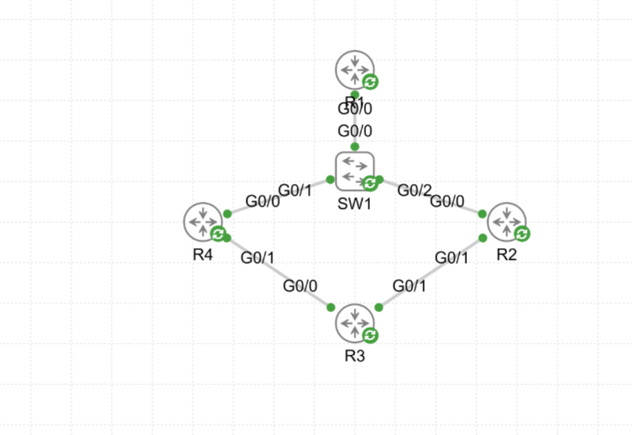

NET 379 - Lab 1: CML Setup | Mikolaj Kubowicz
Screenshot #2 - SSH Access to CML Management
MobaXterm SSH session showing the Minimal Lab nodes and their UUIDs.
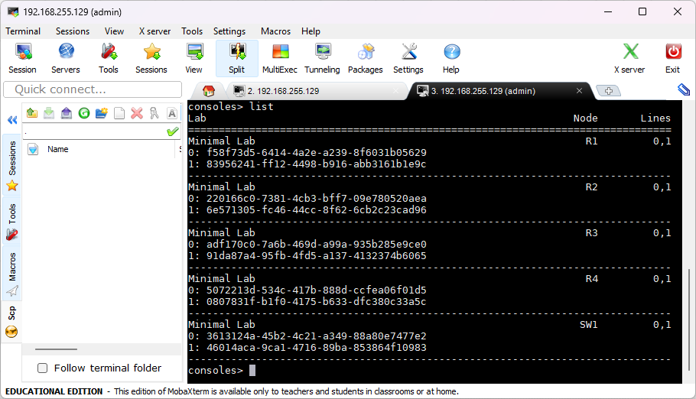

NET 379 - Lab 1: CML Setup | Mikolaj Kubowicz
Screenshot #3 - R2 Console Access
MobaXterm connected to the R2 console, showing the R2 prompt.
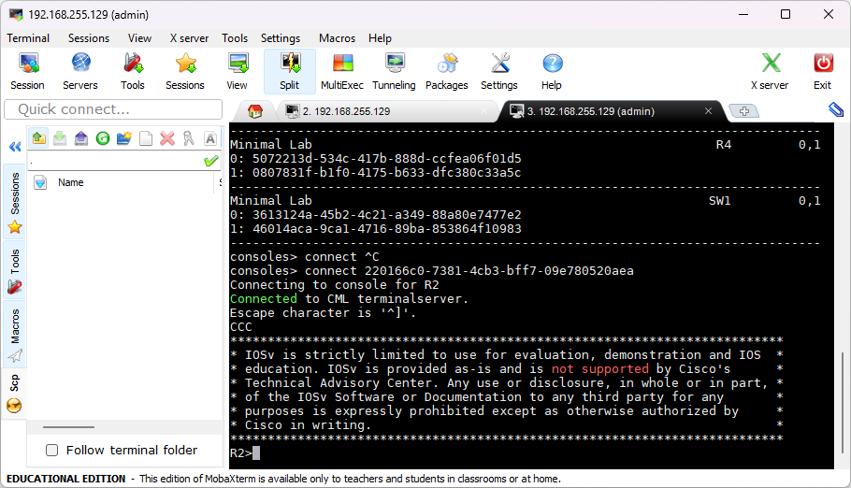

NET 379 - Lab 1: CML Setup | Mikolaj Kubowicz
Screenshot #4 - R2 Console Synchronization
R2 shown simultaneously through the CML web console and MobaXterm while displaying the running configuration.
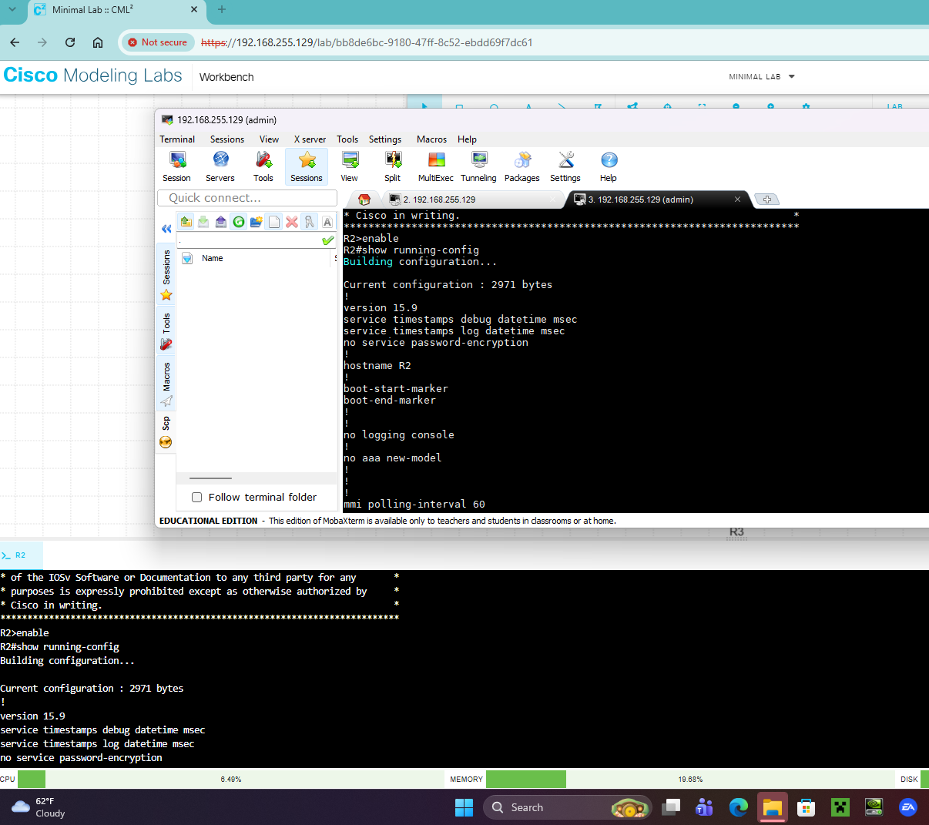

NET 379 - Lab 1: CML Setup | Mikolaj Kubowicz
Screenshot #5 - R2 Hostname Changed
R2 hostname changed to Mikolaj-R2 and the configuration saved with write memory.
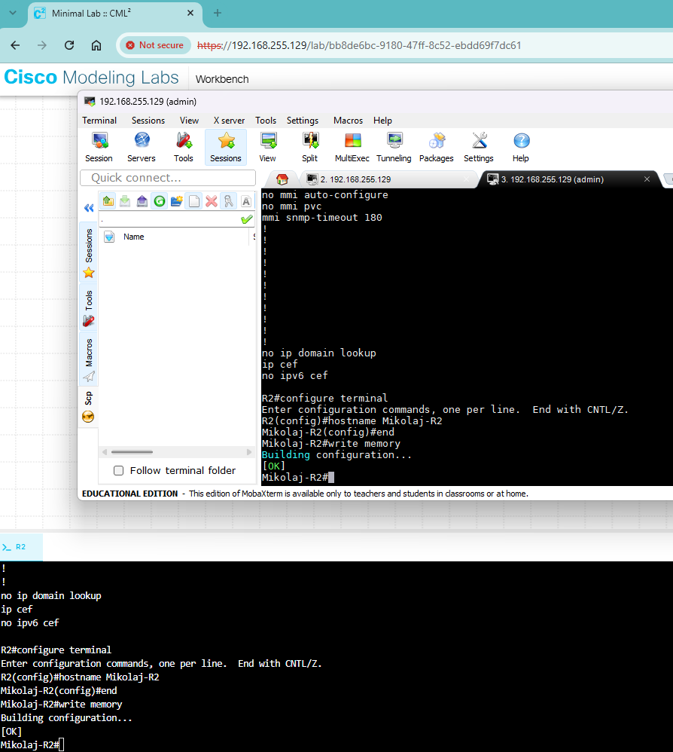

NET 379 - Lab 1: CML Setup | Mikolaj Kubowicz
Screenshot #6 - Extract Configs / Update YAML
CML Nodes view used to extract device configurations back into the lab YAML.
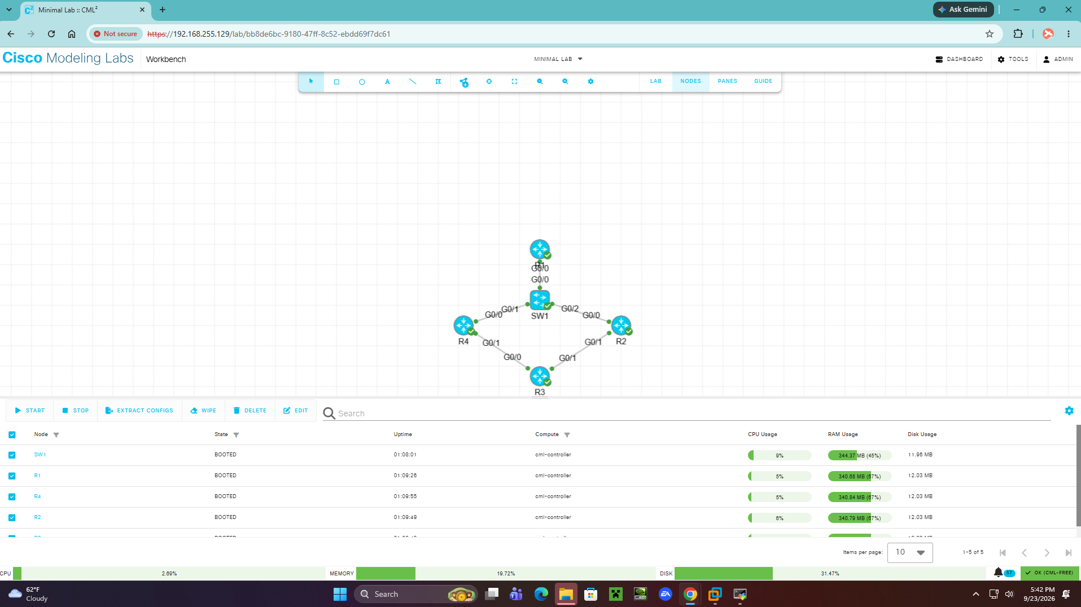

NET 379 - Lab 1: CML Setup | Mikolaj Kubowicz
Screenshot #7 - Complete Test Lab Running
Complete Test Lab running successfully with the full topology online.
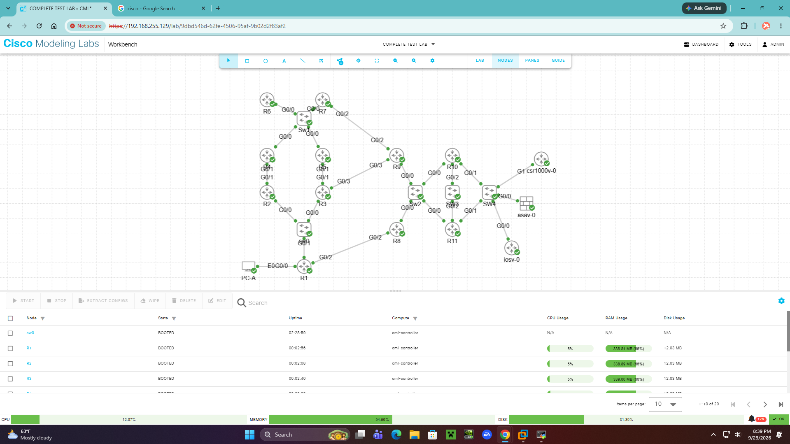

NET 379 - Lab 1: CML Setup | Mikolaj Kubowicz
Screenshot #8 - CML Hardware Utilization Dashboard
CML Dashboard while the Complete Test Lab is running, showing CPU, memory, disk, and system status.
