

|  |
| --- |
| Design Laboratory |
| **Project of Embedded wristwatch module powered by li-pol cell** |
| AGH-CLK |

Mateusz Bik, Mikołaj Markiel, Piotr Mosurek

20.01.2023

# Contents page

Contents page 1

1. Design assumptions 2

1.1. Project description 2

1.2. Block diagram 2

1.3. Technical specification: 2

2. Schematic and layout descriptions 3

2.1. AGH-CLK-01 schematic 3

2.2. AGH-CLK-01 layout design 4

2.3. AGH-CLK-01 Bill of materials 4

2.4. Battery Driver block 5

2.5. Power supply block 6

2.6. RTC clock 6

2.7. Processor and programming block 7

2.8. Debug Block 7

2.9. Keyboard 8

2.10. Display block 8

3. Software description 9

3.1. Environment: 9

3.2. Code: 9

3.3. Performance algorithm 9

4. Performance tests 10

4.1. Battery performance 10

4.2. Clock precision 11

5. Future improvements and fixes 11

# Design assumptions

## Project description

The main goal was to make self-contained embedded wristwatch module that could be used with dedicated wrist as a complete wristwatch. That device has his own power supply made by li-pol cell with dedicated hardware driver. As a display full color LCD screen module is used with 240x240px and ST7789 driver. Device will be controlled by microprocessor STM32L051K6T6 that is placed on a dedicated printed circuit board “AGH-CLK-01” with the rest of peripherals.

## Block diagram

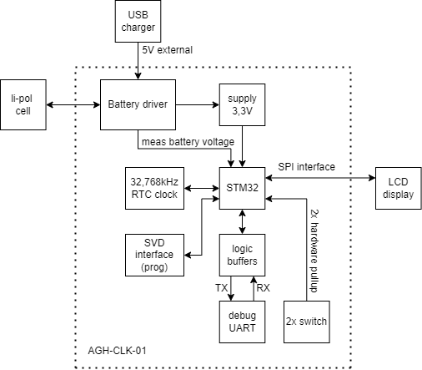

## Technical specification:

* LCD screen 240x240 1,3 inches
* Clock precision: -6 sec/day (would be better with capacitor corrections)
* Current consumption: 54,5 mA (without sleep feature)
* Estimated lifetime per cycle – around 9h (would be better with implemented sleep feature)
* Charging: 5 VDC; 400 mA; around 75 minutes to full charge battery 500mAh

# Schematic and layout descriptions

Schematic and layout was designed in KiCad Version: (6.0.9). PCB was prepared by JLCPCB company based on gerber files generated by KiCad.

## AGH-CLK-01 schematic

Full documentation is available in <https://github.com/MikolajMarkiel/AGH-CLK>

## AGH-CLK-01 layout design

Full documentation is available in <https://github.com/MikolajMarkiel/AGH-CLK>

## AGH-CLK-01 Bill of materials

|  |  |  |  |  |
| --- | --- | --- | --- | --- |
| **Ref** | **Qnty** | **Value** | **Footprint** | **Description** |
| C1, C2, C3, C7, C9, C10, C12, C13, | 8 | 100n | Capacitor_SMD:C_0805_2012Metric_Pad1.18x1.45mm_HandSolder | Unpolarized capacitor |
| C4, C5, | 2 | 18pF | Capacitor_SMD:C_0603_1608Metric_Pad1.08x0.95mm_HandSolder | Unpolarized capacitor |
| C6, C8, | 2 | 1u | Capacitor_SMD:C_0805_2012Metric_Pad1.18x1.45mm_HandSolder | Unpolarized capacitor |
| C11, | 1 | 1u | Capacitor_SMD:C_1206_3216Metric_Pad1.33x1.80mm_HandSolder | Unpolarized capacitor |
| D1, D2, | 2 | BAT54S | Package_TO_SOT_SMD:SOT-23 | schottky barrier diode |
| H1, H2, H3, H4, | 4 | MountingHole | MountingHole:MountingHole_2.2mm_M2_ISO7380 | Mounting Hole without connection |
| J1, | 1 | Conn_01x06_Male | Connector_PinHeader_2.54mm:PinHeader_2x03_P2.54mm_Vertical | Generic connector, single row, 01x06, script generated (kicad-library-utils/schlib/autogen/connector/) |
| J2, | 1 | USB_B_Micro | Connector_USB:USB_Micro-B_Amphenol_10118194_Horizontal | USB Micro Type B connector |
| J3, | 1 | Conn_01x03_Male | Connector_PinHeader_2.54mm:PinHeader_1x03_P2.54mm_Vertical | Generic connector, single row, 01x03, script generated (kicad-library-utils/schlib/autogen/connector/) |
| J4, | 1 | Conn_01x12 | Connector:Flex_Tape_12x0.635 | Generic connector, single row, 01x12, script generated (kicad-library-utils/schlib/autogen/connector/) |
| J5, | 1 | Conn_01x02_Male | Connector_PinHeader_2.54mm:PinHeader_1x02_P2.54mm_Vertical | Generic connector, single row, 01x02, script generated (kicad-library-utils/schlib/autogen/connector/) |
| Q1, | 1 | LGE2300 | Package_TO_SOT_SMD:SOT-23 | 1.2A Id, 60V Vds, 480mOhm Rds, N-Channel HEXFET Power MOSFET, SOT-23 |
| Q2, | 1 | IRLML6402 | Package_TO_SOT_SMD:SOT-23 | -3.7A Id, -20V Vds, 65mOhm Rds, P-Channel HEXFET Power MOSFET, SOT-23 |
| Q3, | 1 | BC817 | Package_TO_SOT_SMD:SOT-23 | 0.8A Ic, 45V Vce, NPN Transistor, SOT-23 |
| R1, R2, R3, | 3 | 100R | Resistor_SMD:R_0603_1608Metric_Pad0.98x0.95mm_HandSolder | Resistor |
| R4, R9, R12, R14, | 4 | 10k | Resistor_SMD:R_0603_1608Metric_Pad0.98x0.95mm_HandSolder | Resistor |
| R5, R6, R7, | 3 | 75k | Resistor_SMD:R_0603_1608Metric_Pad0.98x0.95mm_HandSolder | Resistor |
| R8, | 1 | 1k | Resistor_SMD:R_0603_1608Metric_Pad0.98x0.95mm_HandSolder | Resistor |
| R10, | 1 | 10R | Resistor_SMD:R_0603_1608Metric_Pad0.98x0.95mm_HandSolder | Resistor |
| R11, | 1 | 3k | Resistor_SMD:R_0603_1608Metric_Pad0.98x0.95mm_HandSolder | Resistor |
| R13, | 1 | 680k | Resistor_SMD:R_0815_2038Metric_Pad1.20x4.05mm_HandSolder | Resistor |
| SW1, SW2, | 2 | TSS02-35 | Button_Switch_SMD:SW_SPST_TSS02-035NT | Push button switch, generic, two pins |
| TP1, TP2, TP3, TP4, TP5, TP6, TP7, TP8, | 8 | TestPoint | TestPoint:TestPoint_Pad_1.5x1.5mm | test point |
| U1, | 1 | STM32L051K6Tx | Package_QFP:LQFP-32_7x7mm_P0.8mm | ARM Cortex-M0+ MCU, 32KB flash, 8KB RAM, 32MHz, 1.65-3.6V, 25 GPIO, LQFP-32 |
| U2, | 1 | AP2121N-3.3 | Package_TO_SOT_SMD:SOT-23 | 300mA low dropout linear regulator, shutdown pin, 2.5V-6V input voltage, 3.3V fixed positive output, SOT-23 package |
| U3, U4, | 2 | 74LVC1G125 | Package_TO_SOT_SMD:SOT-23-5_HandSoldering | Single Buffer Gate Tri-State, Low-Voltage CMOS |
| U5, | 1 | TP4054-42 | Package_TO_SOT_SMD:SOT-23-5_HandSoldering |  |
| Y1, | 1 | Crystal | Crystal:Crystal_SMD_3215-2Pin_3.2x1.5mm | Two pin crystal |

## Battery Driver block

For controlled battery charging TP4054-42 driver has been used. Maximum charging current of this driver is up to 1200mA. The particular value of the maximum current is configured by RPROG connected to PROG pin of driver The RPROG value is calculated by formula:

For purpose of this device assumed that the charging current should be around 400mA. The calculated RPROG value should be then no more than 3kΩ. The 3kΩ value has been chosen.

According to documentation weak pull-up should be used for checking battery charging state and connected to CHRG pin and to processor as input.

## Power supply block

The voltage from battery is dropped to 3,3V for purpose of supplying processor and other peripherals. It is done by AP2127-3.3 linear voltage regulator. According to documentation this regulator has 2% accuracy, so the voltage should fit in 3,267-3,333V. The measured voltage is 3,291V, so the value is correct.

## RTC clock

The STM32L051K6T6 supports external RTC crystal for precise counting. Because of that a ABS07-32.768KHZ-T crystal is used. It has 12.5pF load capacitance (CL). There is necessary to add extra capacitance for both terminals that aggregately should be equal to CL of crystal. We should also predict capacitance of copper paths for calculations (CSTRAY) (usually 2-5pF):

We needed to use the same capacitor for this purpose, so the capacitance should then be in range 15-21pF. The correction of capacitance values of this circuit should be verified after assembly by checking clock precision.

## Processor and programming block

This project hasn’t had demanding requirements, so cheap STM32 processor would be enough to fulfil them all. We’ve decided to use STM32L051K6T6 processor. It has all necessary features and peripherals like SPI communication for LCD screen and RTC based on external clock.

To protect processor from unwanted resetting device we’ve placed 100nF decoupling capacitors near every power supply pin.

Programming will be realized by SWD interface. Unfortunately, this processor doesn’t have SWO pin, so real time debugging will be realized by UART.

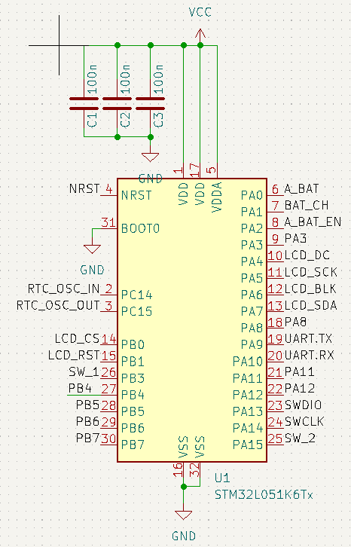

## Debug Block

For real time debugging and testing UART communication has been carried to goldpin headers. To protect pins from dangerous signal RXD and TXD pins are buffered and protected from overvoltage.  
Unfortunately this feature was not necessary to implement in software, and thus wasn’t tested.

## Keyboard

To control device, we’ve added two switches „<” and „>”. They will be used for setting actual time and date feature. To prevent from bouncing effect, we’ve used 100nF capacitor that filter unwanted noise:

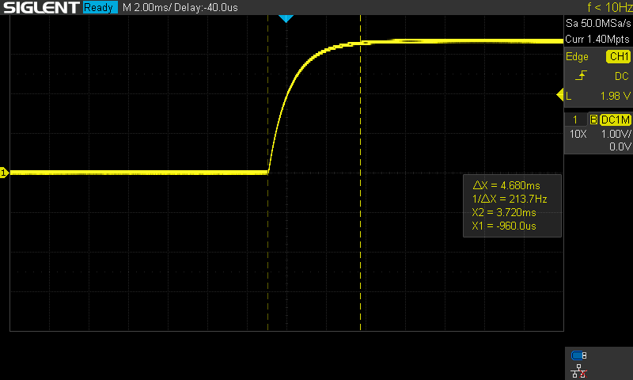

Figure 1: Removing bouncing effect from switches. At the left switch is pressed and pulled to ground, at the right switch is released and capacitor is charging again. The probe was connected directly to processor pin.

## Diagram, schematic Description automatically generatedDisplay block

LCD screen display is communicating with processor via SPI half-duplex interface. The baud rate is 16 MBits/s. To unload processor from long transmission cycle data is transferred by DMA feature. There is also predicted possibility to control backlight of LCD screen.

# Software description

## Environment:

**Software environment**: STM32CubeIDE; Version: 1.10.1; Build: 12716_20220707_0928 (UTC)  
**Programmer**: The ST-LINK/V2-1 programming and debugging tool integrated with NUCLEO-L476RG board

## Code:

Full code is available in <https://github.com/MikolajMarkiel/AGH-CLK>

Libraries we’ve used in project:

* ST7789 driver with UGUI: <https://github.com/deividAlfa/ST7789-STM32-uGUI>

## Performance algorithm

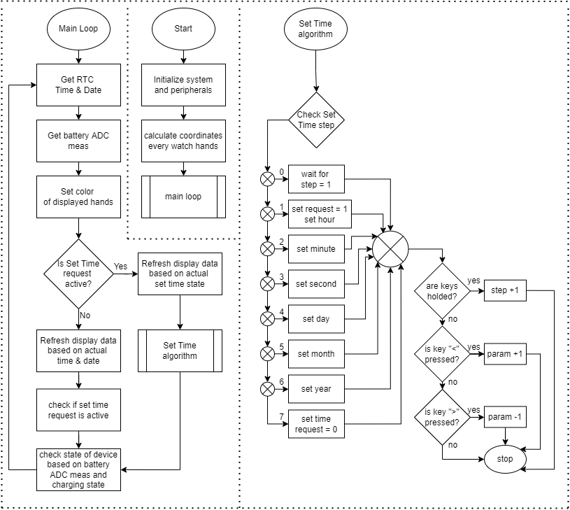

# Performance tests

## Battery performance

All tests were performed on a li-pol cell 2650mAh 3,7V.

Charging cycle:

Discharging cycle:

## Clock precision

The test consist in synchronizing the clock and read its state after 24 hours. It was performed only once.

* Test 1: 18.01.23 18:50:00 – synchronize clock
* Test 2: 19.01.23 18:50:00 – read value 18:49:54 - **6s delay/day.**

# Future improvements and fixes

* **Sleep feature** – to decrease battery consumption and protect battery from over discharging.
* **RTC capacitors update** – for better clock precision.
* **Touch pad** – to allow controlling more features.
* **UART-USB driver** – to allow programming and debug via USB.
* **Wristwatch case** – to make this device wearable.