神经网络优化
- 学习率调整
例如：指数衰减学习率
- 过拟合问题
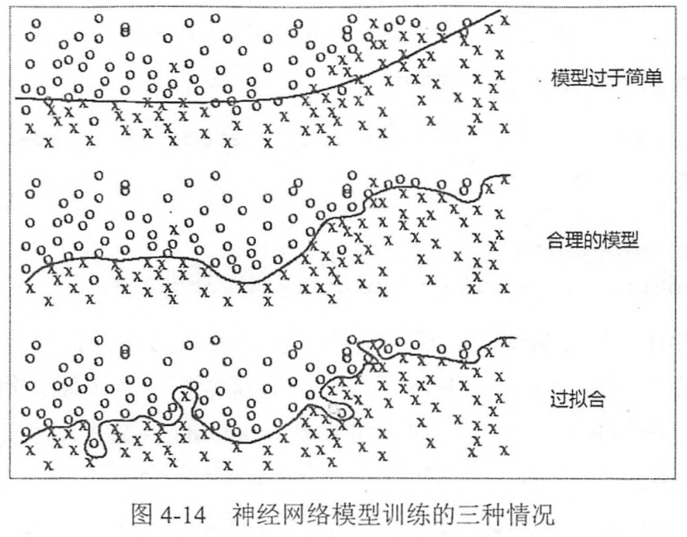

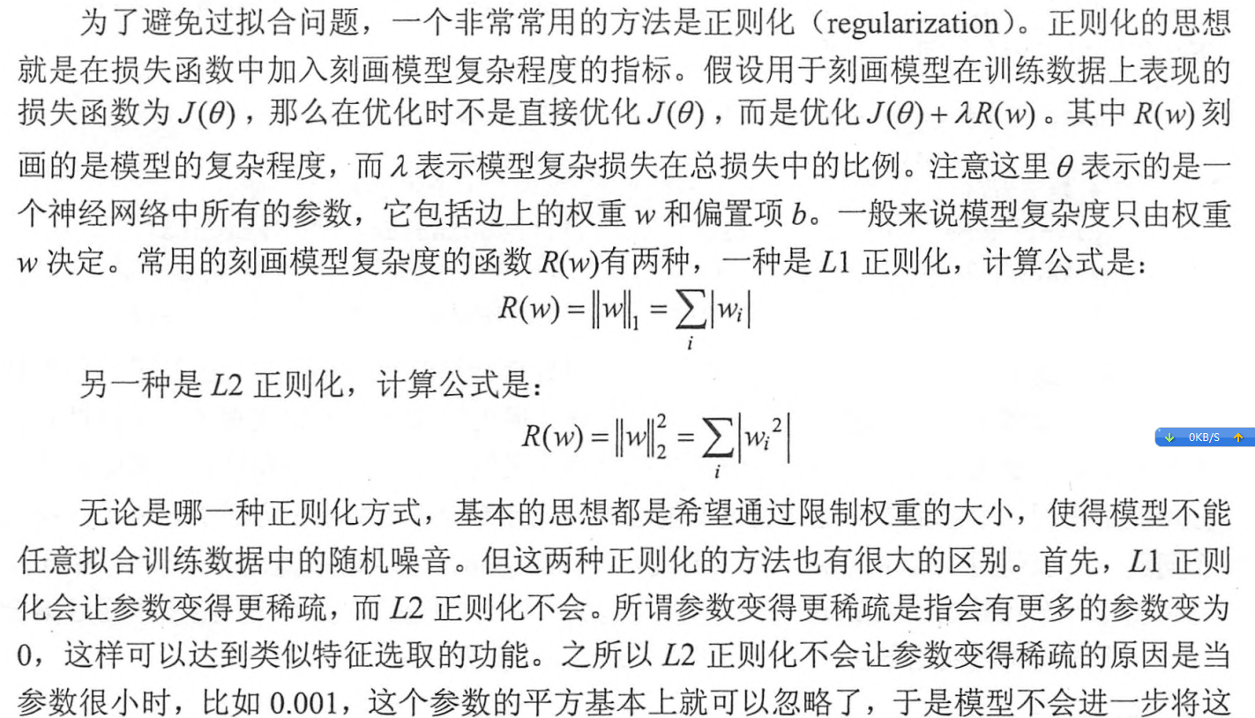
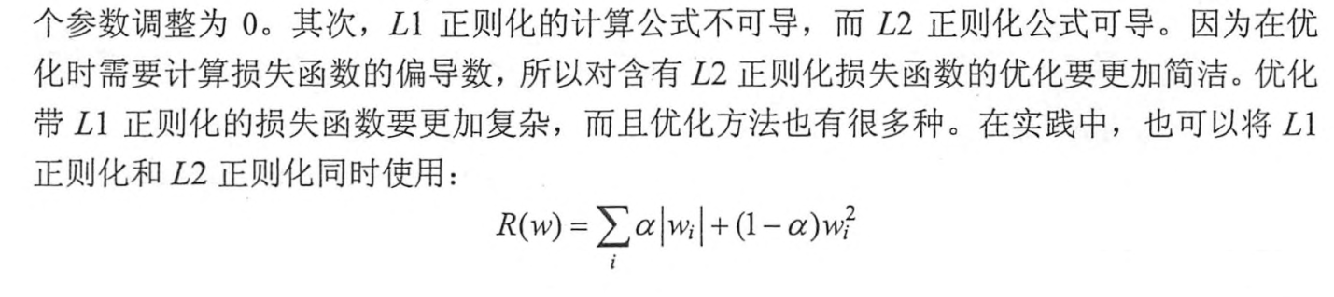

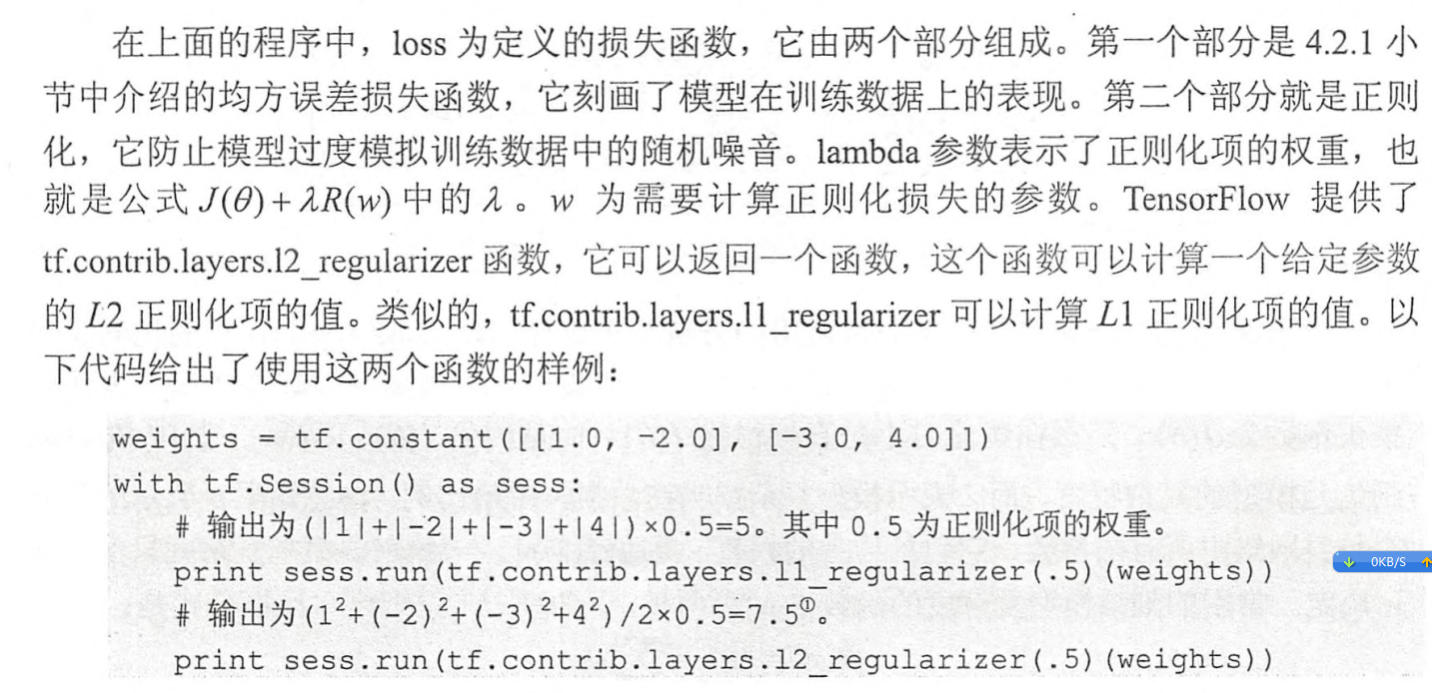
- 滑动平均模型
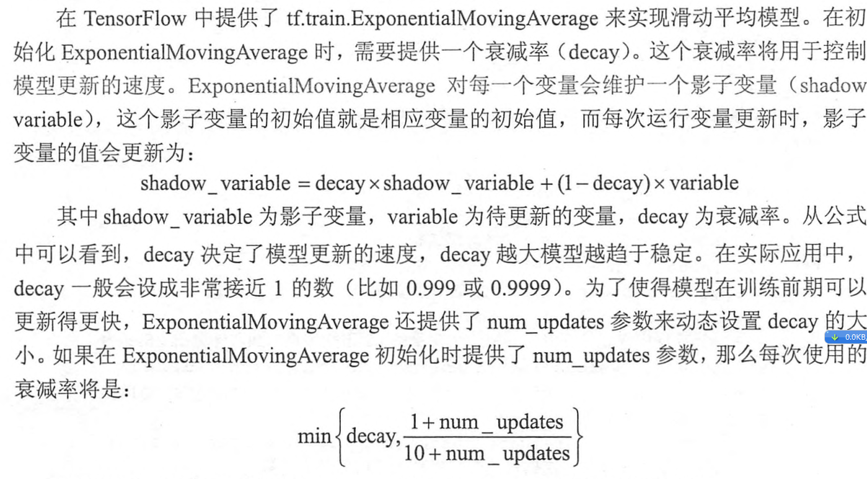
- import tensorflow as tf;
- import numpy as np;
- import matplotlib.pyplot as plt;

- v1 = tf.Variable(0, dtype=tf.float32)
- step = tf.Variable(tf.constant(0))

- ema = tf.train.ExponentialMovingAverage(0.99, step)
- maintain_average = ema.apply([v1])

- with tf.Session() as sess:
- init = tf.initialize_all_variables()
- sess.run(init)

- print sess.run([v1, ema.average(v1)]) #初始的值都为0

- sess.run(tf.assign(v1, 5)) #把v1变为5
- sess.run(maintain_average)
- print sess.run([v1, ema.average(v1)]) # decay=min(0.99, 1/10)=0.1, v1=0.1*0+0.9*5=4.5

- sess.run(tf.assign(step, 10000)) # steps=10000
- sess.run(tf.assign(v1, 10)) # v1=10
- sess.run(maintain_average)
- print sess.run([v1, ema.average(v1)]) # decay=min(0.99,(1+10000)/(10+10000))=0.99, v1=0.99*4.5+0.01*10=4.555

- sess.run(maintain_average)
- print sess.run([v1, ema.average(v1)]) #decay=min(0.99,(1+10000)/(10+10000))=0.99, v1=0.99*4.555+0.01*10=4.6

