Network Intrusion Detection Using Classification and Clustering Techniques on the CICIDS2017 Dataset
Miloš Milić (SV10/2022), Mirko Đukić (SV32/2022)

1. Motivation
As computer networks continue to grow, the amount of traffic they generate increases significantly. Because of this, manually detecting malicious activity becomes difficult and time-consuming. Machine learning offers a way to automate this process by identifying patterns in network traffic that may indicate different types of cyberattacks.
The goal of this project is to evaluate how well machine learning techniques can detect malicious network traffic and to investigate whether different attack types can be grouped together using clustering methods.

2. Research Questions
- How accurately can machine learning models distinguish normal network traffic from malicious traffic?
- Which network traffic features are the most useful for detecting attacks?
- Can clustering algorithms identify meaningful groups of network traffic that correspond to different attack types?
Experiments were performed using the CICIDS2017 dataset, which contains about 2.8 million network flow records and more than 80 features describing network behavior, some of which are: flow duration, packet statistics, byte counts, protocol information, traffic behavior metrics. Each record is labeled as either normal traffic (BENIGN) or as one of several attack categories such as DDoS, DoS, PortScan, Botnet, Brute Force, and Web Attacks. Due to the size of the dataset, a 10% stratified sample was used to reduce computational load.
The dataset used for this project contains 198770 network flow records described by 78 features, of which, 54 are integer-valued and 24 are floating-point, alongside the categorical label column. Only 392 duplicate rows were found, about 0.002% of the data, and no missing values were present, so minimal cleaning was required beyond removing the duplicates.

3. Related Work
Network intrusion detection has been widely studied. Traditional intrusion detection systems are often based on predefined signatures and rules. While effective against known attacks, they struggle with new or previously unseen threats. Former studies have shown that models such as Random Forest, SVMs, neural networks, and gradient boosting can achieve strong results on intrusion detection tasks, and CICIDS2017 has been frequently used for evaluating such approaches. Unsupervised techniques such as K-Means, DBSCAN, and Gaussian Mixture Models have been used to detect anomalies and discover hidden patterns in network traffic. Recent work has also identified data quality issues in CICIDS2017 itself, including duplicate flows, packet misordering, and labeling errors that can artificially inflate reported detection performance if not accounted for.

4. Methodology
The project began with exploratory data analysis to understand the dataset. We examined class distribution, missing values, feature correlations, and possible outliers. Preprocessing involved: standardizing the label column, replacing infinite values with NaN, removing duplicate and incomplete rows, removing zero-variance and near-zero-variance features, scaling all remaining features with a StandardScaler, and balancing classes using undersampling or SMOTE.
For the supervised learning part, three classification models were trained and compared: Logistic Regression (as a baseline), Random Forest, and XGBoost. All models were trained and evaluated on the same stratified train/test split, and feature importance analysis was performed on the best-performing model to determine which features contribute most to attack detection.
For the unsupervised learning part, network traffic records were clustered using K-Means, DBSCAN, and Gaussian Mixture Models. PCA was used to project the scaled feature space onto two components only for visualization. Clustering itself was performed on the full feature space. The resulting clusters were then compared against the true attack labels to determine whether different attack types form distinct groups within the data.

5. Discussion
The dataset was divided into training and testing sets using stratified sampling to preserve class distributions. Hyperparameter tuning was performed using Randomized/Grid Search combined with cross-validation, optimizing for weighted F1-score.
Classification models were evaluated using Accuracy, Precision, Recall, F1-score, and ROC-AUC, with confusion matrices used to analyze common classification mistakes and identify attack categories that are difficult to distinguish from one another.
Model | Accuracy | Precision | Recall | F1-score | ROC-AUC
LogisticRegression | 0.9595 | 0.9523 | 0.9595 | 0.9543 | 0.9969
RandomForest | 0.9945 | 0.9940 | 0.9945 | 0.9939 | 0.9999
XGBoost | 0.9949 | 0.9947 | 0.9949 | 0.9947 | 0.9999

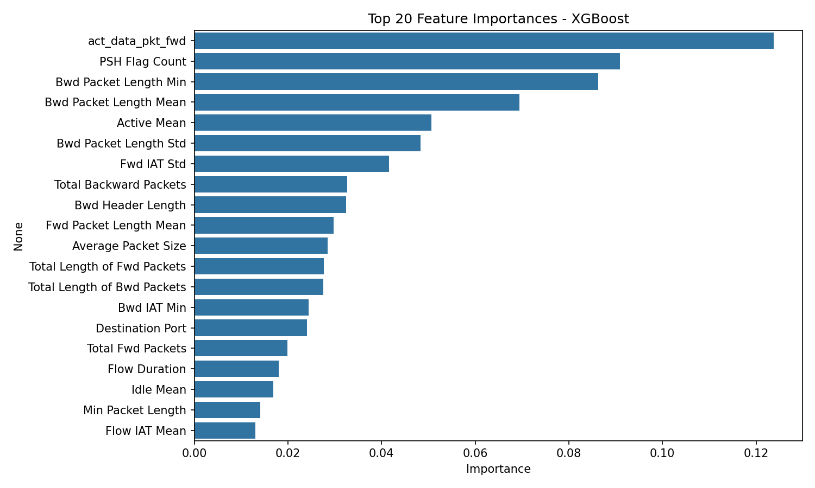
Clustering models were evaluated using the Silhouette Score, Davies-Bouldin Index, and Adjusted Rand Index (ARI), the last of which compares cluster assignments against the true attack labels.
Algorithm | Silhouette | Davies-Bouldin | ARI
K-Means | 0.3229 | 1.0745 | 0.1973
DBSCAN | 0.3959 | 0.4989 | -0.0014
GMM | 0.1227 | 1.5317 | 0.2534
The three classification models performed well, with a gap between the linear baseline and the tree-based ensembles. XGBoost being ahead of other metrics suggests attack traffic is not fully linearly separable from normal traffic. High aggregate scores should still be taken with a grain of salt since weighted metrics can mask weaker performance on rare attack types.

Comparing cluster assignments to the true attack labels shows DBSCAN failed to find meaningful structure, pushing nearly all traffic into a single dominant cluster, with 13 tiny clusters. K-Means and GMM performed better, isolating a primarily DoS Hulk cluster and grouping brute-force and scanning attacks together, suggesting these share similar characteristics, while DoS subtypes overlapped heavily with each other and regular traffic. Rare classes like Web Attacks and Infiltration never formed their own cluster, instead being shared across BENIGN-dominated clusters, showing these cases being hard to predict.

6. References
- Sharafaldin, I., Lashkari, A. H., & Ghorbani, A. A. (2018). Toward Generating a New Intrusion Detection Dataset and Intrusion Traffic Characterization.
- Canadian Institute for Cybersecurity. CICIDS2017 Dataset.
- Engelen, G., Rimmer, V., & Joosen, W. (2021). Troubleshooting an Intrusion Detection Dataset: the CICIDS2017 Case Study.
- Lanvin, M., Gimenez, P. F., Han, Y., Majorczyk, F., Mé, L., & Totel, É. (2023). Errors in the CICIDS2017 Dataset and the Significant Differences in Detection Performances It Makes.
- scikit-learn (LogisticRegression, RandomForest, KMeans, DBSCAN, GMM, PCA, StandardScaler, metrike, itd.) — https://scikit-learn.org/stable/
- XGBoost — https://xgboost.readthedocs.io/en/stable/
- imbalanced-learn (RandomUnderSampler, SMOTE) — https://imbalanced-learn.org/stable/
- pandas — https://pandas.pydata.org/docs/
- NumPy — https://numpy.org/doc/stable/
- Matplotlib — https://matplotlib.org/stable/
- Seaborn — https://seaborn.pydata.org/

