Table 1: Descriptive statistics after stratification by patient demographics in the cohort with completely available eating behavior data (n = 1052). Data is presented as N (%) for continuous and mean (SD) for categorical variables. P-values were calculated using Welch’s t-test for continuous variables; Chi-squared test for categorical variables; and Fisher’s exact test for categorical variables with a low expected variance count.
Variable | Whole population | Age < Median [47.00] | Age ≥ Median [47.00] | Age: p-value | Females | Males | Gender:  p-value | BMI < 30 | BMI ≥ 30 | BMI: p-value
N | 1052 | 495 | 557 | N/A | 860 | 192 | N/A | 497 | 555 | N/A
Demographics and baseline anthropometry
Sex (% of females) | 860 (81.7%) | 408 (82.4%) | 452 (81.1%) | 0.649457595 | 860 (100.0%) | 0 (0.0%) | 2.51E-216 | 432 (86.9%) | 428 (77.1%) | 5.57E-05
Age (years) | 46.83 ± 10.41 | 38.10 ± 6.57 | 54.59 ± 6.20 | 1.14E-222 | 46.83 ± 10.39 | 46.83 ± 10.54 | 0.999102209 | 46.42 ± 10.29 | 47.20 ± 10.52 | 0.226082891
Baseline weight (kg) | 83.16 ± 12.16 | 84.13 ± 11.83 | 82.30 ± 12.39 | 0.014317673 | 79.51 ± 8.65 | 99.53 ± 12.14 | 5.11E-58 | 75.64 ± 8.27 | 89.90 ± 11.09 | 5.26E-100
Baseline BMI (kg/m²) | 30.23 ± 3.00 | 30.09 ± 2.95 | 30.35 ± 3.04 | 0.162889982 | 29.87 ± 2.74 | 31.85 ± 3.53 | 4.41E-12 | 27.57 ± 1.39 | 32.61 ± 1.82 | 1.59E-282
Baseline fat mass (%) | 40.96 ± 5.84 | 40.66 ± 6.04 | 41.21 ± 5.66 | 0.128662897 | 42.00 ± 5.02 | 36.30 ± 6.91 | 1.97E-22 | 36.53 ± 4.06 | 44.92 ± 4.10 | 3.43E-166
Baseline muscle mass (%) | 29.57 ± 3.95 | 31.11 ± 3.78 | 28.21 ± 3.58 | 1.20E-34 | 29.01 ± 3.44 | 32.11 ± 4.97 | 1.61E-14 | 32.20 ± 3.18 | 27.22 ± 2.97 | 8.57E-116
Treatment outcomes
Follow-up length (days) | 80.74 ± 75.46 | 69.40 ± 66.66 | 90.81 ± 81.24 | 3.08E-06 | 84.08 ± 78.11 | 65.78 ± 60.21 | 0.000376379 | 74.24 ± 69.58 | 86.55 ± 79.99 | 0.007712025
Number of visits | 4.46 ± 3.66 | 3.82 ± 3.09 | 5.02 ± 4.03 | 6.26E-08 | 4.60 ± 3.85 | 3.83 ± 2.57 | 0.000869006 | 3.97 ± 3.07 | 4.89 ± 4.08 | 3.47E-05
Number of total measurements | 16.43 ± 19.61 | 14.38 ± 14.49 | 18.25 ± 23.09 | 0.001036965 | 15.99 ± 18.49 | 18.42 ± 23.94 | 0.187998643 | 15.46 ± 16.16 | 17.30 ± 22.22 | 0.121505622
Average measurement frequency (days) | 7.04 ± 5.45 | 6.71 ± 5.28 | 7.34 ± 5.59 | 0.069976079 | 7.45 ± 5.66 | 5.22 ± 3.86 | 5.44E-10 | 6.43 ± 4.48 | 7.59 ± 6.15 | 0.000648446
Total weight loss (%) | -9.16 ± 6.34 | -8.71 ± 6.08 | -9.55 ± 6.53 | 0.031105969 | -9.09 ± 6.47 | -9.44 ± 5.73 | 0.456628198 | -8.84 ± 5.61 | -9.44 ± 6.92 | 0.118251552
BMI reduction (kg/m²) | -2.78 ± 2.01 | -2.61 ± 1.88 | -2.93 ± 2.11 | 0.011322279 | -2.72 ± 2.01 | -3.06 ± 1.99 | 0.032129871 | -2.44 ± 1.58 | -3.09 ± 2.29 | 7.58E-08
Total fat mass loss (%) | -5.20 ± 3.79 | -4.97 ± 3.62 | -5.40 ± 3.93 | 0.065029285 | -5.04 ± 3.74 | -5.91 ± 3.95 | 0.005516708 | -4.59 ± 3.02 | -5.75 ± 4.30 | 4.42E-07
Total muscle mass change (%) | 2.97 ± 2.25 | 2.84 ± 2.15 | 3.09 ± 2.33 | 0.067601672 | 2.82 ± 2.14 | 3.67 ± 2.58 | 3.27E-05 | 2.60 ± 1.78 | 3.31 ± 2.56 | 1.26E-07
Instant dropouts (n) | 55 (5.2%) | 27 (5.5%) | 28 (5.0%) | 0.863240149 | 43 (5.0%) | 12 (6.2%) | 0.600107185 | 23 (4.6%) | 32 (5.8%) | 0.490748938
40-day dropouts (n) | 341 (32.4%) | 180 (36.4%) | 161 (28.9%) | 0.011941657 | 270 (31.4%) | 71 (37.0%) | 0.158734755 | 169 (34.0%) | 172 (31.0%) | 0.328864009
40-day weight loss (%) | -8.27 ± 3.03 | -8.53 ± 3.01 | -8.07 ± 3.03 | 0.04368913 | -7.95 ± 2.85 | -9.86 ± 3.37 | 3.22E-08 | -8.59 ± 2.66 | -7.99 ± 3.29 | 0.007526595
40-day fat mass loss (%) | -4.73 ± 1.91 | -4.92 ± 1.87 | -4.57 ± 1.94 | 0.015004943 | -4.42 ± 1.66 | -6.25 ± 2.32 | 7.52E-14 | -4.51 ± 1.52 | -4.92 ± 2.18 | 0.003526355
40-day muscle mass change (%) | 2.74 ± 1.28 | 2.86 ± 1.28 | 2.65 ± 1.27 | 0.030753362 | 2.50 ± 1.03 | 3.89 ± 1.69 | 7.34E-15 | 2.58 ± 1.06 | 2.88 ± 1.43 | 0.00151767
60-day dropouts (n) | 510 (48.5%) | 281 (56.8%) | 229 (41.1%) | 5.47E-07 | 409 (47.6%) | 101 (52.6%) | 0.235981312 | 257 (51.7%) | 253 (45.6%) | 0.054527449
60-day weight loss (%) | -10.55 ± 3.62 | -10.86 ± 3.78 | -10.34 ± 3.51 | 0.113135307 | -10.22 ± 3.55 | -12.17 ± 3.58 | 5.77E-06 | -10.77 ± 3.20 | -10.37 ± 3.92 | 0.196640176
60-day fat mass loss (%) | -5.98 ± 2.28 | -6.20 ± 2.34 | -5.83 ± 2.23 | 0.068907315 | -5.64 ± 2.07 | -7.64 ± 2.51 | 9.85E-11 | -5.57 ± 1.84 | -6.31 ± 2.53 | 9.18E-05
60-day muscle mass change (%) | 3.46 ± 1.45 | 3.58 ± 1.47 | 3.38 ± 1.43 | 0.117541618 | 3.19 ± 1.25 | 4.79 ± 1.62 | 9.37E-15 | 3.19 ± 1.14 | 3.67 ± 1.62 | 6.45E-05
80-day dropouts (n) | 640 (60.8%) | 345 (69.7%) | 295 (53.0%) | 4.09E-08 | 506 (58.8%) | 134 (69.8%) | 0.006335756 | 318 (64.0%) | 322 (58.0%) | 0.055384831
80-day weight loss (%) | -12.19 ± 3.87 | -12.35 ± 4.26 | -12.10 ± 3.63 | 0.547132585 | -11.98 ± 3.80 | -13.48 ± 4.09 | 0.011073786 | -12.16 ± 3.51 | -12.22 ± 4.14 | 0.882555151
80-day fat mass loss (%) | -6.95 ± 2.44 | -7.05 ± 2.63 | -6.90 ± 2.33 | 0.570709145 | -6.67 ± 2.23 | -8.66 ± 2.93 | 5.26E-06 | -6.29 ± 1.96 | -7.46 ± 2.65 | 4.14E-07
80-day muscle mass change (%) | 4.00 ± 1.55 | 4.02 ± 1.63 | 3.98 ± 1.50 | 0.795303282 | 3.76 ± 1.34 | 5.45 ± 1.88 | 7.98E-09 | 3.56 ± 1.20 | 4.34 ± 1.69 | 8.46E-08
Achieved 5% weight loss (n) | 774 (73.6%) | 359 (72.5%) | 415 (74.5%) | 0.510991624 | 626 (72.8%) | 148 (77.1%) | 0.258834848 | 380 (76.5%) | 394 (71.0%) | 0.052634885
Days to 5% weight loss | 21.29 ± 13.53 | 20.14 ± 14.07 | 22.29 ± 12.99 | 0.028540938 | 22.39 ± 13.92 | 16.66 ± 10.62 | 7.32E-08 | 18.69 ± 11.82 | 23.80 ± 14.58 | 1.08E-07
Achieved 10% weight loss (n) | 489 (46.5%) | 205 (41.4%) | 284 (51.0%) | 0.002323475 | 395 (45.9%) | 94 (49.0%) | 0.496121217 | 219 (44.1%) | 270 (48.6%) | 0.153752902
Days to 10% weight loss | 52.20 ± 25.06 | 49.48 ± 25.19 | 54.17 ± 24.82 | 0.041377436 | 55.29 ± 26.01 | 39.24 ± 14.83 | 5.83E-14 | 49.58 ± 25.44 | 54.33 ± 24.59 | 0.037909189
Achieved 15% weight loss (n) | 211 (20.1%) | 80 (16.2%) | 131 (23.5%) | 0.003763101 | 169 (19.7%) | 42 (21.9%) | 0.551100722 | 80 (16.1%) | 131 (23.6%) | 0.003090373
Days to 15% weight loss | 85.85 ± 34.03 | 78.42 ± 28.69 | 90.38 ± 36.27 | 0.008662683 | 89.53 ± 32.51 | 71.05 ± 36.33 | 0.003850195 | 83.24 ± 30.20 | 87.44 ± 36.18 | 0.364452114
Self-reported eating behavior
Hunger (yes/no) | 679 (64.5%) | 319 (64.4%) | 360 (64.6%) | 1 | 556 (64.7%) | 123 (64.1%) | 0.943606 | 308 (62.0%) | 371 (66.8%) | 0.112833
Satiety (yes/no) | 653 (62.1%) | 310 (62.6%) | 343 (61.6%) | 0.775283028 | 545 (63.4%) | 108 (56.2%) | 0.078968 | 316 (63.6%) | 337 (60.7%) | 0.37289
Emotional eating (yes/no) | 817 (77.7%) | 395 (79.8%) | 422 (75.8%) | 0.135133355 | 671 (78.0%) | 146 (76.0%) | 0.616918 | 370 (74.4%) | 447 (80.5%) | 0.021736
Emotional eating score (1-10) | 6.82 ± 2.44 | 6.92 ± 2.46 | 6.74 ± 2.43 | 0.235500217 | 6.92 ± 2.42 | 6.38 ± 2.51 | 0.00634 | 6.61 ± 2.47 | 7.01 ± 2.40 | 0.008858
Quantity control score (1-10) | 5.75 ± 2.52 | 5.84 ± 2.47 | 5.68 ± 2.57 | 0.309899286 | 5.66 ± 2.52 | 6.17 ± 2.50 | 0.01215 | 5.62 ± 2.50 | 5.88 ± 2.54 | 0.095216
Impulse control score (1-10) | 5.98 ± 2.46 | 6.03 ± 2.44 | 5.94 ± 2.48 | 0.549780215 | 5.98 ± 2.44 | 5.95 ± 2.55 | 0.85481 | 5.98 ± 2.46 | 5.98 ± 2.47 | 0.977308

Table 2: Descriptive statistics after stratifying by weight-associated eating behaviors in the cohort with completely available eating behavior data (n = 1052). Data is presented as N (%) for continuous and mean (SD) for categorical variables. P-values were calculated using Welch’s t-test for continuous variables; Chi-squared test for categorical variables; and Fisher’s exact test for categorical variables with a low expected variance count.
Variable | Emotional eating: No | Emotional eating: Yes | Emotional eating: p-value | Emotional eating score < Median [7.00] | Emotional eating score ≥ Median [7.00] | Emotional eating score: p-value | Quantity control score < Median [6.00] | Quantity control score ≥ Median [6.00] | Quantity control score: p-value
N | 235 | 817 | N/A | 400 | 652 | N/A | 479 | 573 | N/A
Demographics and baseline anthropometry
Sex (% of females) | 189 (80.4%) | 671 (82.1%) | 0.616918108 | 310 (77.5%) | 550 (84.4%) | 0.006679781 | 403 (84.1%) | 457 (79.8%) | 0.080017568
Age (years) | 47.52 ± 10.43 | 46.63 ± 10.41 | 0.247112914 | 47.59 ± 10.48 | 46.36 ± 10.35 | 0.063288542 | 47.34 ± 10.47 | 46.40 ± 10.36 | 0.144168739
Height (m) | 1.66 ± 0.09 | 1.66 ± 0.08 | 0.6799715 | 1.66 ± 0.08 | 1.65 ± 0.08 | 0.222484501 | 1.65 ± 0.08 | 1.66 ± 0.08 | 0.047942306
Baseline weight (kg) | 81.68 ± 12.53 | 83.59 ± 12.02 | 0.038795976 | 82.59 ± 12.37 | 83.52 ± 12.02 | 0.23285029 | 81.91 ± 11.22 | 84.21 ± 12.81 | 0.001993376
Baseline BMI (kg/m²) | 29.62 ± 2.99 | 30.41 ± 2.98 | 0.000422065 | 29.89 ± 3.15 | 30.44 ± 2.88 | 0.005001734 | 29.99 ± 2.97 | 30.43 ± 3.01 | 0.01829998
Baseline fat mass (%) | 39.74 ± 5.92 | 41.31 ± 5.78 | 0.000364212 | 39.90 ± 6.08 | 41.60 ± 5.60 | 6.35E-06 | 40.71 ± 5.92 | 41.16 ± 5.78 | 0.222271532
Baseline muscle mass (%) | 30.16 ± 4.05 | 29.41 ± 3.91 | 0.011358256 | 30.06 ± 4.18 | 29.28 ± 3.78 | 0.002292771 | 29.65 ± 3.99 | 29.51 ± 3.92 | 0.579728942
Treatment outcomes
Follow-up length (days) | 79.51 ± 65.85 | 81.09 ± 78.05 | 0.757027166 | 84.72 ± 81.24 | 78.30 ± 71.65 | 0.193849905 | 82.75 ± 78.14 | 79.05 ± 73.18 | 0.431419675
Number of visits | 4.06 ± 2.56 | 4.57 ± 3.92 | 0.019406457 | 4.40 ± 3.53 | 4.49 ± 3.75 | 0.674567031 | 4.42 ± 3.69 | 4.49 ± 3.65 | 0.761282776
Number of total measurements | 16.41 ± 17.24 | 16.44 ± 20.25 | 0.982194085 | 17.50 ± 19.82 | 15.78 ± 19.47 | 0.16829768 | 16.77 ± 19.82 | 16.14 ± 19.44 | 0.604838556
Average measurement frequency (days) | 6.75 ± 4.54 | 7.13 ± 5.69 | 0.307422895 | 6.85 ± 5.07 | 7.16 ± 5.68 | 0.377853861 | 6.93 ± 4.83 | 7.14 ± 5.93 | 0.529814815
Total weight loss (%) | -9.73 ± 5.98 | -8.99 ± 6.43 | 0.104854578 | -9.54 ± 6.09 | -8.92 ± 6.48 | 0.119759063 | -9.28 ± 6.46 | -9.05 ± 6.23 | 0.553522111
BMI reduction (kg/m²) | -2.89 ± 1.85 | -2.75 ± 2.06 | 0.319557007 | -2.87 ± 1.93 | -2.72 ± 2.06 | 0.249858241 | -2.80 ± 2.08 | -2.76 ± 1.96 | 0.723566014
Total fat mass loss (%) | -5.41 ± 3.53 | -5.14 ± 3.87 | 0.312015999 | -5.36 ± 3.59 | -5.11 ± 3.91 | 0.290726453 | -5.23 ± 3.88 | -5.17 ± 3.72 | 0.795576898
Total muscle mass change (%) | 3.08 ± 2.15 | 2.94 ± 2.28 | 0.389132409 | 3.07 ± 2.16 | 2.91 ± 2.31 | 0.27073758 | 2.98 ± 2.31 | 2.97 ± 2.20 | 0.891783524
Instant dropouts (n) | 11 (4.7%) | 44 (5.4%) | 0.793768317 | 18 (4.5%) | 37 (5.7%) | 0.491224965 | 23 (4.8%) | 32 (5.6%) | 0.66785485
40-day dropouts (n) | 66 (28.1%) | 275 (33.7%) | 0.126034811 | 120 (30.0%) | 221 (33.9%) | 0.213996937 | 145 (30.3%) | 196 (34.2%) | 0.196475029
40-day weight loss (%) | -8.55 ± 2.84 | -8.19 ± 3.08 | 0.158951028 | -8.66 ± 2.97 | -8.02 ± 3.05 | 0.005952465 | -8.26 ± 3.05 | -8.28 ± 3.01 | 0.9488828
40-day fat mass loss (%) | -4.72 ± 1.77 | -4.73 ± 1.96 | 0.960614803 | -4.88 ± 1.87 | -4.63 ± 1.94 | 0.091122491 | -4.69 ± 1.91 | -4.76 ± 1.92 | 0.636047228
40-day muscle mass change (%) | 2.69 ± 1.31 | 2.75 ± 1.27 | 0.606529612 | 2.82 ± 1.32 | 2.69 ± 1.26 | 0.178046042 | 2.71 ± 1.32 | 2.77 ± 1.25 | 0.53302661
60-day dropouts (n) | 100 (42.6%) | 410 (50.2%) | 0.046751212 | 173 (43.2%) | 337 (51.7%) | 0.009471296 | 226 (47.2%) | 284 (49.6%) | 0.47898192
60-day weight loss (%) | -10.66 ± 3.45 | -10.51 ± 3.68 | 0.675661596 | -10.74 ± 3.49 | -10.41 ± 3.72 | 0.292476853 | -10.48 ± 3.54 | -10.61 ± 3.70 | 0.679582186
60-day fat mass loss (%) | -5.86 ± 2.19 | -6.02 ± 2.30 | 0.484281815 | -6.01 ± 2.23 | -5.96 ± 2.31 | 0.794419024 | -5.88 ± 2.23 | -6.06 ± 2.32 | 0.355140094
60-day muscle mass change (%) | 3.38 ± 1.41 | 3.49 ± 1.46 | 0.432438569 | 3.51 ± 1.43 | 3.43 ± 1.46 | 0.54746668 | 3.40 ± 1.41 | 3.51 ± 1.48 | 0.388368898
80-day dropouts (n) | 133 (56.6%) | 507 (62.1%) | 0.15115103 | 230 (57.5%) | 410 (62.9%) | 0.094628264 | 294 (61.4%) | 346 (60.4%) | 0.790635142
80-day weight loss (%) | -12.56 ± 3.87 | -12.07 ± 3.87 | 0.270769035 | -12.25 ± 3.84 | -12.16 ± 3.90 | 0.818294422 | -12.41 ± 3.54 | -12.02 ± 4.12 | 0.305174286
80-day fat mass loss (%) | -6.94 ± 2.53 | -6.96 ± 2.42 | 0.953978568 | -6.85 ± 2.38 | -7.02 ± 2.49 | 0.466243156 | -7.02 ± 2.30 | -6.89 ± 2.56 | 0.595625165
80-day muscle mass change (%) | 3.99 ± 1.62 | 4.00 ± 1.52 | 0.950277862 | 3.94 ± 1.51 | 4.04 ± 1.57 | 0.542246228 | 4.03 ± 1.47 | 3.97 ± 1.61 | 0.707825199
Achieved 5% weight loss (n) | 187 (79.6%) | 587 (71.8%) | 0.02241704 | 312 (78.0%) | 462 (70.9%) | 0.013214126 | 351 (73.3%) | 423 (73.8%) | 0.897203453
Days to 5% weight loss | 20.27 ± 13.75 | 21.62 ± 13.46 | 0.239753901 | 20.65 ± 13.71 | 21.73 ± 13.41 | 0.282366084 | 20.93 ± 13.18 | 21.59 ± 13.83 | 0.496648312
Achieved 10% weight loss (n) | 120 (51.1%) | 369 (45.2%) | 0.127637725 | 204 (51.0%) | 285 (43.7%) | 0.02527677 | 229 (47.8%) | 260 (45.4%) | 0.467978869
Days to 10% weight loss | 48.58 ± 20.70 | 53.38 ± 26.24 | 0.040593605 | 49.43 ± 22.92 | 54.19 ± 26.35 | 0.034063237 | 51.38 ± 23.33 | 52.93 ± 26.52 | 0.489476717
Achieved 15% weight loss (n) | 41 (17.4%) | 170 (20.8%) | 0.29764429 | 72 (18.0%) | 139 (21.3%) | 0.220289055 | 89 (18.6%) | 122 (21.3%) | 0.309493416
Days to 15% weight loss | 86.83 ± 34.43 | 85.61 ± 34.03 | 0.839280545 | 82.29 ± 33.43 | 87.69 ± 34.31 | 0.272134868 | 85.04 ± 31.73 | 86.43 ± 35.73 | 0.766197983
Self-reported eating behavior
Hunger (yes/no) | 115 (48.9%) | 564 (69.0%) | 2.17E-08 | 236 (59.0%) | 443 (67.9%) | 0.004006515 | 293 (61.2%) | 386 (67.4%) | 0.042638263
Satiety (yes/no) | 151 (64.3%) | 502 (61.4%) | 0.479952252 | 262 (65.5%) | 391 (60.0%) | 0.0837604 | 295 (61.6%) | 358 (62.5%) | 0.815765069
Emotional eating (yes/no) | 0 (0.0%) | 817 (100.0%) | 7.17E-242 | 194 (48.5%) | 623 (95.6%) | 3.48E-70 | 325 (67.8%) | 492 (85.9%) | 4.79E-12
Emotional eating score (1-10) | 4.16 ± 2.14 | 7.59 ± 1.94 | 1.04E-68 | 4.22 ± 1.69 | 8.42 ± 1.10 | 9.66E-193 | 6.03 ± 2.65 | 7.49 ± 2.04 | 5.47E-22
Quantity control score (1-10) | 4.76 ± 2.21 | 6.04 ± 2.54 | 2.42E-13 | 4.75 ± 2.16 | 6.37 ± 2.53 | 6.38E-27 | 3.47 ± 1.59 | 7.66 ± 1.25 | 4.38E-244
Impulse control score (1-10) | 5.09 ± 2.21 | 6.23 ± 2.47 | 4.54E-11 | 5.04 ± 2.09 | 6.56 ± 2.50 | 5.90E-25 | 4.71 ± 2.31 | 7.04 ± 2.04 | 4.74E-58

Tables 3A-B: Logistic regressions predicting the probabilities of achieving 10% weight loss or dropping out in the first 60 days of the intervention by emotional eating (yes/no), emotional eating score (1-10) and quantity control score (1-10) with and without adjusting for age, sex and baseline BMI.

Dependent variable | Independent variables | Coefficient | OR (95% CI) | p-value
Probability of achieving  10% weight loss in 60 days | Unadjusted outcome predictions by emotional eating (yes/no)
 | Constant | -0.162055859 | 0.850 (0.658-1.099) | 0.215690799
 | Emotional eating (yes/no) | -0.429922086 | 0.651 (0.485-0.873) | 0.004130674
 | Adjusted outcome predictions by emotional eating (yes/no)
 | Constant | -0.058328849 | 0.943 (0.214-4.166) | 0.938651131
 | Emotional eating (yes/no) | -0.428783955 | 0.651 (0.484-0.877) | 0.004703511
 | Age (years) | 0.001362188 | 1.001 (0.989-1.014) | 0.82521
 | Sex (female) | -0.411231663 | 0.663 (0.477-0.921) | 0.014256088
 | Baseline BMI (kg/m²) | 0.00545991 | 1.005 (0.963-1.050) | 0.805865502
 | Unadjusted outcome predictions by emotional eating score (1-10)
 | Constant | -0.064292873 | 0.938 (0.652-1.350) | 0.729277849
 | Emotional eating score (1-10) | -0.063177124 | 0.939 (0.892-0.988) | 0.01467418
 | Adjusted outcome predictions by emotional eating score (1-10)
 | Constant | 0.00959535 | 1.010 (0.228-4.475) | 0.989922388
 | Emotional eating score (1-10) | -0.058511629 | 0.943 (0.896-0.993) | 0.02617756
 | Age (years) | 0.001526772 | 1.002 (0.990-1.014) | 0.80431111
 | Sex (female) | -0.388240739 | 0.678 (0.488-0.944) | 0.0211837
 | Baseline BMI (kg/m²) | 0.004558655 | 1.005 (0.962-1.049) | 0.837407037
 | Unadjusted outcome predictions by quantity control score (1-10)
 | Constant | -0.227430328 | 0.797 (0.586-1.083) | 0.146677644
 | Quantity control score (1-10) | -0.046361281 | 0.955 (0.909-1.003) | 0.065627896
 | Adjusted outcome predictions by quantity control score (1-10)
 | Constant | 0.070288267 | 1.073 (0.240-4.805) | 0.926789914
 | Quantity control score (1-10) | -0.052140993 | 0.949 (0.903-0.998) | 0.040189561
 | Age (years) | 0.001876657 | 1.002 (0.990-1.014) | 0.760229207
 | Sex (female) | -0.454366246 | 0.635 (0.457-0.882) | 0.00675777
 | Baseline BMI (kg/m²) | 0.000525452 | 1.001 (0.958-1.045) | 0.980986961

Dependent variable | Independent variables | Coefficient | OR (95% CI) | p-value
Probability of dropping out  in 60 days | Unadjusted dropout predictions by emotional eating (yes/no)
 | Constant | -0.300104592 | 0.741 (0.572-0.959) | 0.02292976
 | Emotional eating (yes/no) | 0.307448567 | 1.360 (1.015-1.822) | 0.039525923
 | Adjusted dropout predictions by emotional eating (yes/no)
 | Constant | 2.409433218 | 11.128 (2.560-48.362) | 0.001308569
 | Emotional eating (yes/no) | 0.333330895 | 1.396 (1.035-1.881) | 0.028620322
 | Age (years) | -0.023932846 | 0.976 (0.965-0.988) | 8.85296E-05
 | Sex (female) | -0.302779459 | 0.739 (0.531-1.027) | 0.071653324
 | Baseline BMI (kg/m²) | -0.045068894 | 0.956 (0.916-0.998) | 0.038738938
 | Unadjusted dropout predictions by emotional eating score (1-10)
 | Constant | -0.374183927 | 0.688 (0.479-0.987) | 0.042286912
 | Emotional eating score (1-10) | 0.045887692 | 1.047 (0.996-1.100) | 0.070771089
 | Adjusted dropout predictions by emotional eating score (1-10)
 | Constant | 2.330732574 | 10.285 (2.355-44.915) | 0.001941289
 | Emotional eating score (1-10) | 0.053689166 | 1.055 (1.003-1.110) | 0.039431032
 | Age (years) | -0.023921421 | 0.976 (0.965-0.988) | 8.75564E-05
 | Sex (female) | -0.325803408 | 0.722 (0.518-1.006) | 0.053975718
 | Baseline BMI (kg/m²) | -0.04541041 | 0.956 (0.916-0.997) | 0.037729941
 | Unadjusted dropout predictions by quantity control score (1-10)
 | Constant | -0.320470935 | 0.726 (0.536-0.983) | 0.03812058
 | Quantity control score (1-10) | 0.045072482 | 1.046 (0.997-1.098) | 0.066570055
 | Adjusted dropout predictions by quantity control score (1-10)
 | Constant | 2.284849969 | 9.824 (2.232-43.251) | 0.00251617
 | Quantity control score (1-10) | 0.044918753 | 1.046 (0.996-1.098) | 0.071572672
 | Age (years) | -0.024250708 | 0.976 (0.964-0.988) | 6.94625E-05
 | Sex (female) | -0.26581772 | 0.767 (0.552-1.065) | 0.113310378
 | Baseline BMI (kg/m²) | -0.041436702 | 0.959 (0.920-1.001) | 0.055606138

COULD INCLUDE HERE: linear outcome and adherence predictions, although they did not produce positive results

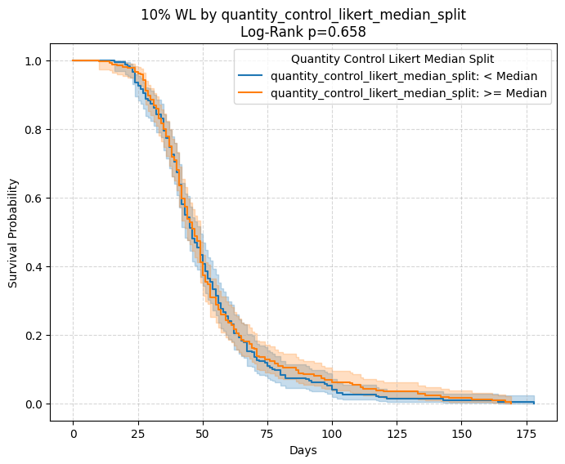
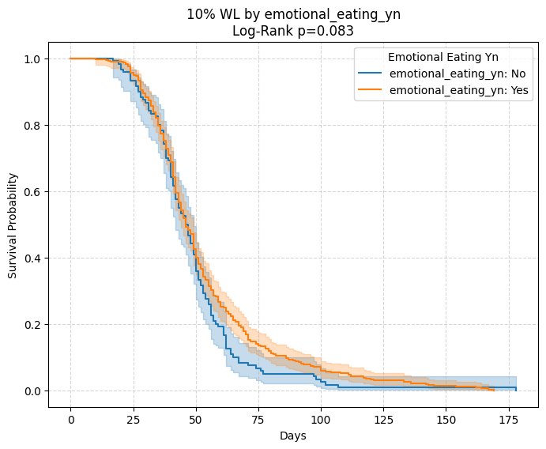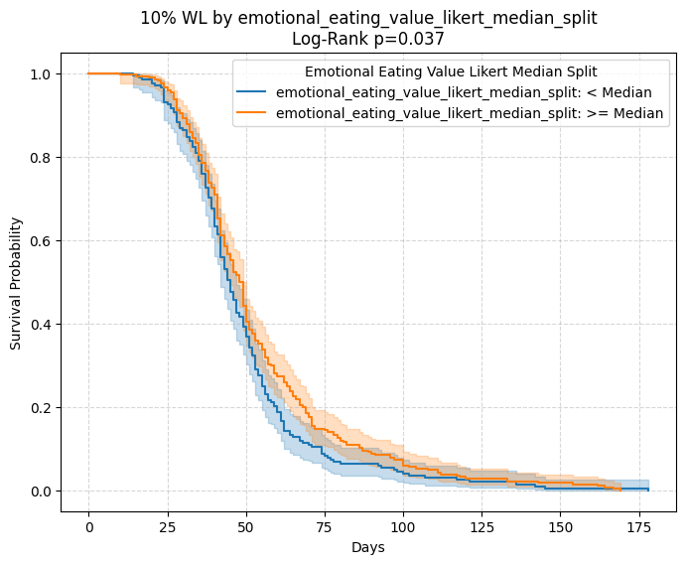Figures 1A-C: Kaplan-Meier plots predicting the number of days needed to achieve 10% weight loss in in the first 60 days of the intervention by emotional eating (yes/no), emotional eating score (under/over the median) and quantity control score (under/over the median). P-values were calculated using a log-rank test.

Figure 2: Random forest models predicting the probability of achieving 10% weight loss in 60 days by baseline anthropometry (’Baseline’ model), baseline anthropometry + all eating behavior variables (’Enhanced Full’ model) and baseline anthropometry + emotional eating + quantity control (’Enhanced Reduced’ model). AUROC scores and F1 values indicate a slight increase of predictive performance when including eating behavior variables.
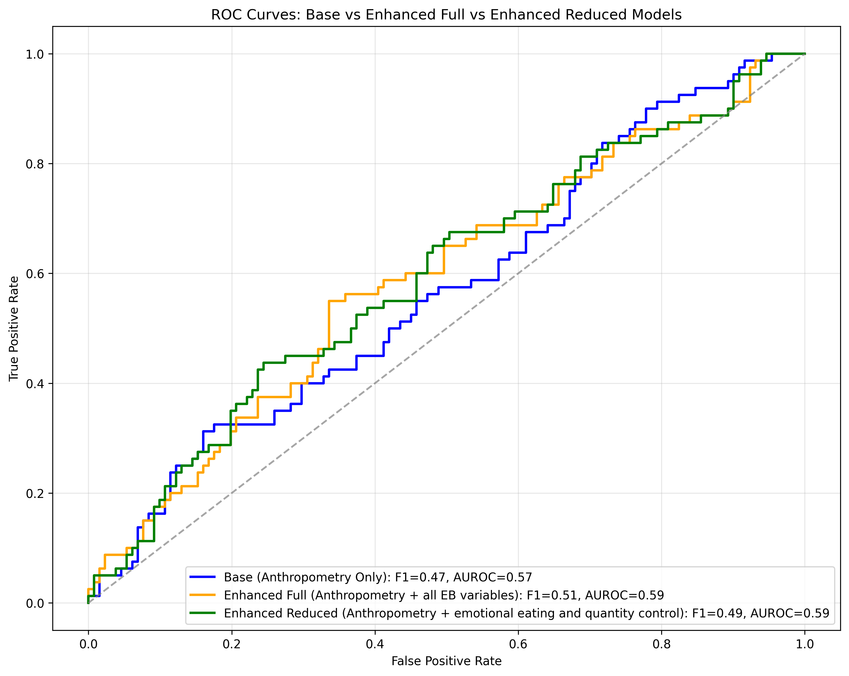
base sin antropometría? o peso?

Table 4: Gini (mean decrease in impurity, calculated during training) and permutation-based (calculated on the test set) feature importance scores from all 3 Random Forest models.
Model | Feature | Gini feature importance (calculated during model training) | Permutation-based feature importance (calculated on the test set)
Base model (anthropometry only) | Age (years) | 0.120245989 | -0.000947867
 | Sex (female) | 0.046618094 | 0.007109005
 | Baseline weight (kg) | 0.169381583 | -0.030331754
 | Baseline BMI (kg/m²) | 0.179431731 | -0.047867299
 | Baseline fat mass (%) | 0.25695921 | -0.022274882
 | Baseline muscle mass (%) | 0.227363393 | -0.011848341
Fully enhanced model (anthropometry + all eating behavior variables) | Age (years) | 0.08559827 | -0.006161137
 | Sex (female) | 0.032561875 | -0.003317536
 | Baseline weight (kg) | 0.142705837 | -0.010900474
 | Baseline BMI (kg/m²) | 0.126123925 | -0.011374408
 | Baseline fat mass (%) | 0.182120219 | -0.002369668
 | Baseline muscle mass (%) | 0.198642424 | -0.001895735
 | Hunger (yes/no) | 0.008309987 | -0.005687204
 | Satiety (yes/no) | 0.010842953 | 0.003791469
 | Emotional eating (yes/no) | 0.034747717 | 0.011848341
 | Emotional eating score (1-10) | 0.075208973 | 0.021800948
 | Quantity control score (1-10) | 0.050405216 | -0.002369668
 | Impulse control score (1-10) | 0.052732604 | -0.013744076
Partially enhanced model (anthropometry, emotional eating and quantity control) | Age (years) | 0.093617313 | -0.000947867
 | Sex (female) | 0.032949399 | -0.002369668
 | Baseline weight (kg) | 0.128040337 | -0.017535545
 | Baseline BMI (kg/m²) | 0.167726719 | -0.020379147
 | Baseline fat mass (%) | 0.211389826 | -0.002843602
 | Baseline muscle mass (%) | 0.200980196 | 0.003791469
 | Emotional eating (yes/no) | 0.027132844 | 0.007109005
 | Emotional eating score (1-10) | 0.082424324 | -0.000947867
 | Quantity control score (1-10) | 0.055739042 | 0.013270142

RF: Could additionally include ’likelihood of dropout’ predictions.

Table 5: Descriptive statistics after stratifying by eating behavior-associated reasons for weight gain in the cohort with completely available eating behavior and weight gain cause data (n = 308). Data is presented as N (%) for continuous and mean (SD) for categorical variables. P-values were calculated using Welch’s t-test for continuous variables; Chi-squared test for categorical variables; and Fisher’s exact test for categorical variables with a low expected variance count.

Variable | Whole population | Weight gain due to mental health issues: No | Weight gain due to mental health issues: Yes | Weight gain due to mental health issues: p-value | Weight gain due to family issues: No | Weight gain due to family issues: Yes | Weight gain due to family issues: p-value | Weight gain due to lifestyle circumstances: No | Weight gain due to lifestyle circumstances: Yes | Weight gain due to lifestyle circumstances: p-value
N | 308 | 229 | 79 | N/A | 290 | 18 | N/A | 266 | 42 | N/A
Demographics and baseline anthropometry
Sex (% of females) | 254 (82.5%) | 186 (81.2%) | 68 (86.1%) | 0.41988554 | 238 (82.1%) | 16 (88.9%) | 0.74889759 | 219 (82.3%) | 35 (83.3%) | 1
Age (years) | 46.39 ± 10.53 | 46.62 ± 10.69 | 45.71 ± 10.10 | 0.497067996 | 46.36 ± 10.57 | 46.83 ± 10.16 | 0.849894973 | 46.89 ± 10.22 | 43.21 ± 11.98 | 0.065698568
Height (m) | 1.66 ± 0.07 | 1.65 ± 0.08 | 1.66 ± 0.07 | 0.725104674 | 1.65 ± 0.07 | 1.67 ± 0.09 | 0.548445808 | 1.66 ± 0.07 | 1.65 ± 0.07 | 0.576583768
Baseline weight (kg) | 30.16 ± 3.04 | 82.66 ± 12.58 | 83.75 ± 10.78 | 0.459525002 | 82.80 ± 11.98 | 85.14 ± 14.68 | 0.515375514 | 82.90 ± 12.06 | 83.20 ± 12.75 | 0.888701523
Baseline BMI (kg/m²) | 40.88 ± 5.90 | 30.07 ± 3.11 | 30.40 ± 2.82 | 0.389961918 | 30.14 ± 3.07 | 30.39 ± 2.65 | 0.704125531 | 30.11 ± 3.03 | 30.43 ± 3.12 | 0.539277446
Baseline fat mass (%) | 29.68 ± 4.04 | 40.58 ± 6.07 | 41.76 ± 5.33 | 0.10393928 | 40.77 ± 5.91 | 42.68 ± 5.65 | 0.181109411 | 40.82 ± 5.92 | 41.32 ± 5.80 | 0.604998443
Baseline muscle mass (%) | 76.82 ± 68.00 | 29.82 ± 4.22 | 29.26 ± 3.44 | 0.244224087 | 29.75 ± 4.05 | 28.42 ± 3.77 | 0.16361984 | 29.63 ± 4.03 | 29.99 ± 4.11 | 0.598119414
Treatment outcomes
Follow-up length (days) | 4.49 ± 3.69 | 77.02 ± 68.01 | 76.25 ± 68.39 | 0.931384331 | 76.63 ± 67.29 | 79.94 ± 80.63 | 0.866320619 | 76.10 ± 67.82 | 81.40 ± 69.74 | 0.647575586
Number of visits | 15.65 ± 17.46 | 4.62 ± 3.80 | 4.11 ± 3.33 | 0.263611545 | 4.49 ± 3.71 | 4.56 ± 3.35 | 0.933329354 | 4.39 ± 3.72 | 5.10 ± 3.45 | 0.231252372
Number of total measurements | 6.96 ± 5.50 | 15.46 ± 16.76 | 16.20 ± 19.44 | 0.763375368 | 15.74 ± 17.71 | 14.28 ± 12.91 | 0.654419961 | 15.75 ± 17.62 | 15.02 ± 16.56 | 0.793965986
Average measurement frequency (days) | 0 (0.0%) | 6.94 ± 5.45 | 7.01 ± 5.67 | 0.923382907 | 6.95 ± 5.48 | 7.12 ± 6.11 | 0.911983772 | 6.88 ± 5.49 | 7.44 ± 5.63 | 0.561564045
Total weight loss (%) | 75.77 ± 11.96 | -8.71 ± 5.75 | -8.31 ± 6.16 | 0.610504596 | -8.69 ± 5.89 | -7.24 ± 5.13 | 0.262472359 | -8.56 ± 5.84 | -8.89 ± 5.96 | 0.743492753
BMI reduction (kg/m²) | -2.60 ± 1.82 | -2.63 ± 1.81 | -2.51 ± 1.87 | 0.609584342 | -2.63 ± 1.84 | -2.20 ± 1.53 | 0.267225618 | -2.59 ± 1.83 | -2.67 ± 1.78 | 0.784480508
Total fat mass loss (%) | -4.87 ± 3.46 | -4.93 ± 3.44 | -4.69 ± 3.51 | 0.603524682 | -4.91 ± 3.49 | -4.26 ± 2.94 | 0.383890164 | -4.85 ± 3.48 | -4.98 ± 3.34 | 0.815920693
Total muscle mass change (%) | 2.77 ± 2.09 | 2.81 ± 2.11 | 2.67 ± 2.04 | 0.610744012 | 2.79 ± 2.11 | 2.42 ± 1.67 | 0.378309921 | 2.76 ± 2.11 | 2.85 ± 1.97 | 0.794323494
Instant dropouts (n) | 15 (4.9%) | 10 (4.4%) | 5 (6.3%) | 0.692397176 | 13 (4.5%) | 2 (11.1%) | 0.215677738 | 13 (4.9%) | 2 (4.8%) | 1
40-day dropouts (n) | 108 (35.1%) | 80 (34.9%) | 28 (35.4%) | 1 | 102 (35.2%) | 6 (33.3%) | 1 | 94 (35.3%) | 14 (33.3%) | 0.936966906
40-day weight loss (%) | -7.99 ± 3.25 | -8.12 ± 3.24 | -7.63 ± 3.28 | 0.362104594 | -8.04 ± 3.29 | -7.27 ± 2.63 | 0.354590405 | -7.87 ± 3.26 | -8.71 ± 3.14 | 0.204431635
40-day fat mass loss (%) | -4.58 ± 2.05 | -4.68 ± 2.06 | -4.27 ± 2.00 | 0.213445028 | -4.59 ± 2.07 | -4.35 ± 1.67 | 0.638240431 | -4.52 ± 2.04 | -4.94 ± 2.09 | 0.33151261
40-day muscle mass change (%) | 2.66 ± 1.45 | 2.73 ± 1.50 | 2.44 ± 1.27 | 0.182393344 | 2.67 ± 1.47 | 2.56 ± 1.05 | 0.753886267 | 2.62 ± 1.46 | 2.90 ± 1.38 | 0.319839236
60-day dropouts (n) | 161 (52.3%) | 120 (52.4%) | 41 (51.9%) | 1 | 152 (52.4%) | 9 (50.0%) | 1 | 139 (52.3%) | 22 (52.4%) | 1
60-day weight loss (%) | -10.22 ± 3.55 | -10.22 ± 3.60 | -10.24 ± 3.46 | 0.977495691 | -10.29 ± 3.52 | -9.13 ± 3.98 | 0.416855229 | -10.06 ± 3.69 | -11.27 ± 2.32 | 0.054600243
60-day fat mass loss (%) | -5.78 ± 2.14 | -5.82 ± 2.18 | -5.67 ± 2.06 | 0.697103786 | -5.80 ± 2.14 | -5.53 ± 2.36 | 0.74332643 | -5.68 ± 2.20 | -6.41 ± 1.61 | 0.085371188
60-day muscle mass change (%) | 3.35 ± 1.37 | 3.41 ± 1.41 | 3.20 ± 1.28 | 0.398550327 | 3.36 ± 1.37 | 3.20 ± 1.49 | 0.752935173 | 3.30 ± 1.41 | 3.72 ± 1.06 | 0.12406684
80-day dropouts (n) | 202 (65.6%) | 156 (68.1%) | 46 (58.2%) | 0.144617389 | 190 (65.5%) | 12 (66.7%) | 1 | 174 (65.4%) | 28 (66.7%) | 1
80-day weight loss (%) | -11.59 ± 3.71 | -11.44 ± 3.68 | -11.93 ± 3.82 | 0.53440726 | -11.56 ± 3.77 | -12.17 ± 2.67 | 0.610367738 | -11.65 ± 3.81 | -11.18 ± 3.07 | 0.607574459
80-day fat mass loss (%) | -6.58 ± 2.27 | -6.57 ± 2.31 | -6.58 ± 2.22 | 0.989152022 | -6.55 ± 2.31 | -7.03 ± 1.57 | 0.508152342 | -6.63 ± 2.33 | -6.24 ± 1.88 | 0.497552562
80-day muscle mass change (%) | 3.77 ± 1.41 | 3.81 ± 1.44 | 3.68 ± 1.35 | 0.666617193 | 3.76 ± 1.43 | 3.93 ± 1.05 | 0.716568334 | 3.79 ± 1.44 | 3.62 ± 1.20 | 0.642920548
Achieved 5% weight loss (n) | 223 (72.4%) | 167 (72.9%) | 56 (70.9%) | 0.838540427 | 210 (72.4%) | 13 (72.2%) | 1 | 194 (72.9%) | 29 (69.0%) | 0.735603942
Days to 5% weight loss | 21.27 ± 15.13 | 20.61 ± 15.04 | 23.23 ± 15.35 | 0.269236149 | 21.19 ± 15.16 | 22.62 ± 15.09 | 0.745439615 | 21.98 ± 15.87 | 16.48 ± 7.21 | 0.002477651
Achieved 10% weight loss (n) | 132 (42.9%) | 100 (43.7%) | 32 (40.5%) | 0.72047035 | 126 (43.4%) | 6 (33.3%) | 0.55115492 | 110 (41.4%) | 22 (52.4%) | 0.240268068
Days to 10% weight loss | 51.42 ± 24.82 | 50.68 ± 25.81 | 53.72 ± 21.65 | 0.512853523 | 51.17 ± 25.00 | 56.67 ± 22.12 | 0.577325412 | 51.50 ± 25.35 | 51.00 ± 22.53 | 0.926493847
Achieved 15% weight loss (n) | 57 (18.5%) | 40 (17.5%) | 17 (21.5%) | 0.527642369 | 55 (19.0%) | 2 (11.1%) | 0.542719757 | 47 (17.7%) | 10 (23.8%) | 0.460214036
Days to 15% weight loss | 93.54 ± 34.33 | 95.12 ± 37.41 | 89.82 ± 26.33 | 0.54576646 | 94.05 ± 34.83 | 79.50 ± 9.19 | 0.194180246 | 89.89 ± 29.11 | 110.70 ± 51.04 | 0.24019813
Self-reported eating behavior
Hunger (yes/no) | 222 (72.1%) | 162 (70.7%) | 60 (75.9%) | 0.456802224 | 207 (71.4%) | 15 (83.3%) | 0.416891619 | 191 (71.8%) | 31 (73.8%) | 0.932963648
Satiety (yes/no) | 195 (63.3%) | 143 (62.4%) | 52 (65.8%) | 0.687903523 | 180 (62.1%) | 15 (83.3%) | 0.080568164 | 170 (63.9%) | 25 (59.5%) | 0.707042511
Emotional eating (yes/no) | 259 (84.1%) | 182 (79.5%) | 77 (97.5%) | 5.24E-05 | 241 (83.1%) | 18 (100.0%) | 0.088497276 | 221 (83.1%) | 38 (90.5%) | 0.264363027
Emotional eating score (1-10) | 7.13 ± 2.37 | 6.72 ± 2.47 | 8.32 ± 1.51 | 1.17E-10 | 7.04 ± 2.39 | 8.67 ± 1.14 | 1.04E-05 | 7.01 ± 2.42 | 7.90 ± 1.85 | 0.00702545
Quantity control score (1-10) | 6.31 ± 2.51 | 6.09 ± 2.57 | 6.96 ± 2.23 | 0.004458591 | 6.26 ± 2.55 | 7.17 ± 1.54 | 0.030243525 | 6.26 ± 2.57 | 6.62 ± 2.11 | 0.328239136
Impulse control score (1-10) | 6.63 ± 2.51 | 6.32 ± 2.56 | 7.52 ± 2.17 | 8.04E-05 | 6.61 ± 2.51 | 6.83 ± 2.68 | 0.739126134 | 6.61 ± 2.56 | 6.71 ± 2.22 | 0.78878476
Self-reported reasons for weight gain
Women's health and pregnancy (yes/no) | 88 (28.6%) | 68 (29.7%) | 20 (25.3%) | 0.549646145 | 83 (28.6%) | 5 (27.8%) | 1 | 79 (29.7%) | 9 (21.4%) | 0.358170357
Mental health (yes/no) | 79 (25.6%) | 0 (0.0%) | 79 (100.0%) | 1.33E-75 | 70 (24.1%) | 9 (50.0%) | 0.030777965 | 69 (25.9%) | 10 (23.8%) | 0.91741138
Family issues (yes/no) | 18 (5.8%) | 9 (3.9%) | 9 (11.4%) | 0.030777965 | 0 (0.0%) | 18 (100.0%) | 1.71E-29 | 14 (5.3%) | 4 (9.5%) | 0.284690449
Medication, disease or injury (yes/no) | 31 (10.1%) | 20 (8.7%) | 11 (13.9%) | 0.269015477 | 30 (10.3%) | 1 (5.6%) | 1 | 29 (10.9%) | 2 (4.8%) | 0.279757897
Physical inactivity (yes/no) | 66 (21.4%) | 53 (23.1%) | 13 (16.5%) | 0.275600553 | 66 (22.8%) | 0 (0.0%) | 0.01669167 | 58 (21.8%) | 8 (19.0%) | 0.839662141
Eating habits (yes/no) | 107 (34.7%) | 77 (33.6%) | 30 (38.0%) | 0.573302925 | 102 (35.2%) | 5 (27.8%) | 0.70077723 | 89 (33.5%) | 18 (42.9%) | 0.310371039
Schedule (yes/no) | 20 (6.5%) | 15 (6.6%) | 5 (6.3%) | 1 | 19 (6.6%) | 1 (5.6%) | 1 | 17 (6.4%) | 3 (7.1%) | 0.743005309
Smoking cessation (yes/no) | 15 (4.9%) | 12 (5.2%) | 3 (3.8%) | 0.767413497 | 15 (5.2%) | 0 (0.0%) | 1 | 14 (5.3%) | 1 (2.4%) | 0.702515041
Treatment discontinuation or relapse (yes/no) | 18 (5.8%) | 14 (6.1%) | 4 (5.1%) | 1 | 14 (4.8%) | 4 (22.2%) | 0.015001513 | 14 (5.3%) | 4 (9.5%) | 0.284690449
COVID-19 pandemic (yes/no) | 35 (11.4%) | 28 (12.2%) | 7 (8.9%) | 0.543617655 | 31 (10.7%) | 4 (22.2%) | 0.13396426 | 29 (10.9%) | 6 (14.3%) | 0.70358216
Lifestyle circumstances (yes/no) | 42 (13.6%) | 32 (14.0%) | 10 (12.7%) | 0.91741138 | 38 (13.1%) | 4 (22.2%) | 0.284690449 | 0 (0.0%) | 42 (100.0%) | 7.96E-53
None of the above (yes/no) | 24 (7.8%) | 24 (10.5%) | 0 (0.0%) | 0.000988987 | 24 (8.3%) | 0 (0.0%) | 0.378100754 | 24 (9.0%) | 0 (0.0%) | 0.056056896

elastic net? con todas variables de ganancia
kg lost/day; cox; mixto; cluster; also of credo logs on the CORRECTED pipeline
en: lineal, edad sexo todos factores de ganancia
modelo mixto
cox con tiempo
- ver qué sale aquí, si algún motivo se asocia con outcome
- si no sale nada, olvidarse, si sale, profundizar
escribir mat met
SUGGESTED SUPPLEMENTARY MATERIALS
- cohort comparisons: EB vs whole, WGC vs EB
- complete EB stratifications in EB
- complete demographic, EB and WGC stratifications in WGC
- outcome predictions in WGC
- linear outcome and adherence predictions with negative results in both EB and WGC
- WGC concrete cases and their translations

