

**The Experiment Report of**

***Machine Learning***

**College Software College**

**Subject Software Engineering**

**Members**   **袁修竹**

**Student ID 201530613535**

**E-mail 1225427085@qq.com**

**Tutor**   **吴庆耀**

**Date submitted** **2017.12.14**

**1. Topic:**

Logistic Regression, Linear Classification and Stochastic Gradient Descent

**2. Time:** 2017/12/8

**3. Reporter:**袁修竹

**4. Purposes:**

Compare and understand the difference between gradient descent and stochastic gradient descent.

Compare and understand the differences and relationships between Logistic regression and linear classification.

Further understand the principles of SVM and practice on larger data.

**5. Data sets and data analysis:**

Experiment uses a9a of LIBSVM Data, including 32561/16281(testing) samples and each sample has 123/123 (testing) features.

**6. Experimental steps:**

（1）Logistic Regression and Stochastic Gradient Descent

Load the training set and validation set.

Initalize logistic regression model parameters, you can consider initalizing zeros, random numbers or normal distribution.

Select the loss function and calculate its derivation, find more detail in PPT.

Calculate gradient G toward loss function from partial samples.

Update model parameters using different optimized methods(NAG，RMSProp，AdaDelta and Adam).

Select the appropriate threshold, mark the sample whose predict scores greater than the threshold as positive, on the contrary as negative. Predict under validation set and get the different optimized method loss Lnag，Lrmsprop，Ladadelta and Ladam .

Repeate step 4 to 6 for several times, and drawing graph of Lnag，Lrmsprop，Ladadelta and Ladam .with the number of iterations.

（2）Linear Classification and Stochastic Gradient Descent

Load the training set and validation set.

Initalize SVM model parameters, you can consider initalizing zeros, random numbers or normal distribution.

Select the loss function and calculate its derivation, find more detail in PPT.

Calculate gradient toward loss function from partial samples.

Update model parameters using different optimized methods(NAG，RMSProp，AdaDelta and Adam).

Select the appropriate threshold, mark the sample whose predict scores greater than the threshold as positive, on the contrary as negative. Predict under validation set and get the different optimized method loss Lnag，Lrmsprop，Ladadelta and Ladam.

Repeate step 4 to 6 for several times, and drawing graph of Lnag，Lrmsprop，Ladadelta and Ladam with the number of iterations.

**7. Code:**

（1）Logistic Regression and Stochastic Gradient Descent

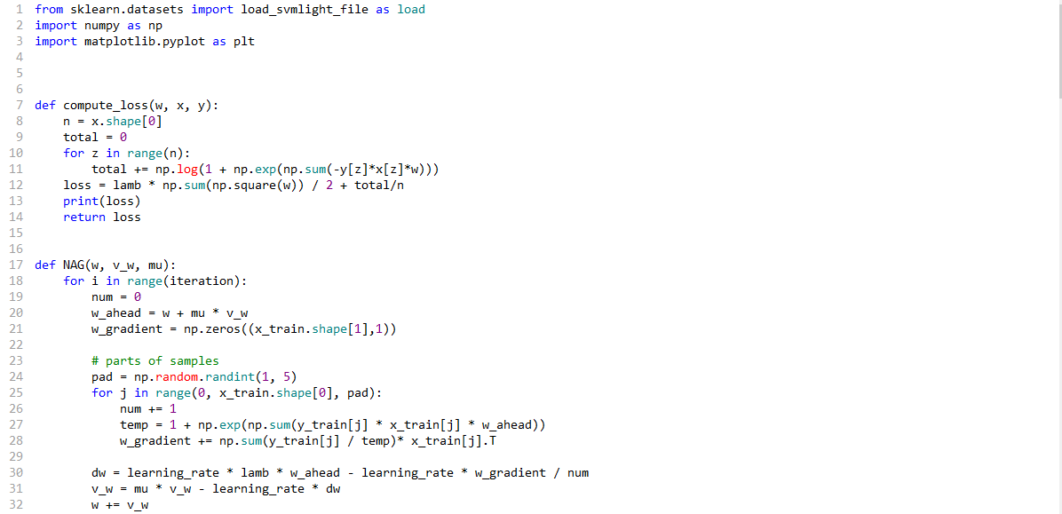

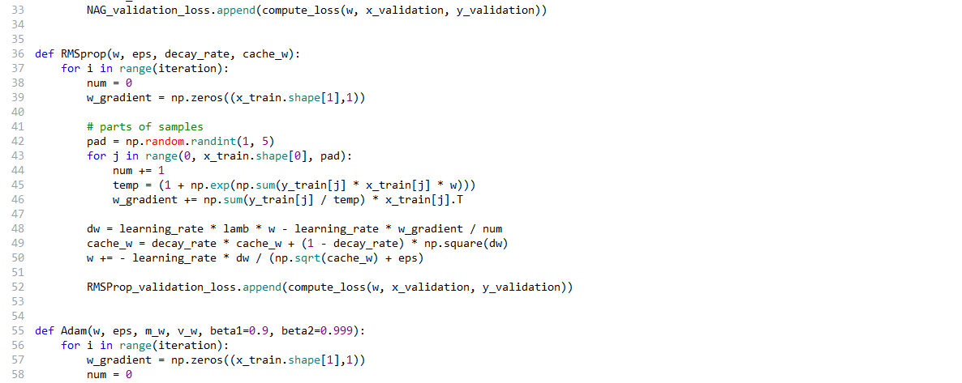

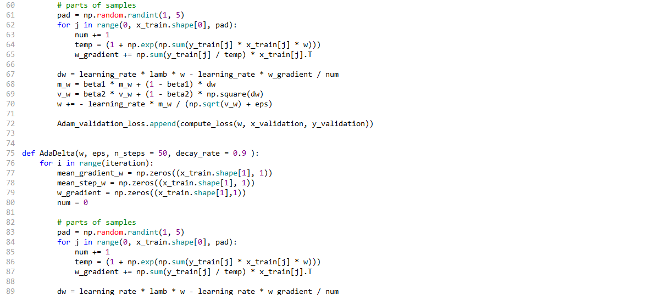

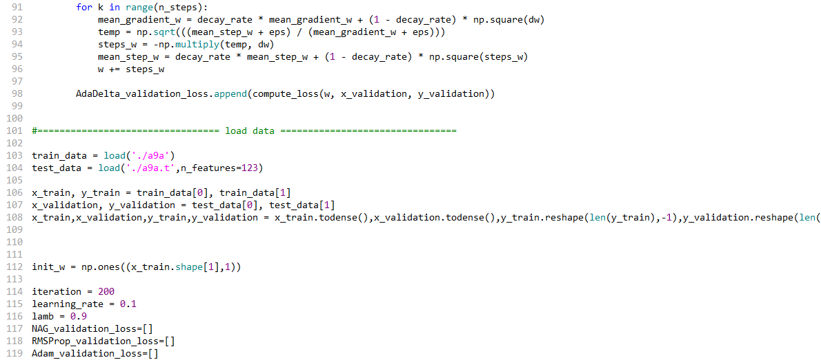

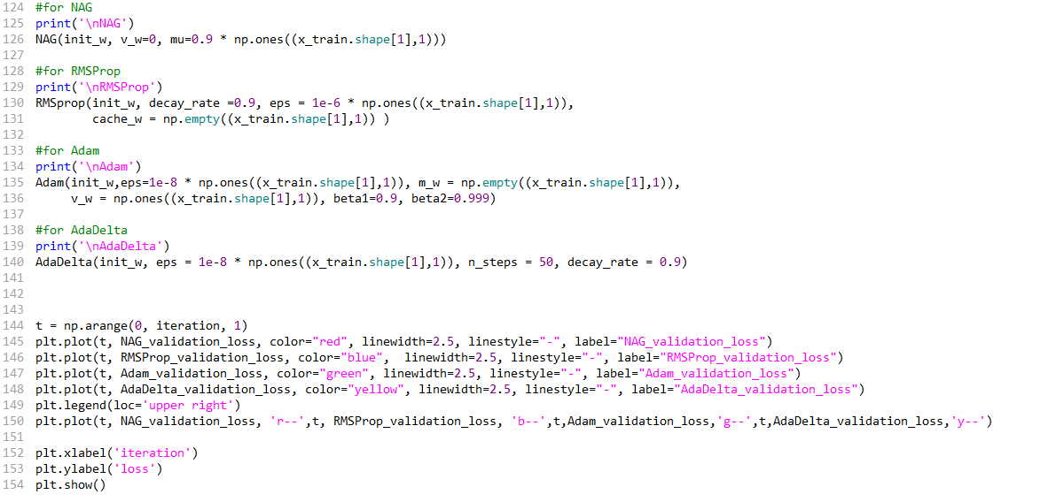

（2）Linear Classification and Stochastic Gradient Descent

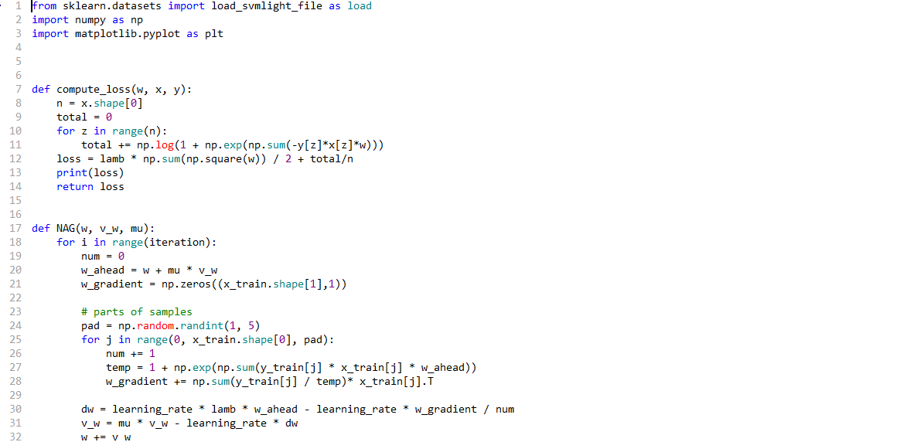

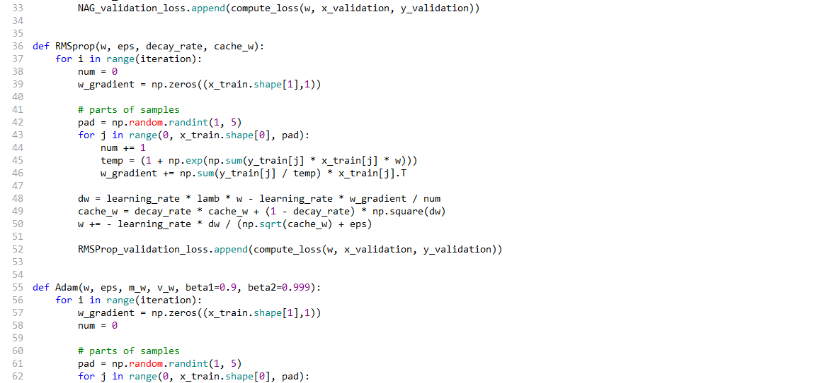

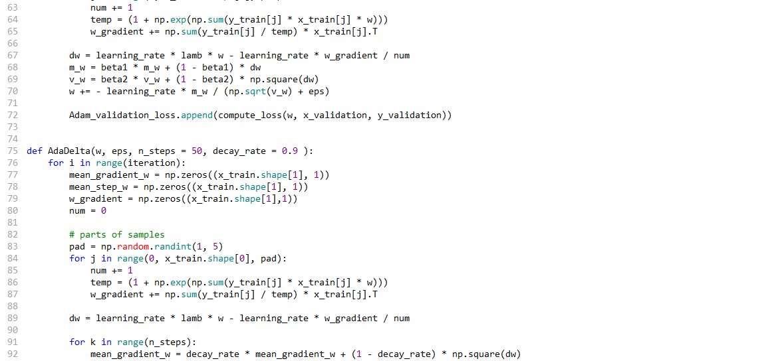

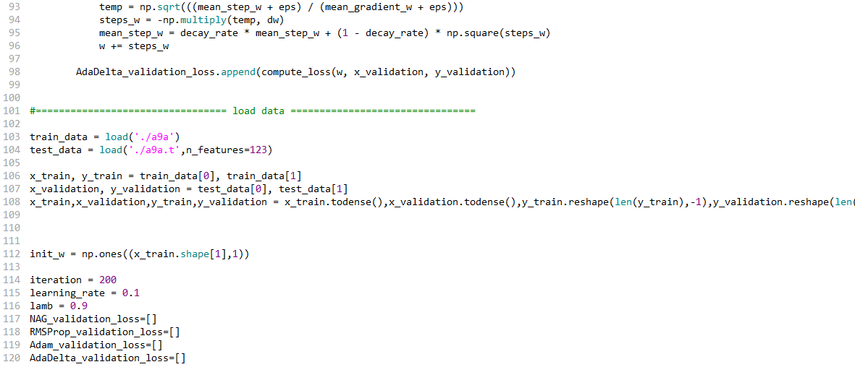

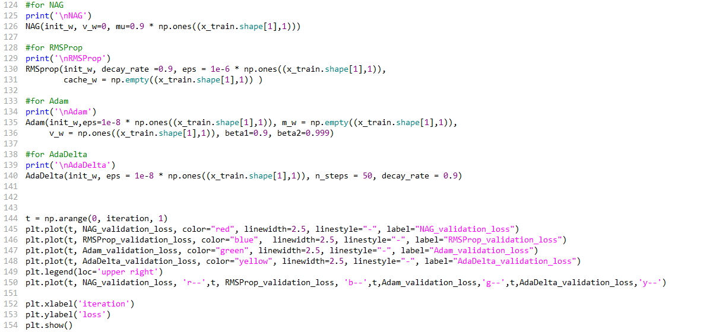

**8. The initialization method of model parameters:**

（1）Logistic Regression and Stochastic Gradient Descent



（2）Linear Classification and Stochastic Gradient Descent



**9. The selected loss function and its derivatives:**



**10. Experimental results and curve:**

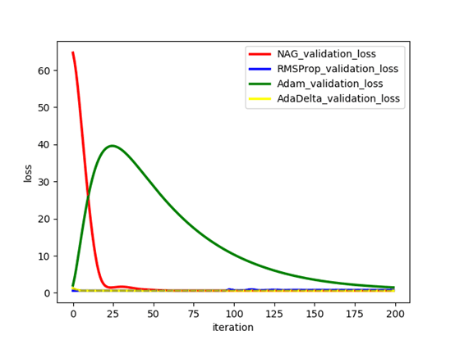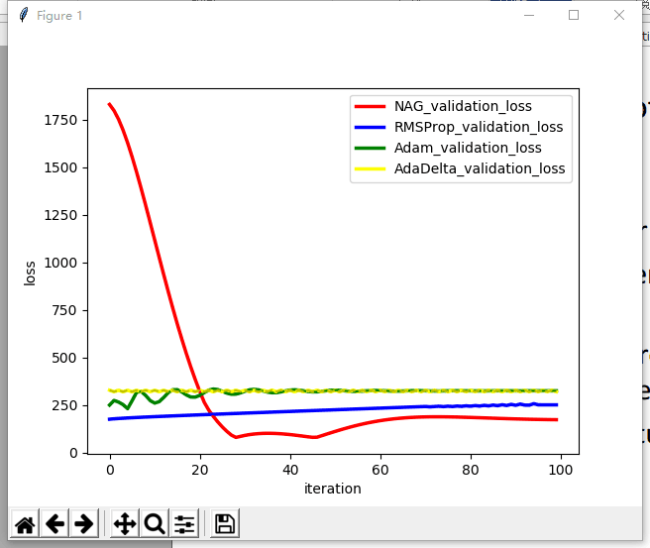

**12. Similarities and differences between logistic regression and linear classification：**

The logistic regression is called as a linear classifier because it produces a decision boundary which is linear in nature. So, the classification makes by logistic regression is linear classification only.

**13. Summary:**

Through this experiment mastered the basic methods of linear regression and linear classification, the process has been further understanding and understanding.