
Project Outline and Plan
School of Computer Science
Faculty of Engineering AND PHYSICAL SCIENCES

Provisional Title of Project
Wenhao Nie
Research on Complex Temporal Reasoning

The candidate confirms that the work submitted is their own and the appropriate credit has been given where reference has been made to the work of others.

I understand that failure to attribute material which is obtained from another source may be considered as plagiarism.

Wenhao Nie

© 2025 The University of Leeds and Wenhao Nie

1. Introduction
Large language models (LLMs) have achieved impressive results in many language tasks, but they often struggle with reasoning about time and events. Temporal reasoning – understanding the order of events, their durations, frequencies, and time-related calculations – is a crucial skill for an AI to interpret stories, plan tasks, or answer time-sensitive questions. For example, people know instinctively that watching a movie typically lasts longer than watching a sunset, and that sunsets happen once a day. Such commonsense temporal knowledge includes understanding typical durations, event frequencies, and the ordering of events. However, current AI models lack much of this understanding. Recent studies have found that even state-of-the-art LLMs perform significantly worse than humans on temporal reasoning benchmarks. In one comprehensive evaluation, the best model (GPT-4) still trailed human-level accuracy by around 10% on a suite of temporal tasks. This gap highlights the need for improving LLMs’ ability to handle temporal information reliably.
Background & Motivation: This project aims to address the above challenge by enhancing an LLM’s temporal reasoning capabilities. Using a specialized benchmark called TRAM (Temporal Reasoning for LAnguage Models), which encompasses multiple categories of time-related tasks, we will fine-tune an existing model to better understand temporal context. TRAM includes diverse tasks such as event ordering, duration estimation, frequency reasoning, resolving ambiguous time expressions, performing date arithmetic, and even temporal natural language inference. By focusing on these facets of temporal reasoning, the project will teach the model to better grasp when events happen, how long they last, how often they occur, and how to disambiguate time-related statements. Ultimately, improving performance in these areas will make the AI more accurate and trustworthy in any application involving dates or the timeline of events. This introduction avoids deep technical details so that a general audience can appreciate the motivation: we want AI to have a more human-like understanding of time, which is something we usually take for granted in everyday reasoning.

2 Aims, Objectives and Deliverables

2.1 Aims
The primary aim of this project is to develop an enhanced language model that can reason about temporal information more accurately than existing baselines. In particular, we aim to fine-tune a state-of-the-art open-source LLM (such as Qwen) so that it can reliably handle a range of time-related reasoning tasks (e.g. understanding event order, durations, frequencies, date calculations, and temporal logical inferences). By the end of the project, the fine-tuned model (tentatively called Baseline B) should demonstrate significantly improved performance on selected temporal reasoning benchmarks, closing the gap towards human-level understanding in this domain.

2.2 Objectives
To achieve the above aim, we set the following specific objectives (each of which is measurable and will be evidenced by project outcomes):
- Objective 1: Model Fine-Tuning for Temporal Tasks – Fine-tune an existing LLM on a curated subset of the TRAM benchmark (covering six key temporal reasoning categories: Ordering, Frequency, Duration, Ambiguity Resolution, Arithmetic, and Temporal NLI). The objective is to obtain a specialized model that achieves higher accuracy on these tasks than the original pre-trained model. Success criterion: an increase in accuracy (or other relevant metrics) on each selected task compared to the baseline model’s performance.
- Objective 2: Performance Evaluation against Baselines – Rigorously evaluate the fine-tuned model’s performance on the chosen temporal reasoning tasks and compare it to baseline models. This includes comparing against the original (non-fine-tuned) model and any published baseline results from prior research. The model should outperform baseline accuracy levels on the six selected temporal tasks – for example, reducing the error rate in event ordering or duration estimation problems. We will provide quantitative evidence (charts/tables) to confirm whether this performance improvement objective is met.
- Objective 3: Error Analysis and Improvement – Analyze the model’s errors on temporal reasoning questions to identify common failure modes (e.g. systematically wrong date arithmetic, misunderstanding ambiguous time expressions, etc.). Using this analysis, implement targeted data augmentation or training enhancements to address at least one major category of errors. For instance, if the model struggles with ambiguous time phrases, we might augment the training data with more examples of disambiguated time questions. Success for this objective will be demonstrated by a reduction in the frequency of the targeted error type and a corresponding performance boost after the intervention (as measured on a validation set).
- Objective 4: Deliverables for Reproducibility – Produce all final deliverables that collectively show the project’s outcomes. This includes the final report documenting the methodology, experiments, and results (meeting all required academic standards), as well as the software deliverables (e.g. source code and the fine-tuned model itself). The code will be documented and packaged so that others can reproduce the fine-tuning process and verify the evaluation results. Evidence of achieving this objective will be the submission of the report and the availability of the code/model (for example, via a Git repository or attached archive) with instructions.

2.3 Deliverables
By the end of the project, we will produce the following deliverables, which will be submitted for assessment and review:
- D1. Final Project Report: A comprehensive written report detailing the entire project. This report will include an introduction and background (explaining temporal reasoning and related work), a methodology section (describing data selection, model fine-tuning approach, etc.), an experimental results section (with performance metrics, comparisons, and analysis of errors), and a conclusion. It will explicitly document how each objective was addressed. This report corresponds to all objectives, especially Objective 2 and Objective 3, by presenting evaluation results and error analysis.
- D2. Fine-Tuned Model & Code Repository: The complete source code developed during the project, along with the final fine-tuned model (Baseline B). This will likely be provided as a link to a repository or as a submitted archive. It should contain training scripts, data processing scripts (including any data augmentation utilities), and documentation on how to run the experiments. This deliverable maps to Objective 1 (the fine-tuned model itself) and Objective 4 (ensuring reproducibility). We will also include a readme explaining how to load the fine-tuned Qwen model and evaluate it on the temporal tasks.
- D3. Intermediate Results & Logs (Optional): In addition to the primary deliverables, we may also provide key intermediate artifacts such as training logs, validation curves, or example outputs. While not a formal deliverable on its own, these artifacts will be included as appendices or supplementary material to support claims in the report. For example, if data augmentation was applied, we might include a sample of augmented data and the before-and-after performance comparison (addressing Objective 3).

3. Project Plan
This project began in December 2025 and will run until the final report submission in mid 2026. The work is organized into several key stages, each focusing on a milestone towards building and evaluating the temporal reasoning model. Below we outline the main stages of the project and their timeline, including how they address the project objectives:
- Literature Review & Planning (Dec 2025 – Jan 2026): In this initial stage, we survey existing research on temporal reasoning in NLP and LLMs. We review benchmarks like TRAM and related datasets (e.g. MC-TACO for temporal commonsense, TimeQA, TempReason) to understand what kinds of questions and challenges have been identified. We also study techniques used in prior work (for example, chain-of-thought prompting for temporal questions, or specialized data augmentation strategies). By the end of this stage, we will have a clear idea of which six TRAM task categories to focus on (as listed in the objectives) and a concrete plan for model fine-tuning. This stage lays the groundwork and corresponds to formulating Objective 1 and part of Objective 3.
- Data Preparation (Jan 2026): Here we gather and prepare the data for training and evaluation. From the TRAM benchmark (which contains ten temporal reasoning datasets in total), we will extract the six chosen categories. This involves writing scripts to load or convert the question-answer format into a format suitable for fine-tuning the model (likely multiple-choice or QA format). We will also split data into training, validation, and test sets as needed. If the datasets are large (TRAM has over 500k questions in total), we may choose a representative subset for faster experimentation. The output of this stage is a cleaned and structured dataset for the model to learn from. This addresses Objective 1, providing the necessary data to fine-tune the model.
- Baseline Implementation & Evaluation (Feb 2026): Before fine-tuning, we will establish baseline performance on our tasks. We will run the original Qwen model (and/or any other baseline model, such as a standard BERT-based model provided in the literature) on the evaluation set of our temporal tasks. This gives us a benchmark to improve upon, and also helps verify that the tasks indeed pose difficulties (we expect to see errors similar to those reported in research, e.g. mistakes in date arithmetic or event ordering). We will document the baseline accuracy for each of the six categories. In parallel, we ensure the computing environment for fine-tuning is ready (setting up the model, GPU resources, etc.). This stage is crucial for Objective 2, as it provides the baseline for later comparison.
- Model Fine-Tuning (initial) (Mar 2026): Using the prepared data, we fine-tune the Qwen LLM (Baseline B model) on the temporal reasoning tasks. We will likely employ a multi-task training approach where the model learns across all selected categories, or a sequential fine-tuning (task by task) depending on what yields better results. We’ll monitor training metrics to avoid overfitting. By the end of March, we expect to have a first version of our fine-tuned model. This directly accomplishes Objective 1 – we will have a specialized model for temporal reasoning. We will also perform a preliminary evaluation on validation data during fine-tuning to gauge improvements.
- Performance Evaluation & Error Analysis (Apr 2026): Once the model is fine-tuned, we conduct a thorough evaluation on the test sets for each temporal task. We will compile results and compare them to the baseline recorded earlier. We anticipate seeing improvements, but it’s important to identify where the model still fails. Therefore, this stage includes detailed error analysis. For each category (Ordering, Duration, etc.), we will manually examine a sample of the model’s incorrect answers. We’ll categorize these errors – for example, are most ordering errors happening with very long event sequences, or does the model misunderstand certain temporal phrases? We’ll also check if some errors are systematic (e.g., always confusing “next Monday” vs “this Monday”, indicating an ambiguity resolution failure). The findings here will inform the next step. This stage addresses Objective 2 (by evaluating performance) and lays the groundwork for Objective 3 (by identifying errors to fix).
- Data Augmentation & Model Refinement (late Apr 2026): Based on the error analysis, we will select one or two strategies to improve the model further. One likely approach is data augmentation – for instance, if the model struggles with temporal arithmetic (e.g., adding or subtracting dates), we can generate additional training questions that target this skill and fine-tune the model on them. Alternatively, if ambiguity in questions is a major issue, we might introduce a preprocessing step where ambiguous questions are rephrased with clarified time frames (perhaps using a heuristic or another model). Another refinement might be adjusting the model’s prompt or using chain-of-thought prompting during inference to see if it improves accuracy. We will implement these improvements and retrain or fine-tune the model as needed (possibly a second round of fine-tuning on the augmented data). By the end of this stage, we will have an improved model (if our interventions are successful) and new evaluation results to compare against the earlier ones. This directly fulfills the improvement aspect of Objective 3.
- Final Evaluation (early May 2026): After refinement, we evaluate the model again on all tasks to measure any gains from the data augmentation or other tweaks. We will use the same metrics and compare the results side-by-side with the initial fine-tuned model’s performance and the original baseline. Here we expect to see at least a modest improvement in the targeted error areas – for example, the augmented model might now handle date calculations correctly for cases that previously tripped it up. We will statistically analyze whether the improvements are significant. This is effectively the completion of the model development cycle, satisfying Objective 2 and Objective 3 by demonstrating the final performance levels and showing evidence of error reduction.
- Report Writing & Final Submission (May 2026): Throughout late April and into May, we will be concurrently writing the project report. This stage involves documenting all the above steps, weaving in literature references to justify our approach, and presenting the results with analysis. Sufficient time is allocated for writing because it’s important to clearly explain technical content in the report and to create informative visuals (charts of performance, examples of model outputs, etc.). We will also discuss any remaining limitations of our approach and potential future work (for instance, how much gap remains to human performance and what could be done to close it). By mid-late May 2026, the final report will be completed and reviewed. The code and model deliverables will be prepared for submission as well. The project then culminates in submitting everything by the deadline. This stage corresponds to Objective 4 (producing the report and deliverables) and ensures the outcomes are well-communicated.

3.1 Timeline
The following Gantt chart provides a visual timeline of the project stages described above. Each bar represents a phase of work and shows when it will take place. This helps illustrate the schedule and overlaps between activities (for example, how evaluation and writing overlap in April-May). The timeline runs from the project’s start in Dec 2025 to the final submission in May 2026:
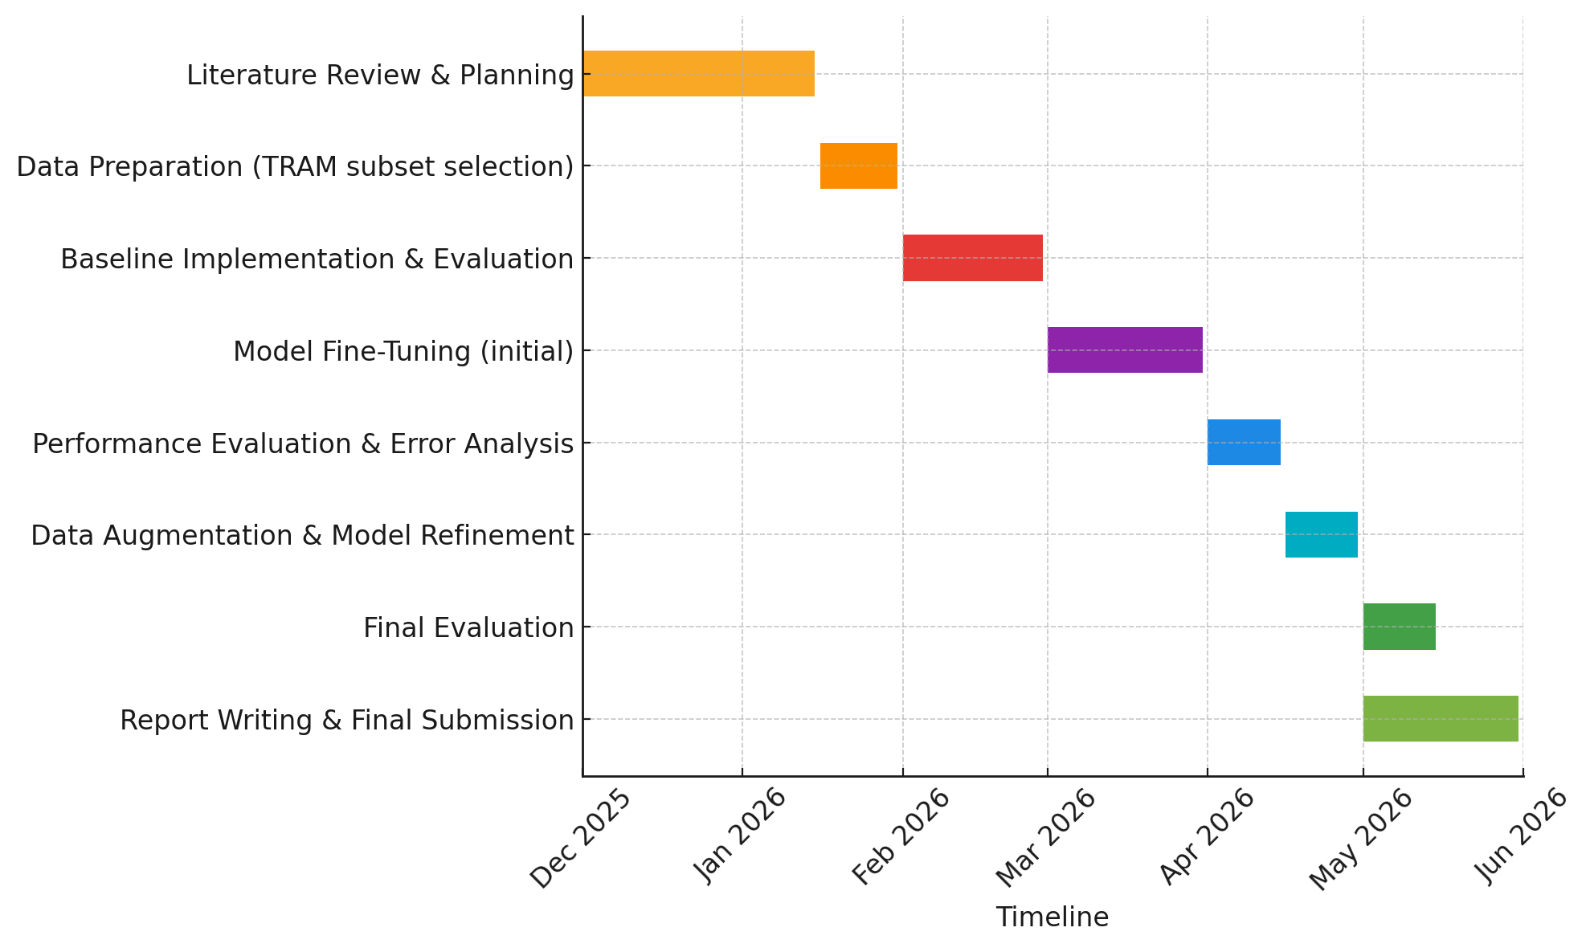
Figure 1: Gantt chart of the project plan, showing the timeline of each stage from literature review to final submission.

4. Risk Mitigation
Like any complex project, this plan faces certain risks. Here we identify key risks and outline mitigation strategies for each:
- Computational Resource Risk: Fine-tuning a large model (such as Qwen, which is multi-billion-parameter) is computationally intensive. There is a risk that running out of GPU memory or exceeding time limits could impede our experiments. Mitigation: We will mitigate this by using efficient training techniques (e.g., mixed-precision training and gradient accumulation) and, if necessary, by reducing the model size or batch size. We have access to a high-performance computing cluster; however, if resources become constrained, we are prepared to switch to a smaller model or use parameter-efficient fine-tuning methods (such as LoRA) to continue making progress. Regular checkpoints will be saved so that training can resume after interruptions without loss of work.
- Data or Performance Risk: The model might not achieve the expected improvement on temporal tasks. This could happen if the six chosen categories turn out to be more difficult than anticipated (for example, temporal NLI might require reasoning abilities beyond the model’s capacity) or if our fine-tuning data is insufficient. Mitigation: We address this risk by adopting an iterative approach. If initial results are poor on a certain category, we will analyze why – perhaps the model needs more examples of a specific pattern. We can then expand the training set (e.g., include additional synthetic questions focusing on that pattern). If one category is extremely challenging and threatens to derail the project, we have the flexibility to narrow the scope – for instance, focus on ensuring robust performance on 5 categories instead of 6, and treat the hardest task as future work. Additionally, we will compare our model’s errors with those reported in literature; if similar issues occur, we can leverage known mitigation techniques (such as structured prompting or external tools for calculations).
- Timeline Risk: The schedule is quite packed, and delays in one stage (say, the fine-tuning taking longer than expected) could compress later stages. This is a risk particularly in the integration and writing phase. Mitigation: We have built some slack into the timeline by starting certain tasks early (for example, writing can begin while experiments are still running, and baseline evaluation is done well before final evaluation). If a significant delay occurs – e.g., fine-tuning runs into repeated technical issues – we will promptly re-prioritize tasks. For instance, we might proceed with error analysis on partial results, or write up methodology sections while troubleshooting. Regular meetings with our supervisor will ensure any timeline slips are identified early, and we will adjust the plan (possibly dropping low-priority experiments or features) to meet the final deadline without compromising the core objectives.
- Integration Risk: Combining multiple task datasets and ensuring the model can handle all formats is non-trivial. There’s a risk of evaluation metrics or data processing bugs (for example, mis-aligning question answers after shuffling data). Mitigation: We will perform careful validation at each step of data preparation (including small-scale sanity checks where we know the correct answer). Also, we’ll use standard libraries for metrics and follow the evaluation scripts provided by dataset authors when possible. By keeping the code under version control and writing unit tests for data preprocessing, we aim to catch integration issues early. In case of any discovered evaluation mistake, we will re-evaluate the model with corrected code as soon as possible and update results (even if it means re-running an experiment late in the project).

5. Ethics
This project does not involve human participants, personal data, or any sensitive/private information. We are using publicly available datasets (the TRAM benchmark and related resources), which consist of crowdsourced or synthesized questions and do not contain personal identifying details. Therefore, there are no direct ethical concerns in terms of data privacy or consent. We will ensure to credit the sources of the datasets and abide by their licenses. Additionally, while improving an AI’s reasoning ability, we will be cautious about not inadvertently introducing biased or harmful content (though the scope here is purely temporal reasoning, which is generally neutral). In summary, there are no ethical issues for this project.

List of References
Anon 2022. Towards Robust Temporal Reasoning of Large Language Models via a Multi-Hop QA Dataset and Pseudo-Instruction Tuning. Arxiv.org. [Online]. [Accessed 4 January 2026]. Available from: https://arxiv.org/html/2311.09821v2.
Chen, W., Wang, X. and Wang, W. Y. (2021) A dataset for answering time-sensitive questions. arXiv preprint arXiv:2108.06314.
Dhingra, B., Cole, J. R., Eisenschlos, J. M., Gillick, D., Eisenstein, J. and Cohen, W. W. (2022) Time-aware language models as temporal knowledge bases. Transactions of the Association for Computational Linguistics, 10, 257–273.
Deng, I., Dixit, K., Roth, D. and Gupta, V. n.d. Enhancing Temporal Understanding in LLMs for Semi-structured Tables [Online]. [Accessed 4 January 2026]. Available from: https://cogcomp.seas.upenn.edu/papers/DDRG25.pdf.
Tan, Q., Ng, H. T. and Bing, L. (2024) Towards Robust Temporal Reasoning of Large Language Models via a Multi-Hop QA Dataset and Pseudo-Instruction Tuning. arXiv preprint arXiv:2311.09821.
Wang, Y. and Zhao, Y. (2024) TRAM: Benchmarking Temporal Reasoning for Large Language Models. In Findings of the Association for Computational Linguistics (ACL) 2024, pp. 6389–6415.
Piryani, B., Abdallah, A., Mozafari, J. and Jatowt, A. 2024. Detecting Temporal Ambiguity in Questions [Online]. Available from: https://aclanthology.org/2024.findings-emnlp.562.pdf.
Zhou, B., Khashabi, D., Ning, Q. and Roth, D. (2019) “Going on a vacation” takes longer than “Going for a walk”: A Study of Temporal Commonsense Understanding. In Proceedings of EMNLP-IJCNLP 2019, pp. 3363–3369.

