Welcome to “**ChatterUp**” where you can send messages with someone in real-time. This manual will guide through the existing necessary steps in using “ChatterUp” application.

So **First**:

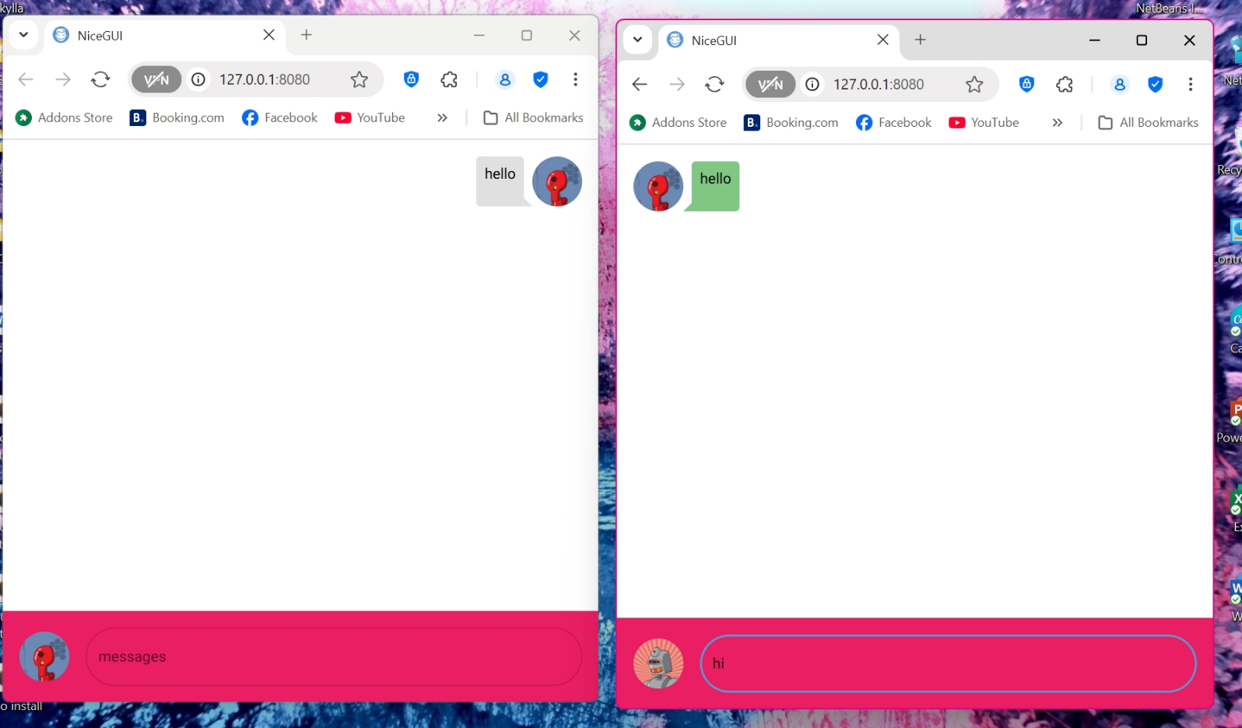Type a text message through the “messages box”.

**Second**, Click [Enter] through your keyboard. This will send your message to other users.