During my exploratory testing, I noticed some issues with the site.

**Main menu:**  
1. The Book Store Application menu section is not visible and if add banner is present it is not clickable

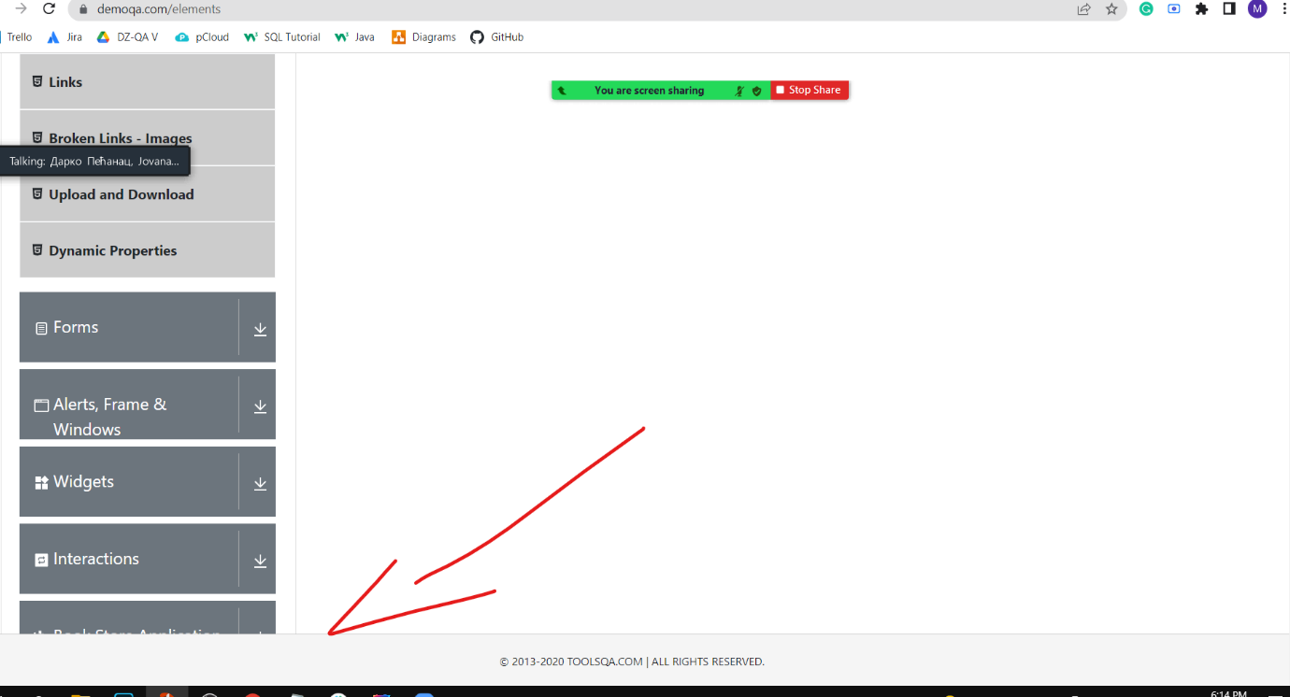

After accessing any element from Home page, you have a gray menu on the left side. The last menu option should be Book Store Application. But it is not visible from the footer. If an add is present it is not clickable/expandable. The add banner is not completely removed if you close it (click on the x button). The add space remains, and the Book store app is not clickable.  
  
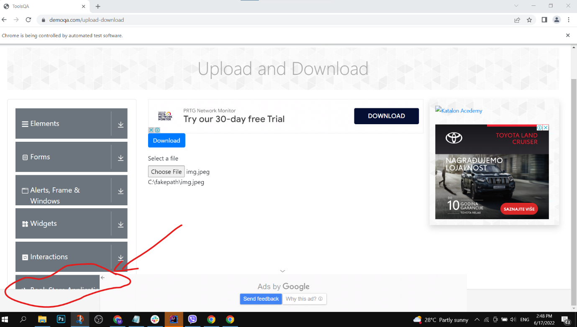

2. All the light-gray options (Text Box, Check Box,…) of any main section from the menu share the same HTML Id and x-paths as other elements from other main sections (Elements, Forms, Alerts, Frames & Windows, Widgets, Interactions, and Bookstore Application).

**Main menu option Elements:**  
1. No radio button is not clickable

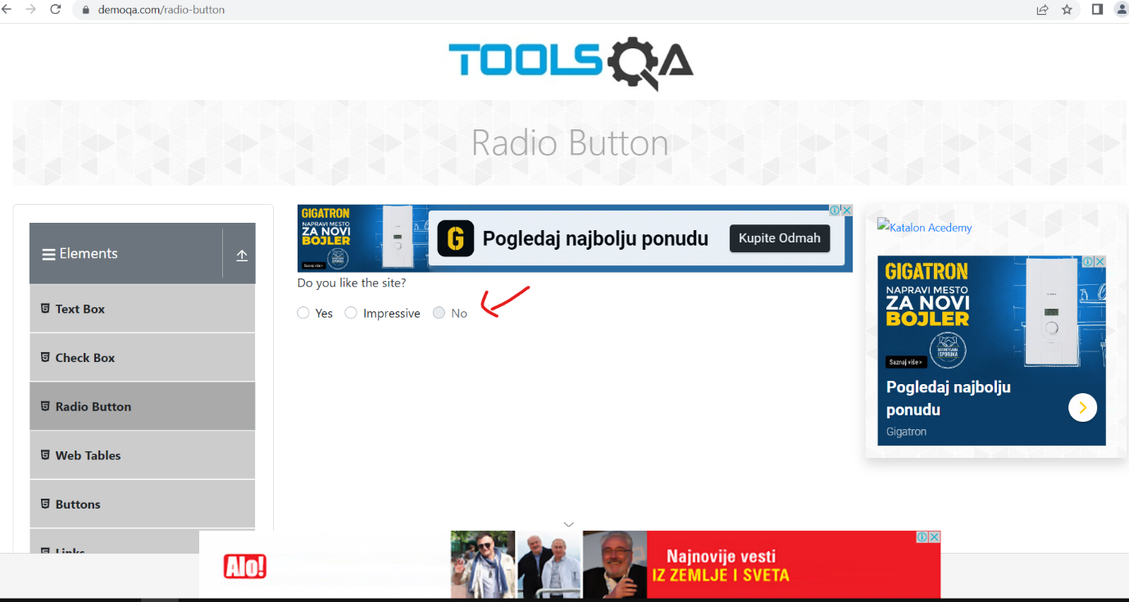Elements, radio buttons option has a not clickable button “No”.

2 Elements, buttons option “Click me “ changes HTML ids periodically.

**Main menu option Widgets:**

1 Slider input field is not manually accessed and changeable

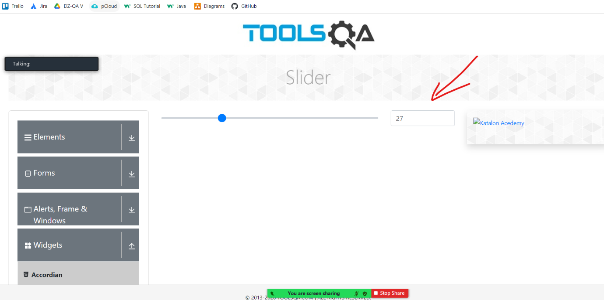

2. Tubs option “More” is not clickable.

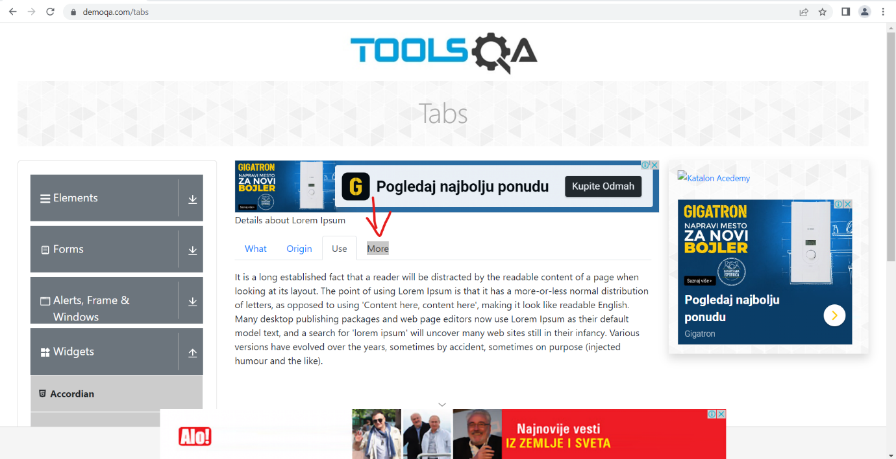

**Main menu option Interactions:**

1. Draggable, Axis Restricted option elements go out of the border

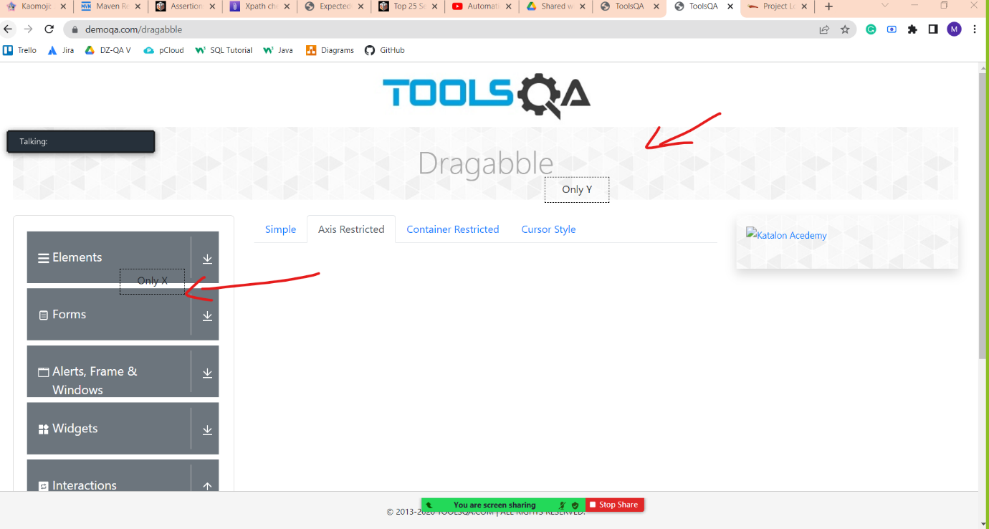

2. Draggable cursor style option elements can go out of boundaries.

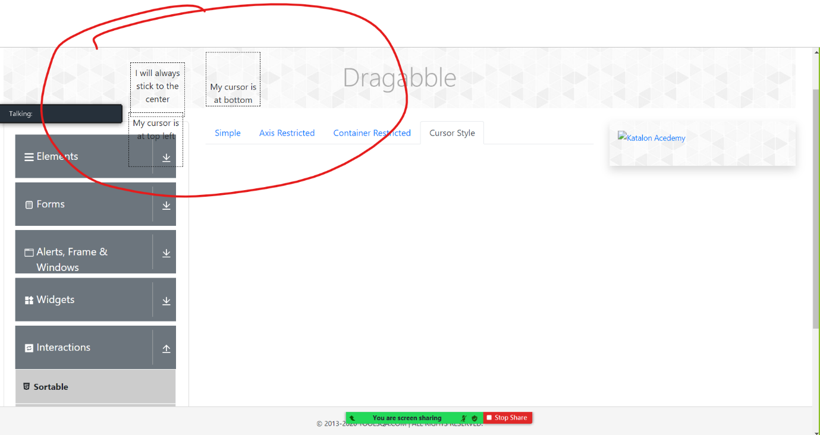

Note: I’m simply documenting things that I have found to be unusual. I have no way of knowing whether they are intentionally fashioned in this way.