Supplementary material 3

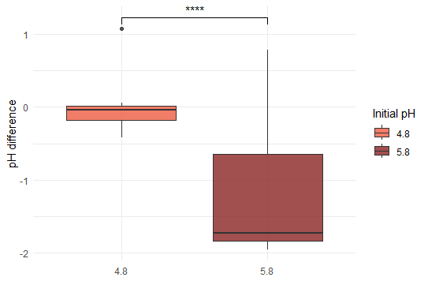
Figure S1: pH changes according to initial pH. The boxplots represent the change in pH after 48 hours of cultivation for the cultures starting with different initial pH (4.8 and 5.8 from left to right). The difference in pH change was calculated with Wilcoxon’s rank sum test: ****p<0.0001.

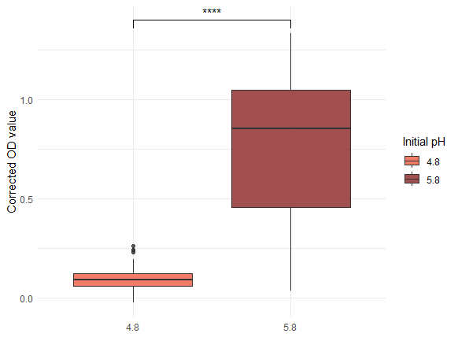
Figure S2: Corrected OD according to initial pH. The boxplots represent the change in OD after 48 hours of cultivation for the cultures starting with different initial pH (4.8 and 5.8 from left to right). The difference in OD value was calculated with Wilcoxon’s rank sum test: ****p<0.0001.

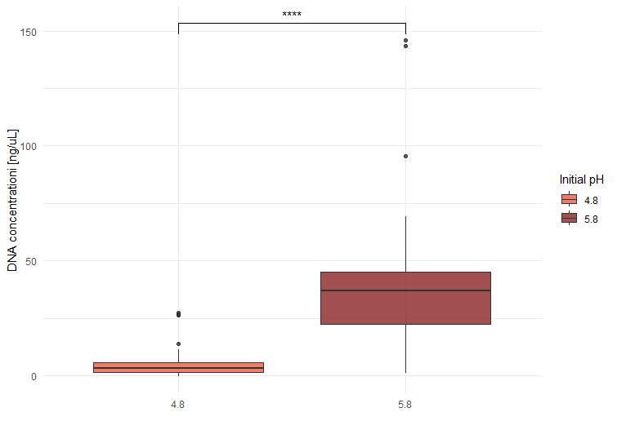
Figure S3: DNA concentration according to initial pH. The boxplots represent the DNA concentration for the two cultures starting with different initial pH (4.8 and 5.8 from left to right). The difference in DNA concentration was calculated with a Welch two sample t-test: ****p<0.0001.

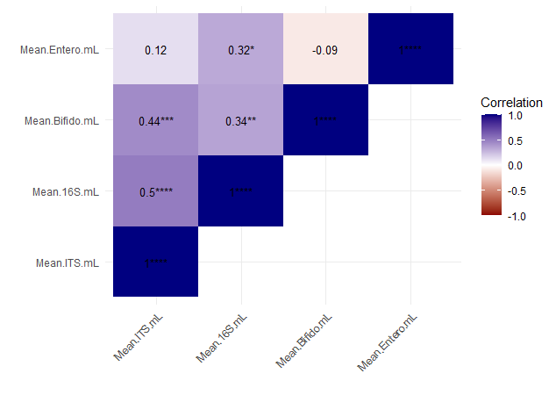
Figure S4: Kendall correlation between the different qPCR target abundance. The squares show the correlation between different targets. Positive and negative correlations are colored in blue and red respectively. Statistical method used is Kendall’s correlation test. *p<0.05, **p<0.01, ***p<0.001, ****p<0.0001.

