Predicting Tuberculosis Incidence in 2022: A Ridge Regression and SHAP Analysis

Mila Jovanoska
Faculty of Computer Science and Engineering (FINKI)
Ss. Cyril and Methodius University (UKIM)
Skopje, North Macedonia
ORCID: 0009-0003-2368-7554
Andrej Ristovski
Faculty of Computer Science and Engineering (FINKI)
Ss. Cyril and Methodius University (UKIM)
Skopje, North Macedonia
ORCID: 0009-0009-5482-0331
Anika Ristevska
Faculty of Computer Science and Engineering (FINKI)
Ss. Cyril and Methodius University (UKIM)
Skopje, North Macedonia
ORCID: 0009-0006-5292-256X
Slobodan Kalajdziski
Faculty of Computer Science and Engineering (FINKI)
Ss. Cyril and Methodius University (UKIM)
Skopje, North Macedonia
ORCID: 0000-0003-3373-8637

Abstract—Tuberculosis (TB) remains a major global and public health challenge, disproportionately affecting low- and middle-income countries. Understanding how nutritional availability, socio-economic development, and health-system capacity jointly relate to tuberculosis incidence is critical for evidence-based policy design. Multiple regression models were used to predict the tuberculosis incidence rate (per 100,000 population) at the country-level for the year 2022. The best performing model was Ridge regression, and was trained on an integrated dataset combining Food and Agriculture Organization Corporate Statistical Database (FAOSTAT) nutrition supply indicators, United Nations Development Programme (UNDP) human development measures, as well as selected health-system variables. Tuberculosis incidence values were initially log-transformed to address strong right-skewness, and all predictors were standardized prior to modeling. Hyperparameters were selected via 5-fold cross-validation, and the final model achieved RMSE of 0.86, R² of 0.69, and MAE of 0.69 (on a log scale) using a held-out test set. To enhance transparency and interpretability, SHAP (SHapley Additive exPlanations) was applied to quantify global feature contributions and identify dominant predictors of tuberculosis incidence. Results highlight the joint importance of dietary supply patterns, health-system coverage and socio-economic development. This work provides a reproducible baseline for cross-country tuberculosis risk modeling and demonstrates the value of explainable machine learning for public health analysis.
Index Terms—tuberculosis incidence, Ridge regression, nutrition supply, human development index, SHAP, explainable machine learning

Introduction
Tuberculosis, caused by Mycobacterium tuberculosis, continues to be one of the leading infectious causes of morbidity and mortality worldwide [1]. Despite effective prevention and treatment strategies, TB incidence remains unevenly distributed across countries, reflecting deep structural inequalities in nutrition, development, and health-system capacity. Cross-national studies have shown that national TB incidence dynamics are associated with broad development and infrastructure measures (e.g., the Human Development Index (HDI) and sanitation access) [2] and with social protection expenditure at the macro-policy level [3]. Longitudinal ecological analyses across 116 countries similarly report associations between TB incidence and social determinants over time [4].
Prior work has explored individual determinants of TB, such as income, vaccination coverage, or malnutrition; however, fewer studies integrate these factors into a unified, explainable machine-learning framework at a global scale. This study addresses this gap by developing a predictive model of TB incidence using harmonized, country-level indicators spanning nutrition supply, human development, and health system parameters. By combining regularized regression with SHAP-based interpretability, we aim to balance predictive performance with transparency, enabling insights into the relative importance of different determinants.

Data Sources and Variables
Four publicly available datasets were integrated at the country level for the reference year 2022 to ensure temporal comparability across all sources.

FAOSTAT Food Balance Sheets
Per-capita food supply and nutrient availability indicators, including dietary energy, protein, fat, and food-group specific supply measures. These variables serve as proxies for population-level dietary patterns and nutritional context [5].

WHO Tuberculosis Data
Tuberculosis incidence per 100,000 population (used as the dependent variable), along with selected health-system and living-condition indicators relevant to TB prevention [6].

UNDP Human Development Index
Composite measure of HDI scores and core dimensions reflecting health, education, and income, capturing broader socio-economic context [7].

BCG Vaccination Coverage
Annual, country-level BCG immunization coverage i.e., the percentage of children aged 12-23 months who received one dose of the BCG vaccine [8].

As shown in Fig. 1, estimated TB incidence rates in 2022 vary substantially across countries. The final integrated dataset represents a unified country-level feature matrix that combines nutritional, socio-economic, and health-system determinants. It consists of 183 countries and 49 variables: 39 FAOSTAT Indicator-Food Group features, six UNDP variables, two BCG-coverage variables, and one WHO target variable. A country identifier was retained for indexing but was not used as a predictor.
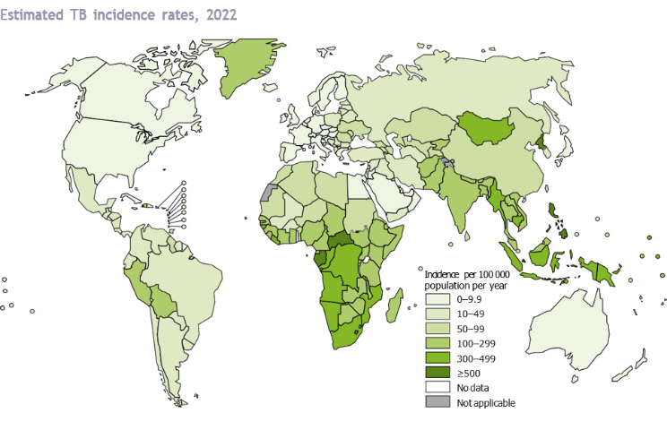
Fig. 1. Global incidence of tuberculosis (TB) per 100,000 population in 2022, based on data from the World Health Organization (WHO)

Data Integration and Preprocessing
Country identifiers were harmonized across datasets using curated replacement mappings to resolve naming inconsistencies (e.g., “UK” vs. “United Kingdom”). FAOSTAT indicators were reshaped into a wide format to produce a single observation per country with multiple nutrition features. TB incidence was log-transformed to mitigate skewness and stabilize variance. After integration, the merged dataset was subjected to consistency checks to verify country-level alignment and to confirm the absence of duplicated or mismatched records.
Nutrition predictors were derived from a targeted subset of FAOSTAT indicators rather than the full indicator set. Selection prioritized indicators with plausible links to TB risk and immune function, including protein supply, energy supply, vitamin A supply, calcium supply, iron supply, zinc supply, vitamin C supply, total saturated fatty acids supply, total monounsaturated fatty acids supply, selenium supply, vitamin B12 supply, and vitamin B6 supply. For each selected indicator, the top-k (k = 5) food groups (ranked by 2022 per-capita supply) were retained to emphasize dominant dietary contributors while reducing feature sparsity and dimensionality.
Integration was performed sequentially: (i) FAOSTAT nutrition features were inner-joined with WHO TB incidence to ensure a valid target value per country; (ii) the resulting dataset was inner-joined with UNDP HDI indicators to retain only countries present in both sources; and (iii) BCG vaccination coverage was left-joined to preserve the maximal TB/FAOSTAT/HDI coverage while allowing missing BCG values to be imputed using Multiple Imputation by Chained Equations (MICE), with HDI indicators used as predictors. Finally, all continuous input variables were standardized prior to modeling and the final produced dataset was validated for missingness and duplication before splitting into training and test sets.

Modeling Approach – SHAP Analysis
Predictive performance was benchmarked across multiple supervised regression models, including baseline mean/median predictors, linear regression, and regularized linear models (Lasso, Ridge, and Elastic Net). Non-linear approaches were additionally evaluated, namely Decision Tree, Random Forest, Gradient Boosting, XGBoost, SVR (RBF kernel), and k-nearest neighbors (KNN) with Principal Component Analysis (PCA) for dimensionality reduction. All models used the same train/test split and standardized features. Hyperparameters were selected via k-fold (k = 5) cross-validation on the training set using grid search. Comparisons relied primarily on RMSE, while R² and MAE were reported to provide complementary performance evidence.
A Ridge regression model was selected to address multicollinearity in the high-dimensional, correlated feature space. Predictors were standardized using training-set statistics to ensure comparable regularization across features, as defined in (1).
$x_{ij}^{'}= \frac{x_{ij}- μ_{j}}{σ_{j}}$ 
where $μ_{j}$and $σ_{j}$ are the mean and standard deviation of feature $j$ computed on the training set.
Because TB incidence is strictly non-negative and right-skewed, the response $y_{i}$ was log-transformed to obtain $z_{i}$, as formulated in (2).
$z_{i}=\ln\left(y_{i}\right)$ 2
where $y_{i}$ denotes the original TB incidence for country $i$ and $z_{i}$ the transformed target.
Model parameters were estimated by minimizing the ℓ₂-regularized least-squares objective in (3), in which the coefficient vector is penalized to control variance under a high-dimensional, correlated feature set. The regularization strength 𝜆 was treated as a tuning parameter and selected via grid search over a logarithmically spaced candidate set of 13 values (𝜆 ∈ [10⁻³, 10³]).
This procedure yielded an optimal setting of 𝜆 = 3.16, which was subsequently fixed for the final model.
$\left({\hat{β}}_{0}, \hat{β}\right)=\arg{\min_{β_{0}, β}\left[\frac{1}{n} \sum_{i=1}^{n}{{\left(z_{i}-β_{0}-x_{i}^{T}β\right)}^{2}+ λ{\left\|β\right\|}_{2}^{2}}\right]}$ 3
where ${\hat{β}}_{0}$is the intercept, $β$ is the coefficient vector, and 𝜆$≥$ 0 controls the regularization strength (selected via internal cross validation).
Predictive performance was evaluated on a held-out test set using 𝑅², RMSE, and MAE, defined in (4)-(6).
$R_{log}^{2}=1- \frac{\sum_{i=1}^{n}{{\left(z_{i}- {\hat{z}}_{i}\right)}^{2}}}{\sum_{i=1}^{n}{{\left(z_{i}-\overline{z}\right)}^{2}}}, \overline{z}= \frac{1}{n} \sum_{i=1}^{n}{z_{i}}$ 4
${RMSE}_{log}= \sqrt{\frac{1}{n}\sum_{i=1}^{n}{{(z_{i}- {\hat{z}}_{i})}^{2}},}$ 5
${MAE}_{log }= \frac{1}{n} \sum_{i=1}^{n}{\left|z_{i}- {\hat{z}}_{i}\right|}$ 6
where $z_{i}$ and ${\hat{z}}_{i}$ denote the observed and predicted TB incidence for sample $i$.
The following Table I summarizes the five best-performing models ordered by increasing RMSE. Alongside this measure, the table reports the corresponding test-set МАЕ and R², providing a balanced view of prediction error. In comparison, alternative candidates offer only modest added value and fail to exceed the Ridge reference, suggesting that additional sparsity or nonlinear capacity does not translate into superior generalization in this setting.
- PREDICTIVE PERFORMANCE OF MODELS
Models & Hyperparameters | Performance on the held-out test set
Models & Hyperparameters | RMSE log | R² log | MAE log
Ridge Regression  (α = 3.16) | 0.86 | 0.69 | 0.69
Lasso Regression  (α = 0.02) | 0.91 | 0.68 | 0.68
Gradient Boosting Regression  (trees = 200; learning rate = 0.05; max depth = 4) | 0.91 | 0.68 | 0.77
Elastic Net Regression  (α = 0.06; l1 ratio = 0.10) | 0.93 | 0.67 | 0.70
Random Forest Regressor  (trees = 300; max features = sqrt; min split = 4) | 0.93 | 0.67 | 0.78

To interpret model predictions, SHAP [9] was applied as a post hoc explainability method. Global importance was assessed using SHAP summary (beeswarm) visualizations [10] and mean absolute SHAP value rankings, calculated using (8). The Fig. 2 presents the SHAP summary plot for the full Ridge model, while Fig. 3 represents the corresponding beeswarm plot restricted to supply indicators (nutrition-only subset). In both figures, the horizontal axis indicates the direction and magnitude of each feature’s impact on 𝑓(𝑥); the method output 𝑓(𝑥) is represented in additive form in (7). The color gradient encodes the feature value, illustrating how high or low predictor values shift the log TB incidence.
$f\left(x\right)= ϕ_{0}+ \sum_{j=1}^{p}{ϕ_{j}}$ 7
where 𝑓(𝑥) denotes the model output (predicated log TB incidence), $ϕ_{0}$ is the expected model output, and $ϕ_{j}$ is the SHAP value capturing the contribution of feature $j$ for a given instance.
$I_{j}= \frac{1}{n} \sum_{i=1}^{n}{\left|ϕ_{ij}\right|}$ 8
where $ϕ_{ij}$ is the SHAP value of feature $j$ for country $i$.
This restriction to FAOSTAT supply indicators (39 features) isolates the dietary contribution to the predicted outcome.
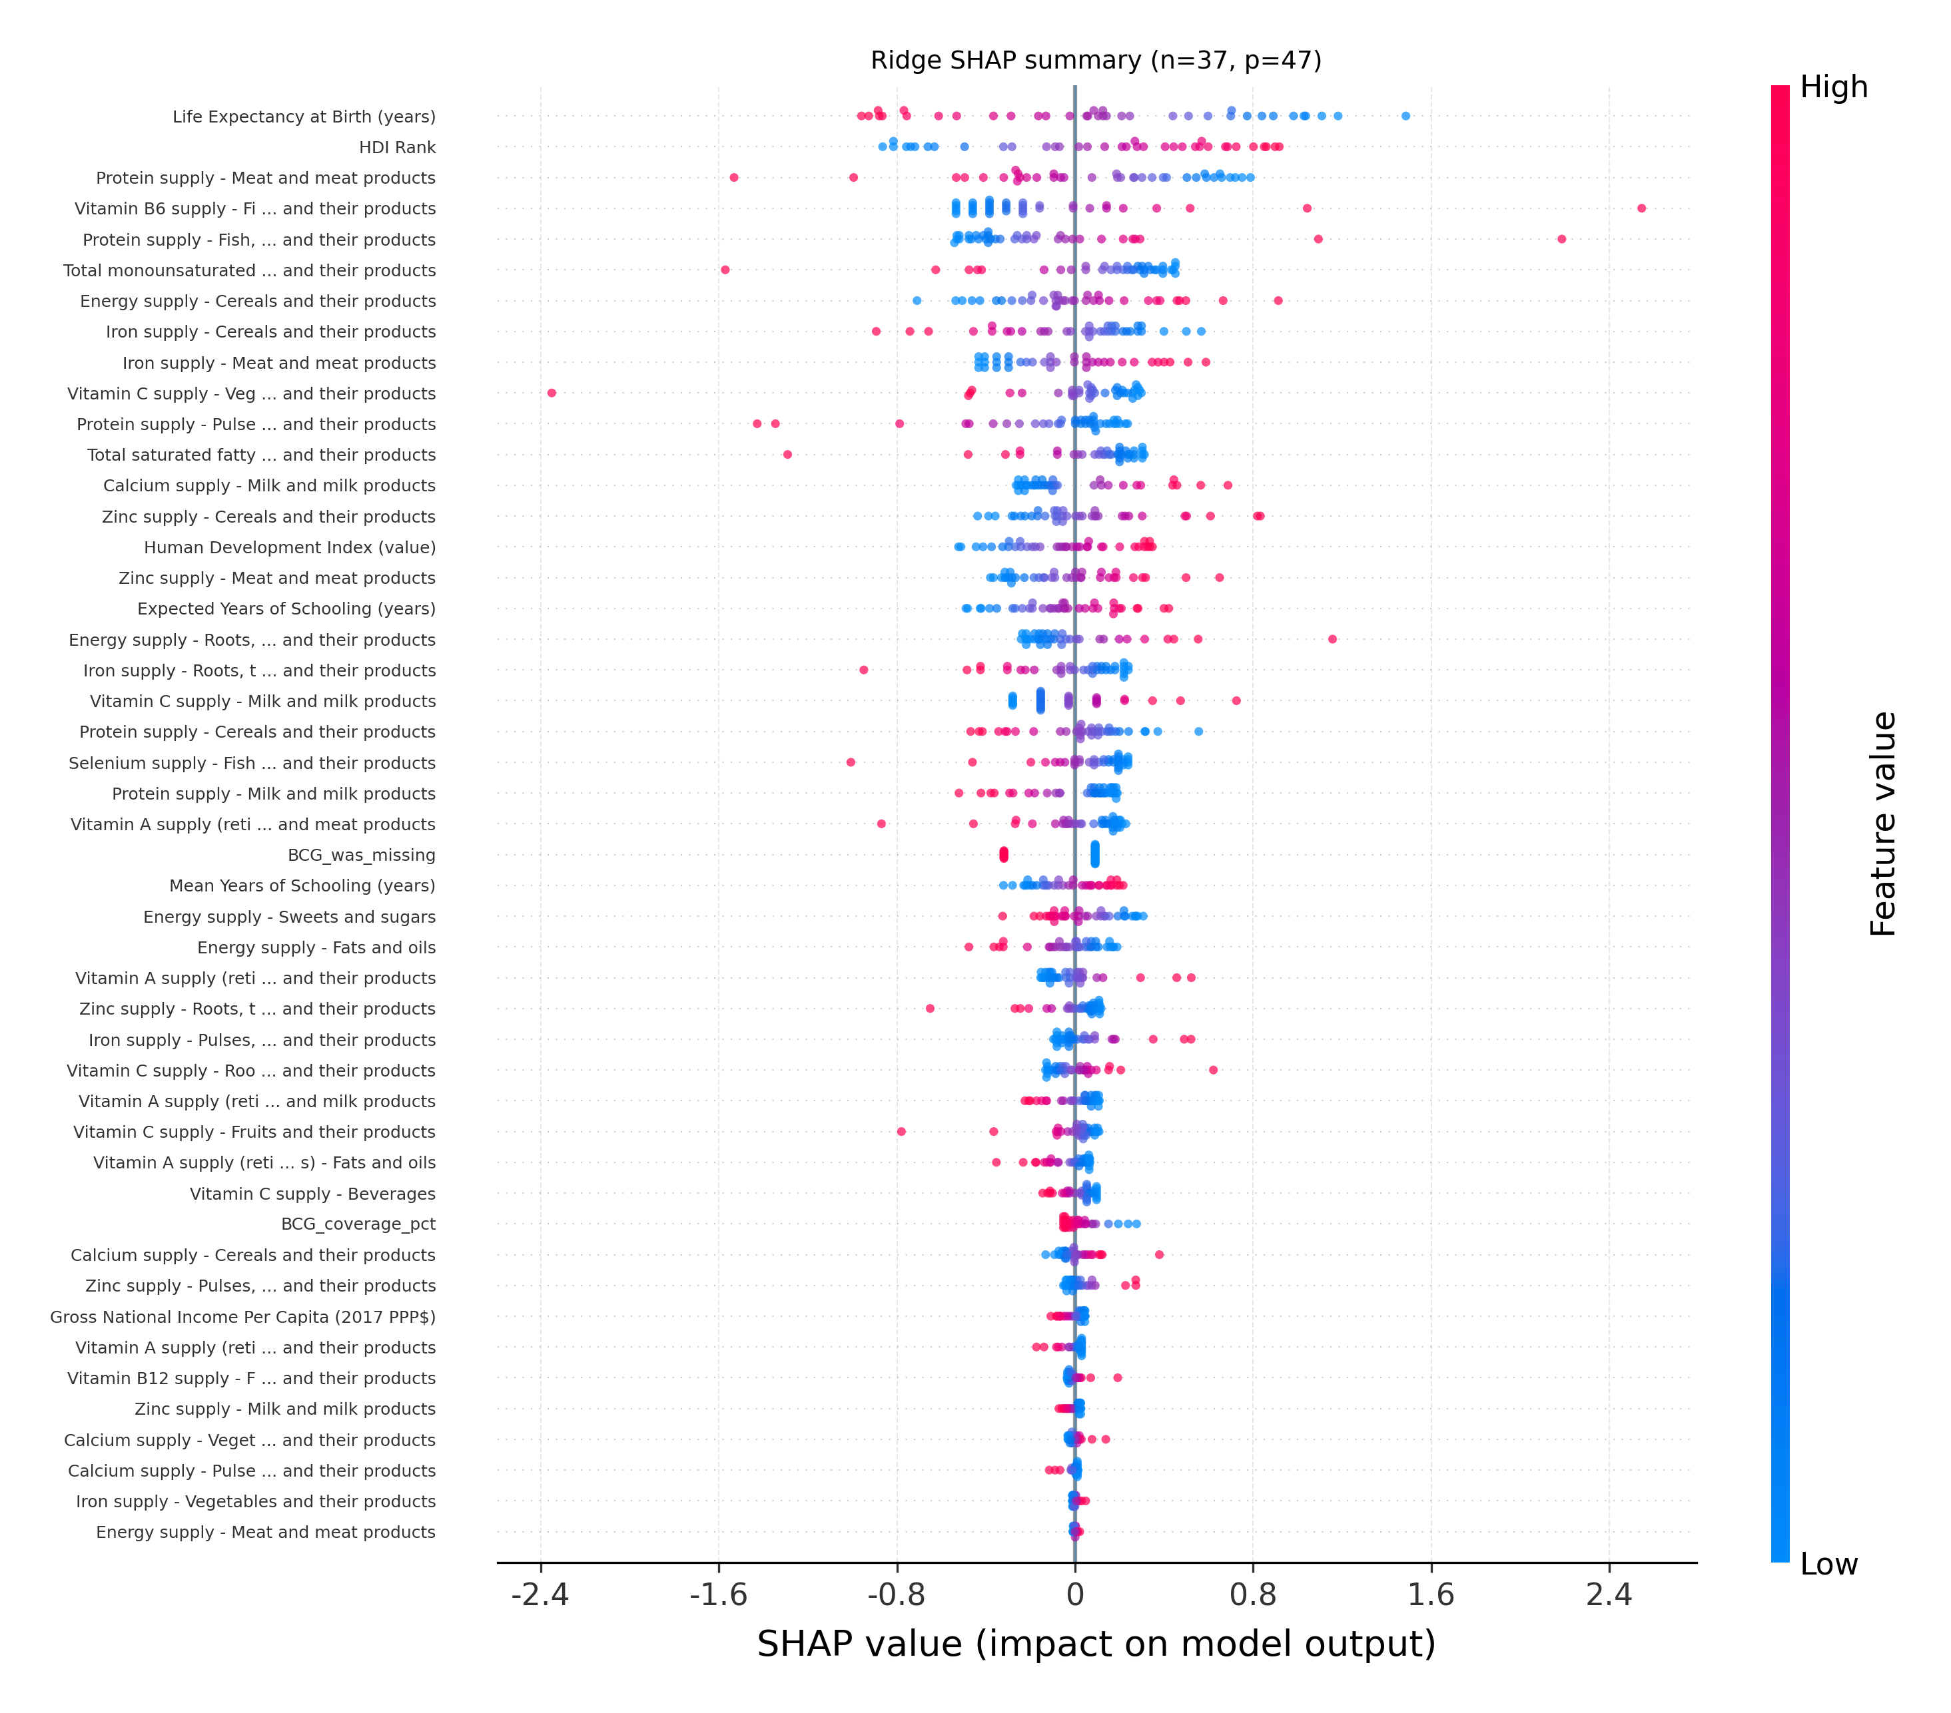
Fig. 2. SHAP summary plot for the Ridge regression model predicting log-transformed tuberculosis incidence (per 100,000 population) in 2022, based on all integrated indicators
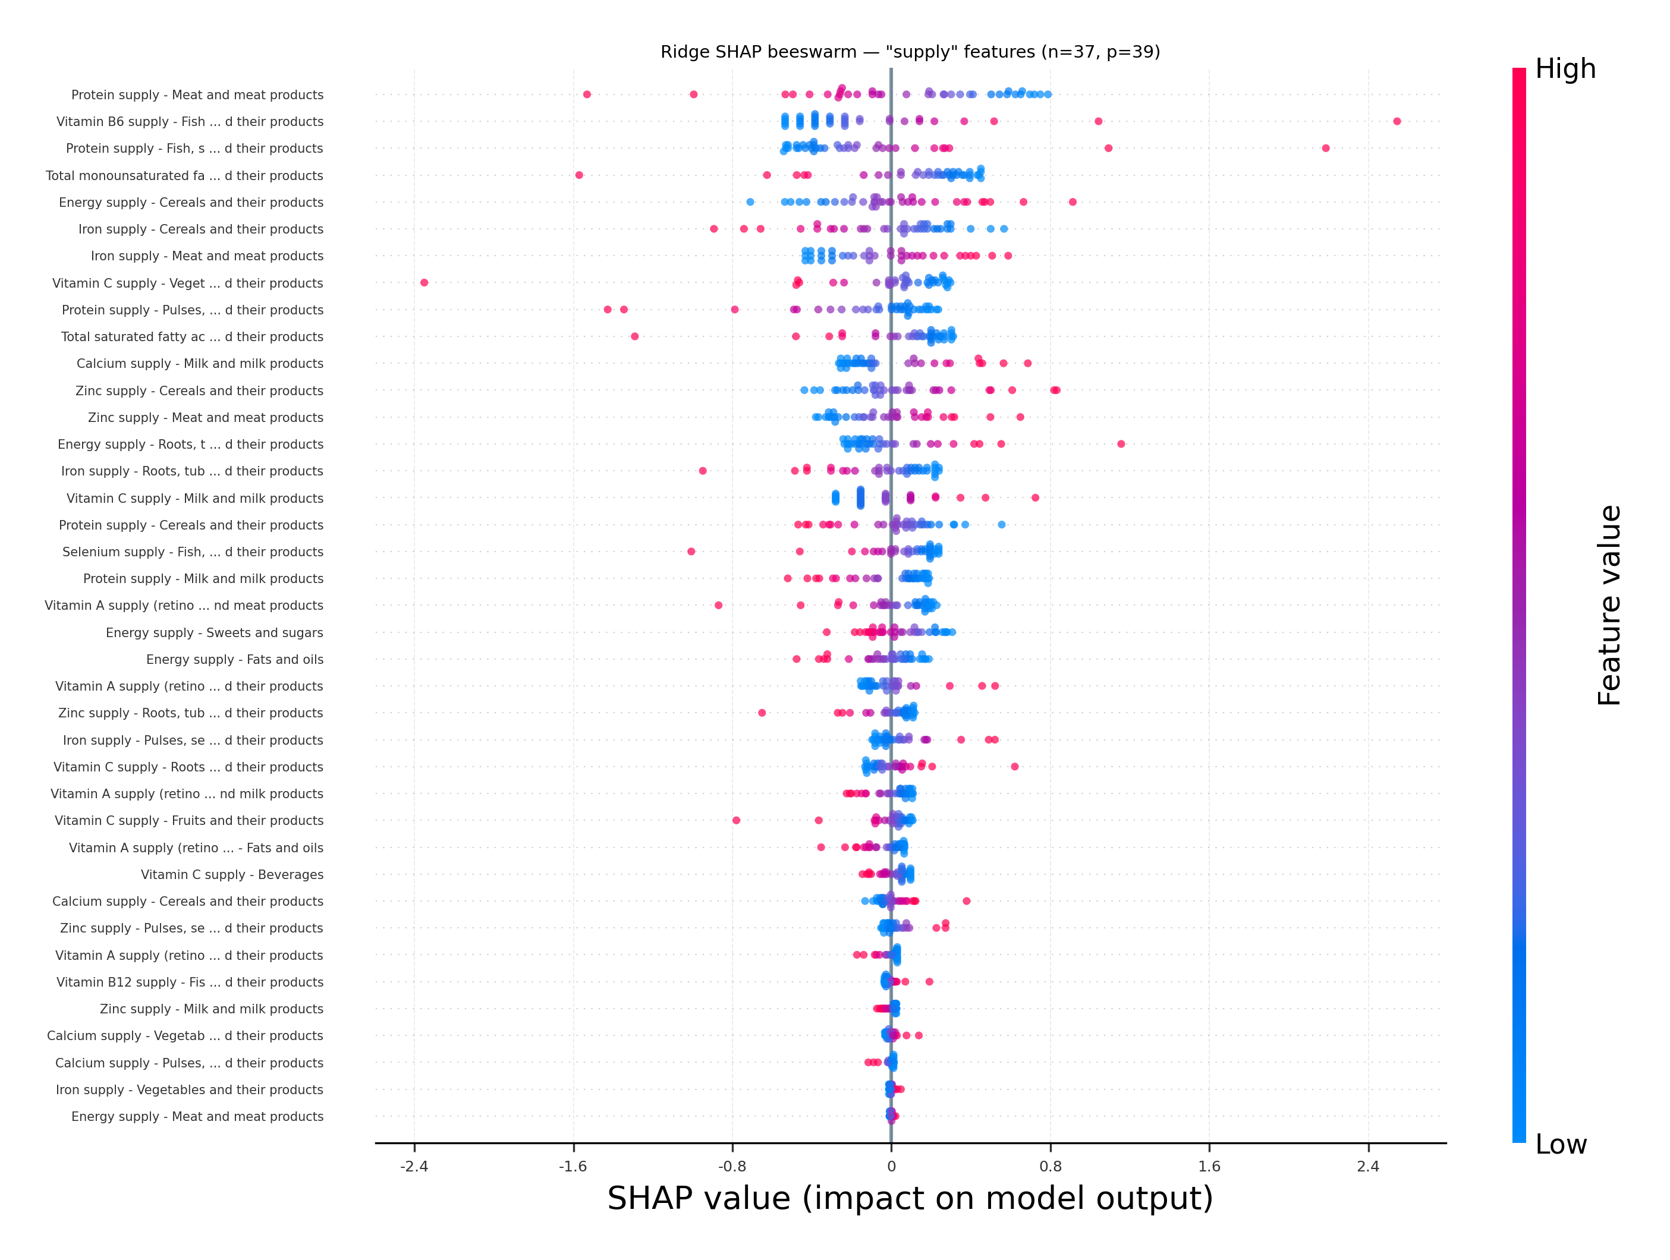
Fig. 3. SHAP summary plot for the Ridge regression model predicting log-transformed tuberculosis incidence (per 100,000 population) in 2022, restricted to nutrition “supply” indicators only

Results and Discussion
The Ridge model achieved moderate-to-strong predictive performance on the held-out test set (R² ≈ 0.69). SHAP explanations indicate that macro-level development factors dominate the predictive signal: higher life expectancy and higher Human Development Index (HDI) values consistently shift predictions toward lower TB incidence. Conversely, a higher numerical HDI rank (i.e., worse development standing) yields positive SHAP contributions and shifts predictions toward higher TB incidence.
Beyond socio-economic context, several nutrition supply features show systematic associations with the predicted outcome. In particular, higher per-capita protein supply from meat and meat products is predominantly associated with lower predicted TB incidence, while higher reliance on cereal-based dietary energy tends to be associated with higher predicted TB incidence. Additional contributions are observed for fat-related indicators (e.g., monounsaturated fatty acids supplied by oils) and micronutrient proxies tied to specific food groups. The nutrition-only SHAP analysis reinforces that the dietary signal is concentrated in a limited set of dominant food-group contributors (top k = 5 per indicator), suggesting that cross-country differences in diet composition-rather than isolated nutrients-are reflected in model predictions.
Prior multi-country ecological analyses have linked TB incidence trends to development indicators such as HDI and sanitation [2] and to macro-level factors such as social protection spending [3], often using longitudinal regression approaches [4]. Building on that literature, this work integrates nutrition supply, human development, and BCG coverage within a single regularized model and uses SHAP to provide interpretable, country-level drivers of predicted TB incidence.
Overall, the findings support a multifactorial pattern in which socio-economic development, health-system context, and nutrition availability jointly shape country-level TB risk profiles. However, these results should be interpreted cautiously and as associative rather than causal. Because the analysis is based on country-level data for a single reference year, it does not capture longitudinal dynamics or year-to-year variation in TB incidence and related determinants. In addition, the ecological aggregation of predictors at the national level may obscure substantial within-country heterogeneity and may not fully reflect local epidemiological, nutritional, or health-system conditions. Although the model combines nutritional, developmental, and health-related indicators, unmeasured or imperfectly measured confounders may still influence the observed associations. Future work should therefore validate this framework using multi-year panel data and alternative country-level datasets in order to assess the stability, robustness, and generalizability of the identified predictive patterns.

Conclusion
This study presents a transparent and reproducible baseline for country-level tuberculosis (TB) incidence prediction for 2022 using regularized regression and SHAP-based interpretability on an integrated multi-source dataset. The proposed framework provides both predictive benchmarking and feature-level insights that help characterize the relative contributions of development, health-system, and nutrition-related factors to the predicted outcome.
Future work should prioritize temporal and external validation by extending the analysis across multiple years and, where feasible, testing the framework on alternative country-level datasets. Such extensions would help assess the stability and generalizability of the identified predictive patterns and further clarify the extent to which the reported associations may be influenced by unobserved confounding.

References

- World Health Organization, World Health Statistics 2023: Monitoring Health for the SDGs. Geneva, Switzerland: WHO, 2023. [Online]. Available: https://www.who.int/publications/i/item/9789240083851
- C. Dye, K. Lönnroth, E. Jaramillo, B. G. Williams, and M. Raviglione, “Trends in tuberculosis incidence and their determinants in 134 countries,” Bull. World Health Organ., vol. 87, no. 9, pp. 683–691, 2009, doi: 10.2471/BLT.08.058453.
- A. Siroka, N. A. Ponce, and K. Lönnroth, “Association between spending on social protection and tuberculosis burden: a global analysis,” Lancet Infect. Dis., vol. 16, no. 4, pp. 473–479, 2016, doi: 10.1016/S1473-3099(15)00401-6.
- F. A. Költringer, K. S. Annerstedt, D. Boccia, D. J. Carter, and W. E. Rudgard, “The social determinants of national tuberculosis incidence rates in 116 countries: a longitudinal ecological study between 2005–2015,” BMC Public Health, vol. 23, no. 1, Art. no. 337, 2023, doi: 10.1186/s12889-023-15213-w.
- Food and Agriculture Organization of the United Nations, “FAOSTAT-Food Balance Sheets (FBS),” FAOSTAT. [Online]. Available: https://www.fao.org/faostat/en/#data/SUA
- World Health Organization, “Tables of health statistics by country and area, WHO region and globally (XLSX),” World health statistics 2024: monitoring health for the SDGs, 2024. [Online]. Available: https://www.who.int/data/gho/publications/world-health-statistics
- United Nations Development Programme, “Human Development Reports-Data Center,” UNDP HDR. [Online]. Available: https://hdr.undp.org/data-center/human-development-index#/indicies/HDI
- Our World in Data, “Share of newborns vaccinated against tuberculosis among one-year-olds across countries,” 2025. [Online]. Available: https://archive.ourworldindata.org/20260119-070102/grapher/bcg-immunization-coverage-for-tb-among-1-year-olds.html
- SHAP Documentation, “SHAP documentation,” [Online]. Available: https://shap.readthedocs.io/en/latest/
- SHAP Documentation, “Beeswarm plot,” [Online]. Available: https://shap.readthedocs.io/en/latest/example_notebooks/api_examples/plots/beeswarm.html

