

CCT College Dublin Continuous Assessment

|  |  |  |  |
| --- | --- | --- | --- |
| Programme Title: | HDIP Data Analytics | | |
| Cohort: | HDIP Feb 22 FT/PT | | |
| Module Title(s): | Data Visualization Techniques | | |
| Assignment Type: | Individual | Weighting(s): | 40% |
| Assignment Title: | CA1_DVis_HDip_Lvl8 | | |
| Lecturer(s): | David McQuaid | | |
| Issue Date: | 20/3/2023 | | |
| Submission  Deadline Date: | 20/4/2023 11:55pm | | |
| Late Submission Penalty: | Late submissions will be accepted up to 5 calendar days after the deadline. All late submissions are subject to a penalty of 10% of the mark awarded.  Submissions received more than 5 calendar days after the deadline above will not be accepted and a mark of 0% will be awarded. | | |
| Method of  Submission: | Moodle | | |
| Instructions for Submission: | Assessment must be submitted before 11.55pm 20/4/2023 as a Jupyter Notebook file and a PDF.  The Jupyter Notebook File Must be saved as “YourName_DVisHDip_CA1.ipynb”  The PDF File Must be saved as “YourName_DVisHDip_CA1.pdf” | | |
| Feedback Method: | Results posted in Moodle gradebook | | |
| Feedback Date: | Approx. 2 weeks after FINAL submission (inc PMC cases) | | |

Learning Outcomes:

Please note this is not the assessment task. The task to be completed is detailed on the next page. This CA will assess student attainment of the following minimum intended learning outcomes:

1. Discuss the concepts, techniques and processes underlying data visualisation (Linked to PLO 1)
2. Critically evaluate visualisation approaches with respect to their suitability for different problem areas.(Linked to PLO 5)
3. Select appropriate data visualisation techniques for a given use case, data characteristics and multiple transmission media.(Linked to PLO 3, PLO 4)

Attainment of the learning outcomes is the minimum requirement to achieve a Pass mark (40%). Higher marks are awarded where there is evidence of achievement beyond this, in accordance with QQI Assessment and Standards, Revised 2013, and summarised in the following table:

|  |  |  |
| --- | --- | --- |
| Percentage Range | CCT  Performance  Description |  |
| Level 6, 7 & 8 awards |
| 90% + | Exceptional | Achievement includes that required for a Pass and in most respects is significantly and consistently beyond this |
|  |  |
| 80 – 89% | Outstanding |  |
| 70 – 79% | Excellent |
| 60 – 69% | Very Good | Achievement includes that required for a Pass and in many respects is significantly beyond this |
| 50 – 59% | Good | Achievement includes that required for a Pass and in some respects is significantly beyond this |
| 40 – 49% | Acceptable | Attains all the minimum intended programme learning outcomes |
| 35 – 39% | Fail | Nearly (but not quite) attains the relevant minimum intended learning outcomes |
| 0 – 34% | Fail | Does not attain some or all of the minimum intended learning outcomes |

Please review the CCT Grade Descriptor available on the module Moodle page for a detailed description of the standard of work required for each grade band.

The grading system in CCT is the QQI percentage grading system and is in common use in higher education institutions in Ireland. The pass mark and thresholds for different grade bands may be different from what you have experience of in the higher education system in other countries. CCT grades must be considered in the context of the grading system in Irish higher education and not assumed to represent the same standard the percentage grade reflects when awarded in an international context.

Assessment Task

Students are advised to review and adhere to the submission requirements documented after the assessment task.

Scenario:

You have been retained by a retail company to analyse a dataset based on board games. This analysis will help determine the sales strategy for the company in their upcoming Winter season.

Each answer MUST have a separate visualization that can be easily understood, visually represents the answer, and all data wrangling, analysis, and visualizations must generated using python.

The companies CTO also requires you to rationalize all the decisions that you have made in your report.

This rationalization MUST include your visualization design decisions, how you have engineered the data, feature selection and any other information that you deem relevant.

# Requirements

You are required to use the dataset contained within the file “board_games.csv” and then answer the following questions:

# Part 1: (Column Names are denoted by quotation marks)

* What are the top 5 “average rated” games?
* Is there a correlation between the “users_rated” and the “max_playtime”?
* What is the distribution of game categories?
* Do older games (1992 and earlier) have a higher MEAN “average rating” than newer games (after 1992)?
* What are the 3 most common “mechanics” in the dataset?

# Part 2

* You must answer a “Statistically Relevant” question, OF YOUR OWN CHOOSING, using the dataset, that has not been asked in Part 1. This must have a logical basis that enhances the information and insight gained in the scenario.

Part3:

You must explain, in detail,

* why you chose a specific method to engineer the data and how you achieved this in python (Part 1/Part 2)
* why you chose your specific visualizations to illustrate each answer (Part 1/Part 2)
* what design decisions you made for each visualization (for example, but not only: colour, font, titles, size, text position, font size etc) (Part 1/Part 2)
* what your rationale is for the visualization created in Part 2 and how your question enhances the information and insight gained in the scenario (Part 2)

All written work MUST be detailed in your Jupyter Markdown (NOT in code comments). You must also provide a PDF copy of your Jupyter Notebook for dissemination. Data Dictionary

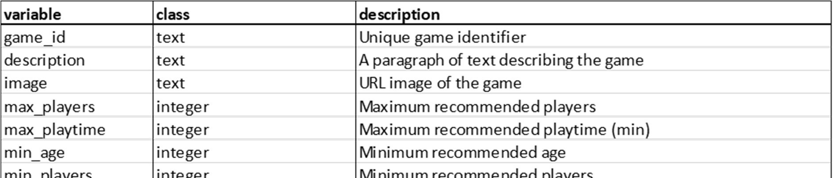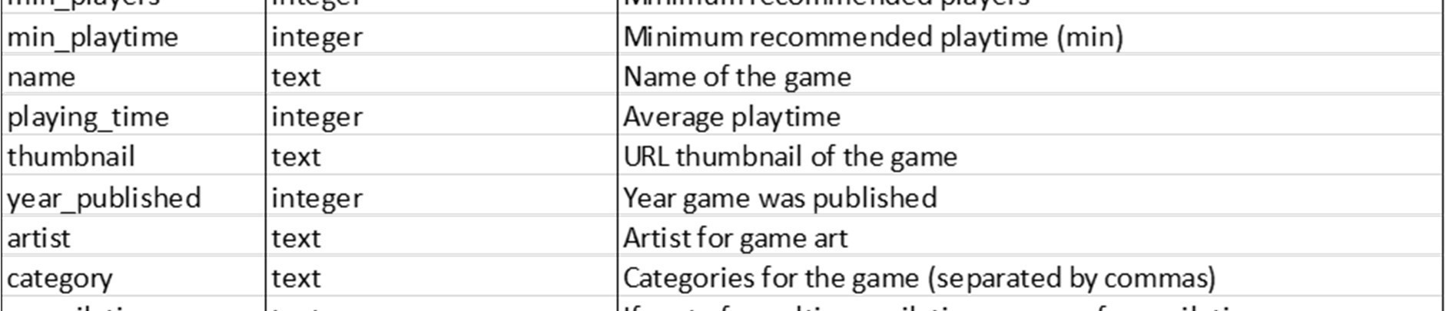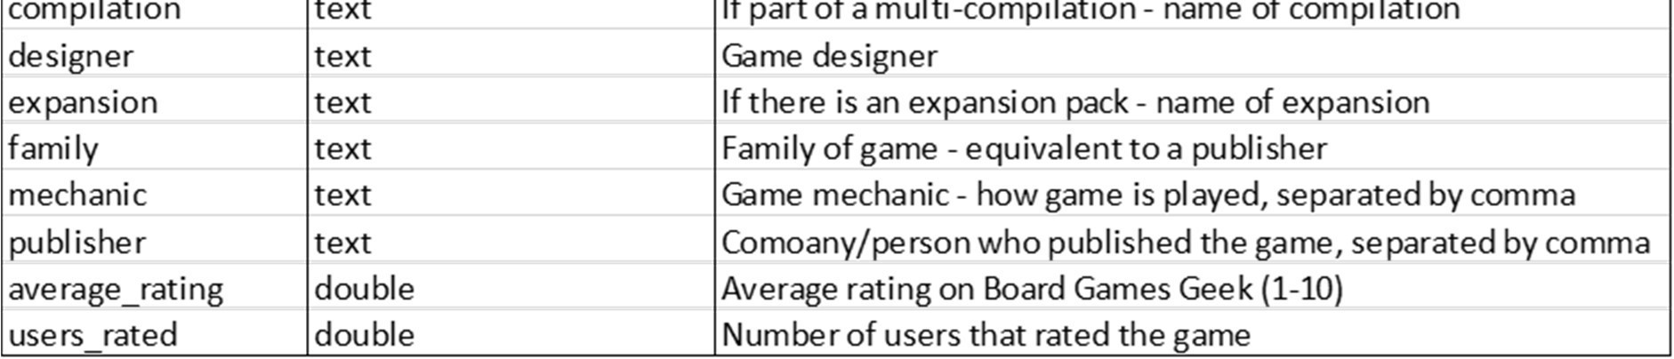

Submission Requirements

All assessment submissions must meet the minimum requirements listed below. Failure to do so may have implications for the mark awarded. All assessment submissions must:

* Be submitted before 11.55pm 20/4/2023 as a Jupyter Notebook file and a PDF.
* The Jupyter Notebook File Must be saved as “YourName_DVisHDip_CA1.ipynb”
* The PDF File Must be saved as “YourName_DVisHDip_CA1.pdf”
* Be submitted by the deadline date specified or be subject to late submission penalties
* Be submitted via Moodle upload
* Use Harvard Referencing when citing third party material
* Be the student’s own work.
* Include the CCT assessment cover page.

Additional Information

* Lecturers are not required to review draft assessment submissions. This may be offered at the lecturer’s discretion.
* In accordance with CCT policy, feedback to learners may be provided in written, audio or video format and can be provided as individual learner feedback, small group feedback or whole class feedback.
* Results and feedback will only be issued when assessments have been marked and moderated / reviewed by a second examiner.
* Additional feedback may be requested by attending the next class, Additional feedback may be provided as individual, small group or whole class feedback. Lecturers are not obliged to respond to email requests for additional feedback where this is not the specified process or to respond to further requests for feedback following the additional feedback.

|  |
| --- |
| Following receipt of feedback, where a student believes there has been an error in the marks or feedback received, they should avail of the recheck and review process and should not attempt to get a revised mark / feedback by directly approaching the lecturer. Lecturers are not authorised to amend published marks outside of the recheck and review process or the Board of Examiners process.  Students are advised that disagreement with an academic judgement is not grounds for review.  For additional support with academic writing and referencing students are advised to contact the CCT Library Service or access the CCT Learning Space.  For additional support with subject matter content students are advised to contact the CCT Student  Mentoring Academy  For additional support with IT subject content, students are advised to access the CCT Support Hub. |

|  |
| --- |
|  |