**Practical – 10**

**AIM**: Implementat prim’s algorithm.

// for adjacency matrix representation of the graph

#include <bits/stdc++.h>

using namespace std;

// Number of vertices in the graph

#define V 5

int minKey(int key[], bool mstSet[])

{

int min = INT_MAX, min_index;

for (int v = 0; v < V; v++)

if (mstSet[v] == false && key[v] < min)

min = key[v], min_index = v;

return min_index;

}

void printMST(int parent[], int graph[V][V])

{

cout << "Edge \tWeight\n";

for (int i = 1; i < V; i++)

cout << parent[i] << " - " << i << " \t"

<< graph[i][parent[i]] << " \n";

}

void primMST(int graph[V][V])

{

int parent[V];

int key[V];

bool mstSet[V];

for (int i = 0; i < V; i++)

key[i] = INT_MAX, mstSet[i] = false;

key[0] = 0;

parent[0] = -1;

for (int count = 0; count < V - 1; count++)

{

int u = minKey(key, mstSet);

mstSet[u] = true;

for (int v = 0; v < V; v++)

if (graph[u][v] && mstSet[v] == false && graph[u][v] < key[v])

parent[v] = u, key[v] = graph[u][v];

}

printMST(parent, graph);

}

int main()

{

int graph[V][V] = {{0, 2, 0, 6, 0},

{2, 0, 3, 8, 5},

{0, 3, 0, 0, 7},

{6, 8, 0, 0, 9},

{0, 5, 7, 9, 0}};

// Print the solution

primMST(graph);

return 0;

}

**OUTPUT**

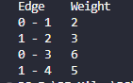

Time analysis

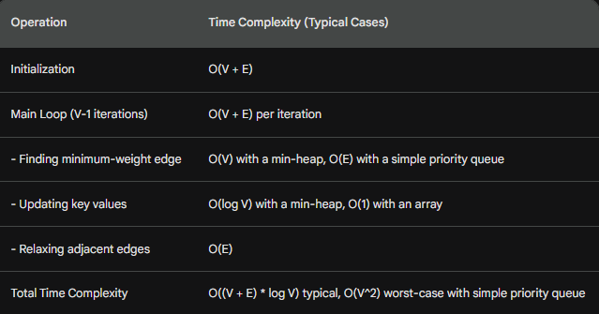

Applications

1. **Network Design:**

* Telecommunications: Designing cost-effective networks for connecting cities, buildings, or devices, such as laying fiber optic cables or establishing wireless links.
* Transportation: Planning routes for roads, railways, or airline networks to minimize construction or travel costs while connecting all destinations.
* Electrical Grids: Designing power distribution networks to minimize the cost of wiring and ensure efficient energy delivery.

2**. Clustering:**

* Image Segmentation: Dividing images into regions with similar characteristics (e.g., color, texture) for object recognition or analysis.
* Data Analysis: Grouping similar data points in various domains, such as customer segmentation for targeted marketing or identifying patterns in scientific data.

3. **Maze Generation:**

* Game Design: Creating random mazes with guaranteed solvability for puzzle games or challenges.

4. **Approximation** **Algorithms**:

* Traveling Salesman Problem: Finding near-optimal solutions for the TSP by using a minimum spanning tree as a starting point.

**5. Other Applications:**

* Bioinformatics: Analyzing protein structures and genetic sequences.
* VLSI Design: Designing integrated circuits.
* Social Network Analysis: Identifying communities and influential nodes in social networks.