**Practical – 11**

**AIM**: Implementat Kruskal’s algorithm.

#include <bits/stdc++.h>

using namespace std;

class DSU

{

int *parent;

int *rank;

public:

DSU(int n)

{

parent = new int[n];

rank = new int[n];

for (int i = 0; i < n; i++)

{

parent[i] = -1;

rank[i] = 1;

}

}

int find(int i)

{

if (parent[i] == -1)

return i;

return parent[i] = find(parent[i]);

}

void unite(int x, int y)

{

int s1 = find(x);

int s2 = find(y);

if (s1 != s2)

{

if (rank[s1] < rank[s2])

{

parent[s1] = s2;

}

else if (rank[s1] > rank[s2])

{

parent[s2] = s1;

}

else

{

parent[s2] = s1;

rank[s1] += 1;

}

}

}

};

class Graph

{

vector<vector<int>> edgelist;

int V;

public:

Graph(int V) { this->V = V; }

void addEdge(int x, int y, int w)

{

edgelist.push_back({w, x, y});

}

void kruskals_mst()

{

// Sort all edges

sort(edgelist.begin(), edgelist.end());

DSU s(V);

int ans = 0;

cout << "Following are the edges in the "

"constructed MST"

<< endl;

for (auto edge : edgelist)

{

int w = edge[0];

int x = edge[1];

int y = edge[2];

if (s.find(x) != s.find(y))

{

s.unite(x, y);

ans += w;

cout << x << " -- " << y << " == " << w

<< endl;

}

}

cout << "Minimum Cost Spanning Tree: " << ans;

}

};

int main()

{

Graph g(4);

g.addEdge(0, 1, 10);

g.addEdge(1, 3, 15);

g.addEdge(2, 3, 4);

g.addEdge(2, 0, 6);

g.addEdge(0, 3, 5);

g.kruskals_mst();

return 0;

}

**OUTPUT**

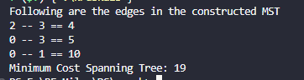

Time analysis

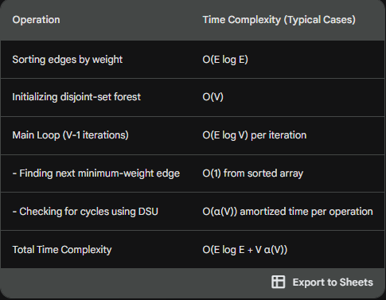

Applications

Network Design:

* Telecommunication Networks: Kruskal's algorithm can be used to design efficient and cost-effective telecommunication networks by connecting all locations with minimum total cable length.
* Computer Networks: It can be employed to design network topologies with minimum cost, ensuring that all computers are connected with optimal communication links.

Circuit Design:

* Printed Circuit Boards (PCBs): In electronics, Kruskal's algorithm can be applied to design the layout of connections on a printed circuit board to minimize the total length of connections.

Transportation Planning:

* Road Networks: In urban planning, Kruskal's algorithm can be used to plan road networks in a city, connecting important locations with the least cost in terms of road construction.
* Railway Networks: Similarly, it can be applied to design railway networks efficiently.

Resource Management:

* Water Supply Networks: Kruskal's algorithm can help in designing a water supply network to connect different areas with pipes of minimum total length, reducing construction costs.
* Power Grids: It can be used in the design of electrical power grids to connect different regions with the least amount of cabling.

Cluster Analysis:

* Data Clustering: Kruskal's algorithm, or variations of it, can be used in data analysis for clustering related data points, where the goal is to minimize the total dissimilarity or distance between clusters.

Molecular Biology:

* Phylogenetic Tree Construction: In bioinformatics, Kruskal's algorithm can be used to construct phylogenetic trees based on genetic data, representing evolutionary relationships among species.

Resource Allocation:

* Project Scheduling: In project management, Kruskal's algorithm can be used to optimize resource allocation and scheduling to complete a project in the least amount of time or cost.