**Practical – 3**

AIM: Implementation and time analysis of Singly linked list and its applications .

#include <iostream>

using namespace std;

class Node

{

public:

int data;

Node *next;

Node()

{

data = 0;

}

Node(int data)

{

this->data = data;

this->next = NULL;

}

};

void insertAtStart(Node *&head)

{

int data;

cout << "enter Value:";

cin >> data;

Node *newnode = new Node(data);

if (head == NULL)

{

head = newnode;

return;

}

newnode->next = head;

head = newnode;

}

void insertAtEnd(Node *&head)

{

int data;

cout << "enter Value";

cin >> data;

Node *newnode = new Node(data);

if (head == NULL)

{

head = newnode;

return;

}

Node *temp = head;

while (temp->next != NULL)

{

temp = temp->next;

}

temp->next = newnode;

}

void deleteAtStart(Node *&head)

{

if (head == NULL)

{

cout << "its already empty " << endl;

return;

}

Node *temp = head;

head = head->next;

delete temp;

}

void deleteAtEnd(Node *&head)

{

if (head == NULL)

{

cout << "its already empty " << endl;

return;

}

Node *temp = head;

Node *prev = NULL;

while (temp->next != NULL)

{

prev = temp;

temp = temp->next;

}

prev->next = NULL;

delete temp;

}

void insertInOrder(Node *&head)

{

bool flag_isvalue_fitted = false;

int data;

cout << "enter Value";

cin >> data;

Node *newnode = new Node(data);

Node *temp = head;

if (head == NULL)

{

head = newnode;

return;

}

while (temp->next != NULL)

{

if (data < head->data)

{

flag_isvalue_fitted = true;

newnode->next = head;

head = newnode;

}

else

{

if (data > temp->data && data < temp->next->data)

{

flag_isvalue_fitted = true;

newnode->next = temp->next;

temp->next = newnode;

}

}

temp = temp->next;

}

if (flag_isvalue_fitted == false)

{

if (temp->next == NULL)

{

temp->next = newnode;

}

}

}

void display(Node *head)

{

Node *temp = head;

while (temp != NULL)

{

cout << temp->data << " -> ";

temp = temp->next;

}

cout << endl;

}

int main()

{

Node *head = new Node(100);

cout << head;

cout << "1) Display " << endl;

cout << "2) insert at start " << endl;

cout << "3) insert at end " << endl;

cout << "4) delete at start " << endl;

cout << "5) delete at end " << endl;

cout << "6) insert in order (just insert)" << endl;

int choice;

do

{

cout << "enter your choice :";

cin >> choice;

switch (choice)

{

case 1:

display(head);

break;

case 2:

insertAtStart(head);

break;

case 3:

insertAtEnd(head);

break;

case 4:

deleteAtStart(head);

break;

case 5:

deleteAtEnd(head);

break;

case 6:

insertInOrder(head);

break;

}

} while (choice != 10);

}

**OUTPUT**

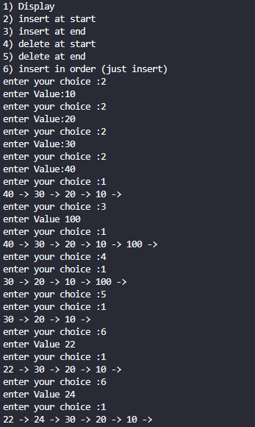

Time analysis

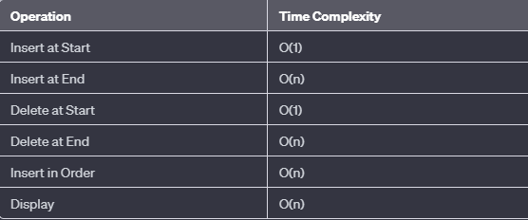

**Applications**

* Dynamic Memory Allocation
* Implementing Stacks and Queues
* Polynomial Representation and Manipulation
* Symbol Tables
* Memory Pools
* Undo Functionality in Software
* Music and Video Playlists
* Expression Evaluation
* Hash Tables
* Graphs Representation (Adjacency Lists)
* Navigation Systems (GPS)
* Undo/Redo Functionality in Editors