**Practical – 4**

AIM: Implementation and time analysis of Doubly linked list .

#include <iostream>

using namespace std;

class Node

{

public:

int data;

Node *prev;

Node *next;

Node()

{

this->data = 0;

this->prev = NULL;

this->next = NULL;

}

Node(int data)

{

this->data = data;

this->prev = NULL;

this->next = NULL;

}

};

void display(Node *head)

{

if (head == NULL)

{

cout << "Empty Linked list!" << endl;

}

while (head != NULL)

{

cout << head->data << "->";

head = head->next;

}

cout << endl;

}

void insertAtStart(Node *&head)

{

int data;

cout << "enter value : ";

cin >> data;

Node *newnode = new Node(data);

if (head == NULL)

{

head = newnode;

return;

}

newnode->prev = NULL;

newnode->next = head;

head->prev = newnode;

head = newnode;

}

void insertAtEnd(Node *&head)

{

int data;

cout << "enter value : ";

cin >> data;

Node *newnode = new Node(data);

if (head == NULL)

{

head = newnode;

return;

}

Node *temp = head;

while (temp->next != NULL)

{

temp = temp->next;

}

temp->next = newnode;

newnode->prev = temp;

}

void deleteAtStart(Node *&head)

{

if (head == NULL)

{

cout << "empty linked list" << endl;

return;

}

Node *temp = head;

head = head->next;

cout << "Deleted successfully" << endl;

delete temp;

}

void deleteAtEnd(Node *&head)

{

if (head == NULL)

{

cout << "empty linked list" << endl;

return;

}

Node *temp = head;

Node *prev = NULL;

while (temp->next != NULL)

{

prev = temp;

temp = temp->next;

}

prev->next = NULL;

cout << "Deleted successfully" << endl;

delete temp;

}

void insertInOrder(Node *&head)

{

bool flag_isvalue_fitted = false;

int data;

cout << "enter value : ";

cin >> data;

Node *newnode = new Node(data);

if (head == NULL)

{

head = newnode;

return;

}

Node *temp = head;

int i = 1;

if (newnode->data < head->data)

{

newnode->next = head;

newnode->prev = NULL;

head->prev = newnode;

head = newnode;

flag_isvalue_fitted = true;

}

else

{

while (temp->next != NULL)

{

cout << " ilteration " << i++ << endl;

if (temp->data < newnode->data && newnode->data < temp->next->data)

{

newnode->prev = temp;

newnode->next = temp->next;

temp->next = newnode;

temp->next->prev = newnode;

flag_isvalue_fitted = true;

return;

}

temp = temp->next;

}

}

if (flag_isvalue_fitted == false)

{

if (temp->next == NULL)

{

if (temp->data < newnode->data)

{

temp->next = newnode;

newnode->prev = temp;

}

}

}

}

int main()

{

Node *head = NULL;

int choice;

cout << "1) Show " << endl;

cout << "2) insert at start " << endl;

cout << "3) insert at end " << endl;

cout << "4) delete at start " << endl;

cout << "5) delete at end " << endl;

cout << "6) insert in order (just insert)" << endl;

do

{

cout << "enter choice :";

cin >> choice;

switch (choice)

{

case 1:

display(head);

break;

case 2:

insertAtStart(head);

break;

case 3:

insertAtEnd(head);

break;

case 4:

deleteAtStart(head);

break;

case 5:

deleteAtEnd(head);

break;

case 6:

insertInOrder(head);

break;

default:

break;

}

} while (choice != 8);

}

Time analysis

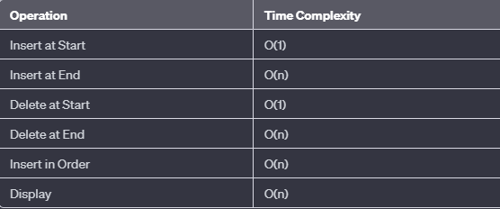

**OUTPUT**

