**Practical – 6**

AIM: Implementation of binary tree and its traversal (preorder, inorder, postorder)   
  
**Program**

#include <iostream>

#include <queue>

using namespace std;

class Node

{

public:

int data;

Node *right;

Node *left;

Node(int value)

{

data = value;

right = NULL;

left = NULL;

}

};

Node *insertNode(Node *root, int value)

{

if (root == NULL)

{

root = new Node(value);

return root;

}

Node *temp = root;

while (true)

{

if (value > temp->data)

{

if (temp->right == NULL)

{

temp->right = new Node(value);

break;

}

temp = temp->right;

}

else

{

// for value<root->data

if (temp->left == NULL)

{

temp->left = new Node(value);

break;

}

temp = temp->left;

}

}

return root;

}

void displayPreorder(Node *root)

{

if (root == NULL)

{

return;

}

cout << root->data << ",";

displayPreorder(root->left);

displayPreorder(root->right);

}

void displayInorder(Node *root)

{

if (root == NULL)

{

return;

}

displayInorder(root->left);

cout << root->data << ",";

displayInorder(root->right);

}

void displayPostorder(Node *root)

{

if (root == NULL)

{

return;

}

displayPostorder(root->left);

displayPostorder(root->right);

cout << root->data << ",";

}

vector<vector<int>> levelorder(Node *&root)

{

cout << endl;

vector<int> level;

vector<vector<int>> ans;

queue<Node *> q;

q.push(root);

q.push(NULL);

while (!q.empty())

{

Node *temp = q.front();

q.pop();

if (temp == NULL)

{

cout << endl;

if (!q.empty())

{

q.push(NULL);

}

}

else

{

if (temp->left != NULL)

q.push(temp->left);

if (temp->right != NULL)

q.push(temp->right);

cout << temp->data << " ";

}

}

return ans;

}

int main()

{

Node *root = NULL;

root = insertNode(root, 100);

root = insertNode(root, 20);

root = insertNode(root, 200);

root = insertNode(root, 10);

root = insertNode(root, 30);

root = insertNode(root, 150);

root = insertNode(root, 300);

cout << "Preorder : ";

displayPreorder(root);

cout << endl;

cout << "inorder : ";

displayInorder(root);

cout << endl;

cout << "Postorder : ";

displayPostorder(root);

cout << endl<< endl;

cout << "-------------level order traversel-------------------";

vector<vector<int>> x = levelorder(root);

return 0;

}

**OUTPUT**

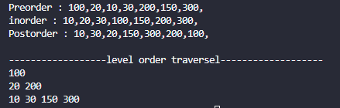

Time analysis

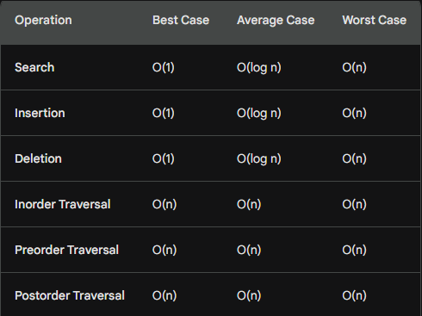

Applications

1. Symbol Tables:

BSTs are frequently used to implement symbol tables in compilers and interpreters. In a symbol table, identifiers (such as variable names) are stored along with their associated information, and the BST structure allows for efficient retrieval.

1. Database Indexing:

In database management systems, BSTs can be employed for indexing. For example, a BST can be used to index records based on certain attributes, enabling faster search operations.

1. File Systems:

BSTs are utilized in file systems for organizing and searching directories and files. The hierarchical structure of file systems can be represented effectively using BSTs.

1. Router Tables in Networking:

In networking, BSTs can be used to implement router tables. IP addresses or routing information can be stored in a BST for efficient routing lookups.

1. Compression Algorithms:

Huffman coding, a widely used compression algorithm, often employs binary trees. Binary trees, including BSTs, can be used to represent the hierarchical structure of Huffman codes.

1. Auto-Completion in Text Editors:

Binary Search Trees can be employed to implement auto-completion functionality in text editors. The tree structure allows for quick search and retrieval of suggestions.

1. Caching:

BSTs are utilized in caching mechanisms. Items with the highest or lowest priority can be efficiently identified and removed using the binary search property.

1. Priority Queues:

BSTs can be used to implement priority queues, where items with higher priority are accessed more quickly. The root of the BST typically represents the highest-priority item.

1. Game Trees in Artificial Intelligence:

BSTs are employed in game trees to represent possible moves and outcomes in game-playing algorithms. The tree structure facilitates decision-making in games.

1. Code Optimization:

In compilers, BSTs can be used for code optimization. Symbolic expressions and intermediate code representations can be efficiently manipulated using BSTs.