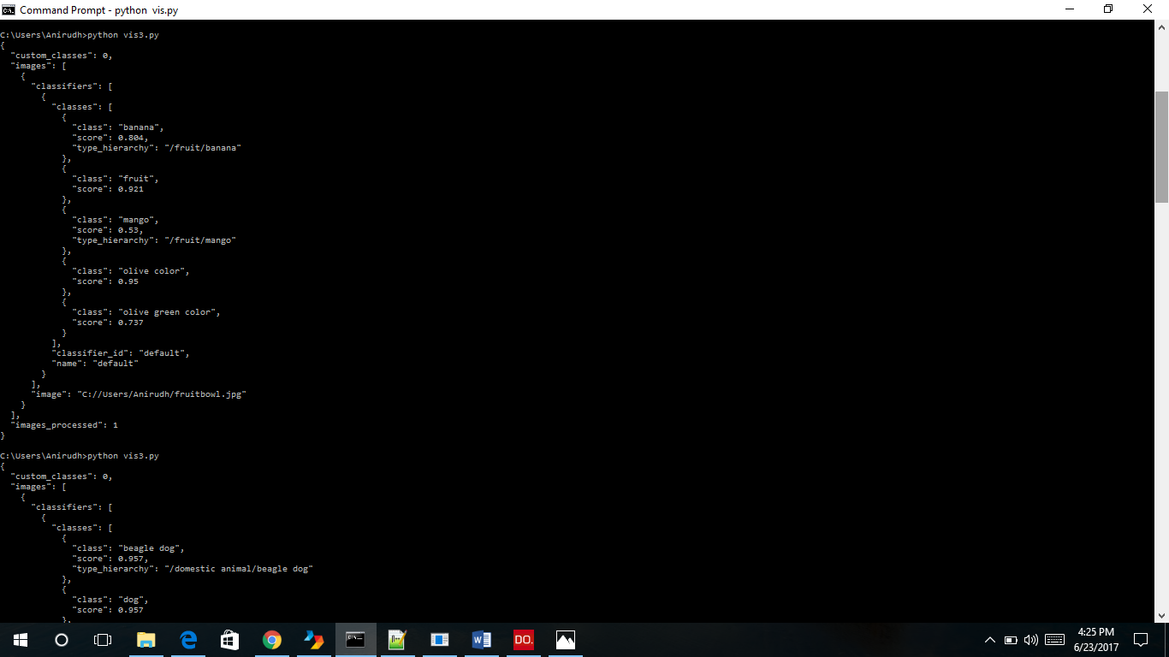

Using image classifier using any image uploaded by user.

vis3.py

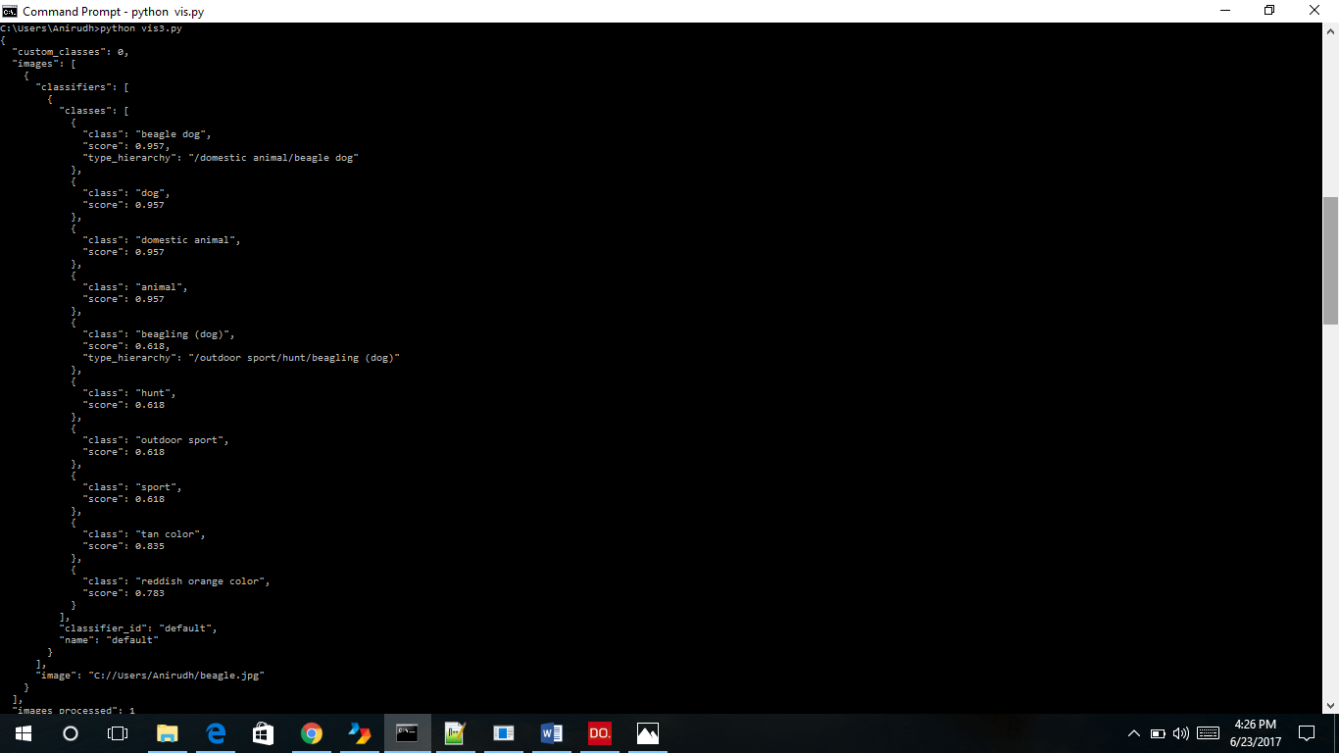

Same as above

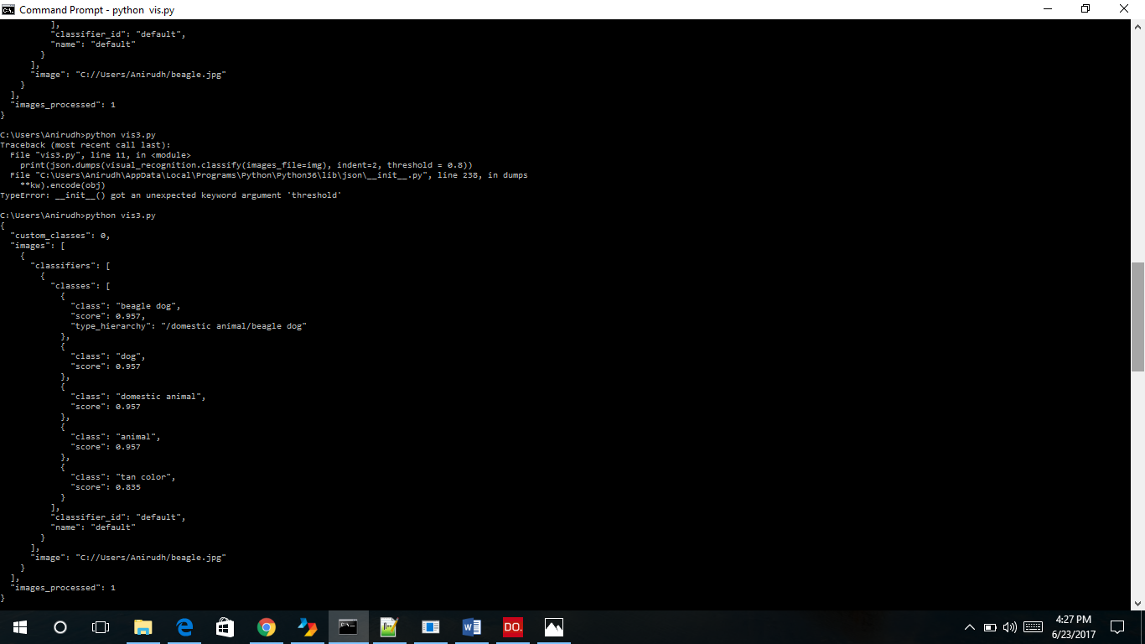

Using image classifier for any user image, with some threshold

**To delete classifier**

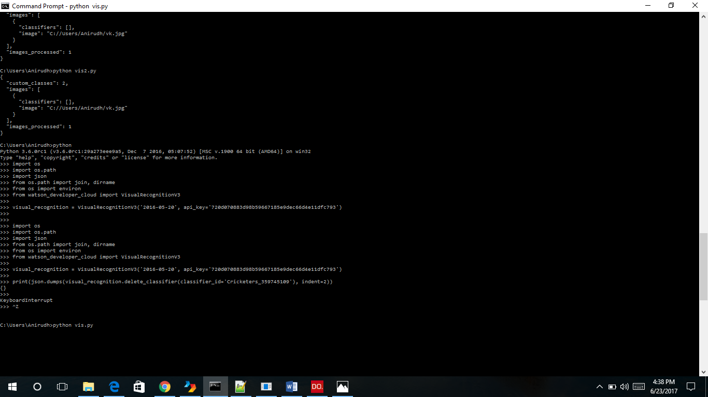

**To train classifier**

vis.py

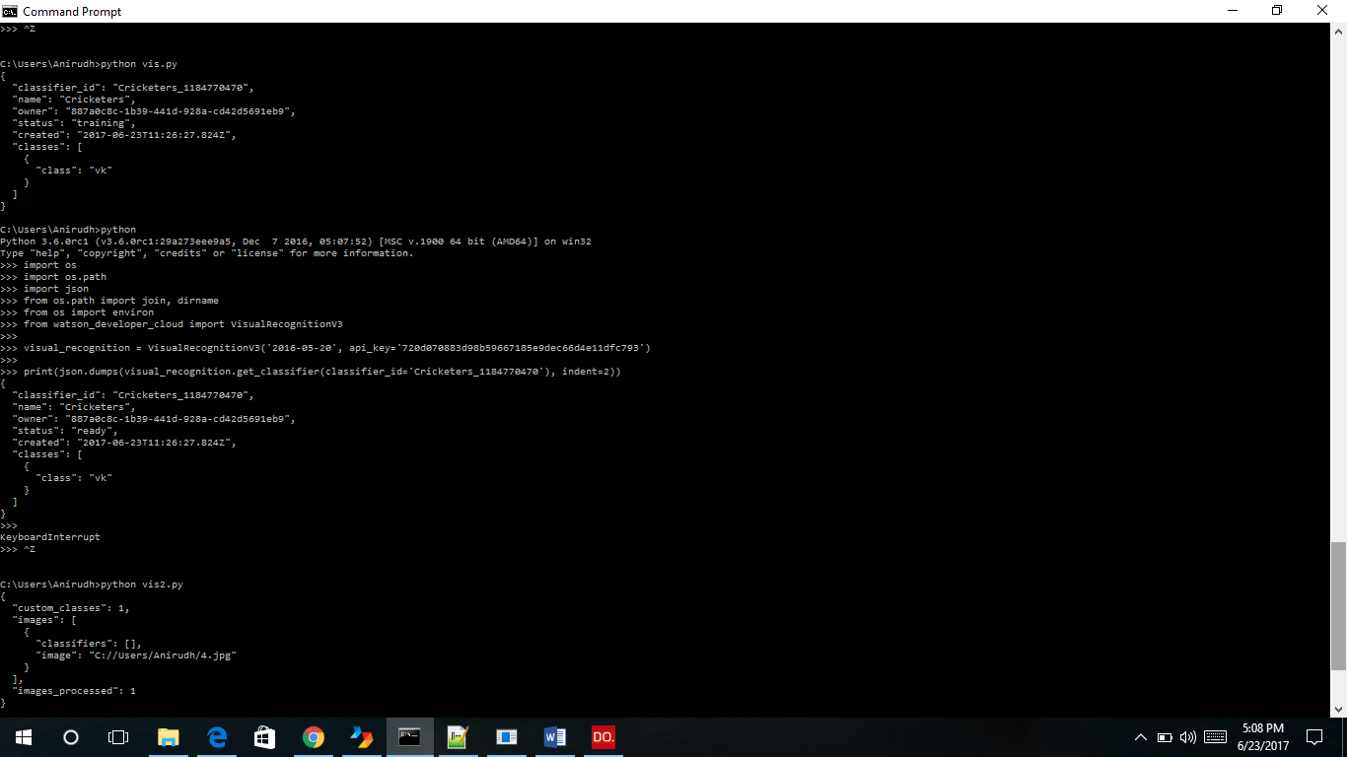

**To test classifier**

vis2.py

**#to delete a classifier**

import os

import os.path

import json

from os.path import join, dirname

from os import environ

from watson_developer_cloud import VisualRecognitionV3

visual_recognition = VisualRecognitionV3('2016-05-20', api_key='720d070883d98b59667185e9dec66d4e11dfc793')

print(json.dumps(visual_recognition.delete_classifier(classifier_id='Cricketers_359745109'), indent=2))

**#to check if classifier is ready**

import os

import os.path

import json

from os.path import join, dirname

from os import environ

from watson_developer_cloud import VisualRecognitionV3

visual_recognition = VisualRecognitionV3('2016-05-20', api_key='720d070883d98b59667185e9dec66d4e11dfc793')

print(json.dumps(visual_recognition.get_classifier(classifier_id='Cricketers_359745109'), indent=2))