**Milan Sahoo**

+91-6296740204

[Milansahoo7211662005@gmail.com](mailto:Milansahoo7211662005@gmail.com)

**Narma , Narayangarh,**

**West Medinipur , 721166**

**D.B.O :- 24.02.2005**

**Academic Details :-**

|  |  |
| --- | --- |
| **Education** | **Percentage** |
| **Diploma in Computer Science Engineering**  **(Brainware University)** | **82.80%(Aggregate till Semester-II)** |
| **HSC**  **(Madanmohanchak Chowdhury Institution)** | **69%** |
| **SSC**  **(Madanmohanchak Chowdhury Institution)** | **88%** |

**Core Skills:-**

* **Problem Solving**
* **Web Development**
* **Written code with C, C++ , Python**
* **Understanding DSA Concept**
* **Strong interpersonal skills**
* **Quick learner**

**Hobbies and Interests:-**

* **Learning Problem Solving**
* **Developed webpages**
* **Reading Bengali Story book**
* **Arts and Craft**
* **Drawing**

**DATE:-**

**PLACE:-**

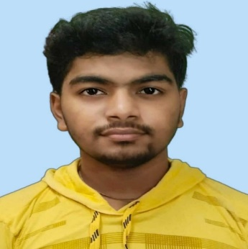

**Career objective:-**

**To secure an entry-level opportunity as a Software Engineer and hone my skills and knowledge in Computer Science and Engineering required for the corporate domain.**

**Publications:-**

* **“Virtual Reality and Human Experience” published in Indian Journal of Modern Research and Reviews, Volume 2, Issue 10,,2024**

**DOI:**

**<https://mrrjournal.in/uploads/articles/MRR-2024-2-10-9.pdf>**

**Seminars and workshops:-**

* **Attend one day seminar on “Cyber Hygiene in HEIs (Webinar)” held on 3rd April 2024.**
* **Attending IIT Bombay Spoken Tutorial course (October 2024 - Present).**
* **Attend one day “Industry visit from Euphoria Genx(salt Lake ,sector-v, Kolkata)” held on 09th November 2024.**

**Projects:-**

**Language :-**

* **Bengali :- Read ,Write &Speak.**
* **English :- Read ,Write & Speak.**
* **Hindi :- Speak.**

**Signature…………………….**