A Project Report On
Online Book Shopping


Developed By :
Milan Savani

From :
3rd Year(SCET)

INDEX

1. PROJECT OVERVIEW

2. E-COMMERCE CONSEPTION

3. PREFACE

4. ACKNOWLEDGEMENT

5. NATURE OF PROJECT

6. SCREENSHOT OF PROJECT

7. PROJECT REQUIREMENTS

8. FLOWCHART

9. DATA DICTIONARY

10. TESTING & IMPLEMENTATION

11. THE BOOKSHOP.COM INFORMATION

PROJECT OVERVIEW

This project is followed the concept of the E-commerce thoroughly. This project is developed to sell the products on line of various Book Collection Category mentioned in the project..

This project definitely helps the user to buy anything from the internet because in the ONLINE BOOK SHOP you can purchase anything with clicking of the some button of the mouse and pressing some keys of the keyboard & entering your credit card no. in that.

By using this project, the user can save his or her time by purchasing the product which time they are wasting by roaming in the market. From here, they can get most probably all the things they want besides fast moving Entertainment goods. They have various choices in the one Collection.

E-COMMERCE CONSEPTION

E-commerce means the purchasing and selling of the products through the Internet.

Now days the internet is used very widely so that the some businessmen always think in the advance who have the vision of the future from the evolution of the internet some are think to implement the internet for the business and that comes true with the evolution of the E-commerce.

In our project, we have tried to implement the concept of the E-commerce thoroughly but as we know that, we have to do the project while learning the E-commerce it means that studying & implementing that concept we have to do simultaneously. We tried to make it perfect but humans are doing mistakes only so that we have put suggestion part also for the customer so that they can help us to improving our site by giving their suggestion to us.

preface

First of all I would like to say that project is very essential part of our educational quota. If we are going only for theory parts, it can not give us perfect knowledge.

This project report of Online Bookshopping Web Site is present against you for project as a subject in

This web site is developed for study purpose of the Computer’s Student. It provides computer e-book.It also provide’s educational software to students.In this web site It requires only registeration of the Buyers which is also free. For that student must have valid email account like yahoo,rediff,hotmail etc.This Bookshopping.com web site is developed in JSP language.

This web site is quite easy in operating so that any student can able to use it easily.

Your co-operation in form of suggestions and comments are most welcome, to improve any knowledge and project.

ACKNOWLEDGEMENT

We wish to convey our sincere gratitude to the staff of College for giving us advice and guidance during development of project.

No serious and lasting achievement or success, one can ever achieve without the help of friendly guidance and cooperation of all people involved in this work.
First of all I am grateful to Miss Madam for helping us so much and showing his keen interest and co-operation in completing this work. Then I would like to thank my lab faculties also for co-ordination.
I would also like to thanks my Parents, friends and all members of my family for encouraging me for this work.
Thanks from,

Date : 28/03/2018

NATURE OF PROJECT

We develop this Web Site “Bookshop.com” which is developed in the Personal Home Page(php) as the Front end and MySql as Back end.

I have put a fair amount of effort in the design of this web site. I have tried my best to satisfy the all requirement in an efficient manner.

This web site provided facilities like make the user account based on emailed and it will provide to student to download the computer e-book totally free.As well as it provide the Software which is useful for students and lots of.

SCREENSHOT OF PROJECT

Homepage

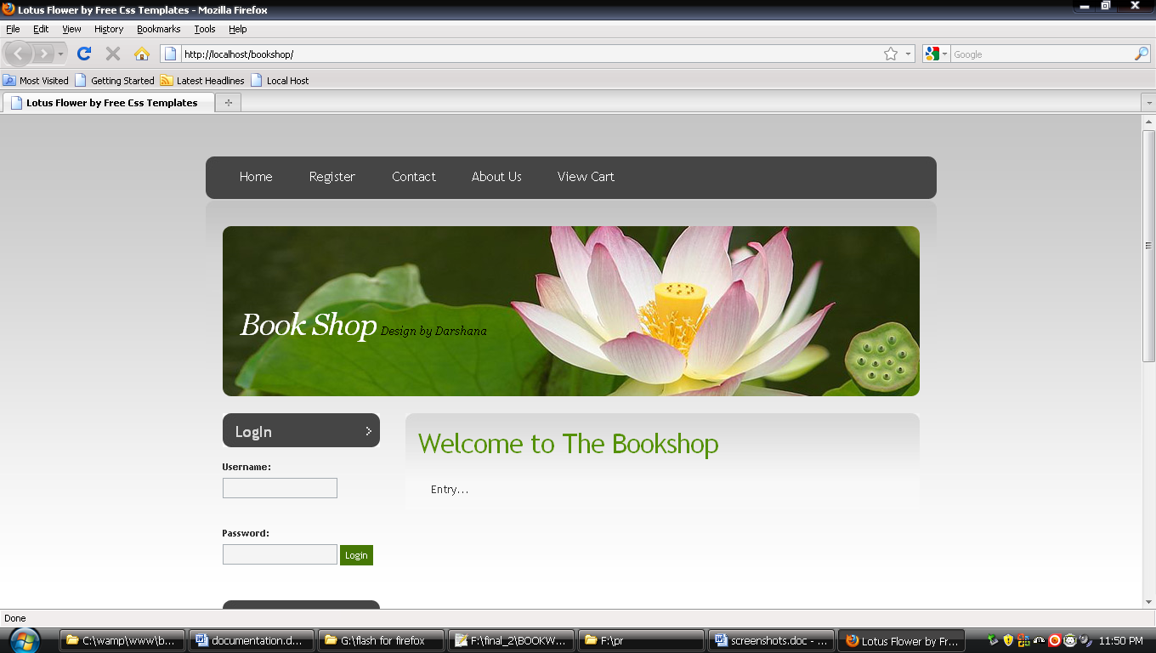

Registration Form

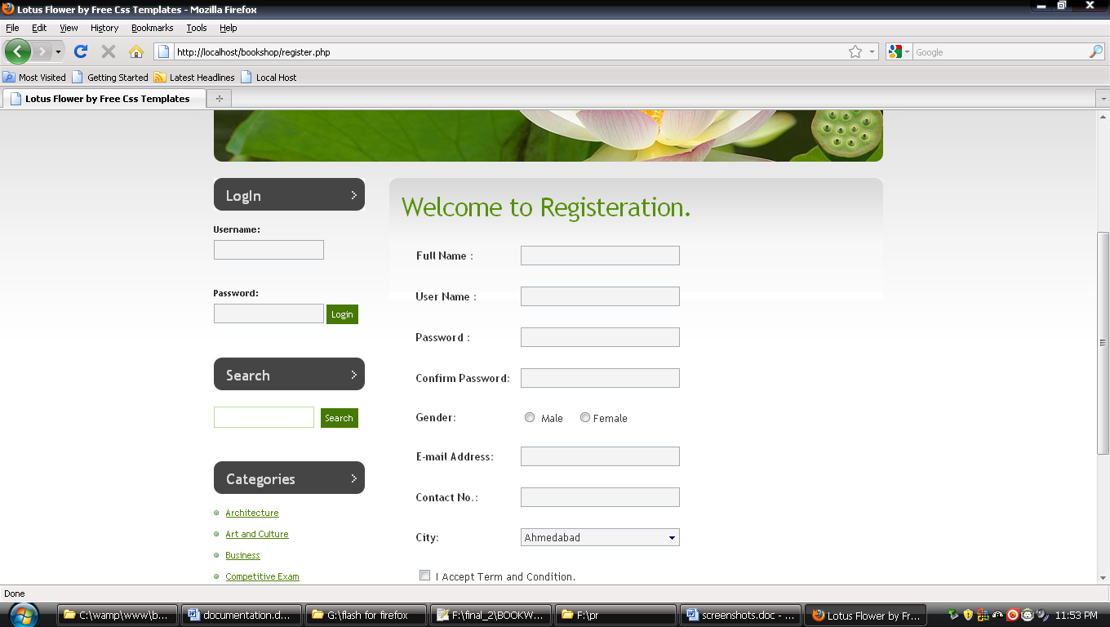

Admin

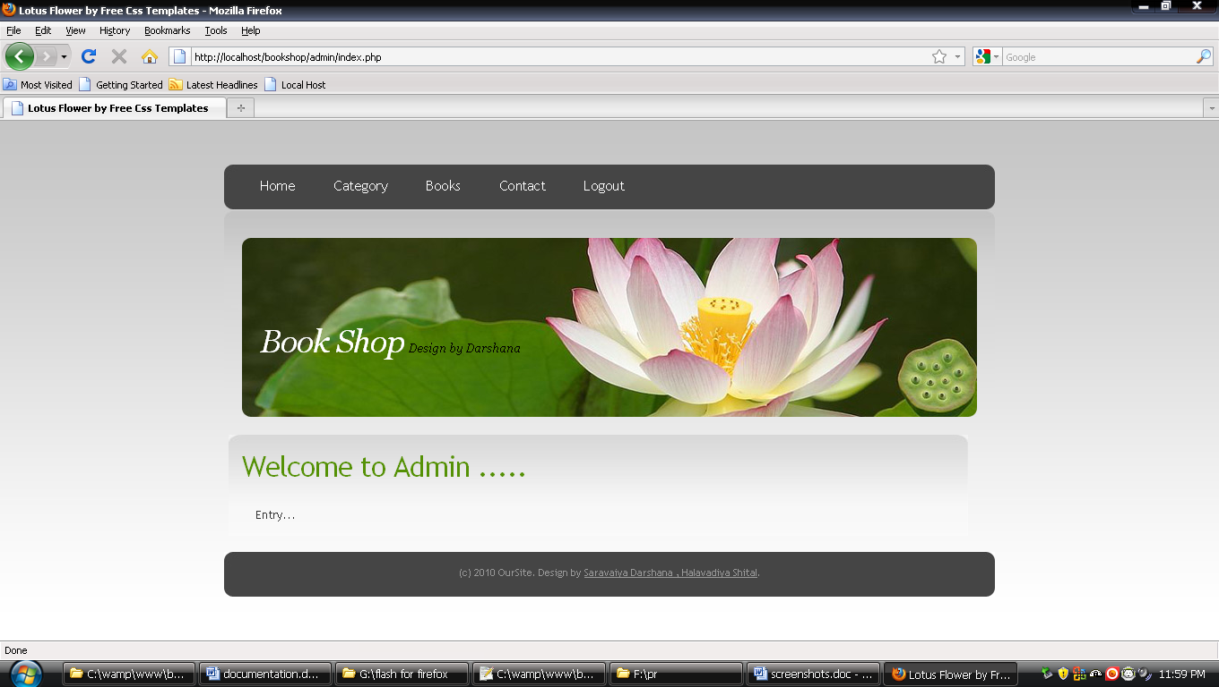

Category

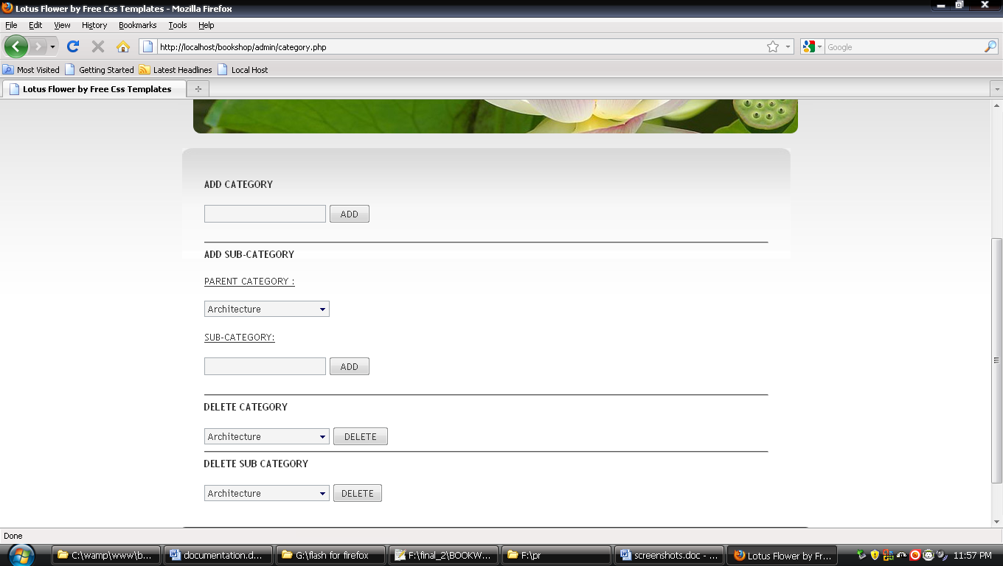

Item Details

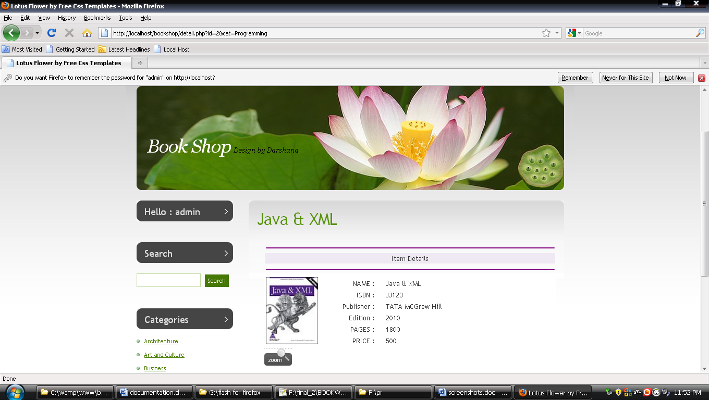

View Cart

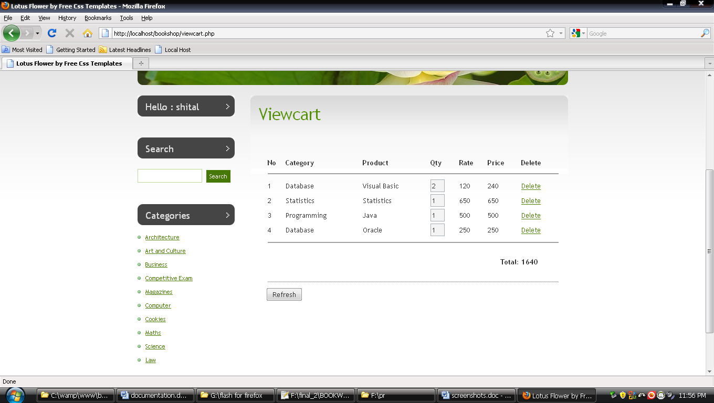

Book List

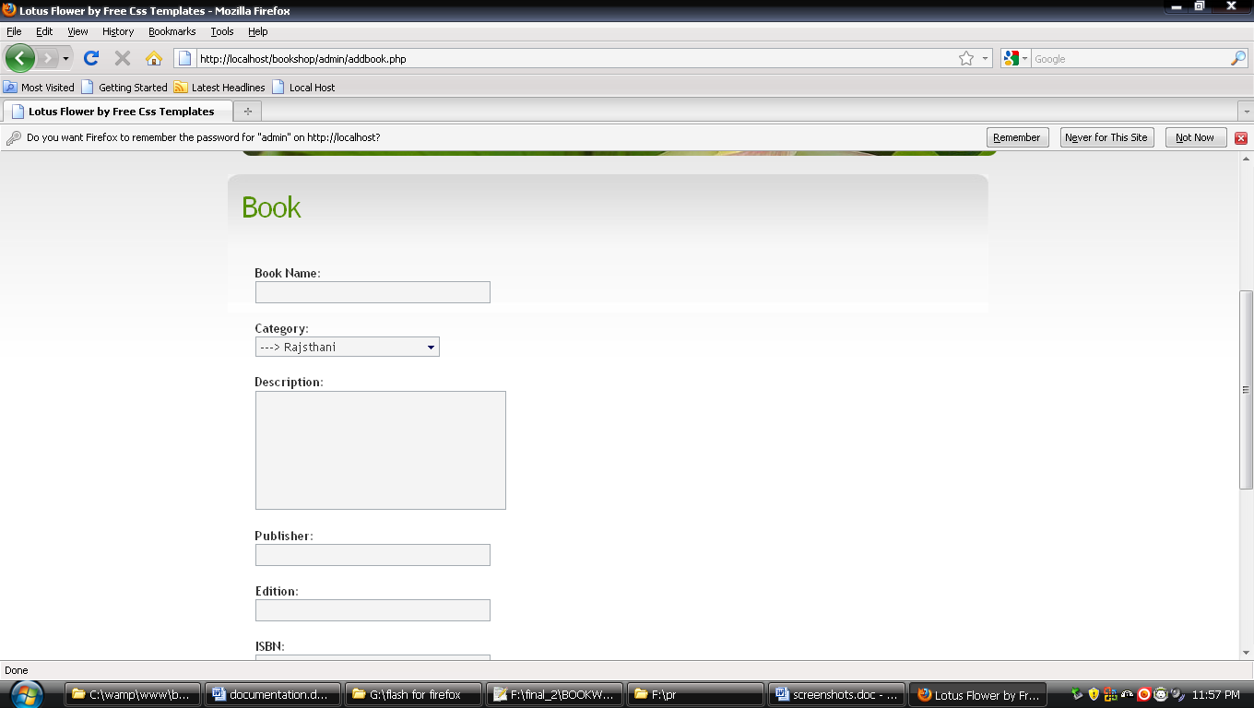

Contact

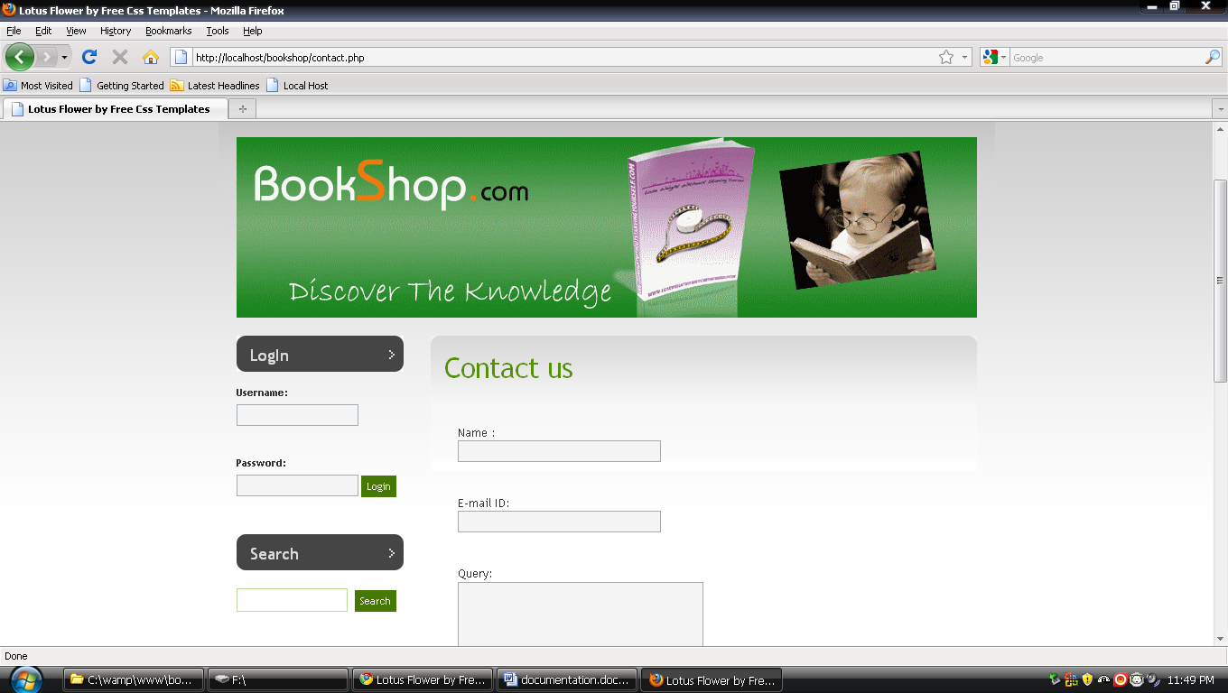

Project Requirement

- Software Requirement

  - Mysql

  - Web server

  - PHP (PHP Hypertext Preprocessor)

  - Notepad++

  - Micromedia Flash 8

Flow chart

- Home Page

HOME

CONTACT
ABOUT US

HOME PAGE
REGISTER

VIEW CART

CATEGORY
ADMIN

BOOK

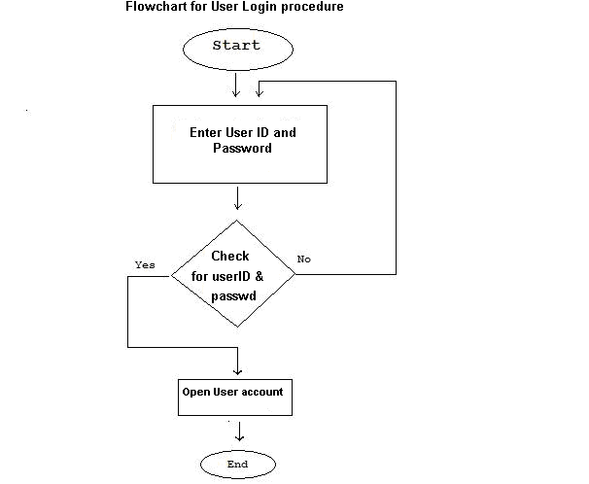

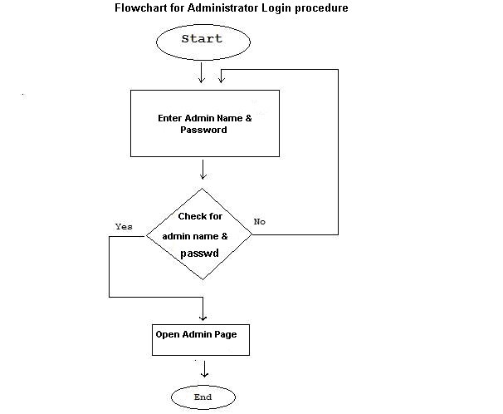

Data Dictionary

The Data Dictionary is very important part of the project through which we can know that where data are stored in the project. The Data Dictionary in this project is as below.

DATABASE NAME: Bookshop

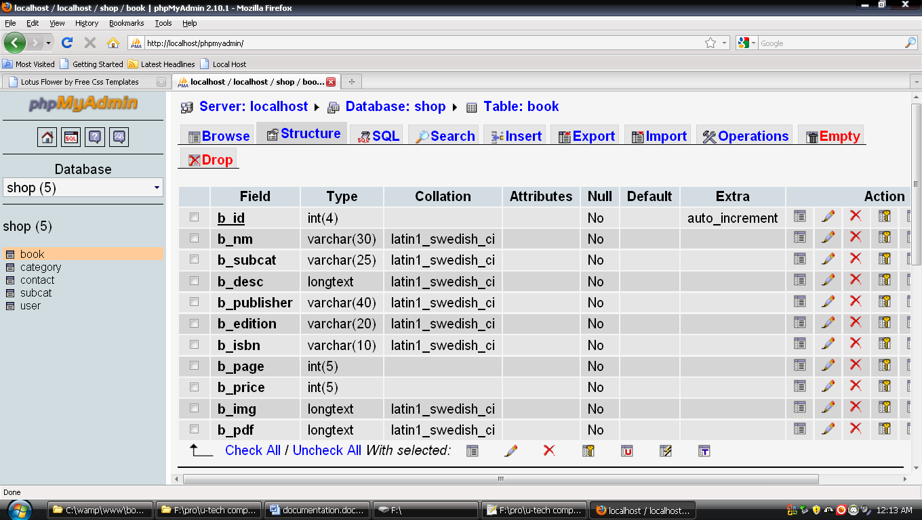
- Book Table

2. Category Table
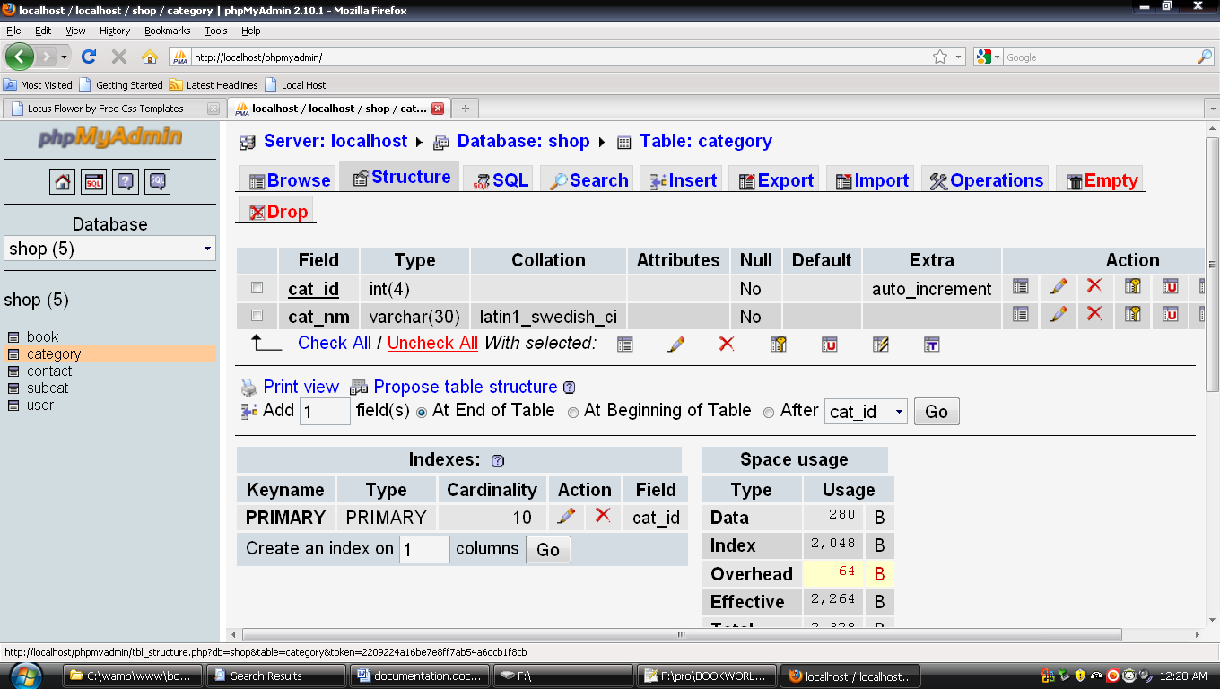

3. Contact Table
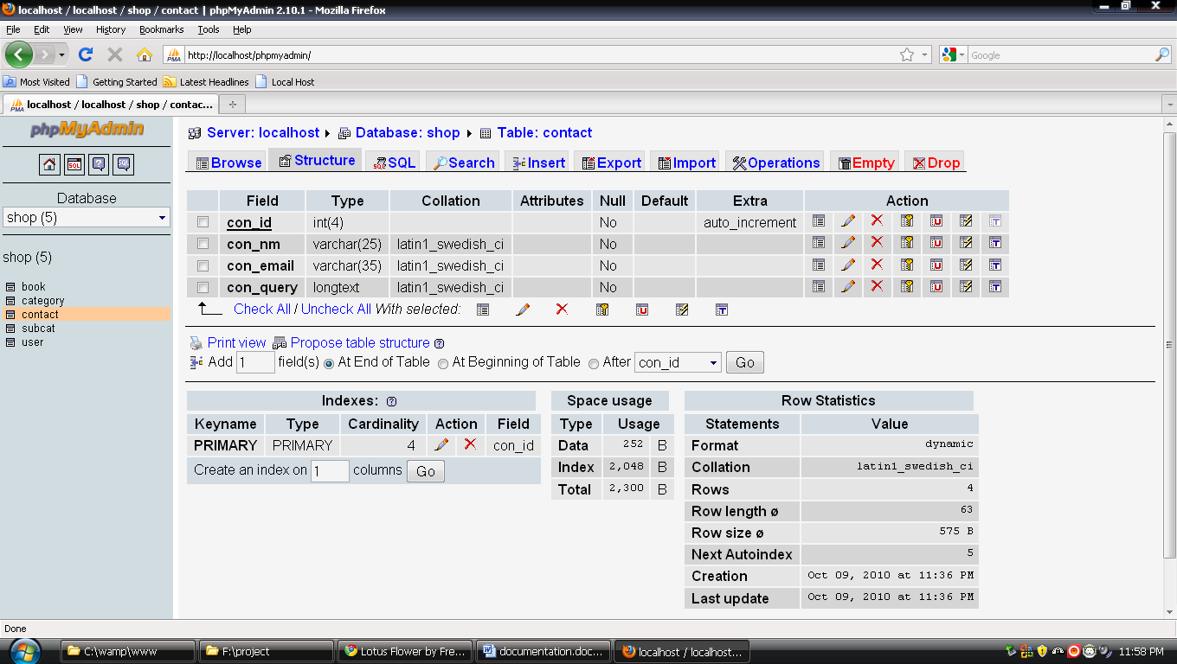

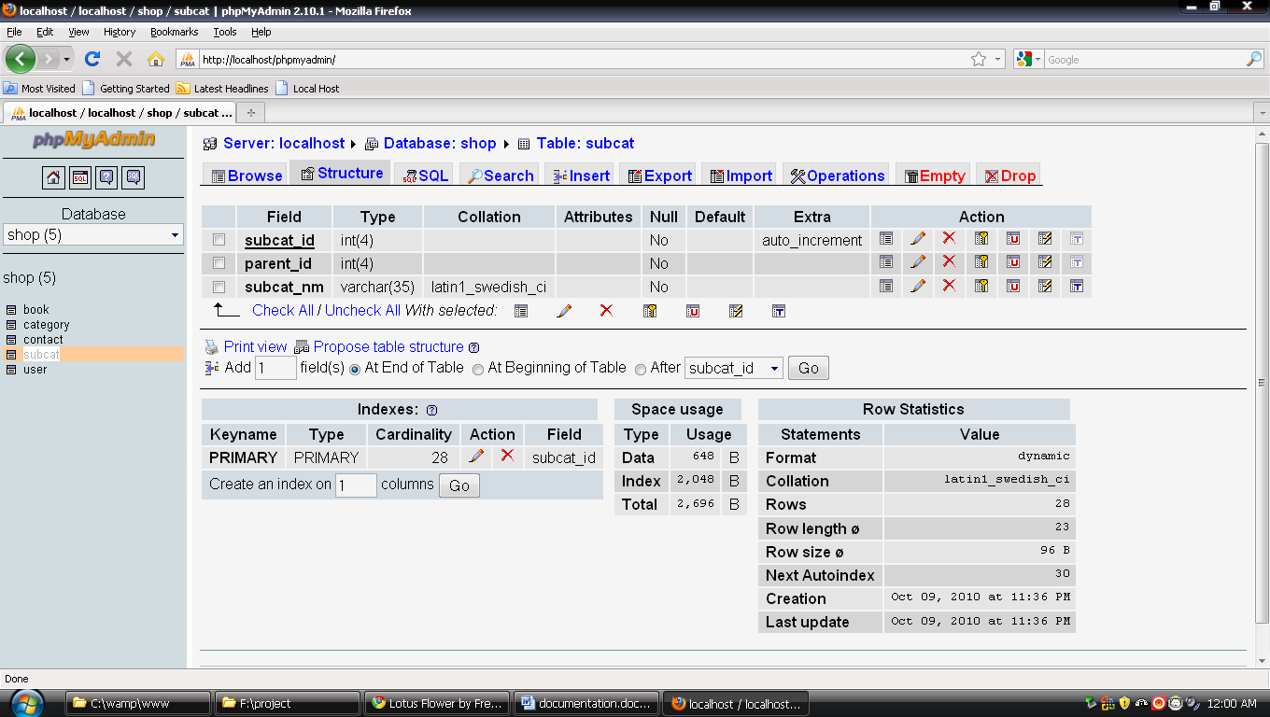
4. Subcat Table

5. User Table

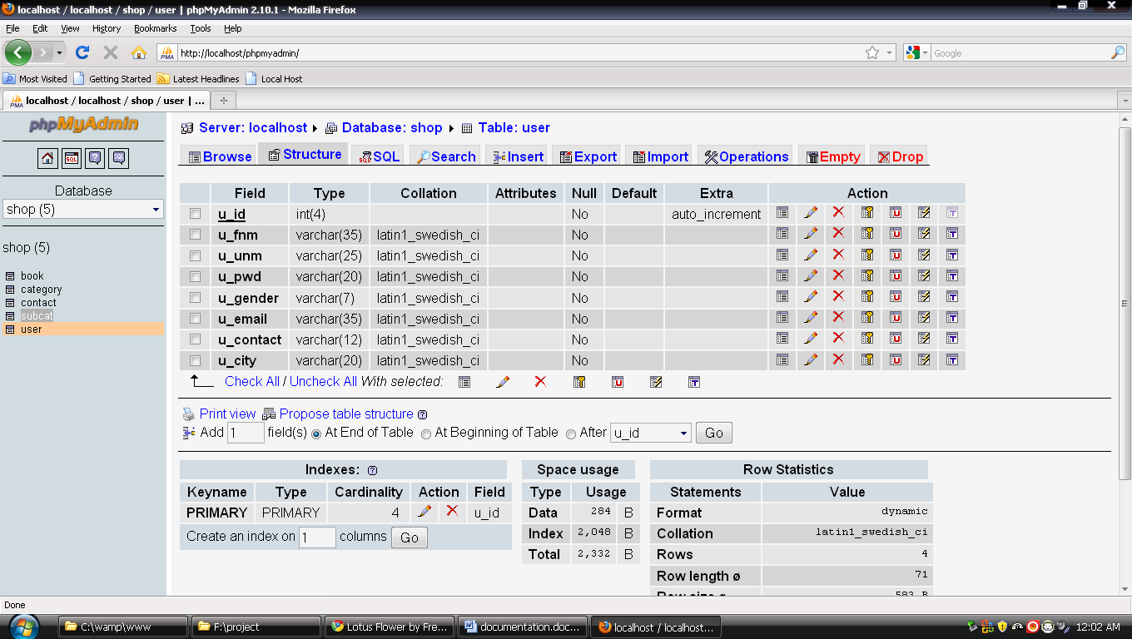

Testing & Implementation

Testing is critical element of software quality assurance and represents the ultimate review of specification, design and coding. It is unusual for the organization to spent 30 or 40 percent of total project effort on testing.

Testing presents the software an interesting anomaly for the software engineer. The engineer creates the series of test cases that are intended to demolish the software that has been built. In fact, testing us one-step in the software engineering process that could be viewed as destructive rather than constructive.

Testing Objectives

The following are the objectives for the testing.

- Testing is a process of executing a program with the intent of finding an error.

- A good test case is one that has a high probability of finding an as-yet undiscovered error.

- A successful test is one that uncovers as-set undiscovered error.

THE BOOKSHOP.COM INFORMATION

General
What is TheBookShop.com?
TheBookShop.com a true marketplace for publishers, which means that you can find all the publishers selling their items under one platform.
There can also be independent sellers and distributors selling their items.
This gamut of choices allows customers to choose to buy a book they want at the price they want to pay.
What can I get here?
You can find books, books and more books. TheBookShop is a one-stop shop for you to look at, read about,
compare and finally buy all books published in India by Indian publishers and also a wide selection of titles from USA and UK.
Are these books only in English?
No. TheBookShop.com has books in all languages from publishers of all sizes throughout the country.
We have books of all regional languages such as Punjabi, Hindi, Marathi, Gujarati, Bengali, Malayalam, and Urdu.
You can specifically search for these books.

TheBookShop.com Account and Registration
How do I purchase an item on TheBookShop.com?
Purchasing an item is a simple 3-step process.
- Create TheBookShop.com account on TheBookShop.com
- Search and add items to your shopping cart
- Enter your credit card details and submit the order
That is it. The item you purchase will be delivered to your doorstep
Can I order without creating TheBookShop.com account?
No, you cannot order without creating TheBookShop.com account.
Do I need a credit card to create TheBookShop.com account?
You do not need a credit card to create TheBookShop.com account.
Credit card information is required only at the time of ordering.
How do I create TheBookShop.com account?
You can create TheBookShop.com account using your email address and relevant information through My Account tab on our website.
Do you charge for creating TheBookShop.com account?
No, TheBookShop.com account creation is free of any charge whatsoever.
What if I forget my password?
You can use our Forgot Password services to send/reset your password.

Order Processing
How can I find an item to order?
If you remember the category of the item, you can browse for the item by category.
For example you can Browse for Computing books under our categories.
If you remember the exact item or some details about it, you can search for the item by Title, ISBN,
Publisher or Author in our powerful Search function. You can also filter this search by Language.
Can I order multiple items in one order?
Yes you can add multiple items to your shopping cart at one time and place it under one order.
However there will be a separate shipping charge for each item on the order.
Can I pre-order?
We do not have the pre-order feature at this time.

