BenGrac interiéry
BenGrac s.r.o. · Landererova 7743/8, 811 09 Bratislava · VAT ID SK2122563080 · info@bengrac.sk · +421 905 431 851 · www.bengrac.sk
QUOTATION
Joinery, upholstery, ceramic cladding and flooring – Restaurant MAZI
Landstraßer Hauptstraße 71, 1030 Vienna
Client | Gattopardo Gastro GmbH, Maximilian Malzacher, Rysergasse 7, 1230 Wien
Quotation no. | ____
Date | __.11.2026
Valid until | 30 days from date of issue
Basis | Detail drawings 261030_d_MAZI_Det (preliminary issue 30.10.2026, 09_01–09_07_2), floor plan 01.12, perspectives 01.13, e-mails of 3 and 5 Nov 2026

Summary
Part 1 – Joinery and upholstery | € (net)
A. Technical preparation
B. Tables
C. Bar, back bar and wardrobe
D. Bench seating and upholstery
E. Mirrors and shelving wall
F. Ceramic cladding on furniture
G. Electrical components, fittings
H. Transport and installation
Total Part 1
Project discount 5 %
Total Part 1 after discount
Part 2 – Flooring (optional)
Project discount 5 %
Total Part 2 after discount
All prices in EUR excluding VAT. VAT treatment (reverse charge) according to applicable law.

Option – oak veneer
As agreed in your e-mail of 3 Nov 2026, oak elements can be made in natural oak veneer with the requested surface finish instead of solid oak. Price difference: € ______ (net). We recommend solid oak for the bar top and table edges due to heavy use.

Part 1 – Joinery and upholstery

A. Technical preparation
Pos. | Description | Unit | Qty | Total (€, net)
A1 | On-site survey in Vienna (dimensions of room, walls, columns, floors) | lump | 1
A2 | Shop drawings of all elements based on drawings 09_01–09_07_2, approval by the architect | lump | 1
A3 | Material samples for approval (limed oak, veneer, decors, upholstery fabric, brass, opal acrylic) | lump | 1

B. Tables
Pos. | Description | Unit | Qty | Total (€, net)
B1 | Standard table top 70×70 cm, oak (solid or oak veneer), 38 mm, corners R5, edge profile var. 1/2/3, limed finish matched to floor | pcs | 17
B2 | Standard table top 70×70 cm, decor Egger U608 Pistachio / Funder Kiwi green, laser edge (zero joint), corners R5 | pcs | 16
B3 | Table base, brass look (Hanos or equal), incl. assembly and bag hook | pcs | 33
B4 | Tiled table 265×108 cm: 30 mm three-layer board, Fioranese Sassi Grigio tile glued, 2–3 mm brass edging, 3-rod hairpin legs H 71 cm (colour by architect) | pcs | 1
B5 | High table approx. 356×158 cm, H 105 cm: shaped oak top, tile-clad base (three-layer board), backlit light band (opal acrylic + LED), ring shelf around column, bag hooks | pcs | 1
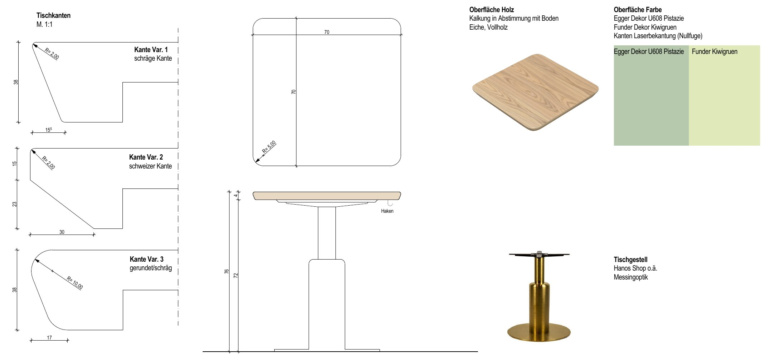
Drawing: 09_01 Standard tables
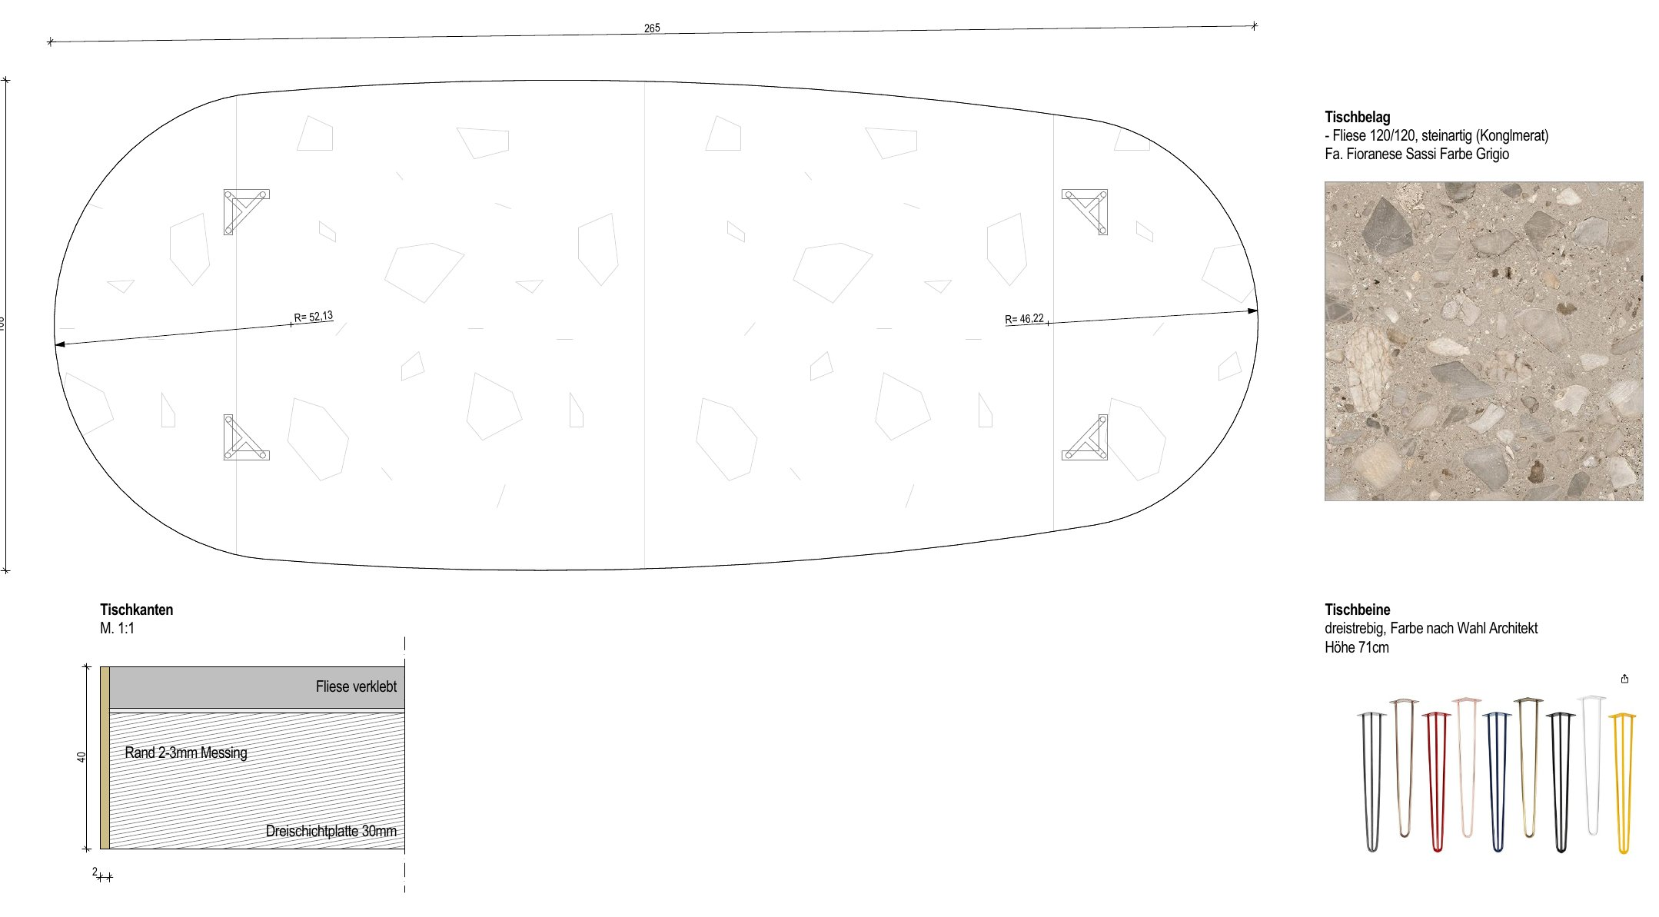
Drawing: 09_02 Tiled table
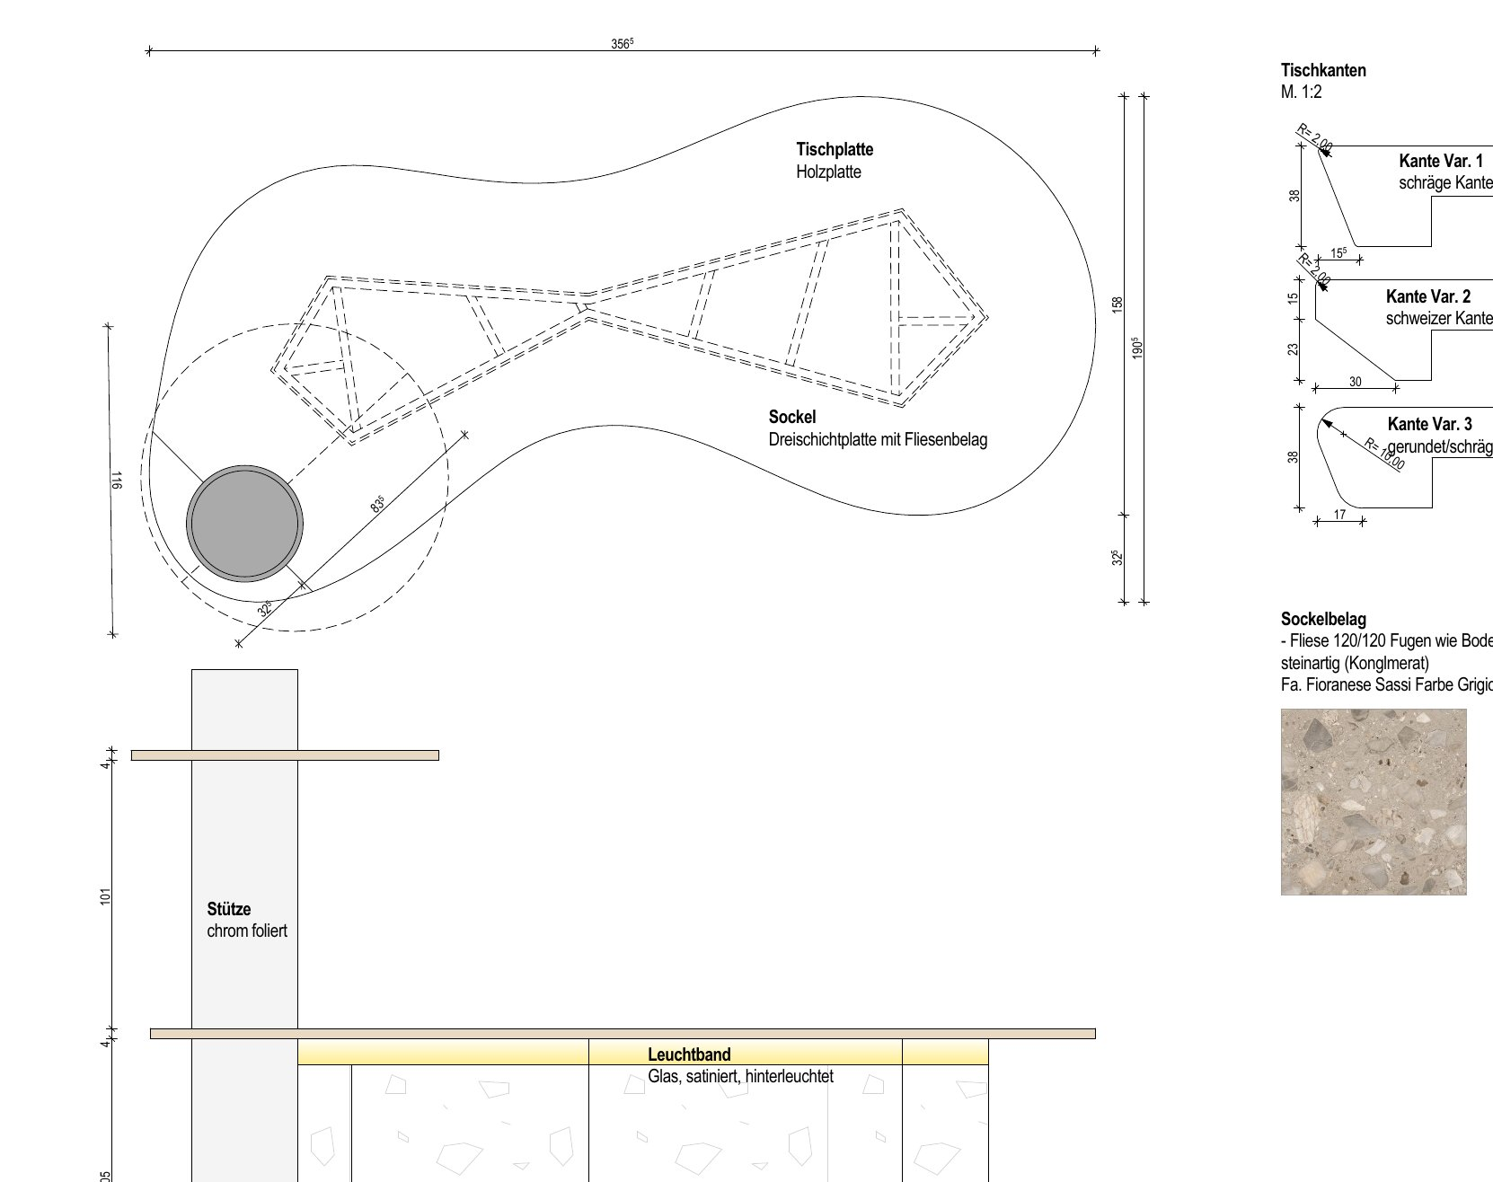
Drawing: 09_03 High table

C. Bar, back bar and wardrobe
Pos. | Description | Unit | Qty | Total (€, net)
C1 | Bar counter approx. 430 × 306 cm, H 95 cm: substructure, three-layer board base for tile cladding, anchoring | rm | 7.7
C2 | Bar top, oak (solid or veneer) approx. 50 mm, 45 cm overhang, gastro-resistant finish | rm | 7.7
C3 | Backlit light band under bar top (opal acrylic + LED), H 10 cm | rm | 7.7
C4 | Brass foot rail Ø 30–40 mm incl. brackets, bag hooks under bar top (10 pcs) | rm | 7.5
C5 | Suspended upper shelf above bar on brass rods from ceiling (for plants / pendants) | rm | 7
C6 | Back bar: wood wall cladding up to 2.5 m | m² | 11.6
C7 | Back bar: shelves, 3 levels, integrated LED | rm | 13.8
C8 | Shelf unit and niche for wine cooler (cooler supplied by client) | pcs | 1
C9 | Wardrobe: wood cladding, chrome hanging rail, shelves, end shelf unit | lump | 1
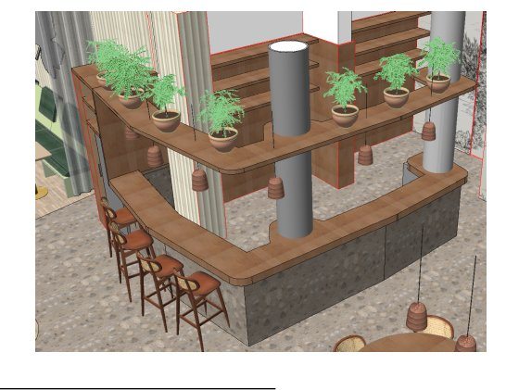
Drawing: 09_04 Bar – 3D view
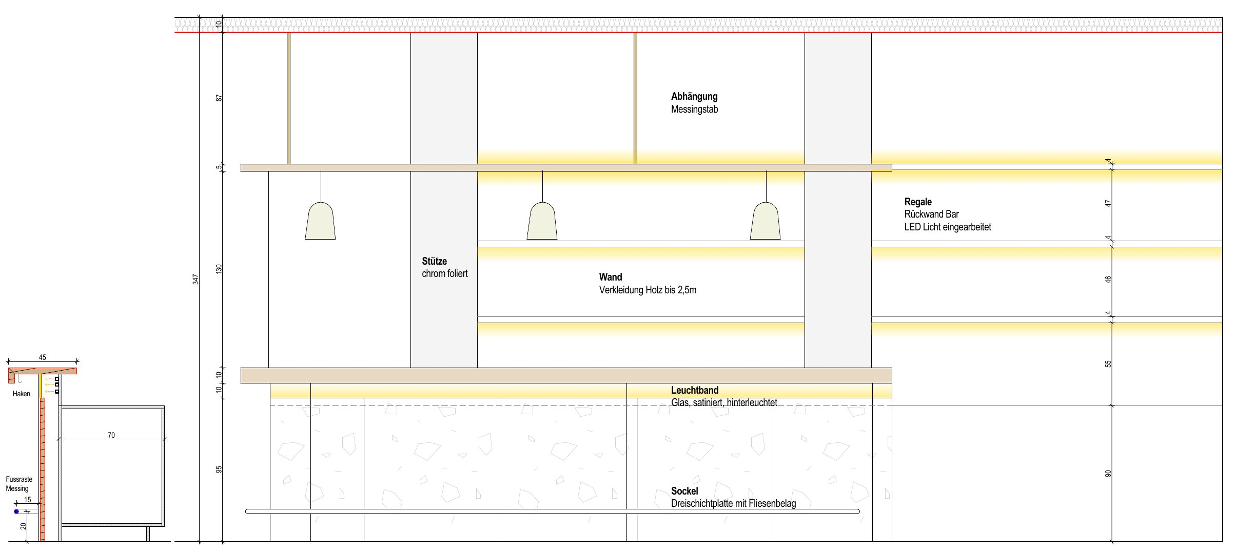
Drawing: 09_04_2 Bar – side elevation

D. Bench seating and upholstery
Pos. | Description | Unit | Qty | Total (€, net)
D1 | Mobile bench 220 cm: carcass in decor board (Egger U608 / Funder Kiwi green), laser edge, backrest 70°, LED with acrylic cover, castors (rear swivel, front lockable) | pcs | 4
D2 | Wall bench approx. 204 cm, without castors (wall length approx. 8.2–8.6 m, to be confirmed on site) | pcs | 4
D3 | Seat cushion approx. 108×55×10 cm, HR foam, piped edge, on carrier board with point fixing | pcs | 16
D4 | Back cushion approx. 60×65×10 cm on sliding carrier board | pcs | 24
D5 | Upholstery fabric: contract quality, flame retardant (EN 1021-1/2 / ÖNORM B 3825), ≥ 50,000 Martindale, colour by architect | rm | 44
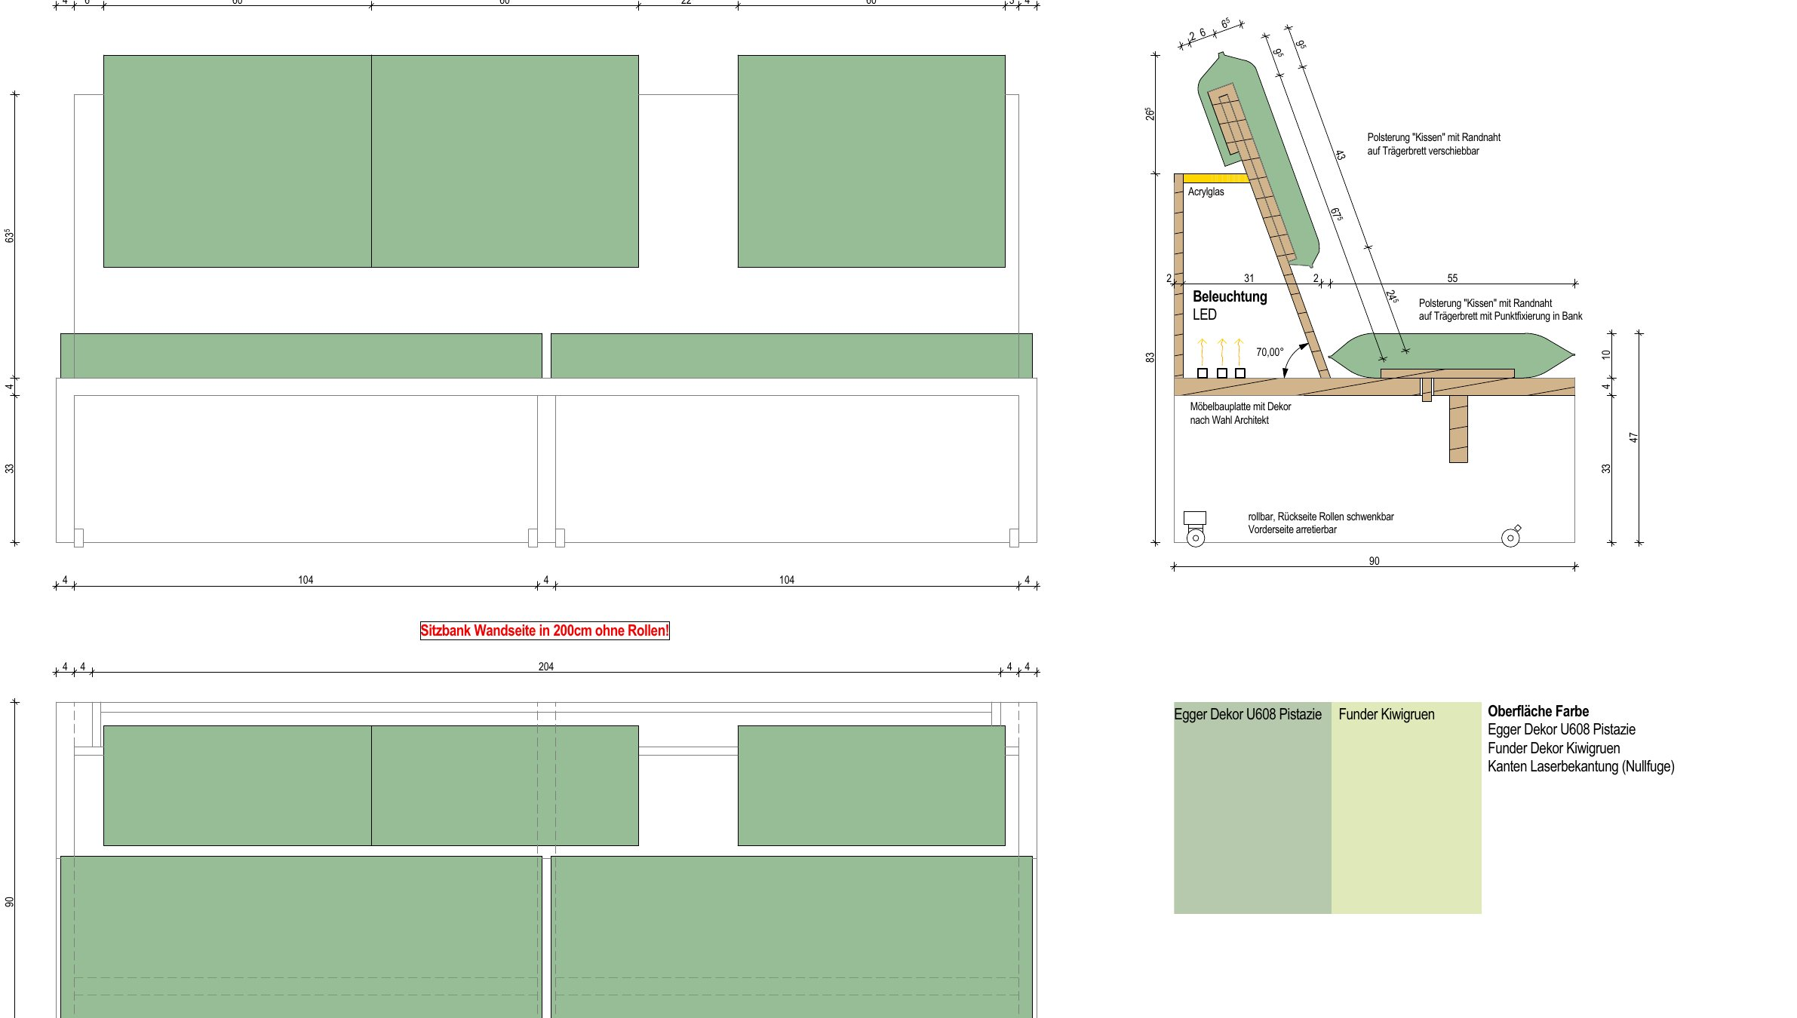
Drawing: 09_05 Bench seating

E. Mirrors and shelving wall
Pos. | Description | Unit | Qty | Total (€, net)
E1 | Mirror “Wild vine leaf” 182×143 cm, CNC-cut, safety film, wooden back frame, LED backlight, wall distance 4/6 cm alternating | pcs | 6
E2 | Shelving wall: shaped shelves level 1–4 (238.5 cm) and top shelf level 5 (approx. 5.8 m), LED strips with opal cover | lump | 1
E3 | Brass support rod floor–ceiling, open-compartment shelf column | lump | 1
E4 | High counter H 105 cm (235.5 cm, shaped around column) and 2 small high tables with hairpin legs | lump | 1
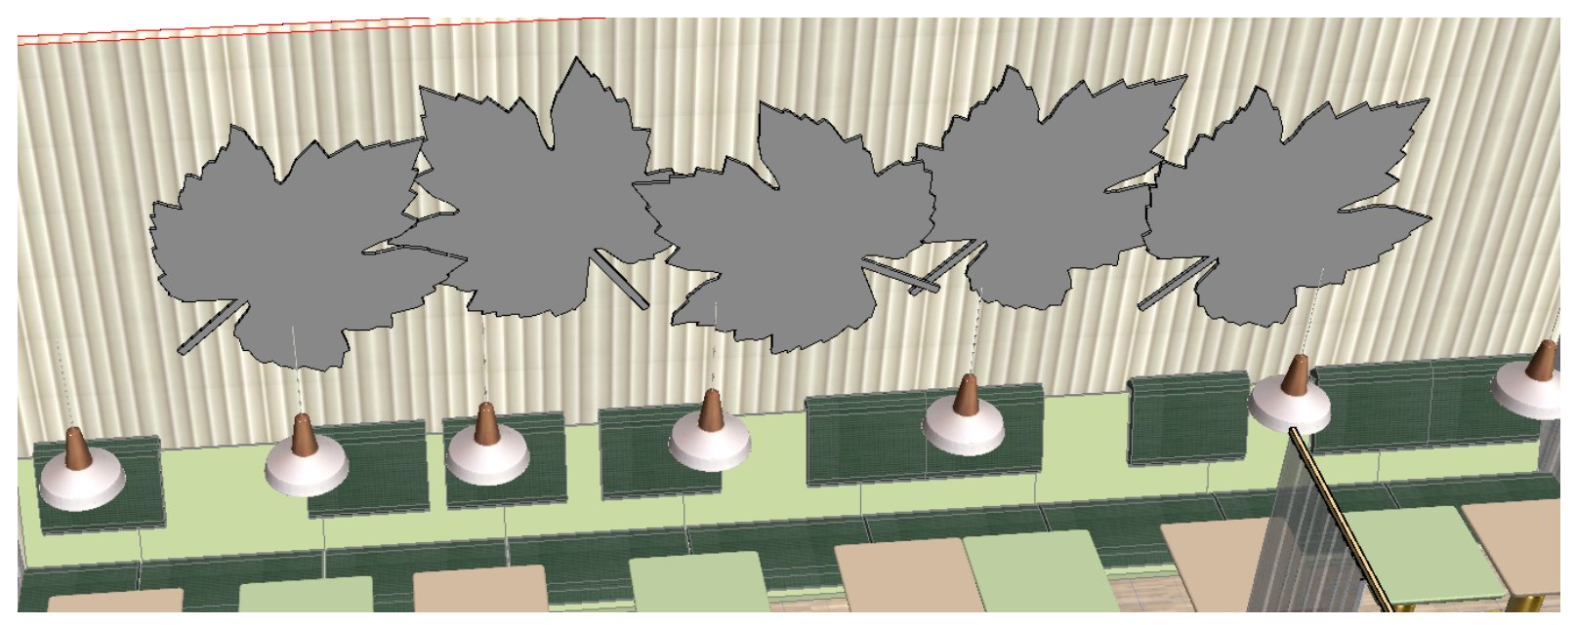
Drawing: 09_06 Mirrors
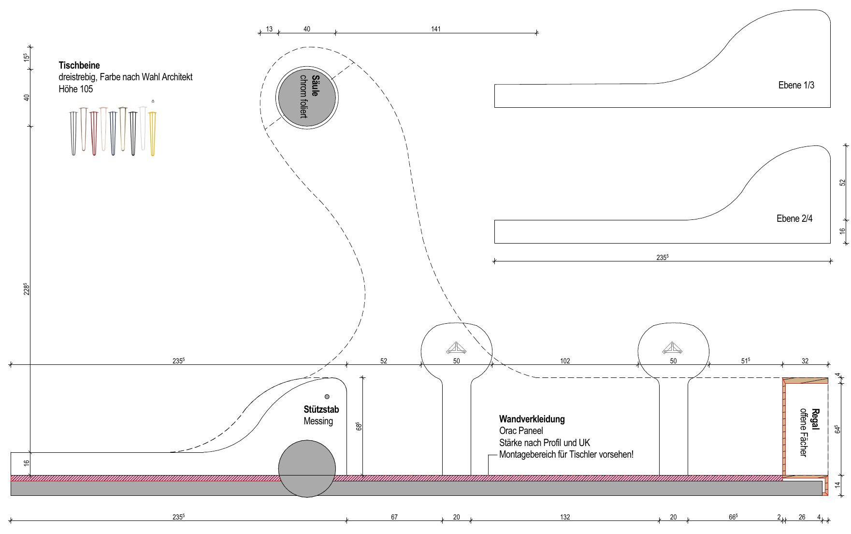
Drawing: 09_07_1 Shelving wall – plan
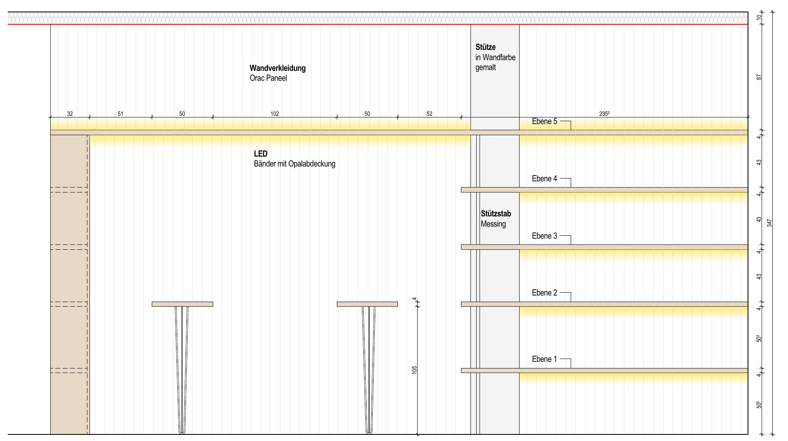
Drawing: 09_07_2 Shelving wall – elevation

F. Ceramic cladding on furniture
Pos. | Description | Unit | Qty | Total (€, net)
F1 | Fioranese I Ciottoli Sassi Grigio 120×120 (or equal) for tiled table, high table base and bar base, incl. cutting, curved sections in strips, grouting as floor | m² | 17

G. Electrical components, fittings
Pos. | Description | Unit | Qty | Total (€, net)
G1 | LED strips 2700–3000 K, CRI ≥ 90, aluminium profiles, opal acrylic covers, power supplies, dimmers – up to junction box | lump | 1
G2 | Fittings, fixing and anchoring material | lump | 1

H. Transport and installation
Pos. | Description | Unit | Qty | Total (€, net)
H1 | Transport Bratislava – Vienna | lump | 1
H2 | Installation on site, protection, cleaning, waste disposal | lump | 1

Part 2 – Flooring (optional)
According to your e-mail of 5 Nov 2026. The tiles on the furniture and on the floor will come from the same series, so they match exactly.
Pos. | Description | Unit | Qty | Total (€, net)
P1 | Porcelain stoneware BIa, Fioranese I Ciottoli Sassi Grigio (or equal) 60×60 cm (alt. 90×90), R10, on heated screed, flexible thin-bed mortar, grey joints | m² | 118
P2 | Porcelain stoneware BIa, grey standard, up to 30×30 cm, R11, on heated screed, grey joints | m² | 41.13
P3 | Solid oak end-grain parquet (Hochkantparkett), glued, parallel pattern, 160 mm / 20–23 mm / 29 cm, incl. sanding, filling and surface finish | m² | 91.36
P4 | Skirting: oak skirting on parquet areas / tile skirting on tiled areas | rm | 110
P5 | Curved transition profiles tile / parquet | rm | 16
P6 | Substrate check incl. CM moisture measurement, primer | m² | 250.49

Scope and conditions

Not included
- Stainless steel bar installations (by kitchen planner), appliances incl. wine cooler
- Pendant and decorative lights, chairs and bar stools
- Orac wall panelling, column finishes (chrome foil / paint)
- Electrical supply and final connection (by client’s electrician); we supply LED components up to the junction box
- Screed and its heating protocol (Aufheizprotokoll), wall tiling in wet areas

Assumptions
- Drawings are a preliminary issue – final quantities and prices will be confirmed after approved drawings and on-site survey
- Heated screed finished, level and dry (CM measurement before laying); free access to site, power and storage area
- Materials and upholstery meet fire safety requirements for restaurants in Austria

Schedule
Production approx. 8–10 weeks after order and approval of shop drawings and samples; installation approx. 2 weeks on site. To meet the opening in March 2027, we need the order and approved drawings by ______.

Payment terms
50 % advance payment with order · 40 % before delivery/installation · 10 % after handover.

Selected references
SAJADO Eurovea, Bratislava and Food Hall, OC Urban Košice – joinery, bench seating and upholstery, realised in cooperation with Prodan Interiér.
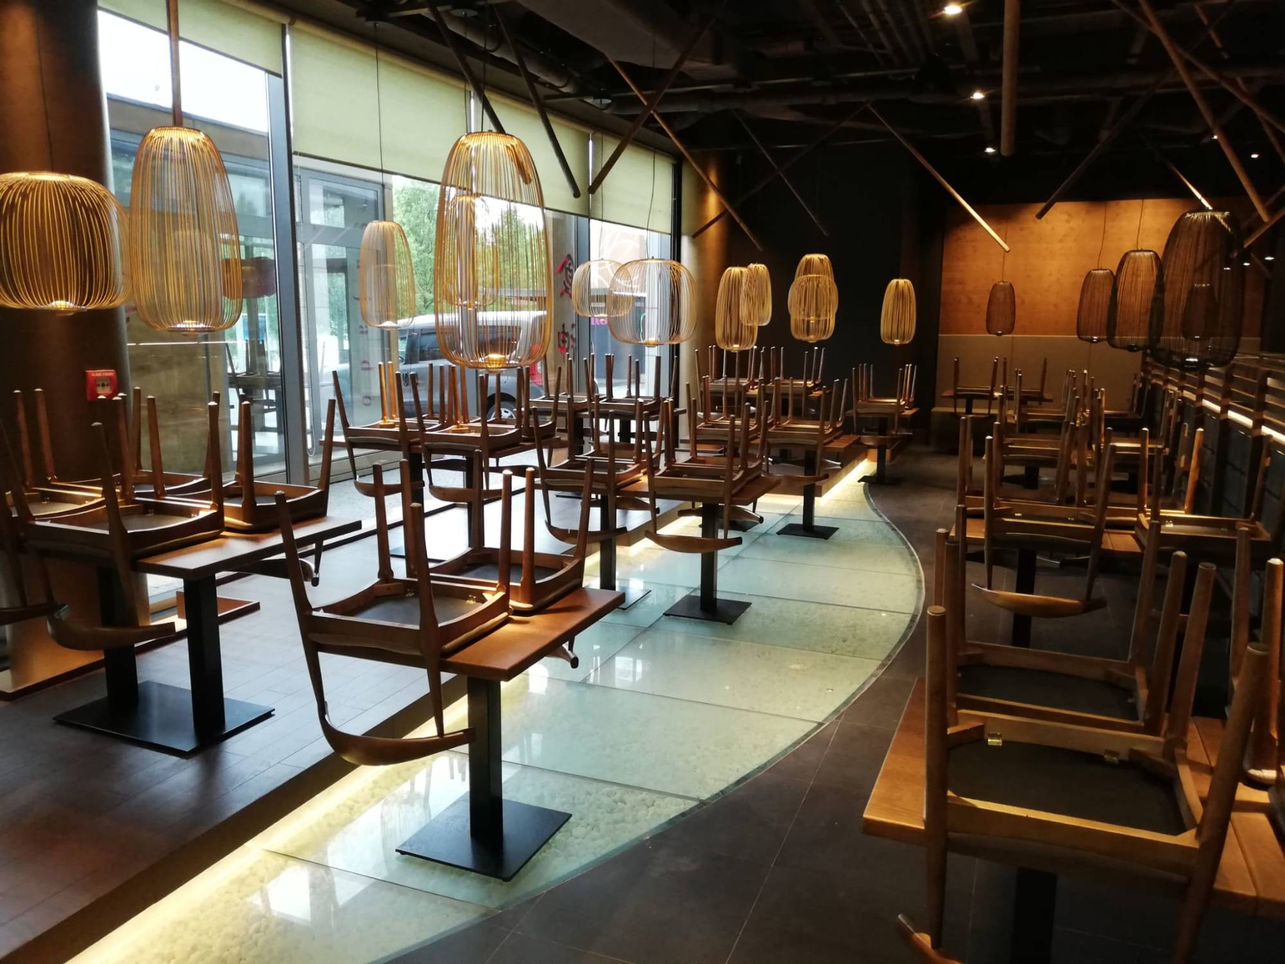
SAJADO Eurovea, Bratislava
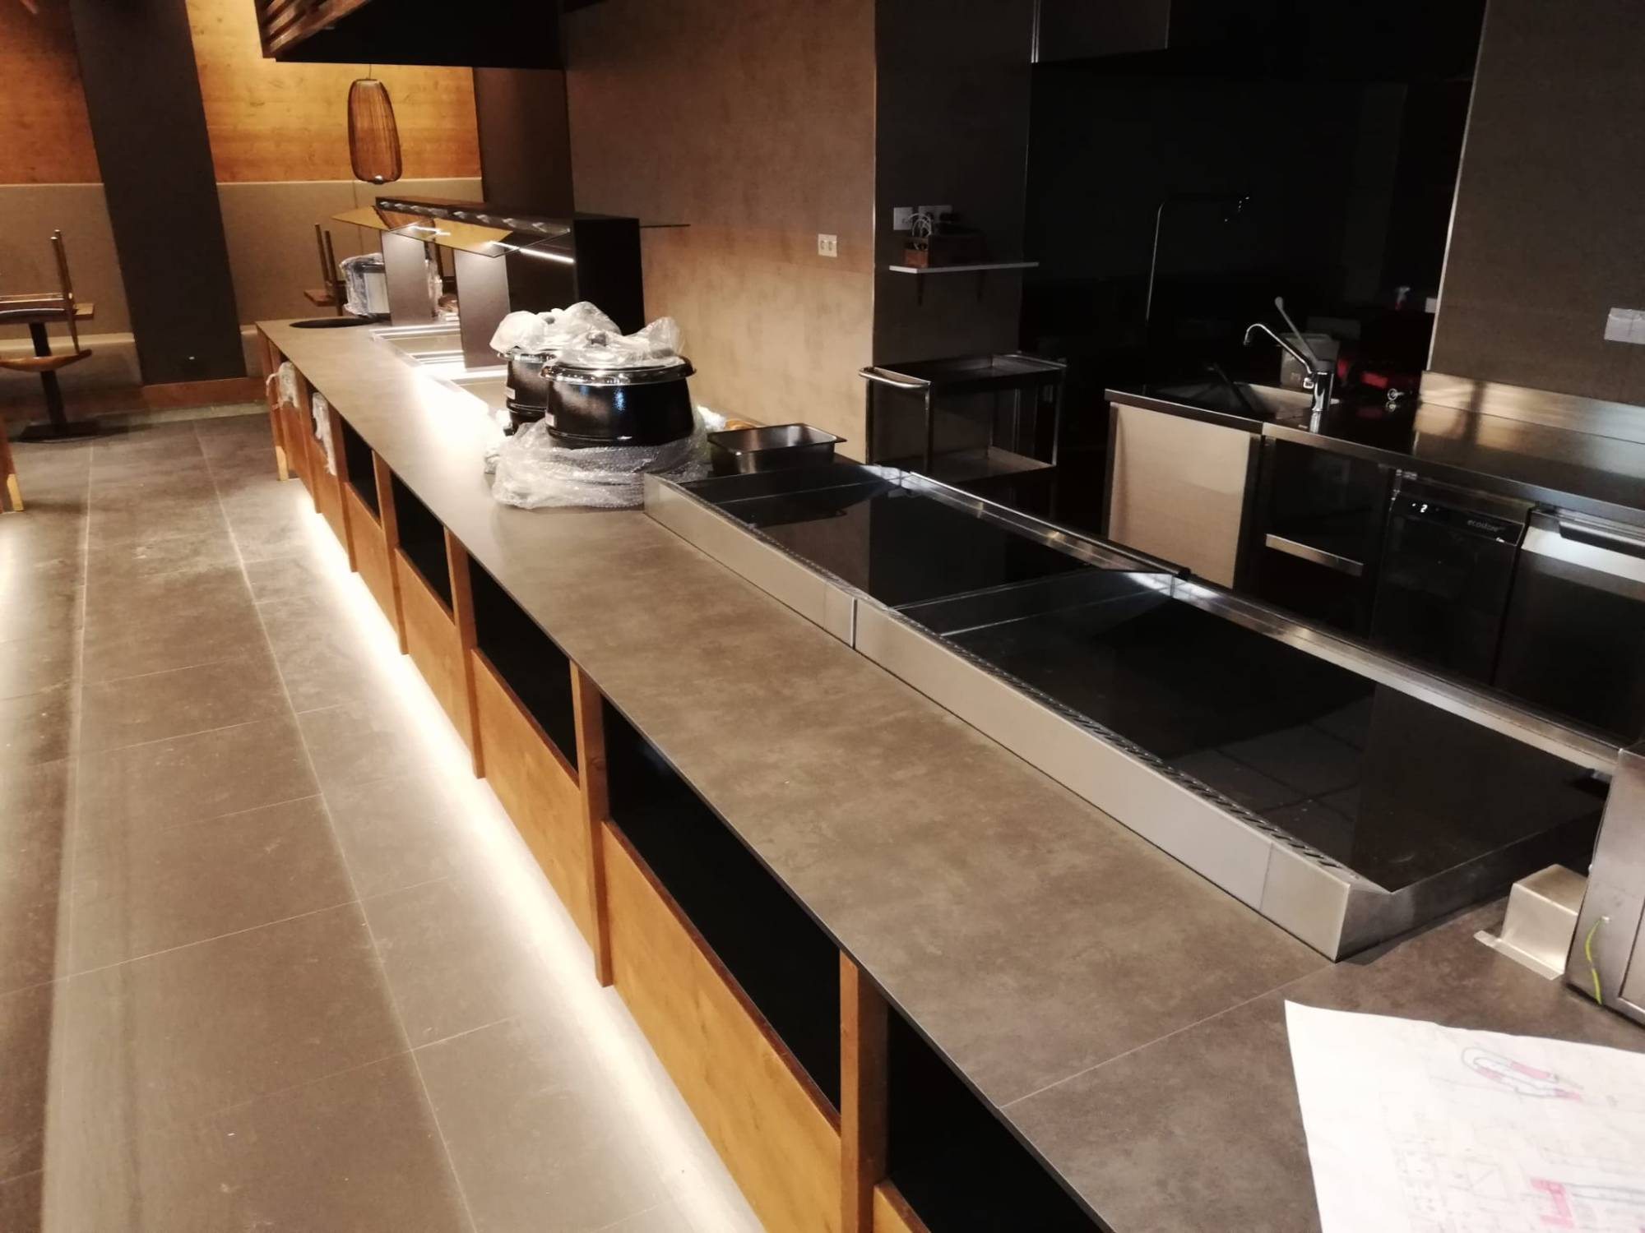
SAJADO Eurovea, Bratislava
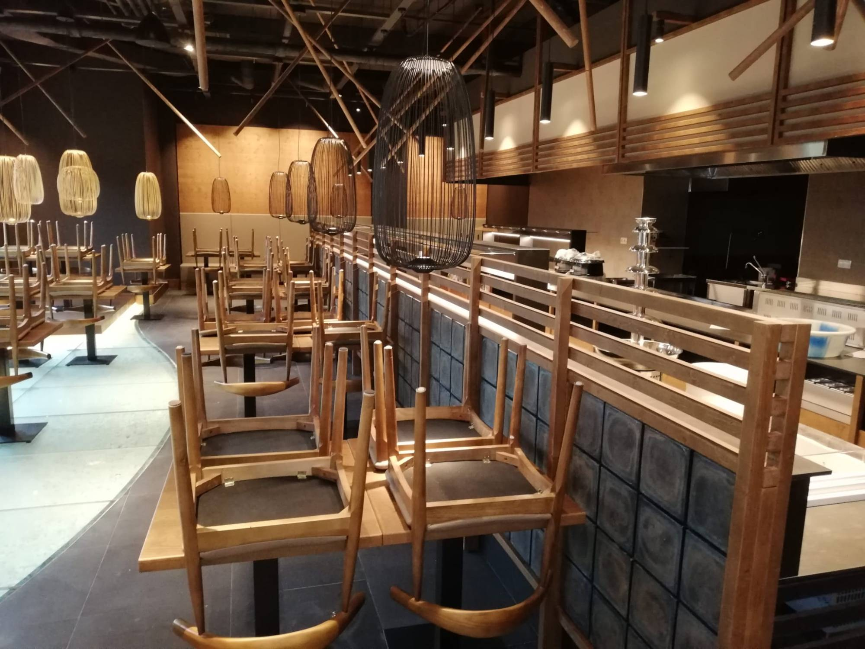
SAJADO Eurovea, Bratislava
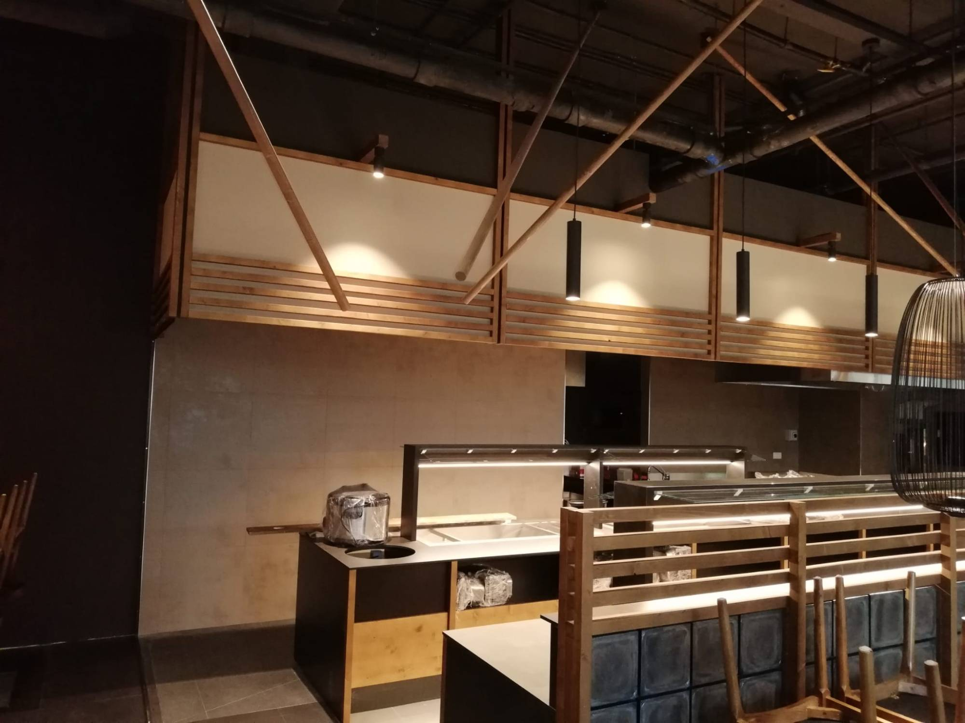
SAJADO Eurovea, Bratislava
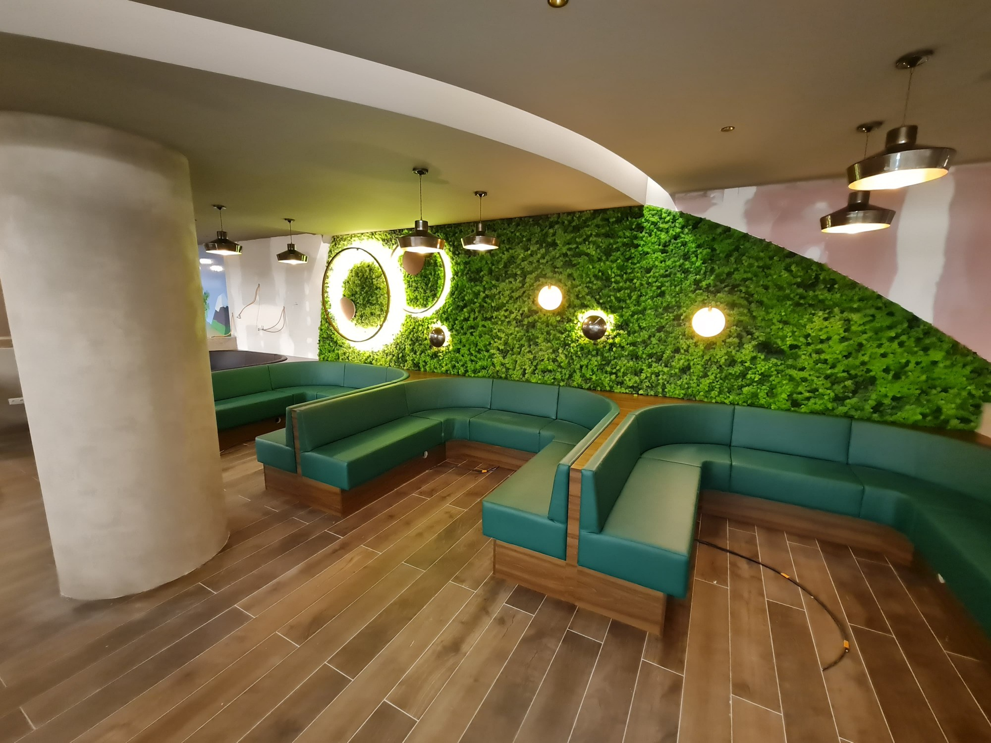
Food Hall, OC Urban Košice
We look forward to working with you.
Rastislav Gračík · BenGrac interiéry

